**Commands For Execution**

* **FRONT END**
* Open VS code and open new terminal ( ctrl+shift+`).
* Create a folder in file explorer and open in VScode.

Step-1 : To Create React setup with Next.js:

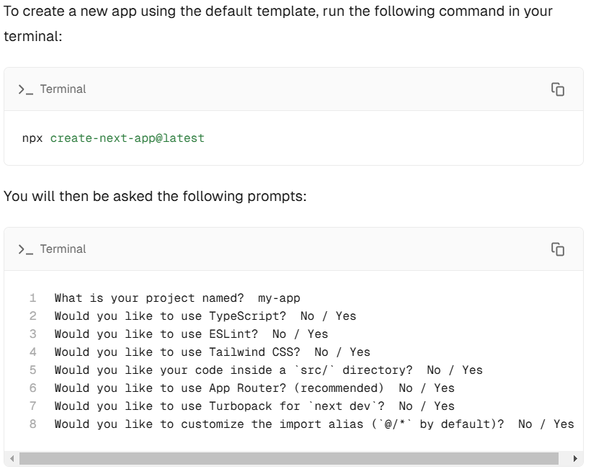

Step-2 : Build the app:

npm run build

step-3: Run the application:

npm run dev

* click on <https://localhost:3000> then it redirect into browser displays our project
* **BACKEND**

* Open IntellijIdea and then open the path where your code is :
* Download PostgreSQL and PostmanAPI and install it
* Then replace your postgreSql password and username in application.properties
* Open SkillCapitalApplication class and Click on Run button.
* Enable Lombok configurations and required permission it ask
* **PostgreSQL**
* Create a Table in Database named as skillcapital
* **Postman API**
* Request the api’s we require
* **U S E R**  
    
    
  METHODS POSTMAN REQUEST API CALLS  
  ------- ---------------- ----------  
    
  FOR REGISTERING AND LOGIN:
* /api/auth  
    
  1. Register : POST /api/auth/register  
  2. Login : POST /api/auth/login  
    
  FOR CRUD OPERATIONS:
* /api/users  
    
  1. Find All Users: GET /api/users/all  
  2. Get User By ID: GET /api/users/{id}  
  3. Get User By Username: GET /api/users/username/{username}  
  4. Update User By ID: PUT /api/users/{id}  
  5. Deleting User: DELETE /api/users/{id}  
    
    
   **L E A D S**  
   /api/leads  
    
  1. Registering Lead: POST /api/leads/register  
  2. Get All: GET /api/leads/all  
  3. Find Lead By ID: GET /api/leads/{id}  
  4. Find Lead By Username: GET /api/leads/name/{name}  
  5 Update Lead By ID: PUT /api/leads/{id}  
  6. Delete Lead By ID: DELETE /api/leads/{id}
* **O P P O R T U N I T I E S**  
    
   /api/opportunities  
    
  1. Registering Opportunity POST /api/opportunities/register  
  2. Get All Opportunities GET /api/opportunities/all  
  3. Get Opportunity By Id GET /api/opportunities/{id}  
  4. Get Opportunity By Name GET /api/opportunities/name/{name}  
  5. Update Opportunity By ID PUT /api/opportunities/{id}  
  6. Delete Opportunity By ID DELETE /api/opportunities/{id}  
    
    
   **L E A R N E R S**  
    
   /api/learners  
    
  1. Register Learner POST /api/learners/register  
  2. Get All Learners GET /api/learners/all  
  3. Get Learner By ID GET /api/learners/{id}  
  4. Get Learner By Username GET /api/learners/name/{name}  
  5. Update Learner By ID PUT /api/learners/{id}  
  6. Delete Learner By ID DELETE /api/learners/{id}  
    
    
   **C O U R S E S**  
    
   /api/courses  
    
  1. Register Course POST /api/courses/register  
  2. Get All Courses GET /api/courses/all  
  3. Get Course By ID GET /api/courses/{id}  
  4. Update Course By ID PUT /api/courses/{id}  
  5. Delete Course By ID DELETE /api/courses/{id}