API Laravel File
API in Laravel is a way to send and receive data
1-In Laravel the API section is api.php and we can manage it on RouteServicesprovider
2- create APi/Controller
3- connect Controller API on API.php
4-test API/url
5- write in Controller Return Response ( $post state Msg )
6-

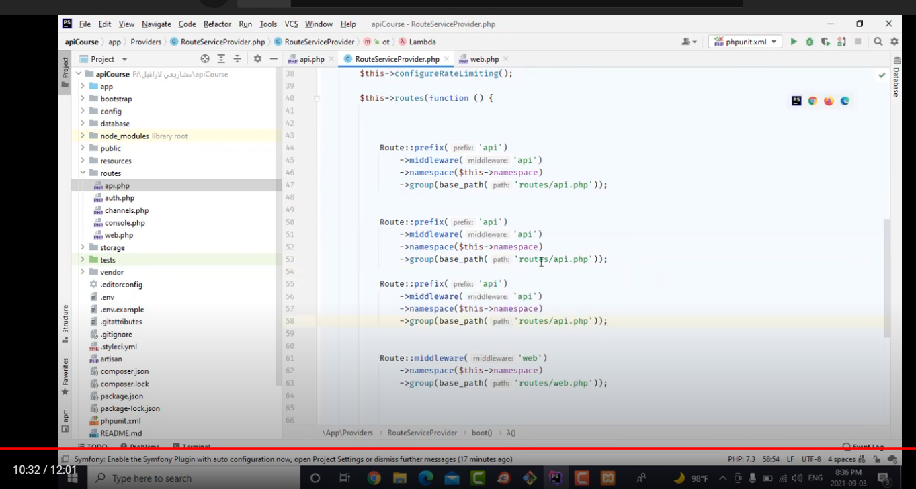

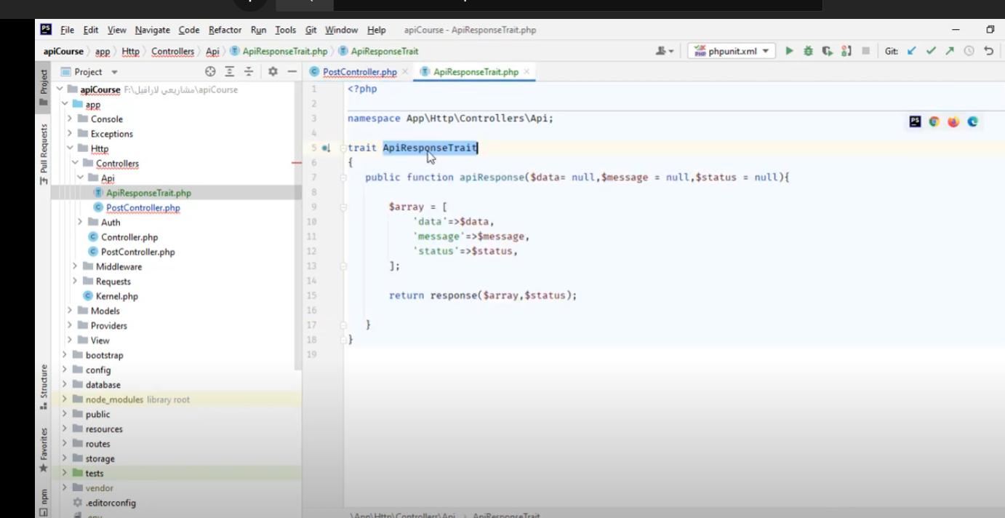
v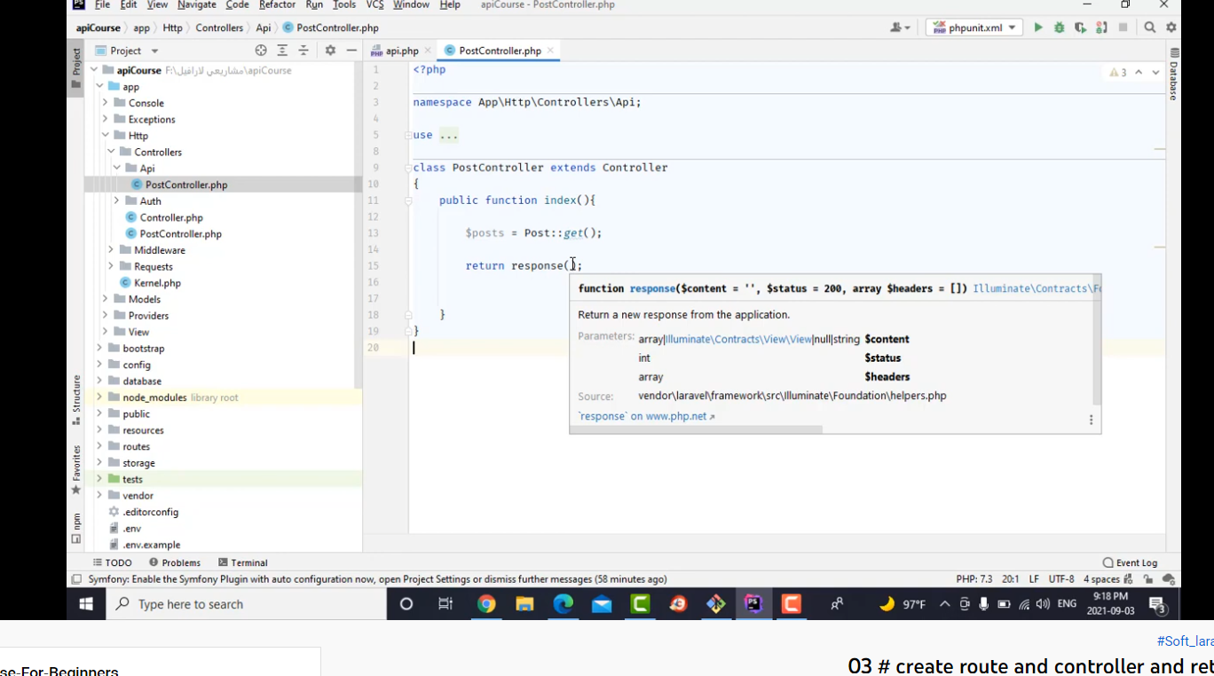

//Format Response Must be like the same in all Controllers
All API Function Include 1- Date 2- Status 3- Msg

If Statement in API
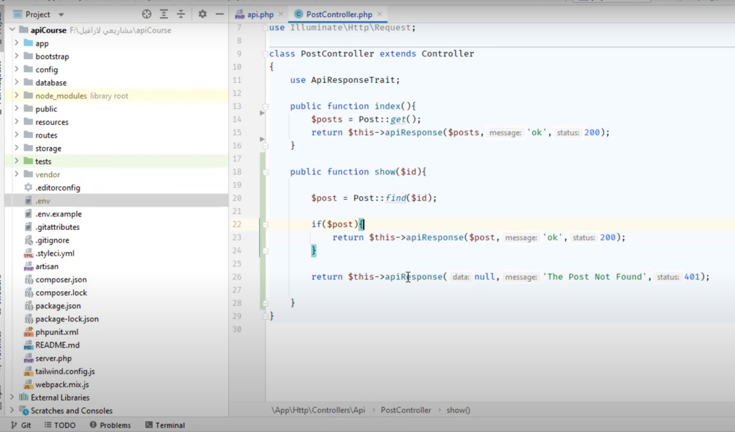
Steps to mange Resouse Date Display
- Create Resourse php artisan make:Resouse PostResousre
- Call Resourse in controller
- 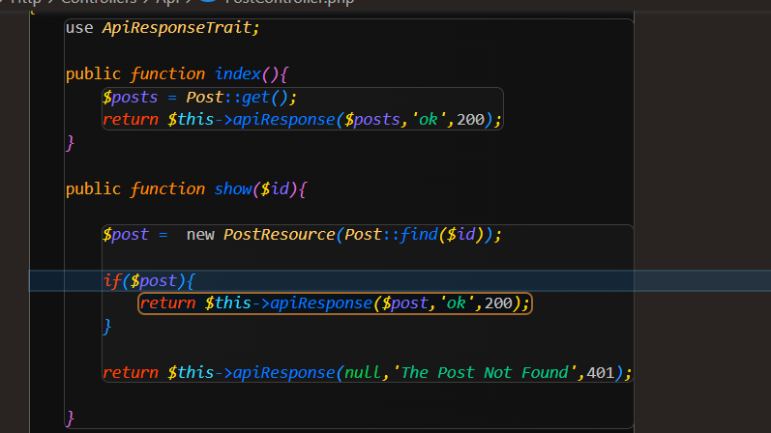
- Set data what you wanna to display in Resouse file
- 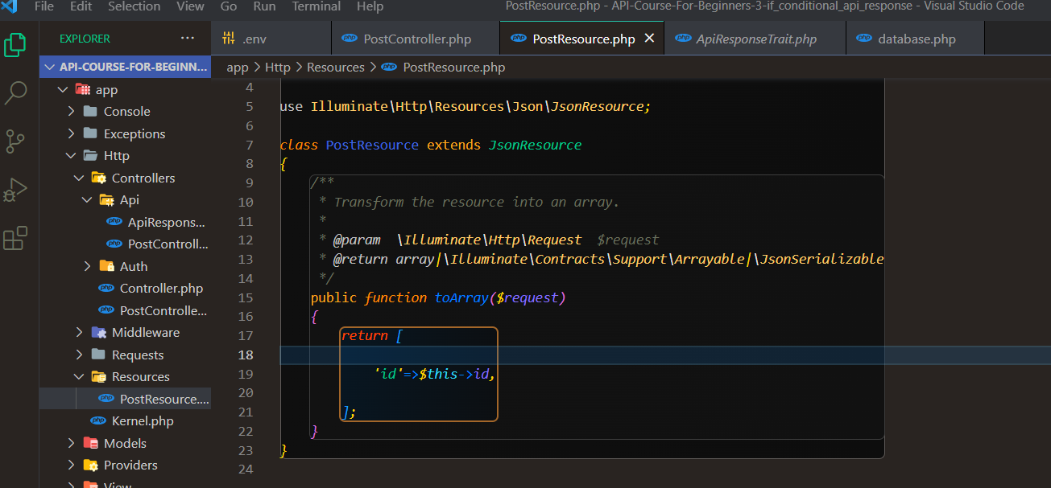

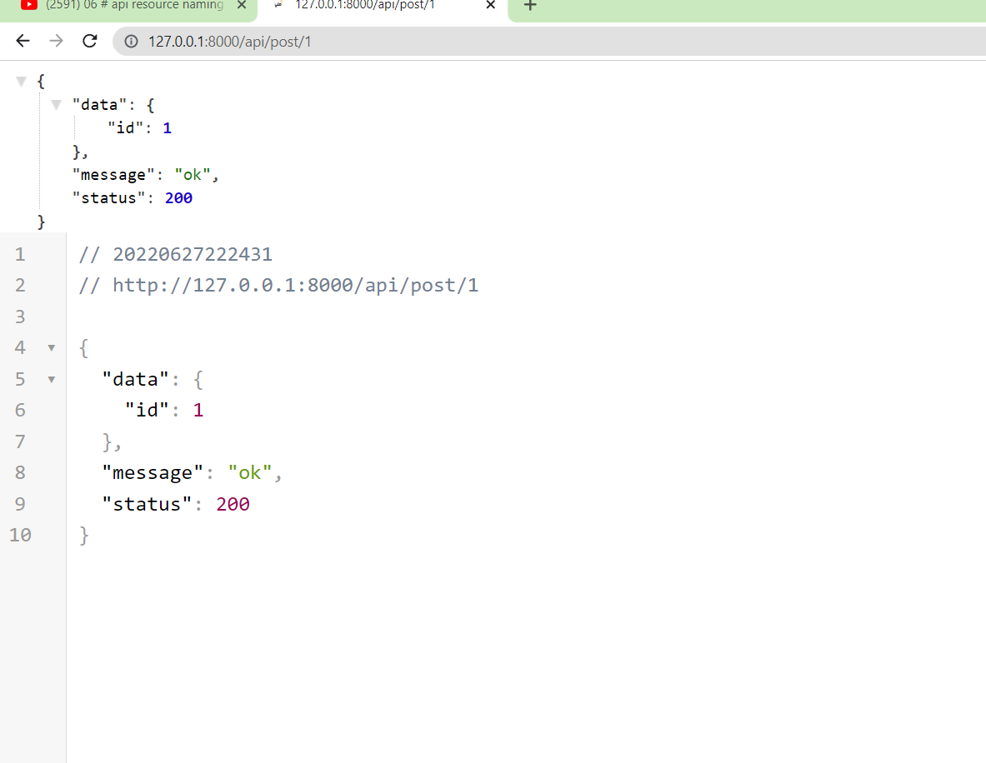
Like you see I Just Display only ID

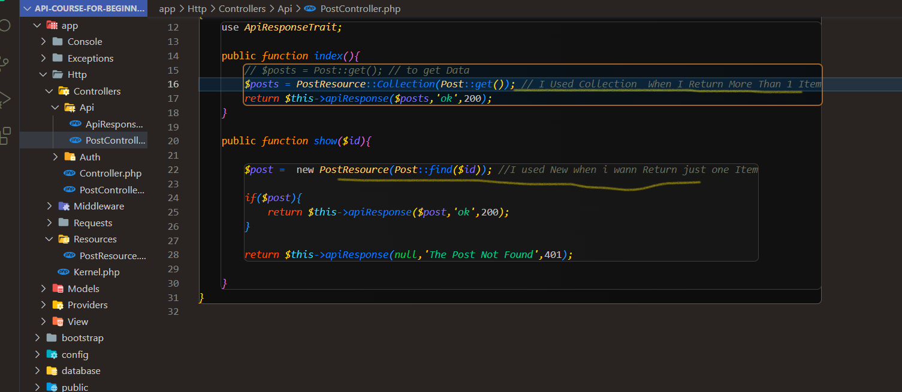

New when Return One Item In View
Collection When Return more Than 1 Item in View

To Return Msg Error When invalid input
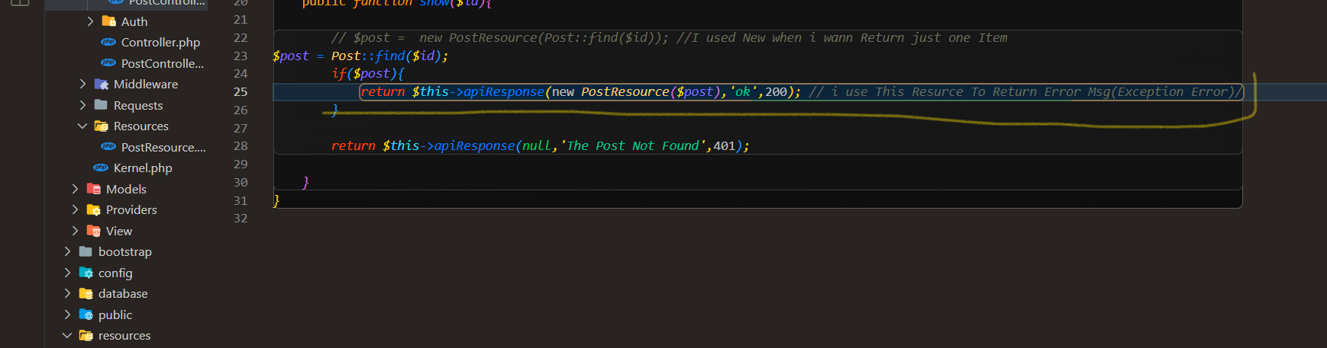

Steps to test URL and Create Project in postman
- New
- Select Collection
- 3- You Should Create Folder For Each Controller Or Section
- Add Request For You Wont
// You Can Set Var Shortcut For URL To Reduce URL {{}} ->Variable Sections

Store Fuction
- Crate Route on API.php
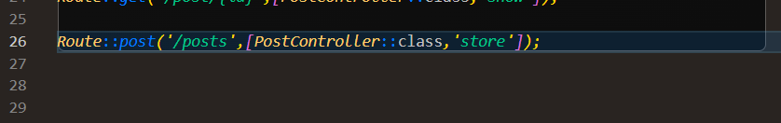2- create Fuction with validate make sure I tested it on post man
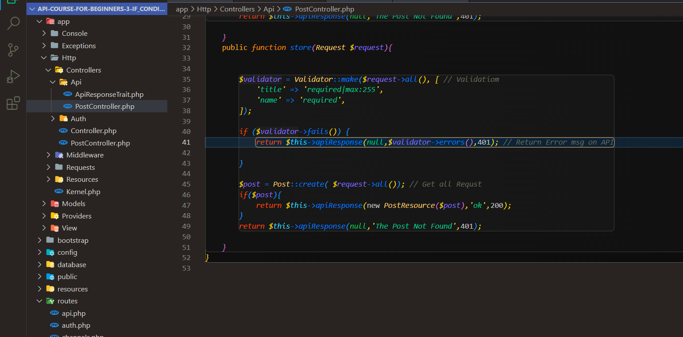

Delete
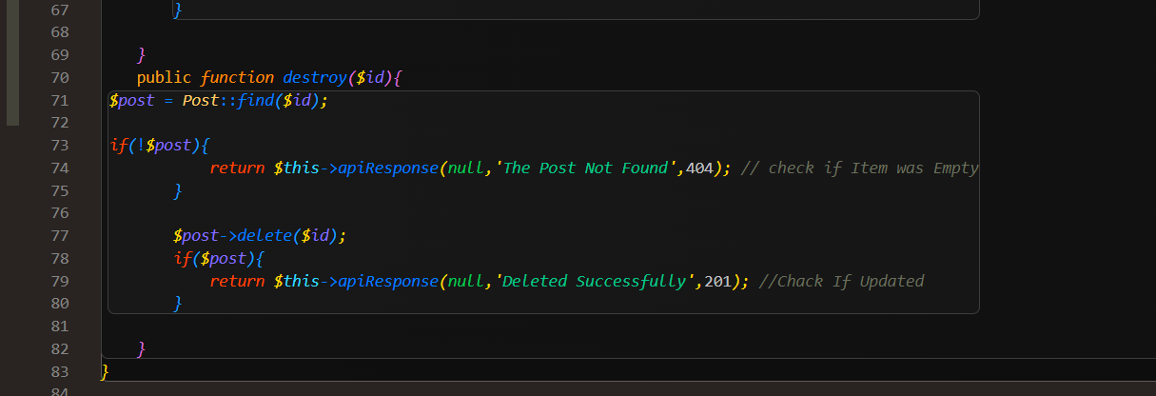

https://www.positronx.io/laravel-jwt-authentication-tutorial-user-login-signup-api/ JWT Steps
https://blog.pusher.com/laravel-jwt/ Middleware JWT

j

