

THE IMPACT OF SUMMER DROUGHT ON THE NITRIFYING MICROBIOME OF REWETTED FEN PEATLANDS

Anna M. Burns

In partial fulfillment for the degree of Master of Science in Landscape Ecology and Nature Conservation

University of Greifswald, 2024

Advised by:

Prof. Dr. Tim Urich

Dr. Haitao Wang

Table of Contents

**Introduction** 3

**Manuscript pre-print: “Ammonia oxidizing archaea and bacteria respond dynamically to drought in rewetted fen peatlands” (Burns et al., under review)** 5

**Appendix I: Clustering Method for Drought Definition** 6

**Appendix II: AOA and AOB Standard Cultivation** 9

**i.** **Plasmid cultivation and linearization for qPCR** 9

**ii.** **Standard transcription for RT-qPCR** 12

**Appendix III: (RT-)qPCR Results** 14

**Appendix IV: AOA Phylogenetic Tree Assembly** 17

**Conclusion** 18

**Works Cited** 18

 To-do:

* Manuscript pre-print:
  + Add rRNA for CW and PW to megafigure
  + Incorporate Haitao’s comments
  + Add redox potential data
  + Look at SEED pathways
* Thesis:
  + Edit plasmid cultivation methods
  + Write clustering method details + put in context w/ literature
  + Write phylogenetic tree assembly details
  + Write RT/qPCR details
  + Write brief conclusion

**Introduction**

Peatlands’ globally important functions as carbon sinks and biodiversity hotspots are currently threatened by large-scale drainage [1]. When drained, peatlands shift from a carbon sink to a source, which in 2022 constituted 4% of anthropogenic greenhouse gas emissions [1]. Rewetting these drained peatlands presents an opportunity not only to restore their carbon sink function, but also to provide other valuable services such as regional cooling, flood protection and biodiversity refugia [2]. In order to meet the net zero emission goal set by the Paris Climate Agreement for 2050, Germany alone will need to rewet 50,000 ha of peatland each year, far outpacing the current rate of 2,000 ha per year [3]. As novel rewetted fen ecosystems necessarily become more widespread, it is vital to study their ecosystem functions and processes, which are not necessarily similar to their pristine counterparts [4].

When central Europe was hit by a record-breaking drought in the summer of 2018, it was a glimpse into a weather pattern that could become status quo within as little as 20 years [5]. It also provided an opportunity to study how two novel rewetted fen ecosystems in northeastern Germany would react to this near-future climate scenario. Of particular interest is how the fen nitrifying microbiome would respond to drought, which has implications for plant nutrient availability, downstream eutrophication and emissions of the potent greenhouse gas nitrous oxide [6–8].

I used multiple molecular methods to quantify the abundance of microbes capable of ammonia oxidation, the rate-limiting step of nitrification in which ammonia is transformed to nitrate via hydroxylamine, before later being oxidized to nitrate and made plant-available [9]. This process is mediated by both ammonia oxidizing archaea (AOA) and bacteria (AOB), as well as complete ammonia oxidizing bacteria (commamox) [10]. The gene *amoA* has been identified in all three groups as a marker that encodes for the enzyme ammonia monooxygenase (amo), which is responsible for the oxidation of ammonia to hydroxylamine [11–13]. I first quantified abundances of the bacterial and archaeal *amoA* genes from the extracted DNA of *in situ* peat soils using qPCR, before evaluating *amoA* transcript abundance from extracted RNA. This was additionally supported by amplicon sequences and metatranscriptomes, and a phylogenetic tree of AOA clades created using the method of Wang et al. (2021) to combine 16S rRNA and *amoA* gene taxonomies [14]. Further, I defined when the field sites were under drought or typical hydrological conditions by applying a k-means clustering algorithm to water table depth in each site, quantitatively defining drought water table thresholds that allow for site-specific analysis of drought cycles.

The results of these experiments are described in the manuscript “Ammonia oxidizing archaea and bacteria respond dynamically to drought in rewetted fen peatlands” (Burns et al., in progress). This thesis consists of the final manuscript draft, written in full by the author of this thesis, which at the time of submission is being reviewed and expanded upon by contributing authors. In addition, I include four appendices with information relevant to the thesis, which was not necessary to include for manuscript publication. In the first, I go into greater detail on using the k-means clustering machine learning method to define drought periods; in the second, I describe the protocol for developing the *amoA* standards that were used for (RT-)qPCR. In the third, I include results for the qPCR and RT-qPCR experiments using the standards described previously. In the fourth and final appendix, I discuss assembly and application of the AOA phylogenetic tree.

In the following manuscript, I hypothesize that ammonia oxidation proxies will increase during the drought in response to soil oxidation as the water table decreases, due to the ammonia metabolism pathway of AOA and AOB being obligately aerobic [15, 16]. I further expect that AOA will outnumber AOB in the peatland soils, due to their higher substrate affinity and ubiquity in low pH soils [17, 18]. Ultimately, I compare the nitrifying microbiomes not only between drought and standard hydrological conditions, but also between multiple molecular proxy methods and mire types. Using this multimodal framework, I conclude that ammonia oxidizers react significantly to drought, responding to changes in soil nitrogen sources and amplifying shifts in nitrogen cycling gene transcription that mimics the dynamics of draining and rewetting.

**Manuscript pre-print: “Ammonia oxidizing archaea and bacteria respond dynamically to drought in rewetted fen peatlands” (Burns et al., under review)**

 ** there are 6 figures in the publication **

**Appendix I: Clustering Method for Drought Definition**

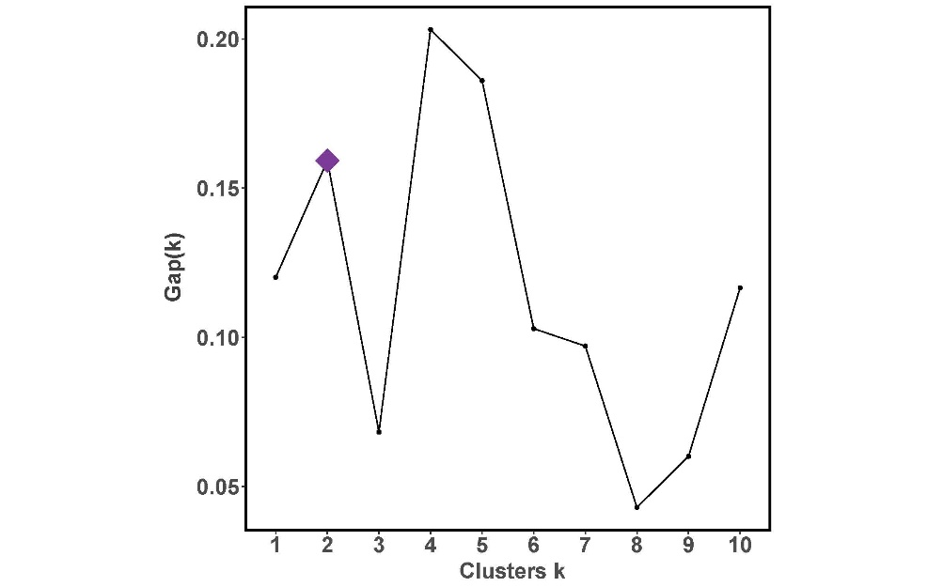

*Figure 7.* Results of the ClusGap function (K.max = 10, B = 500) on each site’s water table depth values . K = 2 was chosen as the optimal cluster number for each site based on the gap statistic (Gapₖ). This was evident for PW (a), PD (b) and CW (c), where k = 2 also had the maximum Gapₖ; for CD (d), k = 2 was selected heuristically due to the sharp decrease in Gapₖ for k = 3 (despite the subsequent increase when k = 4). Therefore, k = 2 was selected to minimize the instability in the Gapₖ metric.

**CDW AOB**

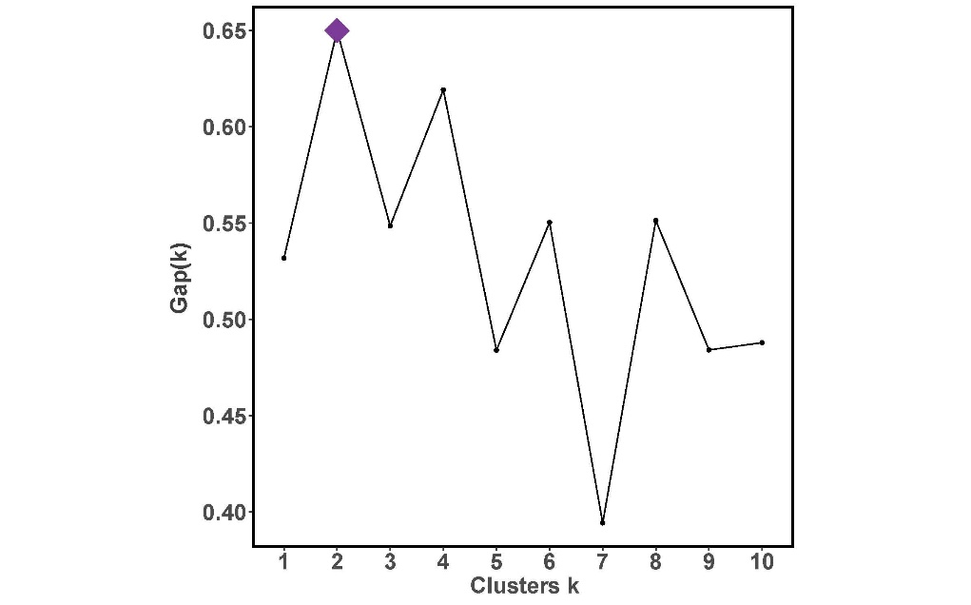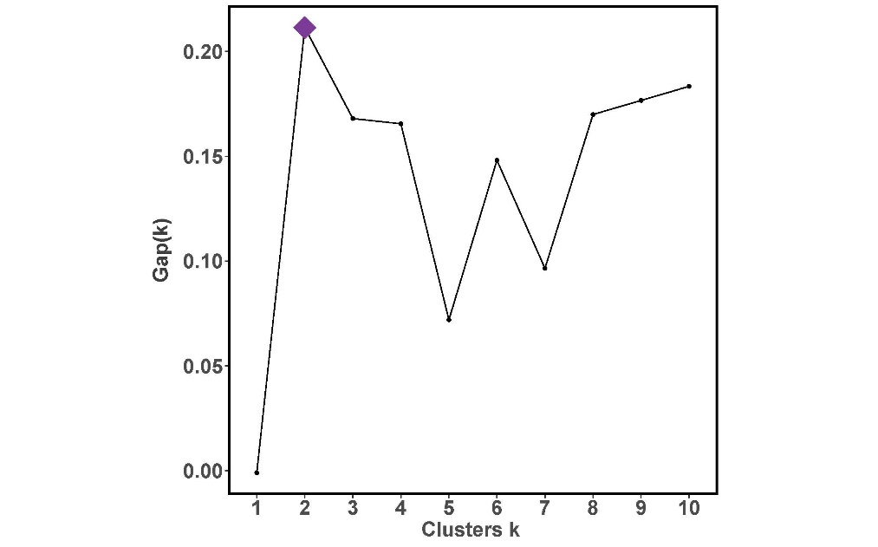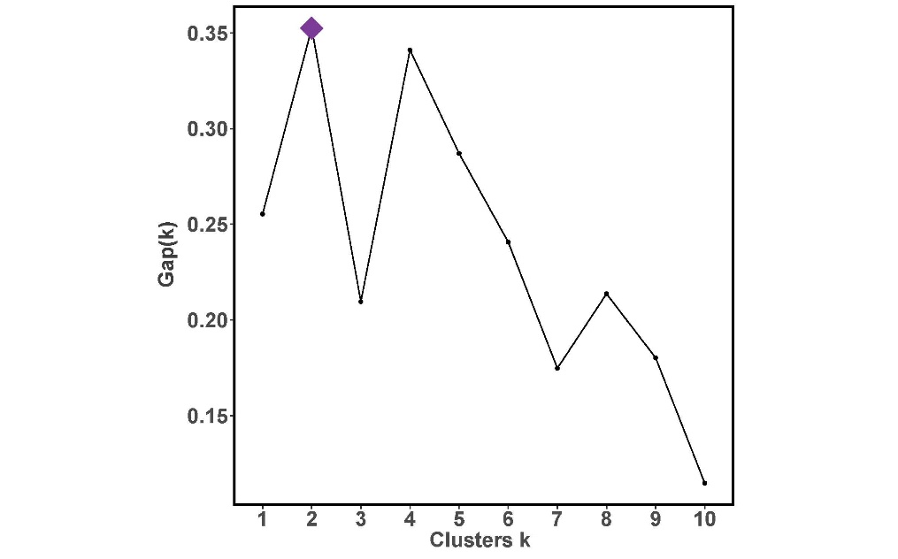

**CWW AOB**

**d) AOB**

**b) AOB**

**PD AOB**

**PWW AOB**

**c) AOB**

**a) AOB**

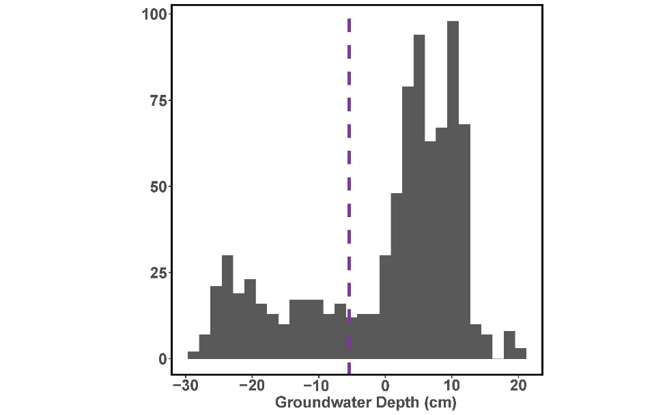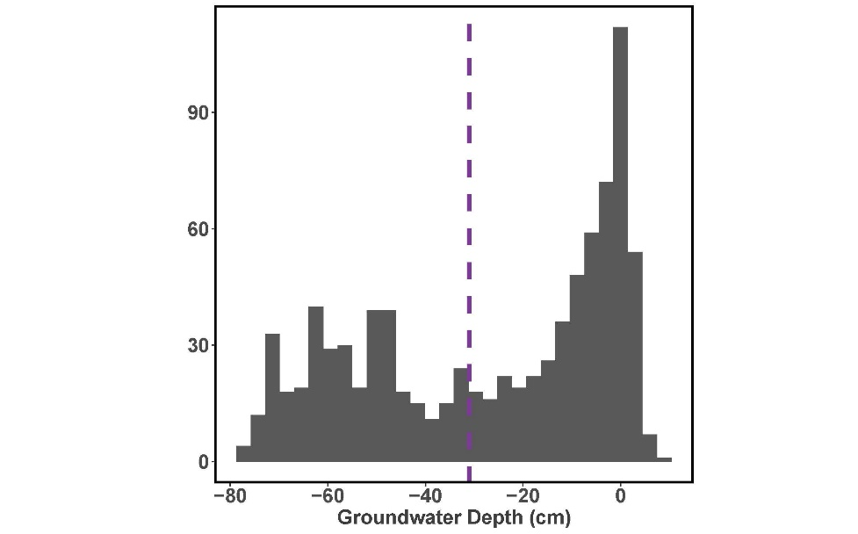

**b) AOB**

**PD AOB**

**PWW AOB**

**a) AOB**

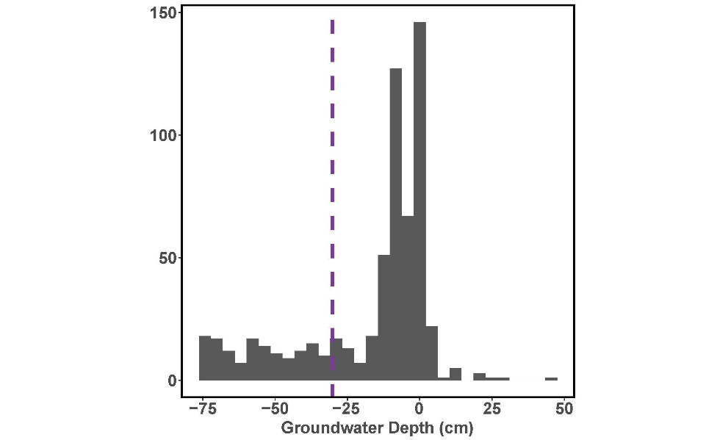

**CWW AOB**

**c) AOB**

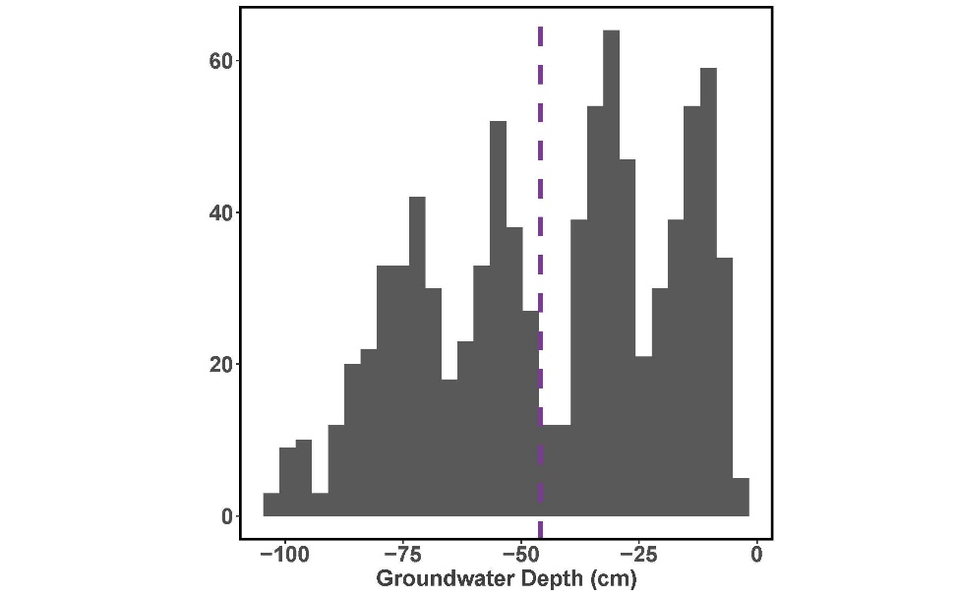

**CD AOB**

**d) AOB**

*Figure 8.* Histograms of water table values in each site. The k-means cluster-identified drought threshold for each site included as follows: (a) PW drought threshold -5.45 cm; (b) PD, -31.05 cm; (c) CW, -30.24 cm; (d) CD, -45.88 cm.

**Appendix II: AOA and AOB Standard Cultivation**

1. **Plasmid cultivation and linearization for qPCR**

The purified cultures chosen to create standards for downstream qPCR analysis were the ammonia-oxidizing bacteria *Nitrosopira multiformis* [16]*,* ammonia oxidizing archaea *Nitrosophaera viennensis* [19], and *Escherichia coli* [citation needed?]. First, the target genes were amplified via PCR with the following 25 ul reaction: 0.75 ul GoTaq® DNA Polymerase (Promega, Wisconsin, USA), 5 ul 5x GoTaq® Reaction Buffer (Promega), 2.5 ul MgCl₂, 0.5 ul DNTPs, 13.375 ul H₂O, 0.125 ul each forward and reverse primer, and 1 ul DNA template. The archaeal *amoA* gene was amplified from *N. multiformis* with the primer pair camoA-19F [19, 20]/tamoA-629R [21], using a PCR cycle with a 5 min initialization at 95°C, followed by 35 rounds of denaturing for 45s at 95°C, 45s of annealing at 55°C, and a 1 min elongation at 72°C, before a 10 min finalization stage at 72°C. The bacterial *amoA* gene was amplified from *N. viennensis* using the primer pair amoA-1F/2R [11], and the 16S rRNA gene was amplified from *E. Coli* using the 515F [22]/806R [23] primers. Both the AOB and 16S rRNA templates were amplified using the following PCR protocol: a 2 minute initialization stage at 95°C, then 35 rounds of a 30s elongation stage at 95°C, a 30s annealing stage at 55°C, and a 45s elongation stage at 72°C, before a 5 minute finalization stage at 72°C.

The lengths of the resulting PCR products of the genes of interest were verified via gel electrophoresis before being cleaned with the Zymo DNA Clean & Concentrator kit following the standard protocol (California, USA). The purity of the resulting gene fragments were assessed with a NanoDrop Spectrophotometer (ThermoFisher, Massachusetts, USA), with the following 260/230 ratios: 1.94 for the 16S rRNA product, 1.66 for the archaeal *amoA* product, and 1.74 for the bacterial *amoA* product.

The PCR products were then ligased to prepare for plasmid insertion with 1 ul of the Promega T4 DNA Ligase (California, USA), 1 ul Promega pGEM®-T Easy Vector, and 5 ul of the Promega 2x Rapid Ligation Buffer. Additionally, the following volumes of the cleaned PCR products were added: 2 ul of the bacterial *amoA* product with 1 ul H₂O, 1 ul of the 16S rRNA product with 2 ul H₂O, and 1.5 ul of the archaeal *amoA* product with 1.5 ul H₂O, resulting in a 10 ul reaction. Two microliters of the ligase solution was then mixed with 50 ul competent *E. Coli* and placed on ice for 20 minutes. The solution was then heat shocked at 42°C for 45-50 seconds before being placed on ice for a further 2 minutes. Then, 950 ul room-temperature SOC medium was added to the solution and incubated at 37°C with 150 rpm shaking for 1.5 hours. Finally, 100 ul of the solution was plated onto an agar medium with 166 mg NaCl, 166 mg yeast, 330 mg Tryptone, 500 mg agar, 0.1 ul ampicillin, 0.04 g X-Gal and 1.67 ml water. The agar cultures were then incubated overnight at 37°C.

Colonies that displayed successful plasmid insertion (as indicated by the white colony color) were picked and amplified via the same PCR protocol as described for the initial gene amplification. The quality of the plasmids was then visually verified on a gel, and two colonies were selected for each inserted gene to amplify in liquid SOC medium with 8.33 ul ampicillin overnight at 37°C with 150 rpm shaking. At this step, cryostocks for each plasmid were frozen at -80°C with a 1:1 glycerin mixture. Two samples for each gene were selected for plasmid extraction and immediate use.

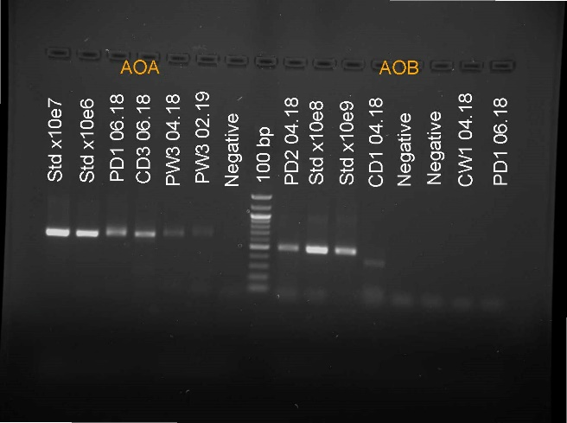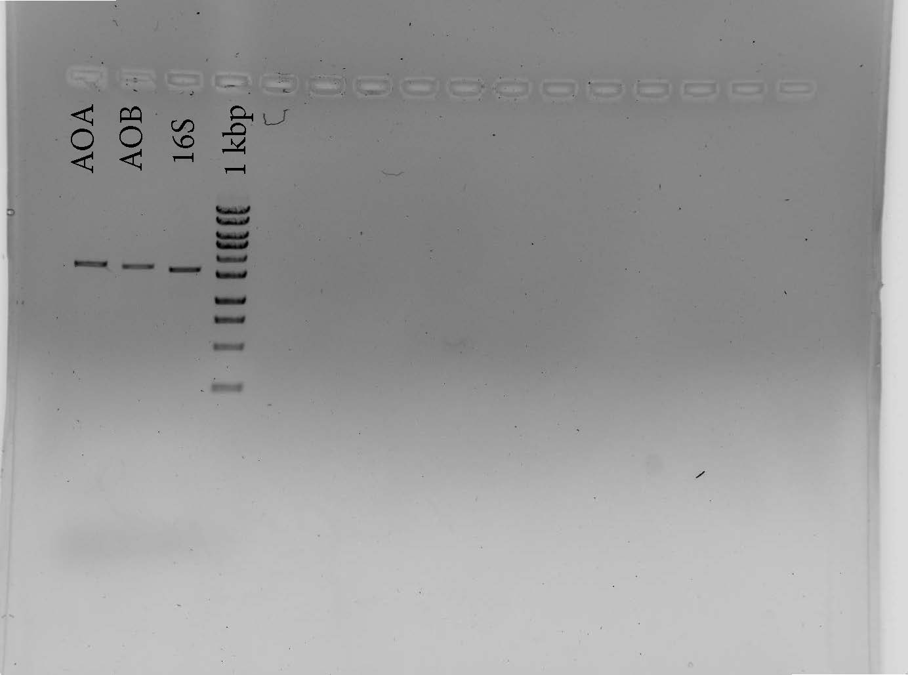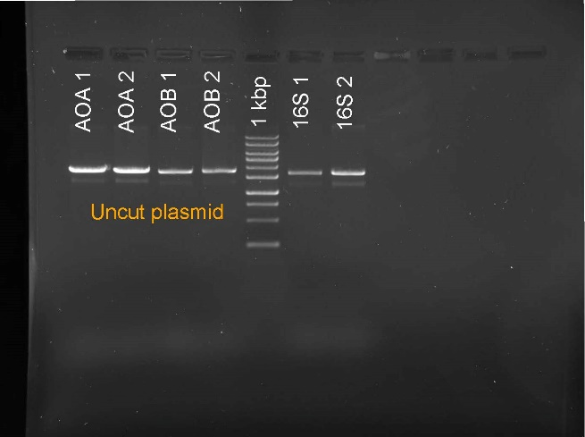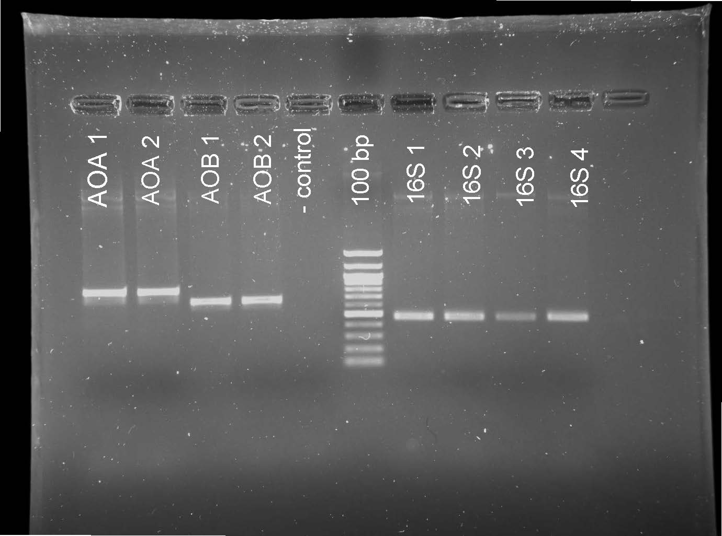

*Figure 9.* Annotated gel electrophoresis printouts from throughout the standard cultivation protocol:

*9a*. Extracted plasma inserts, with two replicates each of inserts for extracted archaeal amoA (AOA 1&2) and bacterial amoA (AOB 1&2). Additionally, there is a negative control and 100 bp ladder for reference. Four replicates of extracted inserts for the 16S rRNA gene (16S 1-4) are included.

*9b.* Linearized plasmid inserts, with two replicates each of linearized archaeal amoA (AOA 1&2), bacterial amoA (AOB 1&2) compared to a 1kbp ladder. Two plasmid inserts of the 16S rRNA gene (16S 1&2) are also included.

*9c.* Double-cut linearized plasmid inserts, after cut plasmid were recovered from the gel in 9b and resuspended. Archaeal amoA (AOA), bacterial amoA (AOB), the 16S rRNA gene (16S) and a 1kbp ladder are pictured.

*9d.* Results from first qPCR plate runs, with samples from the plate with the archaeal amoA standard on the right (including two standards with x10e7 and x10e6 archaeal amoA copies, four samples and one negative control). Samples from the bacterial amoA plate are on the left, and includes 2 standards (x10e8 and x10e9 copies of bacterial amoA), three samples and two negative controls. Between is a reference 100 bp ladder.

**d) AOB**

**c) AOB**

**b) AOB**

**a) AOB**

The selected plasmids were extracted using the Zymo plasmid extraction kit, which resulted in the following elution concentrations measured with NanoDrop: 201.955 and 124.844 ng/ul for archaeal *amoA*, 118.291 and 108.291 ng/ul for bacterial *amoA*, and 92.125 and 72.237 ng/ul for 16S rRNA. A subsample of each extracted plasmid was then amplified via the same PCR protocols as above and visually verified with a gel (Fig. 9a). The extracted genes were then linearized in 50 ul reactions with 1 ug DNA, 5 ul 10x NE buffer, 1 ul enzyme and the rest of the volume with H₂O. The plasmids inserts were linearized at 37°C for 1 hour, and then heat inactivated at 65°C for 20 minutes.

A gel of the linearized plasmid inserts demonstrated that there was still uncut plasmid in the extracted products (Fig. 9b). Therefore, the products at the correct fragment lengths (635 bp for archaeal *amoA*, 491 bp for bacterial *amoA* and 253 bp for 16S rRNA, with the 3015 bp plasmid) were cut from the gels. The cut gel products were resuspended with the Zymoclean Gel DNA Recovery Kit and verified with another gel for purity (Fig. 9c). Then, the copies/ul of each gene was calculated via the following formula:

The ultimate copy numbers of the plasmid products were 3.32e9 for archaeal *amoA*, 1.44e9 for bacterial *amoA*, and 1.65e8 for 16S rRNA. The archaeal and bacterial *amoA* plasmid products were aliquoted to standards with 1e9 copies/ul of the inserted gene in 5 ul of H₂O, and stored at -80°C until use for qPCR applications (Fig. 9d).

1. **Standard transcription for RT-qPCR**

[add content here]

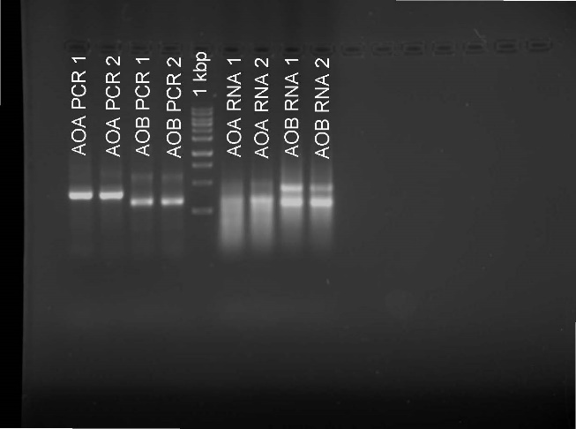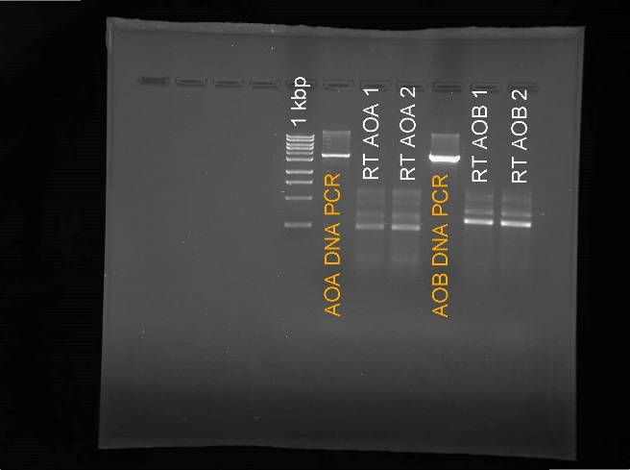

*Figure 10.* Annotated gel electrophoresis printouts from the standard transcription protocol:

*10a.* First (unsuccessful) attempt at transcribing the amoA standards, with PCR products of DNA amplified from each transcribed product. Archaeal amoA products are on the left (AOA) and bacterial amoA products are on the right (AOB), compared to a 1 kbp ladder.

*10b.* Second (and successful) attempt to transcribe amoA standards and fully remove remnant DNA to avoid DNA replication contaminating the RT-qPCR results. On the left are the PCR products amplified with the SP6/T7 primer pair and later reverse transcribed (with two replicates each from archaeal amoA, AOA PCR 1&2, and bacterial amoA, AOB PCR 1&2). On the right are the transcribed RNA standard products, with two replicates each of archaeal amoA (AOA RNA 1&2) and bacterial amoA (AOB RNA 1&2). They are separated by a 1kbp reference ladder.

**b) AOB**

**a) AOB**

**Appendix III: (RT-)qPCR Results**

Enter text here

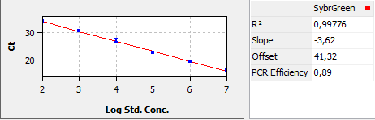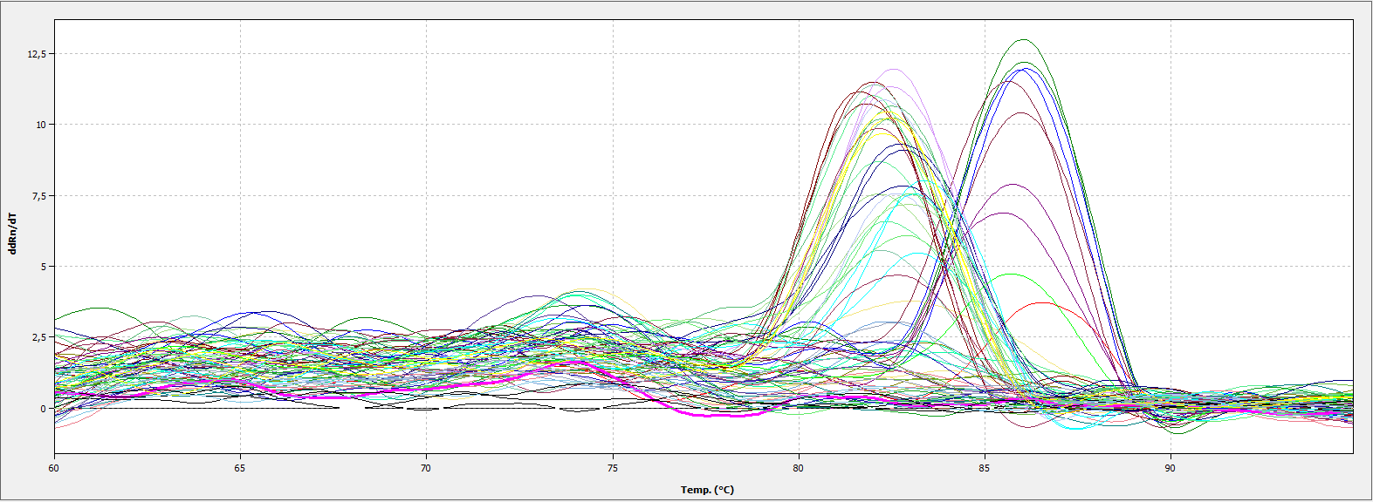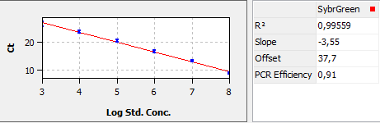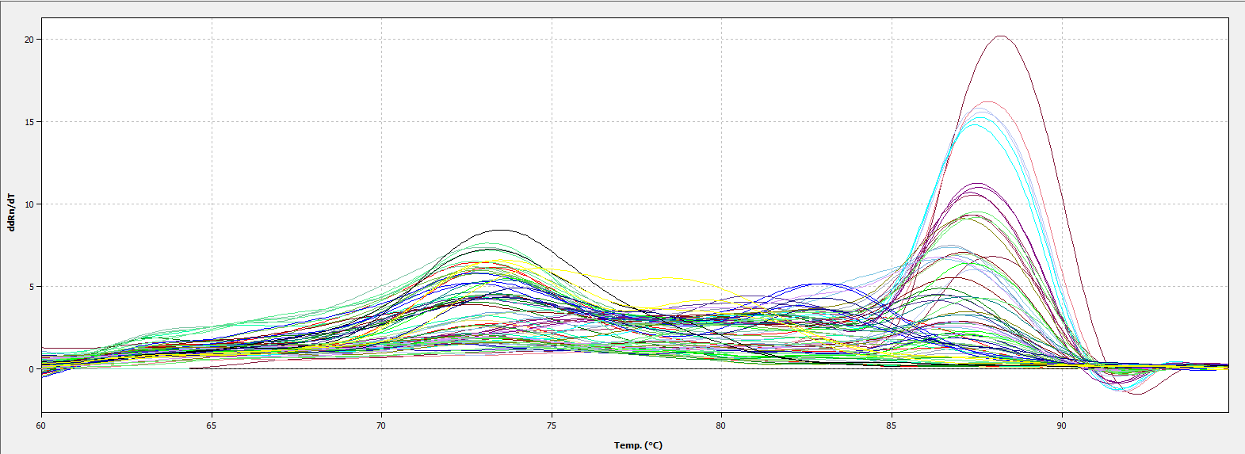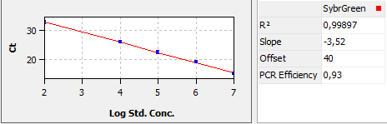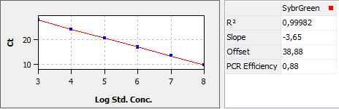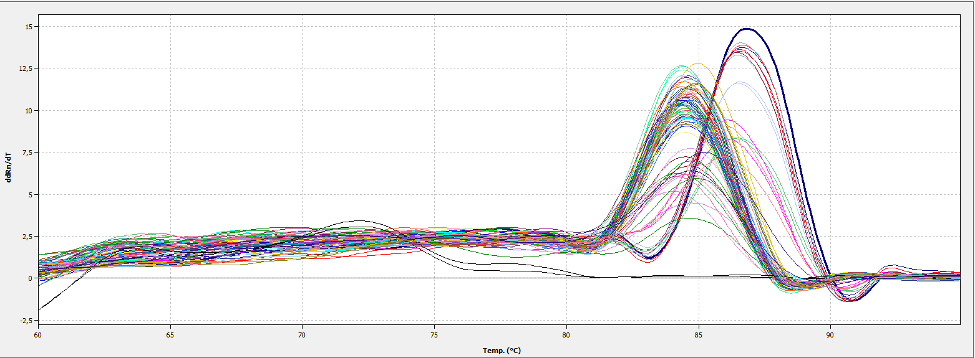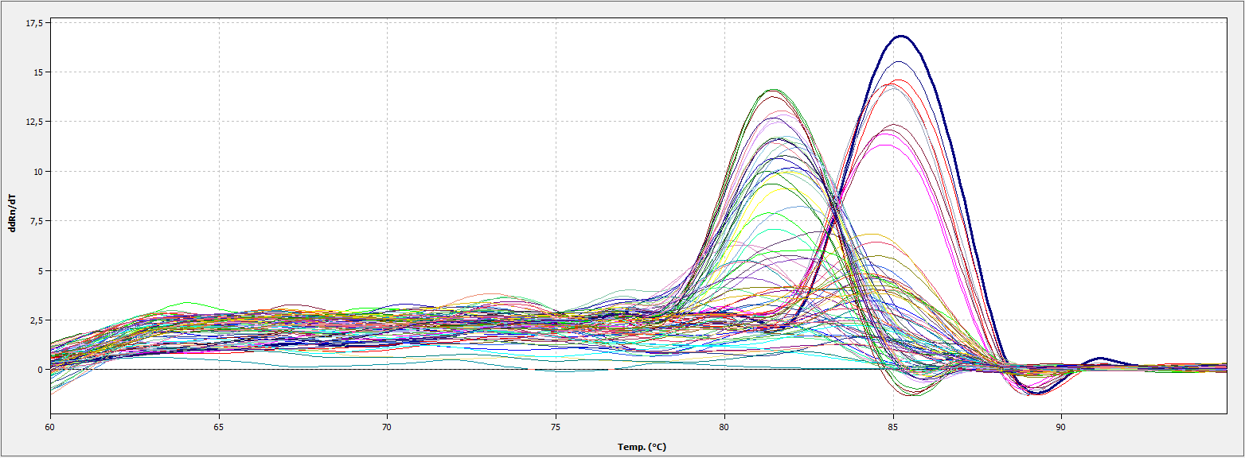

*Figure 11.*

*11a.* Output of one of three qPCR plates using the bacterial amoA standard. The R2 value was 0.996 and the slope was -3.55 with an efficiency of 0.91. The standard curve used to calculate copy numbers is inlaid on the upper left of the figure.

*11b.* Output of one of three qPCR plates using the archaeal amoA standard. The R2 value was 0.998 and the slope was -3.62 with an efficiency of 0.89. The standard curve used to calculate copy numbers is inlaid on the upper left of the figure.

**b) AOB**

**qPCR AOA**

**qPCR AOB**

**a) AOB**

*Figure 12.*

*12a.* Output of RT-qPCR plate using the bacterial amoA standard. The R2 value was 0.999 and the slope was -3.65 with an efficiency of 0.88. The standard curve used to calculate copy numbers is inlaid on the upper left of the figure.

*12b.* Output of RT-qPCR plate using the archaeal amoA standard. The R2 value was 0.999 and the slope was -3.52 with an efficiency of 0.93. The standard curve used to calculate copy numbers is inlaid on the upper left of the figure.

**b) AOB**

**RT-qPCR**

**AOA**

**RT-qPCR**

**AOB**

**a) AOB**

**Appendix IV: AOA Phylogenetic Tree Assembly**

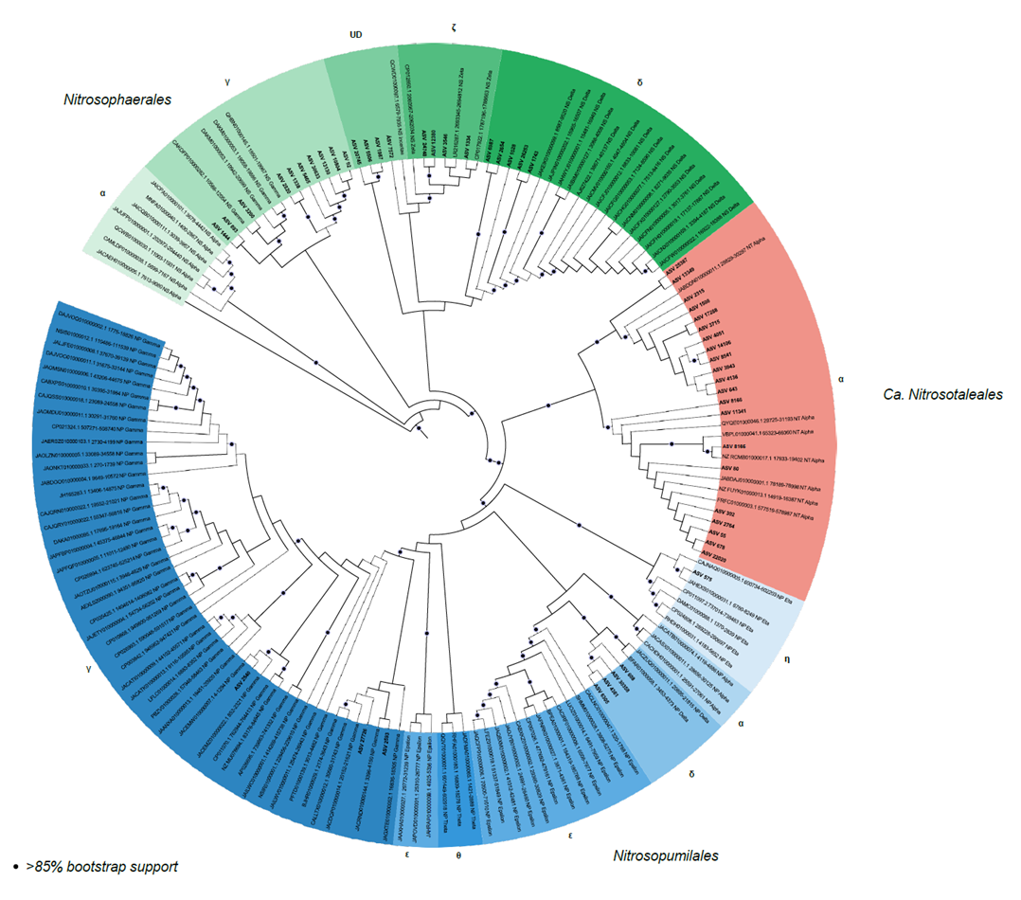

*Figure 13.* Phylogenetic tree

**Conclusion**

**Works Cited**

1. Global peatland assessment: The state of the world’s peatlands. 2022. UN Environment Programme, Global Peatlands Initiative.

2. Dewitz I, Witte T, Hüpperling S, Peters J (eds). Peatland Atlas 2023. 2023. Heinrich Böll Stiftung et al.

3. Peters J, Tanneberger F. Die große Moor-Transformation. *Klimareporter* . 2022.

4. Kreyling J, Tanneberger F, Jansen F, Van Der Linden S, Aggenbach C, Blüml V, et al. Rewetting does not return drained fen peatlands to their old selves. *Nat Commun* 2021; **12**: 5693.

5. Toreti A, Belward A, Perez-Dominguez I, Naumann G, Luterbacher J, Cronie O. The exceptional 2018 European water seesaw calls for action on adaptation. *Earths Future* 2019; **7**: 652–663.

6. Liu H, Zak D, Rezanezhad F, Lennartz B. Soil degradation determines release of nitrous oxide and dissolved organic carbon from peatlands. *Environ Res Lett* 2019; **14**: 094009.

7. Koivunen I, Muotka T, Jokikokko M, Virtanen R, Jyväsjärvi J. Downstream impacts of peatland drainage on headwater stream biodiversity and ecosystem functioning. *For Ecol Manage* 2023; **543**: 121143.

8. Cleveland CC, Houlton BZ, Smith WK, Marklein AR, Reed SC, Parton W. Patterns of new versus recycled primary production in the terrestrial biosphere. *Proc Natl Acad Sci U S A* 2013; **110**: 12733–12737.

9. Stein LY, Klotz MG. The nitrogen cycle. *Curr Biol* 2016; **26**: R94-8.

10. Stein LY. Insights into the physiology of ammonia-oxidizing microorganisms. *Curr Opin Chem Biol* 2019; **49**: 9–15.

11. Rotthauwe JH, Witzel KP, Liesack W. The ammonia monooxygenase structural gene amoA as a functional marker: molecular fine-scale analysis of natural ammonia-oxidizing populations. *Appl Environ Microbiol* 1997; **63**: 4704–4712.

12. Treusch AH, Leininger S, Kletzin A, Schuster SC, Klenk H-P, Schleper C. Novel genes for nitrite reductase and Amo-related proteins indicate a role of uncultivated mesophilic crenarchaeota in nitrogen cycling. *Environ Microbiol* 2005; **7**: 1985–1995.

13. Pjevac P, Schauberger C, Poghosyan L, Herbold CW, Kessel MAHJ, Daebeler A. Targeted Polymerase Chain Reaction Primers for the Specific Detection and Quantification of Comammox in the Environment. *Front Microbiol* 2017; **8**: 1508.

14. Wang H, Bagnoud A, Ponce-Toledo RI, Kerou M, Weil M, Schleper C. Linking 16S rRNA Gene Classification to Gene Taxonomy Reveals Environmental Distribution of Ammonia-Oxidizing Archaeal Clades in Peatland Soils. 2021. , 0054621

15. Stieglmeier M, Klingl A, Alves RJE, SK-MR R, Melcher M, Leisch N. Nitrososphaera viennensis gen. nov., sp. nov., an aerobic and mesophilic, ammonia-oxidizing archaeon from soil and a member of the archaeal phylum Thaumarchaeota. *Int J Syst Evol Microbiol* 2014; **64**: 2738–2752.

16. Norton JM, Klotz MG, Stein LY, Arp DJ, Bottomley PJ, Chain PSG. Complete genome sequence of Nitrosospira multiformis, an ammonia-oxidizing bacterium from the soil environment. *Appl Environ Microbiol* 2008; **74**: 3559–3572.

17. Jung M-Y, Sedlacek CJ, Kits KD, Mueller AJ, Rhee S-K, Hink L. Ammonia-oxidizing archaea possess a wide range of cellular ammonia affinities. *ISME J* 2022; **16**: 272–283.

18. Herbold CW, Lehtovirta-Morley LE, Jung M-Y, Jehmlich N, Hausmann B, Han P. Ammonia-oxidising archaea living at low pH: Insights from comparative genomics. *Environ Microbiol* 2017; **19**: 4939–4952.

19. Tourna M, Stieglmeier M, Spang A, Könneke M, Schintlmeister A, Urich T. Nitrososphaera viennensis, an ammonia oxidizing archaeon from soil. *Proc Natl Acad Sci U S A* 2011; **108**: 8420–8425.

20. Pester M, Rattei T, Flechl S, Gröngröft A, Richter A, Overmann J. amoA-based consensus phylogeny of ammonia-oxidizing archaea and deep sequencing of amoA genes from soils of four different geographic regions. *Environ Microbiol* 2012; **14**: 525–539.

21. Arce MI, Schiller D, Bengtsson MM, Hinze C, Jung H, Alves RJE. Drying and Rainfall Shape the Structure and Functioning of Nitrifying Microbial Communities in Riverbed Sediments. *Front Microbiol* 2018; **9**: 2794.

22. Walters W, Hyde ER, Berg-Lyons D, Ackermann G, Humphrey G, Parada A, et al. Improved Bacterial 16S rRNA Gene (V4 and V4-5) and Fungal Internal Transcribed Spacer Marker Gene Primers for Microbial Community Surveys. *mSystems* 2016; **1**: e00009-15.

23. Apprill A, McNally S, Parsons R, Weber L. Minor revision to V4 region SSU rRNA 806R gene primer greatly increases detection of SAR11 bacterioplankton. *Aquat Microb Ecol* 2015; **75**: 129–137.