**Divergent responses of soil AOA and AOB to drought in drained and rewetted fen peatlands**

[Authors]

*a Institute of Microbiology, Center for Functional Genomics of Microbes, University of Greifswald, Greifswald, Germany*

*\* [corresponding author:]*

1. **Introduction**

Peatlands cover just 3.8% of the Earth’s land surface but are responsible for storing 600 billion tons of carbon [1]. However, this carbon storage function is threatened by the increasing nitrogen eutrophication of soil since the industrial revolution [2]. High volumes of nitrogen in peatland soils competitively disadvantages sphagnum in peatland flora communities, leading to lowered peat formation rates that could cost temperate peatlands 5 g C m⁻²a⁻¹ in carbon sequestration [3]. Further, increased nitrogen loads in degraded peat soils significantly increases nitrous oxide (N₂O) emissions and downstream waterway eutrophication [4, 5]. Nitrifiers are crucial actors in nitrogen cycling; globally, an average of 90% of plant-available nitrogen in soils is mineralized by nitrifying organisms [6]. In peatlands, rates of nitrogen mineralization by nitrifiers have been found to depend highly on both temperature and moisture [7]. Nitrous oxide emission rates in rewetted peatlands are accordingly highly variable and dependent on water table depth below the ground surface, varying from 2.3 - 27.4 kg N ha⁻¹a⁻¹ [4]. Therefore, it is of great interest to study how nitrifying microorganisms respond to changes in water table levels in rewetted peatlands, in order to understand how these changes will impact nitrogen mineralization rates and subsequent N₂O emissions, carbon storage capacity, and waterway eutrophication.

Nitrification is the step of nitrogen cycling which transforms ammonia to nitrate via ammonia oxidation to nitrite and subsequent nitrite oxidation to nitrate [8]. While denitrification is often considered the primary source of N₂O emissions in peatlands, there is also evidence to suggest that ammonia oxidation is a major source of N₂O under intermediate moisture levels [9]. Ammonia oxidation is mediated by both bacteria (AOB) and archaea (AOA) which use ammonia as their sole energy source, as well as complete ammonia oxidizing bacteria (CAOB or comammox) which perform both steps of the nitrification cycle [10]. Ammonia monooxygenase (*amo*) is the key enzyme for oxidizing ammonia to hydroxylamine and has been found to be a functional marker of AOB [11], AOA [12] and CAOB [13]. Therefore, comparisons of archaeal and bacterial *amo* genes (A*amo* and B*amo*, respectively) are useful proxies to quantify the presence and function of various ammonia oxidizing microbes in environmental samples. Although enzymatically similar, most AOA have higher substrate affinities than AOB or CAOB, which has been attributed to the higher surface-to-volume ratios of the archaea [14] and results in AOA having a competitive advantage in acidic environments [15–18]. Additionally, AOA were found to have both higher relative abundance [19] and contribution to gross nitrification [20] than AOB under low substrate conditions, but were outcompeted by AOB during ammonia influxes.

Wang et al. (2021)’s analysis of the Wetscapes fen sites suggested that seasonal dynamics played a minor role in prokaryotic community composition and functional guild activity (including nitrogen cycling), which was attributed to stable site hydrology [21]. This finding is supported by Berendt & Wrage-Moenning (2023), which found that in the same sites fluctuating water content in peat soils increased N₂O emissions [22]. Accordingly, during the drought of summer 2018, the prokaryotic and eukaryotic microbiomes at the sites displayed significant increases in stress-response functions, indicating that the seasonal dynamics of these fen microbiomes were sensitive to extreme weather changes [23, 24]. Although water table was not correlated with N₂O emissions in these sites, there was a positive correlation between N₂O emissions and soil ammonium concentration; additionally, N₂O fluxes increased after August 2018 during drought conditions [25]. The unclear trends in nitrous oxide emissions throughout the 2018 and 2019 drought cycles indicates the need to analyze the response of nitrogen-cycling microbiomes to these conditions, in order to better understand the links between climactic extremes, microbial communities and greenhouse gas emissions.

Central Europe was subject to extreme water table fluctuations during the drought of 2018, which caused a 112 Gt deficit in landscape water mass and a 50% decrease in ecosystem CO₂ uptake [9, 26]. While there was no comparison for the 2018 drought in paleo-reconstructions dating back to 1500 CE, projections indicate that such events could become normal as early as 2043 [27]. This was immediately confirmed by the subsequent 2019 drought, during which the landscape water deficit across central Europe was an even more extreme 145 Gt [26]. Rewetted peatlands in northeastern Germany experienced disruptions in ecosystem functioning from increased aerobic methanotroph abundance and a corresponding decrease in methane emissions [28], to increased vegetation growth that differentially altered CO2 fluxes across sites depending on respiration and photosynthetic uptake rates [29]. However, there has been no studies to date studying the impact of these extreme drought cycles on nitrification in central European peatlands, which is vital to understand drought impacts on peatland ecosystem functions from carbon storage to greenhouse gas emissions.

Prior studies have been inconclusive in determining a standard ammonia oxidizer drought response; further, no studies to date have described such dynamics in rewetted temperate fens. Research across several landscapes indicates an increased abundance of AOB during drought conditions [30–33]. However, trends in AOA abundance during drought is less clear, with evidence for both increasing and decreasing abundance[30, 32–34]. There has been evidence to support an increase in ammonia oxidizers during drought in alpine peatlands on the Zoige Plateau; however, to date there has been no study differentiating between bacterial and archaeal *amo* in peatland ecosystems [35]. It is unclear how the response of archaeal and bacterial ammonia oxidizers differ under drought conditions in rewetted fens. The vast variation in nitrous oxide emissions across temperate rewetted fens (from 2.3 - 27.4 kg N ha⁻¹a⁻¹) indicates the close relationship between water table depth, soil pore oxygen content, and substrate availability [4]. Therefore, in order to understand the role of rewetted fens in greenhouse gas exchange during increasingly frequent drought events, it is necessary to understand dynamics in ammonia oxidizers as the key facilitators of nitrogen mineralization.

In this study, we addressed the annual seasonal dynamics of soil microbiome compositions in two pairs of drained and rewetted fen peatlands through 16S rRNA gene sequencing across six time points. We used unsupervised clustering algorithms to neutrally define the drought period during this time based on site hydrological conditions. Specifically, we focused on how ammonia oxidizing microbial dynamics differ under drought conditions in drained and rewetted fens through quantitative analysis of AOA and AOB phylotypes and their amoA gene abundances during the 2018 drought cycle. We hypothesize that both AOA and AOB abundances will increase under drought conditions due to aeration in the soil as the water table lowers, facilitating the activities of obligate aerobe ammonia oxidizers. Further, ammonia oxidizing archaea should have higher abundances and demonstrate a greater drought response than ammonia oxidizing bacteria because of their higher substrate affinity in acidic soils such as those at the fen sites. Finally, we expect that the rewetted fen nitrogen cycling microbiomes will display greater resilience to drought conditions than those in the drained fens, as restoration through rewetting improves landscape hydrological connectivity and potentially decreases ecosystem susceptibility to extreme drought disturbances.

1. **Methods**

**2.1 Sample collection**

[check that this is not too similar to other wetscapes papers]

The samples analyzed in this study were collected from WETSCAPES project sites between April 2017 and October 2019. The WETSCAPES sampling sites and methods are extensively described and are briefly included here[21, 36, 37]. The samples included in this study were collected from paired drained and rewetted sites of a percolation fen (PD, PW) and coastal fen (CD, CW) in Mecklenburg-Vorpommern, Germany. The percolation fens are in the catchment area of the rivers Trebel and Recknitz and were deeply drained in the 20th century before the PW site was rewetted in 1998 as part of an EU-Life initiative [36]. The coastal fens were first drained for agricultural purposes in 1850; the CW site was rewetted via dyke removal in 1993 and has since been periodically flooded by brackish water from the Bay of Greifswald on the Baltic Sea [36]. While both coastal sites and PD are currently used for cattle pasture, the PW site is not utilized for agricultural purposes and is managed via biannual mowing [36].

Peat cores were sampled in triplicate from each of the sites bi-monthly for three years (February, April, June, August, October and December between 2017 and 2019). Samples were removed from each core at a depth of 05-10 cm, homogenized and stored on ice while in the field before long-term storage at -20°C.

Site water levels and soil temperatures were respectively monitored on a continuous basis between September 2017 and February 2020 with Campbell Scientific CR300 Dataloggers (Logan, USA) and HOBO Dataloggers (Bourne, USA). Additional data on regional precipitation and temperature were accessed on 31.03.2022 from the Deutscher Wetterdienst at weather station 1757 in Greifswald (54.0962, 13.4057). Information on soil moisture and physicochemical measurements is included in the supplementary information.

**2.2 Molecular methods**

The RNA and 16S rRNA extraction protocols have previously been described in detail; brief summaries are included in the supplementary information; information regarding amplicon sequence processing is also available [21, 36, 38]. The qPCR protocol for the 16S rRNA gene is also described in these publications, and here is multiplied with the 16S rRNA relative abundance data to analyze the absolute abundances of various ASVs.

Quantitative PCR of bacterial and archaeal amoA genes were performed with the amoA-1F/2R [11] and camoA-19F [39, 40] /tamoA-629R [41] primer pairs, respectively. Check these citations are correct The 15 μl reactions included 7.5 μl innuMIX qPCR DSGreen Standard 2x (Analytik Jena), 0.75 μl each of the primer pairs, 5 μl nuclease-free water and 1 μl template diluted to a concentration of 5 ng/μl. Reactions were cycled on a qTOWER³G (Analytik Jena) according to the following protocol: denaturation at 95°C for 2 minutes (archaeal amoA) and 5 minutes (bacterial amoA); 40 3-step cycles of 30 seconds denaturation at 95°C, 45 seconds annealing at 55°C, and elongation and scanning for 45 seconds at 72°C; and finally melting from 60 to 95°C for 15 seconds with ΔT 1°C. The reactions were quantified based on serial dilution standard curves of 10⁸-10² gene copies for bacterial *amoA* from *Nitrosopira multiformis* [42] and 10⁷-10¹ gene copies for archaeal amoA from *Nitrososphaera viennensis* [43]. The mean qPCR efficiencies for both the archaeal and bacterial amoA reactions were 0.99; the average slopes were -3.60 and -3.44, respectively, for the archaeal and bacterial amoA reactions; and the mean reaction efficiencies were 0.90 and 0.96.

The protocol for reverse transcription qPCR with the RNA extractions used the same reaction cycles respective to bacterial and archaeal *amoA*, with the addition of an initial 10 minute reverse transcription step at 50°C. The 15 μl reactions again contained 0.75 μl each of the same forward and reverse primers and 5 μl nuclease-free water. For RT-qPCR, the mastermix additionally contained 0.02 μl BSA (20 mg/ml concentration), 1 μl RNA template, and the following components from the iTaq Universal SYBR Green One-Step Kit (BioRad, California, USA): 7.5 μl iTaqSYBRMix and 0.1875 μl iScript reverse transcriptase. To transcribe the standards, 20 ul reactions containing 1 ug template DNA, 1 mM each ATP, GTP, CTP and UTP, 2 ul 10x Transcription Buffer, 40 U T7 RNA Polymerase, 20 U RNase Inhibitor, and up to 20 ul nuclease-free water were incubated at 37°C for 2 hours. Then, the reaction was stopped by adding 2 ul EDTA and 2 ul lithium chloride and gently mixing before adding 75 ul 75% ethanol and incubating at -80°C for 30 minutes. Then, the standards were centrifuged at maximum speed for 15 minutes at 4°C before discarding the supernatant and washing the pellet with 100 ul of 100% ethanol. The ethanol was then removed and the RNA pellet was left to dry on ice for 5 minutes before being resuspended in 20-50 ul nuclease-free water. Finally, the remaining DNA in the standards was digested with the DNase I kit (Zymo Research, California, USA). [Efficiency, slope, R2]

**2.3 Biostatistics**

All statistics were conducted in R (v4.2.2) [44]. Non-metric multidimensional scaling (NMDS) of the resulting absolute abundances of each ASV were calculated with the *vegan* package (v2.6-4) [45]. The resulting group dispersal was verified with vegan’s Betadisper function (ANOVA method), and factor effects were tested with vegan’s Adonis2 package (distance method ‘Bray’).

Due to the random sampling design, each time point at each site is treated as an independent sample with three replicates for statistical purposes. Therefore, comparisons in gene (via qPCR) and nutrient abundances between different time points were calculated using the Kruskal-Wallis rank sum test [46] in base R with a post-hoc Dunn’s test of multiple comparisons in *rstatix* (v0.7.2) [47, 48]. Visualizations (with the exception of the phylogenetic tree) were created in *ggplot2* (v3.4.1) [49].

**2.4 K-means algorithm for drought definition**

Drought periods were neutrally defined by implementing an unsupervised k-means clustering algorithm on water table depths over a two year time period [50]. Water table depths below the ground surface from between September 2017 and February 2020 were separated between the four sites, due to the vast variations in between-site water table depths during this time period (Table 1). Optimal k-values (number of clusters) were identified via the clusGap function (K.max = 10, bootstraps = 500) from *cluster* (v2.1.4) [51]. The optimal Gap statistic (Gapₖ) was identified at k = 2 for each of the sites (values reported in Table 1) [52]. The optimal k was heuristically determined by optimizing the relationship between k and Gapₖ (i.e. at the elbow of the clusGap plot). Subsequently, the water table depth values for each site were clustered via the *kmeans* function in base R (k = 2). The k-means algorithm creates discrete clusters; when k = 2, a dividing value is identified that minimizes within-cluster distribution of the two clusters, and each water table value is assigned only to one group. Once water table depths continuously and consistently fell beneath this drought value, sites were assigned to the drought condition. As such, implementation of the k-means clustering algorithm enabled an unsupervised, hydrologically-defined drought period to be assigned based on site-specific drought thresholds. Because samples were collected bi-monthly, for the purposes of this study June, August and October 2018 were considered to be under hydrologically-defined drought conditions. Further details regarding the k-means algorithm implementation are available in the supplementary information.

|  |  |  |  |  |  |
| --- | --- | --- | --- | --- | --- |
| Site | Mean water table depth (cm) | $Gap_{k}$ (k = 2) | Drought threshold (cm) | 2018 drought dates | 2019 drought dates |
| PW | 0.08 | 0.35 | -5.45 | 25.05.2018-11.11.2018 | 24.07.2019-30.09.2019 |
| PD | -27.2 | 0.21 | -31.05 | 16.05.2018-08.12.2018 | 20.04.2019-07.10.2019 |
| CW | -17.2 | 0.65 | -30.24 | 03.05.2018- 22.10.2018 | 08.04.2019- 04.10.2019 |
| CD | -44.3 | 0.16 | -45.88 | 20.05.2018- 06.12.2018 | 08.04.2019-03.11.2019 |

**2.5 Phylogenetic tree construction**

Table 1. Values interpreted from k-means clustering algorithm for each of the four study sites.

To construct the phylogenetic tree of ammonia oxidizing archaea (AOA), potential AOA ASVs were initially identified from the larger 16S rRNA sequence dataset using the Faprotax database aerobic ammonia oxidation functional classification identified via the *microeco* (v0.14.1) wrapper in R, and filtered for sequences in the class Nitrososphaeria [53, 54]. These reads were then confirmed against the BLASTn database identity threshold of 93% [55]. To further verify the functional identity of these reads within AOA, a phylogenetic tree was constructed using a database linking 16S rRNA gene classifications to amoA taxonomy [38]. First, the BLASTn-curated 16S rRNA sequences were merged with the amoA database and aligned with MAAFT (v7) [56]. Then, the aligned sequences were trimmed to the 16S sequence bp length in AliView [57]. The phylogenetic tree was then constructed via IQTree [58] (v1.6.12) using the TIM3e+G64 model (BIC = 15778.75, identified via ModelFinder[59]) with 1000 ultrafast bootstraps via UFBoot2 [60] to create a maximum likelihood tree. This tree was then visualized using the iTOL platform [61].

1. **Results and discussion**

**3.1 Defining drought periods**

Drought periods in the region were defined via an unsupervised k-means clustering algorithm using site hydrological characteristics to the following periods: May to November 2018 and April to October 2019. During these drought periods, across all sites there was an average decrease in water table depth of 45.57 cm (p < 0.0001, ANOVA with post-hoc Tukey’s Range Test). Within individual sites, the average water table decreases were as follows: PW at 23.85 cm, PD at 47.12 cm, CW at 48.59 cm and CD at 44.89 cm (p < 0.0001 for all within-site tests, ANOVA with Tukey’s Range Test). Interestingly, there was no significant difference between water table levels in PD and CW, during either drought or normal conditions. Drought thresholds were defined by the site-specific lowermost water table value that clustered to the ‘normal’ hydrological conditions. For PW this value was -5.45 cm, for PD -31.05 cm, for CW -30.24 cm and for CD -45.88 cm (Figure 1).

This unsupervised clustering method resulted in defining regionally-specific drought periods (May-November 2018 and April-October 2019) that largely coincided with previously published drought spans [9, 26, 27, 29]. However, often ‘drought’ is synonymous with ‘summer drought,’ which is not the case for events such as those in 2018 and 2019 where drought conditions extended into late autumn. Therefore, incorporating annual data rather than just spring and summer sampling points is necessary to capture the full scope of the drought cycle. Analysis of water table depth values via k-mean clustering facilitates such long-term research because it is cost-effective and requires only measurement of the water table depth.

Further, this method allows direct comparison between multiple sites within a region via the drought threshold metric, which could be useful to assess their resistance to drought conditions (i.e. if all sites are subject to similar climatic conditions but have varied water table depths during drought periods, this suggests differential robustness to drought). In the case of this study, the PW site has the highest water table drought threshold at 5.45 cm below the surface. This suggests that the PW site is more hydrologically robust, as for peatlands the desirable water table depth for peat formation is at the surface [SOURCE]. Additionally, the PD and CW sites have similar drought thresholds at -31.05 and -30.24 cm, respectively, and in fact do not show significant differences in water table depth during either drought or normal conditions. This is in spite of the fact that the CW site has undergone hydrological restoration measures such as dike removal, while the PD site is still undergoing active drainage. This similarity could be due to the differences in fen typologies (drained percolation and coastal fens), or could suggest that the restoration measures undertaken in the CW site were insufficient to restore hydrological resilience. Alternatively, it could suggest that the PD site is a strong candidate for rewetting, as the water table already demonstrates similar robustness to drought as other rewetted sites in the region, so rewetting measures could be highly effective in further restoring hydrological balance to the PD landscape. As in this example, k-means defined drought thresholds could be used as a comparative metric of hydrological stability for fens under similar climatic conditions. Finally, the identification of a drought threshold over multiple drought periods provides the opportunity for identifying future droughts, testing the model based on future observations with the potential to better understand temporal hydrological responses to various climate factors that drive drought conditions.

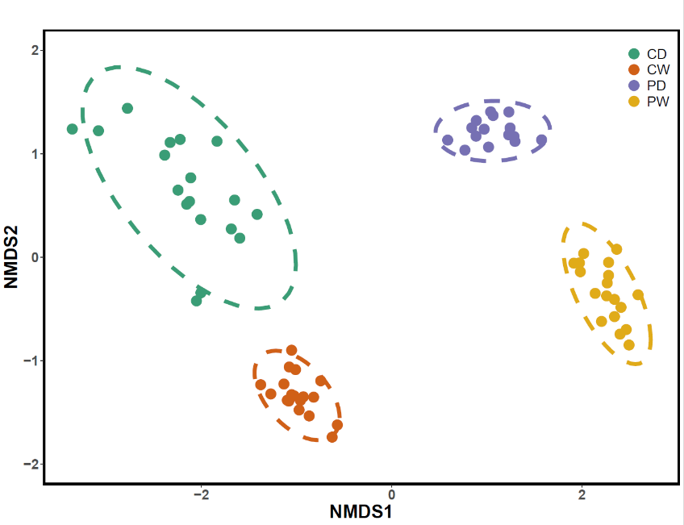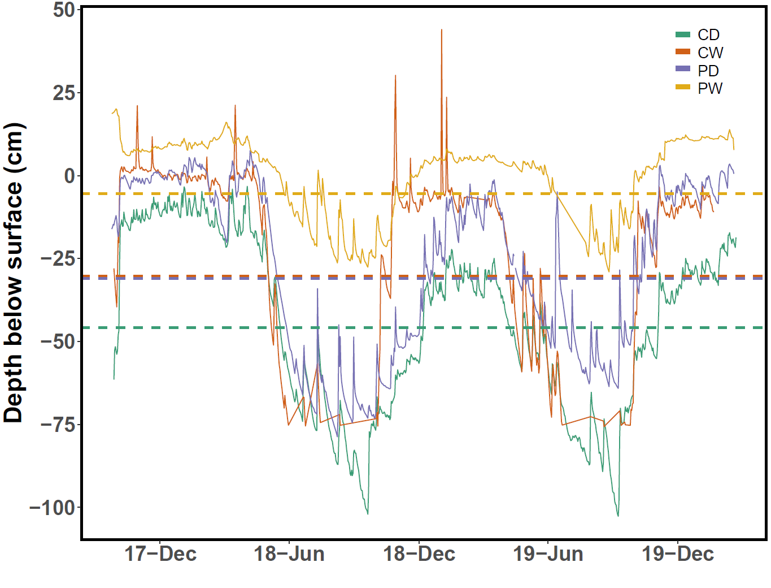**3.2 16s rRNA-based community composition**

Figure 2 (Right). NMDS ordination of the 16S rRNA relative abundance community composition in topsoils (depth of 05-10 cm) as differentiated by site (Adonis2 R² = 0.37 and p = 0.001); within-site dispersal is insignificant (PERMANOVA).

Figure 1 (Left). Daily average water table depth values for each of the four sites (PW, PD, CW and CD) between September 2017 and February 2020, with drought thresholds included (PW = -5.45 cm, PD = -31.05 cm, CW = -30.24 cm, CD = -45.88 cm).

Initial investigation into the community composition of the 2018 drought cycle topsoil samples (April 2018 to February 2019, 05-10 cm depth) via NMDS (Bray distance metric, stress = 0.067) revealed that community composition was strongly differentiated by site (R² = 0.37, p = 0.001, Adonis2) (Figure 2) [62]. Further, in-site dispersal of the 16S rRNA-based community composition was insignificant (PERMANOVA), indicating that the site-based differentiation is not due to within-site variation.

Prior studies of the Trebetal percolation (PW/PD) and Karrendorfer coastal (CW/CD) mires have indicated that the coastal fen soils are slightly more acidic (pH 4.4 ± 0.5 for CW and 4.2 ± 0.6 for CD) than the percolation fens (pH 5.4 ± 0.3 for PW and 5.3 ± 0 for PD) [37]. Further, the dry bulk density of the peat in the percolation sites is much lower (0.19 g/cm³ ± 0 for PW and 0.28 g/cm³ ± 0 for PD) than in the coastal sites (0.57 g/cm³ ± 0 for CW and 0.63 g/cm³ ± 0 for CD) [37]. These differing soil parameters are also reflected in topsoil nutrient content, which vary by site (Supplemental Fig. 3). While there is no significant between-site differences in topsoil ammonium content, there is significant variation (p < 0.05, Dunn test with Bonferroni adjustment) in the following nutrients: nitrate and phosphorous (except for between CD and CW), and dissolved organic carbon (except for between CD/CW and PD/PW). The PW site had significantly higher volumes of phosphorus (Kruskal-Wallis p < 0.0001) and dissolved organic carbon (p < 0.0001) than the other three sites. Additionally, the PD site had significantly higher volumes of nitrate (p < 0.0001).

The high variety in soil edaphic characteristics likely shapes the strongly differentiated microbial communities between sites, and reaffirms the novel nature of rewetted fen sites in comparison to their drained counterparts.

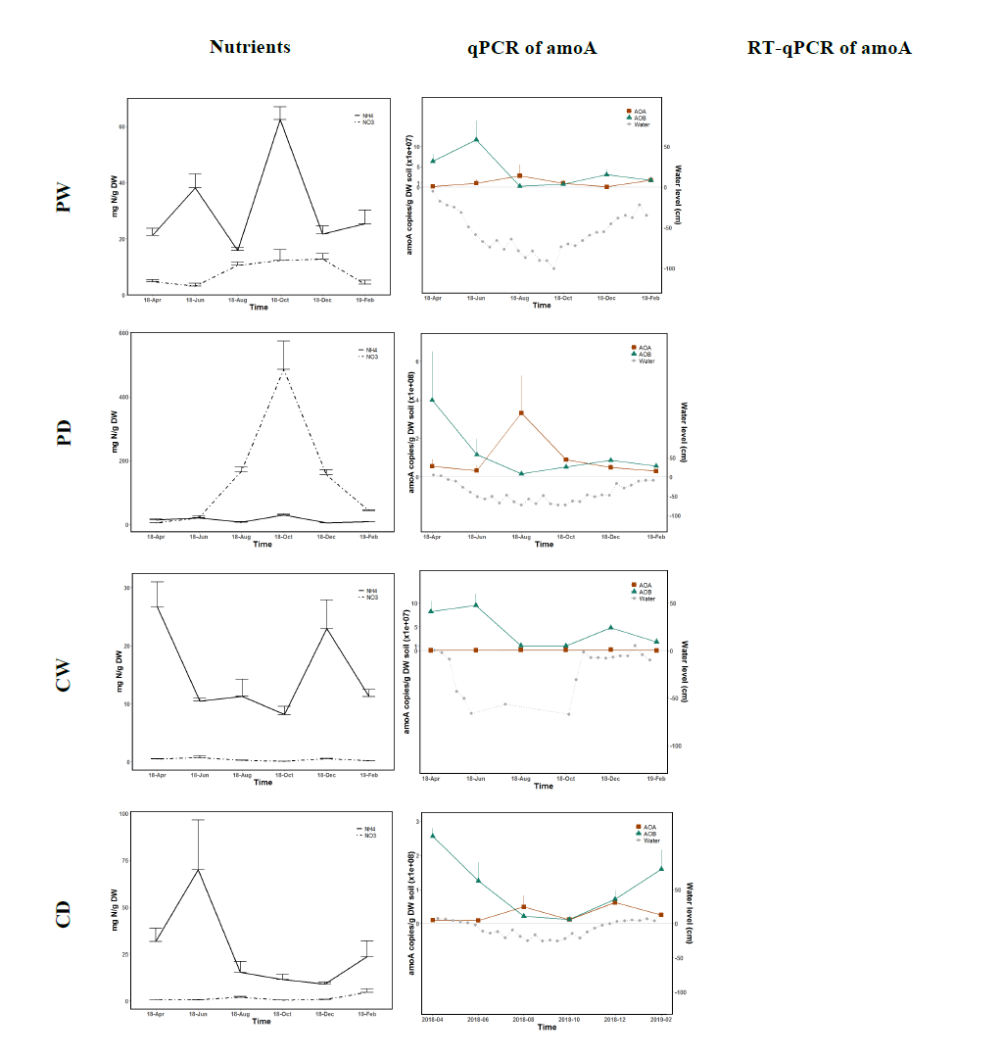**3.3 Absolute abundance of AOA and AOB via qPC****R**

*Figure 3.* [Figure description here] - probably put RT-qPCR next to metatranscriptomics and make horizontal

Commamox had negligble part of community

AOA temporal dynamics insignificant (Kruskal-Wallis), Dunn test Drought vs. Non-drought insignificant for all sites except CW (p = 0.047)

AOB temporal dynamics - Kruskal-Wallis, post-hoc Dunn (k = 2 so no adjustment)

PW: p = 0.02, significant difference between drought/non-drought (p = 0.024)

PD: p = 0.058, drought/non-drought p = 0.031

CW: p = 0.019, no sig. Difference between drought/non-drought

CD: p = 0.014, no sig. Difference drought/non-drought

**3.4 Metatranscriptomes and AOA Phylogeny**

*Figure 4.* [metatranscriptomics, figure description here]

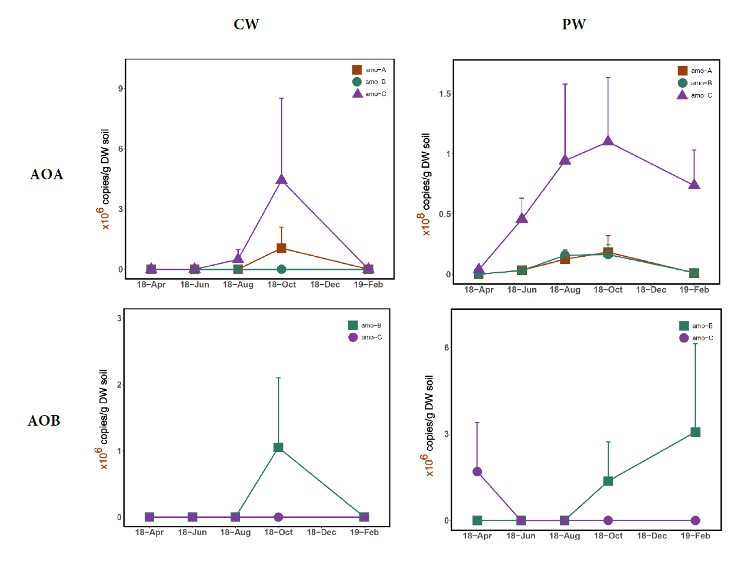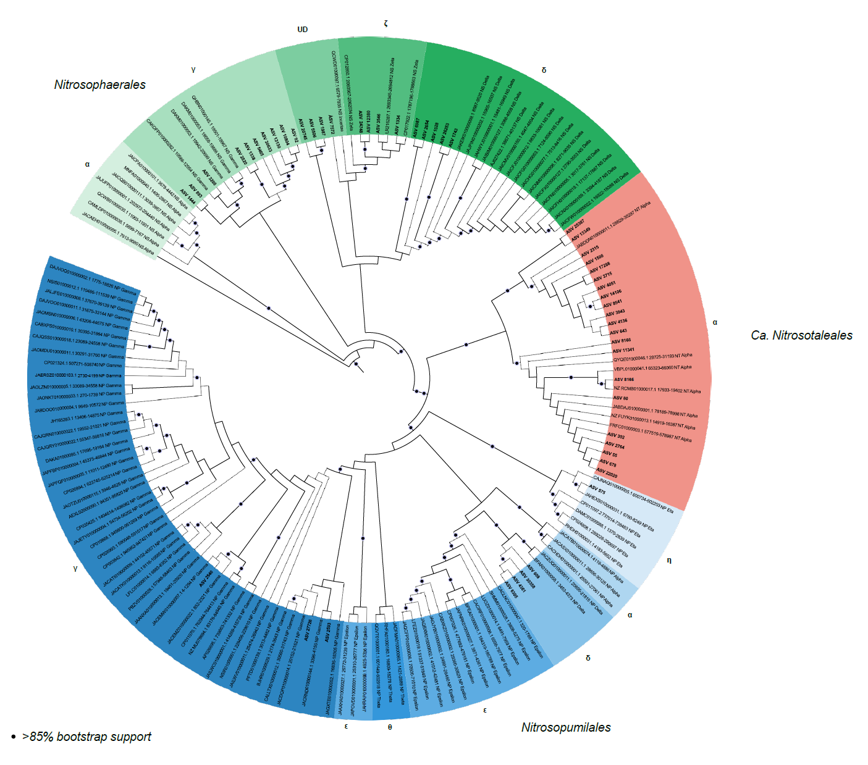

*Figure 5.* [Figure description here]

#### 

*Figure 6.* Relative abundance of AOA clades at each location throughout the 2018 drought cycle. Relative abundance of the respective clades for each site and time point is from 16S rRNA metagenomes, and clade assignments are from the phylogenetic tree constructed with the *amo*A database described above (Fig. 5).

* 1. **Conclu****sion**

1. **Acknowledgements**
2. **Funding**

European Social Fund (ESF) and the Ministry of Education, Science and Culture of Mecklenburg-Western Pomerania under the WETSCAPES project (ESF/14-BM-A55-0027/16 to ESF/14-BM-A55-0035/16). Fulbright and Napier fellowships.

1. **Conflicts of interest**
2. **Sources**

1. Global peatland assessment: The state of the world’s peatlands. 2022. UN Environment Programme, Global Peatlands Initiative.

2. Penuelas J, Janssens IA, Ciais P, Obersteiner M, Sardans J. Anthropogenic global shifts in biospheric N and P concentrations and ratios and their impacts on biodiversity, ecosystem productivity, food security, and human health.

3. Granath G, Limpens J, Posch M, Mücher S, Vries W. Spatio-temporal trends of nitrogen deposition and climate effects on Sphagnum productivity in European peatlands. *Environ Pollut* 2014; **187**: 73–80.

4. Liu H, Zak D, Rezanezhad F, Lennartz B. Soil degradation determines release of nitrous oxide and dissolved organic carbon from peatlands. *Environ Res Lett* 2019; **14**: 094009.

5. Koivunen I, Muotka T, Jokikokko M, Virtanen R, Jyväsjärvi J. Downstream impacts of peatland drainage on headwater stream biodiversity and ecosystem functioning. *For Ecol Manage* 2023; **543**: 121143.

6. Cleveland CC, Houlton BZ, Smith WK, Marklein AR, Reed SC, Parton W. Patterns of new versus recycled primary production in the terrestrial biosphere. *Proc Natl Acad Sci U S A* 2013; **110**: 12733–12737.

7. Maslov MN, Maslova OA. Soil nitrogen mineralization and its sensitivity to temperature and moisture in temperate peatlands under different land-use management practices. *Catena* 2022; **210**: 105922.

8. Stein LY, Klotz MG. The nitrogen cycle. *Curr Biol* 2016; **26**: 94–8.

9. Bastos A, Ciais P, Friedlingstein P, Sitch S, Pongratz J, Fan L. Direct and seasonal legacy effects of the 2018 heat wave and drought on European ecosystem productivity. *Sci Adv* 2020; **6**: 2724.

10. Stein LY. Insights into the physiology of ammonia-oxidizing microorganisms. *Curr Opin Chem Biol* 2019; **49**: 9–15.

11. Rotthauwe JH, Witzel KP, Liesack W. The ammonia monooxygenase structural gene amoA as a functional marker: molecular fine-scale analysis of natural ammonia-oxidizing populations. *Appl Environ Microbiol* 1997; **63**: 4704–4712.

12. Treusch AH, Leininger S, Kletzin A, Schuster SC, Klenk H-P, Schleper C. Novel genes for nitrite reductase and Amo-related proteins indicate a role of uncultivated mesophilic crenarchaeota in nitrogen cycling. *Environ Microbiol* 2005; **7**: 1985–1995.

13. Pjevac P, Schauberger C, Poghosyan L, Herbold CW, Kessel MAHJ, Daebeler A. Targeted Polymerase Chain Reaction Primers for the Specific Detection and Quantification of Comammox in the Environment. *Front Microbiol* 2017; **8**: 1508.

14. Jung M-Y, Sedlacek CJ, Kits KD, Mueller AJ, Rhee S-K, Hink L. Ammonia-oxidizing archaea possess a wide range of cellular ammonia affinities. *ISME J* 2022; **16**: 272–283.

15. Herbold CW, Lehtovirta-Morley LE, Jung M-Y, Jehmlich N, Hausmann B, Han P. Ammonia-oxidising archaea living at low pH: Insights from comparative genomics. *Environ Microbiol* 2017; **19**: 4939–4952.

16. Lehtovirta-Morley LE, Sayavedra-Soto LA, Gallois N, Schouten S, Stein LY, Prosser JI. Identifying Potential Mechanisms Enabling Acidophily in the Ammonia-Oxidizing Archaeon ‘Candidatus Nitrosotalea devanaterra’. *Appl Environ Microbiol* 2016; **82**: 2608–2619.

17. Lehtovirta-Morley LE, Stoecker K, Vilcinskas A, Prosser JI, Nicol GW. Cultivation of an obligate acidophilic ammonia oxidizer from a nitrifying acid soil. *Proc Natl Acad Sci U S A* 2011; **108**: 15892–15897.

18. Kits KD, Sedlacek CJ, Lebedeva EV, Han P, Bulaev A, Pjevac P. Kinetic analysis of a complete nitrifier reveals an oligotrophic lifestyle. *Nature* 2017; **549**: 269–272.

19. Clark IM, Hughes DJ, Fu Q, Abadie M, Hirsch PR. Metagenomic approaches reveal differences in genetic diversity and relative abundance of nitrifying bacteria and archaea in contrasting soils. *Sci Rep* 2021; **11**: 15905.

20. Rütting T, Schleusner P, Hink L, Prosser JI. The contribution of ammonia-oxidizing archaea and bacteria to gross nitrification under different substrate availability. *Soil Biol Biochem* 2021; **160**: 108353.

21. Wang H, Weil M, Dumack K, Zak D, Münch D, Günther A. Eukaryotic rather than prokaryotic microbiomes change over seasons in rewetted fen peatlands. *FEMS Microbiol Ecol* 2021; 97.

22. Berendt J, Wrage-Mönnig N. Denitrification is not Necessarily the Main Source of N2O from Rewetted Fens. *J Soil Sci Plant Nutr* 2023; **23**: 3705–3713.

23. Wang H, Meister M, Jensen C, Kuss AW, Urich T. The impact of summer drought on peat soil microbiome structure and function-A multi-proxy-comparison. *ISME Commun* 2022; 2.

24. Wang H, Jurasinski G, Täumer J, Kuß AW, Groß V, Köhn D. Linking Transcriptional Dynamics of Peat Microbiomes to Methane Fluxes during a Summer Drought in Two Rewetted Fens. *Environ Sci Technol* 2023.

25. Berendt J, Jurasinski G, Wrage-Mönnig N. Influence of rewetting on N2O emissions in three different fen types. *Nutr Cycl Agroecosyst* 2023; **125**: 277–293.

26. Boergens E, Güntner A, Dobslaw H, Dahle C. Quantifying the central European droughts in 2018 and 2019 with GRACE follow‐on. *Geophys Res Lett* 2020; 47.

27. Toreti A, Belward A, Perez-Dominguez I, Naumann G, Luterbacher J, Cronie O. The exceptional 2018 European water seesaw calls for action on adaptation. *Earths Future* 2019; **7**: 652–663.

28. Unger V, Liebner S, Koebsch F, Yang S, Horn F, Sachs T. Congruent changes in microbial community dynamics and ecosystem methane fluxes following natural drought in two restored fens. *Soil Biol Biochem* 2021; **160**: 108348.

29. Koebsch F, Gottschalk P, Beyer F, Wille C, Jurasinski G, Sachs T. The impact of occasional drought periods on vegetation spread and greenhouse gas exchange in rewetted fens. *Philos Trans R Soc Lond B Biol Sci* 2020; **375**: 20190685.

30. Bei Q, Reitz T, Schnabel B, Eisenhauer N, Schädler M, Buscot F. Extreme summers impact cropland and grassland soil microbiomes. *ISME J* 2023; **17**: 1589–1600.

31. Fikri M, Joulian C, Motelica-Heino M, Norini M-P, Hellal J. Resistance and Resilience of Soil Nitrogen Cycling to Drought and Heat Stress in Rehabilitated Urban Soils. *Front Microbiol* 2021; **12**: 727468.

32. de Vries F, Griffiths R, Bailey M, Craig H, Girlanda M, Gweon H. Soil bacterial networks are less stable under drought than fungal networks. *Nat Commun* 2018; **9**: 3033.

33. Séneca J, Pjevac P, Canarini A, Herbold CW, Zioutis C, Dietrich M. Composition and activity of nitrifier communities in soil are unresponsive to elevated temperature and CO, but strongly affected by drought. *ISME J* 2020; **14**: 3038–3053.

34. Osburn ED, Simpson JS, Strahm BD, Barrett JE. Land use history mediates soil biogeochemical responses to drought in temperate forest ecosystems. *Ecosystems* 2021.

35. Yan Z, Li M, Hao Y, Li Y, Zhang X, Yan L. Effects of extreme drought on soil microbial functional genes involved in carbon and nitrogen cycling in alpine peatland. *Front Ecol Evol* 2023; 11.

36. Weil M, Wang H, Bengtsson M, Köhn D, Günther A, Jurasinski G. Long-Term Rewetting of Three Formerly Drained Peatlands Drives Congruent Compositional Changes in Pro- and Eukaryotic Soil Microbiomes through Environmental Filtering. *Microorganisms* 2020; 8.

37. Jurasinski G, Ahmad S, Anadon-Rosell A, Berendt J, Beyer F, Bill R. From Understanding to Sustainable Use of Peatlands: The WETSCAPES Approach. *Soil Systems* 2020; **4**: 14.

38. Wang H, Bagnoud A, Ponce-Toledo RI, Kerou M, Weil M, Schleper C. Linking 16S rRNA Gene Classification to Gene Taxonomy Reveals Environmental Distribution of Ammonia-Oxidizing Archaeal Clades in Peatland Soils. 2021. , 0054621

39. Pester M, Rattei T, Flechl S, Gröngröft A, Richter A, Overmann J. amoA-based consensus phylogeny of ammonia-oxidizing archaea and deep sequencing of amoA genes from soils of four different geographic regions. *Environ Microbiol* 2012; **14**: 525–539.

40. Tourna M, Stieglmeier M, Spang A, Könneke M, Schintlmeister A, Urich T. Nitrososphaera viennensis, an ammonia oxidizing archaeon from soil. *Proc Natl Acad Sci U S A* 2011; **108**: 8420–8425.

41. Arce MI, Schiller D, Bengtsson MM, Hinze C, Jung H, Alves RJE. Drying and Rainfall Shape the Structure and Functioning of Nitrifying Microbial Communities in Riverbed Sediments. *Front Microbiol* 2018; **9**: 2794.

42. Norton JM, Klotz MG, Stein LY, Arp DJ, Bottomley PJ, Chain PSG. Complete genome sequence of Nitrosospira multiformis, an ammonia-oxidizing bacterium from the soil environment. *Appl Environ Microbiol* 2008; **74**: 3559–3572.

43. Stieglmeier M, Klingl A, Alves RJE, SK-MR R, Melcher M, Leisch N. Nitrososphaera viennensis gen. nov., sp. nov., an aerobic and mesophilic, ammonia-oxidizing archaeon from soil and a member of the archaeal phylum Thaumarchaeota. *Int J Syst Evol Microbiol* 2014; **64**: 2738–2752.

44. The R Project for Statistical Computing.

45. Oksanen J, Simpson GL, Blanchet FG, Kindt R, Legendre P, Minchin PR. vegan: Community ecology package. 2022.

46. Kruskal WH, Wallis WA. Use of ranks in one-criterion variance analysis. *J Am Stat Assoc* 1952; **47**: 583–621.

47. Kassambara A. rstatix: Pipe-Friendly Framework for Basic Statistical Tests. 2023.

48. Dunn OJ. Multiple Comparisons Among Means. *J Am Stat Assoc* 1961; **56**: 52–64.

49. Wickham H. ggplot2: Elegant Graphics for Data Analysis. 2016. Springer-Verlag New York.

50. Some Methods for Classification and Analysis of Multivariate Observations. 1966. Defense Technical Information Center.

51. Maechler M, Rousseeuw P, Struyf A, Hubert M, Hornik K. cluster: Cluster Analysis Basics and Extensions. 2022.

52. Tibshirani R, Walther G, Hastie T. Estimating the number of clusters in a data set via the gap statistic. *J R Stat Soc Series B Stat Methodol* 2001; **63**: 411–423.

53. Louca S, Jacques SMS, Pires APF, Leal JS, Srivastava DS, Parfrey LW. High taxonomic variability despite stable functional structure across microbial communities. *Nat Ecol Evol* 2016; **1**: 15.

54. Liu C, Cui Y, Li X, Yao M. microeco: an R package for data mining in microbial community ecology. *FEMS Microbiol Ecol* 2021; 97.

55. Sayers EW, Bolton EE, Brister C JR, K C, J C, D.C. Database resources of the national center for biotechnology information. *Nucleic Acids Res* 2022; **50**: 20–26.

56. Katoh K, Rozewicki J, Yamada KD. MAFFT online service: multiple sequence alignment, interactive sequence choice and visualization. *Brief Bioinform* 2019; **20**: 1160–1166.

57. Larsson A. AliView: a fast and lightweight alignment viewer and editor for large datasets. *Bioinformatics* 2014; **30**: 3276–3278.

58. Nguyen L-T, Schmidt HA, Haeseler A, Minh BQ. IQ-TREE: a fast and effective stochastic algorithm for estimating maximum-likelihood phylogenies. *Mol Biol Evol* 2015; **32**: 268–274.

59. Kalyaanamoorthy S, Minh BQ, Wong TKF, Haeseler A, Jermiin LS. ModelFinder: fast model selection for accurate phylogenetic estimates. *Nat Methods* 2017; **14**: 587–589.

60. Hoang DT, Chernomor O, Haeseler A, Minh BQ, Vinh LS. UFBoot2: Improving the Ultrafast Bootstrap Approximation. *Mol Biol Evol* 2018; **35**: 518–522.

61. Letunic I, Bork P. Interactive Tree Of Life (iTOL) v5: an online tool for phylogenetic tree display and annotation. *Nucleic Acids Res* 2021; **49**: 293–296.

62. McArdle BH, Anderson MJ. Fitting multivariate models to community data: a comment on distance‐based redundancy analysis. *Ecology* .