**Divergent responses of soil AOA and AOB to drought in rewetted fen peatlands**

[Authors]

*a Institute of Microbiology, Center for Functional Genomics of Microbes, University of Greifswald, Greifswald, Germany*

*\* [corresponding author:]*

**Abstract**

Rewetted peatlands will experience more frequent drought conditions as the climate changes, and therefore it is necessary to study how nutrient cycling (and corresponding greenhouse gas emission) will respond in these novel ecosystems. Thus far, the impact of drought on ammonia oxidizing microbes in peatlands is unclear, despite their role as a rate-limiting step in nitrification. This study aims to identify trends in archaeal and bacterial ammonia oxidizer abundances and their feedbacks with nitrogen-cycling genes in two rewetted fens in northeastern Germany (PW and CW). Drought conditions in the peat soils is neutrally defined via a k-means clustering algorithm, and AOA and AOB abundances are quantified with *amoA* gene copy numbers in both DNA and RNA samples from the soil at time points throughout a drought cycle. These results are supported by metatranscriptome analysis and phylogenetic-based clade assignment of AOA ASVs. Shifts in nitrifying communities were found to correlate with overall site hydrological stability, with AOB outnumbering AOA at both sites. Both AOB and AOB increased at the PW site during the drought, following a decrease in nitrogen fixation gene expression after drought onset and preceding an increase in ANRA-associated genes at the end of the drought cycle. In contrast, CW AOA and AOB showed limited dynamism in response to drought. The feedbacks between water table stability, drought and the prevalence of ammonia oxidation functional genes is crucial to understand how novel rewetted fen ecosystems will respond to climate change, as well as how these conditions will further affect the quality of the peat substrate and microbial-driven nutrient cycling.

1. **Introduction**

Peatlands cover just 3.8% of the Earth’s land surface but are responsible for storing 600 billion tons of carbon [1]. However, this carbon storage function is threatened by the increasing nitrogen eutrophication of soil since the industrial revolution [2]. High volumes of nitrogen in peatland soils competitively disadvantages sphagnum in peatland flora communities, leading to lowered peat formation rates that could cost temperate peatlands 5 g C m⁻²a⁻¹ in carbon sequestration [3]. Further, increased nitrogen loads in degraded peat soils significantly increases nitrous oxide (N₂O) emissions and downstream waterway eutrophication [4, 5]. Nitrifiers are crucial actors in nitrogen cycling; globally, an average of 90% of plant-available nitrogen in soils is mineralized by nitrifying organisms [6]. In peatlands, rates of nitrogen mineralization by nitrifiers have been found to depend highly on both temperature and moisture [7]. Nitrous oxide emission rates in rewetted peatlands are accordingly highly variable and dependent on water table depth below the ground surface, varying from 2.3 - 27.4 kg N ha⁻¹a⁻¹ [4]. Therefore, it is of great interest to study how nitrifying microorganisms respond to changes in water table levels in rewetted peatlands, in order to understand how these changes will impact nitrogen mineralization rates and subsequent N₂O emissions, carbon storage capacity, and waterway eutrophication.

Nitrification is the step of nitrogen cycling which transforms ammonia to nitrate via ammonia oxidation to nitrite and subsequent nitrite oxidation to nitrate [8]. While denitrification is often considered the primary source of N₂O emissions in peatlands, there is also evidence to suggest that ammonia oxidation is a major source of N₂O under intermediate moisture levels [9]. Ammonia oxidation is mediated by both bacteria (AOB) and archaea (AOA) which use ammonia as their sole energy source, as well as complete ammonia oxidizing bacteria (CAOB or comammox) which perform both steps of the nitrification cycle [10]. Ammonia monooxygenase (*amo*) is the key enzyme for oxidizing ammonia to hydroxylamine and has been found to be a functional marker of AOB [11], AOA [12] and CAOB [13]. Therefore, comparisons of archaeal and bacterial *amo* genes (A-*amo* and B-*amo*, respectively) are useful proxies to quantify the presence and function of various ammonia oxidizing microbes in environmental samples. Although enzymatically similar, most AOA have higher substrate affinities than AOB or CAOB, which has been attributed to the higher surface-to-volume ratios of the archaea [14] and results in AOA having a competitive advantage in acidic environments [15–18]. Additionally, AOA were found to have both higher relative abundance [19] and contribution to gross nitrification [20] than AOB under low substrate conditions, but were outcompeted by AOB during ammonia influxes.

Wang et al. (2021)’s analysis of the Wetscapes fen sites suggested that seasonal dynamics played a minor role in prokaryotic community composition and functional guild activity (including nitrogen cycling), which was attributed to stable site hydrology [21]. This finding is supported by Berendt & Wrage-Moenning (2023), which found that in the same sites fluctuating water content in peat soils increased N₂O emissions [22]. Accordingly, during the drought of summer 2018, the prokaryotic and eukaryotic microbiomes at the sites displayed significant increases in stress-response functions, indicating that the seasonal dynamics of these fen microbiomes were sensitive to extreme weather changes [23, 24]. Although water table was not correlated with N₂O emissions in these sites, there was a positive correlation between N₂O emissions and soil ammonium concentration; additionally, N₂O fluxes increased after August 2018 during drought conditions [25]. The unclear trends in nitrous oxide emissions throughout the 2018 and 2019 drought cycles indicates the need to analyze the response of nitrogen-cycling microbiomes to these conditions, in order to better understand the links between climactic extremes, microbial communities and greenhouse gas emissions.

Central Europe was subject to extreme water table fluctuations during the drought of 2018, which caused a 112 Gt deficit in landscape water mass and a 50% decrease in ecosystem CO₂ uptake [9, 26]. While there was no comparison for the 2018 drought in paleo-reconstructions dating back to 1500 CE, projections indicate that such events could become normal as early as 2043 [27]. This was immediately confirmed by the subsequent 2019 drought, during which the landscape water deficit across central Europe was an even more extreme 145 Gt [26]. Rewetted peatlands in northeastern Germany experienced disruptions in ecosystem functioning from increased aerobic methanotroph abundance and a corresponding decrease in methane emissions [28], to increased vegetation growth that differentially altered CO2 fluxes across sites depending on respiration and photosynthetic uptake rates [29]. However, there has been no studies to date studying the impact of these extreme drought cycles on nitrification in central European peatlands, which is vital to understand drought impacts on peatland ecosystem functions from carbon storage to greenhouse gas emissions.

Prior studies have been inconclusive in determining a standard drought response from ammonia oxidizing microbes; further, no studies to date have described such dynamics in rewetted temperate fens. Research across several landscapes indicates an increased abundance of AOB during drought conditions [30–33]. However, trends in AOA abundance during drought is less clear, with evidence for both increasing and decreasing abundance [30, 32–34]. There has been research to support an increase in ammonia oxidizers during drought in alpine peatlands on the Zoige Plateau; however, to date there has been no study differentiating between bacterial and archaeal *amo* in peatland ecosystems [35]. It is unclear how the response of archaeal and bacterial ammonia oxidizers differ under drought conditions in rewetted fens. The vast variation in nitrous oxide emissions across temperate rewetted fens (from 2.3 - 27.4 kg N ha⁻¹a⁻¹) indicates the close relationship between water table depth, soil pore oxygen content, and substrate availability [4]. Therefore, in order to understand the role of rewetted fens in greenhouse gas exchange during increasingly frequent drought events, it is necessary to understand dynamics in ammonia oxidizers as the key facilitators of nitrogen mineralization.

In this study, we addressed the annual seasonal dynamics of soil microbiome compositions in two pairs of drained and rewetted fen peatlands through 16S rRNA gene sequencing across six time points. We used unsupervised clustering algorithms to neutrally define the drought period during this time based on site hydrological conditions. Specifically, we focused on how ammonia oxidizing microbial dynamics differ under drought conditions in drained and rewetted fens through quantitative analysis of AOA and AOB phylotypes and their *amoA* gene abundances during the 2018 drought cycle. We hypothesize that both AOA and AOB abundances will increase under drought conditions due to aeration in the soil as the water table lowers, facilitating the activities of obligate aerobe ammonia oxidizers. Further, ammonia oxidizing archaea should have higher abundances and demonstrate a greater drought response than ammonia oxidizing bacteria because of their higher substrate affinity in acidic soils such as those at the fen sites. Finally, we expect that the rewetted fen nitrogen cycling microbiomes will display greater resilience to drought conditions than those in the drained fens, as restoration through rewetting improves landscape hydrological connectivity and potentially decreases ecosystem susceptibility to extreme drought disturbances.

1. **Methods**

**2.1 Sample collection**

Soil samples were collected from WETSCAPES project sites between April 2017 and October 2019. The WETSCAPES sampling sites and methods are extensively described in previous publications, and are briefly introduced here [21, 36, 37]. Samples were collected from a rewetted percolation fen (PW) and a rewetted coastal fen (CW) in Mecklenburg-Vorpommern, Germany. PW is in the catchment areas of the rivers Trebel and Recknitz and was deeply drained in the 20th century before rewetting in 1998 as part of an EU-Life initiative [36]. CW was first drained for agricultural purposes in 1850 and rewetted via dike removal in 1993; since then, it has been periodically been flooded by brackish water from the Bay of Greifswald on the Baltic Sea [36]. While CW is currently used for cattle pasture, the PW site is not utilized for agricultural purposes and is managed via biannual mowing [36].

Three peat cores were sampled from each of the sites bi-monthly between April 2018 and February 2019 (April, June, August, October, December and February). Samples were removed from each core at a depth of 05-10 cm, homogenized and stored on ice in the field before long-term storage at -20°C.

Site water levels and soil temperatures were monitored on a continuous basis between September 2017 and February 2020 with Campbell Scientific CR300 Dataloggers (Logan, USA) and HOBO Dataloggers (Bourne, USA), respectively. Additional data on regional precipitation and temperature were accessed on 31.03.2022 from the Deutscher Wetterdienst at weather station 1757 in Greifswald (54.0962, 13.4057). Information on soil moisture and physicochemical measurements is included in the supplementary information.

**2.2 Molecular methods**

The RNA and 16S rRNA extraction protocols and amplicon sequencing have previously been described in detail and are included in the supplementary documentation [21, 36, 38]. The qPCR protocol for the 16S rRNA gene is also described in these publications. Here, the absolute copy numbers of the 16S rRNA gene in each sample is multiplied with the relative abundance of each ASV in the 16S rRNA metagenome to analyze their absolute abundances.

Quantitative PCR of bacterial and archaeal *amo*A genes were performed with the *amoA*-1F/2R [11] and c*amoA*-19F [39, 40] /t*amoA*-629R [41] primer pairs, respectively. The 15 μl reactions included 7.5 μl innuMIX qPCR DSGreen Standard 2x (Analytik Jena), 0.75 μl each of the primer pairs, 5 μl nuclease-free water and 1 μl template diluted to a concentration of 5 ng/μl. Reactions were cycled on a qTOWER³G (Analytik Jena) according to the following protocol: denaturation at 95°C for 2 minutes (archaeal *amo*A) and 5 minutes (bacterial *amo*A); 40 3-step cycles of 30 seconds denaturation at 95°C, 45 seconds annealing at 55°C, and elongation and scanning for 45 seconds at 72°C; and finally melting from 60 to 95°C for 15 seconds with ΔT 1°C. The reactions were quantified based on serial dilution standard curves of 10⁸-10² gene copies for bacterial *amoA* from *Nitrosopira multiformis* [42] and 10⁷-10¹ gene copies for archaeal *amoA* from *Nitrososphaera viennensis* [43]. The mean qPCR correlation coefficients for both the archaeal and bacterial *amoA* reactions were 0.99; the average slopes were -3.60 and -3.44, respectively, for the archaeal and bacterial reactions; and the mean reaction efficiencies were 0.90 and 0.96.

The protocol for reverse transcription qPCR (hereafter RT-qPCR) with the RNA extractions used the same reaction cycles respective to bacterial and archaeal *amoA*, with the addition of an initial 10 minute reverse transcription step at 50°C. The 15 μl reactions again contained 0.75 μl each of the same forward and reverse primers and 5 μl nuclease-free water. For RT-qPCR, the mastermix additionally contained 0.02 μl BSA (20 mg/ml concentration), 1 μl RNA template, and the following components from the iTaq Universal SYBR Green One-Step Kit (BioRad, California, USA): 7.5 μl iTaqSYBRMix and 0.1875 μl iScript reverse transcriptase. To transcribe the standards, 20 ul reactions containing 1 ug template DNA, 1 mM each ATP, GTP, CTP and UTP, 2 ul 10x Transcription Buffer, 40 U T7 RNA Polymerase, 20 U RNase Inhibitor, and up to 20 ul nuclease-free water were incubated at 37°C for 2 hours. Then, the reaction was stopped by adding 2 ul EDTA and 2 ul lithium chloride and gently mixing before adding 75 ul 75% ethanol and incubating at -80°C for 30 minutes. The standards were centrifuged at maximum speed for 15 minutes at 4°C before discarding the supernatant and washing the pellet with 100 ul of 100% ethanol. The ethanol was then removed and the RNA pellet was left to dry on ice for 5 minutes before being resuspended in 20-50 ul nuclease-free water. Finally, the remaining DNA in the standards was digested with the DNase I kit (Zymo Research, California, USA). The RT-qPCR protocol for AOA resulted in an efficiency of 0.93 and slope of -3.52 (R² = 0.999); the results of the AOB protocol were an efficiency of 0.88 and slope of -3.65 (R² = 0.999).

**2.3 Biostatistics**

All statistics were conducted in R (v4.2.2) [44]. Non-metric multidimensional scaling (NMDS) of the resulting absolute abundances of each ASV were calculated with the *vegan* package (v2.6-4) [45]. The resulting group dispersal was verified with vegan’s Betadisper function (ANOVA method), and factor effects were tested with vegan’s Adonis2 package (distance method ‘Bray’).

Due to the random sampling design, each time point at each site is treated as an independent sample with three replicates for statistical purposes. Therefore, comparisons in gene (via qPCR) and nutrient abundances between different time points were primarily calculated via the Kruskal-Wallis rank sum test (with a Bonferroni adjustment when k > 2) [46] in base R with a post-hoc Dunn’s test of multiple comparisons in *rstatix* (v0.7.2) [47, 48]. When the data met the standards of normality and equal variance (via Shapiro-Wilk [49] and Levene’s [50] tests via *rstatix*) were satisfied, statistics were analyzed with ANOVA in base R and a post-hoc Tukey HSD test [51, 52]. Visualizations (with the exception of the phylogenetic tree) were created in *ggplot2* (v3.4.1) [53].

**2.4 K-means algorithm for drought definition**

Drought periods were neutrally defined by implementing an unsupervised k-means clustering algorithm on water table depths over a two year time period [54]. Water table depths below the ground surface from between September 2017 and February 2020 were separated between the four sites, due to the vast variations in between-site water table depths during this time period (Table 1). Optimal k-values (number of clusters) were identified via the clusGap function (K.max = 10, bootstraps = 500) from *cluster* (v2.1.4) [55]. The optimal Gap statistic (Gapₖ) was identified at k = 2 for each of the sites (values reported in Table 1) [56]. The optimal k was heuristically determined by optimizing the relationship between k and Gapₖ (i.e. at the elbow of the clusGap plot). Subsequently, the water table depth values for each site were clustered via the *kmeans* function in base R (k = 2). The k-means algorithm creates discrete clusters; when k = 2, a dividing value is identified that minimizes within-cluster distribution of the two clusters, and each water table value is assigned only to one group. Once water table depths continuously and consistently fell beneath this drought value, sites were assigned to the drought condition. As such, implementation of the k-means clustering algorithm enabled an unsupervised, hydrologically-defined drought period to be assigned based on site-specific drought thresholds. Because samples were collected bi-monthly, for the purposes of this study June, August and October 2018 were considered to be under hydrologically-defined drought conditions. Further details regarding the k-means algorithm implementation are available in the supplementary information.

|  |  |  |  |  |  |
| --- | --- | --- | --- | --- | --- |
| Site | Mean water table depth (cm) | $Gap_{k}$ (k = 2) | Drought threshold (cm) | 2018 drought dates | 2019 drought dates |
| PW | 0.08 | 0.35 | -5.45 | 25.05.2018-11.11.2018 | 24.07.2019-30.09.2019 |
| CW | -17.2 | 0.65 | -30.24 | 03.05.2018- 22.10.2018 | 08.04.2019- 04.10.2019 |

**2.5 Phylogenetic tree construction**

Table 1. Values interpreted from k-means clustering algorithm in the CW and PW sites.

To construct the phylogenetic tree of ammonia oxidizing archaea (AOA), potential AOA ASVs were initially identified from the larger 16S rRNA sequence dataset using the Faprotax database aerobic ammonia oxidation functional classification identified via the *microeco* (v0.14.1) wrapper in R, and filtered for sequences in the class Nitrososphaeria [57, 58]. These reads were then confirmed against the BLASTn database identity threshold of 93% [59]. To further verify the functional identity of these reads within AOA, a phylogenetic tree was constructed using a database linking 16S rRNA gene classifications to amoA taxonomy [38]. First, the BLASTn-curated 16S rRNA sequences were merged with the amoA database and aligned with MAAFT (v7) [60]. Then, the aligned sequences were trimmed to the 16S sequence bp length in AliView [61]. The phylogenetic tree was then constructed via IQTree [62] (v1.6.12) using the TIM3e+G64 model (BIC = 15778.75, identified via ModelFinder [63]) with 1000 ultrafast bootstraps via UFBoot2 [64] to create a maximum likelihood tree. This tree was then visualized using the iTOL platform [65]

1. **Results and discussion**

**3.1 Defining drought periods**

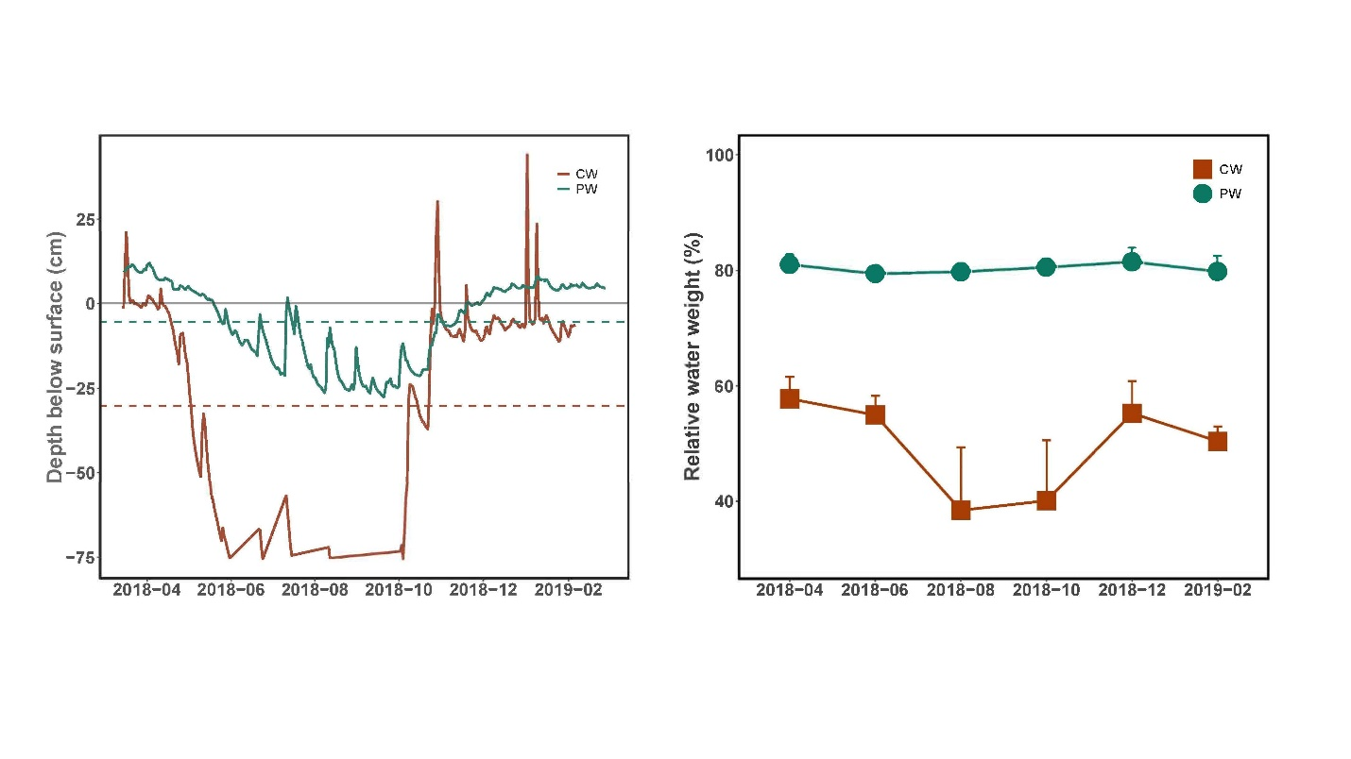Drought periods in the region were defined via an unsupervised k-means clustering algorithm using site hydrological characteristics to the following periods: May to November 2018 and April to October 2019. During these drought periods, across all sites there was an average decrease in water table depth of 45.57 cm (p < 0.0001, ANOVA with post-hoc Tukey’s Range Test). Within individual sites, the average water table decreases were 23.85 cm in PW and 48.59 cm in CW (p < 0.0001 for both). Drought thresholds were defined by the site-specific lowermost water table value that clustered to the ‘normal’ hydrological conditions. For PW this value was -5.45 cm and for CW -30.24 cm (Figure 1). Regionally-specific drought periods were defined from May to November 2018, and April to October 2019.

*Figure 1. Time series of water table depth below surface and soil water content expressed as percentage of weight. Dashed lines indicate the drought thresholds for each site (-5.45 cm for PW and -30.24 cm for CW).*

In spite of the drastic water table depression in both sites, the water content in the PW topsoil remained stable, with an average of 80.32% of the soil weight from water. In contrast, there was a decrease in topsoil water content in the CW site, though this was insignificant (Kruskal-Wallis). Overall, the average water content in CW ranged from 25.80% to 64.30% of soil weight.

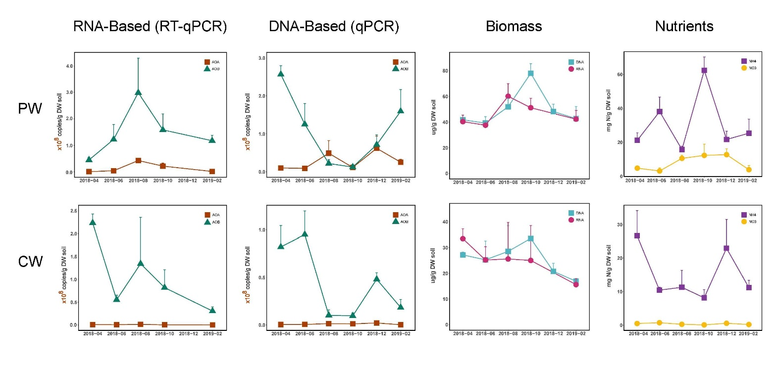**3.2 Absolute abundance of AOA and AOB via qPC****R**

*Figure 2. Time series of bacterial and archaeal amo copies per gram weight dry soil between April 2018 and February 2019 via both qPCR and reserve transcription-qPCR. Additionally, DNA and RNA content (ug per g dry soil), as well as NO₃⁻ and NH₄⁺ content (mg nitrogen per gram dry soil) are included. Mean and standard error for each time point (n=3) are represented.*

To investigate the temporal variability and impact of drought on ammonia oxidizing microbes in fen peatlands, both archaeal and bacterial ammonia oxidizers were considered. Although a third group known as complete ammonia oxidizing bacteria (comammox) within the *Nitrospira* genus has been shown to play a role in ammonia oxidation by fully converting ammonia to nitrate [66, 67], their presence was negligible in the metagenomic data for these sites. Only 10 *Nitrospira* OTUs in the metagenomic dataset between April 2018 and February 2019 had over a 97.5% identification match when compared against 7 known comammox genomic sequences via nucleotide BLAST [68]. Of these, 6 OTUs were present in the PW site and 1 in the CW site. The potential comammox OTUs did not display significant temporal variation in either site (Kruskal-Wallis). Therefore, we considered the impact of potential comammox bacteria negligible on our central question of the impact of drought dynamics on ammonia oxidation in fen peatlands.

Quantification of AOA and AOB was implemented with both genomic data via quantitative PCR (qPCR) and transcriptomic data via reverse-transcription qPCR (RT-qPCR). The genomic qPCR quantification of AOA revealed that temporal dynamics of AOA were insignificant in both sites (Kruskal-Wallis). Further, a comparison of drought AOA abundances compared to non-drought abundances were significant only in CW (Dunn, k = 2, p = 0.047). In contrast, genomic qPCR quantification of B-*amoA* displayed temporal variability in both CW and PW. PW displayed a significant decrease in AOB during the drought period (p = 0.024), as well as sensitivity to temporal variability between sampling points (p = 0.02). Within this time span, there a significant decrease in AOB abundance between April and October 2018 (Dunn with Bonferroni, p = 0.043). Finally, while AOB in CW demonstrated significant temporal variability throughout the sampling period (p = 0.019), there was no significant difference in the AOB abundance between drought and non-drought periods.

Interestingly, the transcriptomic RT-qPCR method demonstrated divergent trends in AOA and AOB abundance when compared to the DNA-based qPCR results. While the qPCR method with DNA samples displayed a significant decrease in PW AOB during the drought period, RT-qPCR analysis of RNA samples from the same time points demonstrated a significant increase in abundance of AOB between April and August 2018 (p = 0.047), and a nearly-significant increase during drought periods (p = 0.059). Although AOA in PW was not found to be sensitive to temporal variability via genomic methods, the transcriptomic method revealed (similarly to AOB) a significant increase in abundance between April and August (p = 0.026), in addition to an increase during drought periods (p = 0.018). In contrast, CW samples displayed no significant temporal variability in either AOA or AOB abundances when analyzed via transcriptomic methods. Further, drought was not a significant corollary for either AOA or AOB in the CW site.

In addition to the quantification of archaeal and bacterial *amoA* copies, the samples were analyzed for soil RNA and DNA content, as well as ammonium (NH₄⁺) and nitrate (NO₃⁻) volumes. First, PW had a higher copy number of both DNA and RNA per gram dry weight soil than CW (ANOVA, p < 0.0001 and p = 0.0002). The DNA content in PW soil was dynamic (ANOVA p = 0.011), with a peak in October compared to June (Tukey p = 0.012) and February (p = 0.022). Soil DNA content was stable in CW, and RNA content was stable in both sites over the sampling period from April 2018 to February 2019. There was no significant within-site difference in DNA and RNA contents at either site.

Ammonium was significantly dynamic in the PW site (ANOVA, p = 0.012), with a peak in October that was significantly higher than both the preceding April and August (Tukey HSD, p = 0.024 and 0.010), as well as the following December and February (p = 0.026 and 0.048). Nitrate was not significantly dynamic across any time points in the PW site. The CW site displayed an opposing trend, with no significant shifts in ammonium content across the study period, but a significant variation in nitrate (Kruskal-Wallis, p = 0.033). Both sites had a higher volume of ammonium than nitrate (Kruskal-Wallis, PW p < 0.0001 , CW p < 0.0001), and PW had both a higher nitrate (p < 0.0001) and ammonium (p = 0.008) content than CW.

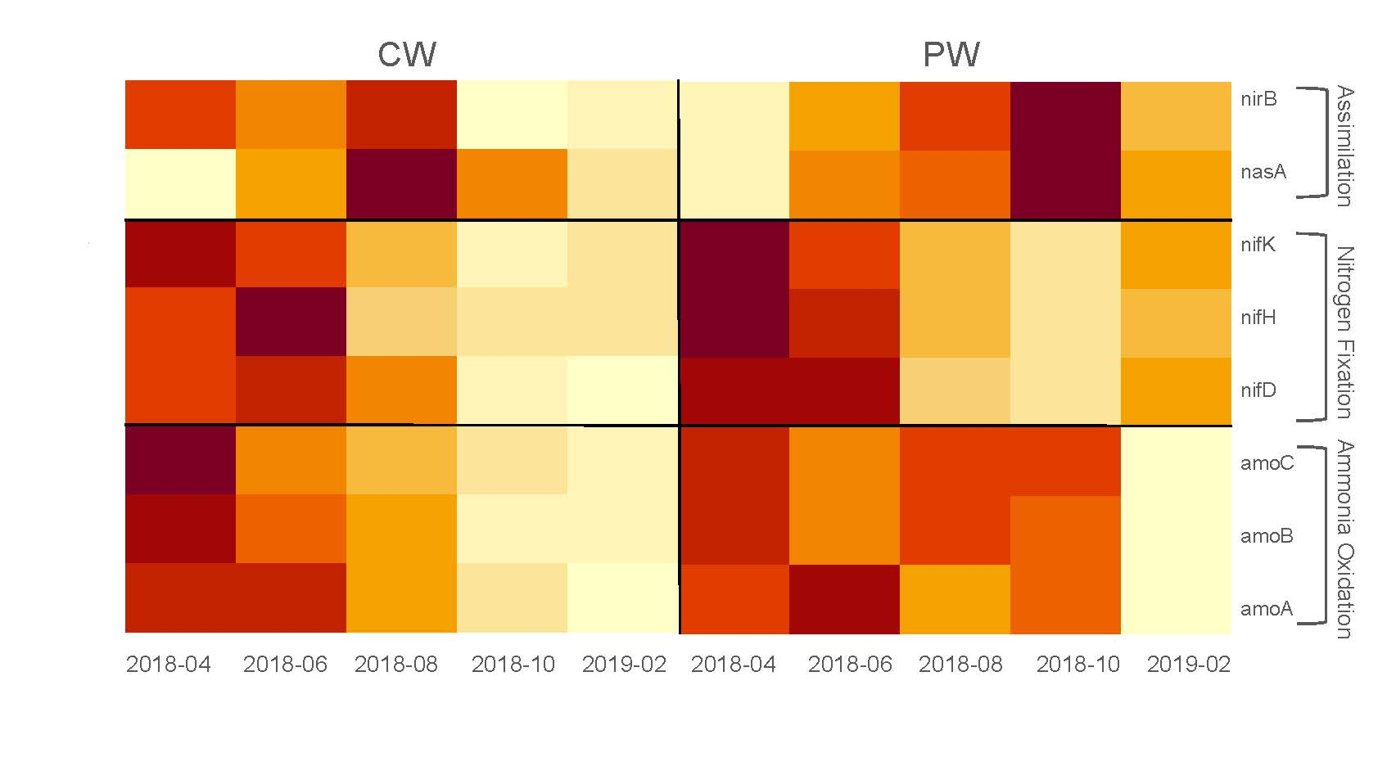**3.3 Metatranscriptomes and AOA Phylogeny**

*Figure 3. Heat map of relevant nitrogen-cycling genes identified within the metatranscriptomic dataset via KEGG. Values are normalized by site and gene to evaluate variation over time (n = 3 per time point and location).*

There was significant fluctuations in gene marker abundance over the drought period for nitrogen fixation, nitrogen assimilation and ammonia oxidation in the PW site, as indicated by KEGG assignment of the metatranscriptomic data. Nitrogen-assimilation indicator *nir*K was variable over time with a significant peak in October as compared to April (ANOVA p = 0.046, Tukey p = 0.038). A similar trend was evident in the related *nasA* gene for assimilatory nitrate/nitrite reduction to ammonium (ANRA) (Kruskal-Wallis p = 0.044, Dunn p = 0.040). Both *nifH* and *nifK* nitrogen fixation marker genes were dynamic over the drought cycle (Kruskal-Wallis, p = 0.002 and p =0.011), with a peak in April and decrease to a minimum in October. Of the ammonia oxidation-indicator genes in the KEGG database (*amoABC*), only *amoA* was significantly dynamic (ANOVA, p = 0.0006) with a peak in June as compared to February (Tukey p = 0.042). No denitrification-indicator genes were significantly variable, though there was a slight increase in *narGH* in the August samples.

In comparison to PW, CW had lower abundances on the scale of an order of magnitude across all marker genes (Kruskal-Wallis, *nifH* p = 0.002, *nifK* p = 0.011, *nirB* p < 0.001, *nasA* p = 0.011, *amoA* p = 0.001, *amoB* p < 0.0001, *amoC* p < 0.0001). Denitrification activity was also higher in PW than CW (p < 0.001), although the transcription rates were not dynamic in either site across the drought cycle. Of the analyzed marker genes, only the nitrogen-fixation associated *nifK* fluctuated meaningfully between April 2018 and February 2019 (p = 0.035), with evidence for a slight decrease in August. While *nifH* also demonstrated a slight decrease in August, none of the variation over time in this gene marker was significant.

Additionally, PW had a higher diversity in AOA clades than CW (Fig. 3). Clades were assigned based on affinity to phylogenetic tree regions based on known AOA clades in the *amoA* database (Supplement Fig. 4) [38]. ASVs with ambiguous locations (i.e. between clades) were labeled as undefined (UD). Hereafter, *Ca.* Nitrosotaleales is denoted as NT, *Nitrosopumilales* as NP, *Ca.* Nitrosocaldales as NC and *Nitrosophaerales* as NS. The CW metagenome contained only one clade at one time point (NT*-*α in December 2018). In contrast, the PW metagenome contained AOA-identified ASVs across all time points, including taxonomic units assigned to NP (NP-η) and NS(NS-δ, NS-γ, NS-ζ and NS-UD), as well as additional unidentified AOA ASVs. There were no ASVs assigned to NC in either site. All AOA clade absolute abundances were stable over time (Kruskal-Wallis), with the exception of NT-α (only present in CW in December) and NP-η (which first appeared in October). The most prominent clades identified in the PW site were NS-γ and ASVs that were undefined within the structure of 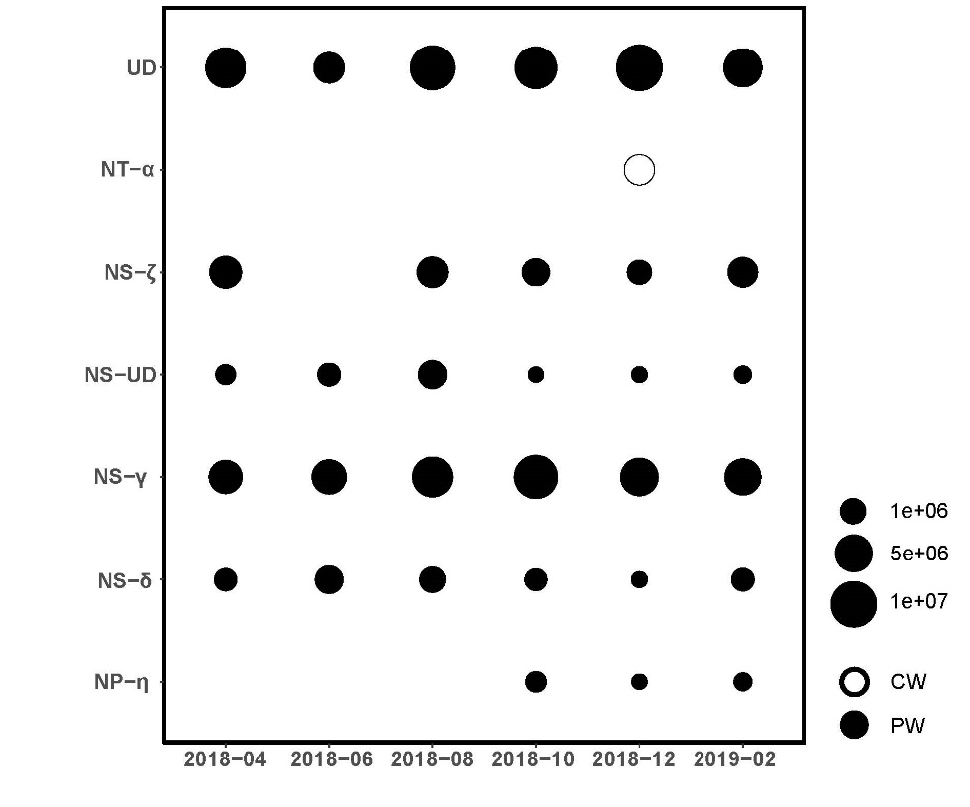the phylogenetic tree.

*Figure 4. Average absolute abundance of AOA clades at each location throughout the 2018 drought cycle. Absolute abundance of the respective clades for each site and time point is from 16S rRNA metagenome OTUs (i.e. relative abundance) multiplied by the total DNA copies per gram dry weight soil to calculate absolute abundance. Clade assignments are from the phylogenetic tree constructed with the amoA database described above (Fig. 5).* *UD indicates undetermined, NT is Ca. Nitrosotaleales, NS is Nitrososphaerales and NP is Nitrosopumilales.*

1. **Discussion and Conclusion**

In April, before the onset of the 2018 drought, there was a peak in nitrogen fixation genes *nifK* and *nifH* in the PW site. Previous studies of nitrifying microbes in alpine fens of the Zoige Plateau found that *nifH* gene copies were positively correlated with soil water content, and that *nifD* gene copies decreased by 25% after the onset of an extreme drought [35, 69]. The evidence for higher nitrogen fixation rates under PW’s typical hydrological condition supports these previous findings, with the subsequent decrease in both *nifK* and *nifH* genes after water table depression confirming the expected drought response of nitrogen fixing microbes to drought.

In comparison to the April pre-drought system, by the middle of the drought in August there was a significant increase in both AOB and AOA transcription in the PW site, as evidenced by the results of the RT-qPCR. However, transcribed B-*amoA* was more abundant than A-*amoA* on the scale of an order of magnitude. It is likely that both AOB and AOA responded positively to the influx of oxygen into the peatland topsoil as the water table fell, as both groups are obligate aerobes. Further, active microbial biomass (proxied by RNA content) was at its maximum in August, suggesting that the increase in AOA and AOB activity could be in response to the greater overall microbial abundance, although RNA content in the soil was not significantly dynamic in either site.

Another potential explanation for the increase in *amo* transcripts in the PW site is the introduction of novel ammonia sources due to the water table depression and corresponding state change from anoxic to oxic sediments. Beyond the increase in microbial biomass, there is also evidence for a decrease in microbial necromass, as evidenced by the significant decrease in bacterial *amoA* DNA copies from April to October (despite the increase in transcription activity from B-*amoA* within the same time period). Bacterial necromass has been found to constitute 11-27% of soil nitrogen, primarily within the muramic acids of peptidoglycan cell walls [70]. While there is evidence that decomposition of these proteins contributes between 65 and 95% of soil organic nitrogen fluxes, preliminary studies in meso-oxic soils indicate that drought is not a significant factor in muramic nitrogen decomposition; however, high temperatures do correspond to significant increases in necromass nitrogen mineralization [71–73]. It could be the case that in anoxic soils, the shift to an oxic state due to drought is enough of a destabilization to trigger muramic nitrogen decomposition. The evidence for microbial necromass decomposition after the shift in hydrological state from anoxic to oxic, combined with the decrease in activity from nitrogen fixation genes and increase in A-*amoA* and B-*amoA* copy numbers, indicates the possibility that the ammonia oxidizers are utilizing novel nitrogen sources in their newly oxygen-rich environment.

The decrease in microbial necromass after drought onset could also explain the discrepancies in bacterial *amoA* abundance trends between DNA- and RNA-based quantitative methods. While B-*amoA* copies significantly decrease in the DNA-based method, they increase in the RNA-based method. This could be due to the degradation of bacterial necromass due to drought-forced soil oxidation leaving fewer ‘ghost’ DNA copies that are then identified by DNA-based methods. In contrast, the short lifecycle of RNA-based methods leaves fewer remnant copies, and in this case provides a more logical reflection of actual microbial trends. This suggests that RNA-based methods could be preferable to study shifts in hydrological states, because transcription activity is not biased by drought-driven degradation of remnant DNA copies.

In addition to decaying microbial necromass, increases in phenol oxidase under drought conditions in peatlands has been found to be an enzymatic latch increasing hydrolases activity and increasing peat degradation [74, 75]. The average total nitrogen concentration in northern herbaceous peat (such as that in both the CW and PW sites) is 1.7%; however, due to the history of drainage and subsequent degradation in both sites, the total nitrogen in the peat soils was likely much lower [76]. In spite of the history of drainage, it is likely that the total nitrogen content in the peat soils was released as the increase in oxygen triggered the hydrolases trophic latch. Correspondingly, there was a significant flux in the NH₄⁺ content in the PW soil over the sampling period, with a significantly lower volume in April and August compared to October, supporting the evidence that the ammonium substrate was utilized by AOA and AOB during this time.

The lack of dynamicism of *amoABC* in the metatranscriptomic dataset compared to the results of quantiative PCR could be attributed to characteristics of the SILVA database that was used for taxonomic assignment. The qPCR of the RNA products indicated higher abundances of bacterial *amoA* gene copies as compared to archaeal copies on the scale of an order of magnitude (10⁷ vs. 10⁸) throughout the entire study period. In contrast, the metatranscriptomic dataset had no presence of AOB-assigned SSU RNA in either site for the months of June and August (Supplementary Fig. 5). This suggests that the resolution of the SILVA database is too low to identify bacterial *amoABC* copies, likely due to their sequence similarity and taxonomic proximity to methanotrophic *pmoAB* genes [77]. Although RT-qPCR copies of archaeal *amoA* still significantly increased during the drought period in the PW site, the shift was much less drastic than in the more-abundance bacterial *amoA*. Therefore, it is likely that the inability to identify AOB SSUs in both the June and August subsequently decreased the resolution of metatranscriptomic *amoABC* analysis. Further improvement of database specificity to differentiate between bacterial *amo* and *pmo* could decrease the discrepancies between quantiative and metatranscriptomic methods in analyzing *amo* fluxes.

In October, the metatranscriptomic data displayed a significant increase in the *nirB* and *nasA* genes. While the *nasA* gene is obligatory for nitrate assimilation [78], *nirB* codes for both dissimilatory and assimilatory nitrate/nitrite reduction [79]. However, due to the lack of shifts in other DNRA markers (particularly the DNRA-exclusive *nrfA* gene), it is likely that the observed increase in *nirB* corresponds to an uptick in ANRA rather than DNRA. Both *nirB* and *nasA* facilitate cytoplasmic nitrite and nitrate reduction (respectively) requiring the synthesis of a [4Fe-4S] cluster [80]. Drained fens that had been subject to soil desiccation often have large pools of iron upon rewetting; fluctuating water tables in these ecosystems facilitates iron-redox which has the potential to mineralize organic matter [81]. The increase in ANRA-related genes indicates that this iron flux after water fluctuations could also facilitate the synthesis of the sulfate-iron clusters required for nitrate assimilation. While studies on ANRA activity in soils are rare, there is evidence that it could be a possible response to hypoxic soil conditions in both tomato and soybean roots [82, 83]. Although PW was still under drought conditions in October, on the date of sample collection there was approximately 5 mm of precipitation. It is possible that after such an extreme drought period as the summer of 2018, such an influx of water could trigger typical hypoxic ammonia synthesis in topsoil microbiomes, although its impact on the overall water table remains negligible. It is unclear why bacterial and archaeal *amoA* transcription decreased during October from their August peak, given the positive flux of available NH₄⁺ substrate in the soil. Perhaps this decrease in activity was also in response to the precipitation on the day of sampling temporarily reducing the oxygen content in the top soil, hemming ammonia oxidation activity. It is also possible that nitrate concentrations in the fen soil was high enough that *nirB* activity contributed only to biomass synthesis, rather than producing ammonia that is available for further oxidation [84]. Further studies on ANRA activity in rewetted fens that fluctuate between oxic and anoxic conditions (particularly during increasingly frequent droughts) would be informative regarding the impact of ANRA on peatland nitrogen cycling.

The unsupervised clustering method resulted in defining regionally-specific drought periods (May-November 2018 and April-October 2019) that largely coincided with previously published drought spans [9, 26, 27, 29]. Although ‘drought’ is often synonymous with ‘summer drought,’ this is not the case for events such as those in 2018 and 2019 where drought conditions extended into late autumn. Therefore, incorporating annual data rather than just spring and summer sampling points is necessary to capture the full scope of the drought cycle. Analysis of water table depth values via k-mean clustering facilitates such long-term research because it is cost-effective and requires only measurement of the water table depth.

Further, this method allows direct comparison between multiple sites within a region via the drought threshold metric, which could be useful to assess their resistance to drought conditions (i.e. if all sites are subject to similar climatic conditions but have varied water table depths during drought periods, this suggests differential robustness to drought). In the case of this study, the PW site has the highest water table drought threshold at 5.45 cm below the surface. This suggests that the PW site is more hydrologically robust, as a stable water table is desirable for maintaining mire landscapes [85]. In comparison, CW does not show significant differences in water table depth during either drought or normal conditions in spite of the dike removal 30 years prior. This could suggest that the restoration measures undertaken in the CW site were insufficient to restore hydrological resilience. As in this example, k-means defined drought thresholds could be used as a comparative metric of hydrological stability for fens under similar climatic conditions. Finally, the identification of a drought threshold over multiple drought periods provides the opportunity for identifying future droughts, testing the model based on future observations with the potential to better understand temporal hydrological responses to various climate factors that drive drought conditions.

One of the notable differences in the study is between the dynamics and microbial profiles of the PW and CW site. Although both sites have undergone restoration measures in the past 30 years after drainage in the second half of the 19th century (PW) and 1850 (CW). Some of these differences are attributable to each sites’ mire type, with the PW site hydrologically linked to a river watershed, while CW is occasionally flooded with brackish water from the Greifswald Bay. These differences in hydrological qualities can explain the more static microbiome factors, such as the lack of overall AOA clade diversity and lower functional gene copy numbers in CW as compared to PW.

However, water quality alone is insufficient to resolve why the nitrifying microbial communities in PW are dynamic in response to drought conditions, whereas those in CW remain largely stable. This is the case both archaeal and bacterial transcribed *amoA* copies from RT-qPCR analysis, as well as for relevant functional genes for ANRA, nitrogen fixation and ammonia oxidation in the metatranscriptomes. This is likely attributable to the fact that during non-drought periods, the water table in PW is often above the ground level. Further, the PW site is only considered to be in drought conditions when the water table drops just below the sampling depth of 0-5 cm (-5.45 cm). In contrast, in the CW site a fluctuating water table is typical outside of drought periods due to flooding from the sea. The drought water table threshold was determined to be significantly lower than the sampling depth at -30.24 cm. This indicates that under typical precipitation regimes, the topsoil nitrifying microbes are already exposed to consistently more oxygen content in the soil than those in the PW site, where the water table is often above the surface of the soil. Therefore, drought conditions are a more extreme shift from a stable hydrological state for the PW microbiome compared to CW, resulting in a greater response from the nitrifying microbiome to the change from anoxic to oxic soil conditions.

A remaining source of uncertainty concerns the soil water content in both sites. Although the water table falls in CW and PW, the soil water content only decreases in CW. There seem to be dampening feedback mechanisms at work in PW that maintain topsoil moisture at approximately 80% even with a low water table. This could be a result of shrinking feedback in the peat structure to maintain the relationship of the peat surface to the water table surface, although this could not have compensated for the greatest water table depressions during the drought (Figure 1) [86, 87]. Given the history of drainage in the site, it is more likely that the hydraulic conductivity of the peat was still low despite rewetting measures after a history of compaction [86]. This feedback mechanism functions to maintain the water content in the substrate, as the reduced pore space and increased bulk density leaves less space for water evaporation and flow-through. In contrast, the soil water content in CW does decrease with the drought-driven water table depression. However, there is limited corresponding ammonia oxidation dynamics or shifts in nitrogen cycling gene copy numbers. This disparity suggests that the correlation between water content and oxygen content alone is not enough to explain the relationship between increased ammonia oxidation activity and drought in PW. Notably, PW is characterized by sedge reed vegetation, and therefore the often-discussed sphagnum feedbacks to water table depressions are of little relevance [37]. The PW site had high biomass production throughout 2018, indicating that its carbon storage function was maintained even during drought [88]. Carex acutiformis covers 80% of the PW site, and has the ability to form intra-tissue gas chambers that allow them to transport oxygen into the root zone in flooded soils [88, 89]. There is a zone within 1mm of new roots where oxygen is radially diffused, which could provide a niche for obligate aerobes such as AOA and AOB, particularly given the evidence for increased root biomass production during the drought of 2018 [90]. However, root production was higher in CW than in PW during the 2018 drought [88], so this explanatory mechanism contradicts the stability (and low abundance) of AOA and AOB in CW.

This study provides evidence that ammonia oxidation functions increased in temperate fen soils in response to drought conditions. This trend was most clearly supported by RNA-based RT-qPCR of bacterial and archaeal *amo* gene copies, while DNA-based qPCR was biased by the presence of remnant DNA, and metatranscriptomic data was biased by low database resolution between *pmo* and *amo* genes. The increase in ammonia oxidation functions was supported by overall dynamicism of nitrogen cycling indicator genes in the metatranscriptomic dataset, with a decrease in nitrogen fixation genes *nifDHK* and an increase in nitrogen assimilation genes *nirB*/*nasA*. Shifts in the nitrogen cycling microbiome were more extreme in the PW site than the CW site across all methods. This suggests that the impact of drought on peatland microbiomes could be more extreme in ecosystems with a consistently high water table, likely because the drought-driven change in abiotic factors is further from the peatlands’ stable state. Further, the CW site is a coastal fen that experiences frequent water fluctuations due to flooding of brackish water from the Greifswald Bay, suggesting that this site’s microbiome is more resistant to hydrological perturbation. As temperate fens are increasingly impacted by drought conditions in the near future, it is crucial to consider the hydrological stable state of restored fen landscapes and its relationship to nutrient cycling functions such as ammonia oxidation. These feedbacks will determine the quality of the peat substrate and nutrient load in subsequent post-drought rewetting, mimicking on a shorter time scale the draining-rewetting process that is key to global peatland viability.

1. **Acknowledgements**

AB and HW developed the study. AB contributed the lab work, statistical analysis and writing of the first draft. HW prepared the metagenome and metatranscriptome datasets, and guided AB throughout the study; HW and Micha Weil conducted fieldwork. DZ analyzed soil nutrient content. Thank you to Marina Schnell for guidance on the RT-qPCR protocol, the AG Urich members for support and advice, and the Wetscapes project members for their collaboration. Funding for AB was provided by the Fulbright U.S. Student Program and Napier Fellowship. [also add Vienna collaborators]

1. **Funding**

The European Social Fund (ESF) and the Ministry of Education, Science and Culture of Mecklenburg-Western Pomerania funded this study under the WETSCAPES project (ESF/14-BM-A55-0027/16 to ESF/14-BM-A55-0035/16). Additional support was provided by the Fulbright U.S. Student Program sponsored by the U.S. Department of State and German-American Fulbright Commission and the Napier Fellowship sponsored by the Napier Initiative and Pilgrim Place in Claremont, CA. The contents of this work are the responsibility of the author and do not reflect the views of any of the aforementioned funding partners.

1. **Conflicts of interest**

The authors declare no competing interests.

1. **Sources**

1. Global peatland assessment: The state of the world’s peatlands. 2022. UN Environment Programme, Global Peatlands Initiative.

2. Penuelas J, Janssens IA, Ciais P, Obersteiner M, Sardans J. Anthropogenic global shifts in biospheric N and P concentrations and ratios and their impacts on biodiversity, ecosystem productivity, food security, and human health.

3. Granath G, Limpens J, Posch M, Mücher S, Vries W. Spatio-temporal trends of nitrogen deposition and climate effects on Sphagnum productivity in European peatlands. *Environ Pollut* 2014; **187**: 73–80.

4. Liu H, Zak D, Rezanezhad F, Lennartz B. Soil degradation determines release of nitrous oxide and dissolved organic carbon from peatlands. *Environ Res Lett* 2019; **14**: 094009.

5. Koivunen I, Muotka T, Jokikokko M, Virtanen R, Jyväsjärvi J. Downstream impacts of peatland drainage on headwater stream biodiversity and ecosystem functioning. *For Ecol Manage* 2023; **543**: 121143.

6. Cleveland CC, Houlton BZ, Smith WK, Marklein AR, Reed SC, Parton W. Patterns of new versus recycled primary production in the terrestrial biosphere. *Proc Natl Acad Sci U S A* 2013; **110**: 12733–12737.

7. Maslov MN, Maslova OA. Soil nitrogen mineralization and its sensitivity to temperature and moisture in temperate peatlands under different land-use management practices. *Catena* 2022; **210**: 105922.

8. Stein LY, Klotz MG. The nitrogen cycle. *Curr Biol* 2016; **26**: 94–8.

9. Bastos A, Ciais P, Friedlingstein P, Sitch S, Pongratz J, Fan L. Direct and seasonal legacy effects of the 2018 heat wave and drought on European ecosystem productivity. *Sci Adv* 2020; **6**: 2724.

10. Stein LY. Insights into the physiology of ammonia-oxidizing microorganisms. *Curr Opin Chem Biol* 2019; **49**: 9–15.

11. Rotthauwe JH, Witzel KP, Liesack W. The ammonia monooxygenase structural gene amoA as a functional marker: molecular fine-scale analysis of natural ammonia-oxidizing populations. *Appl Environ Microbiol* 1997; **63**: 4704–4712.

12. Treusch AH, Leininger S, Kletzin A, Schuster SC, Klenk H-P, Schleper C. Novel genes for nitrite reductase and Amo-related proteins indicate a role of uncultivated mesophilic crenarchaeota in nitrogen cycling. *Environ Microbiol* 2005; **7**: 1985–1995.

13. Pjevac P, Schauberger C, Poghosyan L, Herbold CW, Kessel MAHJ, Daebeler A. Targeted Polymerase Chain Reaction Primers for the Specific Detection and Quantification of Comammox in the Environment. *Front Microbiol* 2017; **8**: 1508.

14. Jung M-Y, Sedlacek CJ, Kits KD, Mueller AJ, Rhee S-K, Hink L. Ammonia-oxidizing archaea possess a wide range of cellular ammonia affinities. *ISME J* 2022; **16**: 272–283.

15. Herbold CW, Lehtovirta-Morley LE, Jung M-Y, Jehmlich N, Hausmann B, Han P. Ammonia-oxidising archaea living at low pH: Insights from comparative genomics. *Environ Microbiol* 2017; **19**: 4939–4952.

16. Lehtovirta-Morley LE, Sayavedra-Soto LA, Gallois N, Schouten S, Stein LY, Prosser JI. Identifying Potential Mechanisms Enabling Acidophily in the Ammonia-Oxidizing Archaeon ‘Candidatus Nitrosotalea devanaterra’. *Appl Environ Microbiol* 2016; **82**: 2608–2619.

17. Lehtovirta-Morley LE, Stoecker K, Vilcinskas A, Prosser JI, Nicol GW. Cultivation of an obligate acidophilic ammonia oxidizer from a nitrifying acid soil. *Proc Natl Acad Sci U S A* 2011; **108**: 15892–15897.

18. Kits KD, Sedlacek CJ, Lebedeva EV, Han P, Bulaev A, Pjevac P. Kinetic analysis of a complete nitrifier reveals an oligotrophic lifestyle. *Nature* 2017; **549**: 269–272.

19. Clark IM, Hughes DJ, Fu Q, Abadie M, Hirsch PR. Metagenomic approaches reveal differences in genetic diversity and relative abundance of nitrifying bacteria and archaea in contrasting soils. *Sci Rep* 2021; **11**: 15905.

20. Rütting T, Schleusner P, Hink L, Prosser JI. The contribution of ammonia-oxidizing archaea and bacteria to gross nitrification under different substrate availability. *Soil Biol Biochem* 2021; **160**: 108353.

21. Wang H, Weil M, Dumack K, Zak D, Münch D, Günther A. Eukaryotic rather than prokaryotic microbiomes change over seasons in rewetted fen peatlands. *FEMS Microbiol Ecol* 2021; 97.

22. Berendt J, Wrage-Mönnig N. Denitrification is not Necessarily the Main Source of N2O from Rewetted Fens. *J Soil Sci Plant Nutr* 2023; **23**: 3705–3713.

23. Wang H, Meister M, Jensen C, Kuss AW, Urich T. The impact of summer drought on peat soil microbiome structure and function-A multi-proxy-comparison. *ISME Commun* 2022; 2.

24. Wang H, Jurasinski G, Täumer J, Kuß AW, Groß V, Köhn D. Linking Transcriptional Dynamics of Peat Microbiomes to Methane Fluxes during a Summer Drought in Two Rewetted Fens. *Environ Sci Technol* 2023.

25. Berendt J, Jurasinski G, Wrage-Mönnig N. Influence of rewetting on N2O emissions in three different fen types. *Nutr Cycl Agroecosyst* 2023; **125**: 277–293.

26. Boergens E, Güntner A, Dobslaw H, Dahle C. Quantifying the central European droughts in 2018 and 2019 with GRACE follow‐on. *Geophys Res Lett* 2020; 47.

27. Toreti A, Belward A, Perez-Dominguez I, Naumann G, Luterbacher J, Cronie O. The exceptional 2018 European water seesaw calls for action on adaptation. *Earths Future* 2019; **7**: 652–663.

28. Unger V, Liebner S, Koebsch F, Yang S, Horn F, Sachs T. Congruent changes in microbial community dynamics and ecosystem methane fluxes following natural drought in two restored fens. *Soil Biol Biochem* 2021; **160**: 108348.

29. Koebsch F, Gottschalk P, Beyer F, Wille C, Jurasinski G, Sachs T. The impact of occasional drought periods on vegetation spread and greenhouse gas exchange in rewetted fens. *Philos Trans R Soc Lond B Biol Sci* 2020; **375**: 20190685.

30. Bei Q, Reitz T, Schnabel B, Eisenhauer N, Schädler M, Buscot F. Extreme summers impact cropland and grassland soil microbiomes. *ISME J* 2023; **17**: 1589–1600.

31. Fikri M, Joulian C, Motelica-Heino M, Norini M-P, Hellal J. Resistance and Resilience of Soil Nitrogen Cycling to Drought and Heat Stress in Rehabilitated Urban Soils. *Front Microbiol* 2021; **12**: 727468.

32. de Vries F, Griffiths R, Bailey M, Craig H, Girlanda M, Gweon H. Soil bacterial networks are less stable under drought than fungal networks. *Nat Commun* 2018; **9**: 3033.

33. Séneca J, Pjevac P, Canarini A, Herbold CW, Zioutis C, Dietrich M. Composition and activity of nitrifier communities in soil are unresponsive to elevated temperature and CO, but strongly affected by drought. *ISME J* 2020; **14**: 3038–3053.

34. Osburn ED, Simpson JS, Strahm BD, Barrett JE. Land use history mediates soil biogeochemical responses to drought in temperate forest ecosystems. *Ecosystems* 2021.

35. Yan Z, Li M, Hao Y, Li Y, Zhang X, Yan L. Effects of extreme drought on soil microbial functional genes involved in carbon and nitrogen cycling in alpine peatland. *Front Ecol Evol* 2023; 11.

36. Weil M, Wang H, Bengtsson M, Köhn D, Günther A, Jurasinski G. Long-Term Rewetting of Three Formerly Drained Peatlands Drives Congruent Compositional Changes in Pro- and Eukaryotic Soil Microbiomes through Environmental Filtering. *Microorganisms* 2020; 8.

37. Jurasinski G, Ahmad S, Anadon-Rosell A, Berendt J, Beyer F, Bill R. From Understanding to Sustainable Use of Peatlands: The WETSCAPES Approach. *Soil Systems* 2020; **4**: 14.

38. Wang H, Bagnoud A, Ponce-Toledo RI, Kerou M, Weil M, Schleper C. Linking 16S rRNA Gene Classification to Gene Taxonomy Reveals Environmental Distribution of Ammonia-Oxidizing Archaeal Clades in Peatland Soils. 2021. , 0054621

39. Pester M, Rattei T, Flechl S, Gröngröft A, Richter A, Overmann J. amoA-based consensus phylogeny of ammonia-oxidizing archaea and deep sequencing of amoA genes from soils of four different geographic regions. *Environ Microbiol* 2012; **14**: 525–539.

40. Tourna M, Stieglmeier M, Spang A, Könneke M, Schintlmeister A, Urich T. Nitrososphaera viennensis, an ammonia oxidizing archaeon from soil. *Proc Natl Acad Sci U S A* 2011; **108**: 8420–8425.

41. Arce MI, Schiller D, Bengtsson MM, Hinze C, Jung H, Alves RJE. Drying and Rainfall Shape the Structure and Functioning of Nitrifying Microbial Communities in Riverbed Sediments. *Front Microbiol* 2018; **9**: 2794.

42. Norton JM, Klotz MG, Stein LY, Arp DJ, Bottomley PJ, Chain PSG. Complete genome sequence of Nitrosospira multiformis, an ammonia-oxidizing bacterium from the soil environment. *Appl Environ Microbiol* 2008; **74**: 3559–3572.

43. Stieglmeier M, Klingl A, Alves RJE, SK-MR R, Melcher M, Leisch N. Nitrososphaera viennensis gen. nov., sp. nov., an aerobic and mesophilic, ammonia-oxidizing archaeon from soil and a member of the archaeal phylum Thaumarchaeota. *Int J Syst Evol Microbiol* 2014; **64**: 2738–2752.

44. The R Project for Statistical Computing.

45. Oksanen J, Simpson GL, Blanchet FG, Kindt R, Legendre P, Minchin PR. vegan: Community ecology package. 2022.

46. Kruskal WH, Wallis WA. Use of ranks in one-criterion variance analysis. *J Am Stat Assoc* 1952; **47**: 583–621.

47. Kassambara A. rstatix: Pipe-Friendly Framework for Basic Statistical Tests. 2023.

48. Dunn OJ. Multiple Comparisons Among Means. *J Am Stat Assoc* 1961; **56**: 52–64.

49. Shapiro SS, Wilk MB. An analysis of variance test for normality (complete samples). *Biometrika* 1965; **52**: 591–611.

50. Levene H. Robust tests for equality of variances. *Contributions to probability and statistics: Essays in honor of Harold Hotelling*. 1960. Stanford University Press, pp 278–292.

51. Chambers JM, Freeny A, Heiberger RM. Analysis of variance; Designed experiments. *Statistical Models in S*. 1992. Wadworth & Brooks/Cole.

52. Tukey JW. Comparing Individual Means in the Analysis of Variance. *Biometrics* 1949; **5**: 99.

53. Wickham H. ggplot2: Elegant Graphics for Data Analysis. 2016. Springer-Verlag New York.

54. Some Methods for Classification and Analysis of Multivariate Observations. 1966. Defense Technical Information Center.

55. Maechler M, Rousseeuw P, Struyf A, Hubert M, Hornik K. cluster: Cluster Analysis Basics and Extensions. 2022.

56. Tibshirani R, Walther G, Hastie T. Estimating the number of clusters in a data set via the gap statistic. *J R Stat Soc Series B Stat Methodol* 2001; **63**: 411–423.

57. Louca S, Jacques SMS, Pires APF, Leal JS, Srivastava DS, Parfrey LW. High taxonomic variability despite stable functional structure across microbial communities. *Nat Ecol Evol* 2016; **1**: 15.

58. Liu C, Cui Y, Li X, Yao M. microeco: an R package for data mining in microbial community ecology. *FEMS Microbiol Ecol* 2021; 97.

59. Sayers EW, Bolton EE, Brister C JR, K C, J C, D.C. Database resources of the national center for biotechnology information. *Nucleic Acids Res* 2022; **50**: 20–26.

60. Katoh K, Rozewicki J, Yamada KD. MAFFT online service: multiple sequence alignment, interactive sequence choice and visualization. *Brief Bioinform* 2019; **20**: 1160–1166.

61. Larsson A. AliView: a fast and lightweight alignment viewer and editor for large datasets. *Bioinformatics* 2014; **30**: 3276–3278.

62. Nguyen L-T, Schmidt HA, Haeseler A, Minh BQ. IQ-TREE: a fast and effective stochastic algorithm for estimating maximum-likelihood phylogenies. *Mol Biol Evol* 2015; **32**: 268–274.

63. Kalyaanamoorthy S, Minh BQ, Wong TKF, Haeseler A, Jermiin LS. ModelFinder: fast model selection for accurate phylogenetic estimates. *Nat Methods* 2017; **14**: 587–589.

64. Hoang DT, Chernomor O, Haeseler A, Minh BQ, Vinh LS. UFBoot2: Improving the Ultrafast Bootstrap Approximation. *Mol Biol Evol* 2018; **35**: 518–522.

65. Letunic I, Bork P. Interactive Tree Of Life (iTOL) v5: an online tool for phylogenetic tree display and annotation. *Nucleic Acids Res* 2021; **49**: 293–296.

66. Daims H, Lebedeva EV, Pjevac P, Han P, Herbold C, Albertsen M, et al. Complete nitrification by Nitrospira bacteria. *Nature* 2015; **528**: 504–509.

67. Van Kessel MAHJ, Speth DR, Albertsen M, Nielsen PH, Op Den Camp HJM, Kartal B, et al. Complete nitrification by a single microorganism. *Nature* 2015; **528**: 555–559.

68. Altschul SF, Gish W, Miller W, Myers EW, Lipman DJ. Basic local alignment search tool. *Journal of Molecular Biology* 1990; **215**: 403–410.

69. Zhang X, Jia X, Wu H, Li J, Yan L, Wang J, et al. Depression of soil nitrogen fixation by drying soil in a degraded alpine peatland. *Science of The Total Environment* 2020; **747**: 141084.

70. Liang C, Amelung W, Lehmann J, Kästner M. Quantitative assessment of microbial necromass contribution to soil organic matter. *Global Change Biology* 2019; **25**: 3578–3590.

71. Hu Y, Zheng Q, Noll L, Zhang S, Wanek W. Direct measurement of the in situ decomposition of microbial-derived soil organic matter. *Soil Biology and Biochemistry* 2020; **141**: 107660.

72. Hu J, Du M, Chen J, Tie L, Zhou S, Buckeridge KM, et al. Microbial necromass under global change and implications for soil organic matter. *Global Change Biology* 2023; **29**: 3503–3515.

73. Wang X, Wang C, Cotrufo MF, Sun L, Jiang P, Liu Z, et al. Elevated temperature increases the accumulation of microbial necromass nitrogen in soil via increasing microbial turnover. *Global Change Biology* 2020; **26**: 5277–5289.

74. Freeman C, Ostle N, Kang H. An enzymatic lathc on a global carbon store. *Nat Commun* 2001; 149.

75. Fenner N, Freeman C. Drought-induced carbon loss in peatlands. *Nature Geosci* 2011; **4**: 895–900.

76. Loisel J, Yu Z, Beilman DW, Camill P, Alm J, Amesbury MJ, et al. A database and synthesis of northern peatland soil properties and Holocene carbon and nitrogen accumulation. *The Holocene* 2014; **24**: 1028–1042.

77. Semrau J, Chistoserdov A, Lebron J, Costello AM, Davagnino J, Kenna EM, et al. Paniculate methane monooxygenase genes in methanotrophs. *Journal of bacteriology* 1995; **177**: 3071–9.

78. Ogawa KI, Akagawa E, Yamane K, Sun ZW, LaCelle M, Zuber P, et al. The nasB operon and nasA gene are required for nitrate/nitrite assimilation in Bacillus subtilis. *J of Bacteriol* 1995; **177**: 1409–1413.

79. Pandey CB, Kumar U, Kaviraj M, Minick KJ, Mishra AK, Singh JS. DNRA: A short-circuit in biological N-cycling to conserve nitrogen in terrestrial ecosystems. *Science of The Total Environment* 2020; **738**: 139710.

80. Moreno-Vivián C, Flores E. Nitrate assimilation in bacteria. *Biology of the nitrogen cycle*. 2007. Elsevier B.V.

81. Emsens W-J, Aggenbach CJS, Schoutens K, Smolders AJP, Zak D, Van Diggelen R. Soil Iron Content as a Predictor of Carbon and Nutrient Mobilization in Rewetted Fens. *PLoS ONE* 2016; **11**: e0153166.

82. Horchani F, Gallusci P, Baldet P, Cabasson C, Maucourt M, Rolin D, et al. Prolonged root hypoxia induces ammonium accumulation and decreases the nutritional quality of tomato fruits. *Journal of Plant Physiology* 2008; **165**: 1352–1359.

83. Oliveira HC, Salgado I, Sodek L. Nitrite decreases ethanol production by intact soybean roots submitted to oxygen deficiency. *Plant Signaling & Behavior* 2013; **8**.

84. Wang X, Tamiev D, Alagurajan J, DiSpirito AA, Phillips GJ, Hargrove MS. The role of the NADH-dependent nitrite reductase, Nir, from Escherichia coli in fermentative ammonification. *Arch Microbiol* 2019; **201**: 519–530.

85. Couwenberg J, Joosten H. Self‐organization in raised bog patterning: the origin of microtope zonation and mesotope diversity. *Journal of Ecology* 2005; **93**: 1238–1248.

86. Whittington PN, Price JS. The effects of water table draw‐down (as a surrogate for climate change) on the hydrology of a fen peatland, Canada. *Hydrological Processes* 2006; **20**: 3589–3600.

87. Waddington JM, Morris PJ, Kettridge N, Granath G, Thompson DK, Moore PA. Hydrological feedbacks in northern peatlands. *Ecohydrology* 2015; **8**: 113–127.

88. Schwieger S, Kreyling J, Couwenberg J, Smiljanić M, Weigel R, Wilmking M, et al. Wetter is Better: Rewetting of Minerotrophic Peatlands Increases Plant Production and Moves Them Towards Carbon Sinks in a Dry Year. *Ecosystems* 2021; **24**: 1093–1109.

89. Voesenek LACJ, Colmer TD, Pierik R, Millenaar FF, Peeters AJM. How plants cope with complete submergence. *New Phytologist* 2006; **170**: 213–226.

90. Gilbert B, Frenzel P. Rice roots and CH4 oxidation: The activity of bacteria, their distribution and the microenvironment. *Soil Biol Biochem* 1998; **30**: 1903–1916.