1. **Results**

**3.1 Defining drought periods**

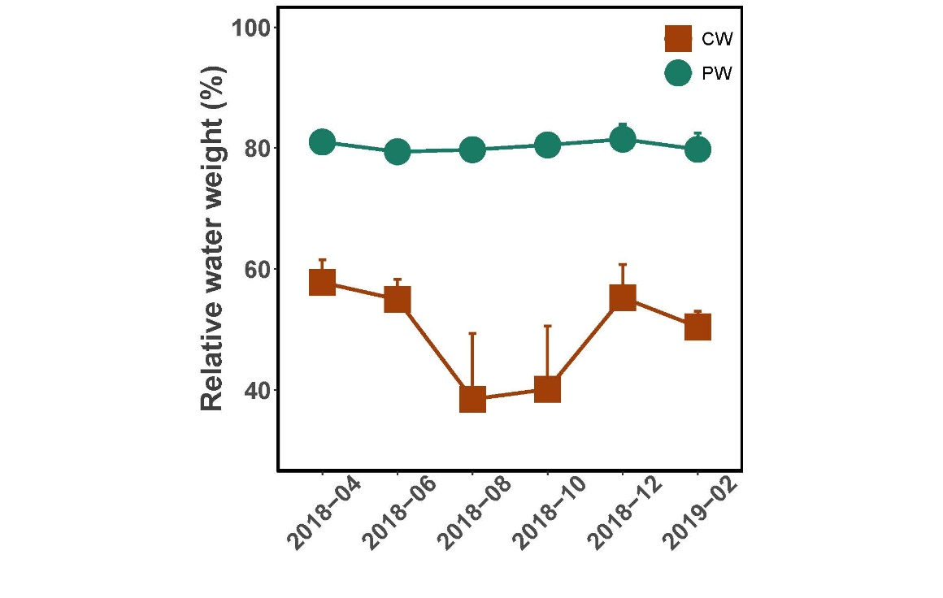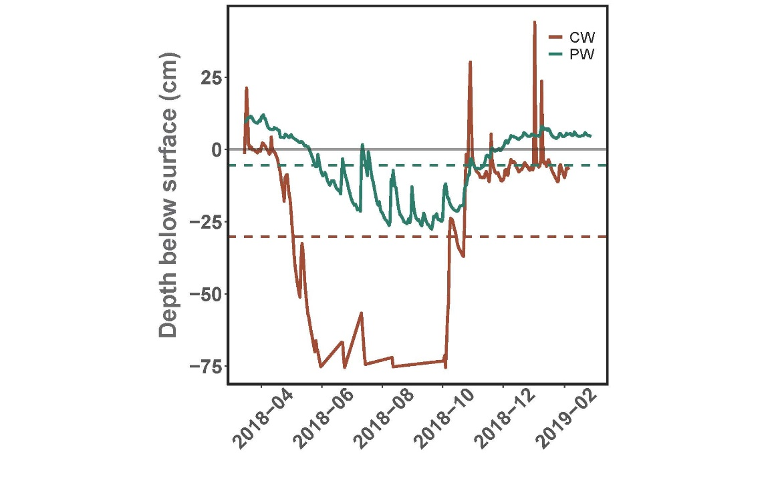Drought periods in the region were defined via an unsupervised k-means clustering algorithm using site hydrological characteristics to the following periods: May to November 2018 and April to October 2019. During these drought periods, across all sites there was an average decrease in water table depth of 45.57 cm (p < 0.0001, ANOVA with post-hoc Tukey’s Range Test). Within individual sites, the average water table decreases were 23.85 cm in PW and 48.59 cm in CW (p < 0.0001).

b)

a)

*Figure 1a.* Time series of daily average water table depth below the surface between 2018-03-15 and 2019-02-28. Dashed lines indicate the drought threshold values for each site as calculated by the k-means clustering algorithm (-5.45 cm for PW and -30.24 cm for CW).

*Figure 1b.* Average soil water content expressed as percentage of weight in the PW and CW sites. Averages were calculated across all subsamples for the sampling period (n = 9) and are included with their respective standard errors.

Drought thresholds were defined by the site-specific lowermost water table value that clustered to the ‘normal’ hydrological conditions. For PW this value was -5.45 cm and for CW -30.24 cm (Fig. 1a).

In spite of the drastic water table depression in both sites, the water content in the PW topsoil remained stable, with an average of 80.32% of the soil weight from water (Fig. 1b). In contrast, there was a decrease in topsoil water content in the CW site, though this was insignificant (Kruskal-Wallis). Overall, the average water content in CW ranged from 25.80% to 64.30% of soil weight.

**3.2 Absolute abundance of AOA and AOB**

To investigate the temporal variability and impact of drought on ammonia oxidizing microbes in fen peatlands, both archaeal and bacterial ammonia oxidizers were considered. Although a third group known as complete ammonia oxidizing bacteria (comammox) within the *Nitrospira* genus has been shown to play a role in ammonia oxidation by fully converting ammonia to nitrate [75, 76], their presence was negligible in the sequencing data for these sites. Only 10 *Nitrospira* ASVs in the genomic dataset between April 2018 and February 2019 had over a 97.5% identification match when compared against 7 known comammox genomic sequences via nucleotide BLAST [77]. Of these, 6 ASVs were present in the PW site and 1 in the CW site. The potential comammox ASVs did not display significant temporal variation in either site (Kruskal-

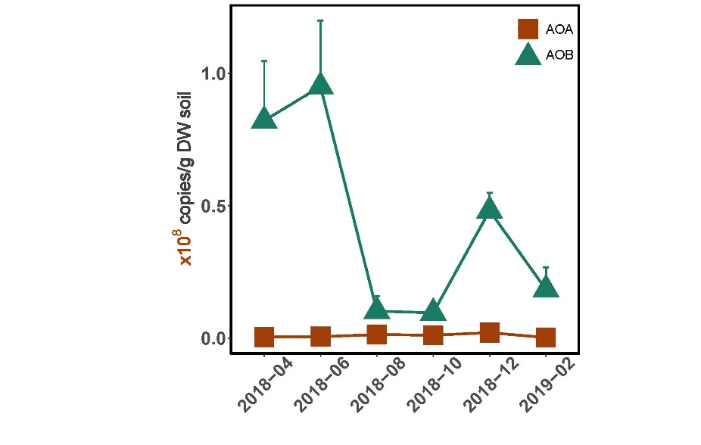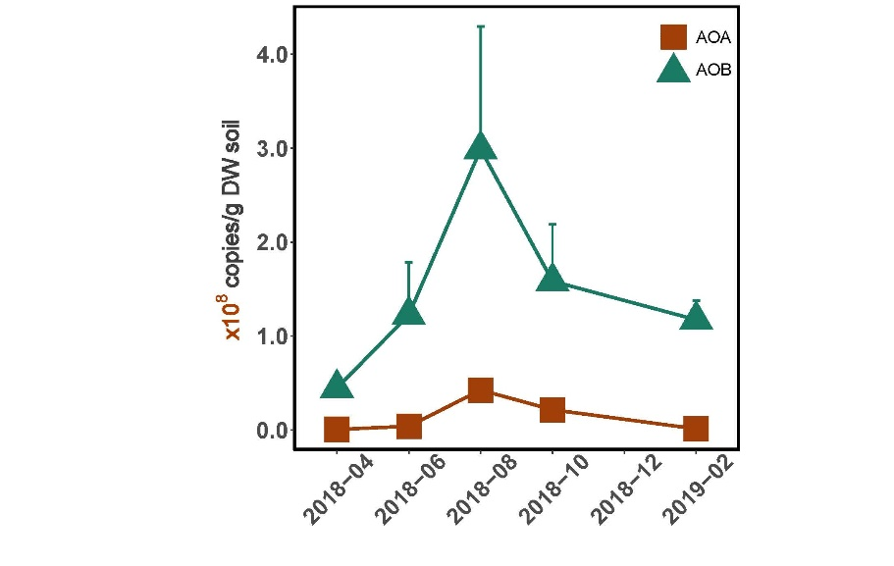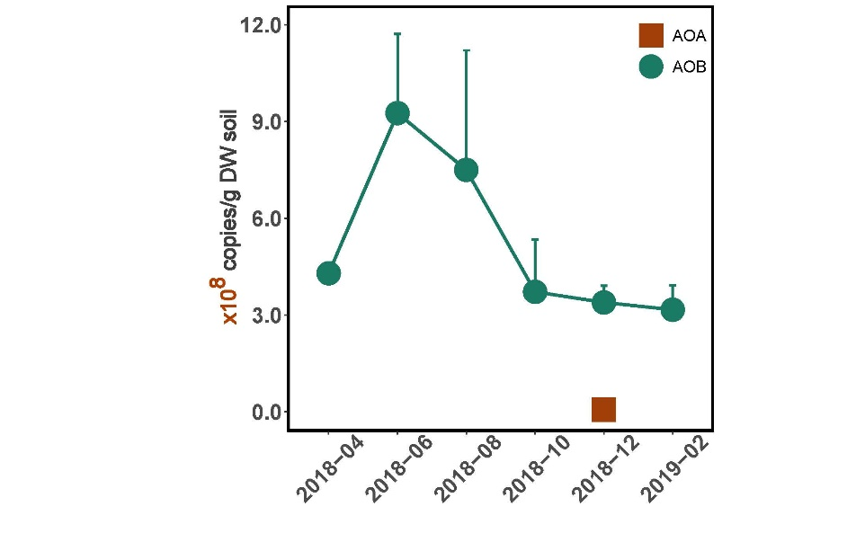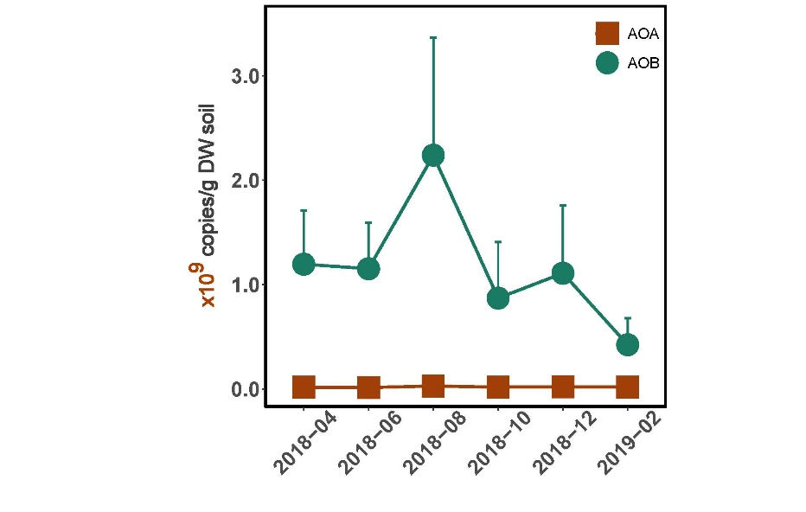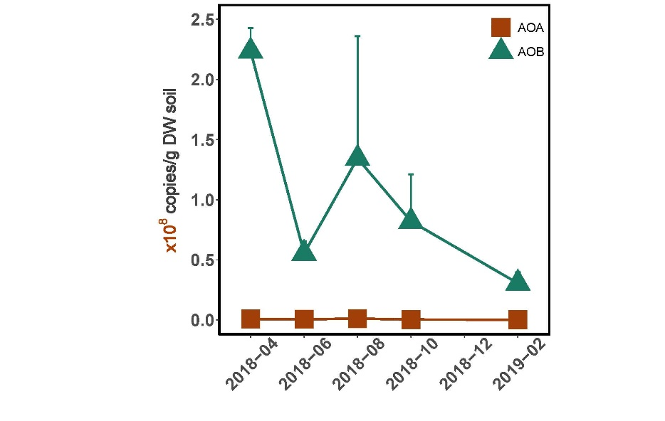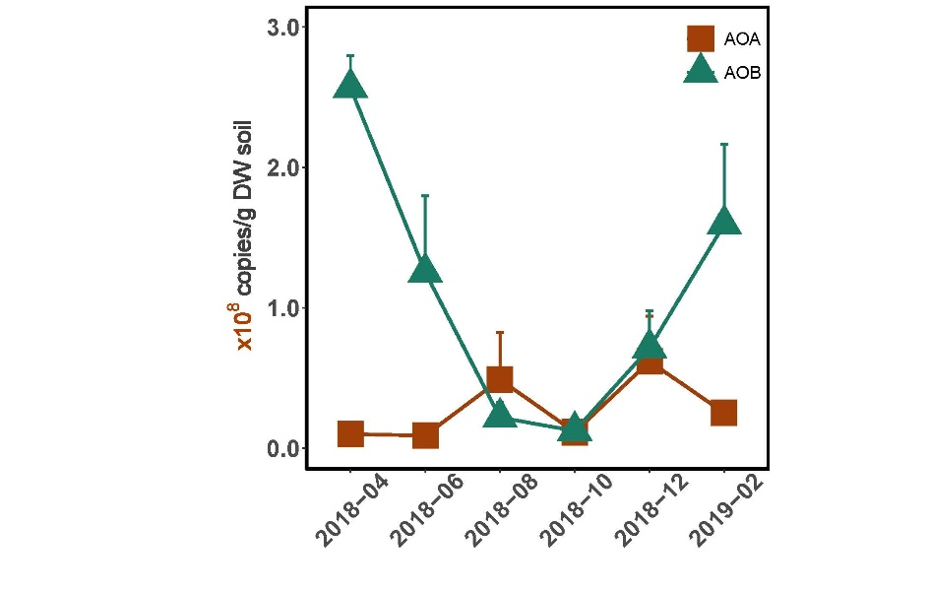

RT-qPCR of *amoA* gene

*Figure 2.*

PW

CW

e)

qPCR of *amoA* gene

16S rRNA genomes

b)

a)

c)

d)

f)

Wallis). Therefore, we considered the impact of potential comammox bacteria negligible on our central question of the impact of drought dynamics on ammonia oxidation in fen peatlands.

*Figures 2a,b.* Relative abundance of AOA- and AOB-identified 16S rRNA amplicon sequences, multiplied by copies of the 16S rRNA gene per gram dry weight soil (as determined via qPCR) to proxy the absolute copy number of AOA and AOB 16S rRNA amplicons per gram of dry weight soil. Mean values and standard errors are included for each time point (n=3).

*Figures 2c,d.* qPCR of the bacterial and archaeal *amoA* gene in both sites, represented in *amoA* copies per gram dry weight of soil, with mean values and standard errors (n=3).

*Figures 2e,f.* RT-qPCR of transcribed bacterial and archaeal *amoA* genes in both sites, with mean transcribed *amoA* copies per gram dry weight soil (n=3) and standard errors.

An initial investigation of AOA and AOB abundances was conducted using 16S rRNA amplicon sequences (Fig. 2a,b). Both AOA and AOB were significantly dynamic in PW throughout the drought cycle, with AOA peaking in August and decreasing after the drought end in December (KW, p<0.05). Additionally, AOB had higher copy numbers in June and August and a decrease in abundance by October (p < 0.01). Similarly, in CW AOB peaked in June before decreasing in October (p<0.005), albeit at abundances an order of magnitude lower than in PW. AOA was only identified in December at the CW site.

Quantification of AOA and AOB was implemented with both DNA-based quantitative PCR (qPCR) and RNA-based reverse-transcription qPCR (RT-qPCR) targeting *amoA*. Based on DNA, temporal dynamics of AOA abundances were insignificant in both sites (Kruskal-Wallis). Further, a comparison of drought AOA abundances compared to non-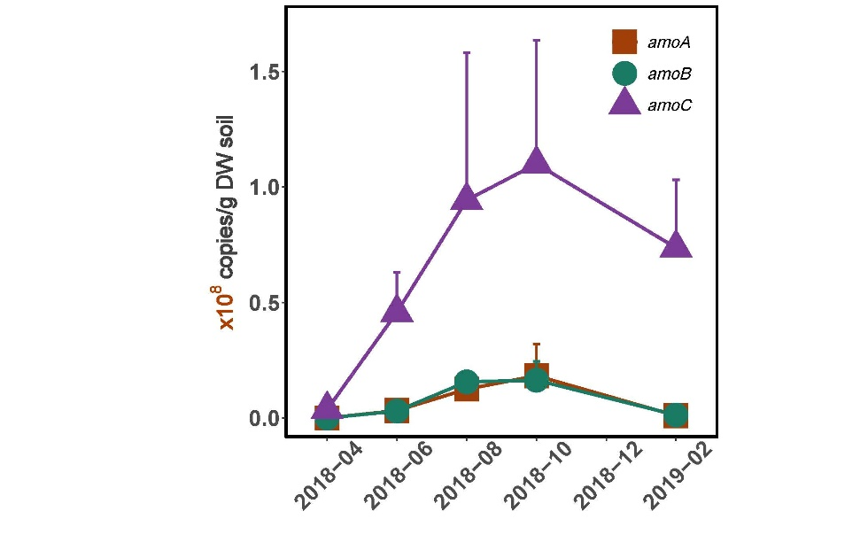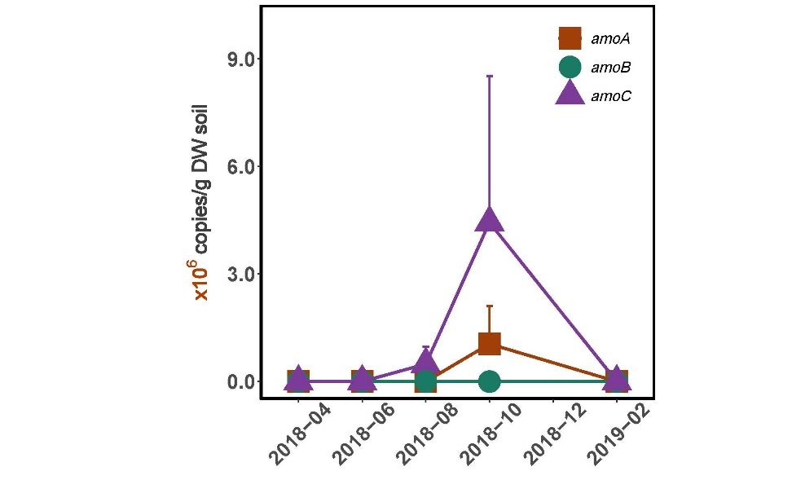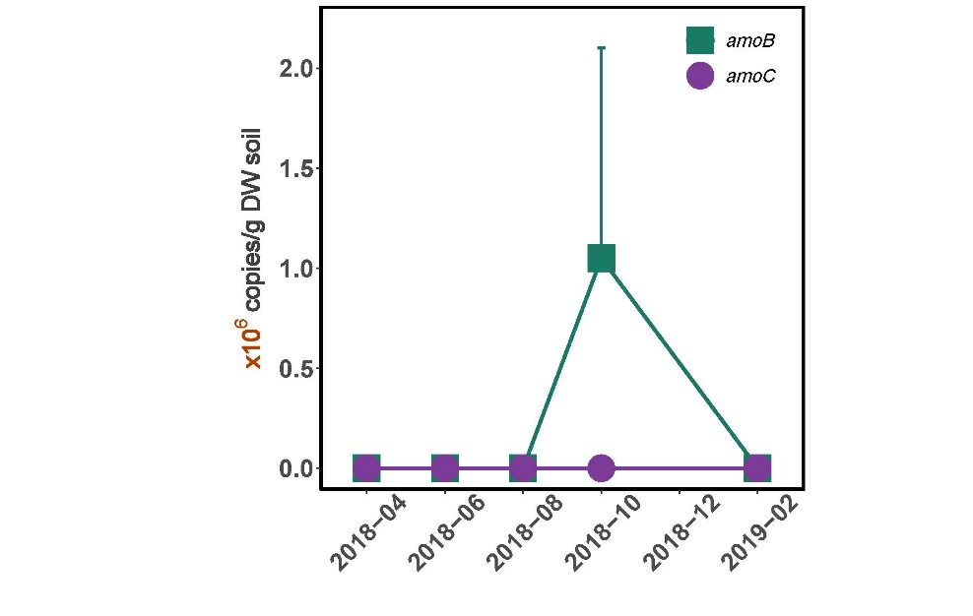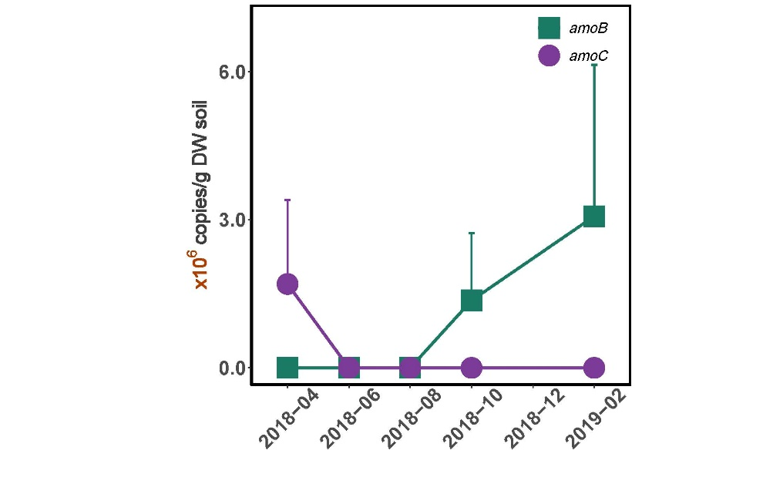drought abundances were significant only in CW (Dunn, k = 2, p = 0.047). In contrast, AOB abundances displayed temporal variability in both CW and PW. PW displayed a decrease in AOB abundances during the drought period (p = 0.024), as well as sensitivity to temporal variability between sampling points (p = 0.02). Within this time span, there was a decrease in AOB abundance between April and October 2018 (Dunn with Bonferroni, p = 0.043). Finally, while AOB in CW demonstrated significant temporal variability throughout the sampling period (p = 0.019), there was no meaningful difference in the AOB abundance between drought and non-drought periods.

*Figures 3a,b.* Abundances of archaeal *amoABC* in the metatranscriptomes of 16S mRNA transcripts in both PW (a) and CW (b). Mean values of the transcript copy number per gram dry weight soil and standard errors thereof are included, and n=3 for each time point.

*Figures 3c,d.* Abundances of bacterial *amoABC* in the metatranscriptomes of 16S mRNA transcripts; bacterial *amoA* transcripts *were* not detected in either site. Each time point is represented with the mean transcript copy number per gram dry weight soil (n=3) and standard error.

d)

c)

b)

a)

AOB 16S mRNA

AOA 16S mRNA

PW

CW

Interestingly, the RNA-based RT-qPCR method demonstrated divergent trends in AOA and AOB abundance when compared to the DNA-based qPCR results. RT-qPCR analysis showed an increase in abundance of PW AOB between April and August 2018 (p = 0.047), and a nearly-significant increase during drought periods (p = 0.059) (Fig. 2B). Similarly, AOA in PW also increased in abundance between April and August (p = 0.026), in addition to an increase during drought periods (p = 0.018). In contrast, CW samples displayed no significant temporal variability in either AOA or AOB abundances (Fig. 2B). Further, drought was not a corollary for either AOA or AOB in the CW site.

No subunit of archaeal or bacterial *amoABC* in the 16S rRNA metatranscriptomes varied over the drought period in either site (Figs. 3a-d). However, the PW abundances of archaeal *amoABC* were two orders of magnitude higher than that of the CW site (KW, p<0.0001). Interestingly, there was no bacterial *amoA* identified in either site. Bacterial *amoBC* was only identified in October in CW (Fig. 3d). In PW, bacterial *amoBC* was identified in half of the time points but was two orders of magnitude lower in abundance than archaeal *amoABC* (p<0.0001), in stark contrast to the other ammonia oxidation proxies previously discussed.

In addition to the quantification of archaeal and bacterial ammonia oxidation proxies, the samples were analyzed for soil dissolved organic carbon (DOC), as well as ammonium (NH₄⁺) and nitrate (NO₃⁻) volumes (Fig. 4). While no fraction of DOC was variable over the 2018 drought cycle, PW had a higher volume of organic matter than the CW site (Fig.4a-b, KW p<0.0001). Ammonium was dynamic in the PW site (ANOVA, p = 0.012), with a peak in October that was higher than other months (TukeyHSD, p < 0.05). Nitrate was not significantly dynamic across any time points in the PW site. The CW site displayed an opposing trend, with no meaningful shifts in ammonium content across the study period, but variation in nitrate loads (Kruskal-Wallis, p = 0.033). Both sites had a higher volume of ammonium than nitrate, and PW had both a higher nitrate and ammonium content than CW (KW, p < 0.01).

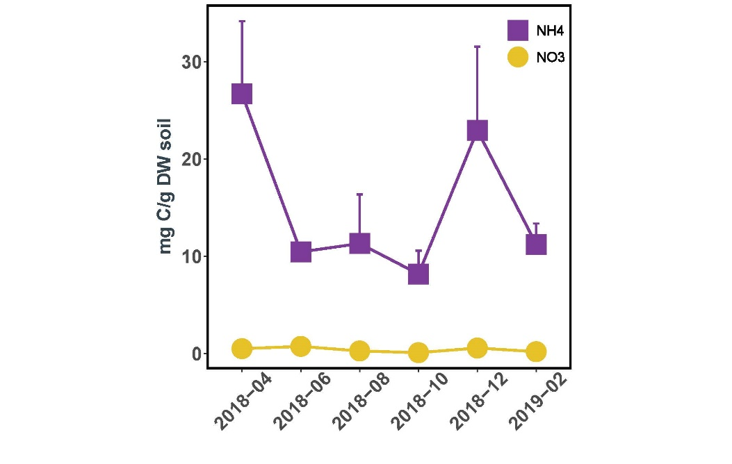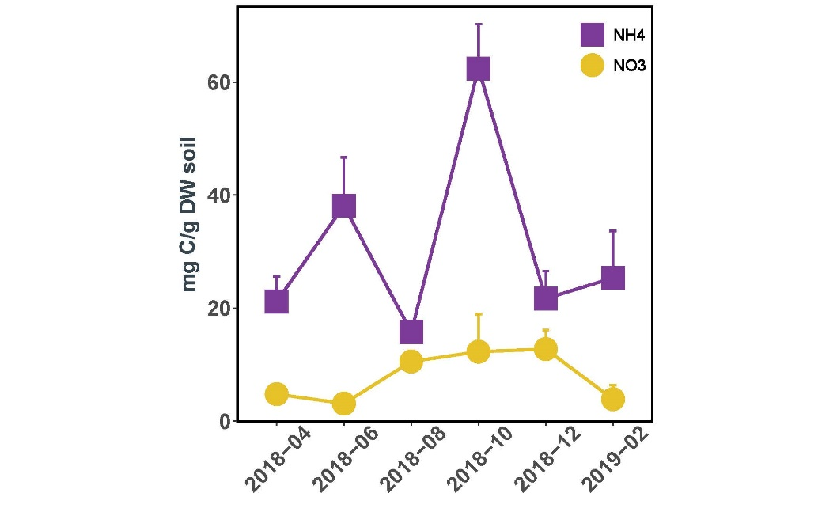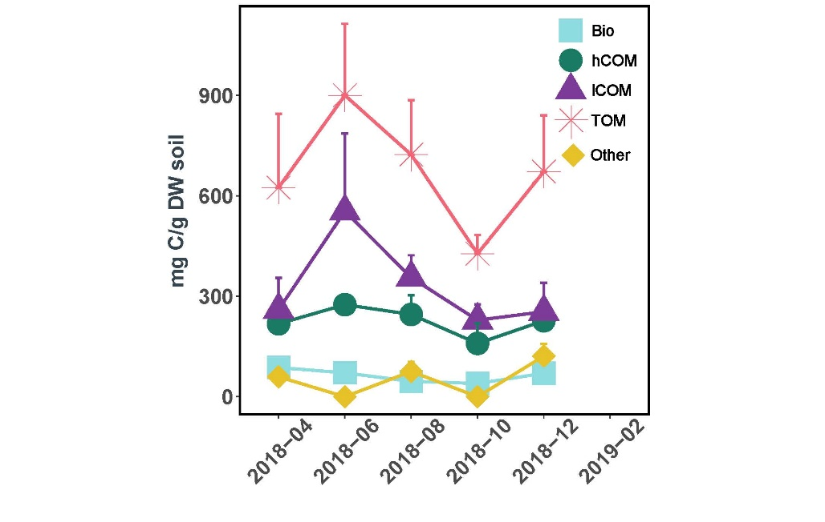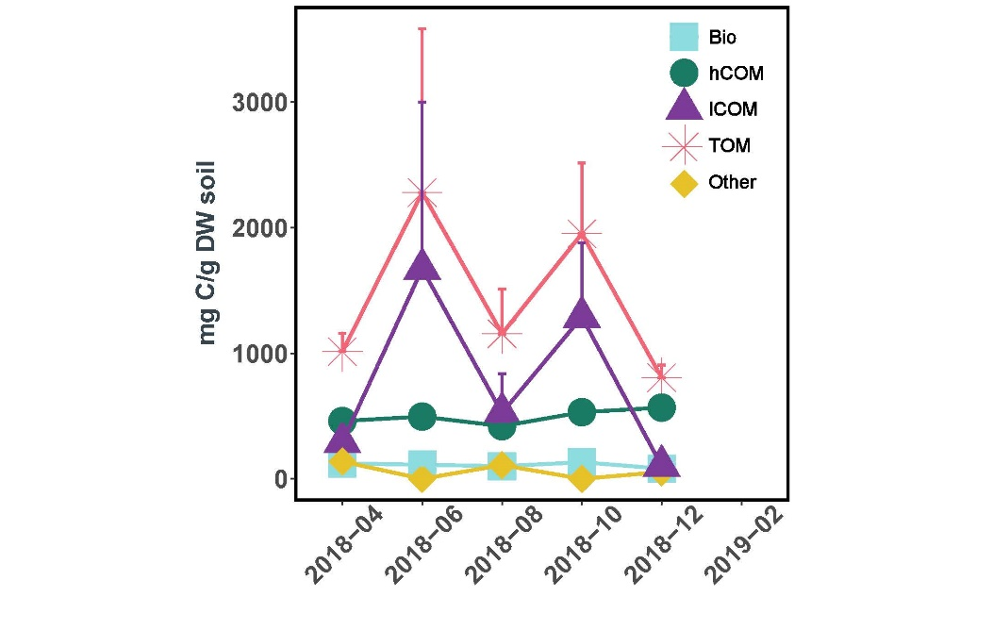

a)

*Figures 4a,b:* The dissolved organic carbon content of the topsoil samples (depth 5-10 cm) at the PW and CW sites. Values are averaged at each time points (n=3) and each have standard error bars. The fractions of soil carbon in milligrams of carbon per gram dry weight soil are as follows: biopolymers (Bio), humic substances (hCOM), low-weight molecular substances (lCOM), total dissolved organic carbon (TOM) and other (remaining TOM values after Bio, hCOM and lCOM were removed).

*Figures 4c,d:* The ammonium (NH₄⁺) and nitrate (NO₃⁻) nutrient contents in the topsoil samples (5-10 cm depth) at the PW and CW sites. Values represented are averages across subsamples with standard error bars (n = 3). The nutrient volumes are measured as milligrams of nitrogen per gram of dry weight soil.

d)

c)

Ammonium and Nitrate

Dissolved Organic Carbon

PW

CW

b)

**3.3 Changes in nitrogen-cycling gene transcript abundances**

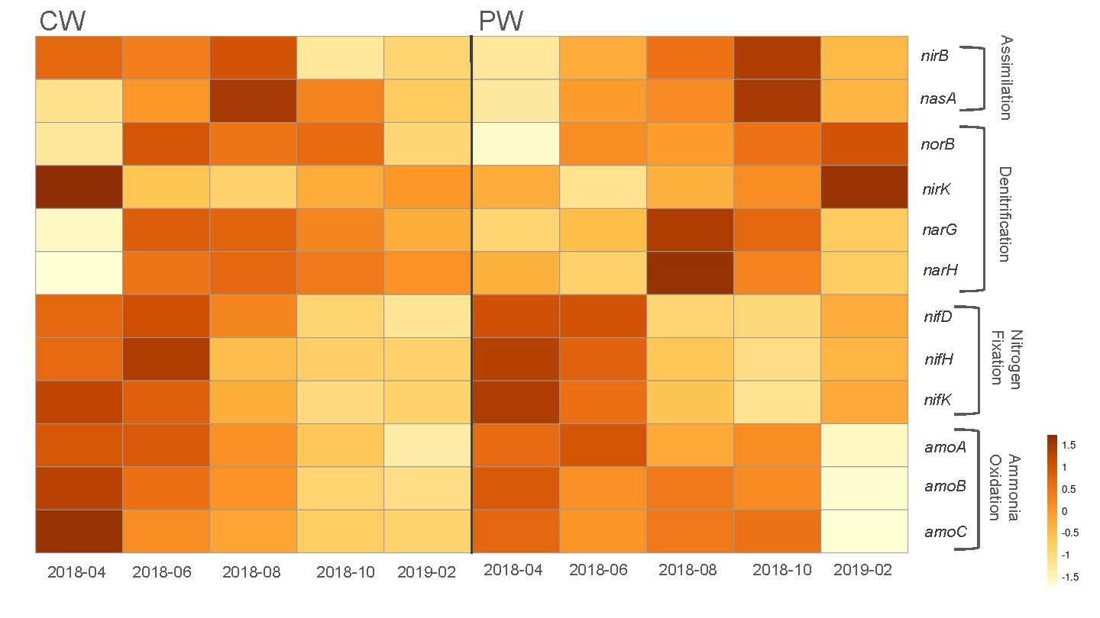There was significant fluctuations in gene transcript abundance over the drought period for nitrogen fixation, nitrogen assimilation and ammonia oxidation in the PW site, as indicated by KEGG functional group assignment based on the metatranscriptome data Fig. 5). Nitrogen-assimilation indicator *nirB* was variable over time with a peak in October as compared to April (ANOVA p = 0.046, Tukey p = 0.038). A similar trend was evident in the related *nasA* gene for assimilatory nitrate/nitrite reduction to ammonium (ANRA) (Kruskal-Wallis p = 0.044, Dunn p = 0.040). Both *nifH* and *nifK* nitrogen fixation marker genes were dynamic over the drought cycle (Kruskal-Wallis, p = 0.002 and p =0.011), with a peak in April and decrease to a minimum in October. Of the ammonia oxidation-indicator genes in the KEGG database (*amoABC*), only *amoA* was significantly dynamic (ANOVA, p = 0.0006) with a peak in June as compared to February (Tukey p = 0.042). No denitrification-indicator genes varied meaningfully over time, though there was a slight increase in *narGH* in the August samples.

*Figure 5.* A heatmap of nitrogen-cycling functional group abundance (mRNA transcripts per gram dry weight soil) across the 2018 drought cycle in the CW and PW sites. Functional genes were assigned via the KEGG database, and all genes are standardized by site, with n=3 per time point. Red values indicate higher than average within-site gene transcript abundances across the time series, while yellow values indicate lower than average values.

In comparison to PW, CW had lower abundances on the scale of an order of magnitude across all marker genes (Kruskal-Wallis, p ≤ 0.01). Denitrification activity was also higher in PW than CW (p < 0.001), although the transcription rates were not dynamic in either site across the drought cycle. Of the analyzed marker genes, only the nitrogen-fixation associated *nifK* fluctuated meaningfully in CW between April 2018 and February 2019 (p = 0.035), with evidence for a slight decrease in August. While *nifH* also showed a slight decrease in August, none of the variation over time in this gene marker was significant.

**3.4** **AOA Phylogeny**

Based on the phylogenetic congruency between 16S rRNA and *amoA* gene in archaeal genomes, we could assign *amoA*-defined clades to their corresponding 16S rRNA gene counterparts (Wang et al., 2021). The *amoA*-defined clades provide a higher resolution on AOA classification and thus a better understanding on their functional diversity. Clades were assigned based on affinity to phylogenetic tree regions based on known AOA clades in the *amoA* database (Supplement Fig. 4) [38]. ASVs with ambiguous locations (i.e. between clades) were labeled as undefined (UD). Hereafter, *Ca.* Nitrosotaleales is denoted as NT, *Nitrosopumilales* as NP, *Ca.* Nitrosocaldales as NC and *Nitrosophaerales* as NS. PW had a higher overall diversity in AOA clades than CW (Fig. 4). The CW metagenome contained only one clade at one time point (NT*-*α in December 2018). In contrast, the PW metagenome contained AOA-identified ASVs across all time points, including taxonomic units assigned to NP (NP-η) and NS(NS-δ, NS-γ, NS-ζ and NS-UD), as well as additional unidentified AOA ASVs. There were no ASVs assigned to NC in either site. All AOA clade absolute abundances were stable over time (Kruskal-Wallis), with the exception of NT-α (only present in CW in December) and NP-η (which first appeared in October). The most prominent clades identified in the PW site were NS-γ, which showed a slight increase during the drought 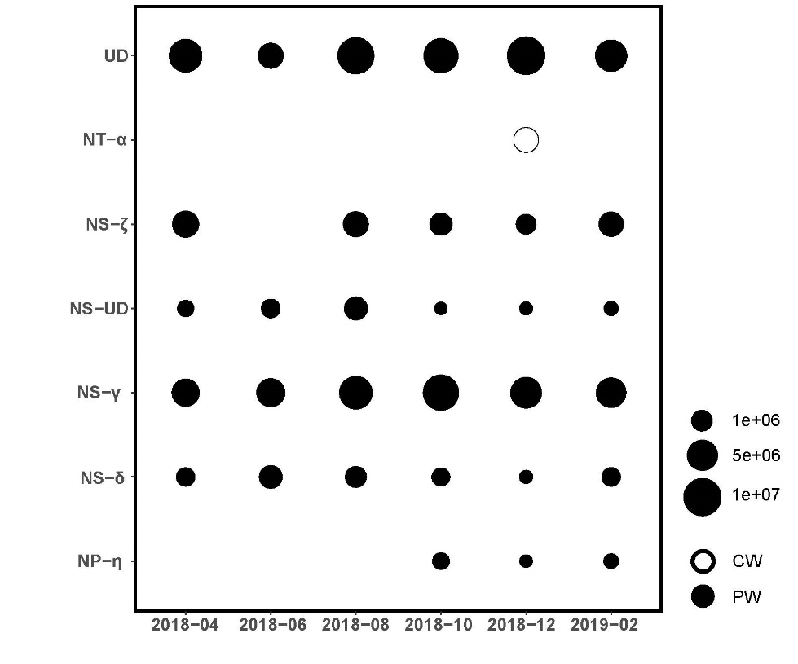period.

*Figure 6.* Average absolute abundance of AOA clades at each location throughout the 2018 drought cycle. Absolute abundance of the respective clades for each site and time point is from 16S rRNA metagenome OTUs (i.e. relative abundance) multiplied by the total DNA copies per gram dry weight soil to calculate absolute abundance. Clade assignments are from the phylogenetic tree constructed with the *amoA* database described in Wang et al. (2021). UD indicates undetermined AOA taxonomy, NT is Ca. *Nitrosotaleales*, NS is *Nitrososphaerales* and NP is *Nitrosopumilales*.