We strongly recommend that you read the 2025 TidyTowns Information Booklet available on www.tidytowns.ie before completing this form.

About You!

Name of your Town/Area/Village/Island: Two Mile Borris

Name of your Town/Area/Village/Island in Irish: Buirios Leith / Burgheis a da Mhile

County:Tipperary

Region: South East (See list of Regions / counties at Terms & Conditions no. 22.)

Specify your Local Authority: Tipperary Co Co

Last Year of Entry: 2024

Organisation Name: Two Mile Borris Development and Tidy Towns

Contact Name: Michael Maher Address: Loughfield,Two Mile Borris,Thurles E41A665

Estimated Location
Your adjudicator may not have visited your area before so please describe briefly where your town or village is located within your county, e.g. Xkm north/south etc. of the nearest large town, or give the road number along which your town is situated. Absolute clarity is of key importance.

Phone: 0862537898 Email: michael@tmbvillage.com Internet or Social Media address: www.tmbvillage.ie

Population Category

Please tick your population category and enter your actual population (based on the latest census). If you are unsure please check with the central statistics office, www.cso.ie or your Local Authority. Your adjudicator may check you have entered the correct category.

Please enter your actual population here e.g. 19,999 __600_______________
Prize Category Population

Village  A (Under 200) Large Town  E (5,001 to 10,000)

 B (201 to 1,000)  F (10,001 to 15,000)

Small Town  C (1,001 to 2,500) Large Urban Centre  G (15,001 to 25,000)

 D (2,501 to 5,000)  H (25,001 and over)

By signing below, I understand and agree to be bound by the terms and conditions of the SuperValu TidyTowns Competition and consent to the personal data contained in this form being released to printers for the purpose of posting invitations, entry forms, results books or other documentation for the purpose of administering the SuperValu TidyTowns Competition and other related initiatives. I also consent to this data being released to the TidyTowns Adjudicators as part of the Entry Form upon which our adjudication is based. I understand that the printers contracted to carry out this work will be advised that all data should be deleted once the specific task has been completed. I understand that Personal Data provided in this form will be retained by the
Department for a period of 3 years for the distribution of entry forms and information directly related to the competition.

The Freedom Of Information body undertakes to use its best endeavors to hold confidential, any information provided by you in this form, subject to the organisations obligations under law, including the Freedom of Information Act 2014. Should you wish that any of the information supplied by you in this form should not be disclosed because of its sensitivity, you should, when providing the information, identify the same and specify the reasons for its sensitivity.

I understand that I can withdraw my consent at any time to this information being stored or used in this way by writing to the TidyTowns Unit stating I am withdrawing my consent.

Signed (on behalf of entrant) Michael Maher Date: 10/05/2025

Community - Your Planning and Involvement 80 Marks
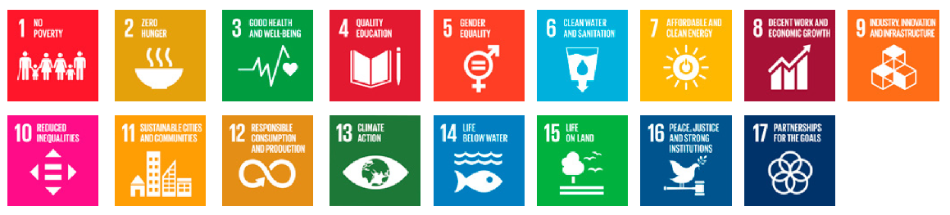
Marks are awarded for the overall quality of the Entry Form, town/village map and appropriateness of backup material submitted with your entry. Other key issues are the participation of the local community, businesses, schools and youth in general; working partnerships with local civic agencies; works carried out and appropriate projects completed; existence of an achievable updated TidyTowns Plan. Consideration will be given to social inclusion, whole of community approach, the role of volunteers and new residents in activities.

Number involved in your Committee: 27

Number not on committee but who volunteer: 5

Please indicate level of voluntary commitment (number of TidyTowns meetings, community meetings, general involvement of the community, new residents, etc.):
We meet two to three times during the year but sub groups meet more often with jobs or maintenance issues being done. We have a WhatsApp group for communication. We are part of our local Split The Pot weekly fundraiser draw which is our main source of funding.

Please list all of the agencies, bodies and businesses that have supported your activities through sponsorship, resources, funding, advice, etc.):
.): Moycarkey Borris GAA,Two Mile Borris National School,TMB Christmas Lights Committee,Thurles Lions Club,Parish Church,TMB Vintage club,Graveyard committee.Defribulator group.MBB Community Development DSP CE scheme.Tipp Co Co.Local Business.

How do you communicate with your community (newsletter, newspapers, public meetings, email, social media, website, etc.)?
Our Website,Whattsapp groups,Parish Leaflet,Tipperary Star Newspaper,social media

How do you engage with your local schools, youth clubs, etc.? How do you involve youth in your work, do you have a Junior TidyTowns, is there youth representation on your committee.
We use our sensory garden for the school children to sow flowers and plants in our raised bed areas.The garden is also used by after school hours children that are cared for in the school building for activities. We bring our children along with us on our litter picks.

Briefly identify ONE specific project where particular effort was applied since May 10th 2024. (This can include ongoing maintenance work or new project)
We got involved with the TWO Mile Borris graveyard committee in the development of an extension to the existing graveyard in the village.We helped with funding and organizing fund raising events. We attended all the meetings and helped on the ground on the big day last February with the Turning of the sod (day 1 of construction).This is located right in the village opposite Bannons Pub.

Approximately how many years has your community entered the competition. How has your community benefited from involvement in the competition?

We entered from 2013 until 2019 and again last year 2024.We benefit hugely from the adjudicators comments on the judging and gives a focus on the future work to be done.

Streetscape & Public Places 80 Marks


Buildings: Conservation and presentation of heritage buildings and quality of shop-fronts will be considered, taking account of the design, sustainability, accessibility, usability and suitability of new structures or civic amenity buildings for all people, regardless of age, size, ability or disability. Please highlight the efforts made to address derelict sites and unoccupied buildings even if unsuccessf
We have brought back to life an old derelict forge (beside the church) and it gets used for storage and becomes our beautiful village crib at Christmas.We with the Christmas lights committee have installed a plaque and a seat in memory of one of our members directly involved ad also a plaque inside to remember past members.We had a great festive night involving the whole community at the Lighting up the Lights party for Christmas – a lovely festive night.
Derelict buildings exist opposite the church.We are keeping in contact with the owner.The property is in planning for redevelopment and hopefully this will happen soon.
Public Spaces: Consideration will be given to; squares, parks, streetscape, paving, landscaping and street furniture mindful of sustainability and access for all. Condition of street lighting, building facade lighting, appropriately designed signage and way-finding relating to streets and place nameplates. Attention will be given to the presentation of parking locations, historical trails, walkways and access points to local amenities or facilities and the general use of the Irish language.

Please refer to the 2025 SuperValu TidyTowns Information Booklet available on www.tidytowns.ie and state if you have entered a Special Award relevant to this category.
List projects undertaken since May 10th 2024 including, new projects (N) completed this year, previous projects that you have improved or maintained (M). It would be helpful if you could number your project descriptions and include date project was initiated and completed, where applicable.
Note: Please ensure all priority projects are uniquely referenced on your map and legend using the reference numbers assigned below.
- Shrubbery area in front of village monument including timber surround (M)
- Power washed around monument area and all along walls and footpaths of village center and in front of Castle Park and Harkin Park housing estates close to the village.(N)
- Area around old forge opposite the shop resurfaced with grit for parking and a border created for the shrubbery (M)
- Shrubbery maintenance,Grass cutting.(M)
- Flower boxes refreshed from Winter to Summer (M)
- -Sensory Garden (Beside the school) maintenance(M)

Green Spaces and Landscaping 80 Marks


Communities should demonstrate the following: The planning, design and management of green spaces. The selection and appropriate siting of trees and their ongoing maintenance, including formative pruning, watering and attention to the stakes and ties. Presentation of landscaping of all entrances to your town/village/locality in consultation with your local authority, where appropriate. The use of suitable plants for hedges and shrubs for year round effect is important as is the siting of seasonal planting schemes where you wish to highlight important areas. The use of plant containers can provide impact where it is not possible to plant directly into the ground. To reduce maintenance tasks limit the use of containers. To demonstrate the year round impact of the landscape works in your community, you are encouraged to provide dated photographs of, for example, planting schemes which are not evident in summertime.

Please refer to the 2025 SuperValu TidyTowns Information Booklet available on www.tidytowns.ie and state if you have entered a Special Award relevant to this category.
List projects undertaken since May 10th 2024 including, new projects (N) completed this year, previous projects that you have improved or maintained (M). It would be helpful if you could number your project descriptions and include date project was initiated and completed, where applicable.
Note: Please ensure all priority projects are uniquely referenced on your map and legend using the reference numbers assigned below.
Our green areas are limited to the entrances to the village which is basically roadside and we maintain well and we have plenty of reasonably young trees which we maintain also.We have a bench installed on one of the more open spots on the Thurles entrance to the village.
We have a little area adjacent to the village monument where we have a small formal type planting.

Nature and Biodiversity in your locality 55 Marks


Show your understanding and awareness of nature and biodiversity in your locality. This may include protected areas and/or areas important for conservation e.g. waterways, field boundaries, coastal features etc.
Show an appreciation of how your local species and habitats should be best managed and protected. Evidence of co-operation with expert groups and relevant authorities, especially in carrying out work in sensitive areas is desirable.

Please refer to the 2025 SuperValu TidyTowns Information Booklet available on www.tidytowns.ie and state if you have entered a Special Award relevant to this category.
List projects undertaken since May 10th 2024 including, new projects (N) completed this year, previous projects that you have improved or maintained (M). It would be helpful if you could number your project descriptions and include date project was initiated and completed, where applicable.
Note: Please ensure all priority projects are uniquely referenced on your map and legend using the reference numbers assigned below.
We have a sensory Garden (beside the school) and it is very nature and biodiversity conscious. We have bird boxes that are being nested in right now and bee hotels and decaying logs for insect life and an ethos of letting it be a bit more wild and less clipping or mowing to let nature do its thing.
Biodiversity planting to attract bees,butterflies and other insects.
Raised bed areas to encourage planting.
Use of natural materials and reused materials
We left the grass areas grow for May to allow the wild flowers to grow and help the insect life

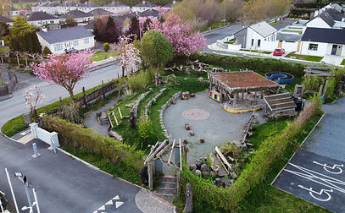

Sustainability - Doing more with less 55 Marks

Describe how your activities help to make your centre more sustainable and reduce your environmental impact. For example, consider how you use your resources (e.g. methods or materials you use), in your project work under one or more of the following key themes: sustainability, water, transport, waste, energy, and climate action. Describe awareness raising activities carried out across your community and detail any involvement with other Community Groups in this category.

Please refer to the 2025 SuperValu TidyTowns Information Booklet available on www.tidytowns.ie and state if you have entered a Special Award relevant to this category.
List projects undertaken since May 10th 2024 including, new projects (N) completed this year, previous projects that you have improved or maintained (M). It would be helpful if you could number your project descriptions and include date project was initiated and completed, where applicable.
Note: Please ensure all priority projects are uniquely referenced on your map and legend using the reference numbers assigned below.

The village has a bottle and clothes bank (beside the church).
Our sensory garden has a rainwater recovery element which is there to demonstrate particularly to young people that rain water can be harvested and how important this for the future.
We are working on recycling the waste we collect as it is currently all piled together and goes to landfill.
Our flower boxes are made by ourselves from salvaged timber.

Tidiness and Litter Control 90 Marks


Tidiness: General lack of clutter, blocked footpaths, redundant poles, unsightly overhead electric cables, absence of graffiti and fly-posting and evidence of control of weed growth at kerbs. Absence of unsightly and or inappropriate advertising, such as that on gables of buildings and mass produced advertising banners in shop fronts. Please note that although general tidiness is evaluated and marked in this category, tidiness is also considered under other categories including the Streetscape & Public Places, Approach Roads, Streets & Lanes.
Litter: The adjudicator will assess the absence of litter and dumping, evidence of litter control strategy, including regular litter patrols, segregation of collected litter during clean-ups and promotion of anti-litter awareness throughout community.

Please refer to the 2025 SuperValu TidyTowns Information Booklet available on www.tidytowns.ie and state if you have entered a Special Award relevant to this category.
List projects undertaken since May 10th 2024 including, new projects (N) completed this year, previous projects that you have improved or maintained (M). It would be helpful if you could number your project descriptions and include date project was initiated and completed, where applicable.
Note: Please ensure all priority projects are uniquely referenced on your map and legend using the reference numbers assigned below.
- Main litter drive is in April when we meet one night a week for four weeks.We clean for approx a mile in every direction from the village and with good help we collect a huge amount of waste from the roads. (N)
- Maintenance Litter picks as needed for the remainder of the year.(M)
- Anti Dog fowling signs stencilled discretely in white paint on the footpaths at regular intervals around the village (N)
- Keeping flower boxes and shrubbery and planting free of weeks and general upkeep.(M)

Residential Streets & Housing Areas 55 Marks


Residential streets that include Town Houses are integral parts of towns and villages and should be treated in a similar fashion to public and private housing developments. Consideration is given to proper presentation and maintenance of all properties with due cognisance given to maintenance of frontages, boundary and gable end walls. Gardens, where applicable, should be presented to a good standard. In housing developments green areas should be cut regularly. Children’s play areas to be considered with equipment maintained to best standards. Where possible individual estates should have suitable name signs - stones, plaques, sign posts, etc. preferably bilingual. Unfinished estates will not reflect badly on the efforts of any community but examples of how the community is addressing this issue should be highlighted.

Please refer to the 2025 SuperValu TidyTowns Information Booklet available on www.tidytowns.ie and state if you have entered a Special Award relevant to this category.
List projects undertaken since May 10th 2024 including, new projects (N) completed this year, previous projects that you have improved or maintained (M). It would be helpful if you could number your project descriptions and include date project was initiated and completed, where applicable.
Note: Please ensure all priority projects are uniquely referenced on your map and legend using the reference numbers assigned below.
We have nine housing estates close to the village center with two of them just very recently occupied.Each estate has its own res association or Co Council maintenance.We keep in touch from a Tidy Towns point of view and some of our committee live in them.The standard of maintenance is very good.

We power washed the road boundary walls and footpaths of two estates
(Harkin Park and Castle Park) (N)

Approach Roads, Streets & Lanes 55 Marks


Appropriate presentation of approach roads, including the roadside verges and their boundary treatment. The appearance of town and village streets, connecting roads, laneways, bridges and cycle lanes. Provision for inclusive access and pedestrian connections.

Please refer to the 2025 SuperValu TidyTowns Information Booklet available on www.tidytowns.ie and state if you have entered a Special Award relevant to this category.
List projects undertaken since May 10th 2024 including, new projects (N) completed this year, previous projects that you have improved or maintained (M). It would be helpful if you could number your project descriptions and include date project was initiated and completed, where applicable.
Note: Please ensure all priority projects are uniquely referenced on your map and legend using the reference numbers assigned below.
Approach roads from all sides (three roads) have green verges and are kept mown and clean. (M)
On the Ballyduff/Moyne road we have power washes and cleaned the walls on both sides ie the front of Harkin Park and the front of Castle Park.(N)

Mapping your town or village
Please draw or attach a sketched or printed map of your town/village/area with street and place names and prominent landmarks. The locations of your new work for this year’s competition should also be marked. Ensure each project is clearly listed in the legend.

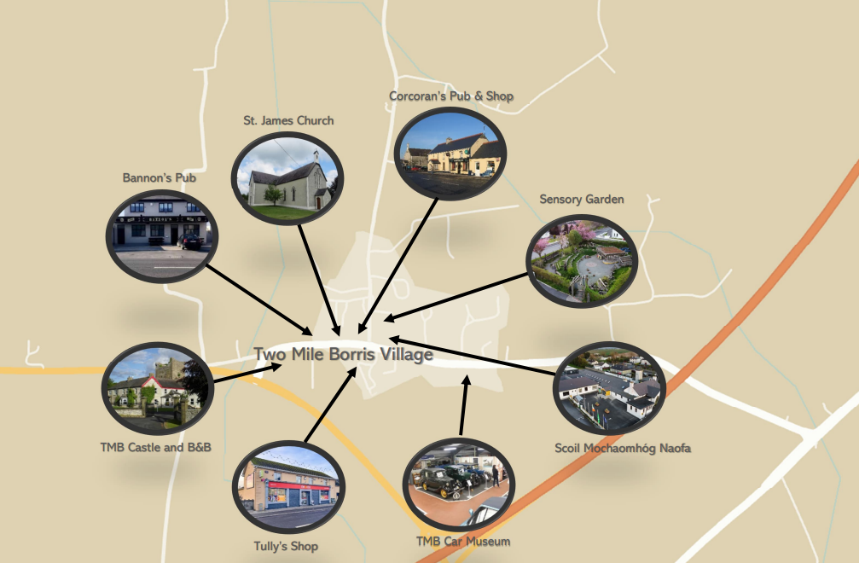

Please refer to the 2025 SuperValu TidyTowns Information Booklet available on www.tidytowns.ie
Please note the following advice;
- A hand-drawn map is perfectly acceptable if a formal printed map is not available or suitable.
- Map should be a manageable size, A4 or A3 depending on the layout of your town or village.
- Please name priority streets/roads as necessary and mark the key public buildings/landmarks.
- You are advised not to use Google mapping.
- You may find Ordnance Survey Ireland Urban (or Rural as applicable) ‘Place’ Maps most useful.
- Examples of effective maps can be found at www.tidytowns.ie in addition to A4 and A3 map graph templates.
- A clear legend is essential; please ensure that a unique numbering sequence is applied.

TidyTowns Entry Form Checklist
Best of Luck!
- Ensure you have signed and dated the entry form in the “About You” section and that you have completed all categories.

- Please ensure it is sent to tidytowns@drcd.gov.ie. It should be all contained in one email and must not exceed 20MB. We will acknowledge receipt of all email entries but please allow 10 days after the closing date for this acknowledgment.

- When emailing photographs, it would be advisable to copy them into a WORD document which will reduce the size of your email entry, you can easily fit up to 4 or 6 photographs per page.

- Sometimes less is more, be mindful of the volume of material you submit, the Adjudicator has limited time to review your work during their adjudication so it should be presented in a clear and concise manner.

- Please ensure you have included a map of your area and your TidyTowns 3/5 year plan with your entry.

- Don’t forget to enter our Special Awards, information can be found on www.tidytowns.ie

Completed Entries should be emailed by Monday 12th May 2025 to: TidyTowns@drcd.gov.ie

Best of Luck!

