Two Mile Borris TidyTowns 2026
Photograph Appendix
Photographs supporting the 2026 entry-form sections, arranged six per A4 page. Each photo is titled with the relevant section number(s) and project reference so the adjudicator can match the visual to the narrative. The full live record of every project, with additional photos and updates as the year progresses, sits on the public tracker at https://aburnsy.github.io/tidytowns/.
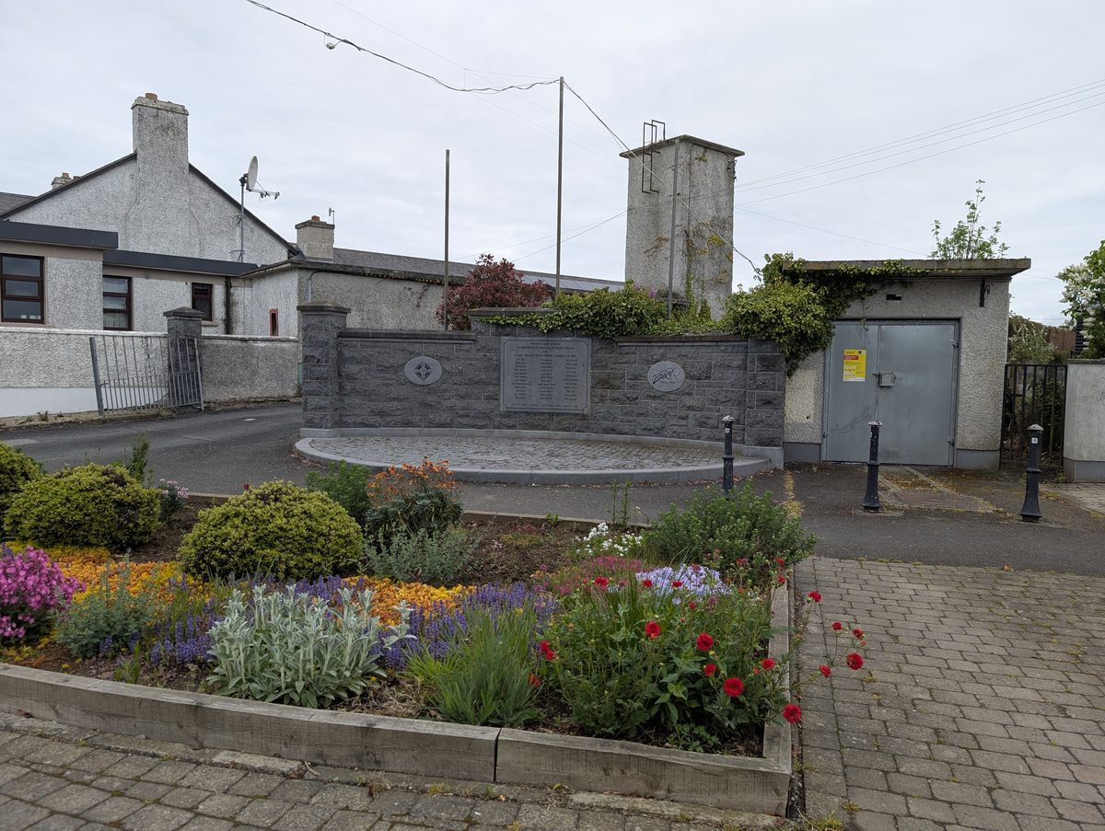  Section 2 — All-Ireland Victory Centennial monument with the 2026 flower bed in the foreground | 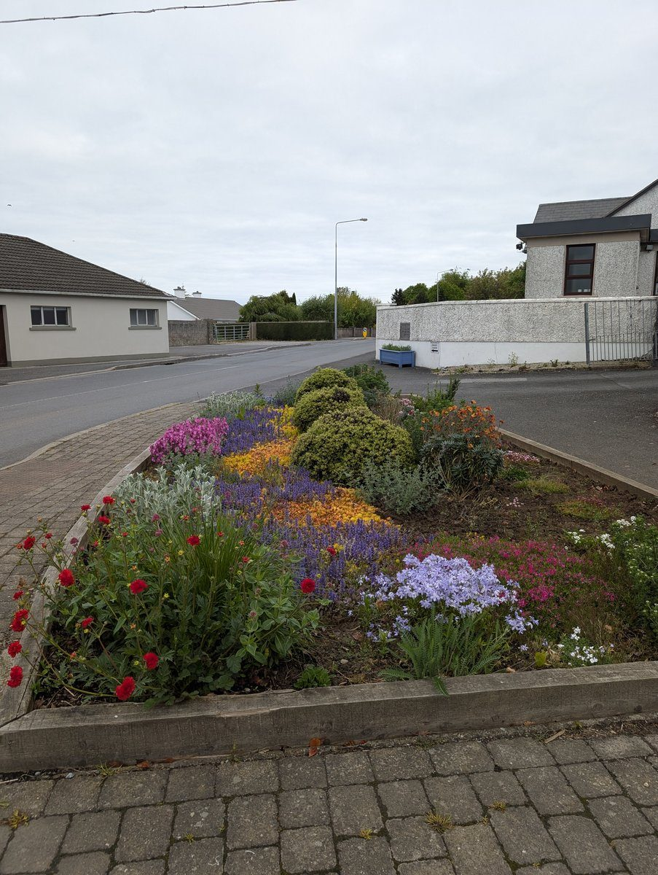  Section 2 / Project 012 — Close-up of the monument flower bed in full bloom, May 2026
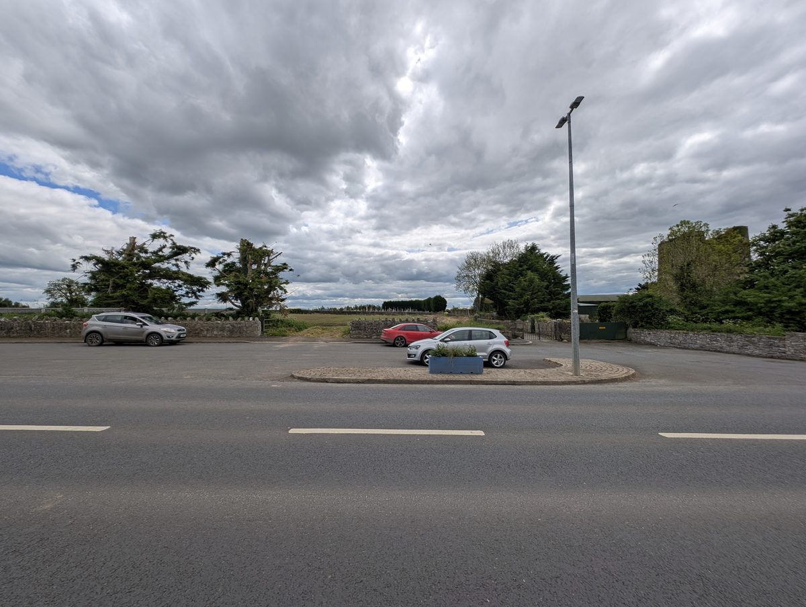  Section 2 / Project 012 — Cohesive blue trough planters at the cemetery parking layby | 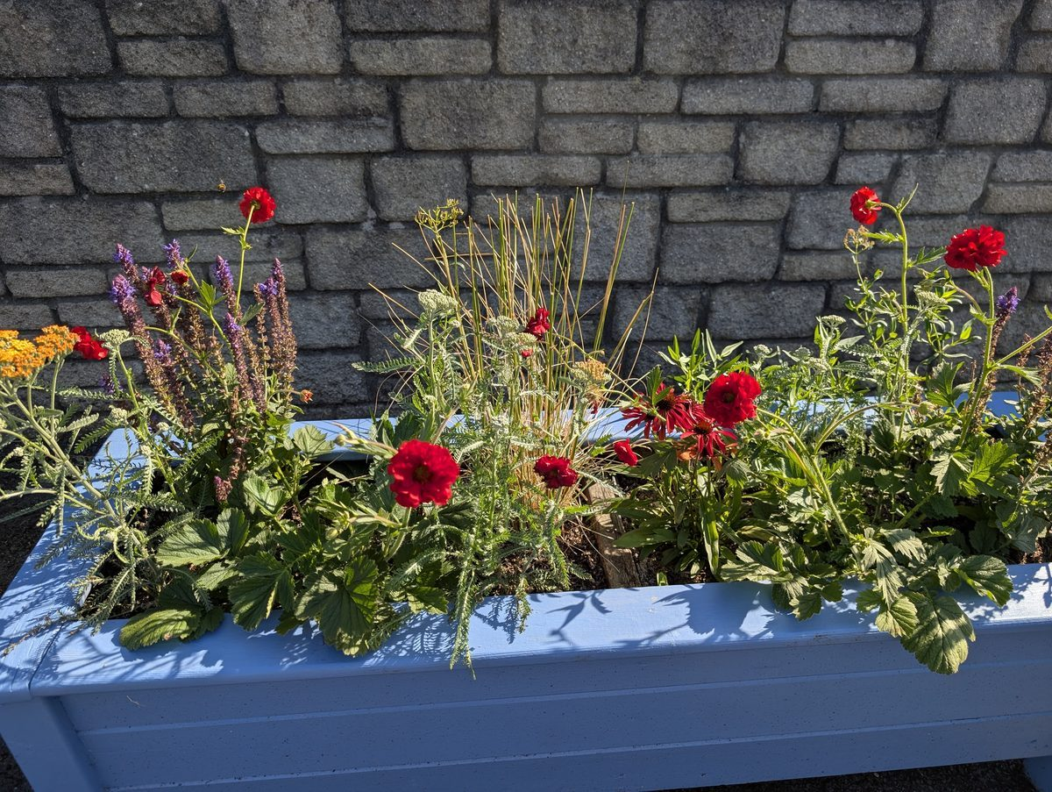  Section 2 / Project 012 — Seamus-built blue trough planter in full summer flower at Meadow Brook
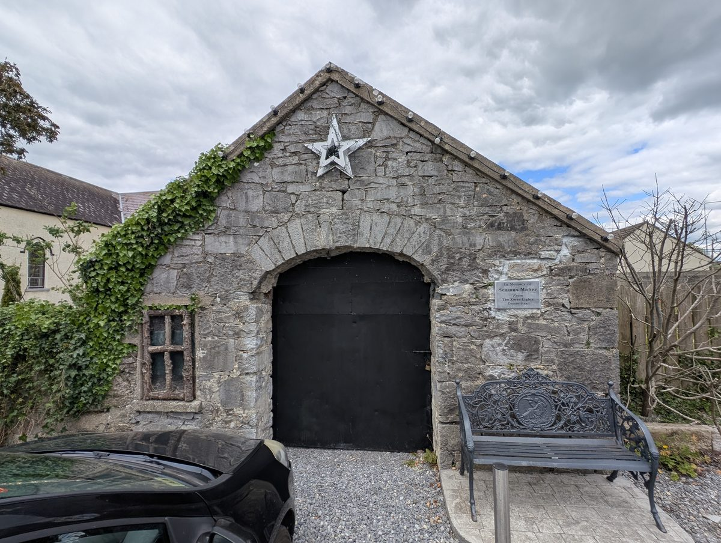  Section 2 / Project 022 / rec #2 — The forge, replica window subject for Heritage Officer outreach | 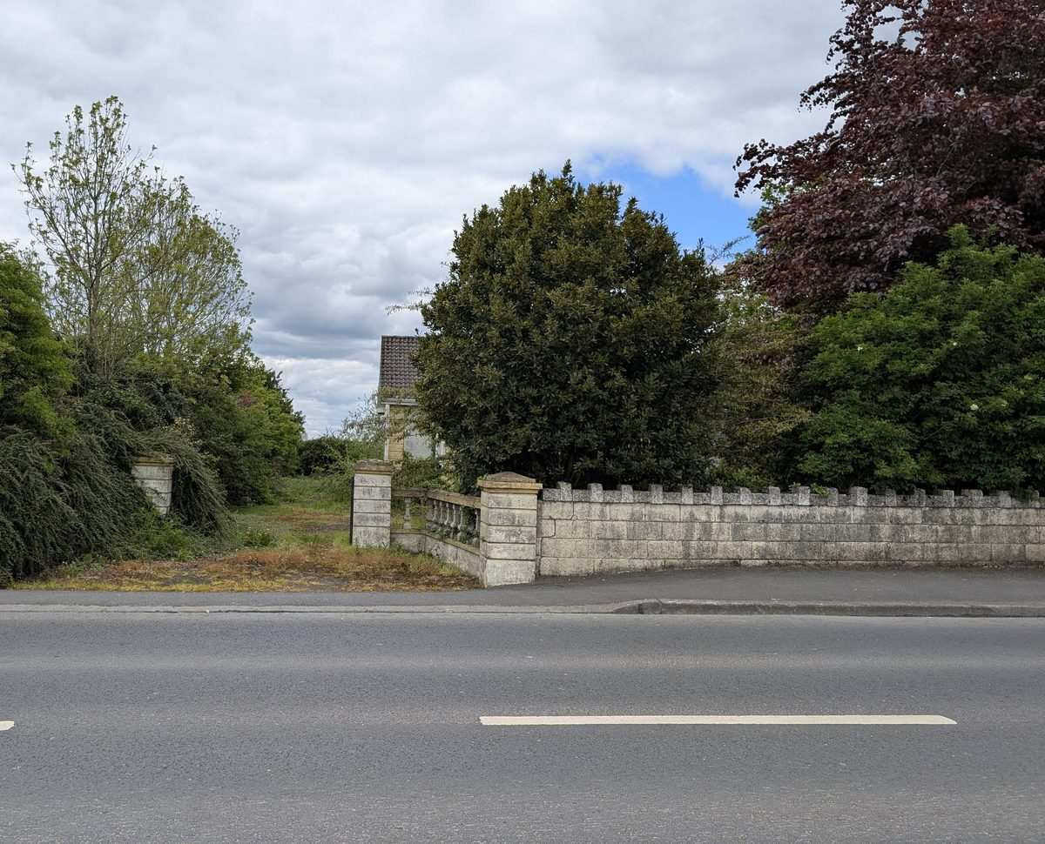  Section 2 / rec #1 — Derelict property on the L4202 opposite the cemetery; formal report submitted May 2026

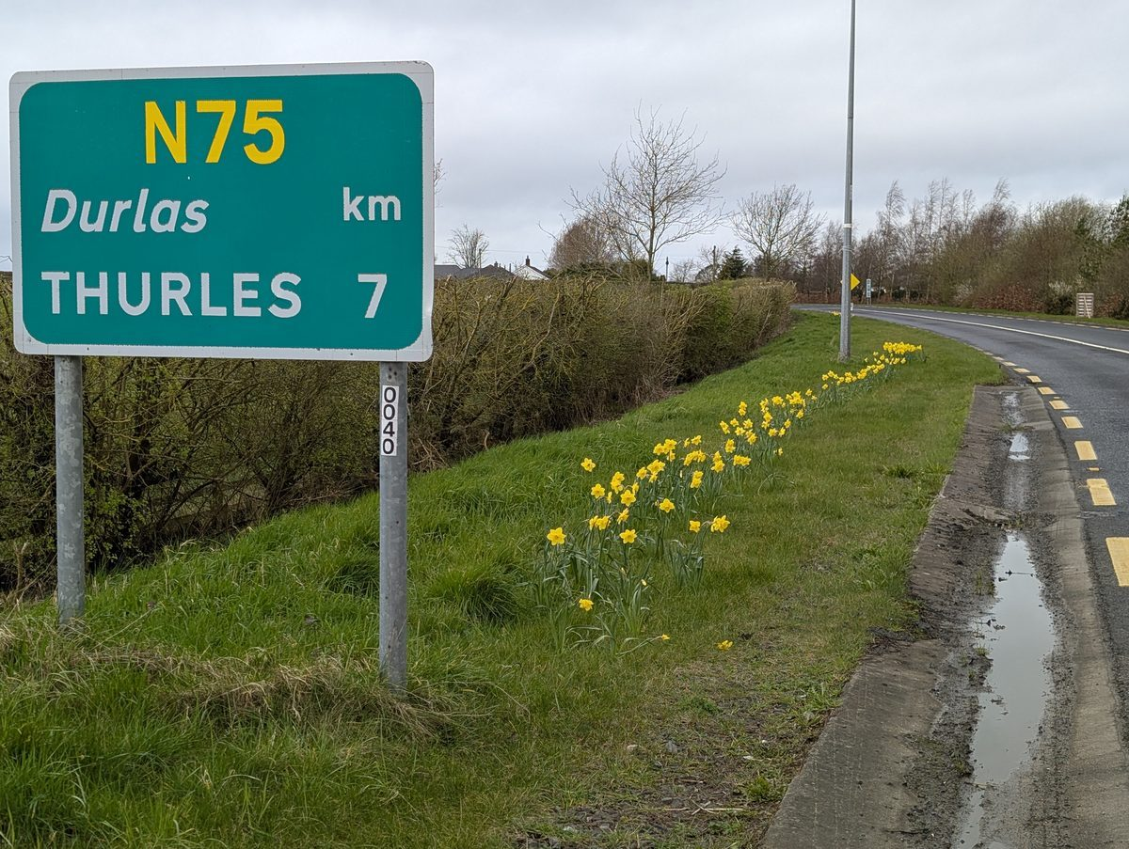  Sections 3, 8 / Project 047 — Dutch Master daffodils on the N75 west approach, spring 2026 | 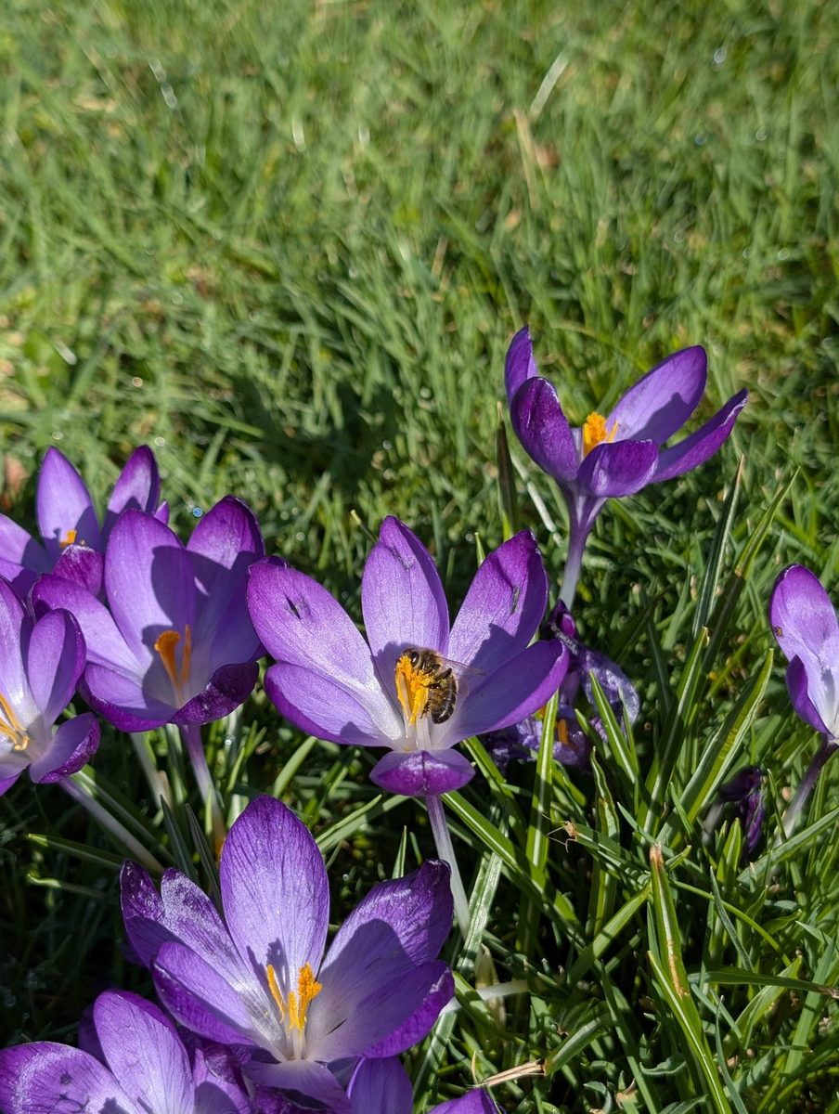  Sections 3, 7 / Project 047 — Honeybee on a Ruby Giant crocus at Glen Carraig, spring 2026
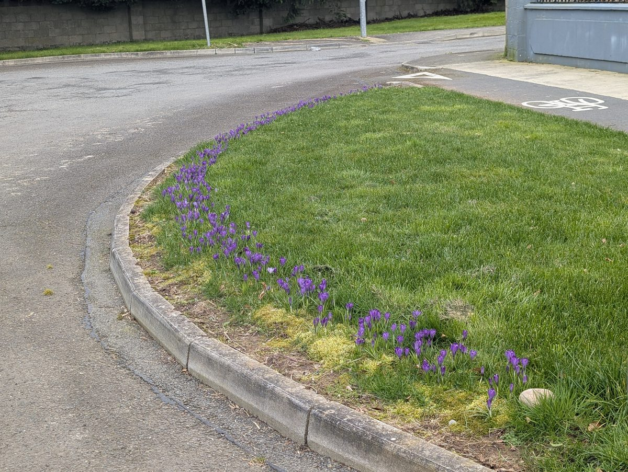  Sections 3, 7, 8 / Project 047 — 1,500 Ruby Giant crocuses at the Cluain Na Seimre entrance green, March 2026 | 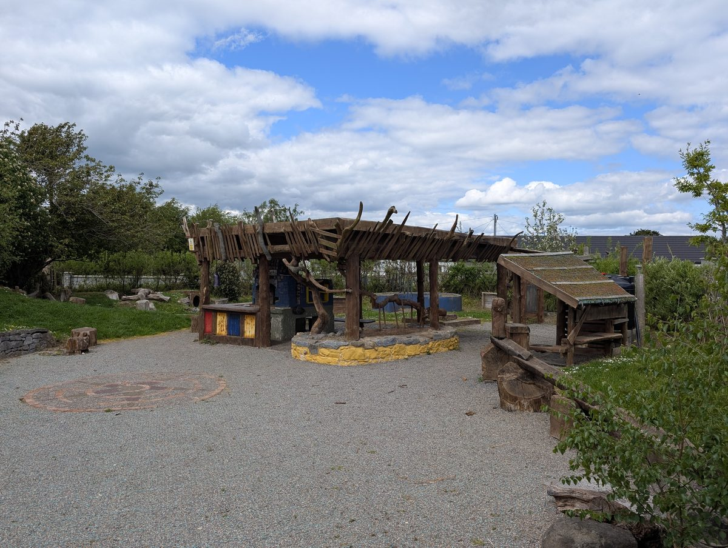  Section 3 / Project 018 — Sensory Garden timber pergola, freshly oiled in the spring 2026 maintenance blitz
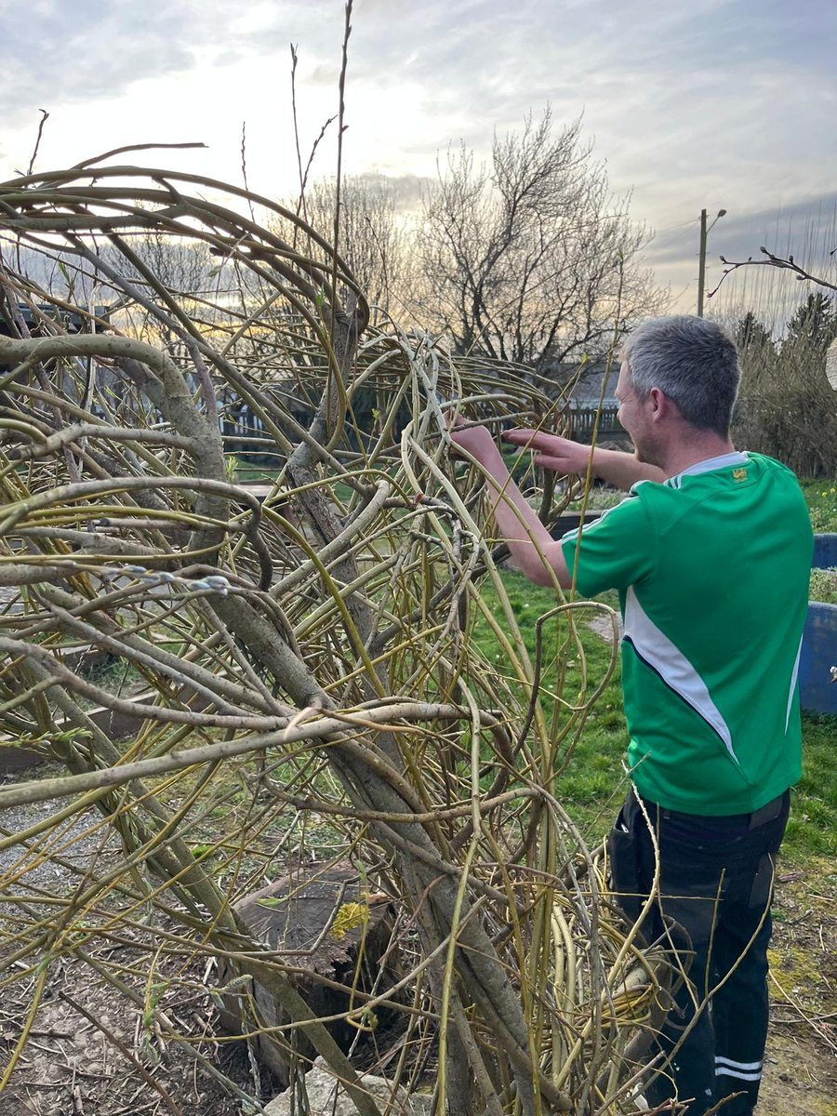  Section 3 / Project 048 — Patrick H weaving the Sensory Garden's living-willow gateway, March 2026 | 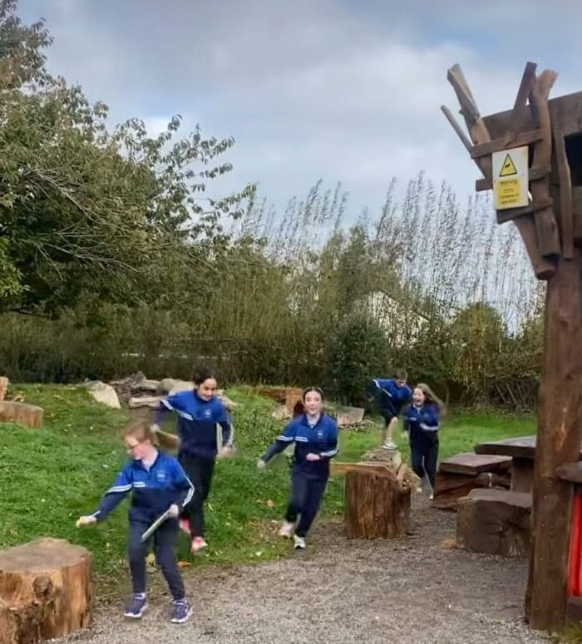  Sections 3, 4 / rec #7 — Sensory Garden in daily use as the school's outdoor classroom

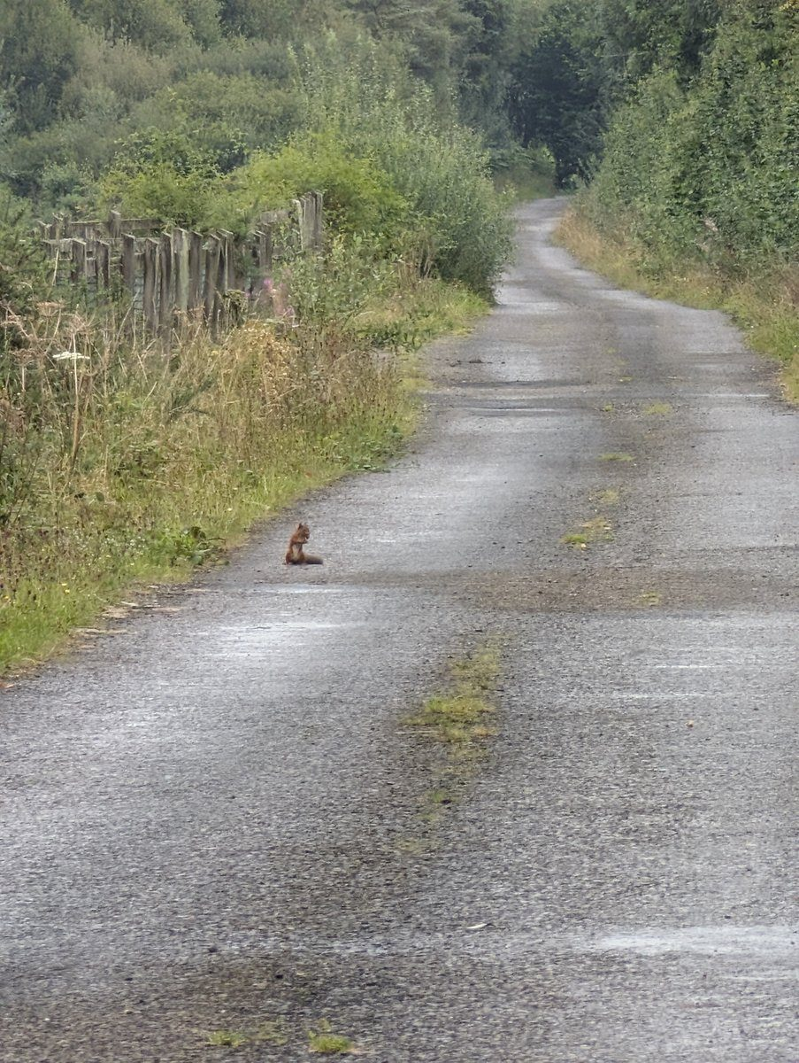  Section 4 / Project 028 — Red Squirrel on the Bog Walk path, summer 2025 (the headline species) | 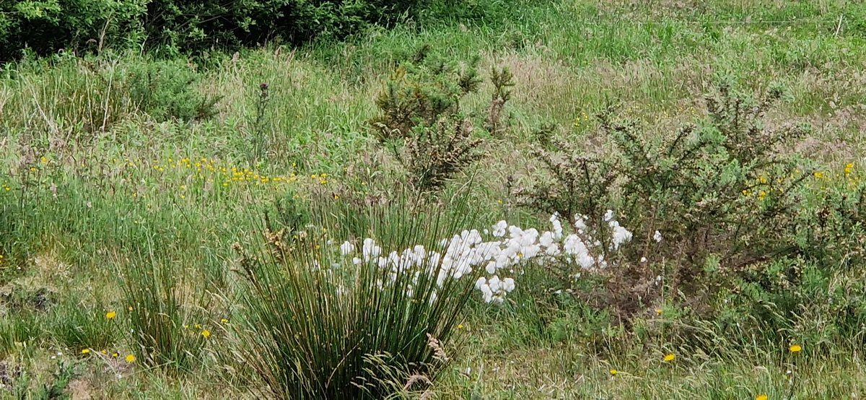  Section 4 / Project 028 — Bog cotton habitat on the Bog Walk Loop, summer 2024
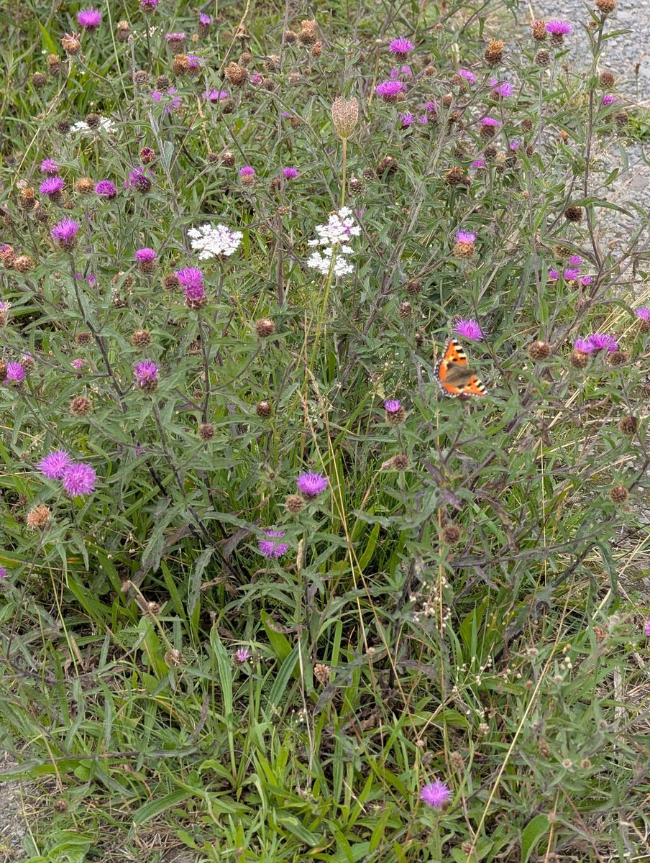  Section 4 / Project 028 — Small Tortoiseshell on Knapweed, Bog Walk wet meadow, summer 2025 | 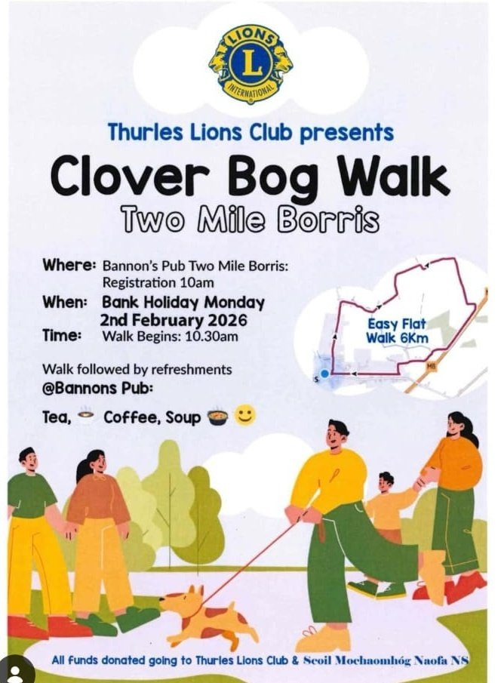  Section 4 / Project 028 — St Bridget's Day Clover Bog Walk, February 2026
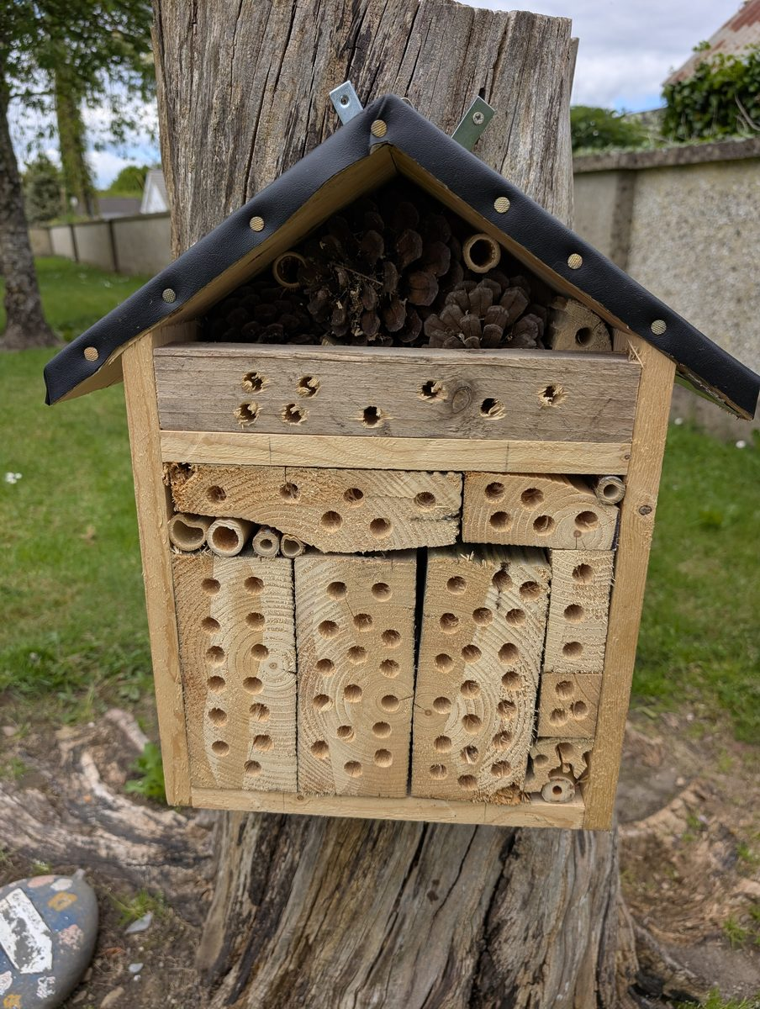  Section 4 / Project 045 — Bug hotel in the St James Church grounds, the existing biodiversity feature | 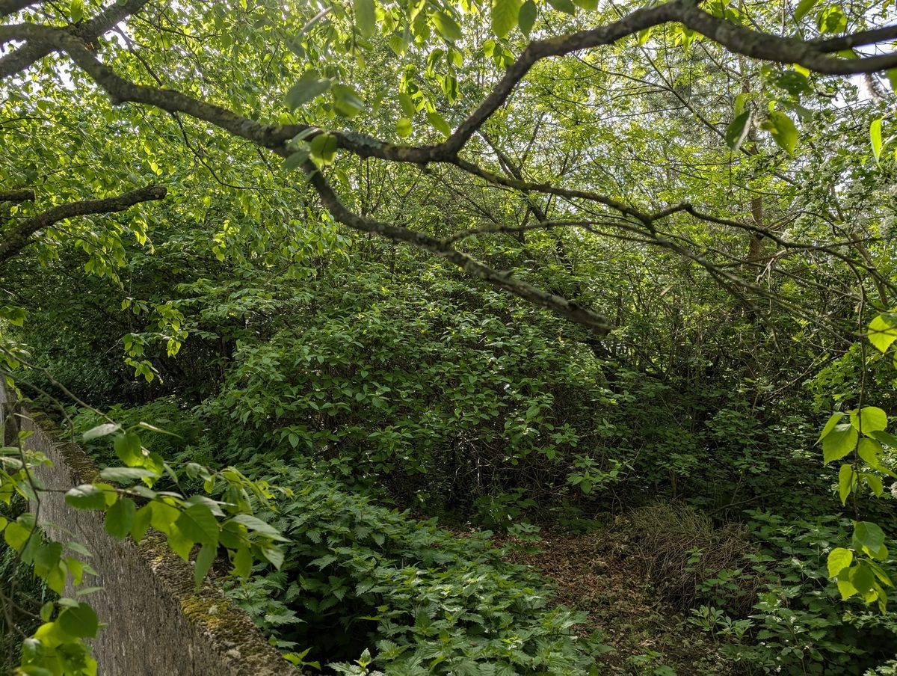  Section 4 — Old Road Triangle under the canopy, deliberate non-intervention biodiversity strategy

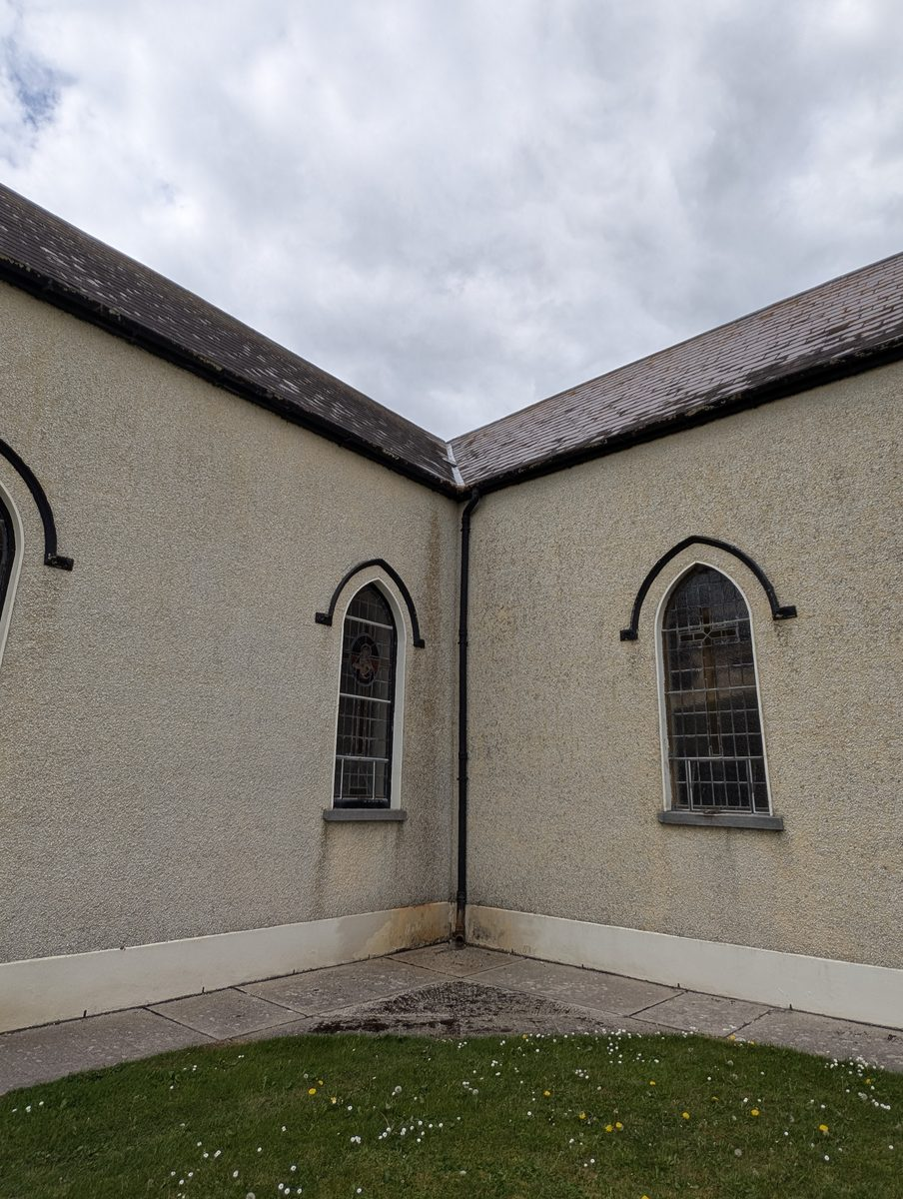  Section 5 / Project 010 / rec #10 — Cast-iron downpipe at St James Church, candidate water-butt site (TRPS840, Heritage Officer sign-off pending) | 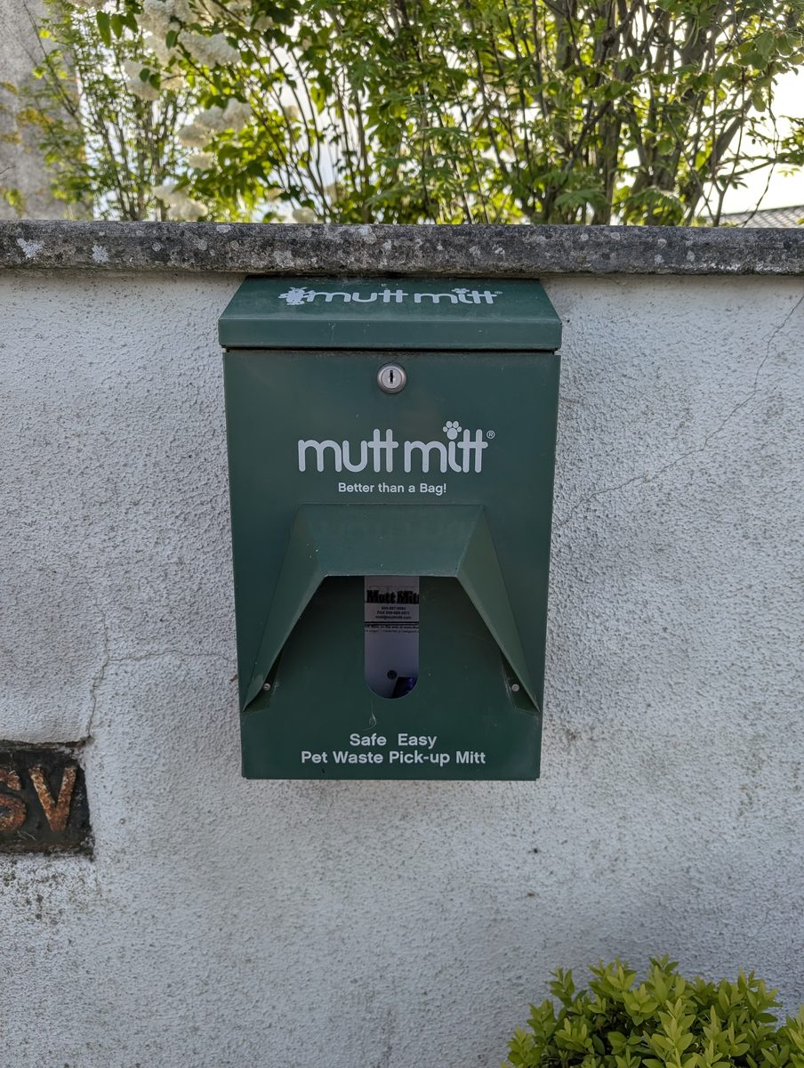  Section 6 / Project 005 / rec #13 — Mutt-mitt dispenser at the monument, back on the volunteer round
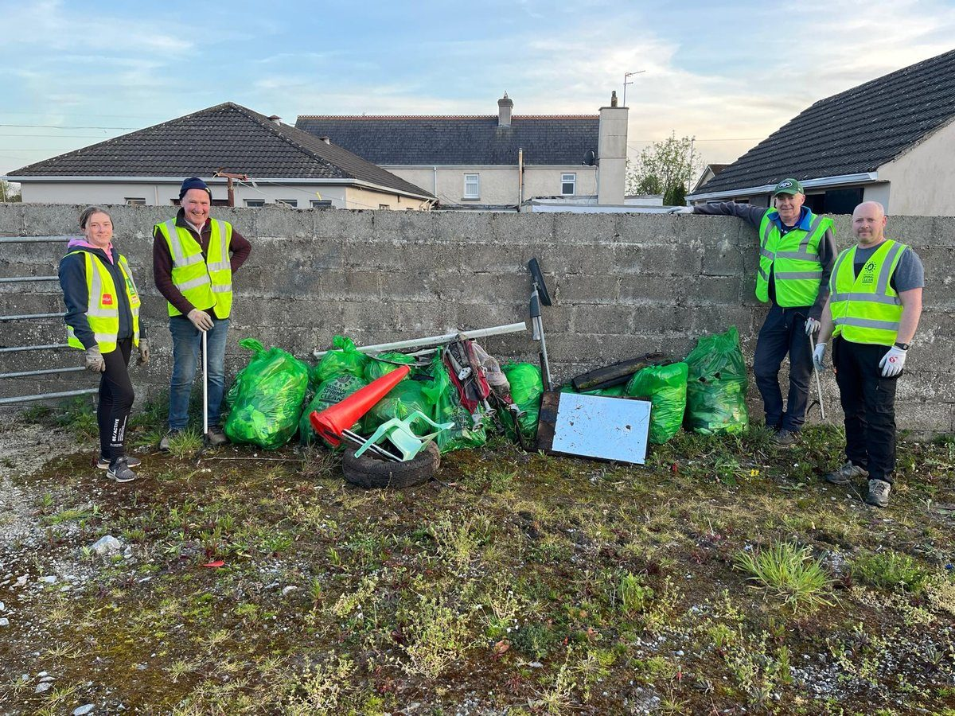  Sections 5, 6 / rec #12 — April 2026 clean-up haul, point-of-collection segregation pilot | 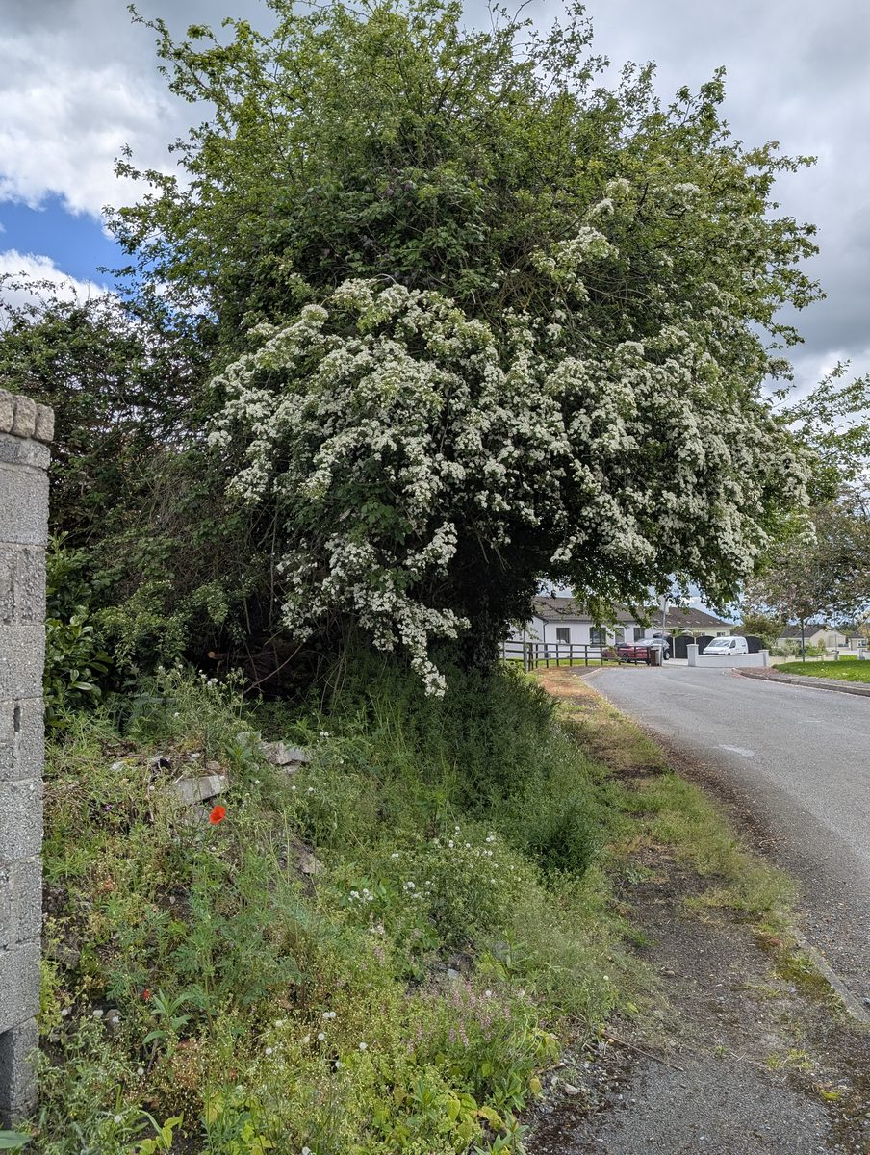  Section 7 — Flowering Hawthorn anchoring the entrance to Fanning Park, May 2026
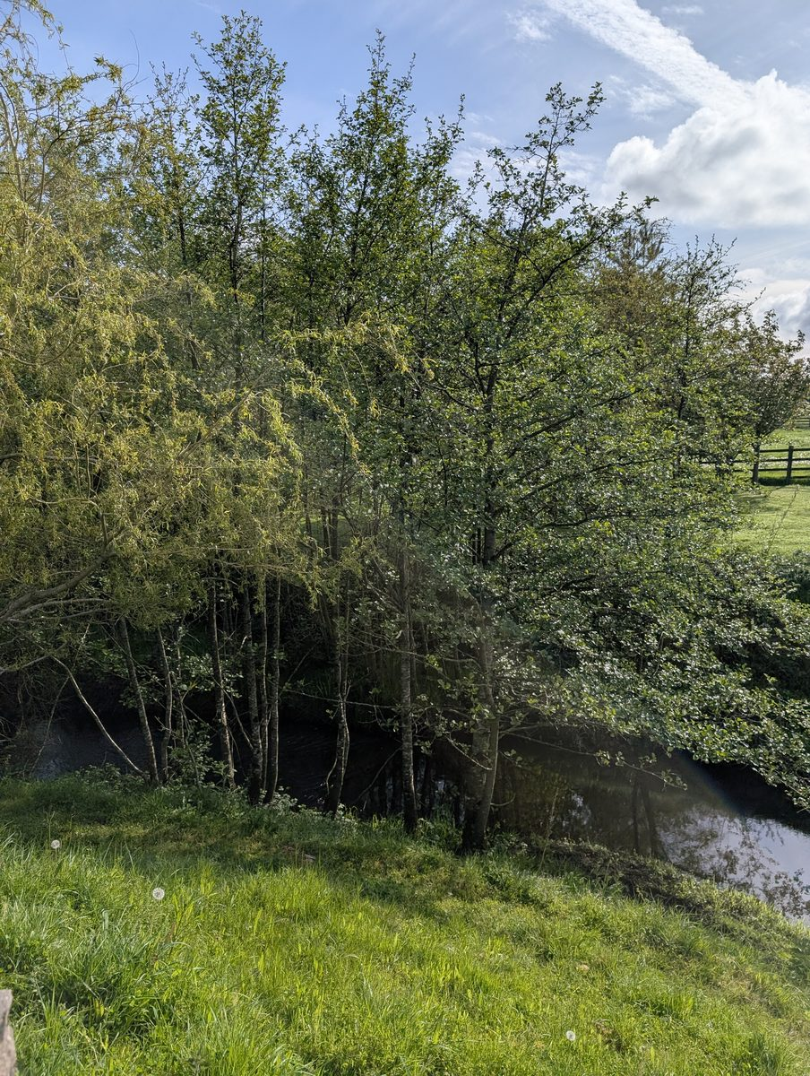  Section 8 — Native Willow and Alder corridor along the Black River, N75 south approach | 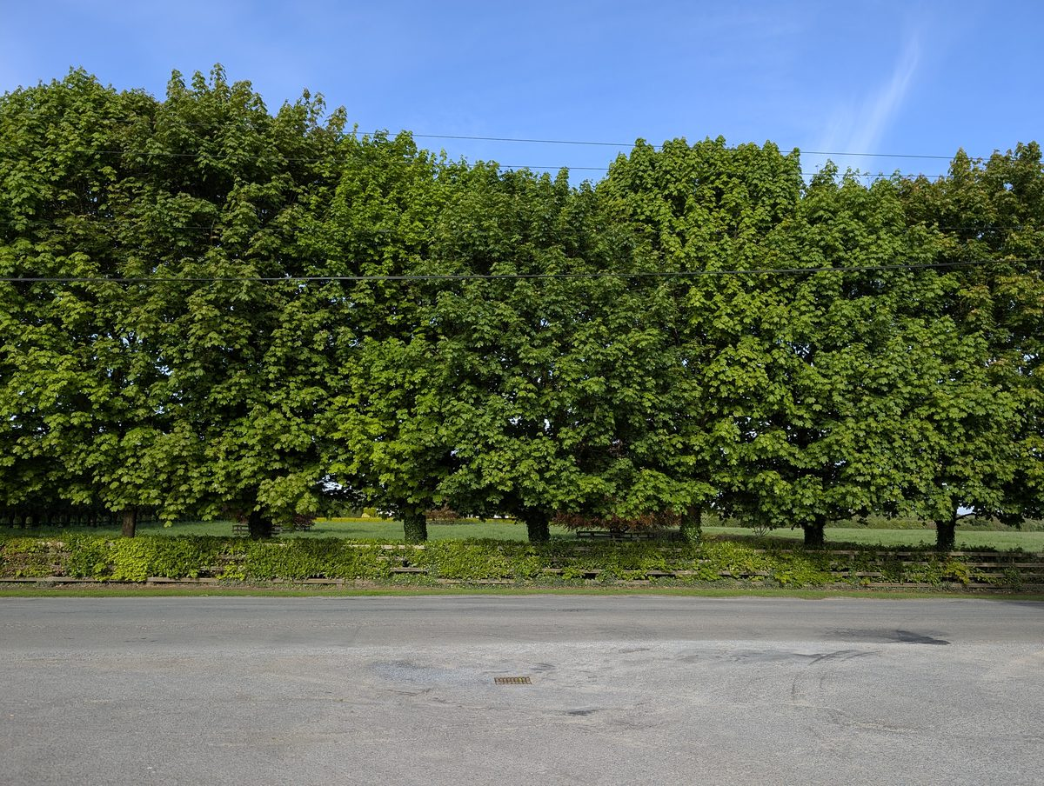  Section 8 — Mature deciduous tree avenue framing the Ballyduff Road approach

