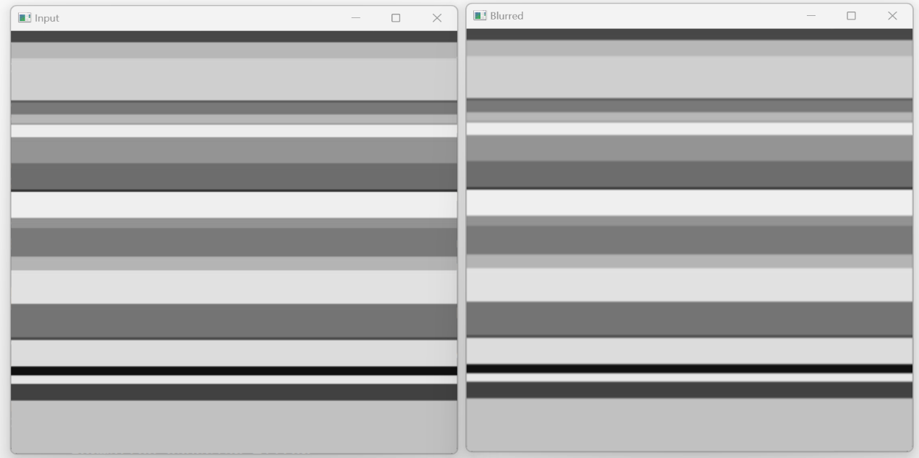 **Fig-1:** Input and Blurred image using Gaussian (5x5) kernel

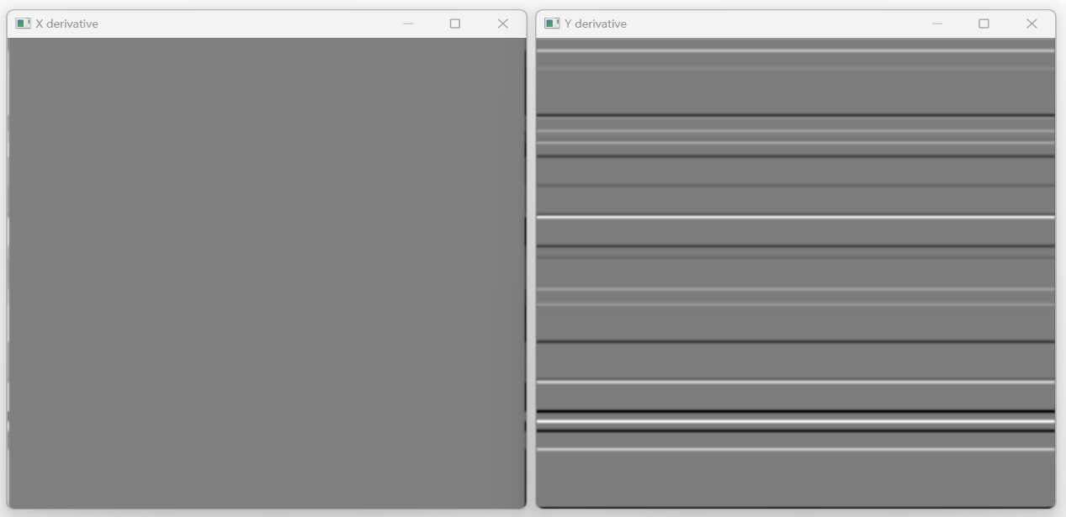

**Fig-2:** Image After applying derivative-x (left) and derivate-y(right)

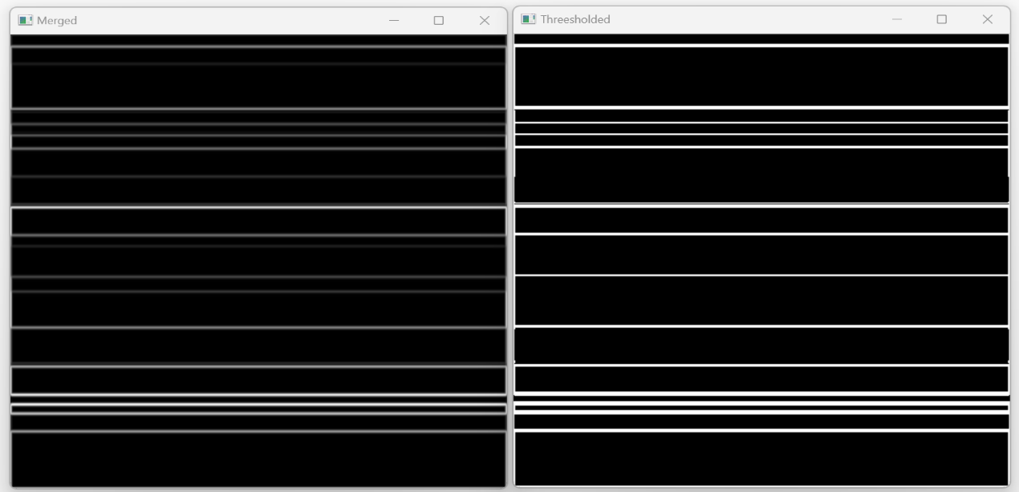

**Fig-3:** Merged, and threshold image using global threshold