Arrays in Java

An array is a group of like-typed variables that are referred to by a common name.Arrays in Java work differently than they do in C/C++. Following are some important point about Java arrays.

* In Java all arrays are dynamically allocated.(discussed below)
* Since arrays are objects in Java, we can find their length using member length. This is different from C/C++ where we find length using sizeof.
* A Java array variable can also be declared like other variables with [] after the data type.
* The variables in the array are ordered and each have an index beginning from 0.
* Java array can be also be used as a static field, a local variable or a method parameter.
* The **size** of an array must be specified by an int value and not long or short.
* The direct superclass of an array type is Object.
* Every array type implements the interfaces Cloneable and java.io.Serializable.

Array can contains primitives data types as well as objects of a class depending on the definition of array. In case of primitives data types, the actual values are stored in contiguous memory locations. In case of objects of a class, the actual objects are stored in heap segment.

[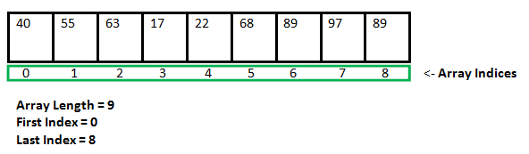](http://cdncontribute.geeksforgeeks.org/wp-content/uploads/Arrays1.png)

## Creating, Initializing, and Accessing an Array

**One-Dimensional Arrays :**  
The general form of a one-dimensional array declaration is

type var-name[];

OR

type[] var-name;

An array declaration has two components: the type and the name. *type* declares the element type of the array. The element type determines the data type of each element that comprises the array. Like array of int type, we can also create an array of other primitive data types like char, float, double..etc or user defined data type(objects of a class).Thus, the element type for the array determines what type of data the array will hold.  
**Example:**

// both are valid declarations

int intArray[];

or int[] intArray;

byte byteArray[];

short shortsArray[];

boolean booleanArray[];

long longArray[];

float floatArray[];

double doubleArray[];

char charArray[];

// an array of references to objects of

// the class MyClass (a class created by

// user)

MyClass myClassArray[];

Object[] ao, // array of Object

Collection[] ca; // array of Collection

// of unknown type

Although the above first declaration establishes the fact that intArray is an array variable, **no array actually exists**. It simply tells to the compiler that this(intArray) variable will hold an array of the integer type. To link intArray with an actual, physical array of integers, you must allocate one using **new** and assign it to intArray.

## Instantiating an Array in Java

When an array is declared, only a reference of array is created. To actually create or give memory to array, you create an array like this:The general form of *new* as it applies to one-dimensional arrays appears as follows:

var-name = new type [size];

Here, *type* specifies the type of data being allocated, *size* specifies the number of elements in the array, and *var-name* is the name of array variable that is linked to the array. That is, to use *new* to allocate an array, **you must specify the type and number of elements to allocate.**

**Example:**

int intArray[]; //declaring array

intArray = new int[20]; // allocating memory to array

OR

int[] intArray = new int[20]; // combining both statements in one

**Note :**

* 1. The elements in the array allocated by *new* will automatically be initialized to **zero** (for numeric types), **false** (for boolean), or **null** (for reference types).Refer Default array values in Java
  2. Obtaining an array is a two-step process. First, you must declare a variable of the desired array type. Second, you must allocate the memory that will hold the array, using new, and assign it to the array variable. Thus, **in Java all arrays are dynamically allocated.**

**Array Literal**

In a situation, where the size of the array and variables of array are already known, array literals can be used.

int[] intArray = new int[]{ 1,2,3,4,5,6,7,8,9,10 };

// Declaring array literal

* The length of this array determines the length of the created array.
* There is no need to write the new int[] part in the latest versions of Java

## Accessing Java Array Elements using for Loop

Each element in the array is accessed via its index. The index begins with 0 and ends at (total array size)-1. All the elements of array can be accessed using Java for Loop.

// accessing the elements of the specified array

for (int i = 0; i < arr.length; i++)

System.out.println("Element at index " + i +

" : "+ arr[i]);

**Implementation:**

filter_none

edit

play_arrow

brightness_4

|  |
| --- |
| // Java program to illustrate creating an array  // of integers,  puts some values in the array,  // and prints each value to standard output.    class GFG  {      public static void main (String[] args)      {        // declares an Array of integers.        int[] arr;          // allocating memory for 5 integers.        arr = new int[5];          // initialize the first elements of the array        arr[0] = 10;          // initialize the second elements of the array        arr[1] = 20;          //so on...        arr[2] = 30;        arr[3] = 40;        arr[4] = 50;          // accessing the elements of the specified array        for (int i = 0; i < arr.length; i++)           System.out.println("Element at index " + i +                                        " : "+ arr[i]);      }  } |

Output:

Element at index 0 : 10

Element at index 1 : 20

Element at index 2 : 30

Element at index 3 : 40

Element at index 4 : 50

You can also access java arrays using foreach loops  
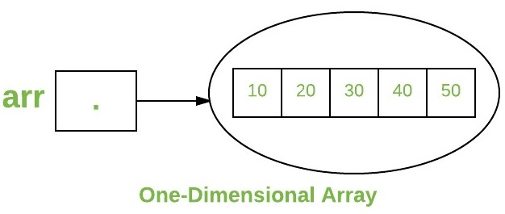

## Arrays of Objects

An array of objects is created just like an array of primitive type data items in the following way.

Student[] arr = new Student[7]; //student is a user-defined class

The studentArray contains seven memory spaces each of size of student class in which the address of seven Student objects can be stored.The Student objects have to be instantiated using the constructor of the Student class and their references should be assigned to the array elements in the following way.

Student arr = new Student[5];

filter_none

edit

play_arrow

brightness_4

|  |
| --- |
| // Java program to illustrate creating an array of  // objects    class Student  {      public int roll_no;      public String name;      Student(int roll_no, String name)      {          this.roll_no = roll_no;          this.name = name;      }  }    // Elements of array are objects of a class Student.  public class GFG  {      public static void main (String[] args)      {          // declares an Array of integers.          Student[] arr;            // allocating memory for 5 objects of type Student.          arr = new Student[5];            // initialize the first elements of the array          arr[0] = new Student(1,"aman");            // initialize the second elements of the array          arr[1] = new Student(2,"vaibhav");            // so on...          arr[2] = new Student(3,"shikar");          arr[3] = new Student(4,"dharmesh");          arr[4] = new Student(5,"mohit");            // accessing the elements of the specified array          for (int i = 0; i < arr.length; i++)              System.out.println("Element at " + i + " : " +                          arr[i].roll_no +" "+ arr[i].name);      }  } |

Output:

Element at 0 : 1 aman

Element at 1 : 2 vaibhav

Element at 2 : 3 shikar

Element at 3 : 4 dharmesh

Element at 4 : 5 mohit

## What happens if we try to access element outside the array size?

Compiler throws **ArrayIndexOutOfBoundsException** to indicate that array has been accessed with an illegal index. The index is either negative or greater than or equal to size of array.

filter_none

edit

play_arrow

brightness_4

|  |
| --- |
| class GFG  {      public static void main (String[] args)      {          int[] arr = new int[2];          arr[0] = 10;          arr[1] = 20;            for (int i = 0; i <= arr.length; i++)              System.out.println(arr[i]);      }  } |

Runtime error

Exception in thread "main" java.lang.ArrayIndexOutOfBoundsException: 2

at GFG.main(File.java:12)

Output:

10

20

## Multidimensional Arrays

Multidimensional arrays are **arrays of arrays** with each element of the array holding the reference of other array. These are also known as Jagged Arrays. A multidimensional array is created by appending one set of square brackets ([]) per dimension. Examples:

int[][] intArray = new int[10][20]; //a 2D array or matrix

int[][][] intArray = new int[10][20][10]; //a 3D array

filter_none

edit

play_arrow

brightness_4

|  |
| --- |
| class multiDimensional  {      public static void main(String args[])      {          // declaring and initializing 2D array          int arr[][] = { {2,7,9},{3,6,1},{7,4,2} };            // printing 2D array          for (int i=0; i< 3 ; i++)          {              for (int j=0; j < 3 ; j++)                  System.out.print(arr[i][j] + " ");                System.out.println();          }      }  } |

Output:

2 7 9

3 6 1

7 4 2

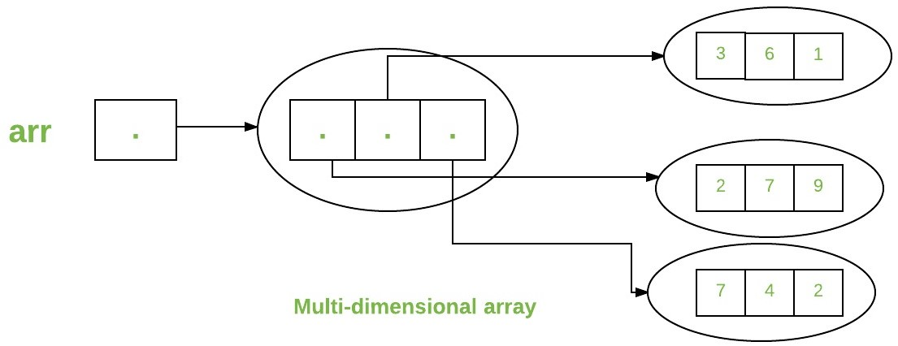

## Passing Arrays to Methods

Like variables, we can also pass arrays to methods.For example, below program pass array to method *sum* for calculating sum of array’s values.

filter_none

edit

play_arrow

brightness_4

|  |
| --- |
| // Java program to demonstrate  // passing of array to method    class Test  {      // Driver method      public static void main(String args[])      {          int arr[] = {3, 1, 2, 5, 4};            // passing array to method m1          sum(arr);        }        public static void sum(int[] arr)      {          // getting sum of array values          int sum = 0;            for (int i = 0; i < arr.length; i++)              sum+=arr[i];            System.out.println("sum of array values : " + sum);      }  } |

Output :

sum of array values : 15

## Returning Arrays from Methods

As usual, a method can also return an array. For example, below program returns an array from method *m1*.

filter_none

edit

play_arrow

brightness_4

|  |
| --- |
| // Java program to demonstrate  // return of array from method    class Test  {      // Driver method      public static void main(String args[])      {          int arr[] = m1();            for (int i = 0; i < arr.length; i++)              System.out.print(arr[i]+" ");        }        public static int[] m1()      {          // returning  array          return new int[]{1,2,3};      }  } |

Output:

1 2 3

## Class Objects for Arrays

Every array has an associated [Class](https://www.geeksforgeeks.org/java-lang-class-class-java-set-1/) object, shared with all other arrays with the same component type.

filter_none

edit

play_arrow

brightness_4

|  |
| --- |
| // Java program to demonstrate  // Class Objects for Arrays    class Test  {      public static void main(String args[])      {          int intArray[] = new int[3];          byte byteArray[] = new byte[3];          short shortsArray[] = new short[3];            // array of Strings          String[] strArray = new String[3];            System.out.println(intArray.getClass());          System.out.println(intArray.getClass().getSuperclass());          System.out.println(byteArray.getClass());          System.out.println(shortsArray.getClass());          System.out.println(strArray.getClass());      }  } |

Output:

class [I

class java.lang.Object

class [B

class [S

class [Ljava.lang.String;

**Explanantion :**

1. The string “[I” is the run-time type signature for the class object “array with component type *int*“.
2. The only direct superclass of any array type is java.lang.Object.
3. The string “[B” is the run-time type signature for the class object “array with component type *byte*“.
4. The string “[S” is the run-time type signature for the class object “array with component type *short*“.
5. The string “[L” is the run-time type signature for the class object “array with component type of a Class”. The Class name is then followed.

## Array Members

Now as you know that arrays are object of a class and direct superclass of arrays is class Object.The members of an array type are all of the following:

* The public final field *length*, which contains the number of components of the array. *length* may be positive or zero.
* All the members inherited from class Object; the only method of Object that is not inherited is its clone method.
* The public method *clone()*, which overrides clone method in class Object and throws no checked exceptions.

## Cloning of arrays

* When you clone a single dimensional array, such as Object[], a “deep copy” is performed with the new array containing copies of the original array’s elements as opposed to references.

filter_none

edit

play_arrow

brightness_4

|  |
| --- |
| // Java program to demonstrate  // cloning of one-dimensional arrays    class Test  {      public static void main(String args[])      {          int intArray[] = {1,2,3};            int cloneArray[] = intArray.clone();            // will print false as deep copy is created          // for one-dimensional array          System.out.println(intArray == cloneArray);            for (int i = 0; i < cloneArray.length; i++) {              System.out.print(cloneArray[i]+" ");          }      }  } |

Output:

false

1 2 3

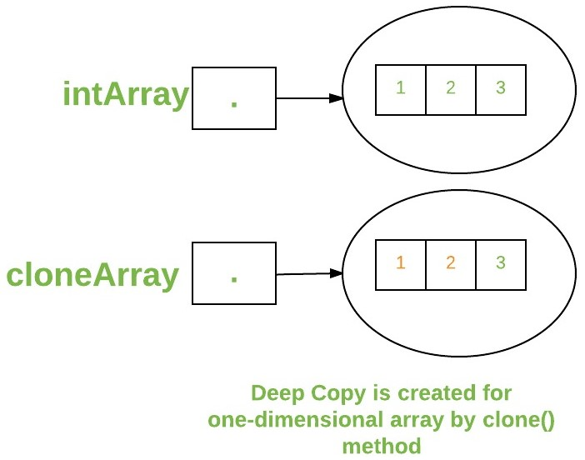

* A clone of a multidimensional array (like Object[][]) is a “shallow copy” however, which is to say that it creates only a single new array with each element array a reference to an original element array but subarrays are shared.

filter_none

edit

play_arrow

brightness_4

|  |
| --- |
| // Java program to demonstrate  // cloning of multi-dimensional arrays    class Test  {      public static void main(String args[])      {          int intArray[][] = {{1,2,3},{4,5}};            int cloneArray[][] = intArray.clone();            // will print false          System.out.println(intArray == cloneArray);            // will print true as shallow copy is created          // i.e. sub-arrays are shared          System.out.println(intArray[0] == cloneArray[0]);          System.out.println(intArray[1] == cloneArray[1]);        }  } |

Output:

false

true

true

