**Playwright vs Cypress**

* Multi Language Support.
* Parallel Testing
* Version Updation Issue
* Multi tab and Multi window handling is not supported By Cypress.
* Mobile app automation
* Difficulty in handling iframe in cypress.

[**Playwright Official Documentation**](https://playwright.dev/)

**Prerequisite:**

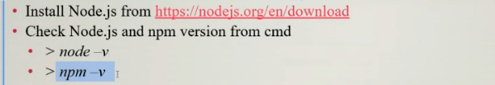

**Starting a Playwright Project :**

Project installation:

npm init playwright@latest

[vpn must be turned off]

Go through example.spec.js [you can compare “page” with driver]

Run to show the parallel testing.

Configure your playwright.config.js

Run your first Test :

npx playwright test [Headless Mode]

npx playwright test example.spec.js [ Run a specific file]

npx playwright test --headed [Headed Mode]

npx playwright test --debug [Run Test in Debug mode]

npx playwright codegen <url> [Start Codegen]

Command to see report :

npx playwright show-report

Every test File in Playwright should contain an extension like : fileName.spec.js

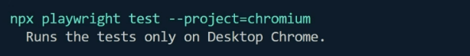

**Configure your playwright.config.js file.**

What is page fixture?

[You can compare this page with driver of selenium]

Locator Strategies in Playwright :

Using page.locator(“”) :

page.locator()

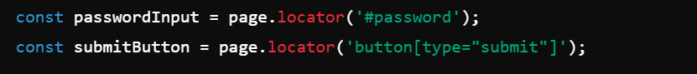

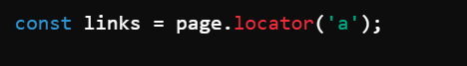

[Demo website](https://www.saucedemo.com/)

[Show it from scratch.]

Locating Multiple Elements :

test('User Can Register successfully', async ({ page }) => {

  await page.goto("/register");

  const ele = page.locator("//input[@type='text']");

  const cnt = await ele.count();

  console.log( cnt );

  await  ele.first().fill("Rashed Vai");

  await ele.nth(1).fill("Tanjid vai");

  await ele.last().fill("Tamanna apu");

  await page.pause();

});

Multiple element methods.

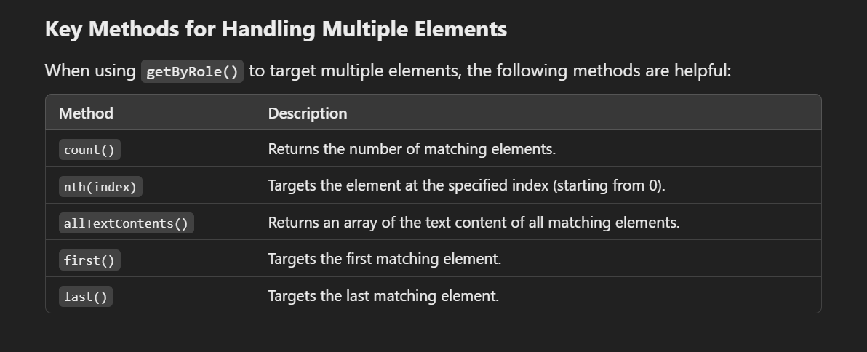

-------------------------------------------------------------------------------------------------------------

Other Options :

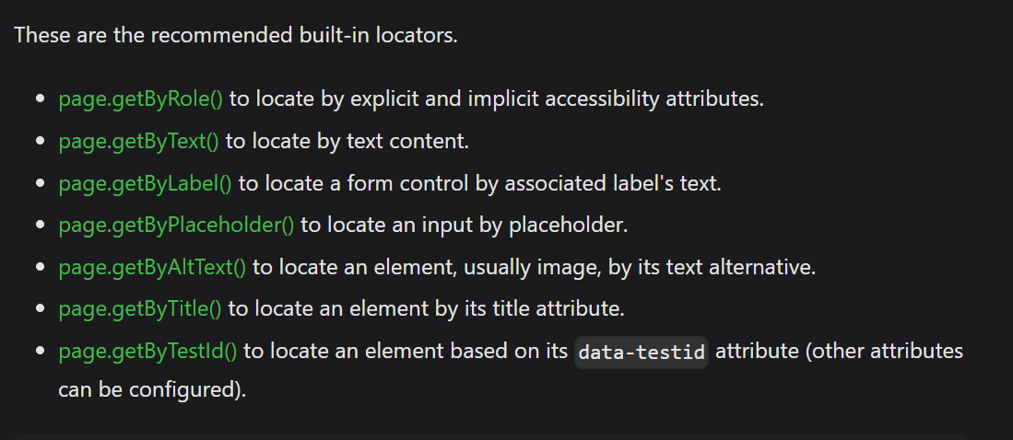

**** Show Them from locatorFinding.spec.js file :

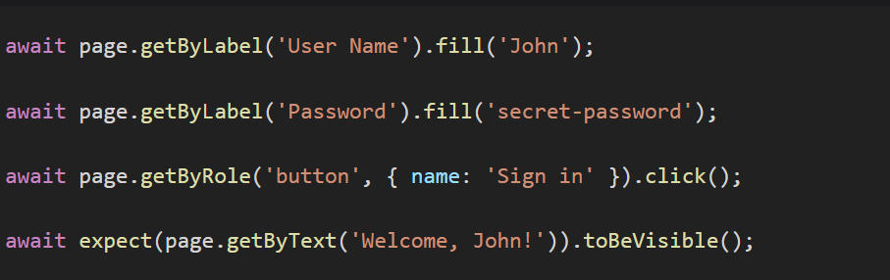

getByRole() :

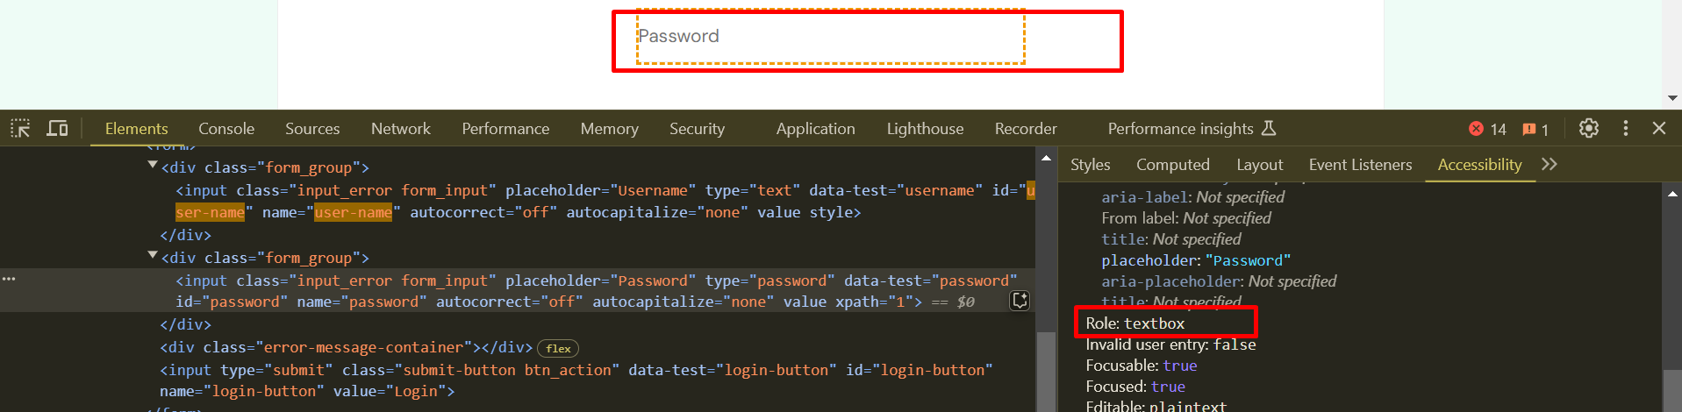

await page.getByRole('textbox', { name : "password" }).fill("123456");

getByLabel() and getByPlaceholder() :

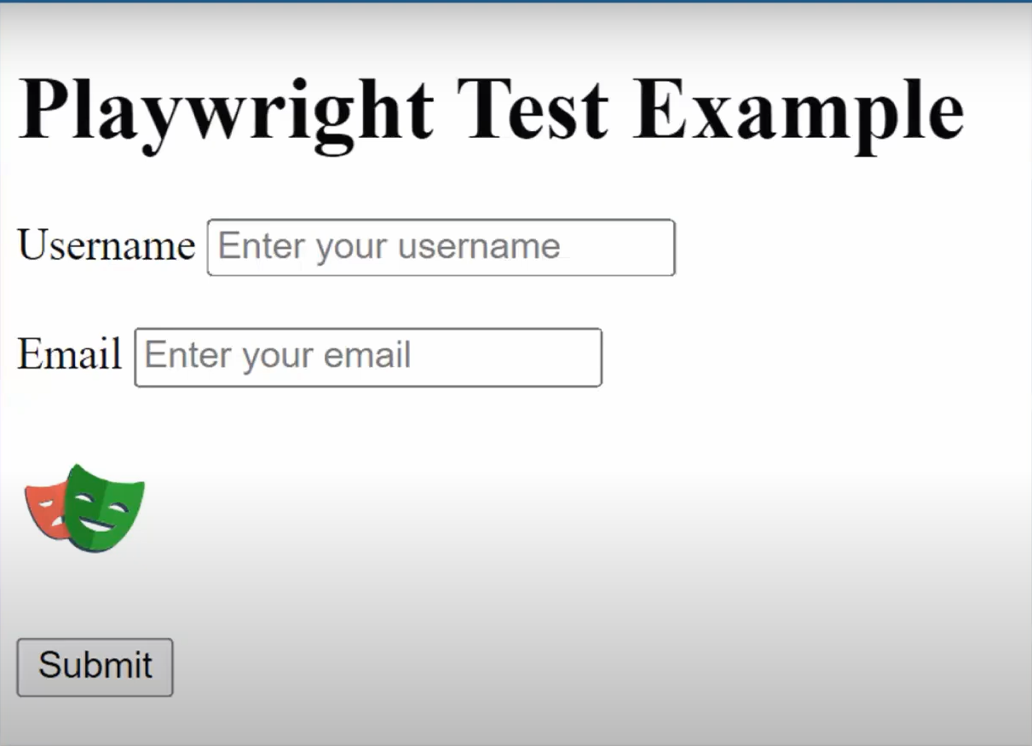

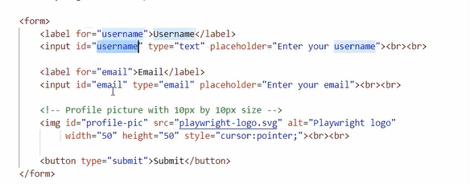

getByText() :

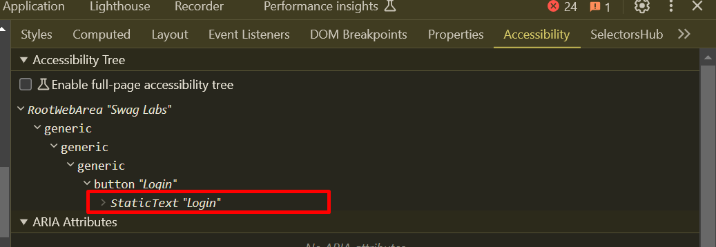

Or you can use the text which is visible in UI

page.getByText("swag labs") ; // Matches with substring , different letter case

page.getByText("Swag Labs", {exact : true}); // matches with exactly the given string.

DailyFinance Login:

await page.getByRole( "textbox" , {name : "Email" }).fill("admin@test.com");

  await page.getByRole( "textbox" , {name : "Password"}).fill("admin123");

  await page.getByRole( "button" ,  {name : "LOGIN"  } ).click();

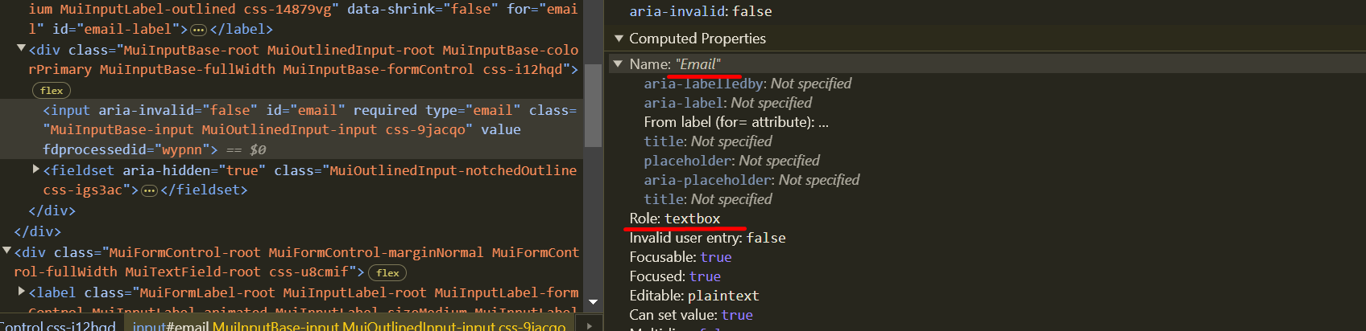

**Static wait :**

await page.waitForTimeout(5000);

Dynamic wait :

implicit wait : already used in playwright.config.js

explicit wait :

await page.getByRole('textbox', { name : "password" }).fill("123456",{timeout : 40000});

**Handling Table in Playwright :**

 await page.locator("tbody tr").first().waitFor(); *// wait for an element*

  const firstRow = await page.locator("tbody tr").first();

  const cells = await firstRow.locator("td").allTextContents();

  console.log(cells);

**To pause the playwright execution :**

await page.pause();

**Show the codegen Functiolity by giving command.**

Then learn about:

Alert Handling:

By default , alerts are auto dismissed by playwright

**Hooks in Playwright :**

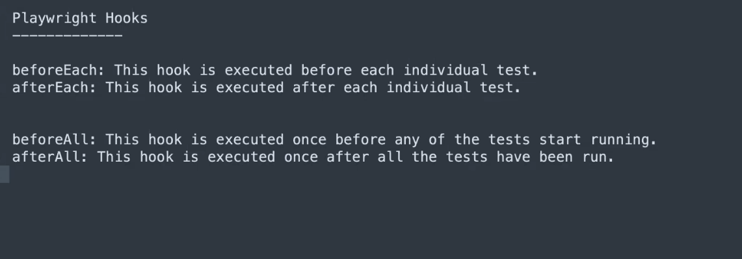

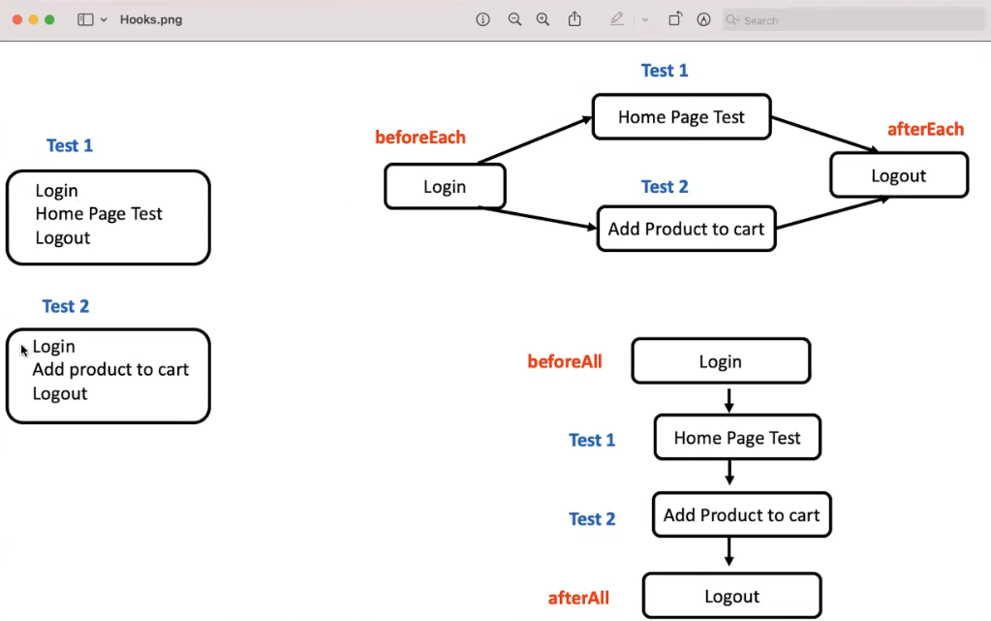

Drop down in playwright :

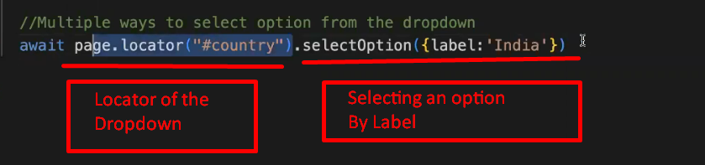

Select By value :



Select by index:



**Select Multi Drop down :**

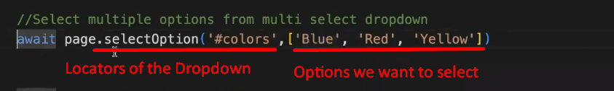

API Calling Using Playwright :

[Demo Website for APIs](https://reqres.in/)