3.Opening PowerShell and Checking the Environment
PowerShell was opened as Administrator (Win + X, then Windows PowerShell (Admin)). The version was checked with the following command:
$PSVersionTable.PSVersion

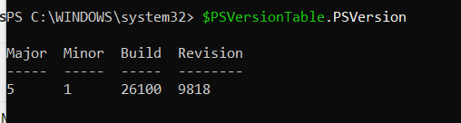

The execution policy was then set for the current user:
Set-ExecutionPolicy -ExecutionPolicy RemoteSigned -Scope CurrentUser

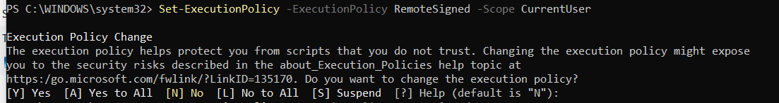
Observation: PowerShell asks for confirmation before changing the policy. RemoteSigned lets locally written scripts run while requiring downloaded scripts to be signed.

4. Part 2: Basic PowerShell Event Log Queries

Exercise 1: View Recent Security Events
Get-WinEvent -LogName Security -MaxEvents 10

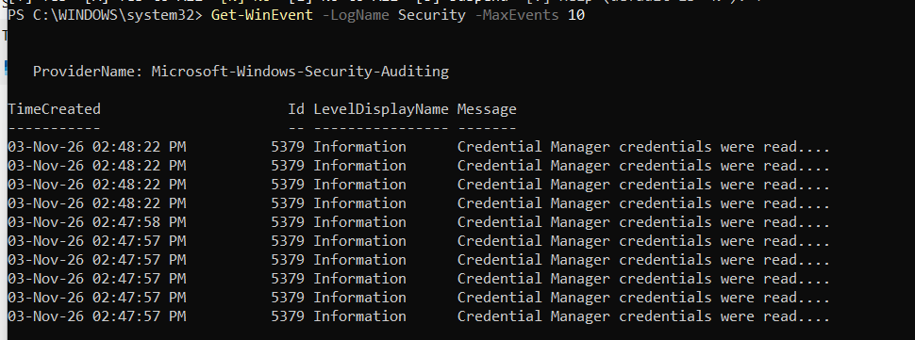

Observation: all 10 most recent events are Event ID 5379 (Credential Manager credentials were read), logged between 02:47:57 PM and 02:48:22 PM on 03-Nov-26. Get-WinEvent returns events newest first.

Exercise 2: Filter by Event ID
Task: view the last 20 successful logon events (Event ID 4624).
Get-WinEvent -FilterHashtable @{LogName='Security'; ID=4624} -MaxEvents 20

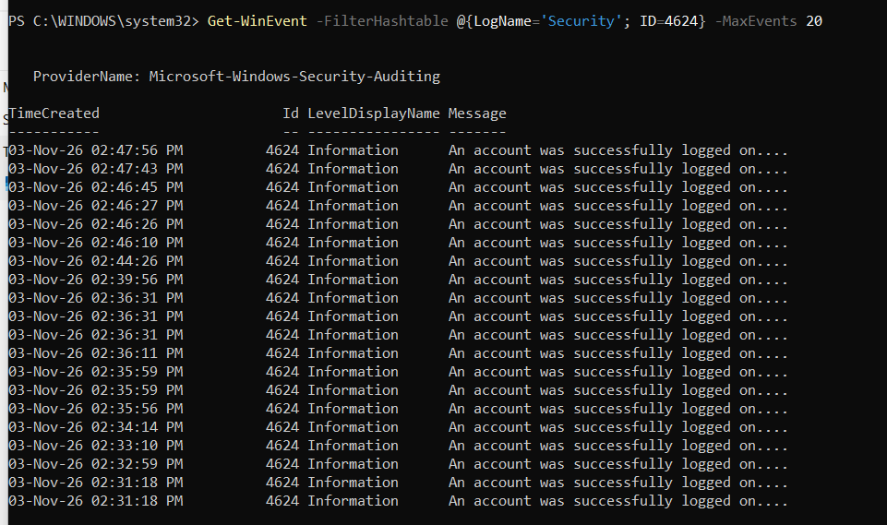
Observation: 20 successful logons were returned, ranging from 02:31:18 PM to 02:47:56 PM. Several occurred within the same second, which is normal because Windows creates separate logon sessions for system and user processes.

Exercise 3: Filter by Time Range
Task: get all security events from the last 24 hours.
$StartTime = (Get-Date).AddDays(-1)
Get-WinEvent -FilterHashtable @{
LogName='Security'
StartTime=$StartTime
} -MaxEvents 100

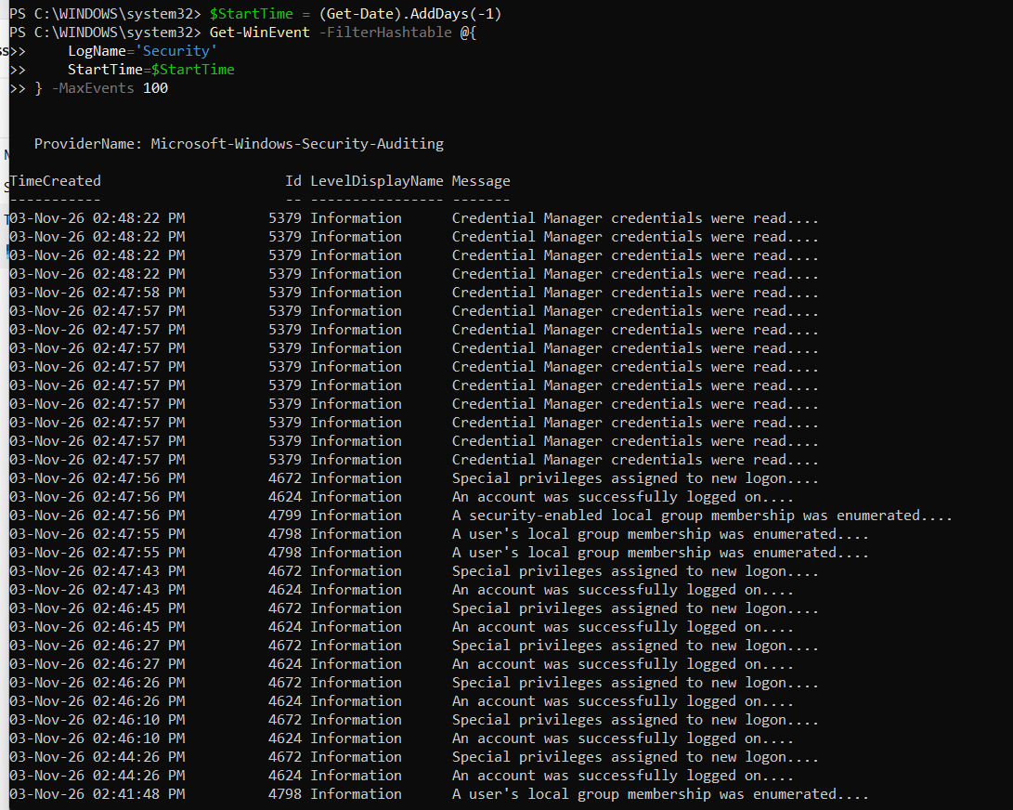
Observation: the last 24 hours contain event IDs 5379 (credentials read), 4672 (special privileges assigned), 4624 (successful logon), 4798 and 4799 (local group membership enumerated). Each 4624 is followed by a 4672 at the same time, meaning the logon was for an account with administrative privileges.
Last hour:
$StartTime = (Get-Date).AddHours(-1)
Get-WinEvent -FilterHashtable @{
LogName='Security'
StartTime=$StartTime
}

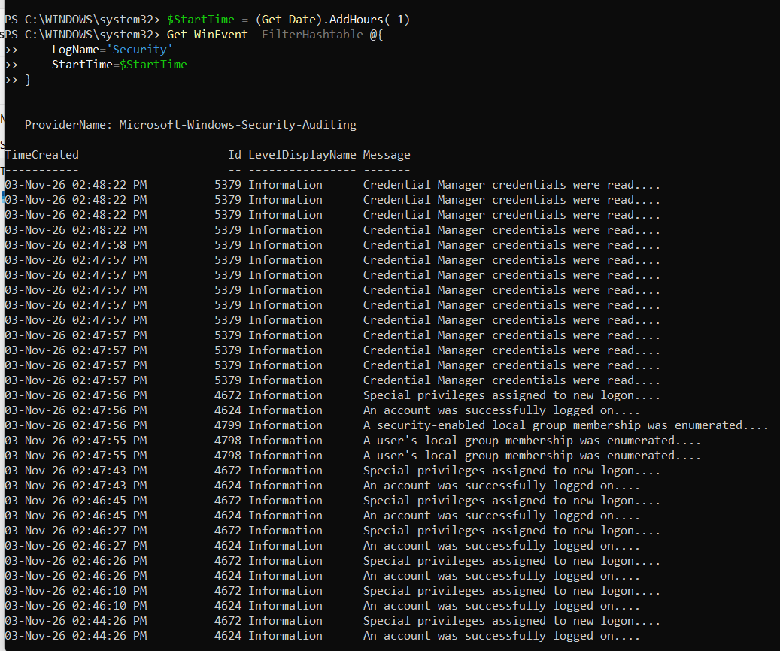
Observation: the one-hour window shows the same event types as the 24-hour query but with a smaller, more recent set of events starting at 02:44:26 PM.

Exercise 4: Count Events
Task: count the failed logon attempts (Event ID 4625) in the last 24 hours.
$StartTime = (Get-Date).AddDays(-1)
$FailedLogons = Get-WinEvent -FilterHashtable @{
LogName='Security'
ID=4625
StartTime=$StartTime
}
$FailedLogons.Count

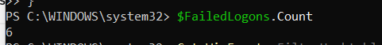
Observation: 6 failed logon attempts occurred in the last 24 hours.

5. Part 3: Extracting Event Properties

Exercise 5: Understanding Event Structure
$Event = Get-WinEvent -FilterHashtable @{LogName='Security'; ID=4625} -MaxEvents 1
$Event | Format-List *

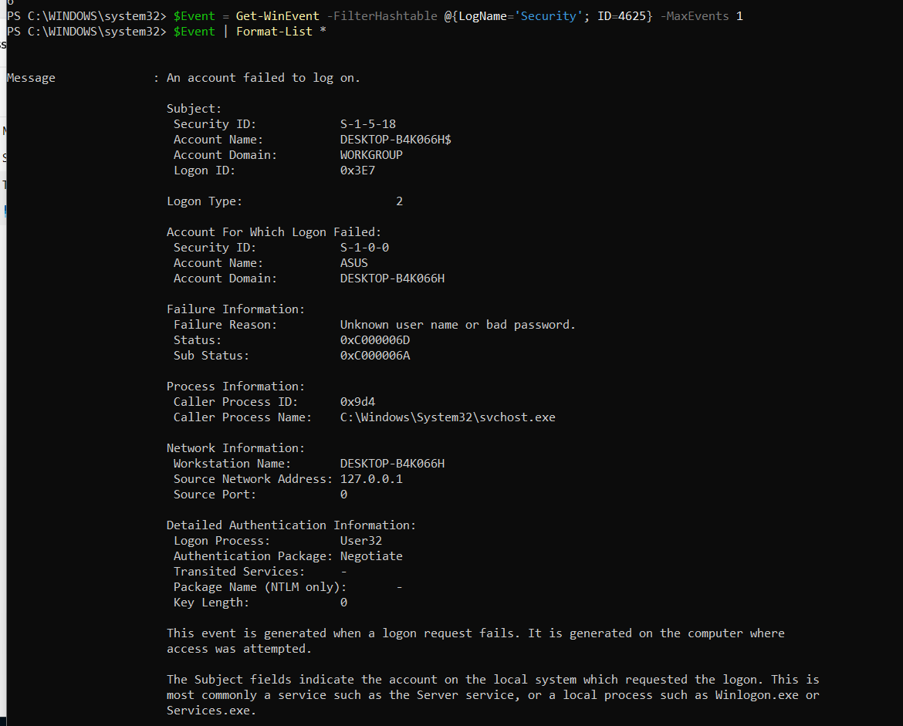

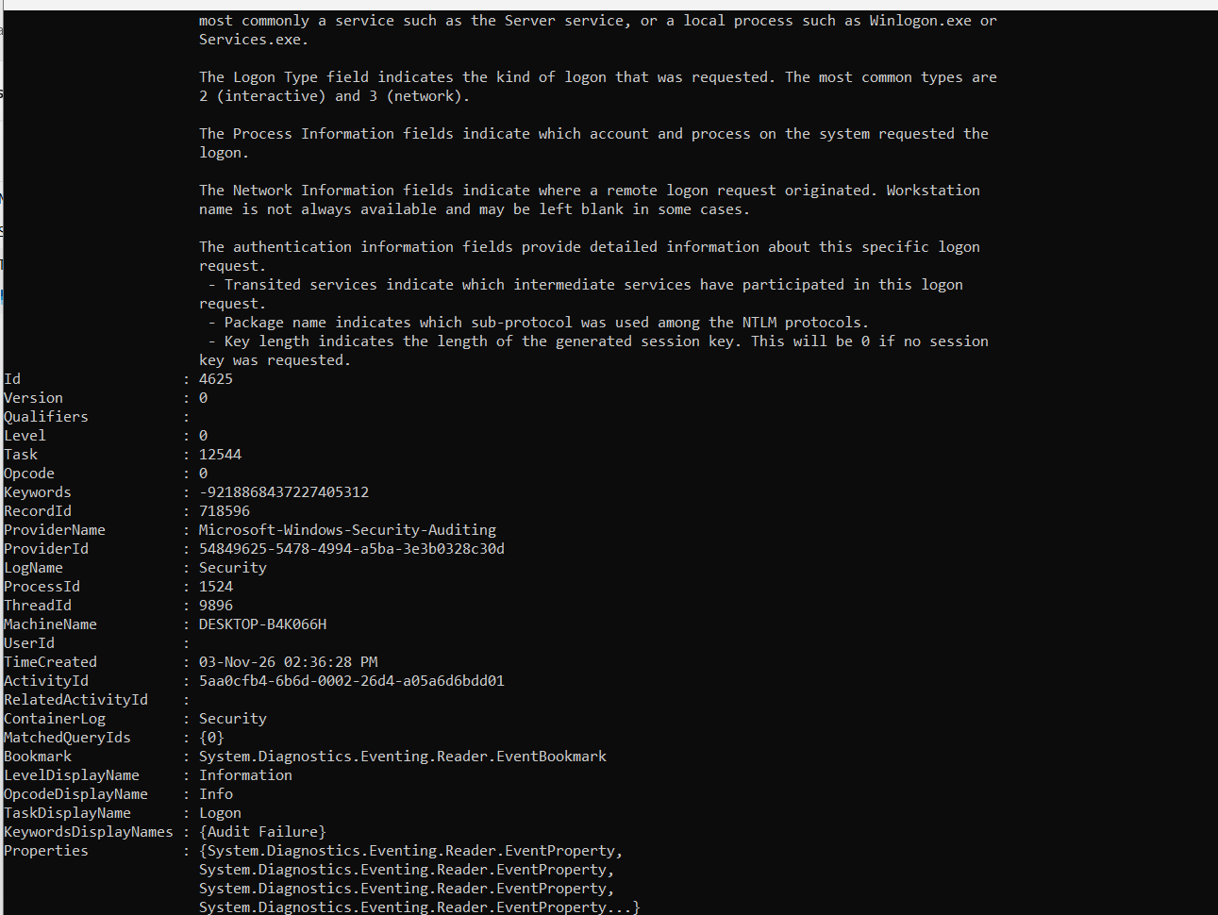
Key details of the failed logon event:
- Time: 03-Nov-26 02:36:28 PM (RecordId 718596).
- Subject: S-1-5-18, DESKTOP-B4K066H$ (the SYSTEM account of the computer itself), logon ID 0x3E7.
- Logon type: 2 (Interactive), meaning a local keyboard/screen logon.
- Account that failed: ASUS on domain DESKTOP-B4K066H.
- Failure reason: Unknown user name or bad password. Status 0xC000006D with Sub Status 0xC000006A, which means the user name exists but the password was wrong.
- Process: C:\Windows\System32\svchost.exe; logon process User32; authentication package Negotiate.
- Network information: workstation DESKTOP-B4K066H, source address 127.0.0.1, port 0, so the attempt came from the local machine.

The event is stored as XML, which can be viewed with:
$Event.ToXml()

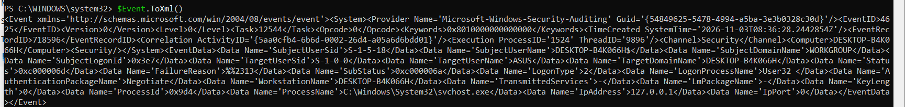

Observation: the XML shows the same data as named fields (SubjectUserName, TargetUserName, Status, SubStatus, LogonType, IpAddress, and so on). The timestamp is recorded in UTC (08:36:28 Z), which is 02:36:28 PM local time (UTC+6).

Exercise 7: Top Source IP Addresses of Failed Logons
Get-WinEvent -FilterHashtable @{
LogName='Security'
ID=4625
StartTime=(Get-Date).AddDays(-1)
} | ForEach-Object {
$_.Properties[19].Value
} | Where-Object { $_ -ne '-' -and $_ -ne '' } |
Group-Object |
Sort-Object Count -Descending |
Select-Object -First 5 Name, Count

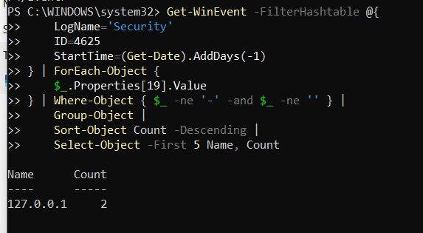

Observation: the only source address is 127.0.0.1 (localhost) with a count of 2. The other failed logons had no usable address (the field was "-" or empty), so the Where-Object filter removed them. Since the source is the local machine, there is no sign of a remote attack.

Exercise 8: Identify Targeted Accounts
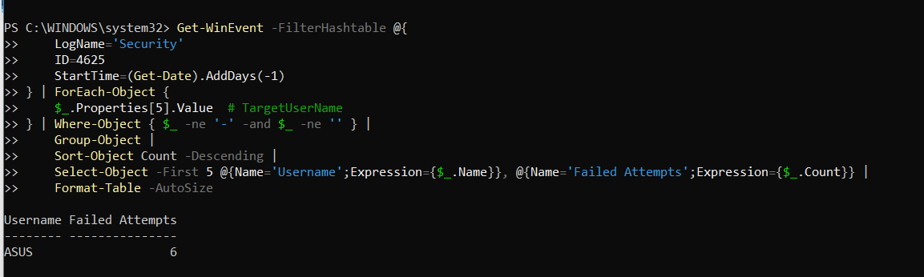

Observation: the only account targeted is ASUS with 6 failed attempts. All six failures involve the same local account, which matches the pattern of a user mistyping their own password at the sign-in screen rather than a password-guessing attack on many accounts.

Exercise 9: Analyse Logon Types
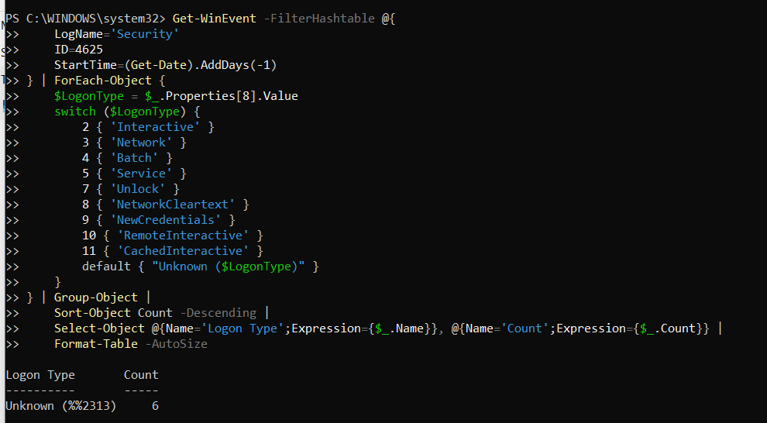

Observation: the lab command returned "Unknown (%%2313)" with a count of 6. %%2313 is the resource code for the failure reason "Unknown user name or bad password". This happens because Properties[8] on this event is the FailureReason, not the LogonType, so the switch statement found no match. The logon type is actually stored in Properties[10]. The corrected command is:

