**Лабораторная работа №7**

*Выполнил студент 3 курса МОиАИС*

*Ибрагимов Адыл*

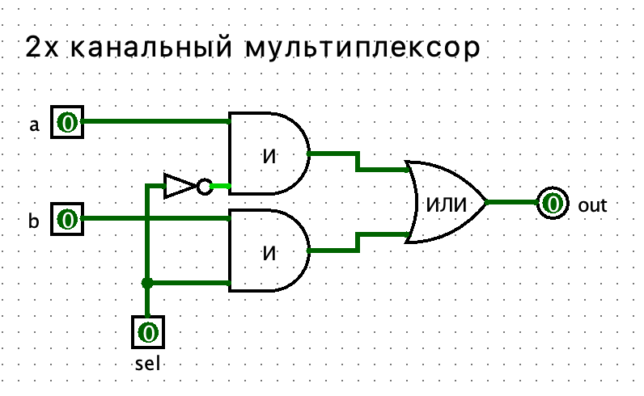

Таблица истинности:

|  |  |  |  |
| --- | --- | --- | --- |
| **a** | **b** | **sel** | **out** |
| 0 | 0 | 0 | 0 |
| 0 | 0 | 1 | 0 |
| 0 | 1 | 0 | 0 |
| 0 | 1 | 1 | 1 |
| 1 | 0 | 0 | 1 |
| 1 | 0 | 1 | 0 |
| 1 | 1 | 0 | 1 |
| 1 | 1 | 1 | 1 |

**2.**

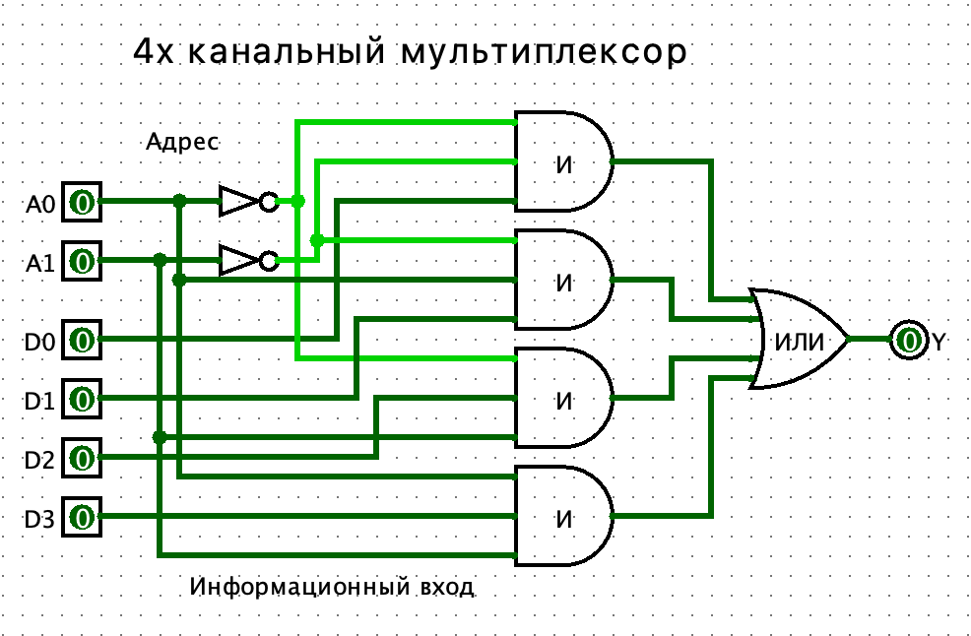

Таблица истинности:

|  |  |  |  |  |  |  |
| --- | --- | --- | --- | --- | --- | --- |
| **A0** | **A1** | **D0** | **D1** | **D2** | **D3** | **Y** |
| 0 | 0 | 0 | 0 | 0 | 0 | 0 |
| 0 | 0 | 0 | 0 | 0 | 1 | 0 |
| 0 | 0 | 0 | 0 | 1 | 0 | 0 |
| 0 | 0 | 0 | 0 | 1 | 1 | 0 |
| 0 | 0 | 0 | 1 | 0 | 0 | 0 |
| 0 | 0 | 0 | 1 | 0 | 1 | 0 |
| 0 | 0 | 0 | 1 | 1 | 0 | 0 |
| 0 | 0 | 0 | 1 | 1 | 1 | 0 |
| 0 | 0 | 1 | 0 | 0 | 0 | 1 |
| 0 | 0 | 1 | 0 | 0 | 1 | 1 |
| 0 | 0 | 1 | 0 | 1 | 0 | 1 |
| 0 | 0 | 1 | 0 | 1 | 1 | 1 |
| 0 | 0 | 1 | 1 | 0 | 0 | 1 |
| 0 | 0 | 1 | 1 | 0 | 1 | 1 |
| 0 | 0 | 1 | 1 | 1 | 0 | 1 |
| 0 | 0 | 1 | 1 | 1 | 1 | 1 |
| 0 | 1 | 0 | 0 | 0 | 0 | 0 |
| 0 | 1 | 0 | 0 | 0 | 1 | 0 |
| 0 | 1 | 0 | 0 | 1 | 0 | 1 |
| 0 | 1 | 0 | 0 | 1 | 1 | 1 |
| 0 | 1 | 0 | 1 | 0 | 0 | 0 |
| 0 | 1 | 0 | 1 | 0 | 1 | 0 |
| 0 | 1 | 0 | 1 | 1 | 0 | 1 |
| 0 | 1 | 0 | 1 | 1 | 1 | 1 |
| 0 | 1 | 1 | 0 | 0 | 0 | 0 |
| 0 | 1 | 1 | 0 | 0 | 1 | 0 |
| 0 | 1 | 1 | 0 | 1 | 0 | 1 |
| 0 | 1 | 1 | 0 | 1 | 1 | 1 |
| 0 | 1 | 1 | 1 | 0 | 0 | 0 |
| 0 | 1 | 1 | 1 | 0 | 1 | 0 |
| 0 | 1 | 1 | 1 | 1 | 0 | 1 |
| 0 | 1 | 1 | 1 | 1 | 1 | 1 |
| 1 | 0 | 0 | 0 | 0 | 0 | 0 |
| 1 | 0 | 0 | 0 | 0 | 1 | 0 |
| 1 | 0 | 0 | 0 | 1 | 0 | 0 |
| 1 | 0 | 0 | 0 | 1 | 1 | 0 |
| 1 | 0 | 0 | 1 | 0 | 0 | 1 |
| 1 | 0 | 0 | 1 | 0 | 1 | 1 |
| 1 | 0 | 0 | 1 | 1 | 0 | 1 |
| 1 | 0 | 0 | 1 | 1 | 1 | 1 |
| 1 | 0 | 1 | 0 | 0 | 0 | 0 |
| 1 | 0 | 1 | 0 | 0 | 1 | 0 |
| 1 | 0 | 1 | 0 | 1 | 0 | 0 |
| 1 | 0 | 1 | 0 | 1 | 1 | 0 |
| 1 | 0 | 1 | 1 | 0 | 0 | 1 |
| 1 | 0 | 1 | 1 | 0 | 1 | 1 |
| 1 | 0 | 1 | 1 | 1 | 0 | 1 |
| 1 | 0 | 1 | 1 | 1 | 1 | 1 |
| 1 | 1 | 0 | 0 | 0 | 0 | 0 |
| 1 | 1 | 0 | 0 | 0 | 1 | 1 |
| 1 | 1 | 0 | 0 | 1 | 0 | 0 |
| 1 | 1 | 0 | 0 | 1 | 1 | 1 |
| 1 | 1 | 0 | 1 | 0 | 0 | 0 |
| 1 | 1 | 0 | 1 | 0 | 1 | 1 |
| 1 | 1 | 0 | 1 | 1 | 0 | 0 |
| 1 | 1 | 0 | 1 | 1 | 1 | 1 |
| 1 | 1 | 1 | 0 | 0 | 0 | 0 |
| 1 | 1 | 1 | 0 | 0 | 1 | 1 |
| 1 | 1 | 1 | 0 | 1 | 0 | 0 |
| 1 | 1 | 1 | 0 | 1 | 1 | 1 |
| 1 | 1 | 1 | 1 | 0 | 0 | 0 |
| 1 | 1 | 1 | 1 | 0 | 1 | 1 |
| 1 | 1 | 1 | 1 | 1 | 0 | 0 |
| 1 | 1 | 1 | 1 | 1 | 1 | 1 |

**3.**

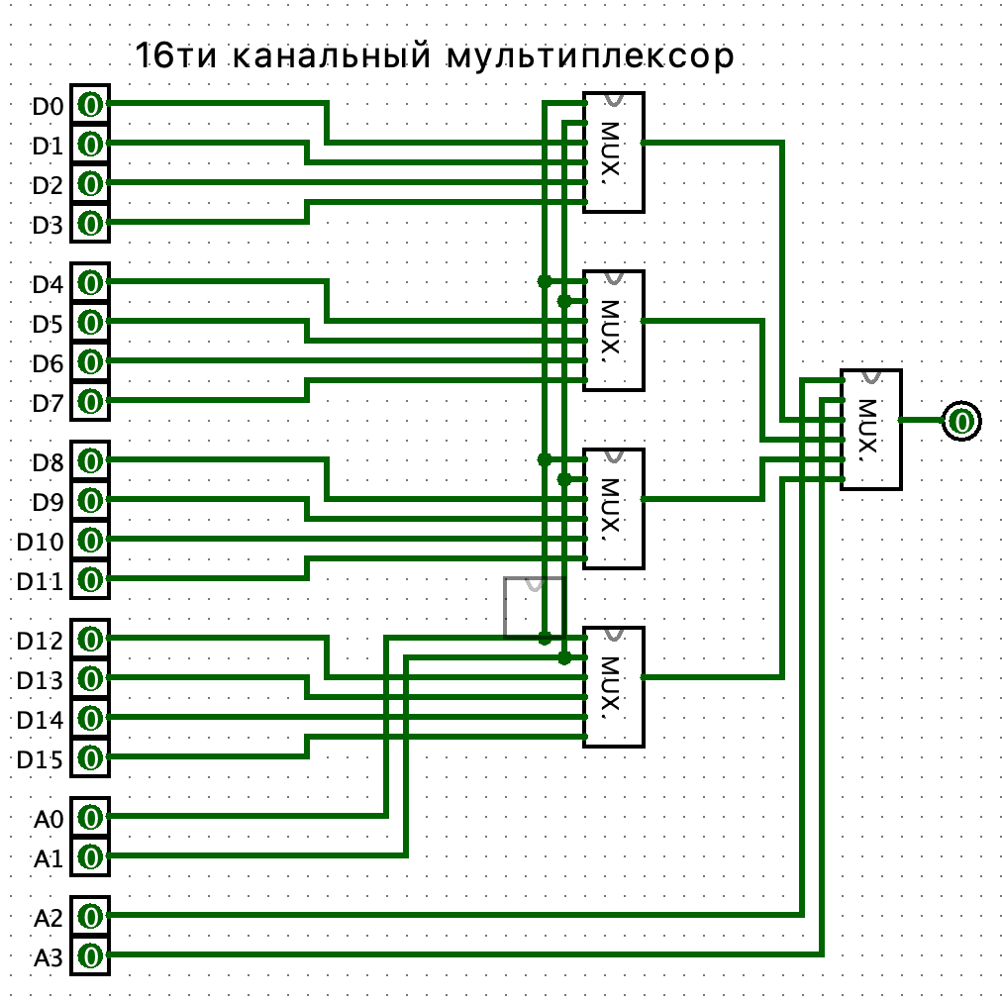

**4.**

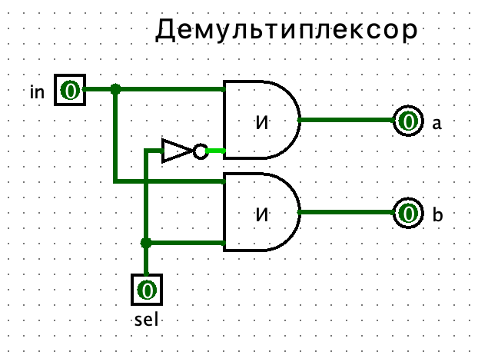

Таблица истинности:

|  |  |  |  |
| --- | --- | --- | --- |
| **in** | **sel** | **a** | **b** |
| 0 | 0 | 0 | 0 |
| 0 | 1 | 0 | 0 |
| 1 | 0 | 1 | 0 |
| 1 | 1 | 0 | 1 |

**5.**

