The Contours of the Unknowable

Jencel Panic

# Synopsis

To reconcile this paradox, we should consider what truth really is, as our current everyday notion of it is obviously wrong - truth does not exist in the world, truth is subjective. Reality is like a canvas that contains the form of the world, but it is up to the observer, to us, to draw the *contours*: we circle one spot and say “This is A”. Then we take another picture and search for where A went, or for other instances of A. It is through these contours, that the unknowable, becomes knowable.

What if everything you believe about the world — every cause and effect, every memory, every sense of understanding — is a fragile mental construct, designed not to reveal the truth but to shield you from it? In *The Contours of the Unknowable*, we embark on a journey to dismantle these mental constructs and confront the chaotic, uncertain nature of existence.

From the moment we are born, our minds begin to weave a narrative, piecing together the fragments of our experiences into a coherent story. This story, guided by the principle of causality, gives us a sense of control, a belief that we can predict and understand the world around us. Yet, as Jencel Panic reveals, this sense of control is a deceptive one. Our memories, far from being accurate representations of past events, are shaped by the very mental images that distort our understanding of the present. The stories we tell ourselves are comforting, but they are also limiting, boxing us into a deterministic worldview that leaves little room for the unexpected, the unexplainable, the truly real.

The roots of this illusion run deep. Drawing on Zen Buddhist philosophy, Jencel Panic explores how our minds, in their quest for stability, create rigid mental images that we mistake for reality. These images become dogmas, reinforcing themselves over time until they are nearly impossible to question. The more we rely on these images, the more disconnected we become from the true nature of the world, which is anything but orderly. In this book, we confront this disconnection head-on, peeling back the layers of illusion to reveal a world that is far more chaotic—and far more fascinating—than we could have ever imagined.

At the heart of this exploration is the concept of determinism, the belief that every event is the inevitable result of preceding causes. While this idea has driven much of human progress, from the development of physics to the creation of complex social systems, it is also a dangerous oversimplification. By treating the world as a predictable machine, we ignore the fundamental unpredictability of life. We create a mental model of reality that is neat and tidy, but utterly detached from the messy, entropic nature of the universe itself.

In the Zen tradition, the mind is likened to a mirror, reflecting the world as it truly is. But over time, our mirrors become clouded with preconceived notions, with expectations, with memories that no longer serve us. *The Contours of the Unknowable* is an invitation to clear away the fog, to see the world with fresh eyes. It is a call to embrace uncertainty, to find freedom in the realization that we do not—and cannot—know everything.

This book is not just an intellectual exercise; it is a practical guide to living more fully in the present moment. Through the insights of Zen Buddhism, cognitive science, and philosophy, Jencel Panic provides tools for breaking free from the mental constructs that bind us. By letting go of the need for order, we open ourselves to new possibilities, to a life that is richer, more vibrant, and more in tune with the true nature of existence.

# Introduction from the author

the concept of knowledge is deeply intertwined with the concept of time — to understand knowledge, we need to understand time. But what do we know about time, and what *can* we know about it? The short answer is: not much. The notion of time is intricately tied to how we perceive the world. Knowledge is accumulated over time, and it largely presupposes the concept of time. Simultaneously, our perceptions shape time—they are the material from which time is crafted. Thus, to understand knowledge, we must first understand time. But the reverse is also true.

This inherent paradox is why this text does not follow a very precise structure — describing paradoxes in a precise manner is just not possible. In fact, this lack of precision is probably the main reason why this subject isn’t studied more. Why devote our (*ahem*) time to trying to understand this subject when the research is arduous and the results are so elusive? My answer is simple: because it’s important. Time is connected to knowledge, aging, youth, and perception itself.

While most of the “results” I’ve reached resemble the Socratic wisdom of “I know that I know nothing,” the process of writing these essays has been very fun.

One thing we do know about time is that the principle of cause and effect is instrumental – if not for time itself, at least to our ability to comprehend it. Almost all of our knowledge is “causal knowledge,” and this is the starting point of this text. So sit back, pour yourself a glass of wine (you might need something stronger for the later chapters), and enjoy the journey.

# Frames of Reality: The Interplay of Causality and Temporal Perception in Defining Knowledge

*On Causality as the Defining Principle of All Knowledge and on the Subjective Nature of All Knowledge.*

If I throw a die or think of a random number and then tell you what it is, I doubt that would you consider this information “knowledge” (unless your goal is to argue with me). This is because such data, when considered in isolation, is highly unlikely to be relevant to anything that will happen in the future. So, we can define knowledge as “information that is relevant in the future, i.e., that can be used to predict it.” Thus, the concept of knowledge is deeply intertwined with the concept of time. So, to understand what knowledge is, we must understand what time is. Indeed, to have a concept of the future at all, we must be able to perceive time. So, let’s explore how we do that. There are many ways to approach this question, but I often find it benefitial to think about things in terms of input and output:

1. We can view the *input* that our brain receives, which forms our perception of time and continuity, as a collection of frames – pictures of different states of reality. These frames are then somehow unified in the *output*.

In other words, the mystery of time can be reduced to the following riddle: We have two pictures, and we have to identify the elements of the first one in the second one, like a reverse version of the “Find the Ten Differences” game. This might sound simple, but it is far from it.

1. For the perception of time to be realized (and for knowledge to be created), the list of frames must be interpreted as signifying some form of change from one state to another—such as a change in position (motion), shape, or color.

* If all the frames are all alike(e.g., if you are staring at a blank wall), you would not be able to perceive change (and thus, time).
* But, if the frames are all entirely different, don’t have anything to do with one another, you also wouldn’t be able to perceive change.

To perceive change, then, we must be able to interpret the frames in such a way that there is an aspect of them which is different for each frame but at the same time stays the same for all of them. This requires us to postulate the *identity* of objects and events (we can view objects as just prolonged events).

1. The basic form of identity of events and objects (where objects are merely collections of events) is grounded in the concept of *causality*. When observing event A in one frame followed by event B in the next, we presume that A ⇒ B (i.e., B is caused by A).

This implies that identity is just a manifestation of causality — they are basically the same thing. For instance, if I see an object on my desk, and then I see a similar object in the next moment, I assume it is the same object, meaning that the object’s presence at time x *causes* its presence at time x + 1.

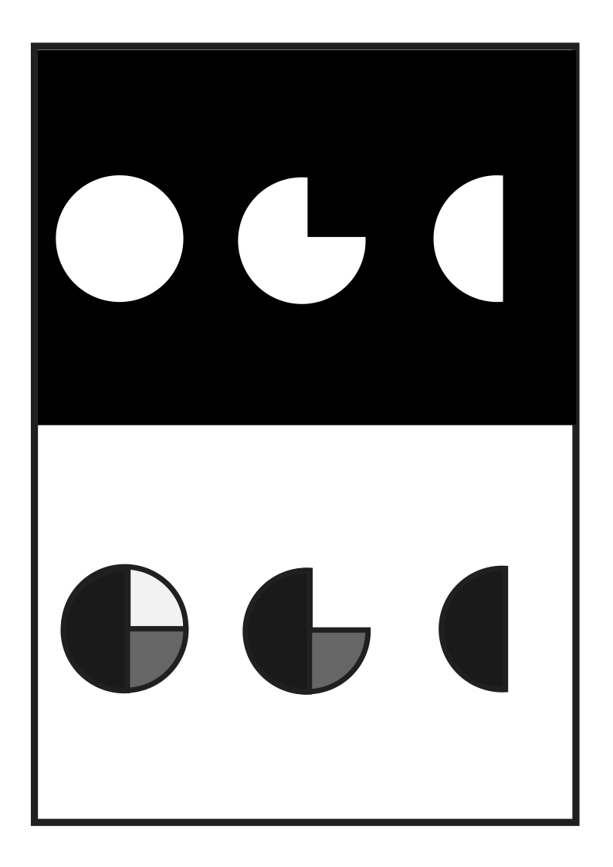

There are other ways for defining the identity of objects (we can say, for example, for example, that an object is the same only if it is composed of the same atoms), but this is the main way that identity is perceived by people in practice. A ship that has had all its parts replaced over time is still considered the same ship, even though its material composition has changed.

However, if we think more about the ship, we realize that identity, defined in this way, is not absolute.

1. Causality is in the eye of the beholder. A ⇒ B is not an objective fact about the world but a mental image. This is because B is partly defined by its internal characteristics and partly by being “the thing that follows from A (if B occurs without A occurring first, (e.g. if there is thunder without lightning) to what extend would it still be B?).” Similarly, A is partly defined as the thing that precedes B.

This is the central proposition of this text. Imagine we know that A ⇒ B and we observe A and then another event, B', that resembles B but also differs in some characteristics (note that this is not just a thought experiment but a general description of perception, as all events are unique).

In this situation, we have two choices:

* We may assume that A is not actually A but some other event A', thus discovering a new fact: A' ⇒ B'.
* Or we may assume that since it follows from A, B' must be some variant of B, thereby expanding the rule A ⇒ B to include this new characteristics of B.

The former kind of thinking is called “empirical”, the latter one — “dogmatic”. When thinking empirically we *obtain* new information about the world, while dogmatic thinking allows us to *use* this information to make predictions. These two approaches complement each other, like input and output, like question and answer.

With this, we establish that dogmas like A ⇒ B are not truths but rules for organizing information. We might naively consider them true because they “work” — they help us achieve goals or avoid trouble — but in reality, they are neither true nor false. Instances that follow a rule might only follow it by accident or because we perceive them that way. Instances that don’t follow a given rule *are simply not instances of that rule*. No rule is inherently true or false, and so no proposition is true or false either.

By the same token, we may naively think of the causality maxim (of A ⇒ B) as true (true as in “valid law of nature”, let’s say), because when we perceive A, followed by B, and it is easier to explain that by postulating causality than to just say it happens by accident (Occam’s razor). This may lead us to believe that causality is some kind of law that exist in the world, or rather a meta-law, which implies the existence of all kinds of other laws. In this case, we would be overlooking the following:

1. B is not a specific state of affairs but a mental image, a pattern we begin to search for based on our prior knowledge of A ⇒ B.

We search for B and often find it, even when there are no perfect candidates. If we already believe in A ⇒ B, we will see B wherever we see A. In this case, we say that someone sees B *even when it is not really there*, but the fact of the matter is we cannot possibly see anything that *is* there (in the way that we see B in this example).

Causality is neither a rule nor a meta-rule, but a *belief* that every thinking being must hold to some extent, in order to be a thinking being at all.

The last statements may rise some objections which I will attempt to address, using the somewhat forgotten form of philosophical dialogue. Let’s imagine that the physicist Isaac Newton, (who pioneered the modern scientific method) had a chat with the philosopher David Hume (who challenged the principles on which this method is based).

## **Hume and Newton**

**Hume:** Causality is not a quality of the world, but merely a *belief*. It is a very general belief and one that every thinking being should hold to some extent, but still, it is just a belief.

**Newton:** That is nonsense. The world clearly adheres to certain laws, independent of our observation. This means causality is a characteristic of the world itself i.e. a law.

**Hume:** OK, let’s say you are right. If causality were a law, there ought to be a way to test it, as we do with all other scientific laws, right?

**Newton:** Of course, and as a matter of fact, we do that often. All scientific theories are based on the causality maxim. A scientific theory is nothing but the assumption that a statement of the form A ⇒ B is true. We then test this theory by conducting experiments where we make A happen repeatedly and see if B follows. So, besides testing a given theory, every scientific experiment also tests whether causality itself works.

**Hume:** This is true, but many, if not most, experiments fail, at least to some extent. Doesn’t this suggest that causality itself fails?

**Newton:** The only reason why experiments fail is that we don’t yet know enough to conduct them properly. Blaming causality for our failure is ridiculous. If our theory is exactly right, it will produce the expected outcome every single time.

**Hume:** That sounds too theoretical. Can you give a concrete example of an experiment that always gets the expected outcome? If you do, you win.

**Newton:** Very well. Let’s consider this very simple experiment: a pistol is aimed at a window. The trigger is pulled, and the window shatters.

**Hume:** But what if there’s no bullet in the pistol? Or if the pistol is broken?

**Newton:** OK, let’s assume a bullet is necessarily fired, and the aim isn’t off. Then the glass breaks.

**Hume:** What if the window already has a hole?

**Newton:** No, there isn’t. The bullet hits the glass, okay?

**Hume:** Alright, but how fast is the bullet moving?

**Newton:** Let’s say it hits the glass with *sufficient* speed.

**Hume:** Sufficient for what?

**Newton:** Sufficient to break it.

**Hume:** See what you did there? You defined the situation so that the effect is embedded in the setup.

**Newton:** So, you’re saying the effect can be *embedded* in the setup? That sounds quite objective — not really a belief.

**Hume:** Look, there may be possible cases where you will be able to *guess* whether the glass gets broken, but this does not make the general principle true. Because there is no general principle, in a first place, only a mental image and situations which remind you of the mental image.

## References

* Dogmatism and Empiricism are two schools of medicine in ancient Greece and Rome. Dogmatism was pretty much lame, but Empiricism, also known as Pyrrhonism (and later skepticism), is the origin of many of the ideas that I discuss here.
* The definition of identity and the example with the ship are from the treatise of human nature by David Hume.

# From Mental Images to Truth: The Role of Goals and Emotions in Knowledge

*On the different systems of knowledge depending on the goals that a given individual has and on urges and emotions as the ultimate source of truth.*

Let me describe to you a natural phenomenon that I observed. It is a very weird one - at one moment it is green, but at the second it fades to black and then it becomes invisible. I suspect it can take some other colors too… It sometimes produces sounds too, but here is no way you can tell what it is going to do next. Such phenomena may very well exist (it might be completely random or it might be governed by some laws, that we just cannot perceive), but there is neither a way for us to know that it does exist, nor a reason for us to be interested in it. Because this phenomenon does not repeat itself in a way that we can perceive, it cannot be mapped by any mental images, and we can only perceive the world through mental images.

1. A mental image (or dogma) is a set of impressions combined into a single perceptible entity. All objects and events we perceive are actually just mental images.

Because the of fact that we only see mental images implies reality as we perceive it is not objective, many (weird) philosophers have argued that we are actually living in a dream or a simulation of some kind, and that reality as we perceive it is not at all related to the reality that actually exists. But for me that is clearly not true - while mental images themselves do not say anything about the real world, *the fact that we have gotten the habit of creating mental images* does say something - their existence is a proof (the only proof?) that the world is not completely random.

So we are put in a really weird situation:

* Mental images would only make sense only in a non-random world (in a world that is completely random there will be no point nor reason to combine several things as one).
* The concentration on different aspects of reality and the usage of different sets of mental images results in widely different interpretations of reality (none of which are correct).

So, 1) there exist some truth in this world, but at the same time 2) we can never know this truth is. The collision between those two statements has naturally led to many philosophers to despair.

To reconcile this paradox, we should consider what truth really is, as our current everyday notion of it is obviously wrong - truth does not exist in the world, truth is subjective. Reality is like a canvas that contains the form of the world, but it is up to the observer, to us, to draw the *contours*: we circle one spot and say “This is A”. Then we take another picture and search for where A went, or for other instances of A. It is through these contours, that the unknowable, becomes knowable.

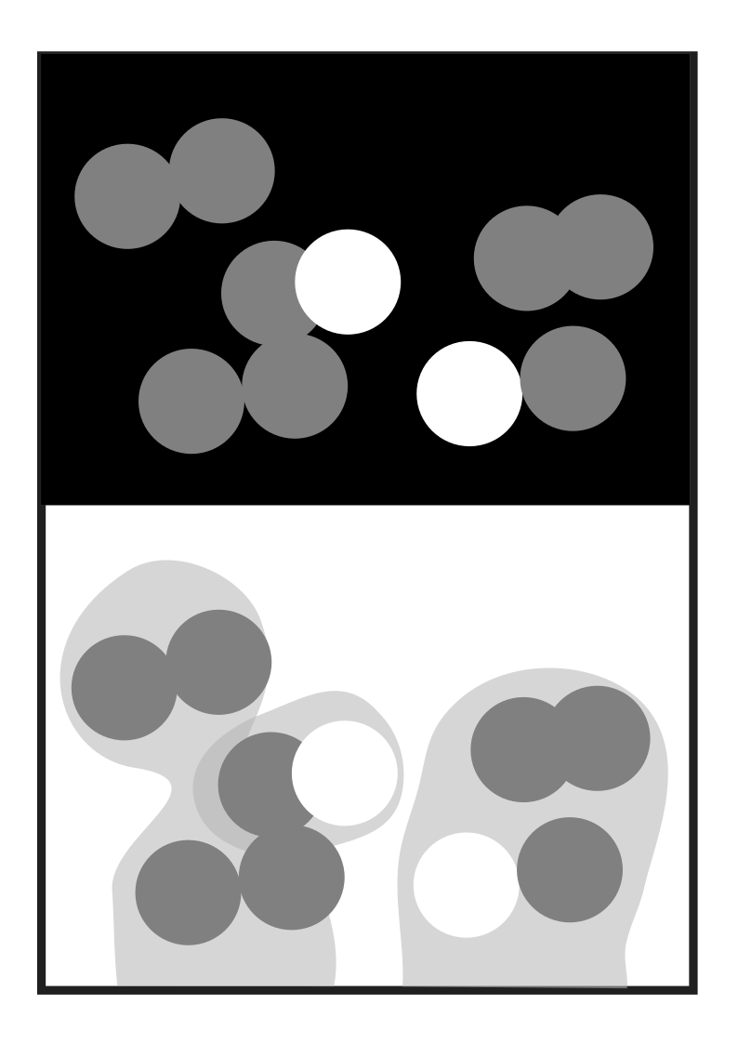

But where does A originate from initially? What provokes us to start perceiving the world in terms of A-s and B-s and not just gaze at it and wonder what the hell is happening all the time? Up until now, we spoke a lot about the subjective aspect of knowledge, but we never said anything about the *subject* AKA the human, animal, robot, god or other lifeform that/who actually perceives reality, makes these assertions and has these thoughts. But how do we even define what a subject is in this context? I claim (you will see why shortly) that it is defined by the things they *want* - their will, urges, wishes, emotions etc. or their “goals” as I will call them here.

Now, a goal is not a specific state of affairs of the world - there may be many states of affairs that constitute the realization of a given goal - rather a goal is a kind of mental image that a given observer has, with one more detail, that it is associated with feelings of pleasure.

1. A goal is a mental image representing a state of affairs which is for some reason desirable for an individual, or the opposite - undesirable.

With that in mind, let’s go back to the distinction between dogmatic and empirical thinking. As we said, when thinking empirically, we *obtain* information about the world, and when thinking dogmatically are we able to *use* the information that we gained. We said that empirical and dogmatic thinking go hand in hand, that you cannot have one without the other, but another way to look at it is that they are actually in conflict - one makes you smarter, but at the expense of your inaction (you are not unable to do anything) — the other turns you into a mindless machine that can only chase windmills.

Furthermore, when comparing the two modes of thinking, we might say that the empirical part is somewhat more “legit” than the dogmatic one. When thinking empirically, we enrich our representation of the world. If we have goals, empirical thinking helps us find more ways of achieving them. If our aim is knowledge and precision, we should only think empirically and practice suspension of judgment, collecting all information and enriching our knowledge without trying to unite and structure it, as every structure is a simplification.

We think dogmatically simply because of our (living beings’) modus operandi — sometimes, we just *have* to act. The situation becomes “do or die” for some of these goals, as abstract as they may be, and sometimes our whole existence depends on achieving them.

If this factor wasn’t there, our whole world would be different — we would just observe reality forever, studying it, becoming more intimately knowledgeable with the way it works, but doing nothing more. But we get hungry. And when that moment comes, we *have* to assume we know enough and switch to dogmatic mode in order to catch some prey or get to the grocery store. It is at this moment that the mental image is formed. The image of food is a product of the fact that we get hungry. In general, any mental image is a product of a goal:

1. All mental images that a given individual forms are either desirable or undesirable. So all mental images are trivially associated with, or are themselves, goals (or anti-goals).

A corollary of that is:

1. No mental image or piece of knowledge that relies on mental images is objective — they are all actually a product of the individual’s characteristics.

For example, the pistol and glass example is associated with the desire to break the glass for some reason.

As we said, mental images are not, by themselves, true or false. This is because (let’s reiterate it once more) we can assess whether a given mental image works only by applying it and interpreting the result, but we can only do that using *other mental images*. We cannot see reality outside of the mental images, so, when considered by itself, we cannot call an image true or false. We cannot even compare one image to another and say which is better or closer to the “real world” (because, again, we only perceive the “real world” through images). This idea is laid out in Wittgenstein’s essay “On Certainty,” especially the opening sentence, which was written in response to G. E. Moore’s argument against skepticism, where he raised his hands and said, “I know that this is a hand, and that this is another one.” Wittgenstein’s response is apt: “If you do know that here is one hand, we’ll grant you all the rest.” That is, if we have a starting point — if there is one thing that we know to be true — then everything else can indeed follow from it. But we do not have such a starting point, which is why mental images are, by themselves, neither true nor false.

The situation changes when we observe mental images in connection to goals. Goals are, by definition, desirable (or undesirable), they cause pain (or pleasure), they make us fed (or hungry). And it is based on these sentiments that we deem the mental images that correspond to them true (or false).

1. A mental image has a degree of reality that can be equated with the degree to which its corresponding goal is desirable for the individual (based on the individual’s own subjective criteria). Comparing mental images with one another is a converged way of comparing the goals for which they stand.

Notice that I don’t say that truth can be equated with how often the goal is successfully **achieved** by the individual. This is because achieving a goal is abstract; having it influence our worldview is not.

In our everyday thinking, we don’t always associate truth with pleasure and falsity with pain. For example, we have expressions like “truth hurts,” representing the conflict between mental images and reality. Let’s discuss how perception evolved to reach that point.

## Evolutionary Perspective

The behavior of the simplest organisms, those with no brain or a rudimentary one, can be described by the stimulus-reaction model — they perceive an object (called a *stimuli*, as it stimulates their senses) and *react* to it immediately in the manner they are predisposed to, with natural selection clearing out inadequate responses.

A little more complex, but still simple, are organisms that can also judge whether a given reaction was “good” or not (e.g., by using pain detectors) and store good stimulus/reaction pairs in their brain (e.g. seeing a predator and running away). These pairs resemble rudimentary memories, but unlike real memories, they don’t require an organism to have concepts of time, causality, or other related concepts in order to be recorded, as:

* They do not constitute sequences of actions or events.
* They are not related to one another in any way, i.e., there is no before and after.

Such organisms would also be able to process concepts, though in their case, a concept is simply a collection of similar memories. However, these organisms remain quite simple, as for them, the concepts of truth and falsity — if we can even call them that — are equivalent to feelings of pleasure and pain.

More complex are organisms that possess the ability — or perhaps it’s more accurate to say “ambition” — to predict the future. These organisms have a concept of both the future and the past, as the notion of prediction precedes the concept of the future itself. Predicting the future requires more than just recalling past experiences and reacting accordingly, it requires the organism to understand the concept of a “world” (or “substance,” as it is sometimes called). This allows them to produce mental images that:

* Involve multiple steps leading toward a common goal.
* Can be organized into a hierarchy, where one goal serves as a step toward a larger goal.
* Are self-reinforcing (more on that later).

The main distinction between those two types of organisms lies in the types of knowledge they possess. Simple organisms hold knowledge with a *limited scope*, while more complex ones have knowledge that is *universally valid*. These two types of knowledge correspond to two types of Aristotelian syllogisms:

* Some A-s are B (limited scope)
* All A-s are B (universal)



When we consider how these types of knowledge are acquired, we see that, although comparable, they are fundamentally different:

For a simple organism that thinks in terms of statements with *limited scope*, thoughts are merely tools for achieving more favorable outcomes in reality. Their significance is limited. For example, a simple organism that encounters a sour apple may be “unhappy” with the taste, but it would never be unhappy about the *fact* that its assumption turned out to be false. A simple organism discards an idea as soon as it feels wrong. Being wrong doesn’t lower its self-esteem, cause an existential crisis, or force it to abandon related ideas. Furthermore, a simple organism doesn’t feel the need to unify different phenomena under a common cause, nor does it ponder why things are the way they are instead of some other way (as I currently do). The simple organism is humble — it doesn’t hope to ever truly know the nature of things, so it doesn’t concern itself with them.

If simple organisms assume they are *wrong by default*, whereas we, because we are “smarter,” assume we are correct by default.

1. Statements with limited scope can only be justified by *observation*. If I observe two or three objects that I categorize as As (e.g., “apples”) and find that they possess the property B (e.g., “tasty”), I can conclude that Some A-s are B based on those observations alone, relying on my instincts.

On the other hand, statements with universal scope are axiomatic by nature — they shape reality as much as they describe it. My basis for asserting All A-s are B is not fundamentally different from my basis for saying Some A-s are B. What differs is my decision to assume that this piece of knowledge is universal.

## References

* The idea that mental images are goals is likely influenced by Immanuel Kant, who suggests that concepts resemble *rules* of perception. From this, one could speculate that these rules define goals.
* The notion that everything is uncertain due to the lack of a starting point in our thoughts and judgments has been around for a long time but was articulated most effectively by Wittgenstein. Later, related ideas were formalized by Kurt Gödel and Alan Turing, both of whom were influenced by him.
* David Hume wrote extensively about emotions (“passions”) in the second part of his *Treatise of Human Nature*.
* For more on the evolutionary perspective, consider Robert Sapolsky’s work.

# From Deterministic Models to Entropic Realities: Rethinking Our Understanding of the World

*On the Concept of the World and Determinism as the “Default” Worldview*

In the world, there would always be events and things that challenge our established worldview. Sometimes when these unexpected occurrences arise we adjust our thinking to accommodate them, to take them into account. But, if there is no way to adjust our thinking, we just ignore the things that don’t fit into our worldview as if they do not exist. If there is an event (or even a whole aspect of reality) that does not uphold to our worldview we would not be merely unable to *make sense* of that event or aspect (as seeing an event without being able to make sense of it would indicate that we can theoretically comprehend it by merely adjusting our thinking), we would not be able to perceive it in any way, even if it happens before our very eyes.

1. Mental images of the particular shape the mental images of the general e.g. having the image of A ⇒ B in our head, when we search for a new image, we will search for it only in the space which is not occupied by A-s and B-s so the new image would be supplementary to A-s and B-s, like a jigsaw puzzle and hence our whole worldview.

The only way to prevent this narrowness of perception is to assume that the world is fundamentally unknowable or chaotic—that it is unlawful by its nature. However, this assumption is a cognitive dead end — it halts our ability to perceive and process information. This is why we typically operate under the opposite assumption: that the world is orderly and knowable.

When applied to broader thinking, this assumption of an orderly world establishes determinism as the “default” worldview. It compels us to interpret even non-deterministic phenomena within a deterministic framework: the mental image that represents “the world.”

The mental image of the world (let’s call it M) functions as a central dogma, controlling this world and making correct predictions about it is the central goal.

In this context, the goal of “controlling the world” is encoded in the defining characteristic of this mental image — determinism.

In deterministic systems, non-deterministic events can only be explained by “hidden variables” theories. These theories posit that any failure to predict an outcome is due to a lack of knowledge or understanding. While it is good stance to adopt for evolutionary reasons, as it drives us to analyze and systematize our surroundings, it becomes problematic when we take it too seriously.

If we think about it, it would be quite strange if the world were truly deterministic.

1. We perceive the world through mental images.
2. These mental images are subjective representations, evolved primarily for the survival of our species.
3. Therefore, the idea that we could model the objective world deterministically using our subjective mental images seems implausible.

Indeed, while we can model certain aspects of the world with some degree of accuracy, the notion that we could perfectly model the entire world suggests that it was designed specifically for us — a proposition that I find highly unlikely. The resemblance between our mental images and the world is, in my view, an illusion. These mental images, including M, exist solely to satisfy our urges. If we ever reached a state where our urges were fully satisfied, time would freeze for us, and our mental image of the world (M) would cease to exist. However, such perfection is unattainable—not due to physical limitations, but because of the inherent limitations of our inner world, of ourselves as “non-gods.”

This is actually where the belief in God comes from: one could define God as a being who possesses what Kant calls “active intuition”—a being whose thoughts directly create reality. Unlike ordinary beings, whose thoughts do not alter reality, God is singular, unique, and immortal by definition. For God, the mental image (M) *is* the real world (W). In contrast, for humans, M and W may seem similar but are fundamentally different.



Simply put, God’s mental image (M) *is* the real world (W), while our mental images only bear some resemblance to W, reflecting the idea that humans are created in God’s image.

In the many ways we differ from God, we can say that M is not the same as W, although they are often observed as similar. While M is deterministic and orderly, W is not.

Conflating M with W, not recognizing that they are different things, can lead us to the mistaken belief that the world (W) is deterministic (i.e. everything we see that is not lawful is an illusion), when in reality, unpredictability is the defining characteristic of the world. When we fail to observe anything unpredictable, it means we are perceiving the world dogmatically, through a pre-established set of images. In contrast, perceiving the world empirically means engaging with its unpredictable nature. This illustrates that M and W are not only slightly different but do not overlap at all. This is not because they lack any similarity but because they operate according to two different, even opposing, principles.

1. The real world (let’s call it W) is our source of empirical knowledge.

Physics offers a perfect example of this difference. Although physics began as a discipline rooted in determinism, it has gradually shifted towards probabilistic models, such as those found in quantum mechanics.

The principle behind M is, of course, the same principle that is behind all other mental images i.e. causality. To understand the principle governing W, let’s revisit the concept of a mental image. Mental images don’t describe specific substances or materials, rather, they describe arrangements of these substances. Causality explains how these arrangements change over time. However, given a set of arrangements, some will fit into our mental images and follow the principle of causality, while others will not. The latter type of arrangements are much more probable. So, over time, ordered arrangements tend to become disordered — a paraphrase of the second law of thermodynamics, which states that the entropy increases over time. Unless, we (the ones who make up all those mental images) don’t put effort to preserve and develop these images, they won’t follow the principles of causality, but will follow the second law of thermodynamics and would shift to entropy.

1. If M is based on information governed by the principle of *causality*, then we might say that W’s defining characteristic is the somewhat opposite concept of *entropy*.

Why? Each mental image describes a specific arrangement of elements, e.g. the mental image (concept) of a bicycle represents a specific way in which a given set of parts (tires, diamond frame, chain pedals etc.) are assembled, and agents for whom this mental image is a goal, (e.g. ones who ride bikes) may, due of their bias, perceive this arrangement as *natural* or *logical*, and other arrangements (e.g. the wheels mounted to the steering) as illogical. So, this in the M world, having the parts results in having a bike.

However, from the standpoint of the real, objective world (W), mental images are just arrangements of elements. And improbable ones at that. That’s because in W the “lawful” arrangement (the one that corresponds to a mental image) would be only one of the countless other arrangements, (i.e. there, is only one way in which wheels, frame, steering etc. form a bicycle and an infinite ways in which they don’t). For this reason, in W, the bike parts will most likely never form a bike (and a bike would sooner or later be disassembled to its parts). This is why we say, that the entropy of the world (W) increases. And as it increases, our ability to predict its development decreases. Over time, fewer events occur, and all mental images become obsolete – W naturally resists mental appropriation and the principle of causality.

In contrast, the entropy of our mental world (M) rarely increases. M is ordered and predictable, but only because we actively make it so. Our actions create order and make causality work.

This brings us back to our central proposition:

1. “Causality is in the eye of the beholder; A ⇒ B is not a fact about the world, but a mental image.” It may seem that we use cause and effect to *understand* order, but in reality, we use it to act, and through our actions, *create* order.

The principle of causality is ultimately irrelevant to W, because causality can only be defined in contexts where we are in control. Asserting that **A** causes **B** simply means that removing **A** will eliminate **B**. Thus, causality is a tool for control, not an inherent characteristic of the world.

## Evolutionary Perspective

The second law of thermodynamics has baffled many people. Why is it this principle, which has no theoretical explanation, valid: Why does entropy *always* increases with time i.e. why is the world always shifting from order to chaos.

But making the distinction between W and M provides a very adequate answer: the principle isn’t valid everywhere, it is valid just in W, and physicists are under the impression that it is valid everywhere because they only study *non-living* phenomena, such as gasses and not living beings, and the reality around them. If examined, the living reality (M) provides many examples in which entropy decreases with time — a human city, for example is one big exception of the second law.

We don’t have to think much of the fact about how living beings reverse the second law. Can think of them as a mere coincidences/exceptions, as physicists probably do. But if we consolidate all the ideas presented here, we move a step further, and come to realize that the second law is nothing more than the definition of what living beings are: processes that do follow it, that go from order to chaos, are what we call non-living (or “inanimate”, as per Sidis), while processes that go from chaos to order constitute the living (“animate”), i.e. we, humans, as all other lifeforms, are also one of those “improbable arrangements” that, decrease the entropy, when we reproduce ourselves.

The bike analogy make it more approachable, but the proto-example of the process in which entropy is decreased is *you*, as “the person reading this sentence right now”: just as a bike is just an arrangement of parts, we can view a human being (as any other lifeform) as an arrangement (actually a set of different arrangements) of molecules that meet certain criteria when viwed macroscopically, i.e. that correspond to a given mental image. So, living beings decrease entropy, both by reproducing themselves, thus occupying more and more of their environment, and by manipulating the inanimate environment around them. The latter is, of course, a recent development (only humans and a handful of other species do it).

Up till now, we presented the distinction between W and M in a pretty abstract manner, but we now see that it also constitutes a material border — a human city, for example, or a thriving ecosystem, is an M territory, while a dessert, or space is a realm of W.

## References

* The concept of the world as an idea is central to Arthur Schopenhauer’s work.
* The dichotomy between causality (or information) and entropy is inspired by Hans Reichenbach’s book *The Direction of Time*, particularly Chapter 4, “The Time Direction of Macrostatics.”
* For more on the connection between the second law of thermodynamics and living beings, check for example “The Animate and the Inanimate” by Sidis

# Dogmatism Through the Lens of Memory: The Unreliability of Past Events in Shaping Our Worldview

*On the Ability to Memorize and How Our Thinking Becomes More Dogmatic Over Time Due to Mental Images and Goals Mistaken for the Actual World*

Practitioners of mnemonics have long understood that the easiest way to remember a collection of unconnected pieces of information is to just make up some connections between them. This is because our brains cannot capture raw perception data — they can only capture mental images and causal connections i.e. we only remember events that are connected with one another.

1. Because we necessarily see them as connected, all events that we remember form a structure known as a causal chain.

An event that has nothing to do with our causal chain is simply not perceived by us (or, if perceived, it is not remembered even for a second). In many ways, placing the event in the causal chain is perception itself.

However, since humans have only one causal chain—i.e., we do not have multiple ways to perceive a given set of events that we can switch between—placing an event on the causal chain also means replacing it with a mental image.

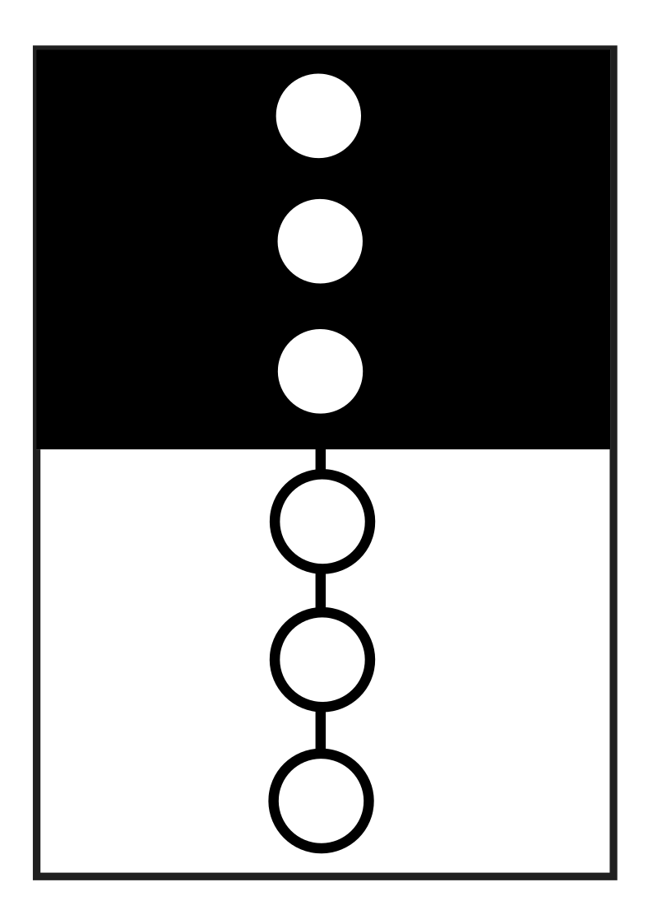

1. Due to the way memories work, mental images reinforce themselves over time — having the image of A ⇒ B in our minds, we would see A-s and B-s all over the place.

One of the most significant biases in our perception of time, which we’ve already discussed, is our inability to distinguish between the mental images representing the world (M) and the world itself (W). This bias leads us to believe that our perceptions reflect the state of affairs when, in fact, they are merely a record of our mental images. Memories contribute heavily to this bias, as they can amplify it indefinitely: when we perceive a given “frame,” the memory of it is rich in sensory (empirical) data, which we can analyze and interpret. But once we perceive the next frame, many aspects of the previous one are compressed, leaving only those details that provide context for the next frame. Then, when a third frame is perceived, the first two are compressed further, retaining only what’s useful for interpreting the third. The problem is that *we cannot know which aspects will actually be useful for future context*.

Like causality, we naively view our memories as true representations of reality because they “work”—i.e., they have a good success rate at predicting future events. But, (as with any mental image), we lack a clear criterion for what it means for memories to “work”. Like all mental images, memories represent an interpretation of reality, but they are also immutable. Once a past event is categorized under a mental image (say, A), it cannot be reinterpreted as anything other than A, even if we later adopt better or more accurate mental images for similar events.

1. The interpretation of past events cannot be modified, and different interpretations cannot be compared, as the raw perceptual data is lost once details of the event are forgotten. If we label an event A at time T1, and later, at time T2, we “upgrade” our understanding and categorize similar events as A' (which we might consider more accurate), this upgraded view will affect future events but not the event at time T1, which remains A. Without the raw data, we have no way to know whether it was truly A' all along.

In other words, past events we remember are mere projections of the mental images we used at the time of perception. They are as unstable and subject to change as our future projections.

Additionally, events within the causal chain are further compressed as more structure is imposed over time. For example, if I remember going to school yesterday, I don’t remember every detail—locking the door, waiting for the bus, etc.—because much of that is implicit (some computer compression algorithms are based on the same principle). This compression intensifies with time. Ten years from graduating, I don’t remember any specific day at school, only an abstract image of the time spent there. However, this compression is “lossy”, meaning that over time, our memories become more abstract, and we recall fewer concrete details about what actually happened, focusing instead on mental images. This process is sometimes called “stylization” (a term from visual arts): an image is non-stylized when it reflects perceptual data (like a photorealistic painting) and stylized when it reflects ideas (like a road sign).

1. Stylization works in the following way:
2. We *recall* an event or a chain of events from our memory.
3. We *interpret* it.
4. We save the interpretation of the memory in the place of the original memory

In truth, this isn’t entirely accurate way to put it, as the memory *was an interpretation all along*, just less stylized. Memories are interpretations of interpretations of interpretations.

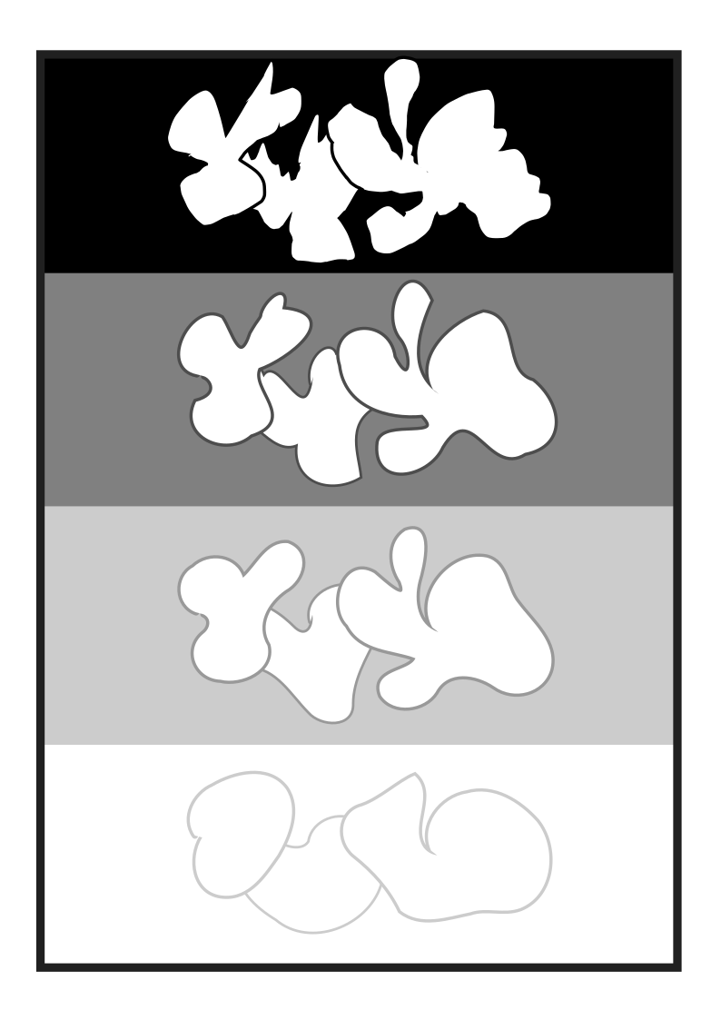

The more distant an event, the more abstract and stylized it becomes, i.e. it is more connected to the mental images we used at the time of perception. Consequently, we cannot create any *new* mental images from our memories, only extrapolate from the ones we already have. This is why older people tend to be more dogmatic than younger people—over time, we accumulate more mental images, and thus perceive less. The only way to avoid this is to have no memories at all.

## The Default Interpretation

Memories are an unreliable source for understanding reality, a fact we should account for when drawing conclusions. However, as we will see, this isn’t our typical stance, since many of these images are deeply embedded in our minds.

Every set of events allows for many interpretations, an interpretation being the simplification that enables us to process and store the events in our brains. A valuable skill, that I discuss here, is the ability to “switch” between interpretations—to see a set of events from a new perspective, for example, realizing that something once perceived as beneficial is actually harmful, or even seeing ourselves in a new light. This skill is a prerequisite of all new ideas, it is thinking itself.

However, the more abstract (stylized) a concept, memory, or mental image, the harder it is to modify its interpretation, as it is already interpreted when stored as a memory (i.e. it is already connected to a particular interpretation). To reuse the previous example, if we believed that a given action was beneficial for us, memories of performing that action would be happy ones (even if the experience itself wasn’t entirely happy). Thus, relying on memories can prevent us from reconciling our stance. This is why recordings or other people’s accounts of past events can help shift our perception better than memories alone.

Moreover, mental images reinforce themselves through memories. If the better part of our memories are recorded with a particular interpretation, than that interpretation will eventually dominate our consciousness. For this reason, it makes sense to talk about *the default interpretation*—the one through which a person sees the world, connecting all experiences into a coherent whole, and which is rarely questioned because it essentially becomes the self.

This default interpretation is closely tied to the concept of the self.

## References

* Nassim Taleb often explores the human inability to see and account for uncertainty.
* Marshall McLuhan discusses the cultural impact on our worldview in his book *Understanding Media*.

# The Real World and the Self: Deconstructing Identity and Choice

When the Roman emperor Julius Caesar crossed the Rubicon and entered enemy territory, he famously declared, “The die has been cast.” This phrase implied that from that moment onward, battle was his only option, and, in this sense, its outcome had been predetermined. I believe (though I’ve never seen this interpretation elsewhere) that he refered to the die belonging to the Greek/Roman deity Decuma/Lachesis—one of the three Fates, who, according to the myth, determined the course of each person’s life by casting a die. Whether or not this interpretation is accurate, the phrase serves as a fitting metaphor for the Greco-Roman view of fate as a predetermined and immutable destiny, a thread through which we are all bound to travel (another image drawn from the myth of the Fates).

But, that view is nonsense. Fate isn’t predetermined. At any moment, Caesar could have chosen to retreat, surrender, spend the day fishing by the Rubicon, or pursue countless other options instead of fighting. We all have access to paths that can change the entirety of our life for seconds. The reason Caesar dismissed those paths wasn’t that he was incapable of going through them, but because if he had, then he *wouldn’t be Julius Caesar* i.e. he would destroy the narrative that is himself. His identity was tied to the narrative of a bold, decisive leader; would Caesar still be Caesar if he had retreated?

In much the same way, each of us faces countless choices that could radically alter our fate. Yet, we rarely consider most of them, because we feel that choosing certain paths would cause us to lose our sense of identity.

The concept of the self, like identity more broadly, is a personification of what is interpretable (through the default interpretation). The memories, beliefs, and knowledge that make up who we are. Any thought, habit, or urge outside this narrative isn’t truly part of the self. This isn’t because those thoughts or urges are rarer, better/worse, or less characteristic or ourselves than the rest, but because they fall outside the established narrative.

1. The self is not who you are, but who you aspire to be—your projected goal, interpreted through the default interpretation. The self does not exist in W.



We are defined by what we identify with. When we tie our identity to a particular idea or dogma, our sense of self is tied to its validity. If that idea is challenged, our identity feels threatened.

This is why people cling so tightly some of their beliefs: unlike ordinary, empirical ideas that can be proven wrong, the self resists such challenges, leading to so-called “inner conflicts.”

1. All inner conflicts (or conflicts with ourself) are essentially conflicts between different sets of goals, each of which requires a different interpretation of reality. For example, believing that A ⇒ B and perceiving the world through the lens of A and B entails one role for us, while believing that X ⇒ Y and seeing the world in terms of X and Y entails another. The common thread between these views is that each requires a role for us, as neither would exist otherwise. In this sense, there isn’t just one self (M), but many interconnected selves (M’s).

Having memories makes these conflicts especially prevalent, because in order to abandon a given interpretation, you must also drop the memories, associated with it and we cannot drop our memories without dropping “ourselves”. However, our new memories are associated with a diffent interpretation which we also cannot abandon.

## The Societal Perspective

It is often said that the definition of insanity is doing the same thing over and over and expecting different results. This saying embodies one of the main postulates of all human societies — in just a few words, it captures both the function that people have in society (making the world behave uniformly for everyone) and what society does with those who refuse to conform (labeling them as “insane” and thus excluding them).

In reality, this principle is false. In fact, the opposite is often true. For example, if I experience something that brings me positive emotions (e.g., eating a delicious meal), I would expect to feel the same way if I repeat that experience. However, this rarely works. When you eat a tasty snack and feel pleasure, many factors contribute to that feeling—your hunger, the time of day, what you ate earlier. Each event is connected to every prior event, going all the way back to your first perceptions before birth. Every experience influences your current experience, whether you’re consciously aware of it or not. Similarly, in the universe, it’s inaccurate to say that one event simply follows another. rather, everything follows from everything else. Sane people should be aware of this complexity (e.g. that having a second sandwich is not like having the first one for a second time) so a more fitting definition of insanity might be—doing the same thing over and over and expecting *similar* results every time.

You might argue that my example is simplistic (e.g., that anyone in their right mind knows when to stop eating). However, the reality is that most of us don’t know (or we know in theory but not in practice). Even this basic fallacy is something we struggle to grasp, and it illustrates the point. Thoughts like “more is better” and the aforementioned definition of insanity are inherent flaws in how we perceive the world. These truisms hold society together.

As actors always play roles for an audience, we cultivate our self—our default interpretation — in sync with the society we live in. Society is also why we remember the things we do. If we forget, someone else remembers for us. If we want to change our self, society may deny us that right. It is society, not the individual, that creates the default interpretation of reality, implanting it in our minds through memory.

Using this view, we can understand cultural conflits with the same framework we explained self conflicts — every society has it’s way of interpreting reality, which maintains order and having a different way of interpreting reality (even if you don’t want to impose it on anyone) makes you a menace to that order.

And memory plays an important role in societal consciousness: here it’s enough to remember Orwell’s saying that who controls the past, controls the present. Memory is what underpins the very concept of a particular people, or of the whole human race as a whole.

## References

For more on the recursive nature of the self, see *Gödel, Escher, Bach* by Douglas Hofstadter.

# Appendix 1: Where universality breaks: about Kant’s triads and the dual to Laplace’s demon

*The following essay is not part of the book, and started as an treatment of an entirely unrelated topic. However, it ended up referencing so many of the ideas that I outlined in it, that I decided that it would make a great conclusion. Besides, I didn’t have another one.*

## The Mystery of Kant’s Triads

In *The Critique of Pure Reason*, Immanuel Kant introduces his famous list of pure concepts of understanding, also known as the *categories*, which, according to him, form the basic building blocks from which all other concepts are derived. These categories are divided into four groups: *quantity*, *quality*, *relation*, and *modality*. Each of these groups contains three categories, forming what Kant refers to as *triads*. For readers of Kant, the fact that each group contains three categories (instead of two) might seem strange, as Kant’s other classifications are typically based on dichotomies. What’s more perplexing is that the third category in each triad does not seem as obviously derived as the other two. For example, in the category of quality, the first two categories roughly correspond to “true” and “false” states, so what does the third one correspond to? According to Kant, it is a kind of blend of the two. Hmm…

For context, here is the list of Kant’s categories (with descriptions in my own words):

**Quantity**

* Unity (measure): Recognizing a thing as one
* Plurality (plurality): Recognizing there are several things
* **Totality** (whole): Unifying all things (of a given group) as one

**Quality**

* Reality: Recognizing presence
* Negation: Recognizing absence
* **Limitation**: Recognizing a thing as both present and absent (e.g., in different times)

**Relation**

* Inherence and subsistence: Representing a thing as being inherent or constant
* Causality and dependence: Representing causal effects (where things depend on each other)
* **Community**: Representing a reciprocal causality (where one substance causally determines another and vice versa)

**Modality**

* Possibility–Impossibility: Speculating whether a given thing can or cannot exist
* Existence–Non-existence: Perceiving whether something exists or does not
* **Necessity–Contingency**: Accepting a thing as inherently true (where existence is given through possibility itself)

## Combination, But Not Entirely

Here’s what Kant says about these third categories:

“II. The number of the categories in each class is always the same, namely, three—a fact which also demands some consideration, because in all other cases division à priori through conceptions is necessarily dichotomy. It is to be added, that the third category in each triad always arises from the combination of the second with the first.”

But wait—if the third member of each triad is merely a combination of the other two, doesn’t that mean it’s not truly pure/atomic/first-order and should be excluded? Kant argues otherwise, although his explanation remains somewhat ambiguous:

Thus totality is nothing else but plurality contemplated as unity; limitation is merely reality conjoined with negation; community is the causality of a substance, reciprocally determining, and determined by other substances; and finally, necessity is nothing but existence, which is given through the possibility itself. Let it not be supposed, however, that the third category is merely a deduced, and not a primitive conception of the pure understanding. For the conjunction of the first and second, in order to produce the third conception, requires a particular function of the understanding, which is by no means identical with those which are exercised in the first and second. Thus, the conception of a number (which belongs to the category of totality) is not always possible, where the conceptions of multitude and unity exist (for example, in the representation of the infinite). Or, if I conjoin the conception of a cause with that of a substance, it does not follow that the conception of influence, that is, how one substance can be the cause of something in another substance, will be understood from that. Thus it is evident that a particular act of the understanding is here necessary; and so in the other instances.

What is this *particular acts of the understanding* for which Kant talks about and which enables the creation of each third category from the other two. For me it has to do with a peculiar process which converts empirical knowledge to universal knowledge, using the concept of the (understandable) universe (or “the world”) for which I want to talk about in this article. This process is based on faith, not knowledge, or more precisely, it is based on *faith of knowledge*.

If empirical knowledge involves constructing models, universal knowledge involves accepting those models as *universally true*. It is precisely this function that the third pure concepts of understanding enable us to accomplish.

## Universal Knowledge and the Concept of the Universe

In this section, I aim to challenge Kant by proposing the following thesis: *the third member of each triad of categories is not a pure concept of understanding*. Rather, it serves as a bridge linking the other two concepts of understanding with reason. In other words, the third member enables us to form a mental image of the *understandable universe* (or *substance*, in philosophical terms), allowing us to apply the other two concepts to it.

To elucidate, consider the problem of induction, a problem that originally inspired Kant to write the *Critique*. This issue can be phrased as follows: We know our knowledge often becomes outdated and that what holds in one time/place/context may not apply in another. So, how can we justify the generalizations we make so frequently (which form the foundation of our thinking)? The simple answer: *we cannot justify them*. This has been known for millennia. The answer is so straightforward that it invites a follow-up question: How and why are we even able to make such claims in the first place? From where does our logical apparatus derive (an apparatus not shared by other animals), and what does it look like?

The answer lies in the concept of the *understandable universe*, or substance (I’ll use “universe” since the meaning of “substance” is unclear). The concept of the universe is both obvious and odd; after all, why do we have such a vivid notion of something we can never observe in its entirety?

The universe concept enables us to make general claims and to act as though we understand everything. General claims shape our understanding in a way that may be incorrect but remains useful; they allow us to make (sometimes incorrect but useful) predictions about our world.

**Digging into Kant’s Epistemology**

The section of the *Critique* where Kant puts forward his theory of knowledge, which occupies most of the book, is divided into two parts: *transcendental analytics* and *transcendental dialectics.* These parts correspond to the two main types of knowledge, according to Kant: *understanding* and *reason.* The main distinction between these is that concepts of understanding, based on categories, relate to *possible experience,* whereas concepts of reason, such as the soul, God, and the world, do not. For this reason, Kant sees concepts of reason as somewhat illusory.

A key question arises: to which of these two faculties does the concept of the universe belong? Kant explicitly classifies it under reason (if you accept that the concepts of “the universe” and “the world” are somewhat similar) but also implicitly places it under understanding (by including it in the categories). Personally, I view it as existing somewhere between the two. The concept of the universe is *not a concept of experience* because, although we experience the universe constantly, no one can claim to know something universally valid for all of it, neither practically nor theoretically. At the same time, the universe is *not a concept of reason* because it is a precondition for reason’s existence, just as causality is a precondition for experience.

But we are getting ahead of ourselves, so let’s start from the beginning - by tracing how the idea of the universe appears in each third category of Kant’s four triads.

### Quantity

Unity | Plurality | Totality |



Let’s start with the categories of *quantity,* or *number.* Categories originate from concepts in logic, and the categories in this triad are based on the logical predicates of *singular,* *particular,* and *universal,* often articulated as “one/unique,” “some,” and “all.”

The distinction between *singular* and *particular* predicates—and thus between unity and plurality—is clear. For example, it is the difference between perceiving 20 birds as 1 flock or as 20 birds. However, the distinction between these and totality is vast; they represent different types of knowledge. The first two types of knowledge have *limited scope,* while the third is *universally valid.*

To ellucidate this, let’s examine the predicates from classical Aristotelian syllogisms:

* Plurality - One A is B / Some A-s are B (limited scope)
* Totality - All A-s are B (universal scope)

This distinction becomes clearer: statements with limited scope can only be justified through *observation.* – if I observe any number of objects categorized as A (e.g., “apples”) and find they possess property B (e.g., “tasty”), I can conclude, based on those observations alone, that Some A-s are B or One A is B.

Statements with universal scope, on the other hand, are axiomatic by nature. Although All A-s are B and Some A-s are B differ significantly, the basis/reason for someone to concluding that All A-s are B are no different from the basis for saying Some A-s are B — if I enjoy apples and have never had a bad one, I might say, “All apples are tasty,” whereas someone with the same experience but in a more skeptical mood might say, “All apples that I have eaten are tasty.” Our experiences are identical; my choice to assume universality is the only difference.

Thus, even both of them reference the same two variables (A and B), statements of the form Some A-s are B and All A-s are B are very different categorically. We might say that the latter type references a “secret third thing”—the *universe.* In other words, we could rephrase All A-s are B as All A-s in this universe are B.

This reveals a paradox: while the concept of the universe underlies empirical statements, it is not itself empirical, as we cannot make empirical observations about the universe (unless we are Laplace’s demon, but more on that later). And one way to navigate this paradox (actually, the only way I can think off) is to assume that universal statements are not entirely empirical—they *create reality as much as they describe it.* By saying all A-s are B-s, we are defining what A is, rather than simply describing the world.

For more details, see the second chapter of the book.

### Quality

Reality | Negation | Limitation |



The category of *Limitation* is often misunderstood because this triad is based on *truth.* Classical logic is bivalent: propositions are either true or false, yet this triad of quality has three categories. So, what is the third?

To approach this, let’s examine intuitionistic logic, where a proposition need not be strictly true or false. This connection is particularly interesting, as intuitionistic logic relates to category theory—a mathematical theory on which I wrote a book, also inspired by Kant’s categories (or perhaps Aristotle, it’s hard to say).

Anyway, classical logic, is rooted in Platonic epistemology which assumes that we humans have universal knowledge. Plato held that knowledge was given by God and that we *recollect* ideas already given to us. To postulate this universality, classical logic employs *limitation,* such as when everything is either B or *non-B,* meaning the B/non-B distinction is inherent to each object.

In contrast, intuitionistic logic represents the opposite view, that knowledge is subjective and limited in scope. Here, rather than contrasting reality with limitation, we use *negation.* A thing may be *B* or it may not be B, but it doesn’t have to be one or the other, because, since the predicate *B* is made up, there is no reason to think that it should apply to every object in the universe. This is a contrast to classical logic where all things are either *B* or *non-b*.

Again, in intuitionistic logic, when using reality and negation, I can make a statement that concerns a given object, such as saying it is **B** or **not B.** When using classical logic and limitation, however, I am making a statement about the entire universe, postulating it as divided into B’s and non-B’s.

This is how Kant puts it in “The transcendental clue to the discovery of all pure concepts of understanding”:

For example, if I say of the soul, “It is not mortal”—by this negative judgment I should at least ward off error. Now, by the proposition, “The soul is non-mortal,” I have, in respect of the logical form, really affirmed, inasmuch as I thereby place the soul in the unlimited sphere of immortal beings. Now, because of the whole *sphere of possible existences,* the mortal occupies one part, and the immortal the other, neither more nor less is affirmed by the proposition than that the soul is one among the infinite multitude of things which remain over, when I take away the whole mortal part.

Here, “the sphere of possible existences” essentially serves as a reference to the universe.

For further reading, see the chapter on logic in my book “Category Theory Illustrated”.

### Relation

Inherence | Causality | Community |

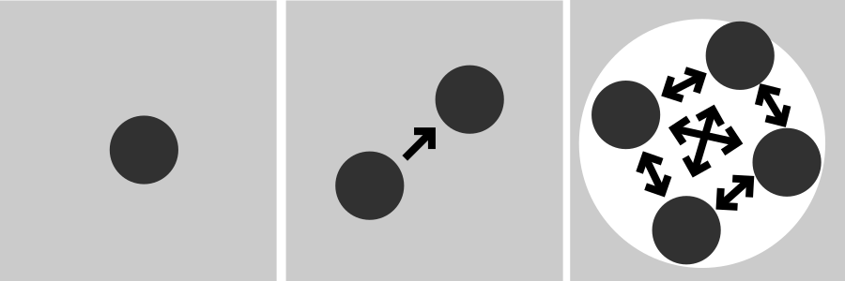

We now turn to the *dynamic* categories, which (unlike quantity and quantity) concern not the phenomena themselves but the ways phenomena are perceived. In these triads, the relationship between the third categories and the rest differs slightly but still clarifies the idea of the universe.

The first triad is the category of *relation,* whose schema are the relationships between events in time.

The first category which (as all other first categories) is something like the base of the triad, is the category of *inherence* which determines the relations of appearances to time itself. The second category, the most famous one, is the relation of events based on cause and effect. And the third one concerns another relation - that of *community* or of *interaction* as Kant also calls it.

So, what is community? Let’s first see the explanation for the disjunctive logical statement on which it is based on, in “The transcendental clue…”:

Finally, the disjunctive judgment contains a relation of two or more propositions to each other—a relation not of consequence, but of logical opposition, in so far as the sphere of the one proposition excludes that of the other. But it contains at the same time a relation of community, in so far as all the propositions taken together fill up *the sphere of the cognition.*

Replacing “the sphere of the cognition” with “the universe” would bring us close to my initial thesis. The disjunctive relation here resembles limitation and the *A* versus *non-A* dichotomy we examined, though here we’re not discussing predicates, but relationships that change over time.

But there is something else we should note - this quote makes it seem like *community*, (which is based on disjunctions) is different from causality (which is based on consequence), but later Kant says that “nothing determines the position of anything else in time except that which is it’s cause?”

So, what is *community*? Later in the book, it is defined as reciprocal cause and effect: two substances exist simultaneously in community when each “contains within itself the causality of certain determinations in the other substance and, at the same time, the effects of the causality of that other substance.”

And where do the two approaches meet? Although the way Kant frames it is a little different, I view community as the idea of the universe as a system in which everything is in a causal relationship to everything else, including the things that are simultaneous (on which Kant stresses on the most.) It is the main “causal chain” which does not allow for the existence of other causal chain and demands that everything be connected to it in order to be considered real.

We don’t talk about this causal chain but intuitively we are always aware of it. For example, we see a phenomena that is at the same time unexplained and very real (it affects our senses very much), we often say that there *must* be some explanation for it. And I believe that the reason why we say that is because *we are operating withing the bounds of the category of community*.

Conclude with one more quote, this time from “Systematic representation of all synthetic principles of pure understanding”:

These are the three analogies of experience. They are nothing but the principles for determining the existence of appearances in time, according to all its three modes, namely:

* the relation to time itself, as a magnitude (magnitude of existence, that is, duration);
* the relation in time as a series (successively);
* and finally also the relation in time as a *sum total of all existence* (that is, as simultaneous).

Here again, we see the universe’s necessity, as *time as a sum total* requires a universal scope.

### Modality

possibility/impossibility | existence/non-existence | necessity/contingency |



The final triad, *modality,* is especially intriguing. Unlike the other three triads, it doesn’t deal directly with knowledge itself but rather with the relationship between knowledge and the knower—that is, you. Again, as in the other triads, the first two categories here create a clear dichotomy: *possibility* versus *actuality.* Possibility involves things that could theoretically happen, while actuality pertains to things that have indeed happened. This distinction mirrors Kant’s two types of logical propositions: *problematic* propositions (those without a necessary relation to reality) and *assertoric* propositions (those that you accept as true or false).

From these two types emerges a third one emerges: *apodeictic* propositions, or propositions that are *necessarily* true. In *The Transcendental Clue,* Kant explains this evolution:

“The apodeictical proposition cogitates the assertoric as determined by these very laws of the understanding, consequently as affirming à priori, and in this manner it expresses logical necessity. Now because all is here gradually incorporated with the understanding—inasmuch as in the first place we judge problematically; then accept assertorically our judgment as true; lastly, affirm it as *inseparably united with the understanding*, that is, as necessary and apodeictical.”

This passage outlines the three stages of evolution of our understanding, which eventually lead to the concept of the universe:

1. Initially, we formulate (make up) explanations based on what we observe and hear, without confronting these explanations with reality (we *don’t* expect things to make sense).
2. Next, we find that some explanations align well with reality, leading us to base some decisions on these explanations (we think it is *possible* for things to make sense).
3. Finally, we accept certain explanations as universally true, integrating them into our understanding. At this stage, we reject or ignore information that contradicts our established theories (we insist that things must *necessarily* make sense).

The transition from stages 1 and 2 to 3 represents a qualitative shift, similar to the difference between the categories of negation and limitation: possibility suggests that something may be true in some instances, while necessity implies it must be true in all cases.

Additional distinctions between stages 1,2 and 3 illustrate this evolution:

1. At stage 1 and 2, we operate on a phenomenological level, dealing only with things we directly perceive. In stage 3, however, we extend to imagining entities and concepts based on what we perceive but which cannot be directly observed.
2. At stage 1 and 2, our observations are fragmented. At stage 3, they coalesce into a cohesive whole, implying an underlying presumption that the universe itself forms a cohesive whole.
3. At stage 2, we can make random observations or discard observations as they lose relevance. At stage 3, however, every observation must connect with all the other ones (it is this connection which is *necessary*). New observations must align with our worldview, and we cannot disregard established observations without impacting our entire conceptual structure.

In essence, at stage 3, an observer *feels* they understand the fabric of reality, believing that, from some scattered observations, they can infer universal truths valid across all times and places. This assumption of universal knowledge is what Kant refers to in *Systematic Representation…*:

“That the connection of which with the actual is determined according to *universal conditions of experience* is (exists as) *necessary*.”

The concept of necessity embodies this belief: that the universe is comprehensible and that, furthermore, *we* have the capacity to comprehend it.

## Where Universality Breaks

Consider this quote on negation and limitation:

“The whole sphere of possible existences, the mortal occupies one part, and the immortal the other.”

This sentence contains the assumption that all objects in the universe are either mortal or immortal, which is questionable e.g. what about the objects that are not alive in the first place? e.g. is a chair mortal or immortal?

This issue doesn’t arise in the dichotomy between *reality* and *negation*—for example, between “mortal” and “not mortal.” Here, it’s straightforward to categorize all possible objects: a chair, for instance, is clearly “not mortal” meaning that it doesn’t posess the quality of being mortal.

This is one of the many examples where the principle of universality breaks i.e. cases where our illusion that we possess universal knowledge leads us ashtray.

### Universality and Bias

Whether we can truly understand without the categories of totality, limitation, community, and necessity depends on how we define *understanding.* But what we do know is that, even without these categories, we would still be able to accomplish quite a lot. We could still:

* Identify different phenomena (using the categories of unity/plurality),
* Classify some phenomena as present or absent in our perception (reality/negation), and
* Identify relationships among phenomena that allow us to see them as objects (inherence/causality).
* Finally, we could interpret what we observe and distinguish possible ideas from actual occurrences (possibility/existence).

Simple organisms are capable of surviving without concepts like totality, limitation, community, and necessity. And even for us, temporarily setting these categories aside can foster humility. You might even argue that removing them could make our thinking more objective, albeit less capable.

* *Totality* represents the bias toward universal claims that are valid for all objects in the universe, as opposed to more limited claims that concern our own environment. Without *totality*, we would remember that nothing we say is valid about *all* things or *all* people and at all times.
* *Limitation* represents the bias of applying systems of predicates to objects that don’t confront to this system (AKA boolean thinking). The loss of *limitation*, would prevent us from, seeing everything as being either or, according to some subjective criteria, when in reality many things can be both or neither.
* *Community* represent the bias of thinking that all events must be causally connected with all other events and excludes everything what doesn’t fit in this picture as unreal. So without it, we can have a richer understanding of the events around us.
* **Necessity** leads us to impose hierarchical relationships where none may exist. By abandoning the necessity for this hierarchy, we can put our preconceptions aside and see things more objectively.

So, if you take understanding to mean having an unbiased view of what we perceive, then one could argue that not only is understanding possible without these categories, but that these categories might actually cloud it.

### Universality and entropy

So if those principles (which are based on universality) are wrong, then why have we adopted them? Well, as we said at the beginning, the existence of each third category follows from that of the other two. At first sight, that might look like a good-enough reason for them to “exist”. But, if you think about it, this line of thought is just an application to the same principle of universal knowledge that is embedded in all of those categories - considering something as *necessarily* true just because it follows from other things that we consider true i.e. disregarding the fact that we might be wrong and that every piece of knowledge has scope of validate (so it’s not universal.) So, just because we have the first category and we have the second one, does not mean that we have one that is a combination of the two. This is a problem that Kant himself acknowledges and talks about a lot in the transcendental dialectic - the problem that each piece of knowledge has a scope of validity and if you go outside of that scope, then the piece of knowledge becomes irrelevant.

But if our knowledge isn’t universal, how do we *know* where it ends?

That’s the root of all issues—we cannot know that.

Perhaps the only satisfactory (albeit wrong) answer to this question is that it somehow doesn’t end, and that we must be capable of somehow perceiving the whole world, the whole universe. This is the answer proposed by Plato, who posits a divine world of forms we can “recollect.” Kant, too, gives a similar answer by separating things as they are in themselves from things as they appear to us and talking about the second category. We can adopt this as an axiom of the world, which I’ll call the axiom of causality (I realize this name coincides with one of the categories, but I’ll use it here for its aptness). Accepting this axiom, the concept of the universe and each third category would logically follow from the other two categories and from this principle.

Alternatively, if we don’t insist on our answer being satisfactory (or want it to be 100% true), we could take the skeptic’s path and say that knowledge ends as soon as it begins—that we truly do not know anything. This perspective implies that everything we observe as a law is impermanent, and our knowledge would slowly disintegrate over time—a principle that I dub with the often-misused word *entropy* (which I am also probably misusing here.)

### Laplace’s Demon and Its Archnemesis

The two different answers not only paint two different pictures of the universe that we are living in, but they describe two ways of seeing our role in this universe and our modus operandi. To end the article with a twist, I will write something about them here.

But first, let’s talk about entropy. We can say that the entropy of a given system corresponds to how easy it is to describe it’s state. e.g. an ordered deck of cards has a low entropy because it is easy to describe, while the only way to describe a shuffled one is to just make a list of all cards in the order in which they appear in the deck. The second law of thermodynamics follows directly from this definition - there are billions of ways a deck of cards can be unordered, but there are a just a few ways that it can be ordered. Thus, *entropy increases with time* (as we continue shuffling). The more we shuffle, the less accurate our description of the deck’s state becomes. A fascinating, often-overlooked fact is that this law holds true regardless of the method of description, or the type of order that the system has—whether precise (e.g., “the cards are in numerical order”) or imprecise (e.g., “the first half is red, the second half black”). Regardless of the simplicity or complexity of our description, it will gradually lose validity over time. This is entropy, and we observe similar phenomena as we move through space.

In one of his essays, philosopher and mathematician Pierre-Simon Laplace describes a godlike creature known as *Laplace’s Demon*:

We may regard the present state of the universe as the effect of its past and the cause of its future. An intellect which at a certain moment would know all forces that set nature in motion, and all positions of all items of which nature is composed, if this intellect were also vast enough to submit these data to analysis, it would embrace in a single formula the movements of the greatest bodies of the universe and those of the tiniest atom; for such an intellect nothing would be uncertain and the future just like the past would be present before its eyes.

If our knowledge were universal, humans might be considered “crippled” versions of Laplace’s Demon, theoretically capable of knowing and predicting everything but limited by perceptual and computational constraints. And (this is an extension of this idea that we see all the time) even if a person by themselves is not able to be Laplace’s demon, *the humanity as a whole* can collectively function as such. This thesis might sound weird, but it is the dream and promise of the human civilization and what many people are subconsciously subscribed to it.

But let’s now look into the unnamed archnemesis of Laplace’s demon that is hidden in a dark dual universe that is governed by entropy other than causality (I am not saying that it has to be called “Jencel’s Demon”, I am just putting the name out there and letting you make a decision). At first glance, this demon might seem inferior to the all-knowing demon of Laplace. Unlike Laplace’s demon, who seems to know everything, this demon does not comprehend any general principle for the way the universe works (except for the lack of such principles.) Unlike Laplace’s demon, which exist beyond time, this demon is always stuck in the present moment and it cannot really make any decision for the future, as it is not sure whether the knowledge it has in a given moment won’t become obsolete in the next one.

You might pity this incapable demon, but its situation is no worse than that of its powerful counterpart. Like Laplace’s Demon, it *cannot be disappointed by anything,* albeit for opposite reasons: Laplace’s Demon cannot be disappointed because it knows everything, while the other demon cannot be disappointed because it knows nothing. Entropy teaches this demon that all it knows and is will gradually vanish. In fact at every instant, this demon sees everything disappearing before its eyes.

Because this demon knows that nothing is universal, it feels no attachment to any principles it might discover, while Laplace’s Demon is intimately connected to the universe’s principles. Thus, for Laplace’s Demon, life is unchanging, while for the entropy-bound demon, it is ever-interesting.

You might consider this entropy demon an agent of chaos or a villain, as its personality mirrors that of many fictional villains. But it’s actually harmless, as it lacks the motivation to destroy anything or anyone. If reborn as a human, this demon would likely make an excellent Buddhist monk.

The only “evil” aspect, by modern standards, is its lack of inherent belief in progress or actions based on doctrines. But this view is not truly harmful. In fact, some of us might benefit from adopting it.

Not sure how to conclude, as there’s much more to say, but thank you for reading, and stay tuned for more updates.

# Appendix 2: The table of M and W

|  |  |  |
| --- | --- | --- |
|  | M | W |
| **Kantian equivalent** | World as we perceive it | World as it is |
| **Characteristic** | Fragmented | Unified * |
| **Mode of perception** | Dogmatic | Empirical |
| **Defined by** | Causality | Entropy |
| **Time structure** | Chain | Graph |

* M is unified in a sense, as it obeys common principles. However, W is unified on a much deeper level—where chaos and lack of structure make everything interconnected. Meanwhile, our mental world (M) is fragmented, allowing us to isolate and view specific parts independently.

# Appendix 3: Short History of Causality, Determinism, and Time

* **~520 BCE** - **Heraclitus** comments on the elusive nature of the causal chain and its connection to the self.
* “We both step and do not step in the same rivers. We are and are not. Moreover, we step into and out of the river as different beings.” (B49a)
* **~360 BCE** - **Zeno of Citium**, the founder of Stoicism, proposes that every event has a cause, and given the same circumstances, the same result will occur.
* “It is impossible that the cause be present yet that of which it is the cause not obtain.”
* **~300 BCE** - **Euclid** publishes *Elements*, demonstrating how a complex deterministic system can arise from a small set of rules using inductive reasoning.
* **~210 BCE** - **Sextus Empiricus** nailed it with his critique on inductive reasoning, arguing that a universal rule cannot be established from an incomplete set of instances.
* “When they propose to establish the universal from the particulars by means of induction, they will effect this by a review of either all or some of the particulars. But if they review some, the induction will be insecure, since some of the particulars omitted in the induction may contravene the universal; while if they are to review all, they will be toiling at the impossible, since the particulars are infinite and indefinite.”
* **1687** - **Isaac Newton** publishes *Principia Mathematica*, introducing calculus and positing the existence of absolute time and universal laws.

“Absolute space, in its own nature, without regard to anything external, remains always similar and immovable. Relative space is some movable dimension or measure of the absolute spaces; which our senses determine by its position to bodies: and which is vulgarly taken for immovable space … Absolute motion is the translation of a body from one absolute place into another: and relative motion, the translation from one relative place into another …”

* **1739-40** - **David Hume** publishes *A Treatise of Human Nature*, critiquing induction and asserting that cause and effect are subjective and imaginary.
* “This deficiency in our ideas is not, indeed, perceived in common life, nor are we sensible, that in the most usual conjunctions of cause and effect we are as ignorant of the ultimate principle, which binds them together, as in the most unusual and extraordinary. But this proceeds merely from an illusion of the imagination; and the question is, how far we ought to yield to these illusions. This question is very difficult, and reduces us to a very dangerous dilemma, whichever way we answer it. For if we assent to every trivial suggestion of the fancy; beside that these suggestions are often contrary to each other; they lead us into such errors, absurdities, and obscurities, that we must at last become asham’d of our credulity.”
* On Newton:
* “While Newton seemed to draw off the veil from some of the mysteries of nature, he showed at the same time the imperfections of the mechanical philosophy, so agreeable to the natural vanity and curiosity of men; and thereby restored her ultimate secrets to that obscurity, in which they ever did and ever will remain.”
* **1781** - **Immanuel Kant** responds to Hume’s critique, investigating causality in *The Critique of Pure Reason*, and refuting Newton’s concept of absolute time.

Now let us proceed to our problem. That something happens, i.e., that something or a state comes to be that previously was not, cannot be empirically perceived except where an appearance precedes that does not contain this state in itself; for a reality that would follow on an empty time, thus an arising not preceded by any state of things, can be apprehended just as little as empty time itself. Every apprehension of an occurrence is therefore a perception that follows another one. Since this is the case in all synthesis of apprehension, however, as I have shown above in the case of the appearance of a house, the apprehension of an occurrence is not yet thereby distinguished from any other. Yet I also note that, if in the case of an appearance that contains a happening I call the preceding state of perception A and the following one B, then B can only follow A in apprehension, but the perception A cannot follow but only precede B. E.g., I see a ship driven downstream. My perception of its position downstream follows the perception of its position upstream, and it is impossible that in the apprehension of this appear­ance the ship should first be perceived downstream and afterwards upstream. The order in the sequence of the perceptions in apprehension is therefore here determined, and the apprehension is bound to it. In the previous example of a house my perceptions could have begun at its rooftop and ended at the ground, but could also have begun below and ended above; likewise I could have apprehended the manifold of empirical intuition from the right or from the left. I n the series o f these perceptions there was therefore no determinate order that made it necessary when I had to begin in the apprehension in order to combine the manifold empirically. But this rule is always to be found in the perception of that which happens, and it makes the order of perceptions that follow one another (in the apprehension of this appearance) necessary.

(…)

If, therefore, we experience that something happens, then we always presuppose that something else precedes it, which it follows in accordance with a rule. For without this I would not say of the object" that it follows, since the mere sequence in my apprehension, if it is not, by means of a rule, determined in relation to something preceding, does not justify any sequence in the object.d Therefore I always make my subjective synthesis (ofapprehension) objective with respect to a rule in accordance with which the appearances in their sequence, i.e., as they occur, are determined through the preceding state, and only under this presupposition alone is the experience of something that happens even possible.

On Hume:

“I freely admit that the remembrance of David Hume was the very thing that many years ago first interrupted my dogmatic slumber and gave a completely different direction to my researches in the field of speculative philosophy.”

* **1814** - **Pierre-Simon Laplace** introduces scientific determinism:
* “We may regard the present state of the universe as the effect of its past and the cause of its future. An intellect which at a certain moment would know all forces that set nature in motion, and all positions of all items of which nature is composed, if this intellect were also vast enough to submit these data to analysis, it would embrace in a single formula the movements of the greatest bodies of the universe and those of the tiniest atom; for such an intellect nothing would be uncertain and the future just like the past would be present before its eyes.” (*A Philosophical Essay on Probabilities*)
* **1905** - **Albert Einstein** publishes “The Thermodynamic of Moving Bodies,” proposing the special theory of relativity and slowly killed Newton’s concept of absolute time, aligning with some of Kant’s ideas on space and time (though Einstein opposed Kant’s idealism).

the same laws of electrodynamics and optics will be valid for all frames of reference for which the equations of mechanics hold good. We will raise this conjecture (the purport of which will hereafter be called the “Principle of Relativity”) to the status of a postulate, and also introduce another postulate, which is only apparently irreconcilable with the former, namely, that light is always propagated in empty space with a definite velocity c which is independent of the state of motion of the emitting body. These two postulates suffice for the attainment of a simple and consistent theory of the electrodynamics of moving bodies based on Maxwell’s theory for stationary bodies. The introduction of a “luminiferous ether” will prove to be superfluous in as much as the view here to be developed will not require an “absolutely stationary space” provided with special properties, nor assign a velocity-vector to a point of the empty space in which electromagnetic processes take place.

On Kant:

The very fact that the totality of our sense experiences is such that by means of thinking (operations with concepts, and the creation and use of definite functional relations between them, and the coordination of sense experiences to these concepts) it can be put in order, this fact is one which leaves us in awe, but which we shall never understand. One may say “the eternal mystery of the world is its comprehensivibility.” It is one of the great realizations of Immanuel Kant that the setting up of a real external world would be senseless without this comprehensibility. (Albert Einstein, Out of My Later Years)

*1935* - ***Einstein*** (again) along with *Podolsky* and *Rosen* argues that the universe puts forward what is now known as the *EPR paradox*, and argues that the quantum-mechanical wave function must be an incomplete description of the physical world. But the real significance of the paper is that it takes as a given the assumption that the universe is deterministic.

While we have thus shown that the wave function does not provide a complete description of the physical reality, we left open the question of whether or not such a description exists. We believe, however, that such a theory is possible.

Or in Einstein’s own words:

I, at any rate, am convinced that [God] does not throw dice

*1964* - ***John Stewart Bell*** publishes a paper titled “On the Einstein Podolsky Rosen Paradox” where he makes the simplest and at the same time most ground-breaking discovery in this list by just realising that there exist some quantum phenomena which cannot be accounted for any deterministic model of the universe (that is unless you are willing to believe that two particles can “communicate” with each other so that they can synchronise their states, and they can do so faster than the speed of light). This article is largely an effort to examine the philosophical implications of Bell’s inequality are outlined in this article.

Einstein said that it is theory which decides what is ‘observable’. I think he was right - ‘observation’ is a complicated and theory-laden business. Then that notion should not appear in the formulation of fundamental theory. Information? Whose information? Information about what? On this list of bad words from good books, the worst of all is ‘measurement’. It must have a section to itself.

On Euclidian geometry

I agree with them about that: ORDINARY QUANTUM MECHANICS (as far as I know) IS JUST FINE FOR ALL PRACTICAL PURPOSES. Even when I begin by insisting on this myself, and in capital letters, it is likely to be insisted on repeatedly in the course of the discussion. So it is convenient to have an abbreviation for the last phrase: FOR ALL PRACTICAL PURPOSES = FAPP.

(…)

I expect that mathematicians have classified such fuzzy logics. Certainly they have been much used by physicists. But is there not something to be said for the approach of Euclid? Even now that we know that Euclidean geometry is (in some sense) not quite true? Is it not good to know what follows from what, even if it is not necessarily FAPP? Suppose for example that quantum mechanics were found to resist precise formulation. Suppose that when formulation beyond FAPP was attempted, we find an unmovable finger obstinately pointing outside the subject, to the mind of the observer, to the Hindu scriptures, to God, or even only Gravitation? Would that not be very, very interesting?

From “Against ‘measurement’”, Physics World (August 1990)