Case 5: Linear Regression and Correlation

# Linear Regression and Correlation Report

You’re an HR analyst for a large tech company. The company is reviewing its compensation practices and wants to ensure salaries are competitive. This report analyzes the relationship between years of experience and salary using a dataset from Kaggle.

## Regression Equation

The linear regression equation derived from the dataset is:

Salary = 24,848.20 + 9,449.96 × Years of Experience

## Graph

The scatterplot below shows the relationship between years of experience and salary, along with the regression line.

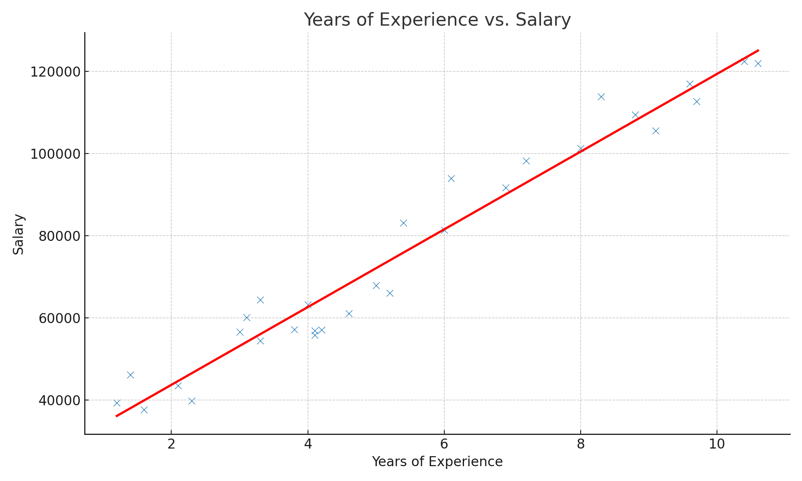

## Strength of the Relationship

R-squared = 0.957

This indicates that 95.7% of the variability in salary can be explained by years of experience.

Pearson correlation coefficient = 0.978

This suggests a very strong positive correlation between years of experience and salary.

## Interpretation of the Results

Intercept (24,848.20): Base salary for someone with 0 years of experience.

Slope (9,449.96): Each additional year of experience is associated with an increase of approximately 9,450 ETB in salary.

The p-values are less than 0.001, indicating the model is statistically significant.

## Recommendations to the Organization

1. Salary Benchmarking:

* Use the regression model to determine fair salary offers. For example, someone with 5 years of experience can be offered approximately 72,098 ETB.

2. Market Competitiveness:

* Tying salary to experience ensures competitiveness.

3. Internal Equity:

* Adjust current employees' salaries to maintain fairness.

4. Budget Planning:

* Use the model to forecast salary expenses.