eMithran
Architecture and Design Document
Control plane run by eMithran, data plane owned by the client, Auth0 for identity
Field | Value
Version | 2.0 (replaces the 30 Oct v1 doc)
Date | 30 October 2026
Status | Draft for engineering review
Owner | eMithran engineering
Companion | eMithran PRD v2.0
Scope | Current and target architecture, identity, tenancy, isolation, pipeline, jobs, budgets, AI, security, operations, migration, standards, cleanup

In one sentence
One small NestJS monolith, one control plane and one data plane per enterprise client: tenancy enforced twice, customer data never resting on eMithran disks, and nothing added without a measured need.

Confidential. Prepared for eMithran internal planning. Market figures carry their source and date; items marked hypothesis are to be validated in pilots.

Contents
1. Summary and scope
2. Current architecture (legacy)
3. Target architecture
4. Architecture decisions
5. Components and open-source choices
6. Identity, sessions and organizations
7. Tenancy, routing and revocation
8. Database isolation: proving RLS holds
9. Data access layer and the PostgREST exit
10. Files and the CAD-to-cost pipeline
11. Jobs and workers
12. Resource budgets
13. AI gateway
14. Observability, logging and SLOs
15. Security and threat model
16. Deployment, operations and recovery
17. Migration and rollout
18. Code structure and engineering standards
19. Cleanup plan
20. Appendix

1. Summary and scope
eMithran runs all code in its own control plane. Each enterprise client keeps business data and files in its own Postgres and S3-compatible bucket. Auth0 signs people in. One small NestJS monolith enforces tenancy twice: in the application and in Postgres row-level security.
This document describes how the requirements in the PRD v2.0 are built. It covers the current architecture, the target architecture, identity, tenancy, database isolation, the CAD-to-cost pipeline, jobs, resource budgets, AI, observability, threats, operations, migration, code standards and cleanup. It resolves every P0 and P1 item from the October review.
Principle | What it means in practice
Do not add services without a measured need | No microservices, Redis, message broker or new ORM. Postgres is the queue; the monolith stays.
Two walls for tenant data | The application scopes every query to the active organization; Postgres RLS enforces the same rule underneath.
Customer data never rests on eMithran disks | Dedicated tenants: memory and per-job tmpfs only; logs carry ids, never payloads.
Vendors behind ports | Auth0, S3 and model providers sit behind small platform interfaces; feature code never imports a vendor SDK.
Boring, observable, reversible | Plain SQL migrations, OpenTelemetry everywhere, feature flags for cutover, explicit point of no return.

Review items and where they are closed
Review item | Priority | Section
Precise data promise and data-flow inventory | P0 | 10, 14 and PRD 10
One rollback policy | P0 | 17.3
Identity linking, multi-org, server-side idle timeout | P0 | 6
RLS cannot be bypassed: ownership, BYPASSRLS, FORCE RLS, SECURITY DEFINER | P0 | 8
Multi-org routing across data planes | P0 | 7
Job identity, revocation versus cache | P0 | 7.4 and 11
Worker and storage data handling | P0 | 10
Fleet migration and PostgREST-to-Kysely parity | P1 | 9 and 17
Connection and concurrency budgets; recovery ownership | P1 | 12 and 16
Three diagrams plus threat table | P2 | Figures 3, 5, 7 and section 15

2. Current architecture (legacy)
Today every runtime depends on one Supabase project for login, data, files and realtime. The browser talks to the database directly in 26 places, and the API bypasses row-level security in 177.

2.1 Current architecture diagram
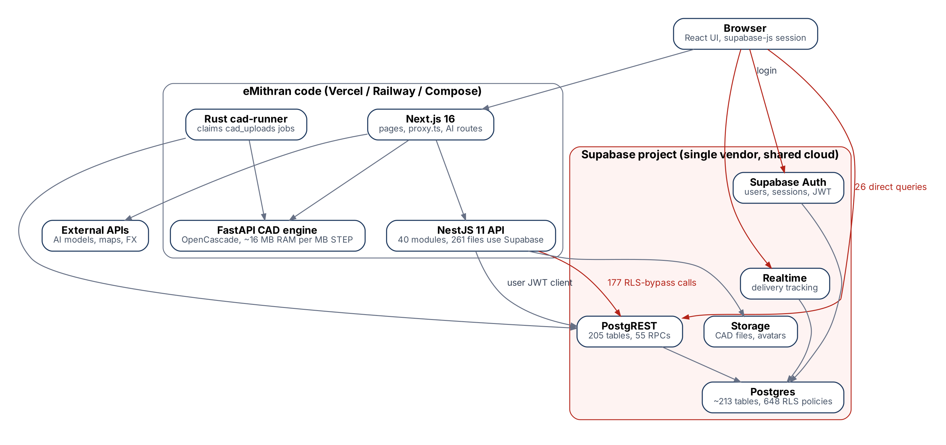
Figure 1. Current architecture. Red paths are the ones the migration removes: browser-to-database calls and RLS-bypassing service calls.

2.2 Inventory (commit 6e6f044f, 29 Oct 2026)
Area | Today | Evidence
Frontend | Next.js 16, React 19; 17 files import Supabase; 26 direct queries (organizations, workspaces, members, delivery, exchange rates, avatars, auth callback) | lib/api/organization.ts, lib/api/delivery-tracking.ts
API | NestJS 11 modular monolith, 40 feature modules; 261 files reference Supabase; 205 tables via .from(), 55 RPCs | backend/src
RLS bypass | 177 privileged call sites; worst in delivery and quality control (EA-002) | getPrivilegedClient(...)
Schema | 792 SQL files in backend/migrations plus 96 in a second tree; about 213 tables; 648 RLS policies | backend/migrations
CAD | FastAPI + OpenCascade; ~16 MB RAM per MB of STEP; 100 MB limit; 900 s watchdog; contract schema v1 | cad-engine/ARCHITECTURE.md
Jobs | Postgres queues (job_queue, cad_uploads) claimed with FOR UPDATE SKIP LOCKED; Rust cad-runner | migrations 917, 920
Migration bridge (built) | Flags DB_BACKEND, AUTH_BACKEND, STORAGE_BACKEND; Auth0 verifier; backend-minted DB token for PostgREST; S3 ObjectStore; baseline dump/load with row-count checks | docs/CUTOVER_AUTH0_POSTGRES.md
Ops | Docker Compose with Cloudflare Tunnel; OpenTelemetry to Prometheus and Grafana | docker-compose.prod.yml

2.3 What is wrong with it
Problem | Consequence | Fixed in
One vendor holds login, data and files | Cannot offer client-owned data; lock-in | Sections 3, 7
Browser queries the database | Two enforcement points; tokens in the browser | Sections 6, 9
177 RLS-bypassing calls | Cross-tenant exposure possible (EA-002) | Section 8
PostgREST as the data path | No multi-statement transactions; string-typed queries; cannot route one request to many databases | Section 9
Three migration trees | Live schema cannot be rebuilt reliably | Section 17.1
Historical secrets in git (39) and old Supabase service key | Valid credentials may exist outside the team | Section 15, gate G1

3. Target architecture
A control plane run by eMithran and one data plane per enterprise client. Only the BFF is public. The API reaches each data plane over a private path with credentials the client can revoke.
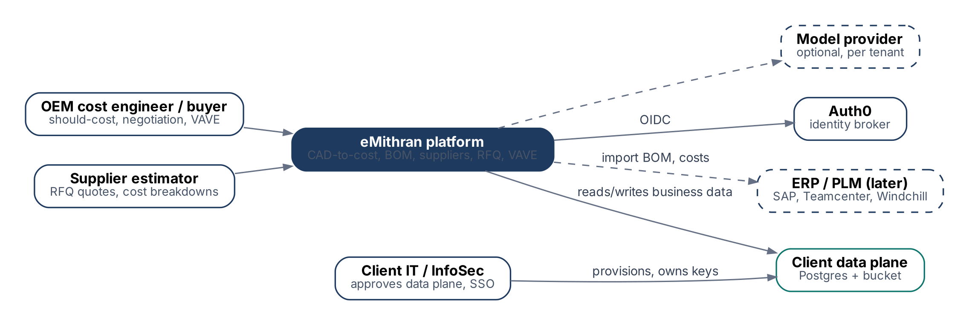
Figure 2. System context (C4 level 1): who uses eMithran and which systems it depends on.

3.1 Container view
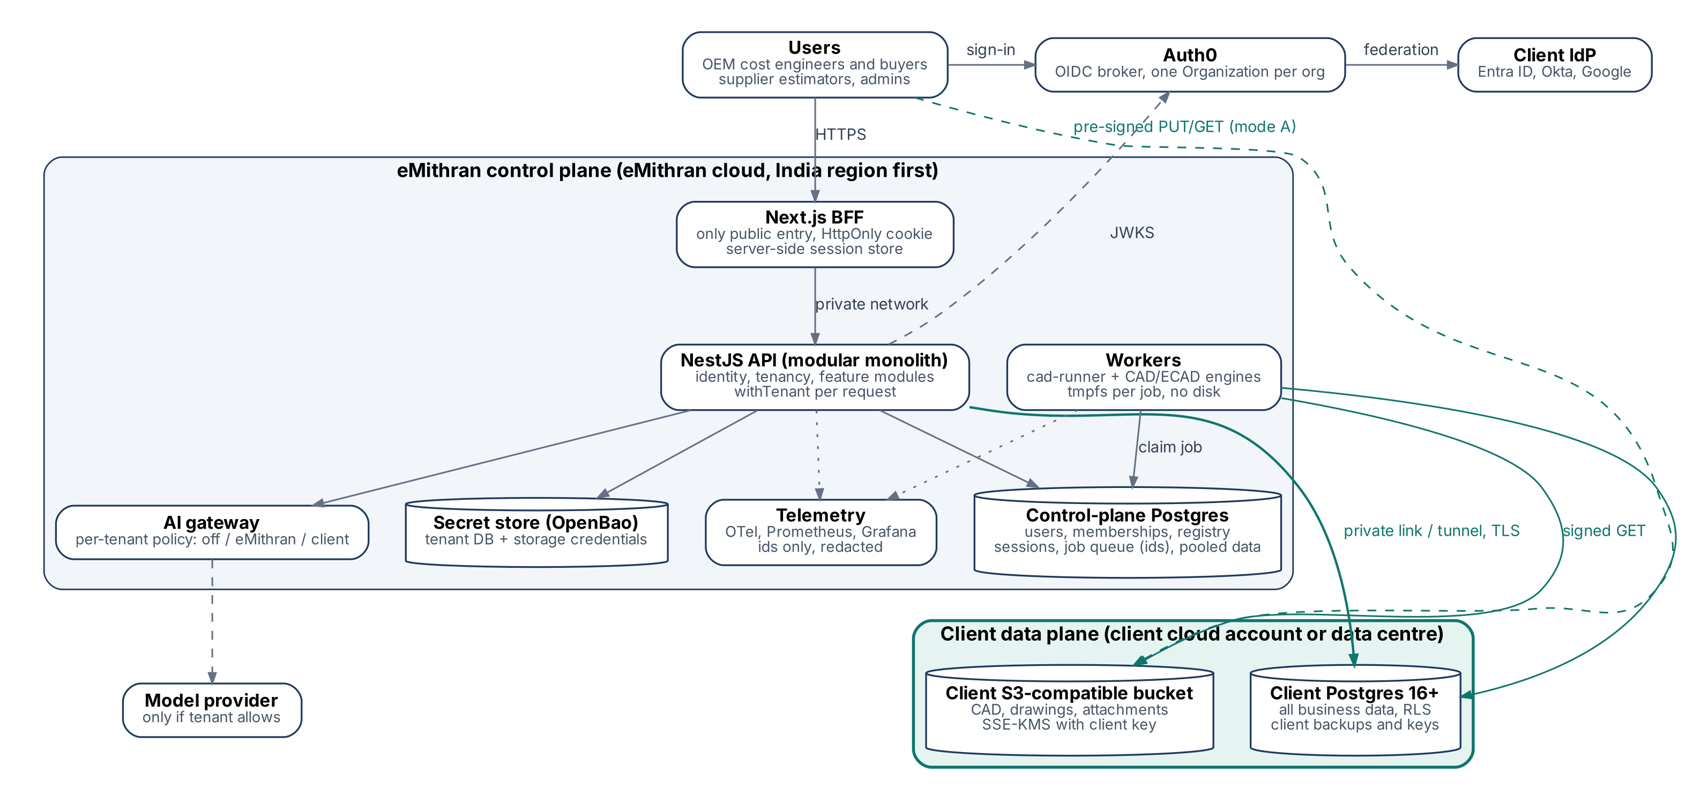
Figure 3. Container view (C4 level 2): control plane, pooled and client data planes, identity and optional AI.

3.2 Planes and responsibilities
Plane | Contains | Owned and run by
Control plane | BFF, API, workers, CAD/ECAD engines, AI gateway; control-plane database (users, identities, organizations, memberships, tenants, sessions, jobs, audit); reference data (rates, materials, process models); secret store; telemetry | eMithran
Pooled data plane | One tenant database (separate database in the eMithran cluster) and one bucket, shared by many organizations, isolated by organization_id and RLS | eMithran
Dedicated data plane | Client Postgres 16+ and S3-compatible bucket in the client account, encrypted with client keys | Client IT, or eMithran under a managed-service agreement

Reference data such as machine-hour rates, materials and process models is eMithran intellectual property. It stays in the control plane and is read by the costing engine through a cached read-only service. Client-specific rates and overrides live in the tenant database. This keeps eMithran's IP out of client environments, in line with the decision not to ship code or models to clients.
Code in tenant databases. Migrations are themselves an IP carrier: whatever they create ships into every database they run on, including a client's. Today the applied tree (backend/migrations) creates about 141 SQL functions, among them cost aggregation, supplier-nomination scoring and vendor rating, and five migrations seed calculator rows. The 58 calculator definitions under backend/migrations/calculators/ are not applied by the runner, but their content must not reach a client database either. The rule:
- Costing, scoring and rating logic, formulas and templates move to TypeScript in the API or to control-plane reference data. Tenant migrations contain schema and data mechanics only: tables, indexes, constraints, RLS policies, the tenancy helpers, triggers that emit NOTIFY or maintain timestamps, and transactional write functions with no business formulas.
- A CI rule rejects any tenant migration that creates a function whose name is not on the reviewed mechanics list (ci/tenant-functions.json). Adding a name needs review.
- A code-in-tenant inventory (generated from the catalog of a freshly migrated database) lists every function, view and seeded row a client database receives. It is part of the security questionnaire pack.

4. Architecture decisions
Ten decisions carry the design. Each one is recorded as an ADR in docs/adr before its phase starts.
ADR | Decision | Rejected alternative | Reason
001 | Control plane run by eMithran; data plane owned by the client | On-premises install | Clients keep data; eMithran keeps IP and one release train
002 | Auth0 as OIDC broker; code reads one vendor-neutral claim contract | Vendor SDK calls in features | An IdP change becomes configuration
003 | Backend-for-frontend with server-side session store | Tokens in browser JS | RFC 10017 (BCP 212) recommends BFF for business apps
004 | NestJS modular monolith | Microservices | 10-100 users per client; one deployable is cheaper to run and to reason about
005 | Kysely + node-postgres with generated types | PostgREST, Prisma, TypeORM, Drizzle | Real transactions, per-tenant routing, SQL stays SQL, schema stays in SQL migrations
006 | Every request in a tenant transaction; RLS as the second wall | App-only or RLS-only scoping | Defence in depth; closes the EA-002 class
007 | Memberships and routing in the control plane; tenant DB trusts transaction settings set only by app_user | Membership tables in every tenant DB | Needed for multi-org users across data planes
008 | Postgres is the job queue; S3 API for files | Redis, RabbitMQ, vendor SDKs | Fewer systems; already proven in the codebase
009 | Forward-only SQL migrations, expand and contract, rolled across tenants in waves | ORM-generated migrations | Many databases on different versions need reviewable SQL
010 | SSE over LISTEN/NOTIFY for live updates | Supabase Realtime, WebSockets server | One-way updates only; no extra service

4.1 What we deliberately do not build
- No service mesh, event bus or Kubernetes until replica counts or regions make Docker Compose painful (section 16.1 gives the threshold).
- No in-house password, MFA or SSO code; Auth0 and the client IdP own credentials.
- No generic repository base classes or DTO mappers; queries return the shape an endpoint needs.
- No cross-tenant analytics on client data without written consent.
- No on-premises or air-gapped edition.

5. Components and open-source choices
Every component is either open source with a permissive or well-understood licence, or a managed service with an open-source exit.
Concern | Choice | Licence | Alternatives considered | Why
Database | PostgreSQL 17 now; 18 after its first minor releases on the chosen provider | PostgreSQL | MySQL, managed Supabase | RLS, SQL functions, existing 213-table schema. PG18 (25 Sep 2025) adds async I/O, uuidv7() and OAuth auth
Pooling | PgBouncer (pooled plane, transaction mode) | ISC | Pgpool-II, Supavisor | Small, proven; transaction-local settings keep RLS safe
Data access | Kysely + node-postgres; kysely-codegen | MIT | Prisma, Drizzle, TypeORM, PostgREST | Typed SQL without an ORM model; no schema rewrite
API and web | NestJS 11, Next.js 16, zod | MIT | Express, Fastify, tRPC | Already in use
Identity | Auth0 (B2B plan, Organizations) | Proprietary | Keycloak (Apache 2.0, CNCF), Zitadel (AGPL-3.0) | Decided; exit path is configuration because code depends on OIDC only
Object storage | Cloud S3 (Mumbai) pooled; client chooses for dedicated; SeaweedFS for self-run | Apache 2.0 (SeaweedFS) | MinIO (community edition in maintenance mode since Dec 2025), Garage (AGPL-3.0), RustFS (Apache 2.0, young) | S3 API only, so any compliant store works
Secrets | OpenBao or the cloud secret manager | MPL-2.0 (OpenBao) | HashiCorp Vault (Business Source Licence) | Open-source fork with the same API
Queue | Postgres FOR UPDATE SKIP LOCKED (existing) | n/a | pg-boss, BullMQ + Redis | No new system; already in production code
Telemetry | OpenTelemetry Collector, Prometheus, Grafana, Loki | Apache 2.0; Grafana and Loki AGPL-3.0 | Datadog, OpenObserve | Already wired; run unmodified as separate services
Backups | pgBackRest (pooled, self-run) or provider PITR | MIT | WAL-G (Apache 2.0) | PITR, verified restore
Kubernetes (later) | CloudNativePG operator | Apache 2.0 | Zalando operator | Only when Kubernetes is adopted
Private network | Cloud private link / VPN; cloudflared or WireGuard tunnel | Apache 2.0 / GPL-2.0 | Public IP allow-list only | Client chooses; nothing of eMithran runs on their side
Supply chain | Trivy, gitleaks, Renovate | Apache 2.0 / MIT / AGPL-3.0 | Snyk | Already partly configured
CAD kernel | OpenCascade via pythonocc | LGPL-2.1 with exception / LGPL-3.0 | Commercial kernels | Existing engine

Licences as stated by each project; confirm AGPL obligations with counsel before redistributing any AGPL component. Running them unmodified as separate services is the intended use.

6. Identity, sessions and organizations
Auth0 proves who someone is. eMithran decides what they may do, which organization is active and which data plane serves the request. The browser holds a cookie, never a token.
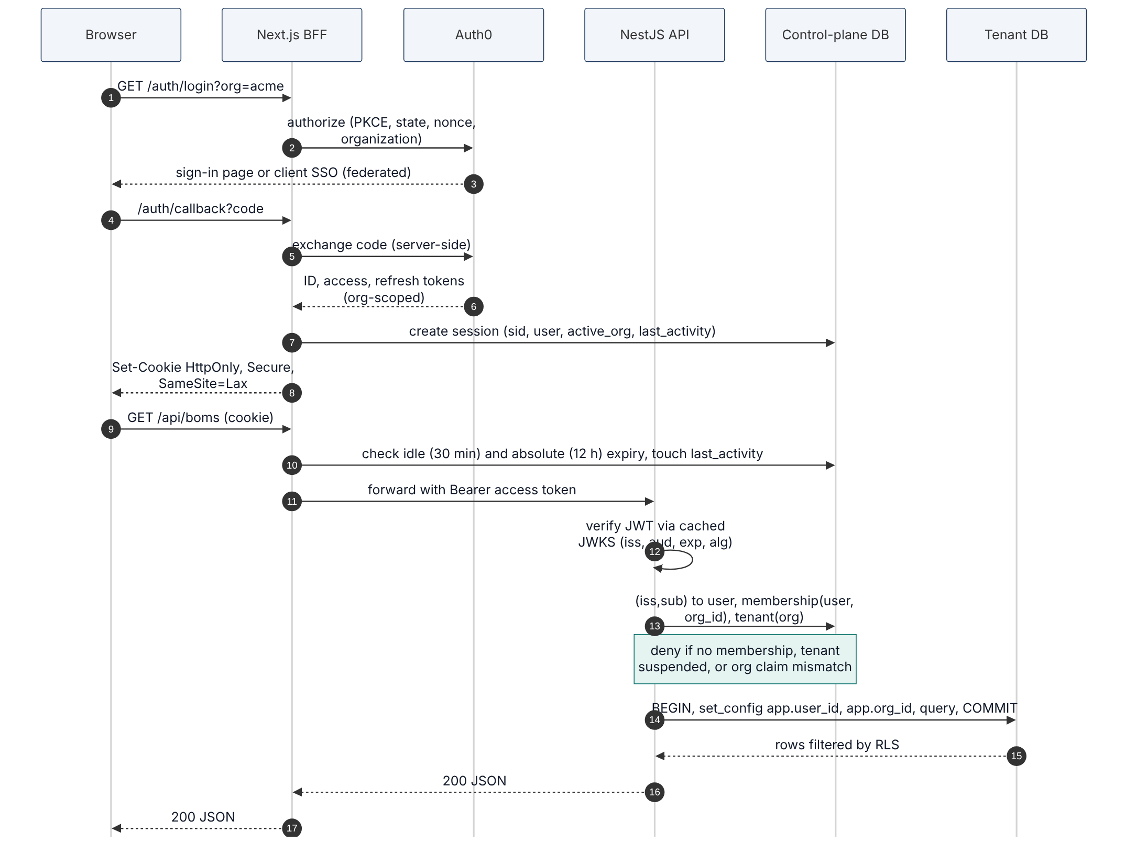
Figure 4. Sign-in, tenant resolution and data access.

6.1 Identity model
- user_identities(iss, sub) is unique and maps to one users.id. The same person can have several identities (password and Google, for example), each linked by an explicit action.
- Email is stored for display and invitations only. It is never used as a key after linking.
- Users carried from Supabase keep their internal id. Their first verified Auth0 login links by exact normalised email to a pre-provisioned row; anything ambiguous is refused and listed for an admin.

6.2 Invitations and linking
- An admin invites name@client.com to organization X with a role. The control plane stores a single-use token hash with a 7-day expiry and sends the link.
- The invitee signs in through Auth0 (in organization X). The callback compares the verified email, normalised (lower case, NFKC, trimmed), with the invitation.
- On match, the identity is linked (if new) and a membership row is created. On mismatch, nothing is linked and the user sees "this invitation was sent to a different email".
- Changed or reassigned emails never relink. A new person needs a new invitation.

6.3 Sessions and the 30-minute idle timeout
A sid identifies a session; it does not measure inactivity. The BFF therefore keeps a server-side session in the control-plane database, shared by all BFF replicas:
sessions(id uuid pk, user_id, auth0_sid, active_org_id,
created_at, last_activity_at, absolute_expires_at, revoked_at,
refresh_token_enc bytea) -- AES-GCM with a key from the secret store

- On each authenticated user request the BFF loads the session by cookie id. If now - last_activity_at > 30 min, or now > absolute_expires_at (12 h), or revoked_at is set, the session ends and the user is sent to sign in.
- It updates last_activity_at at most once a minute, so idle expiry is accurate to about 60 seconds. Background polling and SSE heartbeats do not update it.
- Access tokens last 10 minutes and are refreshed server-side with rotating refresh tokens. Reuse of an old refresh token revokes the session.
- Sign out everywhere sets revoked_at on all of the user's sessions and calls Auth0 to end the IdP session. Auth0 back-channel logout does the same when the client IdP ends a session.

6.4 Organizations and switching
- Every eMithran organization is one Auth0 Organization. Tokens are organization-scoped (org_id claim).
- Switching organization re-authenticates silently into the target Auth0 Organization, then updates sessions.active_org_id.
- On every request the API checks: token org_id equals the session's active organization, a membership row exists and is active, and the tenant is active. A tampered X-Org-Id header is ignored; the organization comes from the verified token and session.

6.5 Auth0 configuration and cost
Setting | Value
Plan | B2B Essentials while 3 or fewer enterprise SSO connections; Professional when more connections or enterprise MFA are needed
Applications | One Regular Web Application (BFF); one API (audience) with RS256
Connections | Database (sign-up off), Google, one enterprise connection per client that uses SSO
Post-login Action | Adds verified email and sid claims; blocks unverified emails from linking
Logout | Back-channel logout to the BFF endpoint

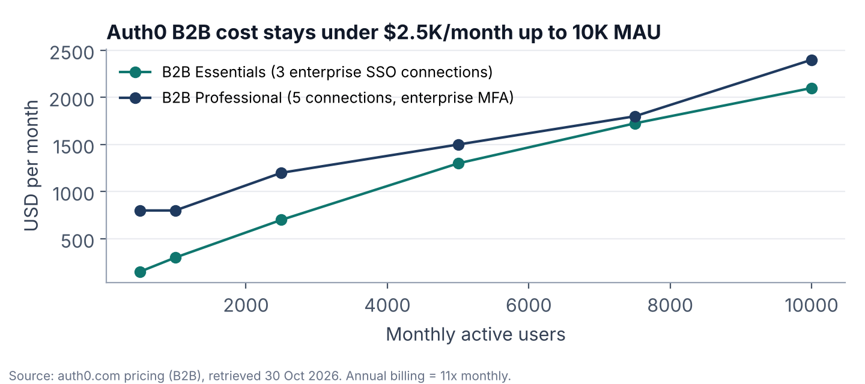
Figure 5. Auth0 B2B list price by monthly active users.

7. Tenancy, routing and revocation
Routing is keyed by organization, not by identity. One user can belong to organizations on different data planes; every request resolves exactly one organization and therefore exactly one tenant.

7.1 Data model across planes
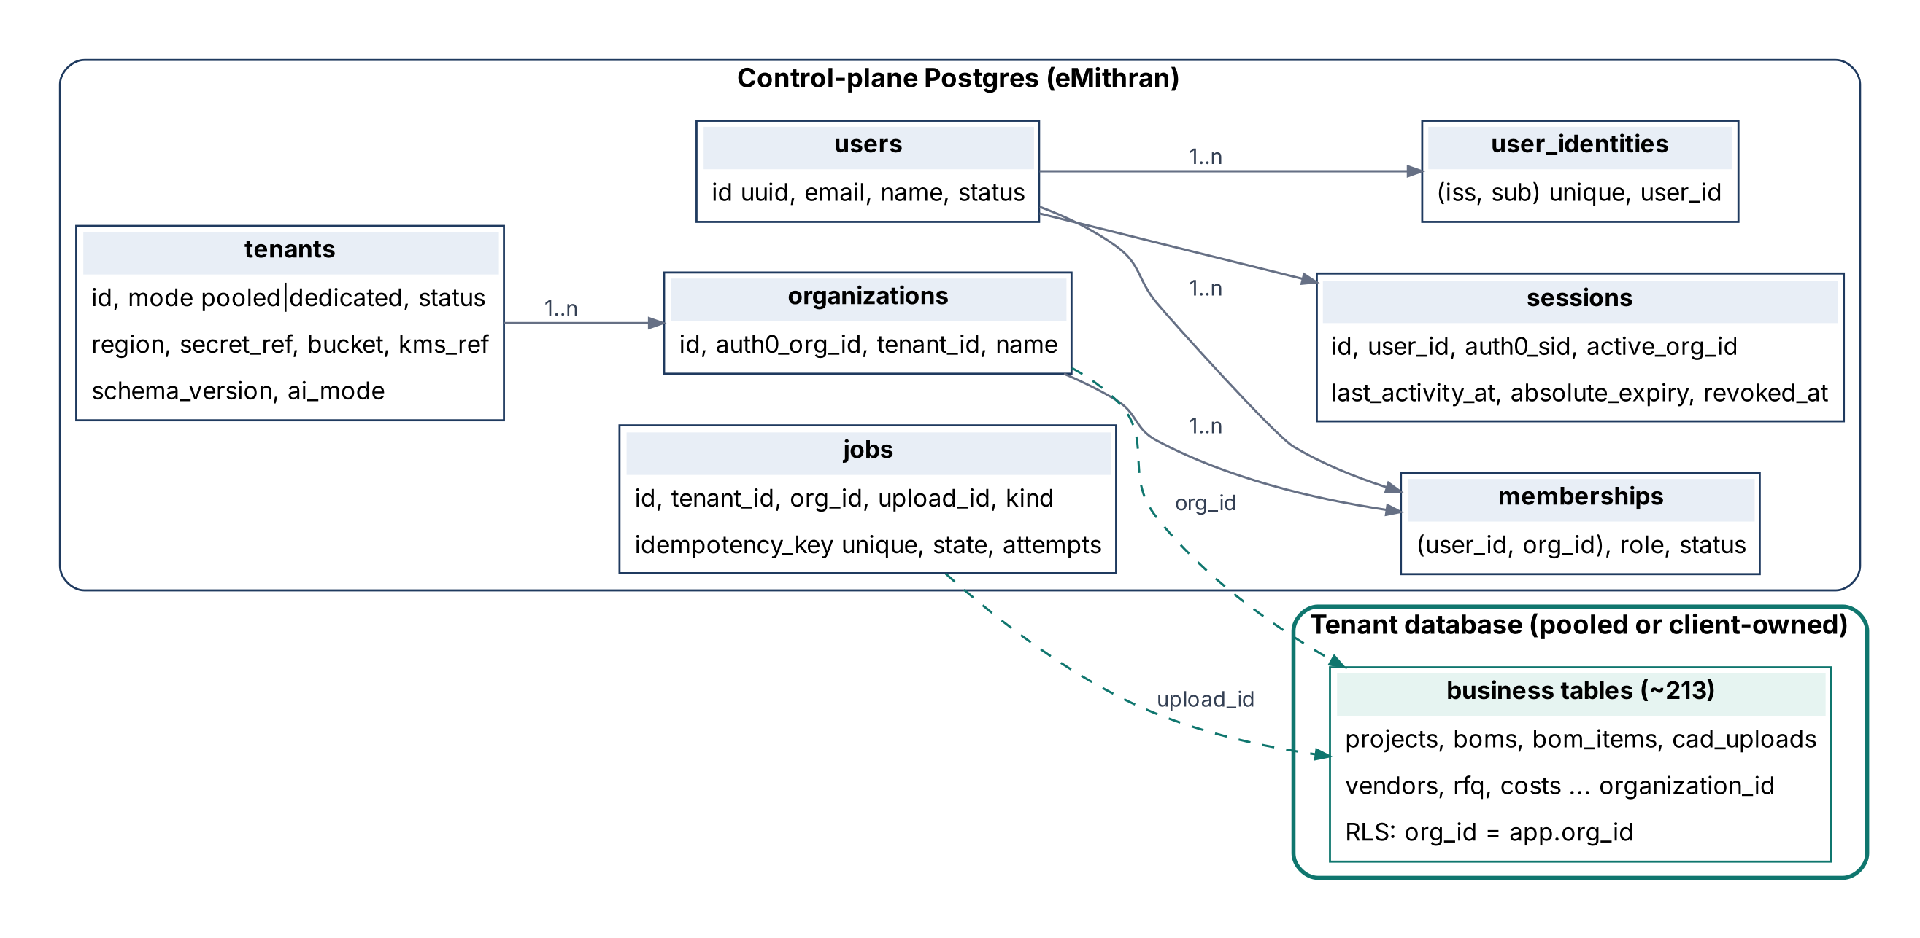
Figure 6. Control-plane tables route and authorise; tenant databases hold business data scoped by organization_id.

7.2 Resolution algorithm
resolve(request):
identity = verifyJwt(token) // iss, sub, org_id, sid
user = identities.find(identity.iss, identity.sub) or 403
session = sessions.get(cookie) must match user and sid or 401
org = identity.org_id == session.active_org_id or 403
member = memberships.active(user, org) or 403
tenant = registry.get(org.tenant_id) status == 'active' or 503
return { userId: user.id, orgId: org.id, role: member.role, tenant }

Cardinality is explicit: user 1..n identities, user 1..n memberships, organization 1 tenant, tenant 1..n organizations. A pooled tenant hosts many organizations; a dedicated tenant normally hosts one.
A guest supplier (section 7.5) resolves differently: there is no membership, so the resolver checks an active guest grant instead and returns { userId, orgId: the OEM's organization, role: 'guest_supplier', rfqId, tenant }. Every query a guest can reach is additionally scoped to that one RFQ.

7.3 Registry caching
- Registry and membership lookups are cached in each API and worker process for at most 15 seconds.
- Any change to tenants or memberships fires a Postgres NOTIFY (tenant_changed, membership_changed); every process evicts the entry immediately.
- If the notification listener disconnects, the cache is cleared and the 15-second limit applies until it reconnects. This keeps the worst case well inside the 60-second revocation target.

7.4 Revocation paths
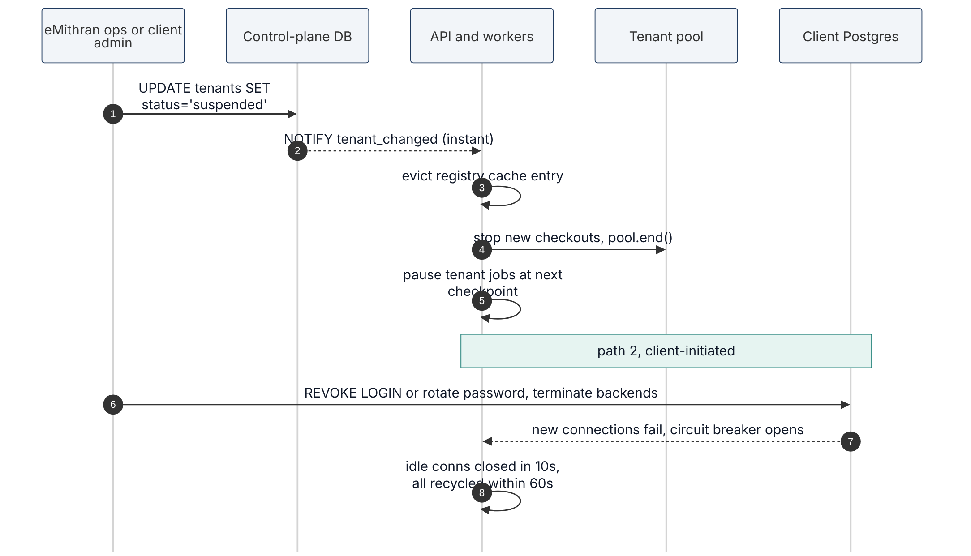
Figure 7. Revocation: eMithran-initiated suspension and client-initiated credential revocation.
Path | Database | Storage | Worst case
eMithran suspends tenant | NOTIFY evicts cache; pools ended; new checkouts refused | No new signed URLs issued; STS sessions not renewed | No new operation after 60 s; issued links expire within 5 min
Client revokes role or rotates password | Revoking table or schema privileges applies to the next statement on every open connection. A password change or NOLOGIN stops new connections at once; open ones end within 30 min (max lifetime). The supplied revocation script does both and ends eMithran's sessions with pg_terminate_backend | n/a | Immediate with the script or a privilege revoke; up to 30 min for a password change alone
Client disables KMS key or adds bucket deny policy | n/a | All reads and writes fail at once | Immediate
Client removes cross-account role trust | n/a | Existing STS credentials valid until expiry | Up to 15 min (STS duration); use KMS or bucket policy for instant cut

7.5 Supplier collaboration
An OEM sends RFQs to suppliers who are not members of its organization. Two models, in this order:
Model | How it works | When
Guest supplier access | The OEM invites a supplier contact to one RFQ. The invitation is single-use and expires; the supplier signs in with an email one-time code (Auth0 passwordless) and gets a guest grant scoped to that RFQ. The supplier sees the RFQ, its drawings and CAD through 5-minute signed URLs, and submits a quote. Everything, including the quote, stays in the OEM's data plane. | Pilots
Organization-to-organization exchange | A supplier with its own eMithran organization receives a copy of the RFQ in its own data plane. Each side keeps its own copy; the OEM consents per RFQ before anything is copied, and the copy carries only the documents the OEM selected. | When two paying organizations need it

Rules for guests:
- A guest grant names one RFQ, one OEM organization and one identity; it expires when the RFQ closes or after 30 days, whichever comes first, and the OEM can revoke it at any time.
- Guests never see organization data outside the RFQ, never join the organization, and cannot invite others.
- Grants, views, downloads and quote submissions are audit events.
- CAD and drawings are never sent as email attachments. Invitation emails carry a link only.

8. Database isolation: proving RLS holds
RLS only protects data when the requesting role does not own the tables, cannot bypass RLS and cannot call a function that leaks across tenants. Each of these is checked by a catalog query in CI, and each query must return zero rows.

8.1 Roles (every tenant database)
Role | Login | Rights | Used by
emithran_owner | No | Owns all schema objects | Nobody connects as it; migrations SET ROLE to it for DDL
migrator | Yes | Member of emithran_owner; BYPASSRLS for data backfills | Fleet migration job only
app_user | Yes | DML on tenant tables; NOBYPASSRLS; owns nothing; CONNECTION LIMIT 20 | API and workers for user requests
app_system | Yes | BYPASSRLS; limited grants | Allow-listed system jobs: exports, deletion, reconciliation
authenticator / authenticated / service_role | As today | PostgREST bridge | Removed in phase 4

8.2 Rules
- Every tenant table has ENABLE and FORCE ROW LEVEL SECURITY. FORCE applies policies even to the owner, so a mistaken owner connection still cannot read across organizations.
- Policies read app.org_id and app.user_id from transaction-local settings. The existing helper functions are redefined to read them, so the 648 existing policies keep working unchanged.
- Only app_user and app_system can connect from eMithran, and only the API sets the settings, after resolution (section 7.2).
- Every SECURITY DEFINER function pins search_path (pg_catalog, public), revokes EXECUTE from PUBLIC, is granted to named roles only, and checks app.org_id inside. New ones need security review and an allow-list entry.
- Views use security_invoker = true (Postgres 15+) so the caller's RLS applies.
- Global read-only tables (unit lists, enumerations) are on an explicit allow-list with SELECT-only policies.
-- helper used by existing policies: now reads the transaction setting
CREATE OR REPLACE FUNCTION public.current_user_org_ids() RETURNS SETOF uuid
LANGUAGE sql STABLE SET search_path = pg_catalog, public AS $$
SELECT nullif(current_setting('app.org_id', true), '')::uuid
$$;

8.3 Catalog checks run in CI (each must return zero rows)
-- 1. tenant tables without RLS enabled and forced
SELECT c.relname FROM pg_class c
WHERE c.relnamespace = 'public'::regnamespace AND c.relkind = 'r'
AND (NOT c.relrowsecurity OR NOT c.relforcerowsecurity)
AND c.relname NOT IN (SELECT name FROM ci.global_tables);

-- 2. request roles that bypass RLS or own objects
SELECT rolname FROM pg_roles WHERE rolname = 'app_user' AND (rolbypassrls OR rolsuper);
SELECT c.relname FROM pg_class c WHERE c.relowner = 'app_user'::regrole;

-- 3. SECURITY DEFINER functions without a pinned search_path, or not reviewed
SELECT p.oid::regprocedure FROM pg_proc p
WHERE p.pronamespace = 'public'::regnamespace AND p.prosecdef
AND (p.proconfig IS NULL OR NOT EXISTS (SELECT 1 FROM unnest(p.proconfig) s WHERE s LIKE 'search_path=%')
OR p.oid::regprocedure::text NOT IN (SELECT signature FROM ci.reviewed_definers));

-- 4. functions any role can execute
SELECT p.oid::regprocedure FROM pg_proc p
WHERE p.pronamespace = 'public'::regnamespace AND has_function_privilege('public', p.oid, 'EXECUTE');

-- 5. views that do not run with the caller's rights
SELECT c.relname FROM pg_class c
WHERE c.relnamespace = 'public'::regnamespace AND c.relkind = 'v'
AND NOT coalesce('security_invoker=true' = ANY (c.reloptions), false);

8.4 Isolation test matrix
Test | Runs as | Expect
Org B user reads, updates, deletes org A rows in each module | app_user with B settings | 0 rows, 0 affected
Org B calls every RPC with org A ids | app_user with B settings | Error or empty
Read every view as org B | app_user | Only B rows
Missing settings (no app.org_id) | app_user | 0 rows everywhere
Same identity, org A on pooled and org B on dedicated | Through the API | Never sees A while B is active
Tampered X-Org-Id and stale membership | Through the API | 403
Job for org A replayed with tenant B id | Worker | Rejected (section 11.2)
Signed URL for org A requested by org B | Through the API | 403
Guest for RFQ 1 reads RFQ 2 of the same OEM | Through the API | 403
Guest reads any non-RFQ module (BOMs, costing, vendors) | Through the API | 403
Guest after the grant is revoked or expired | Through the API | 401 or 403 on the next request

Tests run against a real Postgres built from the migrations, with the exact production roles, on every merge (Testcontainers).

9. Data access layer and the PostgREST exit
Feature code touches data only through withTenant. PostgREST stays as a bridge while modules are ported one by one behind contract tests.
// platform/db/with-tenant.ts - the only way feature code reaches tenant data
export async function withTenant<T>(ctx: TenantContext, work: (db: Kysely<DB>) => Promise<T>): Promise<T> {
const db = dataPlanes.forTenant(ctx.tenant); // pooled or dedicated Kysely instance
return db.connection().execute(async (conn) => {
// ids were validated as UUIDs at the edge, so BEGIN and both settings go in one round trip
await sql.raw(beginWithSettings(ctx.userId, ctx.orgId)).execute(conn);
try { const result = await work(conn); await sql`commit`.execute(conn); return result; }
catch (error) { await sql`rollback`.execute(conn); throw error; }
});
}

// modules/boms/boms.repository.ts - a repository is just queries
export const listBoms = (tx: Transaction<DB>, projectId: string) =>
tx.selectFrom('boms').select(['id', 'name', 'updated_at'])
.where('project_id', '=', projectId).orderBy('updated_at', 'desc').execute();

- set_config(..., true) is transaction-local, so it is safe behind PgBouncer in transaction mode and cannot leak to the next request on the same connection.
- Repositories still filter by organization where the table has organization_id: the application wall does not rely on RLS.
- SQL functions are allowed in tenant databases only for data mechanics (section 3.2): for example a transactional multi-row write with no formulas. Costing, scoring and rating logic lives in TypeScript.
Round-trip budget per request. Distance, not the number of round trips, decides whether the latency target can be met: in one cloud region a round trip costs about 1 ms, between India and the EU about 110-130 ms.
Step | Round trips | Rule
BFF session lookup (control DB) | 1 | last_activity is written at most once a minute
BEGIN and tenant settings | 1 | One statement (above); values validated as UUIDs first
Queries | 1 or more | Batch endpoints; no N+1 queries; contract tests assert query counts on hot paths
COMMIT | 1
New connection (TCP, TLS, SCRAM) | about 4-5 | Avoided on the hot path by keeping one warm connection per active tenant (section 12)

A dedicated data plane is therefore supported only in a cloud region where eMithran runs API and worker compute (section 16.1).

9.1 Porting a module from PostgREST to Kysely
- Record contract tests from current API responses with two-organization fixtures: nulls, empty results, errors and status codes, pagination order, filters, RPC side effects, RLS outcomes.
- Rewrite the module's repository on Kysely inside withTenant. Keep response shapes identical.
- Run contract and isolation tests. For read-heavy modules, run a shadow comparison in stage for a day.
- Ship behind a per-module flag; remove the PostgREST path in the next release once error rates match.
Behaviour that often differs | Check
NULL versus missing keys in JSON | Snapshot compare with exact keys
Default ordering | Every list query has an explicit ORDER BY
Error shape and status | Map Postgres error codes in one place; contract tests assert status and code
Count and range headers | Pagination contract test
Transaction scope of RPC side effects | Integration test asserts all-or-nothing

10. Files and the CAD-to-cost pipeline
Files go between the browser and the client bucket directly when the network allows it, and through a streaming BFF path when it does not. Workers process each file in a per-job memory workspace that is always deleted.
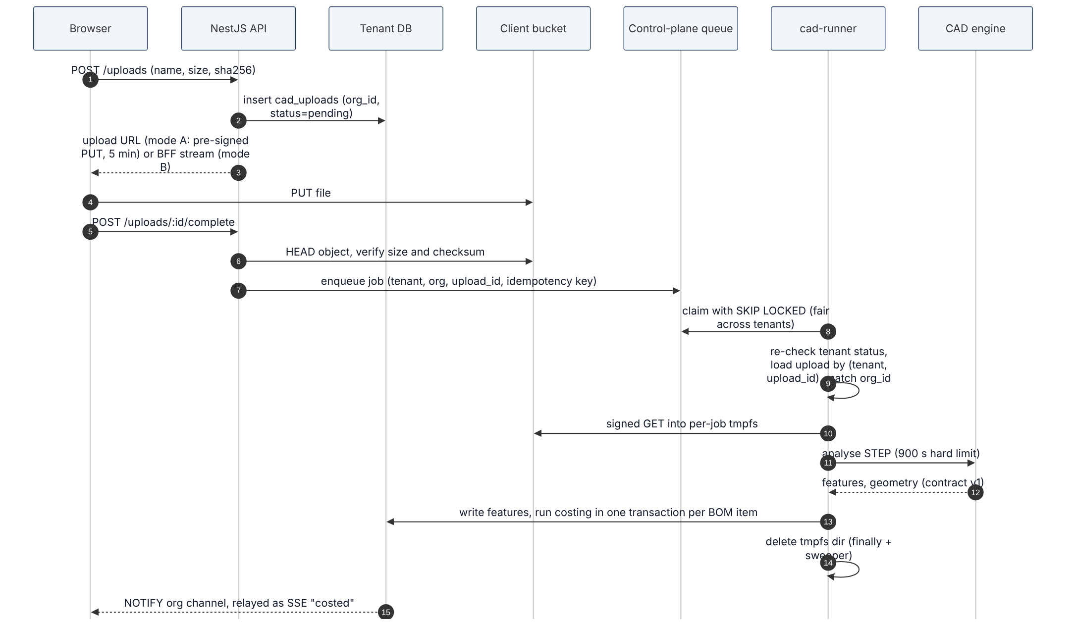
Figure 8. Upload to CAD analysis to cost.

10.1 Two file modes
Mode | When | How | Data on eMithran
A. Direct signed URL | Bucket reachable from the user's network | Pre-signed PUT and GET, 5-minute expiry, content-length and checksum bound | None
B. Streamed | Private bucket reachable only from eMithran | BFF streams the request body to the API, which streams to the bucket; no buffering to disk; 100 MB cap enforced while streaming | Bytes in memory during transfer

10.2 Worker data handling
Risk | Control | Test
File left on disk | Per-job directory on tmpfs; deleted in finally; sweeper at start-up and every 5 min removes directories older than 30 min | Kill the worker mid-job; directory gone after restart
Swap writes memory to disk | Swap disabled on worker hosts; tmpfs mounted noswap where the kernel supports it | Host check in deployment pipeline
Core dumps hold file contents | ulimit -c 0 and container core-dump disabled; crash reporters off | Force a segfault in stage; no core file
Logs or traces hold content | Allow-list logger; file names hashed; URL query strings stripped; payload bodies never logged | Canary file name and canary text never appear in telemetry
Oversized or hostile files | 100 MB limit, extension and magic-number checks, zip-bomb ratio limit, 900 s hard limit per analysis | Fuzz and boundary tests
Checksum mismatch | API verifies size and SHA-256 after upload before enqueueing | Corrupted upload rejected
Signed URL leakage | 5-minute expiry; scoped to one object and method; never logged | Expired URL returns 403

10.3 Live updates
Tenant tables fire NOTIFY on status changes (upload, costing, delivery). The API holds one listener connection per active tenant and relays events to browsers over Server-Sent Events on an organization channel. This replaces Supabase Realtime and the DeliveryTracking postgres_changes subscription.

11. Jobs and workers
The control-plane jobs table carries ids only. Tenant context comes from the authenticated request that created the job and is re-verified before any credential is used.
jobs(id uuid pk, tenant_id, org_id, upload_id, kind,
idempotency_key text unique, -- tenant_id:upload_id:kind
created_by uuid, state, attempts, max_attempts, run_at, locked_at, error, created_at, finished_at)

11.1 Claiming fairly
UPDATE jobs SET state = 'running', locked_at = now(), attempts = attempts + 1
WHERE id = (
SELECT j.id FROM jobs j
WHERE j.state = 'queued' AND j.run_at <= now()
AND (SELECT count(*) FROM jobs r -- soft per-tenant cap
WHERE r.tenant_id = j.tenant_id AND r.state = 'running') < 2
ORDER BY j.run_at
FOR UPDATE SKIP LOCKED
LIMIT 1)
RETURNING *;

11.2 Binding and replay protection
- Only the API (role api_jobs in the control plane) can insert jobs, and only after resolving the request (section 7.2). The browser never supplies tenant or organization ids.
- The idempotency key tenant_id:upload_id:kind is unique, so duplicate submissions collapse into one job.
- Before using credentials, the worker re-reads the tenant (must be active), loads the upload by (upload_id) from that tenant's database and checks that its organization_id equals the job's org_id. Any mismatch fails the job with a security event.
- Workers write results through withTenant with the job's org id, so RLS applies to worker writes too.
- Retries back off exponentially up to max_attempts; a job stuck in running longer than the hard limit is reclaimed; suspended tenants' jobs move to paused.

12. Resource budgets
Budgets are set per tenant and fleet-wide so one tenant cannot exhaust a client database or starve others.
Resource | Budget | Why
Dedicated tenant, API pool | Max 4 connections per API replica; min 1 while the tenant is active; idle close 5 min; max lifetime 30 min with random jitter of up to 10% | Avoids reconnect cost (4-5 round trips) on the hot path; jitter stops all connections recycling at once; revocation is immediate through the client's revocation script (section 7.4)
Dedicated tenant, worker pool | Max 2 per worker handling that tenant; created lazily | Per-tenant job cap is 2
Client DB requirement | app_user CONNECTION LIMIT 20; client max_connections leaves headroom | 3 API replicas x 4 + 2 jobs x 2 = 16 at peak
Pools per API replica | At most 50 dedicated tenant pools; least recently used closed | Bounded memory
Pooled plane | PgBouncer transaction mode, pool 20 per database user; Postgres max_connections 200; managed Postgres with a multi-AZ standby | Standard sizing for a small cluster; failover in under 5 min (section 16.4)
CAD engine | 1 analysis per engine container; container memory 4 GB (1.6 GB peak for 100 MB STEP plus 1 GB tmpfs) | ~16 MB RAM per MB of STEP measured
Jobs per tenant | 2 running at once (soft cap); others queued | Fairness
API rate limit | 600 requests per minute per user; uploads 30 per hour per user | Abuse and runaway clients

13. AI gateway
All model calls go through one module that enforces the tenant's AI mode. Default is off for dedicated tenants.
Mode | Behaviour | Data sent
off | AI features hidden; gateway refuses calls | None
emithran_provider | eMithran's contracted provider; zero data retention and no training required by contract; region pinned | Only the extracted text or image needed for the task; no file names or ids
customer_endpoint | Client's own endpoint (for example their Azure OpenAI); credentials in the secret store | Same, sent to the client endpoint

- The mode lives in tenants.ai_mode; only a tenant owner can change it; every change is audited.
- Prompts and responses are never logged; metrics record tokens, latency and outcome only.
- Copilot memory is scoped per organization (the cross-tenant memory bug EA-014 is already fixed and covered by tests).

14. Observability, logging and SLOs
Telemetry is built for operations, not for content: ids, timings and outcomes, tagged by tenant.
Signal | Content | Retention
Traces | Span names, durations, status, tenant_id, org_id, request_id; no attributes with bodies or URLs with queries | 7 days
Logs | Allow-listed fields only; file names hashed; errors with codes, not payloads | 30 days
Metrics | Latency, error rate, queue age, pool usage, data-plane reachability per tenant | 13 months
Audit events | Sign-in, role change, org switch, export, deletion, AI mode change, support access, registry change | 1 year (DPDP Rule 8(3)), then erased

14.1 SLOs and alerts
SLO / alert | Target or trigger
Availability (BFF probe, India region) | 99.5% monthly internal SLO; 99.0% contractual until six months of measured data exist (PRD 8.3)
API latency (load-test conditions in PRD 8.3) | Server time measured at the BFF, in region: p95 200 ms pooled, 250 ms dedicated in-region, 800 ms dedicated cross-region (only where a contract states it)
User-perceived latency | Reported per user region, not an SLO; the user's own network path is outside eMithran's control
Error budget | When the month's availability budget is spent, risky deploys (schema changes, infrastructure, new flags on) are frozen until the next month or a written exception
Secret store errors or rotation failure | Alert on the first error (section 16.5)
Tenant data plane unreachable | Alert after 2 minutes; status page entry for that tenant
Queue age | Alert when the oldest queued job is older than 10 minutes
Migration wave failure | Page on first failure; wave halts
Auth failures | Alert on a 5x spike over the 7-day baseline
Log canary | Page if a canary value ever appears in logs or traces

15. Security and threat model
Every threat maps to a control and a test. The table is reviewed at each phase gate.
Threat | Control | Test
Tenant spoofing (tampered org header or token) | Org from verified token + session; membership check each request | Tampered header and stale membership tests
Cross-tenant query bug | withTenant + organization filter + FORCE RLS | Isolation matrix (8.4)
SECURITY DEFINER leak | Pinned search_path, reviewed allow-list, org check inside | Catalog check 3 and 4
Job replay or tampering | Jobs only from API; idempotency key; worker re-verifies upload org | Replay test with changed tenant id
Tenant credential leakage | Secret store; short-lived where possible; rotation 30-90 days; never in logs | Secret scan; log canary
Signed URL abuse | 5-minute expiry, single object and method, never logged | Expired and cross-org URL tests
Residual customer data on workers | tmpfs, swap off, no core dumps, sweeper | Crash injection test
Token theft via XSS | BFF; HttpOnly cookies; CSP | No token reachable from JS (automated check)
CSRF | SameSite=Lax plus CSRF token on state-changing BFF routes | CSRF test suite
SSRF through file proxy | HTTPS only, host allow-list, redirects rejected (EA-004 fixed) | Existing 15 route tests
Hostile CAD file | Size, type, ratio and time limits; engine runs unprivileged in a container | Fuzz corpus in CI
Noisy neighbour | Per-tenant job cap, pool caps, rate limits | Load test with one hot tenant
Insider or support misuse | Support access only by client-granted, time-boxed, audited grant | Quarterly access review
Supply chain | Pinned images by digest, Trivy, gitleaks, SBOM per release | CI gates
AI data leakage | Per-tenant AI mode; zero-retention contract; no prompt logging | Mode-off test blocks calls

16. Deployment, operations and recovery
Start on Docker Compose in one India region. Move to Kubernetes only when the numbers say so.

16.1 Environments and topology
Item | Now | Move when
Environments | dev (local data stack), stage, prod | n/a
Region | India (Mumbai, ap-south-1) for control plane, pooled data plane and all compute. A dedicated data plane is supported only in a region where eMithran runs API and worker compute | Add a Frankfurt compute cell when the first EU client signs; a cross-region data plane needs its own contractual latency SLO
Runtime | Docker Compose with profiles on 2-3 VMs behind Cloudflare Tunnel | Kubernetes when more than 6 replicas of any service, or a second region
Control-plane DB | Managed Postgres with a multi-AZ standby, automatic failover and PITR; backups copied to a second region | n/a
Pooled data plane DB | Same as the control-plane DB | n/a
Secret store | AWS Secrets Manager with KMS in the control-plane region, replicated to the DR region (section 16.5) | n/a
Deploys | Image per commit, pinned by digest; blue-green per service; migrations before code (expand) | n/a

16.2 Onboarding a dedicated tenant
- Client provisions Postgres 16+ and a bucket from eMithran's published Terraform module (it creates resources only; it contains no eMithran application code).
- Client creates the roles (section 8.1) and the KMS key, and grants eMithran a cross-account role for the bucket.
- Network: private link, VPC peering, VPN, or outbound tunnel; eMithran's fixed egress IPs allow-listed.
- Credentials are submitted through the secret-store intake, never by email.
- eMithran registers the tenant, applies the current schema, runs connectivity, catalog and isolation checks, then creates the Auth0 Organization and the enterprise connection.
Schema changes reach a client database in one of two ways, chosen at onboarding:
- eMithran's fleet migrator runs them with the migrator role (section 17.2).
- A reviewed SQL bundle goes to the client's DBA, who applies it in their window and reports the resulting schema_version. eMithran verifies it with the catalog checks before routing traffic. This suits DBAs who will not grant DDL rights or BYPASSRLS.
Both are acceptable because tenant migrations carry schema and data mechanics only (section 3.2).

16.3 Who does what (dedicated tenants)
Activity | eMithran | Client
Application, control plane, queue, workers | Responsible | Informed
Client Postgres and bucket | Consulted (responsible under managed option) | Responsible
Backups and restore of client data | Consulted; joins quarterly drill | Responsible
Schema migrations on client DB | Responsible (fleet migrator) | Approves maintenance window
Network path | eMithran side | Client side
Incident response | Leads for eMithran scope | Leads for client infrastructure

16.4 Recovery and reconciliation
Event | Procedure
Database instance or availability-zone failure (pooled or control plane) | Automatic failover to the multi-AZ standby, under 5 min; counts against the 99.5%
Application or host failure | 2 or more replicas per service behind the tunnel; seconds
Data corruption or bad migration (pooled) | Point-in-time restore: RPO 5 min, RTO under 2 h for a database under 100 GB, proven by the monthly drill; a declared incident that counts against the 99.5%; replay queued jobs; reconcile files
Client restores their DB to time T | Pause tenant; mark jobs for uploads missing after T as orphaned; flag uploads whose files are missing; list objects without rows for the client (never auto-delete); resume
Client bucket restore | Same reconciliation, from the file side
Control-plane DB loss | PITR; sessions invalidated (users sign in again); jobs in running re-queued idempotently
Region loss | Restore control plane and pooled plane in the second region from cross-region backups: RTO 4 h, RPO 15 min. A disaster, excluded from the availability SLA and covered by DR terms in the contract (PRD 11.5); client data planes unaffected

16.5 Secret store failure mode
The secret store is needed only when a pool is created or a credential rotates, so an outage must not affect running traffic.
Measure | Effect
Managed AWS Secrets Manager with KMS, not a self-run Vault cluster | No cluster to operate
Credentials cached in process memory; on a store error the cached value is used for up to 24 h | Existing and new pools keep working during an outage
Health checks never call the secret store | A store outage cannot take down healthy replicas
Rotation with two database users (A/B), switching only after the new one is verified | A failed rotation never locks eMithran out
Secrets replicated to the DR region; deleted secrets recoverable within the 7-30 day recovery window | Covers region loss and accidental deletion
Alert on any store error or rotation failure | Problems surface well before the 24-hour cache runs out
Re-issue runbook: clients issue new credentials through the same intake, about 1 hour per tenant | Last resort that needs no escrow of client passwords

A new replica cannot start while the store is down: the runbook says not to deploy during a store outage, and the running replicas carry traffic.

17. Migration and rollout
Five phases, each closed by a gate. The cutover in phase 1 is reversible until the point of no return and forward-fix only after it.
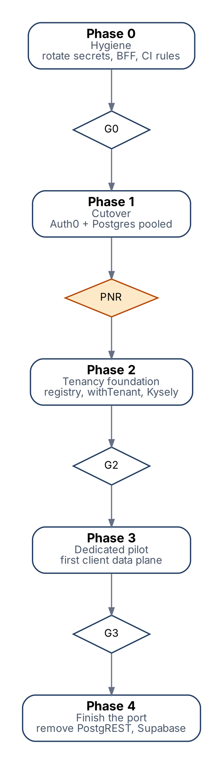
Figure 9. Phases and gates. PNR = point of no return.
Phase | Work | Exit gate
0 Hygiene | Rotate 39 historical secrets and the Supabase service key; BFF route handler; CI rules (no browser DB, no new privileged calls); squash migrations to a verified baseline | G1 Security
1 Cutover | Load Postgres from baseline, copy files with hash check, link identities, flip flags in stage then prod | PNR (section 17.3)
2 Tenancy foundation | Control-plane tables, registry, sessions, withTenant, Kysely platform layer; browser queries moved behind NestJS; delivery and QC tenancy fix; SSE | G2 Isolation
3 Dedicated pilot | First client data plane; reference data served from control plane; AI gateway | G3 + G4 for that tenant
4 Finish the port | Remaining modules to Kysely; delete PostgREST, Supabase code and the three backend flags | @supabase imports = 0; privileged calls in features = 0

17.1 Canonical migration source
- After phase 0 the only migration source is backend/migrations, starting at 0000_baseline.sql generated from the production schema. Older trees are kept in git history under the tag pre-squash.
- The baseline is verified: build an empty database from it, dump the schema, normalise and diff against production. The diff must be empty before old files are deleted.

17.2 Fleet migrations
Rule | Detail
State per tenant | pending, running, succeeded, failed, paused - stored in the registry with schema_version
Order | Stage copy, then pooled, then dedicated tenants in waves of 3; a failure halts the wave
Safety | lock_timeout 5 s; statement_timeout declared per migration; long backfills run in batches as app_system
Retry | Only migrations marked idempotent are retried automatically; others need an engineer
Compatibility | Application supports schema N and N-1; contract step only after all tenants reach N
Drill | A deliberate canary failure is part of the stage drill before each phase gate

17.3 Recovery policy (same as PRD 12.1)
Window | Authoritative | Recovery
Cutover window (write freeze) | Supabase, read-only | Abort: flip flags back; nothing written to the new stack
After cutover, before PNR | New Postgres | Rollback only if no customer writes occurred, or if they can be replayed from the audit log by a tested script; otherwise forward-fix
After PNR | New Postgres | Forward-fix only; Supabase read-only 30 days for forensics, then deleted

PNR is declared in writing when row counts and file hashes match, every active user has linked, the 2-week soak had no Sev-1 or Sev-2 incident, and a restore drill on the new database passed.

18. Code structure and engineering standards
A thin platform layer owns every outside system, feature modules own their tables, and the costing domain is pure. Conventions are enforced by lint, not by base classes.
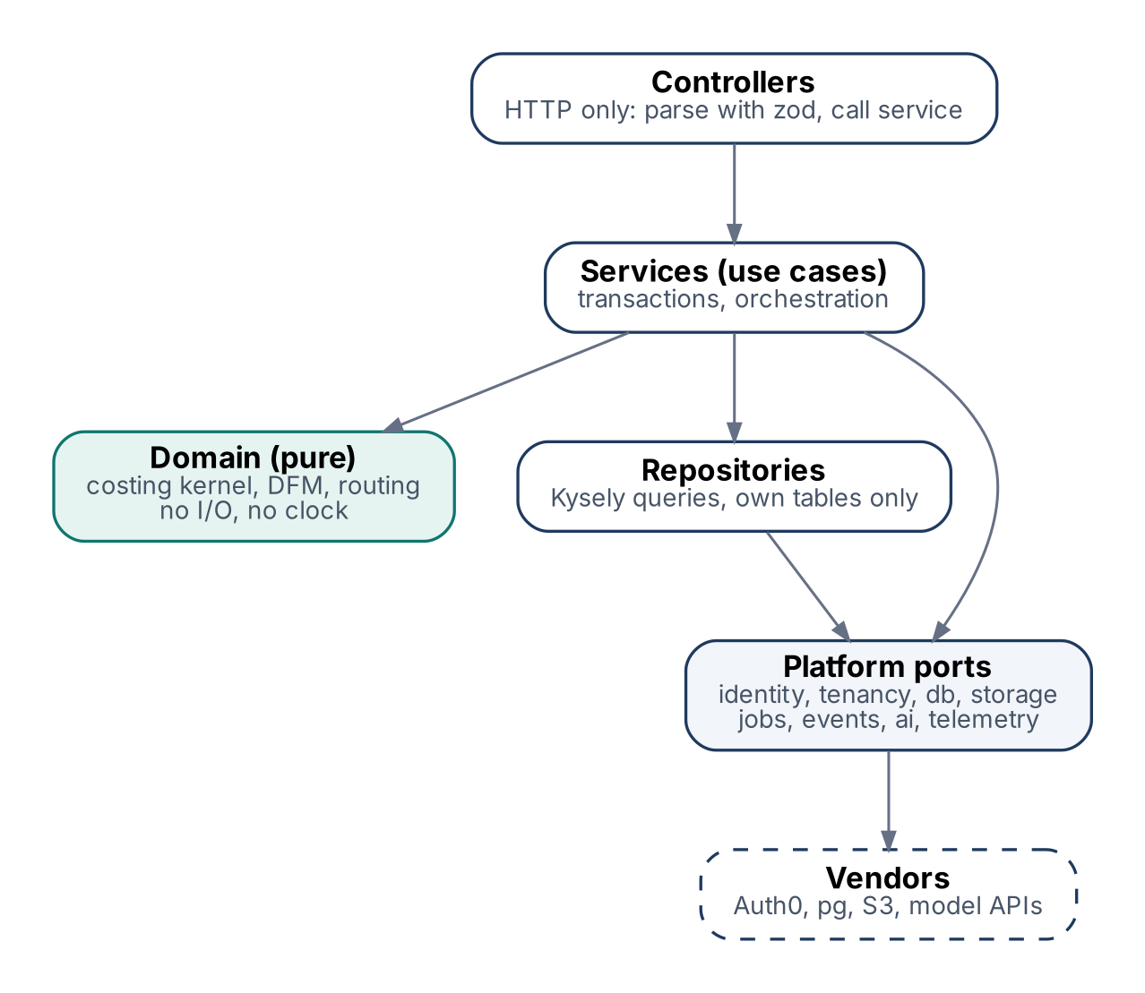
Figure 10. Dependency direction: controllers to services to domain and repositories; only platform ports touch vendors.
backend/src/
platform/ identity/ tenancy/ db/ storage/ jobs/ events/ ai/ telemetry/
modules/<feature>/ <feature>.controller.ts <feature>.service.ts
<feature>.repository.ts <feature>.schema.ts (zod)
domain/ costing kernel, DFM, routing, process engines (pure functions)

18.1 Rules
Rule | Enforced by
Feature code never imports @auth0/*, @aws-sdk/*, pg or @supabase/* | ESLint no-restricted-imports + boundary rule
A module reads and writes only its own tables; other modules are called through their service | Boundary lint + review
withSystem only from files listed in platform/db/system-callers.ts | check-rls-bypass extended
Domain functions are pure: inputs in, result out, no clock or I/O | Domain tests run without Nest
Validate once at the edge with zod; trust types inside | Contract tests
No any, no as unknown as, no non-null assertions on external data | typescript-eslint strict
One API contract: OpenAPI from NestJS generates the typed client for Next.js | CI fails on drift
Log through the allow-list logger only | Lint rule + log canary

18.2 Avoiding boilerplate
- Generate instead of writing: database types (kysely-codegen), API client (openapi-typescript), CAD vocabulary (already generated).
- No generic BaseRepository, entity classes or DTO-to-entity mappers.
- Interfaces only at the platform boundary where a second adapter is real (storage, identity, queue, AI).
- Small functions, names that say what happens, comments explain why.

18.3 Test strategy
Layer | What | Where
Domain | Formulas and engines; the 1,783 existing backend tests stay the safety net | Every commit
Data | Real Postgres from migrations; catalog checks; isolation matrix | Every merge
API | Contract tests per endpoint; parity tests during porting | Every merge
End to end | Playwright with an Auth0 test tenant: sign-in, org switch, upload to cost, export | Nightly and pre-release
Operations | Load, revocation, restore, migration canary-failure and crash-injection drills | Each phase gate

19. Cleanup plan
Removal candidates found in the repository on 30 October 2026. Nothing is deleted yet; each goes in its own small PR after the phase that makes it safe. memory/ (1,210 files) and generated vocabulary are real inputs and stay.
Path or pattern | Problem | Action | When
backend/database/migrations (96), backend/src/database/migrations | Extra migration trees | Fold into the baseline, then delete | Phase 0
backend/data/... - Copy.xlsx, ...(1).xlsx, ..._Abushan.xlsx | Duplicate and personal copies of reference data | Pick the canonical file; delete copies; fix references | Phase 0
backend/eng.traineddata | OCR model binary at backend root | Fetch at image build as an artifact | Phase 0
docker-compose.observability.yml vs docker-compose.monitoring.yml | Two observability stacks | Keep Prometheus + Grafana | Phase 0
docker-compose.yml vs docker-compose.prod.yml | Dev file points at a missing Dockerfile | One compose file with profiles | Phase 0
cad-engine/railway.json, backend/.railwayignore, Render/Vercel leftovers | Several deployment targets | Keep one target | After deployment decision
env templates (3) | Drift | One template plus overrides | Phase 0
@nestjs/typeorm | Unused dependency | Remove | Phase 0
lib/supabase, supabase-auth-provider, supabaseSource branch, usesAuth0 flags | Supabase frontend code | Delete | After PNR
common/supabase (8 files), supabase-object-store, runner Supabase backend | Supabase backend code | Delete | After PNR
common/db/postgrest-client.ts (Proxy cast as unknown as SupabaseClient) | Typed lie; bridge only | Delete with PostgREST | Phase 4
177 getPrivilegedClient calls | RLS bypass in features | withTenant; withSystem allow-list | Phases 2-4
Root ESLint scanning dist/ | 41,763 errors mostly from build output | Ignore build output; no-new-errors ratchet | Phase 0

20. Appendix

20.1 Glossary
Term | Meaning
Control plane | eMithran-run services and metadata: identity, routing, jobs, telemetry, reference data
Data plane | Where business data and files rest: pooled (eMithran) or dedicated (client)
Tenant | One data plane registered in the control plane; hosts one or more organizations
Organization | A customer account; maps 1:1 to an Auth0 Organization
PNR | Point of no return in the cutover; after it, forward-fix only
BFF | Backend-for-frontend: the Next.js server that holds tokens for the browser
RLS | Postgres row-level security

20.2 Sources
Topic | Source
Browser OAuth best practice | RFC 10017, OAuth 2.0 for Browser-Based Applications (BCP 212), Aug 2026 - rfc-editor.org
Auth0 B2B pricing | auth0.com pricing page, retrieved 30 Oct 2026
PostgreSQL 18 | postgresql.org, "PostgreSQL 18 Released", 25 Sep 2025
MinIO status and alternatives | InfoQ, "MinIO S3 API alternatives", 28 Dec 2025
DPDP Rules 2025 | S.S. Rana & Co., MeitY notification of 13 Nov 2025
Repository facts | eMithran at commit 6e6f044f: docs/CUTOVER_AUTH0_POSTGRES.md, docs/architecture/*, cad-engine/ARCHITECTURE.md, backend/src, backend/migrations
Review input | eMithran PRD + Design Doc review and prompts (uploaded .docx, Oct 2026)

