Prerequisites for the lab
- Install Dotnet 9.0 Desktop Runtime (v9.0.14) from the installer.
https://dotnet.microsoft.com/en-us/download/dotnet/9.0
https://dotnet.microsoft.com/en-us/download/dotnet/thank-you/runtime-desktop-9.0.14-windows-x64-installer (for windows).
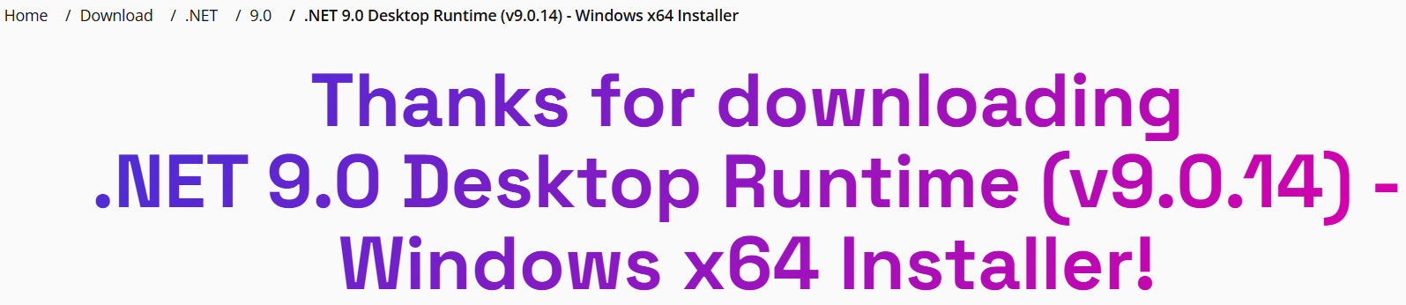

- Install Node.Js (typically called Node):
https://nodejs.org/en/download
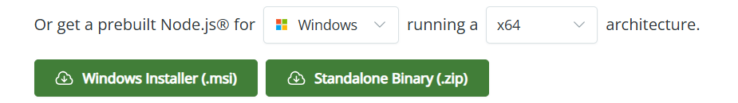

- Install Git:
https://git-scm.com/ install for Windows
https://git-scm.com/install/windows and change it to your OS type.

- Install VS Code from the user installer
https://code.visualstudio.com/download

- Create a github account (optional)
See this video: https://www.youtube.com/watch?v=PqBYIZ5uySI

