4. Software
VitaShop is built entirely on standard web technologies — HTML5, CSS3 and JavaScript — hosted on Vercel and version-controlled through GitHub. Every tool choice prioritises speed for shoppers, simplicity for the team, and zero licensing cost.
4.1 Front-End Software
VitaShop's storefront uses HTML5 for page structure, CSS3 for responsive layout, and vanilla JavaScript for the cart, filtering, live search and gallery. We compared this native approach with a JavaScript framework before deciding.
Criteria | Native Stack (HTML5 + CSS3 + JS) | JavaScript Framework (React / Next.js)
Learning curve | Gentle – standard web skills only | Steep – needs Node tooling and JSX
Performance | Very fast; no framework overhead | Larger download; requires a build step
Maintenance | Simple – edit a file and refresh | More complex dependency tree to manage
Suitability | Ideal for a focused catalogue store | Better for very large, app-like systems
Cost | Free, open web standards | Free, but higher development time

Decision: The native stack was chosen because pages load instantly with no framework overhead, and any team member can edit a file and see the result straight away.
4.2 Application Pages (Software Structure)
VitaShop is a set of individual pages sharing one stylesheet (styles.css) and two scripts — app.js (cart, login, shared logic) and data.js (product catalogue). A single edit to a shared file updates every page at once.
Page | File | Purpose
Home | index.html | Landing page with featured products and categories
Shop | shop.html | Full catalogue with filters, live search and sorting
Product Details | product.html | Single product view, gallery, reviews, add to cart
Cart | cart.html | Review items, change quantity, apply a promo code
Checkout | checkout.html | Shipping details and Malaysian payment options
Account | account.html | Orders, subscription, profile and saved addresses
Sign In / Register | login.html, register.html | Customer authentication
About / Contact | about.html, contact.html | Company information and enquiries

Figures 4.1 to 4.4 show how this structure renders into the finished store.
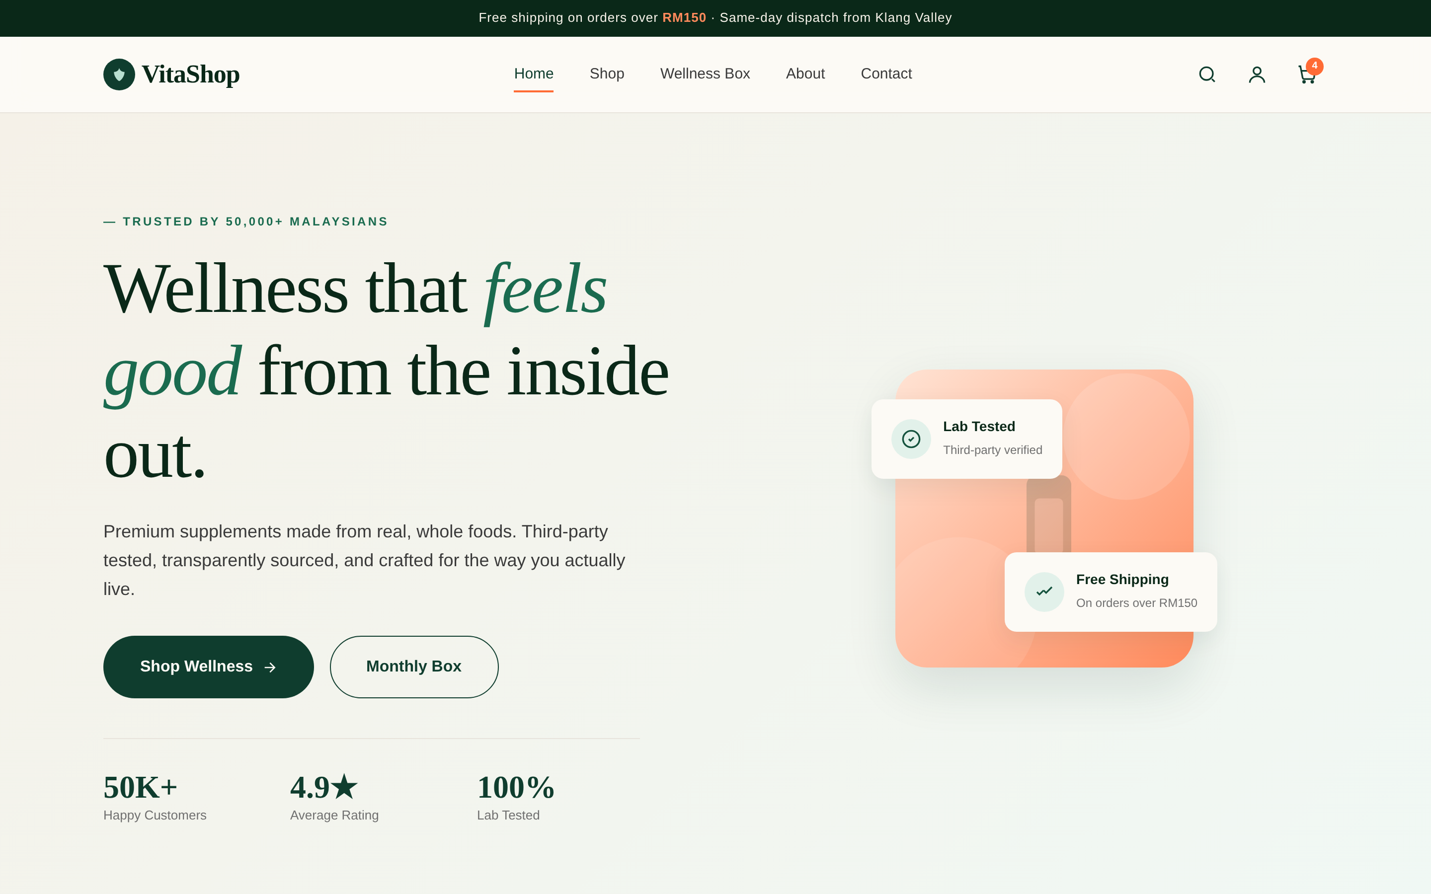
Figure 4.1 — Home page: hero section, headline and key trust statistics.
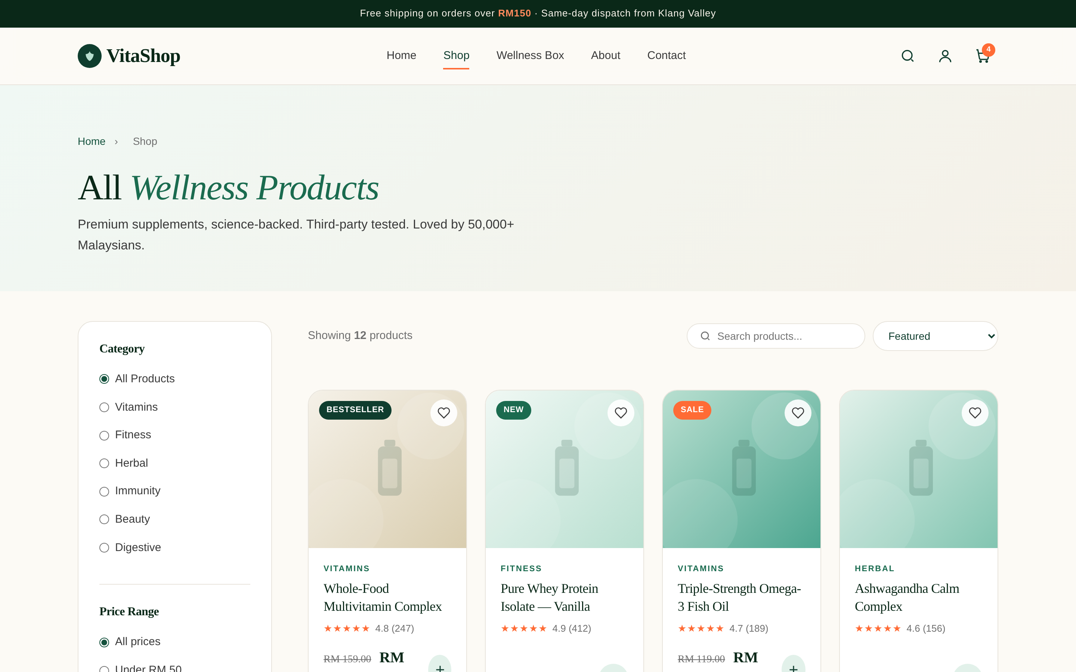
Figure 4.2 — Shop page: category filters, live search, sorting and product grid.
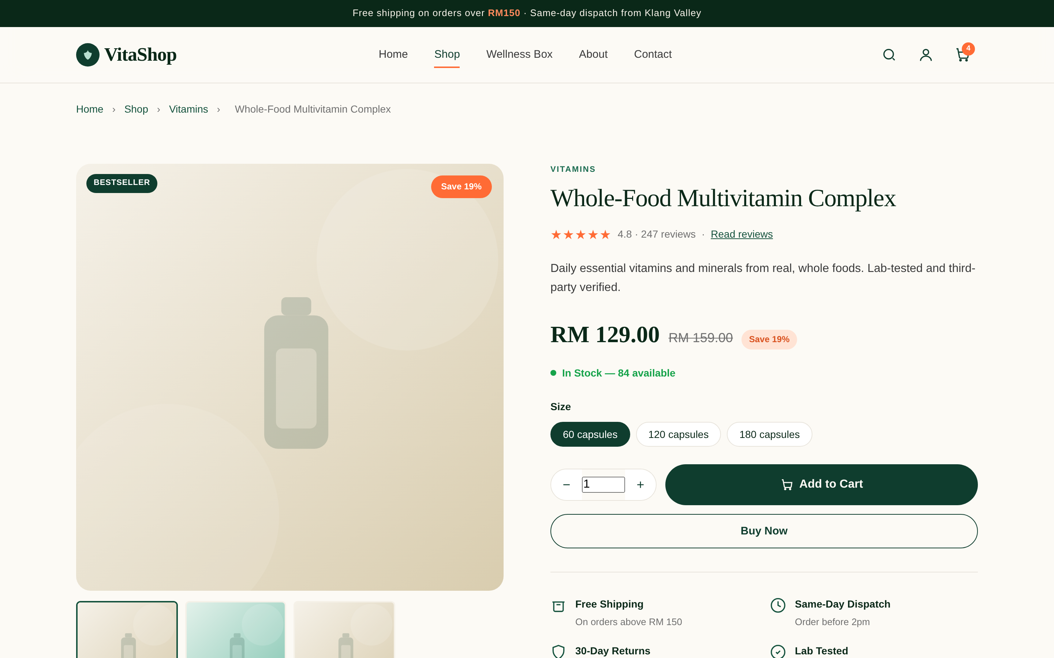
Figure 4.3 — Product details page: image gallery, pricing, size options and add-to-cart.
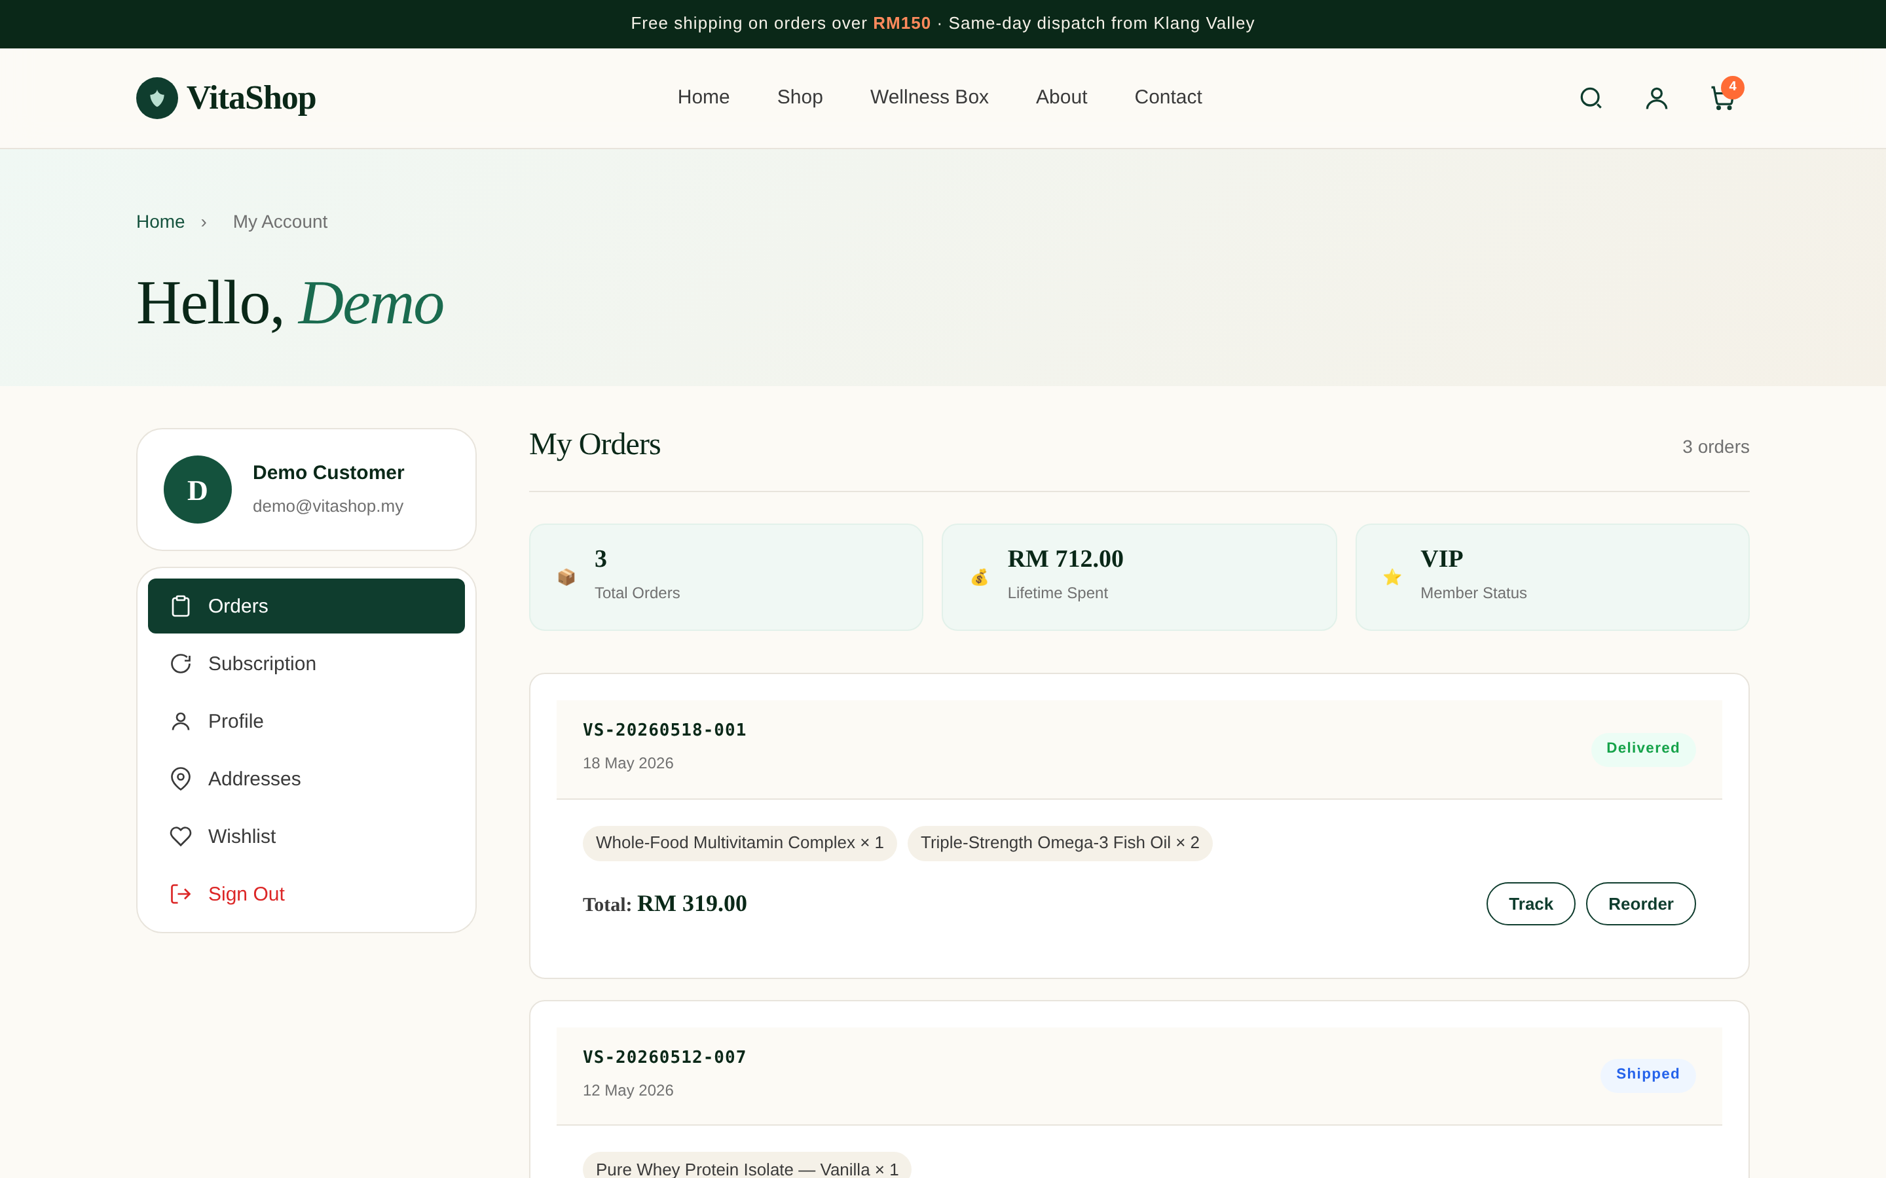
Figure 4.4 — Customer account: order history, subscription, profile and addresses.
4.3 Hosting & Deployment Software
VitaShop's code is version-controlled on GitHub and deployed on Vercel. Every push to GitHub triggers an automatic rebuild and republish within seconds — no manual file uploads needed.
Criteria | Vercel (Cloud Platform) | Traditional Shared Hosting
Deployment | Automatic from GitHub on every push | Manual file upload over FTP
Cost | Free tier, suitable for launch | Monthly fee from the start
Speed | Global CDN – very fast delivery | Single fixed server location
Scaling | Absorbs traffic spikes automatically | Limited by the chosen plan

Decision: Vercel's free tier, automatic GitHub deploys and global CDN eliminate server-administration work entirely at launch.
4.4 Data Storage Software
Cart contents, the signed-in user and order history are stored in localStorage, a storage space built into every browser. No back-end server is needed, keeping the demonstration free to host.
Criteria | Browser localStorage | Server Database (MySQL)
Setup | None – built into every browser | Needs a server, schema and upkeep
Cost | Free | Hosting and administration cost
Best for | Prototype / demonstration | Large-scale production with many users

Decision: localStorage suits the current prototype; a managed cloud database (e.g. MySQL on AWS RDS) would replace it as VitaShop scales to real users.
4.5 Development & Supporting Software
The site was written in Visual Studio Code, with Git and GitHub handling version control. Google Chrome DevTools was used to verify responsive layouts across screen sizes (Figure 4.5). Canva was used to create UI mockups and product graphics, and Google Analytics tracks visitor behaviour on the live site.
Tool | Purpose
Visual Studio Code | Primary code editor
Git / GitHub | Version control and source repository
Chrome DevTools | Responsive layout testing across screen sizes
Canva | UI mockups and product graphics
Google Analytics | Visitor tracking on the live site
Vercel | Hosting and continuous deployment

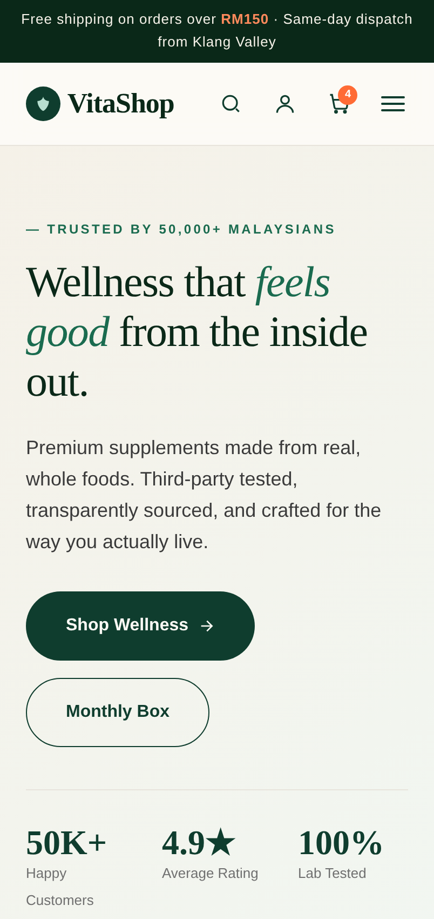 | 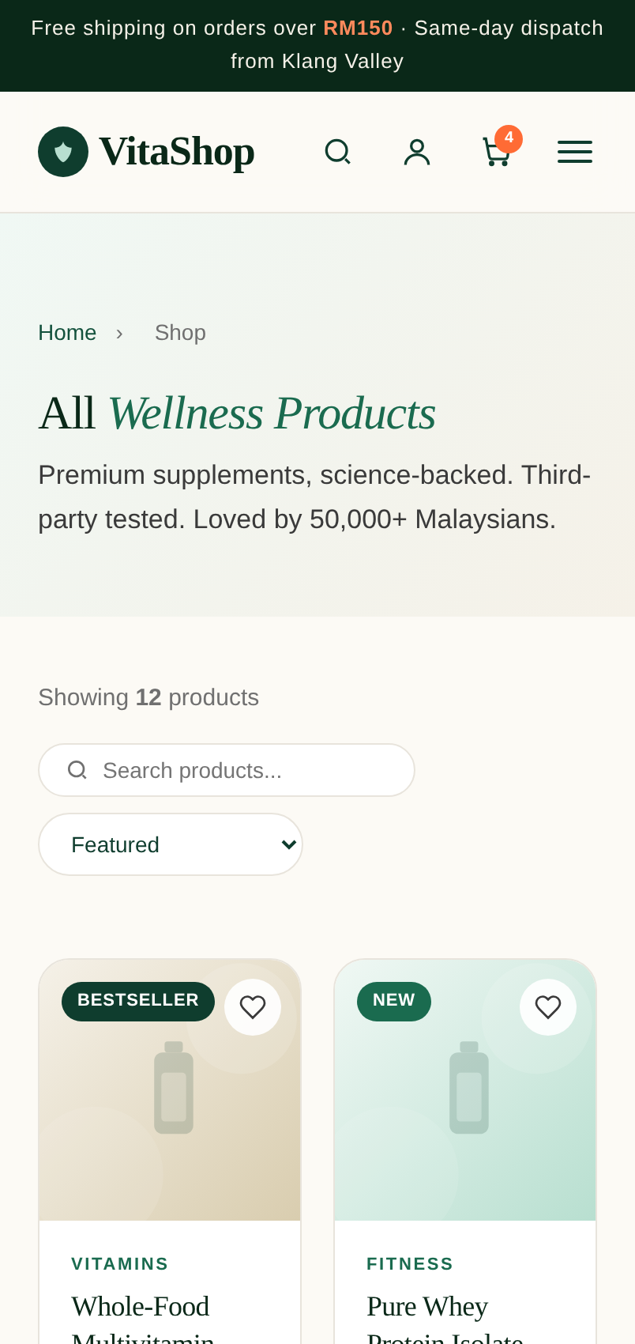 | 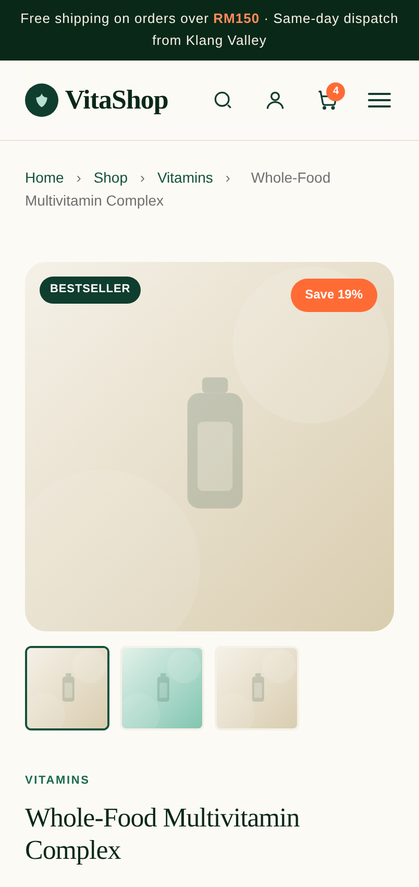
Figure 4.5 — The same pages on a mobile screen, confirming the responsive design.
4.6 End-User Software Requirements
Customers need no installation — any modern browser on any device is enough. The table below lists the minimum tested versions.
Browser | Min Version | Notes
Google Chrome | 90+ | Recommended — best tested
Mozilla Firefox | 88+ | Full support
Microsoft Edge | 90+ | Full support
Safari (macOS / iOS) | 14+ | iPhone, iPad and Mac
Chrome for Android | 90+ | Android phones

All features — localStorage, CSS Grid, Flexbox and ES6 JavaScript — are natively supported in the versions above. No plugins or extensions are needed.
4.7 Admin & Supporting Tools
VitaShop includes a built-in admin area for managing products and orders. The admin pages are admin/dashboard.html, admin/products.html, admin/orders.html, admin/customers.html and admin/analytics.html — all accessible from a single login with no extra software required. For the contact form, EmailJS (free tier) handles message delivery directly from the browser without a back-end server.

