Calvin James Tyler
2024/2025

Semester Project for Deep Neural Networks and Advanced Artificial Intelligence Techniques
Neural Networks for Tumor Detection and Classification from MRI
Convolutional Approach

Abstract
Convolutional neural networks (CNNs) are a cornerstone of machine learning and artificial intelligence, particularly in tasks involving image recognition and analysis. This project focuses on MRI-based tumor detection and classification, employing CNNs to tackle a practical and impactful problem. Leveraging transfer learning, challenges associated with limited training data were addressed while achieving a high level of accuracy. A key emphasis was placed on model interpretability, using techniques including Grad-CAM, Integrated Gradients and occlusion to visualize and validate the model’s decision-making process.

Contents
Abstract 1
Introduction 3
Core Developments and State of the Art 4
Data 6
Description 6
Preprocessing 7
Intermediary Results 9
Model Selection 9
Second Iteration 10
Interpretability 12
Grad-CAM 12
Integrated Gradients 14
Results Analysis 16
Misclassification analysis 18
Conclusion 22
Bibliography 23
Appendix 25
Classification Report 25

Introduction
The healthcare field has experienced remarkable growth over the past 50 years, particularly in medical imaging. Advances in imaging technology have enabled the production of higher-quality data, offering significant opportunities to enhance healthcare delivery. When applied effectively, CNNs can play a transformative role in saving resources, reducing wait times, and improving diagnostic accuracy.
This report explores the application of the RESNET18 model architecture, leveraging pretrained weights to analyze a Kaggle dataset of magnetic resonance imaging (MRI) scans. The dataset comprises four categories: three types of brain tumors and a healthy control group. With the help of transfer learning, this study demonstrates how existing models can be adapted to solve problems efficiently, including in scenarios with limited training data, achieving impressive accuracy. Additionally, the study incorporates techniques for explainability and a thorough evaluation of the model to ensure transparency and reliability in its predictions.
The objective of this report is not to develop novel technologies but to showcase the practical application of existing machine learning techniques. It serves as an educational exercise in utilizing advanced models to address real-world challenges in medical imaging while emphasizing the importance of model interpretability and robust evaluation.

Core Developments and State of the Art
In the 1950s and 60s research into the anatomy of the eyes and brains regarding their neural connection was explored by David Hunter Hubel and Torsten Nils Wiesel. Based on their work Kuniko Fukushima published a paper in 1969 about convolutional neural networks and development has continued since then. Milestone changes have included a 2d design in 1989 by Denker, the concept of pooling in 1990 by Yamaguchi, LeNet in 1995 by LeCun which deepened the architecture and was implemented commercially with great success, and the breakthroughs in the 2000s when GPU implementations of CNNs showed efficiency and speed increases which made their widespread use more feasible.
Currently Vision Transformers have been shown to exceed the capabilities of CNNs for image classification and segmentation. Notable examples include the original Vision Transformer (ViT) in 2020 followed by DETR also in 2020 and the Swin Transformer in 2021. There have also been hybrid models which have shown promising results including CoAtNet in 2021. DETR uses a CNN backbone so it could be classified as a hybrid model as well. Although these models seem to have surpassed the performance of CNNs, they are outside the scope of this project.
Edge computing for AI has seen a rise in research thanks in part to the continually improving and now impressive capabilities at the “edge.” MobilNet was designed in 2017 to run on mobile and embedded devices, EfficientNet was designed to be lightweight and operate on Google’s edge TPUs, and TinyML includes models small enough to run on microcontrollers. Although this is a noteworthy area of development and is of personal interest to me, it is not directly applicable to MRI diagnostics since accuracy far outweighs efficiency in this field and moderate to extensive compute power can reasonably be assumed to be available where this type of imaging takes place.
As with all AI models the desire for human interpretability is a continued concern. Incredible performance has been shown on tasks previously unthinkable, but the increasing complexity of models often renders them to be black boxes regardless of their complete transparency of design and trained weights. The interpretability of CNNs has been explored notably by Grad-Cam, Saliency Maps and LIME (Locally interpretable model-agnostic explanations) for CNNs. This area of development is especially relevant to my project because trust is such a foundational aspect of medicine. Regardless of performance, medical professionals and patients are human and therefore inherently mistrustful. Although this ignorance often impacts its bearer most painfully, it cannot be ignored as a critical aspect of medicine.

Data

Description
The dataset utilized in this experiment was sourced from Kaggle, specifically the "Brain Tumor MRI Dataset" compiled by Masoud Nickparvar. This dataset was created using images from various publicly available repositories and resources, including the Figshare platform. The original sources include research datasets such as "Brain MRI Images for Brain Tumor Detection" and others that provide labeled MRI scans for academic and medical research purposes. The dataset has been curated to facilitate machine learning experiments in brain tumor detection and classification tasks.

The dataset comprises a total of 1,311 MRI images, divided into four categories representing different medical conditions. These include healthy brains with no tumors and three types of brain tumors: glioma, meningioma, and pituitary tumors. Each category contains an approximately equal number of images. This near balance ensures that no class dominates the dataset, which is crucial for unbiased model training. Dealing with imbalances is explored in the results section related to the second iteration of the model.
These tumor types were selected due to their prevalence and clinical significance in brain abnormality diagnoses. Gliomas are among the most common malignant primary brain tumors, while meningiomas and pituitary tumors, though often benign, require accurate diagnosis to guide appropriate treatment. The inclusion of healthy brain images provides a baseline for distinguishing between normal and pathological conditions.
This dataset is fully anonymized and does not include any patient-identifiable information, adhering to ethical standards for the use of medical data in research. The inclusion of images from multiple sources introduces variability in imaging protocols and scanner types, which can improve model generalizability but also introduce noise.

Preprocessing
The images are grayscale and were originally collected in various resolutions. For this experiment, all images were resized to 224x224 pixels to match the input requirements of the neural network used. Although various data augmentations were applied, no distinct preprocessing was done. The images varied widely in format and quality. One notable difference in image types is the angle at which the MRI was taken as is shown in the following image. This drastic difference in image type could be resolved by a sorting network preceding the diagnostic network. Different networks could be trained on each type of image to further improve accuracy. This step was not taken for two reasons. Firstly, it has little application in actual deployment since angle of imaging should be available in metadata. Secondly, initial results yielded such high accuracy that this step proved unnecessary.
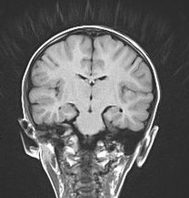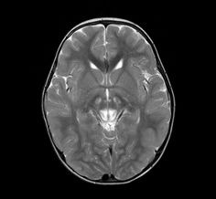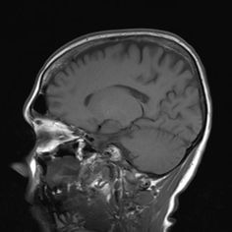
One common step in processing MRIs is to mask the background to focus training only on relevant information. The section on interpretability outlines why this may be a useful process for our data. After initial experimentation with building a masking process with OpenCV, this approach was abandoned. MRI data is normally produced in a unique format. The used dataset converted this data into jpg format to ease use. There are tools which do exceptional work at masking the MRI format to only focus on the brain. Attempting to convert this dataset back into an MRI format to use that tool then back into jpg to use with my network is an efficient use of time and has little real-world application. While masking was not used in this experiment’s final implementation, there was considerable time spent on experimenting with its implementation and investigating existing methods. In future work starting with raw MRI format and masking would certainly be utilized.

Intermediary Results

Model Selection
Initial results using the encoder half of a UNet model were misguided but informative. During the first presentation a variety of potential models were proposed. There was encouragement around exploration of UNet . Upon further research the UNet architecture was determined to have capabilities which exceed the project’s needs. The first (downward) side of the UNet does the encoding of the image and can be connected directly to a linear layer to output classification nodes. This strategy is absolutely feasible. Light technical issues were faced in this implementation, but the core issue was that it the wrong tool/model for the job. Where a UNet excels is its second (upward) half for decoding and segmentation of the image. If the data had the masking information to train where the tumors were then this architecture could additionally be used to locate tumors. While exceptionally valuable this is outside the scope of the project, and an alternate architecture was turned to better suit the task.
The second implementation involved using a pretrained ResNet18 which quickly rendered fantastic results. After ten epochs of training the model exceeded 98% efficiency on the test set. Before further tuning, or trying a larger ResNet, interpretability of the model was explored to glean a deeper understanding of the inner workings of the CNN. Those results are shared in the following section.
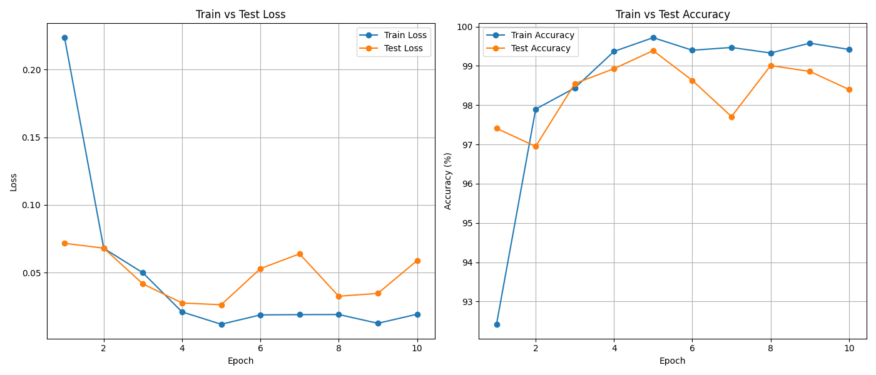

Second Iteration
Through conducting interpretability analysis and model effectiveness evaluations it was clear there were opportunities for improvement. The primary area of concern was false negatives. Although false positives can cause unnecessary concern in cancer diagnosis, a false negative could result in delayed or missed treatment for a patient. To address this concern a multi-pronged approach was taken.
Given that model is a ResNet18, a simple alternative would be to use a larger ResNet. In a real-world application this step would be taken. An additional model of a differing architecture could be added for redundancy. These steps were not taken. Several data augmentation methods were used to increase robustness of the model and rendered positive results. Flips, rotations, and color jitter were implemented to distort the images and force more rigorous training.
Being that a specific goal was to reduce false negatives, an alteration in the loss function was also made regarding adjusting the weights. While it would be reasonable to disproportionately weight the tumorous images, this could lead to overly false positives. Although our dataset had roughly equal numbers of healthy brains to unhealthy brains it is reasonable to assume that in a population representative dataset most images would be “no tumor.” Because of this a good strategy to use on an unbalanced dataset, and the one implanted for this project, is to simply weight each class to balance their respective proportions.
Because the above methods performed so well at reducing false negatives without detrimentally effecting precision, recall, or F1 score, the decision was made to not implement a decision threshold. By softening the decision threshold for the model to select a tumor class or hardening the threshold to select the no tumor class, rather than simply selecting the max output from the SoftMax output, false negatives could certainly be reduced. Tuning this parameter would be a logical step after training on additional datasets.

Interpretability

Grad-CAM
In this project Gradient-weighted Class Activation Mapping (Grad-CAM) was implemented to enhance the interpretability of a convolutional neural network (CNN) trained for tumor detection. Grad-CAM enables the visualization of regions in an image that the model focuses on during its decision-making process. By leveraging these visualizations, insights can be gained into the model’s behavior, even for complex tasks such as this one.
Grad-CAM heatmaps were generated for the final convolutional layer of our ResNet-18 model. These heatmaps highlight regions in the input image that contribute most to the model’s classification decisions. In simple terms: the activated area should be where the tumor is. The following image shows this is happening and indicates the model is performing as desired.
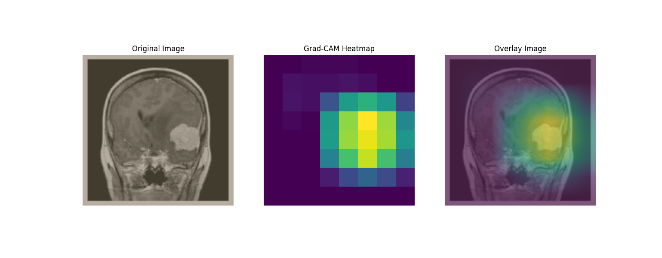
To deepen the understandability of the model, Grad-CAM analysis was applied to multiple layers of the model. This revealed how the network processes the input image at different levels, from low-level feature extraction to high-level semantic understanding. It is less valuable to the overall understandability of the mode but is interesting nonetheless.
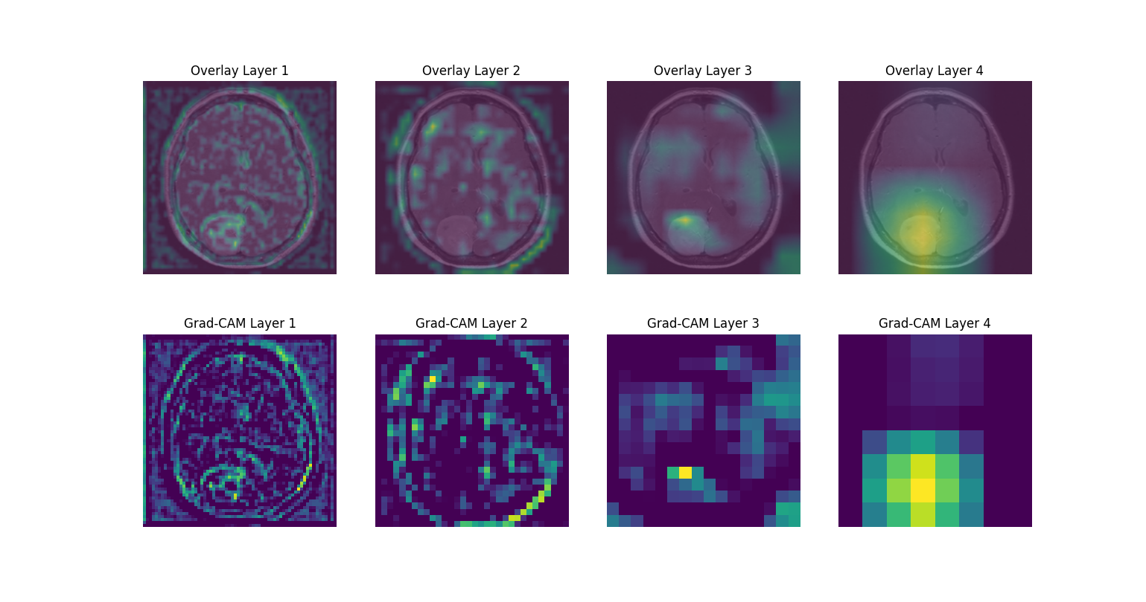
Grad-CAM visualizations help verify that the model is focusing on relevant areas, such as tumor regions, rather than irrelevant background noise. This builds trust in the model’s predictions, which is crucial for medical applications. Clinicians can use Grad-CAM heatmaps to validate whether the model’s focus aligns with human expertise. This is especially valuable in high-stakes fields such as oncology.
By comparing Grad-CAM outputs across layers, we observed how the network’s focus evolves. In early layers focus on basic features like edges and textures. In the middle layers it captures intermediate structures. And in the final layer is concentrate on tumor-specific patterns.
This analysis can reveal unintended biases, such as the model focusing on irrelevant artifacts or regions consistently across images. Identifying such issues helped refine the dataset and model training process. This analysis lead to further refinements in the model and a final evaluation of mislabeled scans highlights this process in the misclassification analysis section.

Integrated Gradients
Much like Grad-Cam, Integrated Gradients (IG) is a powerful explainability method. It provides pixel-level attributions, highlighting the input features most influential to the model’s predictions. IG computes feature attributions by integrating the gradients of the model’s output with respect to the input along a path from a baseline to the actual input image. An all black baseline image was used and gradients were calculated with respect to the target class. These gradients were integrated over several interpolated inputs between the baseline and the original MRI image. The resulting attributions were visualized as heatmaps overlaid on the original images to highlight regions contributing most to the predictions.
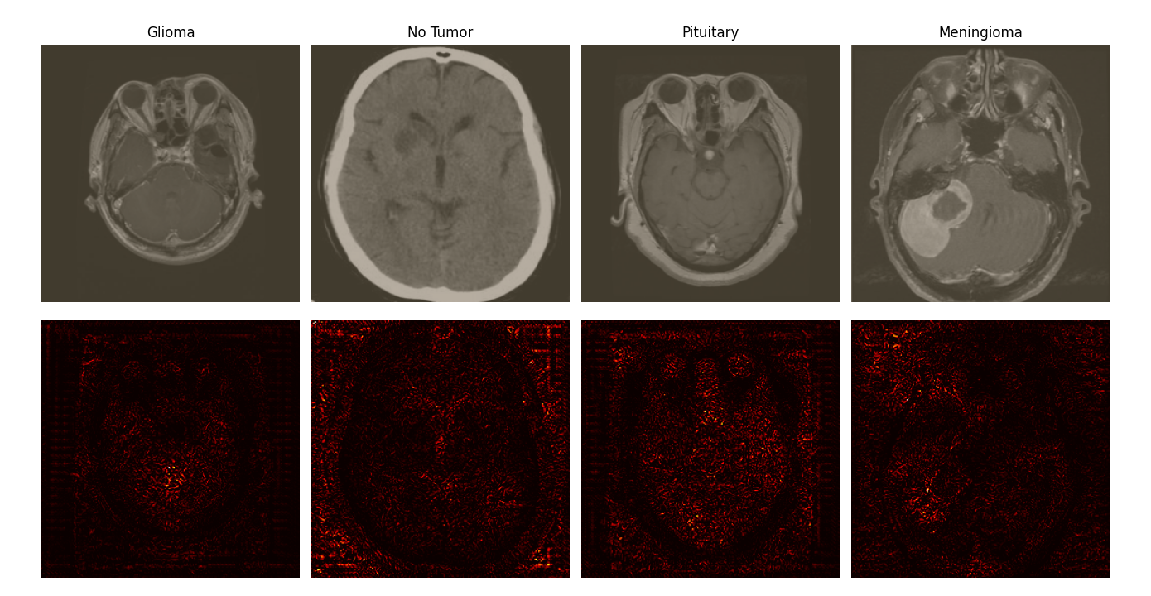
Although the model did render strong predictions, results of this analysis showed attention was being wrongly directed to the background of the image which should be irrelevant. This result led to an exploratory path on eliminating (masking) the background regions to avoid their unintended incorporation into the decision-making process. This is outlined in the data preprocessing section.

Results Analysis
The intermediary results proved robust enough to move forward but during their analysis the false positives of the “no tumor” class proved worrisome. Although training this model on a broader dataset is certainly a critical step if it were to be used in practice, implementing the basic data augmentations outlined in the data preprocessing section was a straightforward way to attempt resolving the false positive issue. The results below demonstrate the improvements made by those modifications.
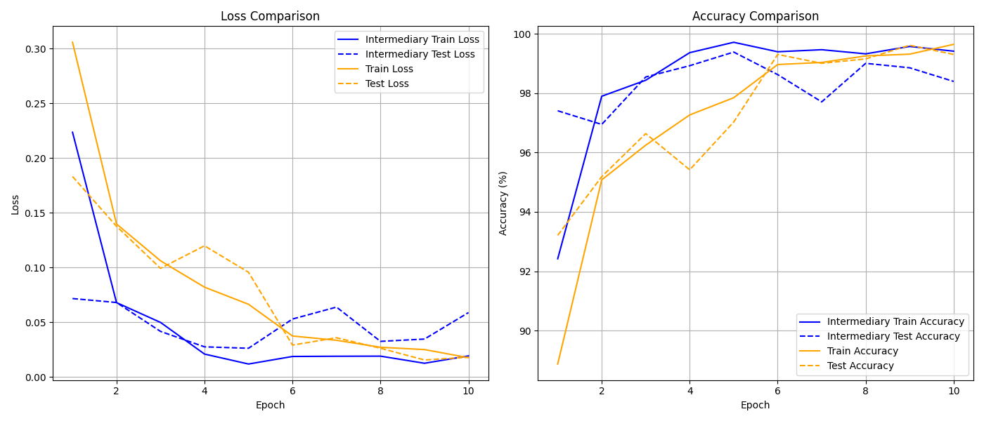
Through these modifications our critical failure area was substantially reduced as is demonstrated in the confusion matrix below. Notably there is only one case in which a “no tumor” prediction is made in which there is in fact a meningioma tumor. The classification report including the precision, recall and F1 score is included in the appendix however due to the high level of accuracy the best way to interpret our results is with the confusion matrix.
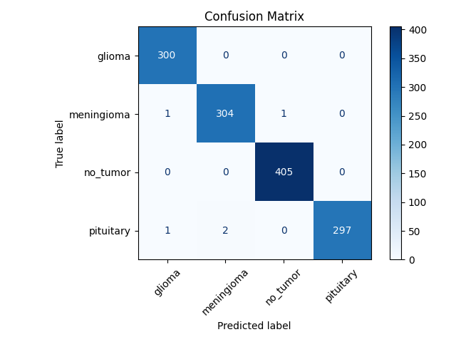

Misclassification analysis
The best way to evaluate misclassification is with the confusion matrix as was explored in the results analysis section. We can divide these results into false positives and false negatives. As has been previously explained, we are much more concerned with our false negative results and of those we are specifically concerned with false negatives for the no tumor category. This can be best explained with a secondary confusion matrix in which we combine all tumor categories.
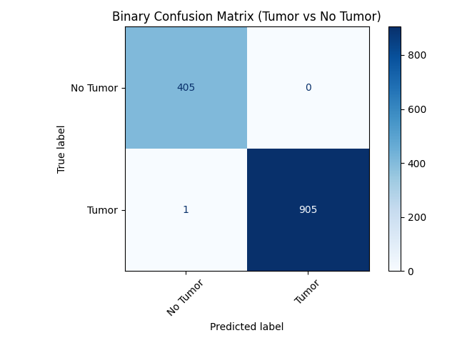
A rigorous examination of the failed result can be conducted with the grad cam, integrated gradients and occlusion tools. Before conducting these tests, it is valuable to simply manually review the problematic image or images. Below is the noted image. Although the tumor is plainly evident, it is worthwile to note that a mouse cursor is present on the milabeled image. It is resonable to hope that this type of problem would be overcome by a good model, however in a standard pipeline the image should be fed directly into the models pipeline and this type of problem should not arise.
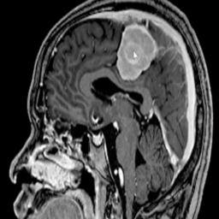

Although this model incorrectly identifies this tumor, one epoch away the model correctly identifies this model with high confidence. That model does however mistake other images at a higher rate. It is possible that further training could improve this model since the disparity between test and train is close and the test category was not yet degrading. It is also possible that the model could reach a grokking level despite what seems to be a plateau in current training.
The model predicts “no tumor” with 61.7% certainty as is shown below. In a situation such as this where missed tumors are potentially so dangerous, certainty predictions could be shared with the medical professional and a high threshold for “no tumor” could be implemented.
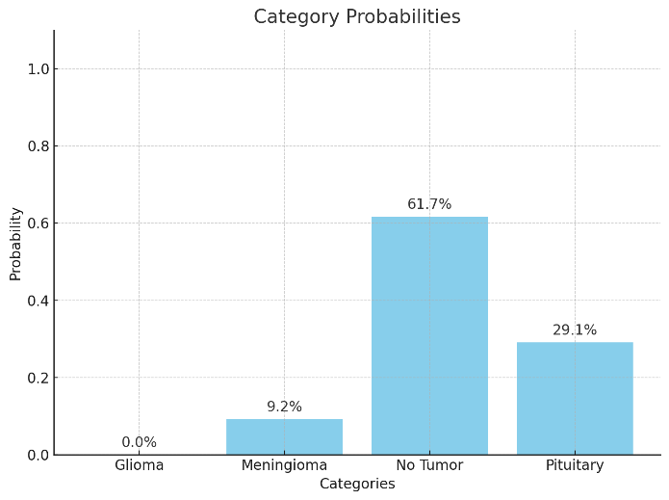
The evaluation of the grad cam outputs for the MRI show that the model is failing to focus on the tumor which is what could be expected. It is notable that the region of focus is not on the brain at all. While the model appears to have avoided concentrating on the background of the image or the cursor, it is focusing on the area below the brain. Our rudimentary implementation of masking the background would not have helped in this case but a more rigorous masking of the image to study only the brain certainly could have resolved this problem.
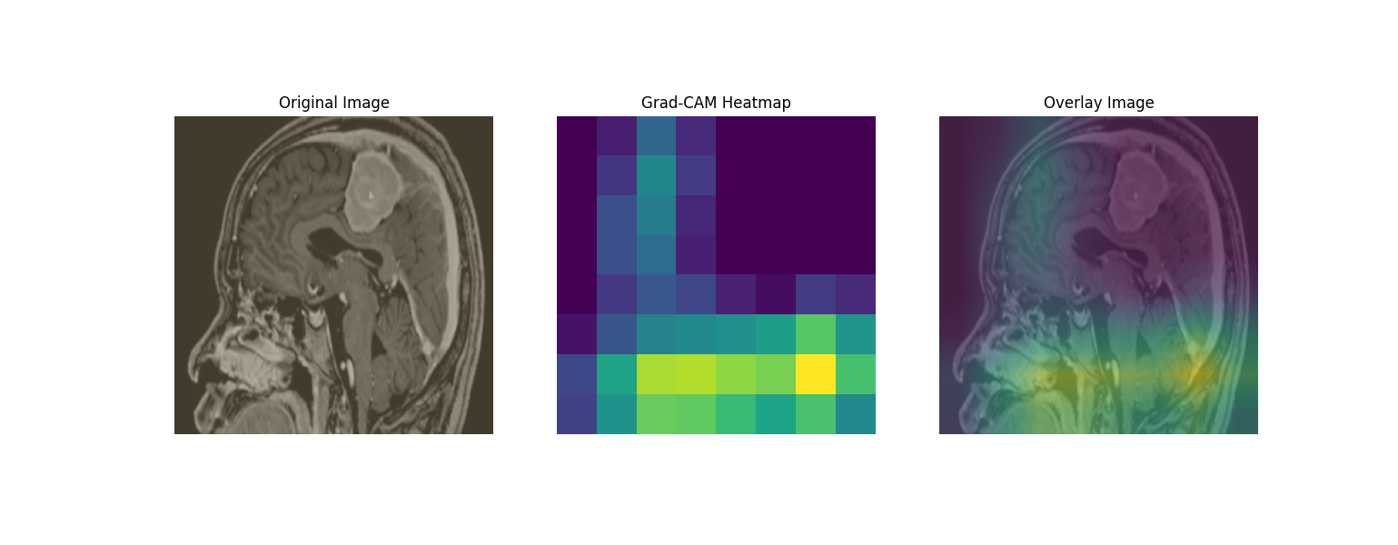
The results of the integrated gradients analysis show a pixel level attention to the tumor region and seem counter to the findings of the grad cam results. They also do show a hot spot on where the cursor is which validates the original assumption that this could be problematic.
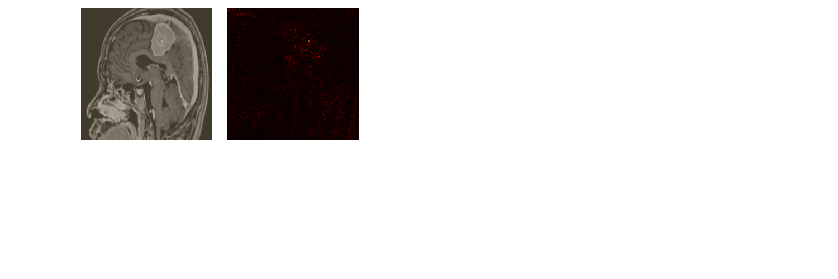
The occlusion test shows that the model is sensitive to losing the tumor area which is indicative of a likely correct prediction in spite of its failure.
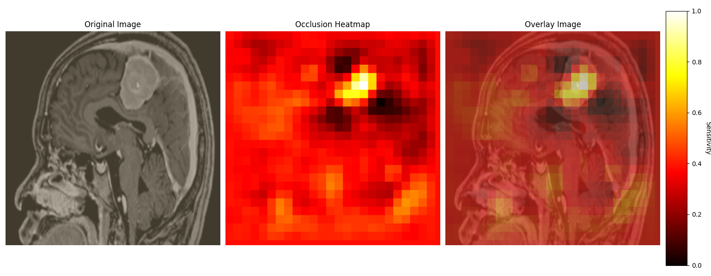

Conclusion
A pretrained ResNet18 model trained for 10 epochs with only moderate adjustments is able to correctly identify and classify tumors with over 99% accuracy. The relative simplicity of the model indicates that further accuracy is possible but also allows for easier interpretation of the models decision making as was highlighted in the interpretability section of the paper.
Whether CNNs or some other machine learning architecture for image recognition is used, it is clear there is a bright future for this in medical imaging analysis. Capabilities increase every year and costs continue to decrease. This technology excels as well in its scalability and promises to bring cutting edge medicine to those less privileged.

Bibliography
LeCun, Y., Bottou, L., Bengio, Y., & Haffner, P. (1998). Gradient-based learning applied to document recognition. Proceedings of the IEEE.
Tan, M., & Le, Q. (2019). EfficientNet: Rethinking Model Scaling for Convolutional Neural Networks. arXiv preprint arXiv:1905.11946.
Liu, Z., et al. (2022). ConvNeXt: A Pure ConvNet for the 2020s. arXiv preprint arXiv:2201.03545.
Radosavovic, I., et al. (2020). Designing Network Design Spaces. arXiv preprint arXiv:2003.13678.
Zhang, H., et al. (2020). ResNeSt: Split-Attention Networks. arXiv preprint arXiv:2004.08955.
Liu, Z., et al. (2021). Swin Transformer: Hierarchical Vision Transformer using Shifted Windows. arXiv preprint arXiv:2103.14030.
Carion, N., et al. (2020). End-to-End Object Detection with Transformers. arXiv preprint arXiv:2005.12872.
Dai, Z., et al. (2021). CoAtNet: Marrying Convolution and Attention for All Data Sizes. arXiv preprint arXiv:2106.04803.
Howard, A. G., et al. (2017). MobileNets: Efficient Convolutional Neural Networks for Mobile Vision Applications. arXiv preprint arXiv:1704.04861.
Simonyan, K., et al. (2013). Deep Inside Convolutional Networks: Visualising Image Classification Models and Saliency Maps. arXiv preprint arXiv:1312.6034.
Ribeiro, M. T., et al. (2016). "Why Should I Trust You?": Explaining the Predictions of Any Classifier. arXiv preprint arXiv:1602.04938.
Selvaraju, R. R., et al. (2017). Grad-CAM: Visual Explanations from Deep Networks via Gradient-based Localization. arXiv preprint arXiv:1610.02391.
Grill, J.-B., et al. (2020). Bootstrap Your Own Latent: A New Approach to Self-Supervised Learning. arXiv preprint arXiv:2006.07733.
Chen, T., et al. (2020). A Simple Framework for Contrastive Learning of Visual Representations. arXiv preprint arXiv:2002.05709.
Gatys, L. A., et al. (2016). Image Style Transfer Using Convolutional Neural Networks. arXiv preprint arXiv:1508.06576.
Redmon, J., et al. (2016). You Only Look Once: Unified, Real-Time Object Detection. arXiv preprint arXiv:1506.02640.
Ronneberger, O., et al. (2015). U-Net: Convolutional Networks for Biomedical Image Segmentation. arXiv preprint arXiv:1505.04597.

Appendix

Classification Report
