Metropolis Campaign

## 1 *Metropolis algorithm simulation*

*based on* [*Markov Chain Monte Carlo | Columbia Public Health*](https://www.publichealth.columbia.edu/research/population-health-methods/markov-chain-monte-carlo) *with slightly changed assumptions (10 counties, pre-defined populations either systematically chosen or randomized) and these rules:*

1. *Flip a coin. Heads to move east, tails to move west. If in borderline county, wrap around (alternative: move towards center?)*
2. *If the district indicated by the coin (east or west) has more voters than the present district, move there.*
3. *If the district indicated by the coin has fewer likely voters, make the decision based on a probability calculation:*
4. *calculate the probability of moving as the ratio of the number of likely voters in the proposed district, to the number of voters in the current district:*
5. *Pr[move] = voters in indicated district/voters in present district*
6. *Take a random sample between 0 and 1.*
7. *If the value of the random sample is between 0 and the probability of moving, move. Otherwise, stay put.*

pacman::p_load(wrappedtools, tidyverse, ggrepel, ggforce,   
 ggnewscale, ggtext)  
  
set.seed(1012)  
counties <- tibble(County = LETTERS[1:9],  
 Population_defined=seq(from=10^4,   
 to= 9*10^4,   
 by=10^4),  
 Population_sampled = runif(n = 9,  
 min = 10^4,  
 max = 9*10^4) |>   
 roundR(level = 2,  
 textout = F,  
 smooth = T))  
pop_selected <- 'Population_sampled'  
ggplot(counties,aes(County,.data[[pop_selected]]))+  
 geom_col()

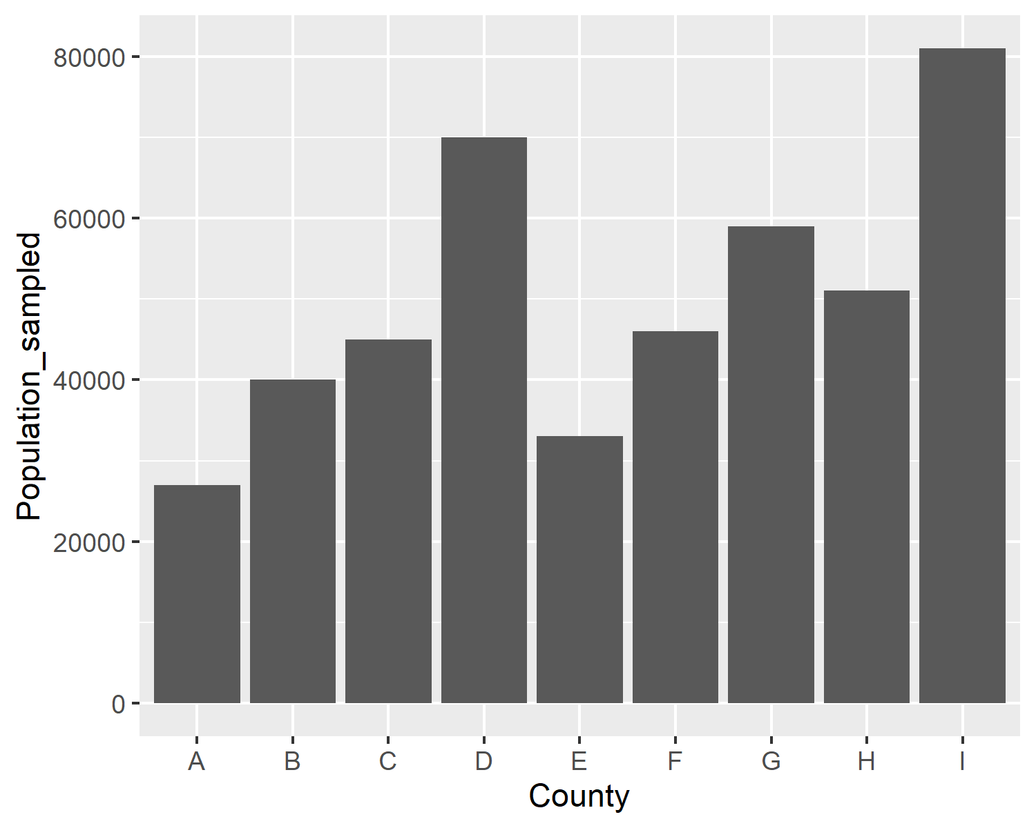

move_selection <- function(.counties=counties,   
 current_county,  
 which_population=pop_selected) {  
 coinresult <- sample(x = c(1,-1),  
 size = 1)  
 # if(current_county==1) {  
 # coinresult <- 1  
 # }  
 # if(current_county==nrow(.counties)) {  
 # coinresult <- -1  
 # }  
 next_county <- current_county+coinresult  
 if(next_county==0) {next_county <- nrow(.counties)}  
 if(next_county>nrow(counties)) {next_county <- 1}  
 population_ratio <- .counties[[next_county,which_population]] /  
 .counties[[current_county,which_population]]  
 if(runif(n = 1,0,1)>population_ratio){  
 next_county <- current_county  
 }  
 return(next_county)  
}  
  
n_moves <- 10^5  
n_burnin <- 10^3  
start_county <- 5

moves <- tibble(move=seq_len(n_moves),  
 position=NA_integer_)  
moves$position[1] <- start_county

set.seed(1210)  
tictoc::tic('here we go...')  
for(step_i in 2:n_moves){  
 moves$position[step_i] <-   
 move_selection(current_county = moves$position[step_i-1])  
}  
tictoc::toc()

here we go...: 47.64 sec elapsed

visits <- moves |>   
 group_by(position) |>   
 summarise(Visits=n()) |>   
 ungroup() |>   
 mutate(County = LETTERS[position]) |>   
 select(-position) |>   
 full_join(counties)  
ggplot(visits,aes(.data[[pop_selected]],Visits))+  
 geom_smooth(method='lm')+  
 geom_abline(intercept = 0,  
 slope = n_moves/sum(counties[[pop_selected]]),  
 linetype=2)+  
 geom_point()+  
 geom_label_repel(aes(label=County),nudge_x = 0, nudge_y = 100)+  
 scale_shape_manual(values=LETTERS, guide = NULL)+  
 scale_x_continuous(breaks=seq(0,10^5,10^4))+  
 scale_y_continuous(breaks=seq(0,10^5,10^3))+  
 ggtitle('All moves analyzed')

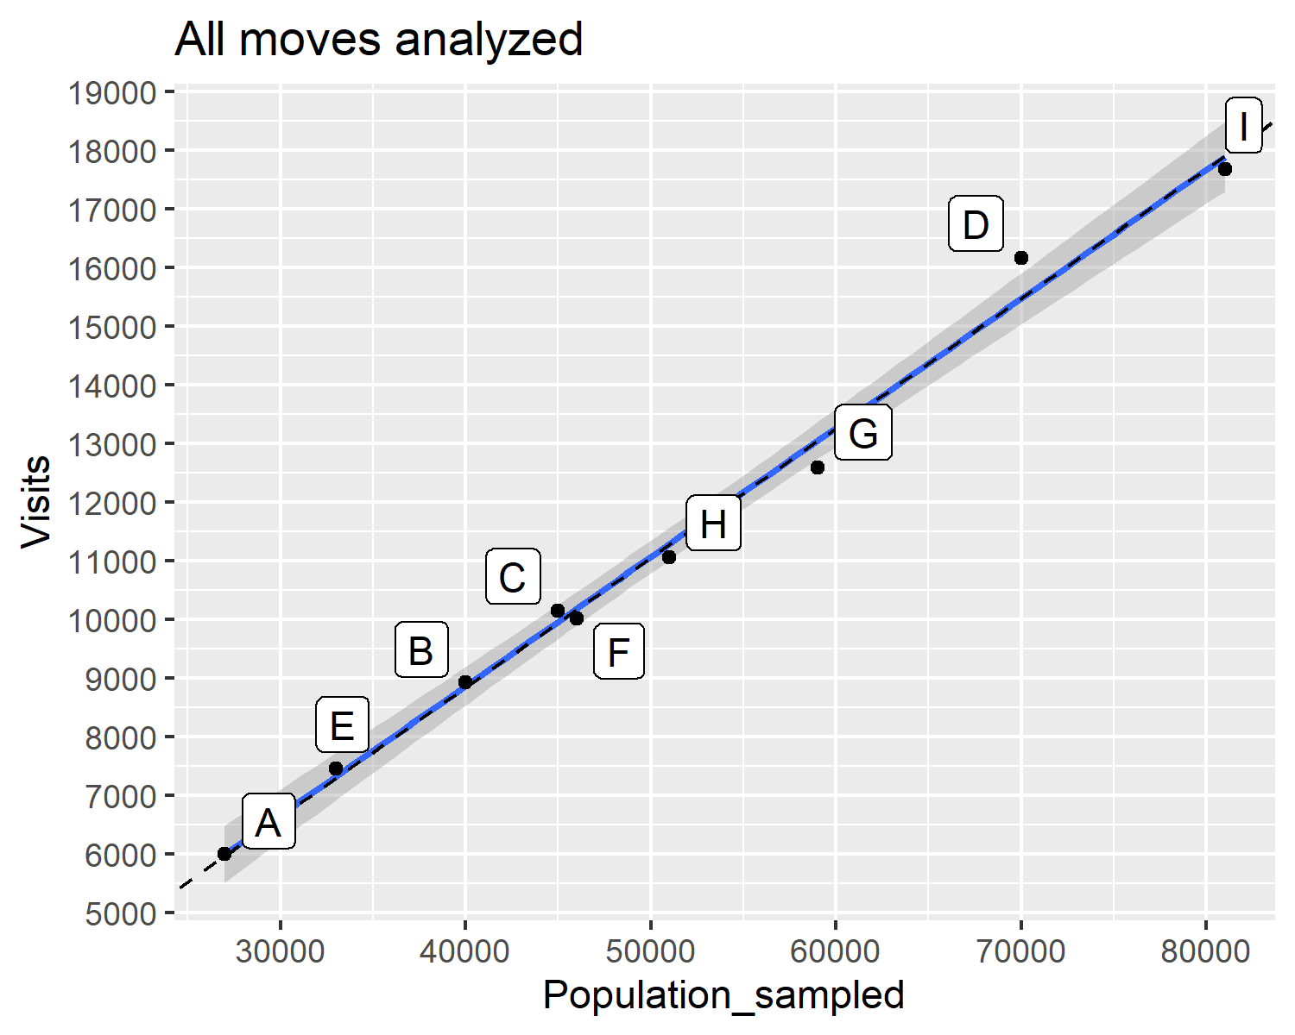

visits <- moves |>  
 filter(move>n_burnin) |>   
 group_by(position) |>   
 summarise(Visits=n()) |>   
 ungroup() |>   
 mutate(County = LETTERS[position]) |>   
 select(-position) |>   
 full_join(counties)  
moves_from_to <- expand.grid(1:9,1:9) |>   
 as_tibble() |>   
 rename(from=Var1,  
 to=Var2) |>   
 filter(abs(from-to)<2|abs(from-to)==8) |>   
 mutate(count=0,  
 start=LETTERS[from],  
 stop=LETTERS[to])  
for(move_i in seq_len(nrow(moves_from_to))){  
 moves_from_to$count[move_i] <-   
 sum(moves$position[-nrow(moves)]==moves_from_to$from[move_i] &  
 moves$position[-1]==moves_from_to$to[move_i])  
}  
moves_to <- moves_from_to |>   
 filter(to!=from)|> group_by(to) |> summarize(moves_to=sum(count)) |>   
 mutate(County=LETTERS[to])  
moves_from <- moves_from_to |>   
 filter(to!=from)|> group_by(from) |> summarize(moves_from=sum(count)) |>   
 mutate(County=LETTERS[from])  
moves_stay <- moves_from_to |>   
 filter(to==from)|> group_by(from) |> summarize(moves_stay=sum(count)) |>   
 mutate(County=LETTERS[from])  
moves_from_to_stay <-   
 full_join(moves_from,moves_to) |>   
 full_join(moves_stay) |>   
 full_join(counties |> select(-Population_defined)) |>   
 select(-from,-to) |>   
 pivot_longer(cols=c(moves_from,moves_to,moves_stay),  
 names_to='move',  
 values_to='count') |>   
 mutate(County=paste0(County,"\n",  
 round(Population_sampled/1000),  
 "k"  
 ))   
  
ggplot(moves_from_to_stay,aes(County,count, fill=move))+  
 geom_col()+  
 scale_fill_manual(values=c('red','blue','green'))+  
 ggtitle('Moves from, to, and stay')

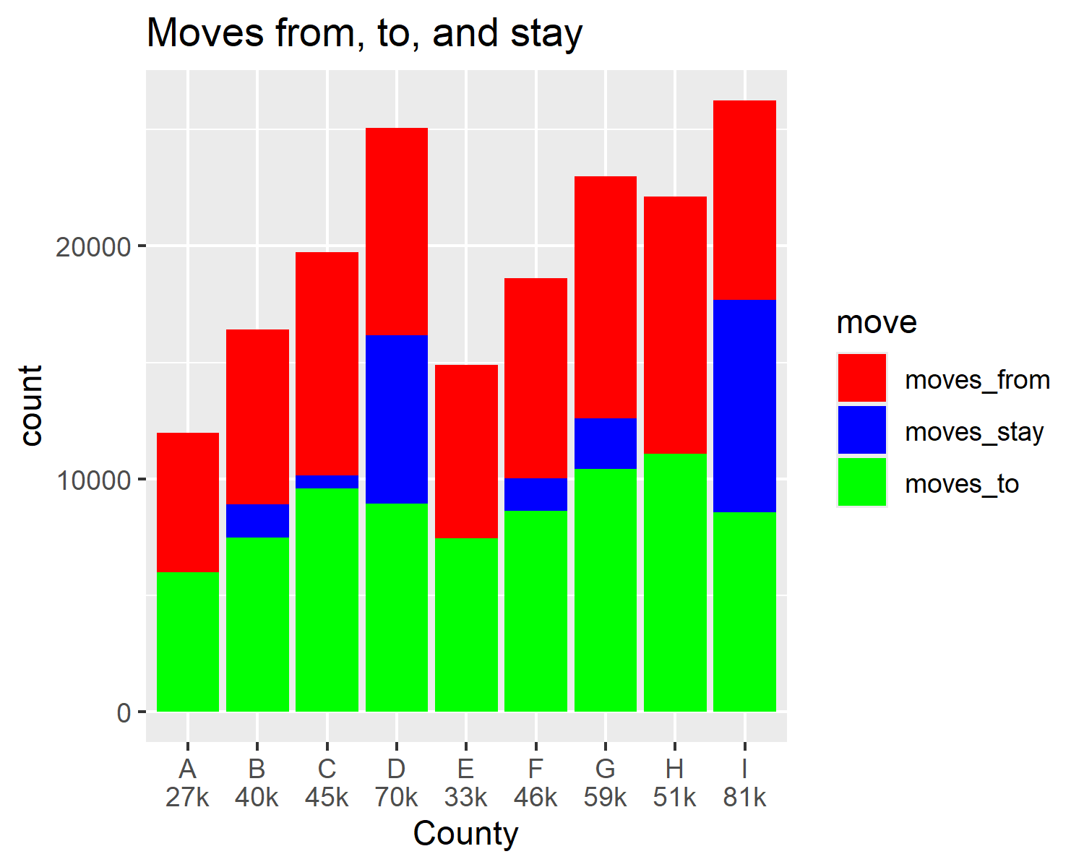

cat("<br>\n\n")

<br>

ggplot(visits,aes(.data[[pop_selected]],Visits))+  
 geom_smooth(method='lm')+  
 geom_abline(intercept = 0,  
 slope = (n_moves-n_burnin)/sum(counties[[pop_selected]]),  
 linetype=2)+  
 geom_point()+  
 geom_label_repel(aes(label=County),nudge_x = 0, nudge_y = 100)+  
 scale_shape_manual(values=LETTERS, guide = NULL)+  
 scale_x_continuous(breaks=seq(0,10^5,10^4))+  
 scale_y_continuous(breaks=seq(0,10^5,10^3))+  
 ggtitle('Only moves after burn-in analyzed')

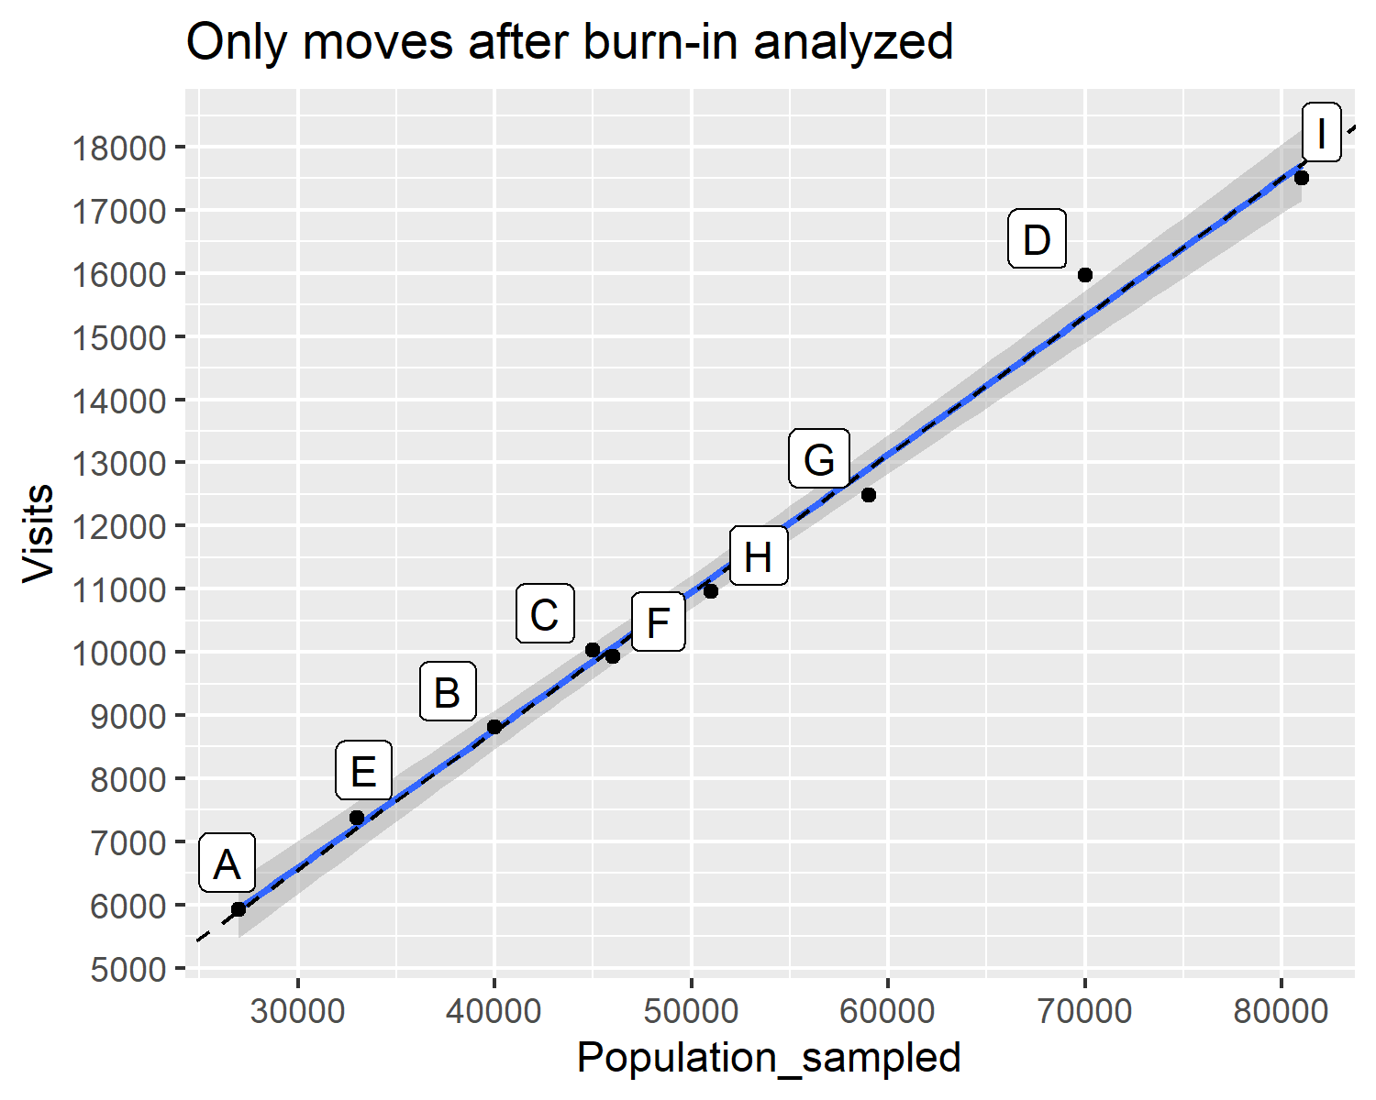

cat("<br>\n\n")

<br>

# circle for county plot  
# Define circle aesthetics  
theta <- seq(0, 2*pi, length.out = 10)[c(4:9,1:3)] |>   
 rev()  
# Create sequence for angles (0 to 2*pi) with 5 equally spaced points  
radius <- 1 # Set radius of the circle  
  
# Create data frame with circle coordinates and labels  
circle_data <- tibble(  
 angle=theta,  
 x = radius * cos(theta),  
 y = radius * sin(theta),  
 label =LETTERS[1:9] # Assign letters A to E as labels  
) |>   
 full_join(visits, by=c('label'='County')) |>   
 mutate(plotlabel=paste0(label,"\n",  
 round(Population_sampled/1000),  
 "k"  
 ))   
arrow_data <-   
 moves_from_to |>   
 full_join(circle_data |>   
 select(x:label, angle), by=c('start'='label')) |>   
 rename(from_x="x",from_y="y") |>   
 full_join(circle_data |>   
 select(x:label), by=c('stop'='label')) |>   
 rename(to_x="x",to_y="y") |>   
 mutate(x_end=from_x+count*10/n_moves*cos(angle),  
 y_end=from_y+count*10/n_moves*sin(angle),  
 count=case_when((from<to & !(from==1 & to==9)) | (from==9 & to==1)~-count,  
 .default=count))   
  
   
# Createggplot with circle and labels  
# ggplot(circle_data, aes(x = x, y = y)) +  
# # geom_point(aes(size = Visits), shape=1) + # Increase point size for better visibility  
# geom_circle(aes(r=1,x0=0,y0=0),  
# color="darkorange2")+  
# geom_curve(data=arrow_data |>   
# filter(from<to),  
# aes(x=from_x,y=from_y,  
# xend=to_x,yend=to_y,  
# linewidth=count),  
# arrow=arrow(length=unit(0.1,"inches")),  
# curvature=-1.0,  
# color="darkolivegreen")+  
# geom_curve(data=arrow_data |>   
# filter(from>to),  
# aes(x=from_x,y=from_y,  
# xend=to_x,yend=to_y,  
# linewidth=count),  
# arrow=arrow(length=unit(0.1,"inches")),  
# angle=90,  
# curvature=-.75,  
# color="dodgerblue")+  
# geom_text(aes(label = plotlabel, size=.data[[pop_selected]]),  
# hjust = 0.5, vjust = 0.5) + # Adjust text position slightly  
# scale_size_continuous(range=c(3,7)) + # Set size of labels  
# scale_linewidth_continuous(range=c(.5,3)) + # Set size of labels  
# coord_fixed(xlim = c(-radius - radius/5, radius + radius/5), ylim = c(-radius - radius/5, radius + radius/5)) + # Set axis limits slightly bigger than radius  
# labs(title = "County population and move count", x = "", y = "",  
# caption = "inner arrows: moves to left neighbor,\nouter arrows: moves to right neighbor") + # Add title and remove axis labels  
# guides(size="none", linewidth="none")+  
# theme_void() # Remove background gridlines  
# cat("<br>\n\n")  
  
# Create ggplot with circle and labels  
ggplot(circle_data, aes(x = x, y = y)) +  
 # geom_point(aes(size = Visits), shape=1) + # Increase point size for better visibility  
 # geom_circle(aes(r=1,x0=0,y0=0),  
 # color="darkorange2")+  
 geom_curve(data=arrow_data |>   
 filter((from<to & !(to==9 & from==1)) | (to==1 & from==9)),  
 aes(x=from_x,y=from_y,  
 xend=to_x,yend=to_y,  
 color=count, linewidth=abs(count)),  
 arrow=arrow(length=unit(0.1,"inches")),  
 curvature=.75,  
 alpha=.6)+#, linewidth=1.5,)+  
 scale_colour_gradient2(low="gold", mid="grey",high="red")+  
 # scale_color_gradient("move count", low = "gold",high = "gold4") +  
 geom_curve(data=arrow_data |>   
 filter(from>to &!(from==9 & to==1) | (to==9 & from==1)),  
 aes(x=from_x,y=from_y,  
 xend=to_x,yend=to_y,  
 color=count, linewidth=abs(count)),  
 arrow=arrow(length=unit(0.1,"inches"),  
 type="closed"),  
 # angle=90,#linewidth=1.5,  
 curvature=.75,  
 alpha=.6)+  
 geom_segment(data=arrow_data |>   
 filter(from==to,count>0),  
 aes(x=from_x,y=from_y,  
 xend=x_end,  
 yend=y_end),  
 arrow=arrow(length=unit(0.1,"inches"),  
 ends = "both",  
 type="closed"),  
 color='dodgerblue', linewidth=1.2)+  
 geom_text(aes(label = plotlabel, size=.data[[pop_selected]]),  
 hjust = 0.5, vjust = 0.5) + # Adjust text position slightly  
 scale_size_continuous(range=c(3,7)) + # Set size of labels  
 scale_linewidth_continuous(range = c(.25,2))+# Set size of labels  
 coord_fixed(xlim = c(-radius * 1.75, radius * 1.75),  
 ylim = c(-radius * 1.75, radius * 1.75)) + # Set axis limits slightly bigger than radius  
 labs(title = "County population and move count", x = "", y = "",  
 caption = "inner golden arrows: moves to right neighbor (clockwise),\nouter redish arrows: moves to left neighbor (counter-clockwise)\nstraight blue arrows: stay put") + # Add title and remove axis labels  
 guides(size="none", linewidth="none", color="none")+  
 theme_void() # Remove background gridlines

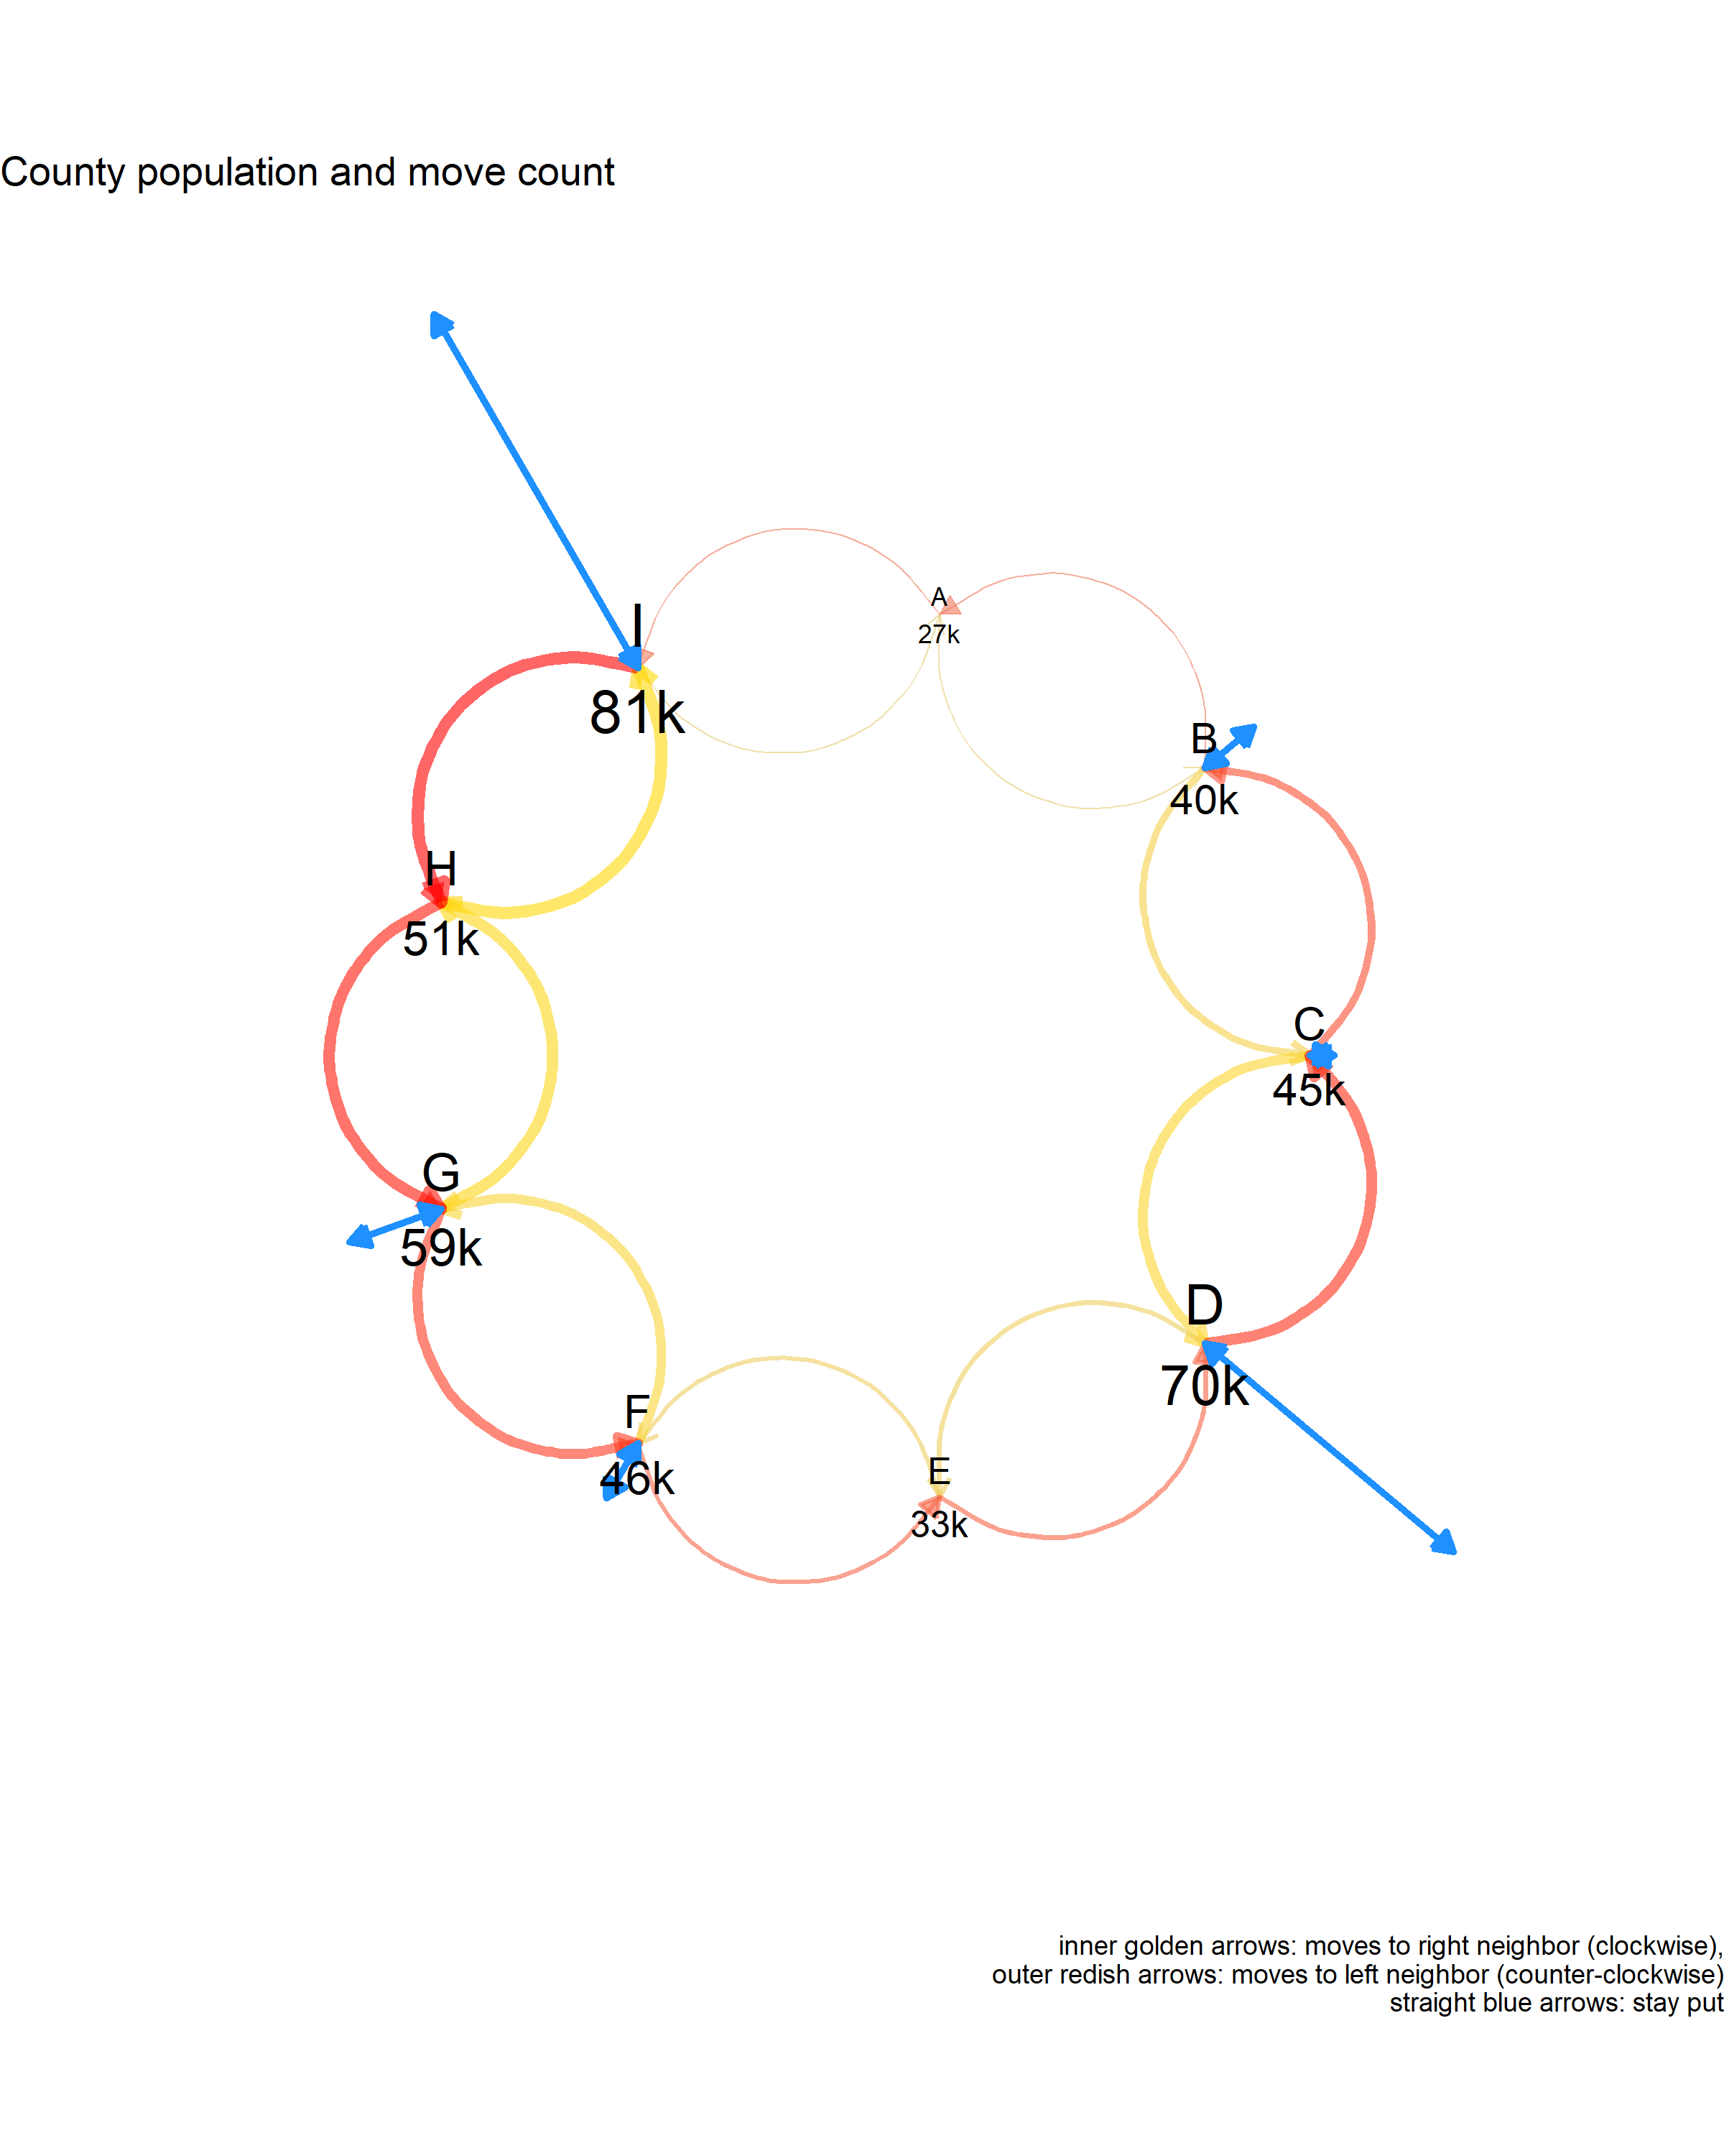

visits <- moves |>  
 filter(move<=n_burnin) |>   
 group_by(position) |>   
 summarise(Visits=n()) |>   
 ungroup() |>   
 mutate(County = LETTERS[position]) |>   
 select(-position) |>   
 full_join(counties)  
ggplot(visits,aes(.data[[pop_selected]],Visits))+  
 geom_smooth(method='lm')+  
 geom_abline(intercept = 0,  
 slope = n_burnin/sum(counties[[pop_selected]]),  
 linetype=2)+  
 geom_point()+  
 geom_label_repel(aes(label=County),nudge_x = 0, nudge_y = 10)+  
 scale_shape_manual(values=LETTERS, guide = NULL)+  
 scale_x_continuous(breaks=seq(0,10^5,10^4))+  
 scale_y_continuous(breaks=seq(0,10^5,10^1))+  
 ggtitle('Only burn-in moves analyzed')

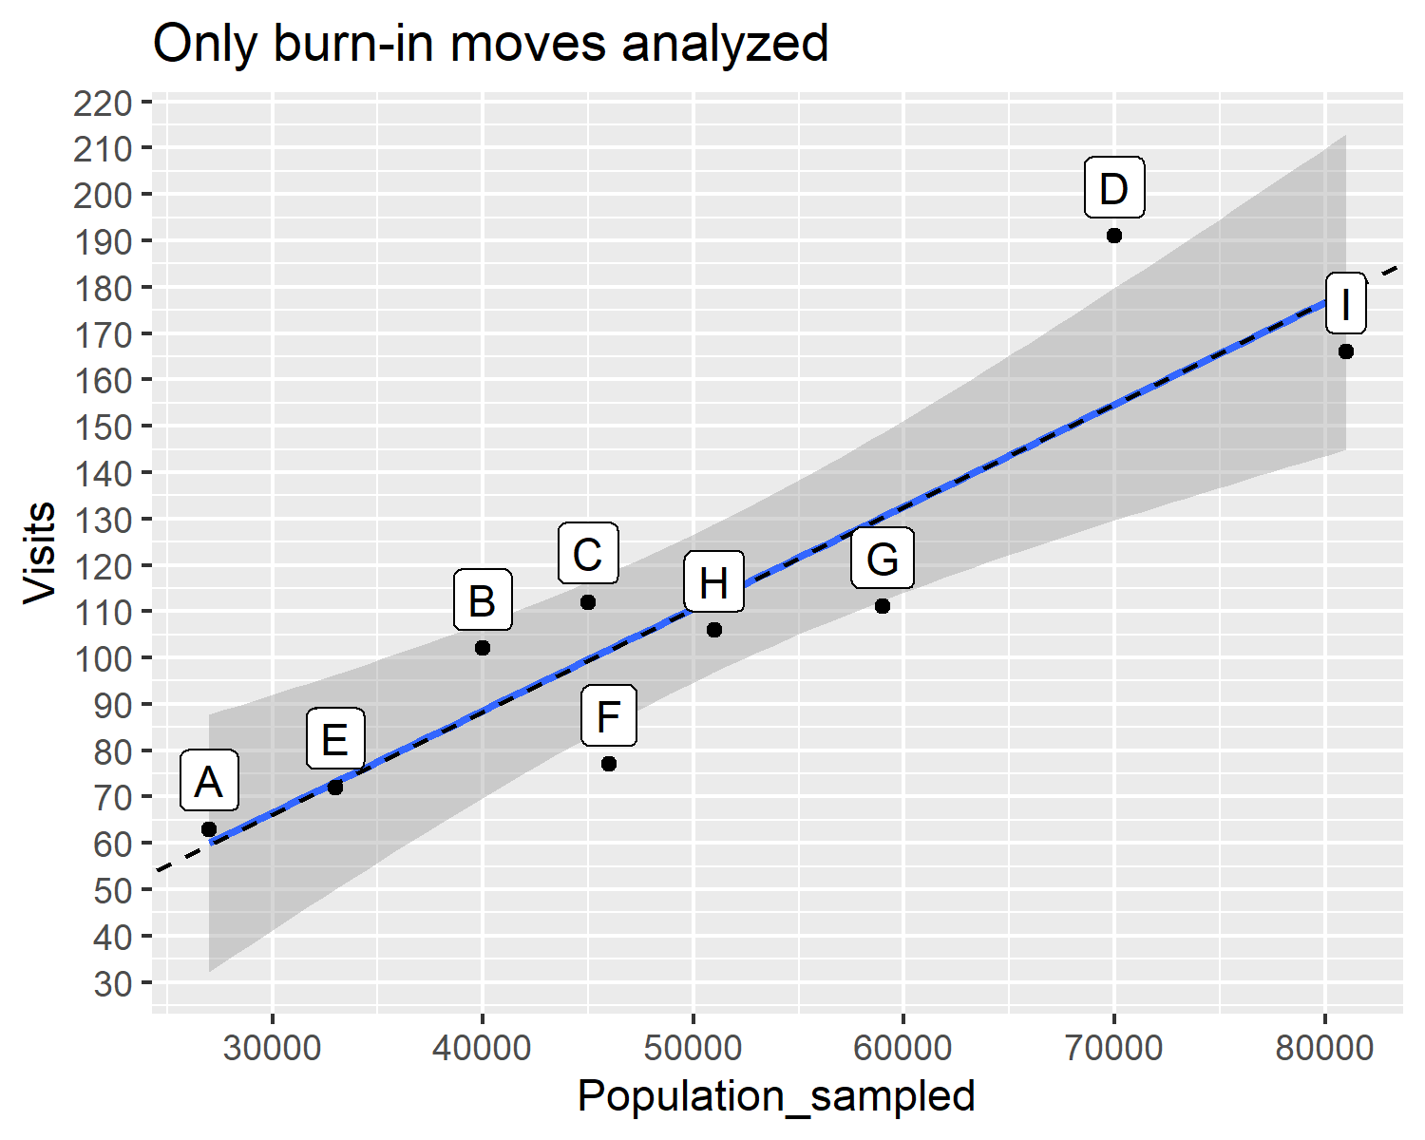

moves |>   
 filter(move<=n_burnin) |>  
 ggplot(aes(move,position))+  
 # geom_point()+  
 geom_line()+  
 scale_y_continuous(breaks=1:9,  
 labels = LETTERS[1:9])

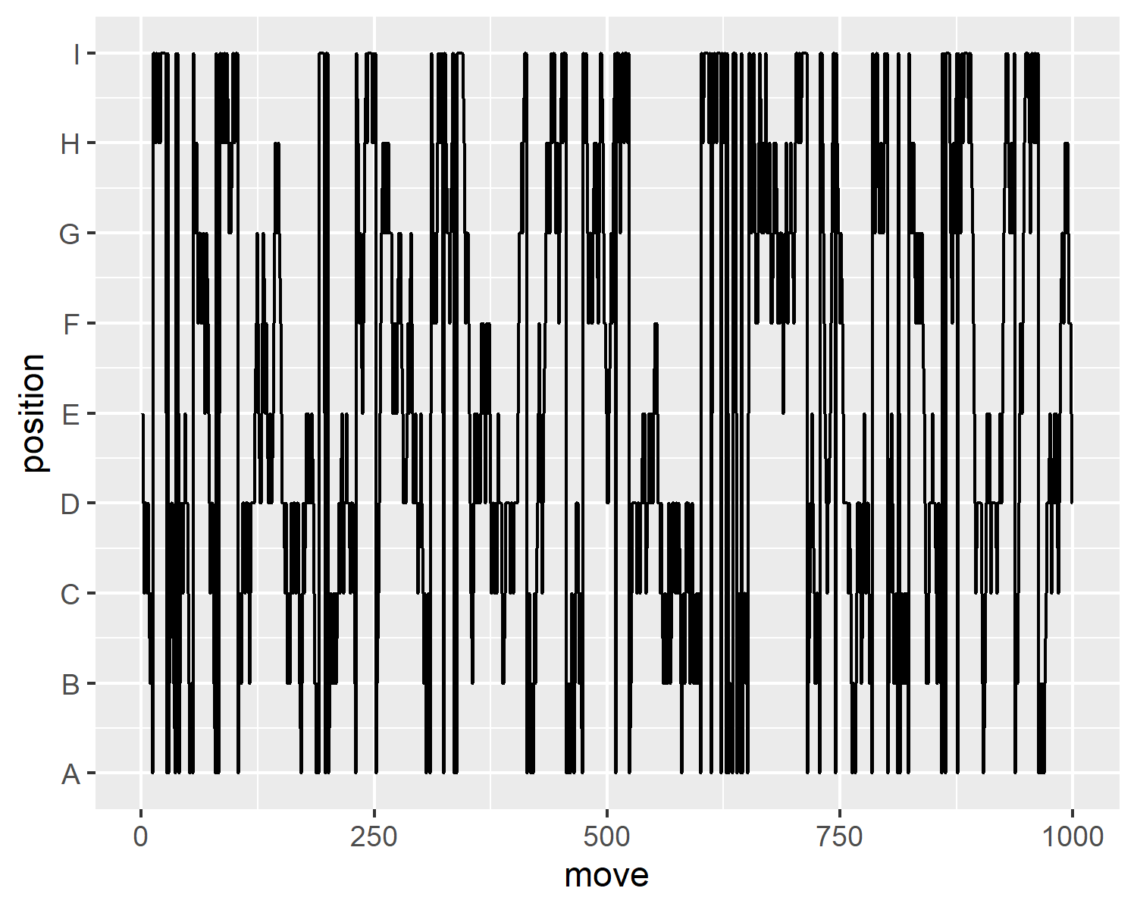

moves |>   
 filter(move<=100) |>  
 ggplot(aes(move,position))+  
 # geom_point()+  
 geom_line()+  
 scale_y_continuous(breaks=1:9,  
 labels = LETTERS[1:9])

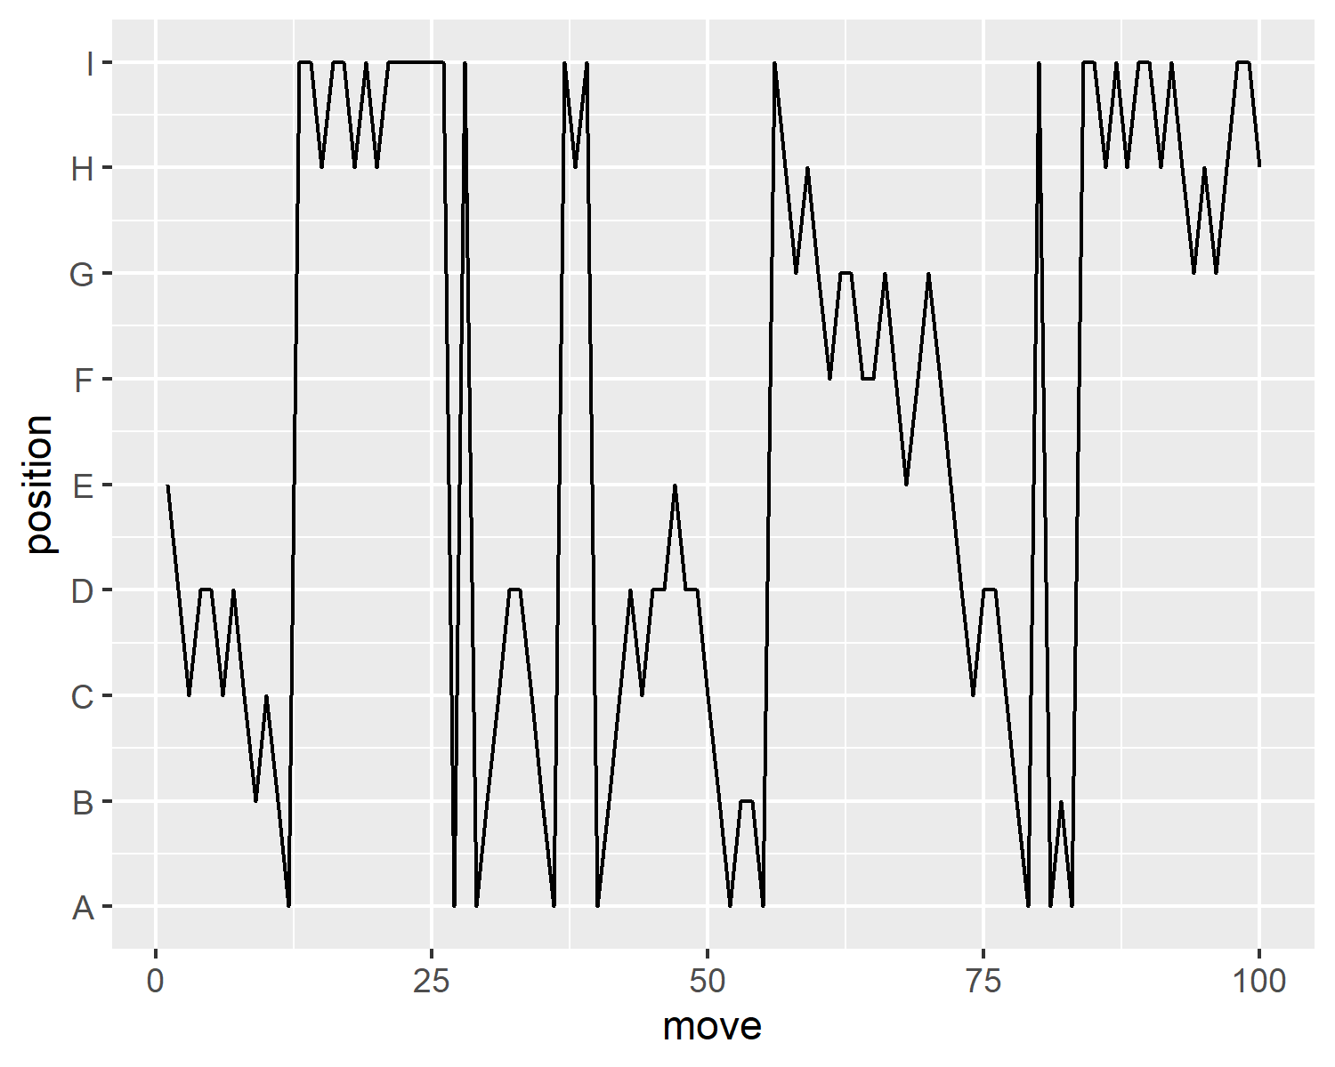

moves |>   
 filter(move>9500, move<10000) |>  
 ggplot(aes(move,position))+  
 # geom_point()+  
 geom_line()+  
 scale_y_continuous(breaks=1:9,  
 labels = LETTERS[1:9])

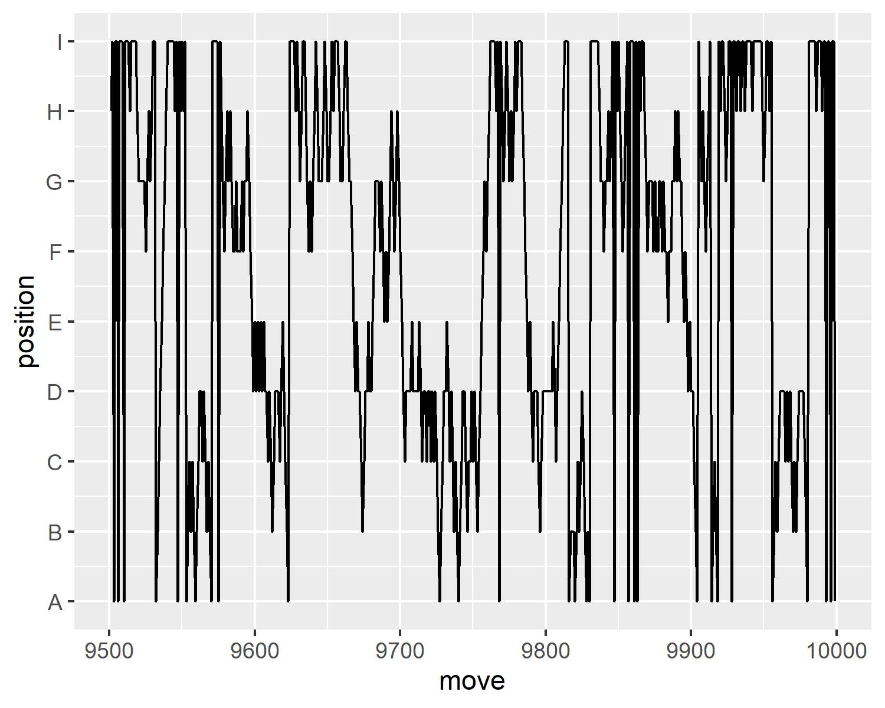

moves |>   
 # filter(move<=n_burnin) |>  
 ggplot(aes(move,position))+  
 # geom_point()+  
 geom_line()+  
 scale_x_continuous(limits = c(1,30))+  
 scale_y_continuous(breaks=1:9,  
 labels = LETTERS[1:9])

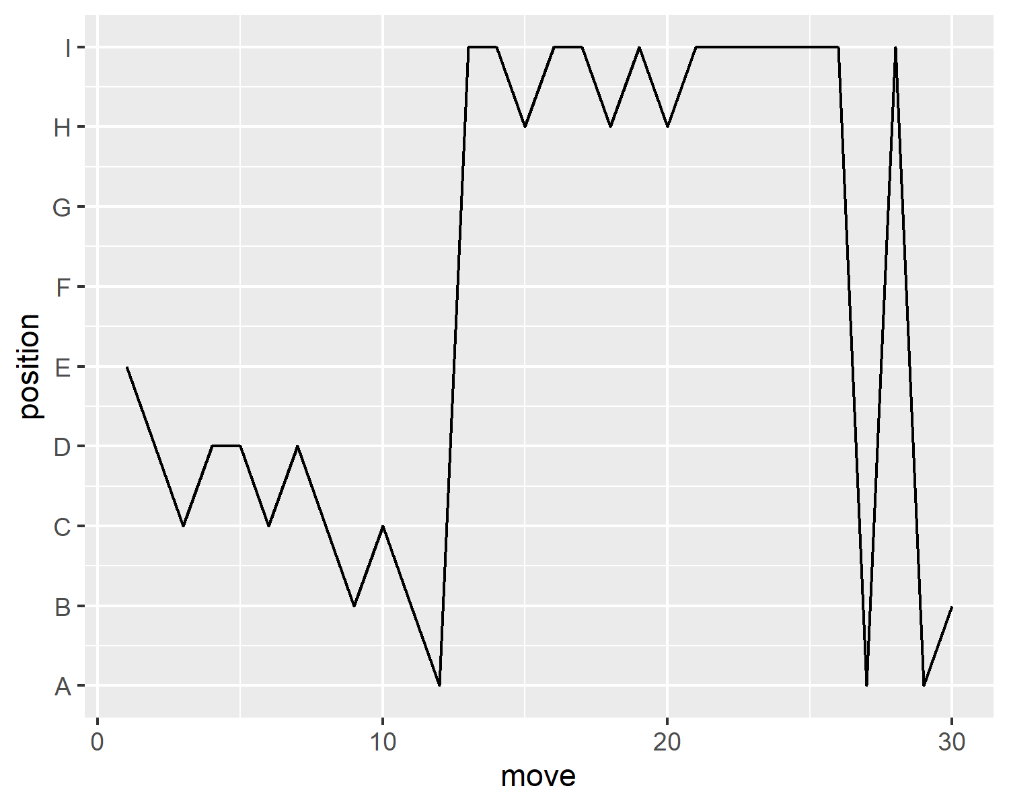

moves |>   
 # filter(move<=n_burnin) |>  
 ggplot(aes(move,position))+  
 # geom_point()+  
 geom_line()+  
 # scale_x_continuous(limits = c(1,30))+  
 scale_y_continuous(breaks=1:9,  
 labels = LETTERS[1:9])+  
 coord_cartesian(xlim=c(1,30))

