Local Execute -> Client Side Languages.

1 website: server low. / hardware, RAM LOW, Processor -> Low

100 rows. Name, address

300ms ---

2 website server high. Hardware -> higher,

100 rows. Name, address

200ms ----

Website : PHP

Website: ASP.NET

PHP server != ASP.NET

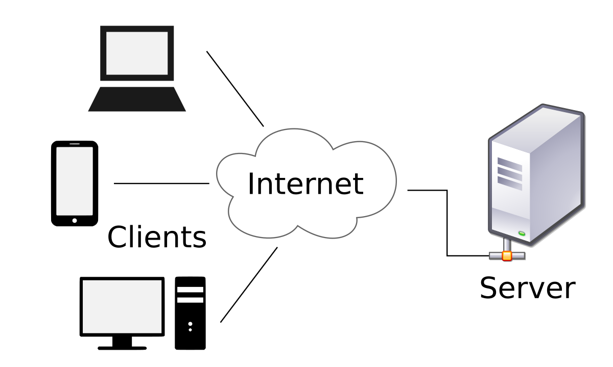

PHP -> Hypertext Preprocessor Langauge….

PHP…

Server Side…

Dynamic Website Develop.

Data ->fetch -> database.

Database -> Tables

Tables: Row / Columns

Multiple tables -> Relations…

Relational Database …

Data -> Information …. SHOW.

Data

Information