Dear Kun,
I have spent about 2 weeks to finish preliminary analysis of DFT volume calculations.
The main conclusion is as follows:
The calculations rightly predict common properties of the magnetic excitation, but the fine details of the dispersion are different.
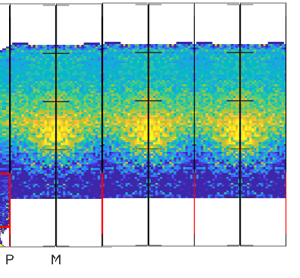
In particular, the odd feature in the PN direction, looking different from the experiment, looks much close to the reality if 3D effects and resolution effects are taken into account:
Cut without reresolution
Resolution convolution:
Experiment (combined cuts)
P N
I will look further, as higher energies transfer data are available, but difficult to extract (Toby did some extraction)
Unfortunately, such shape cannot be fitted by 5J Heisenberg Hamiltonian, so I need either extending the analytical model I am currently using, or start using SpinW, which is generic but an order of magnitude slower. Do you, occasionally, have references to the Hamiltonian with large number of pair interactions included or better existing code to model such Hamiltonian?
Despite technical difficulties, all this allows us to conclude, that main features of the magnon’s dispersion are captured properly.
Unfortunately, there are some issues, which do not look so good.
First of all,
Your simulations, like Martin's simulations, do not fully converge and producing Brillouin zone edges artefacts:
TD-DFPT implementation based on Quantum Espresso Full-potential LMTO code Questal (?):

The artefacts are different – not fully suppressed scattering around [1,0,0] points and “squaring” of the spin-wave rings in Quantum Expresso case vs clear Brillouin zone shapes in the case of Questal, but you would never guess the integral influence of such artefacts on the whole dispersion. The Quantum expresso dispersion looks fine while Questall is not providing good match to experiment for high scattering energies.
The unpleasant issue I am seeing from the results of Quantum Espresso calculations is dependency of spin-wave scattering intensity on direction at low energy transfer. Questal calculations do not produce such dependency.
Instead of the nice sphere in all directions, we are observing in experiment, the QE simulations produce the dependency on the scattering angle:
Of course, we have very poor q-resolution, but it does not seems explain this dependency.

I spent substantial time looking for such behaviour in experiment as previous theories predicted it and can certainly say that it is not observed in reality and the resolution effects would not mask it. The q-resolution of QE calculations is poor, so I still cannot be entirely sure if this is not some kind of aliasing due to the poor resolution. To fully clarify this question, could you, please calculate scattering along the line above for one energy transfer? This is only 32 q-points at the same energy should not take much time. The points of interest are attached. Of course, if the picture is significantly different from the one above and is much smoother, one may need to analyse the resolution effects but will see….

I have also estimated the validity of the idea, that we can calculate significant contribution of the energy transfer around dispersion and ignore all other energy transfer points.
There are about 500 q- points you have calculated and this approximation is good for about 400 of these points.
The stray points “miss” contribution looks like the one on the picture (reddish line where straight line indicates extrapolation over missing points) I can give you 100 points where the approximation does not hold well, but if you can calculate all points after all – thins will become much easier.
.
Another undesirable contribution of the missing points comes from Chebyshev’s interpolation. While the Chebyshev’s interpolation works really well on Marty’s data, missing points in your simulations cause unpleasant aliasing:

Kun's calculations -- Linear vs Chebyshev's approximations

Chebyshev’s approximation, I am using appeared to be implemented extremely inefficiently for 3D calculations. I need either write my own implementation or optimize the existing code. Both approaches are not difficult but may be time consuming, so may go with linear approximation after all…

Unfortunately, I need to interrupt the analysis to do some work on other project, where people depend on me, but things are coming together. I hope we will finish this work soon.

Regards,
Alex

