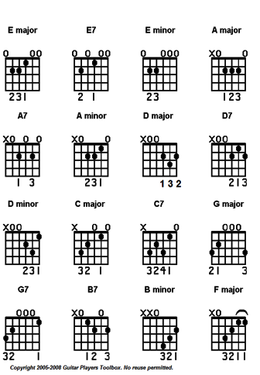
New magic type based upon music main frame is string instrument, magic is tangeable in effect and colour.
violet 380–450 nm blue 450–495 nm green 495–570 nm yellow 570–590 nm orange 590–620 nm red
white balance of all black absence of all

