From Manual Entry to AI Automation
A case study in reducing contract administration, improving CRM data accuracy and releasing employee capacity
Abuzar Arshi | 6 October 2026
Company name withheld. This case study describes an internal implementation without disclosing confidential contracts or customer information. Figures are team-reported estimates and reviewed outputs.

Setting the stage: from adoption to impact
McKinsey’s July 2026 article From adoption to impact: Three horizons of AI transformation starts from a simple point: AI does not create enterprise value just because more people use it. Individual productivity gains matter, but they rarely become lasting advantage while the organization around them stays the same.
Based on a survey of 750 employees and leaders, the article groups organizations into three horizons by how deeply AI is embedded in daily work. In enablement, employees get general AI tools that help with parts of their existing jobs. In automation, AI automates and improves cross-functional workflows at scale. In reinvention, roles, workflows and operating models are redesigned around what AI makes possible. Each horizon builds on the one before.
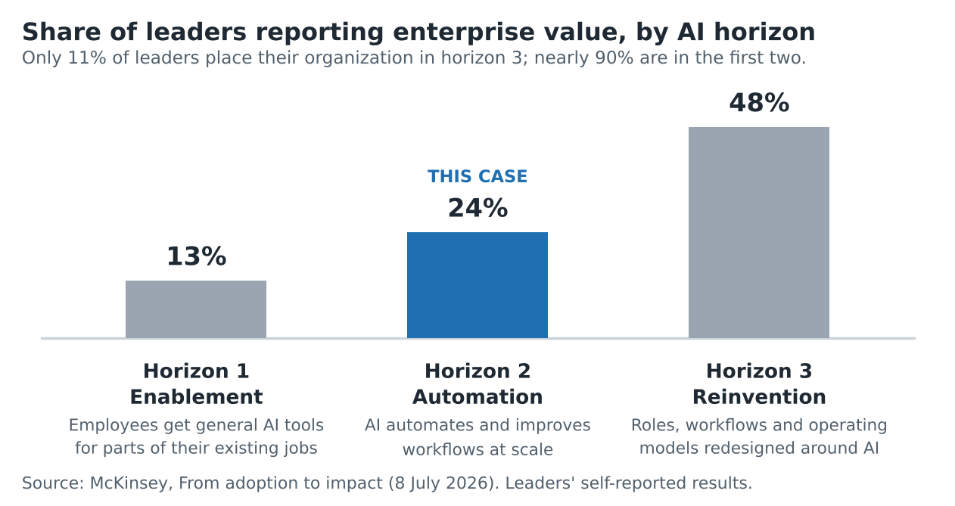
Most organizations are still early. Only 11% of leaders place theirs in reinvention, and nearly 90% are in the first two horizons. The gap is not about people: 70% of respondents felt personally ready to use AI, but only 27% of leaders thought their organization was ready to change around it. Organizational readiness explained 48% of the difference between leaders who reported capturing value and those who did not, against 25% for personal readiness.
What separated the organizations capturing value was how they changed work, not how many people had tools. Even in the first horizon, leaders were 5.3 times more likely to report enterprise value when workflows had been redesigned than when they stayed the same (32% against 6%). In the automation horizon, they were 3.9 times more likely to report value when the leadership team was fluent in AI (35% against 9%), and 3.3 times more likely when they had received support to build new skills (30% against 9%).
Source note. The survey ran from February to April 2026. Responses are individuals’ views, not company records, and McKinsey recruited extra respondents from more advanced organizations, so the shares may not match the wider market.
Where this case sits. This case sits in the second horizon, automation. AI was used to automate and improve one existing workflow whose output feeds teams such as Finance and Operations: extracting information from signed partner agreements into Google Sheets and transferring it to HubSpot. McKinsey’s findings explain why that is a starting point, not the destination. Moving up the horizons means redesigning how work gets done and directing the capacity AI releases toward business priorities, which depends on leadership, a roadmap, resources and roles as well as the tool. The case follows the problem, design choices, live pilot, adoption work and results, and shows where the productivity gain ended and further business value still depended on management decisions.

The case at a glance
Problem | After each partner agreement was signed, the Partnership team spent about an hour reconciling 30+ CRM fields against the final contract.
Solution | Upload the signed agreement, let AI document extraction fill a spreadsheet, check it, and a scheduled process sends it to HubSpot at the end of each day.
Result | About 5 minutes of employee time per contract instead of about 60, roughly 90% less. No errors found in a post-refinement review of 15+ contracts with 30+ fields each.
My role. I worked on this initiative as project manager, helping facilitate it rather than leading it end to end. The IT team built and maintained the extraction workflow. My hands-on contribution was adoption: I informed the affected employees, asked for the training materials (a written guide and step-by-step videos) to be produced, circulated them to the Partnership team, and followed up on completion alongside the head of the department.

1. Align: objective and sponsorship
After a partner agreement was signed, the Partnership team had to reconcile it against the information entered in HubSpot during negotiations: 30+ fields, about an hour per contract. The goal was to cut that final reconciliation work, capture the terms actually signed, and free time for account management, partner relationships, new partnerships and upselling.
The IT team sponsored the initiative as part of its wider AI adoption responsibilities. The Partnership team and the head of the department agreed the objective and approach. In scope: extracting signed-agreement information, preparing the CRM fields and creating the contract record through an automated workflow. Out of scope: negotiating agreements, drafting legal terms and signing contracts.

2. Discover: the existing workflow
The team studied the process by talking with the Partnership team and observing the workflow end to end. Employees had repeatedly raised the time it took, and the opportunity also came up in wider discussions about automating administrative work.
During negotiations, employees updated CRM fields as terms changed, sometimes several times. After signing, they compared each field with the final document and corrected any differences. The signed agreement, not an earlier entry, was the source of truth.
The 30+ fields covered the partner and products covered, contract length and renewal terms, exclusivity and geography, and financial and payment terms. Agreements came from a mix of company and external templates with the same information in different places. Non-AI approaches were considered first; given that variation, the extraction had to handle different layouts rather than one fixed format.

3. Prioritize: why this pilot first
It became the team’s first opportunity because the manual burden was substantial, the output was clearly defined and the benefit could be seen quickly. The existing CRM field list made the extraction target easy to specify. “Lower effort” is relative to other automation options; the pilot still needed refinement.
Factor | Why it fit
High operational value | Removed a recurring hour-long task from a team handling a lot of documentation.
Lower effort | A simple submission form, an existing field structure and a spreadsheet as the intermediate output.
Measurable | Handling time and field correctness could be compared with the old process.
Contained risk | Extracted data stayed in internal systems (the spreadsheet and the CRM) and could be checked against signed agreements and existing deal records.
Visible win | A simpler task for the Partnership team could build confidence in further AI workflows.

4. Build and live pilot
The pilot was the build. The workflow went live in production from the start, and the Partnership team and IT refined it as real contracts exposed gaps.
Design. Azure AI Document Intelligence extracts the agreement information into Google Sheets, with columns matching the existing HubSpot fields, so business users have a visible place to check it. A separate scheduled process sends the sheet data to HubSpot at the end of each day. The earlier automatic creation of a contract record from a deal was switched off; the new workflow creates the contract record separately, while the deal keeps the information captured during negotiation, so the two can be compared.
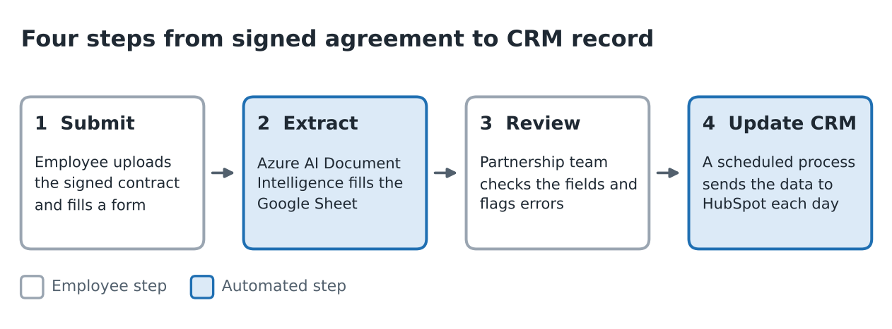
The form has three fields (employee name, partner name and solution or contract type) plus the attachments: the signed agreement and any relevant earlier agreements. Submitting takes under two minutes, typically under one. That is separate from reviewing the output and from the wait until the end-of-day CRM update.
Pilot and refinement. Roughly 10–15 contracts went through early testing and exposed scenarios the first configuration did not handle. Refinement took two to three weeks, and after about a month the workflow ran well with far fewer reported issues.
Issue found | Response
Earlier contracts missing | Renewals and upsells relied on terms in an earlier contract. Submission instructions changed to include all relevant agreements.
Third-party signatories | Some contracts were signed by a third party representing two or three partners, causing wrong field assignments. The extraction configuration was changed.
Format variation | Refined for the document structures and contract scenarios met in testing.

A cross-functional task force of Operations, Finance, the Partnership team and IT monitored the pilot. Teams checked the fields their own downstream work depends on, such as invoicing and operations, and the Partnership team checked extracted values as contracts were submitted. After the changes, outputs were reviewed again before the workflow was accepted for regular use. A separate review after refinement covered 15+ contracts with 30+ fields each. Accuracy depended on both the extraction and complete inputs, so fixing the submission process mattered as much as tuning the technology.

5. Adopt: communication, training and support
Before launch, affected employees were told why the process was changing, how it would reduce administrative effort, how it fitted the company’s move toward automation, and what training and support would be available.
- Training. An end-to-end written guide and step-by-step videos using a dummy account, which employees can return to as a reminder. Early guidance stressed checking the spreadsheet output and giving feedback, especially on the first few submissions.
- Ownership. Adoption was co-owned by me and the head of the department. The department head sent direct messages and reminders; I followed up on completion.
- Support. A dedicated Google Chat space for questions and error reports, with email as a fallback, so there was no need for a separate feedback form.
- Reinforcement. With the old automatic route switched off, employees had to start the workflow after each signed deal. Reports of missing contract creations drove reminders and extra training for anyone who had not completed it on time. Within a few weeks the form was in regular use. The Partnership team kept responsibility for checking results, and its feedback surfaced the issues fixed during refinement.

6. Measure: results
How to read the numbers. Both handling times are team estimates, not timed studies, so the roughly 90% reduction compares two estimates. Accuracy comes from field-by-field review of a sample after refinement and is not a guarantee for future contracts.
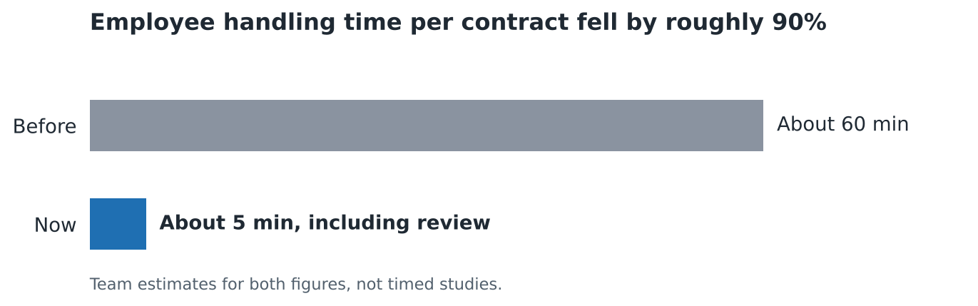
Measure | Result
Time per contract before | About 60 minutes (team estimate).
Time per contract now | About 5 minutes including submission and review (team-confirmed estimate), about 55 minutes less and a reduction of roughly 90%.
Reviewed accuracy | No errors found across 15+ contracts with 30+ fields each (450+ fields), reviewed after refinement.
Contract volume | About 1.5 a week on average (one or two), so roughly 80 minutes of employee time released per week (estimate).
CRM update timing | Daily transfer at the end of the day. The 5 minutes is employee handling time, not the time until the CRM is updated.
Running cost | Not tracked. The extraction service runs on every signed contract, so it carries a usage cost to set against the time saved.
Business impact and its limits. The observed benefit was less manual administration and more reliable reviewed CRM data. At current volume the direct saving is about 80 minutes of employee time a week; the larger value is a repeatable pattern with headroom as volume and fields grow. Released time is not evidence of more revenue or lower payroll cost. Leadership still has to direct that capacity to useful work and track the result. This case shows an operational improvement; commercial impact is a next opportunity, not a measured result.

7. Scale and lessons
Ownership. The IT team owns maintenance, technical issues, new contract scenarios and future development. Business users remain responsible for spotting incorrect output and explaining the operational needs a change affects.
Scaling. More contract volume would raise the time released. More fields and other document-heavy workflows are candidates, not completed work. Adding fields needs updates to field definitions, extraction configuration, spreadsheet mapping and validation, plus more review time, so the 5-minute figure should not be assumed to hold. A sampling approach to review was discussed for the future if output proves consistently reliable; routine human review has not been removed, and any change would need agreement from the teams relying on the data.
Next horizon. In McKinsey’s terms, this case is the automation horizon at small scale. Moving up would mean questioning the process itself, not only speeding it up: what contract data the business needs and when, how roles and decisions change once that data arrives already extracted, and how the released time is deliberately redirected.
Next measures. Track how released time is used (for example account coverage or partner follow-up) and the extraction running cost against the time saved.
Lessons
- Start with a specific burden and an output the business can verify.
- Treat complete document context as part of the design.
- Learn from a live pilot, with the teams that depend on the data reviewing the output.
- Make adoption operational: instructions, support, named owners and reminders tied to the workflow.
- Separate efficiency from business impact: released capacity is an opportunity, not a result.
Further reading
- McKinsey: From adoption to impact: Three horizons of AI transformation
- Microsoft Learn: Azure AI Document Intelligence overview

