# **Al-Huda Model School**

# **Half Yearly Examination 2023-2024**

# Subject – Science

# Class – Preparatory (Prep)

**Total Marks: 50**

**Time :**

**Name:**……………………………………………………

**Section:** ………………………………………….

**Date:**……………………………………………..

Q1: Answer the following questions. **Mark 3 X 4=12**

A: Name two flesh eating animals.

Ans: 1-………………………………………………………………………. 2-…………………………………………………………………

B: What are wild animals?

Ans:………………………………………………………………………………………………………………………………………………

C: Name two animals that are useful to us

Ans:1-………………………………………………………… 2-…………………………………………………………………………………….

D: Name two insects which have wings.

Ans:1-……………………………………………………………. 2-……………………………………………………………………………………

Q2- Tick the correct option. **Mark: 5**

1. Animal need food to
2. Move b) Live c) None
3. Birds have
4. Mouth b) Beak c) None
5. Animal which are useful to us are called.
6. Wild animals b) Water animals c) Domestic animals
7. They hold the plant in the soil
8. Leaves b) Stem c) Roots
9. Living things
10. Move b) Do not move

Q 3: Fill in the blanks with the help of given below words. **Mark:5**

(Plants, many, fruits, shrubs, domestic animals)

1. All animals and …………………………………………………………. are living things.

(2) ……………………………………………………………. grow from flowers.

(3) ………………………………………………………………. are bushy and woody stems.

(4) Horse is a ……………………………………………………… animal.

(5) Monkeys eat both plant and ……………………………………………………….

Q4: Give to example of each. **Mark: 10**

1. Climber 1-……………………………………………………………… 2-…………………………………………………………………
2. Bird that can swim 1-…………………………………………………………. 2- ……………………………………………………
3. Non-living things 1-……………………………………………………………. 2-………………………………………………….
4. Big plants 1- ……………………………………………………………. 2- ……………………………………………………….

Q5: Match the following. **Mark 4 X 2=8**

Herb 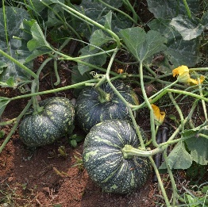

Shrub 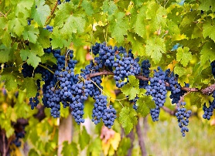

Climber 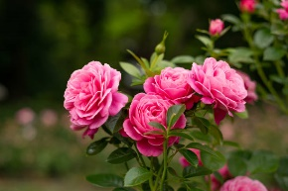

Q:6 Label the parts of plant. **Mark: 10**

