Sprint 3 Plan
Product Name: SproutLabs
Team Name: SproutLabs Test Automation / Alexa
Sprint End Date: 11/19/2017

Sprint 3 Goal: Unit/Integration Testing & Skill Testing
For Sprint 3, as Test Automation developers, we want to continue writing unit tests and to start writing integration tests for the SproutLab web application. As Alexa developers, we want to test that the Alexa skills are retrieving the right information.

Test Automation Team – User Stories

User Story 1
As a developer, I want to test my page components so that we can ensure that the web application is designed efficiently.

Tasks Time Estimate
- Write unit tests for SensorAvatar. 1 hours
- Write unit tests for SensorBox. 2 hours
- Write unit tests for DashboardChart. 3 hours
- Write unit tests for Welcome. 6 hours
- Write unit tests for ConfigureNode. 3 hours
- Write unit tests for Dashboard. 6 hours

Total for User Story 1: 21 hours

User Story 2
As a developer, I want to improve my unit tests by avoiding duplicate code so that future changes only have to be made to one source.

Tasks Time Estimate
- Researching and creating a test data file. 2 hours
- Update RecentNotificationBox. 1.5 hours

Total for User Story 2: 3.5 hours

User Story 3
As a developer, I want to write integration tests for the SproutLabs web application.

Tasks Time Estimate
- Setup SproutLabs devDB server. 1 hour

Total for User Story 3: 1 hour (per developer)

Alexa Team – User Stories

User Story 4
As a developer, I want to test that the Alexa skill is retrieving the right information.

Tasks Time Estimate
- Test the three intents of the skill. 5 hours
- Test connection to the server. 3 hours

Total for User Story 4: 8 hours

Team Roles
- Alejandra Buznego: Alexa Developer
- Edgar Bernal Sanchez: Test Automation Developer
- Michael Pluguez: Test Automation Developer
- Nicole Thompson: Test Automation Developer
- Terence Tang: Scrum Master and Test Automation Developer

Initial Task Assignment
- Alejandra Buznego [Alexa]
  - User Story 3: As a developer, I want to test that the Alexa skill is retrieving the right information.
  - Task Test the three intents of the skill.

- Edgar Bernal Sanchez [Test Automation]
  - User Story 1: As a developer, I want to test my page components to ensure that the web application is designed efficiently.
  - Task: Write unit tests for DashboardChart.

- Michael Pluguez [Test Automation]
  - User Story 1: As a developer, I want to test my page components to ensure that the web application is designed efficiently.
  - Task: Write unit tests for Welcome.

- Nicole Thompson [Test Automation]
  - User Story 1: As a developer, I want to test my page components to ensure that the web application is designed efficiently.
  - Task: Write unit tests for SensorAvatar.

- Terence Tang [Test Automation]
  - User Story 1: As a developer, I want to test my page components to ensure that the web application is designed efficiently.
  - Task: Write unit tests for SensorBox.

Scrum Times
Scrum Meeting | Date | Time | Location
Standup #1 | Monday | 11:00am – 11:30am | BE 302
Standup #2 with TA | Wednesday | 10:50am – 11:15am | BE 302
Standup #3 | Friday | 10:30am – 11:00am | BE 302
Sprint Review + Retrospective | Sunday | 3:00pm – 4:00pm | BE 302

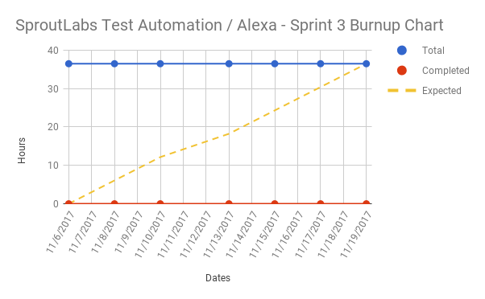
Initial Burnup Chart

Initial Scrum Board
