**HEAD MOTION & VOICE CONTROLLED WHEELCHAIR**

Edwin Easo Mathew #1, Akash S. Nambiar #2, Kaushik Balasundar, Abhishek S.A., Aby J. Kottoor

Department of Mechanical Engineering

BMS Institute Of Technology & Management

Doddaballapur Main Road, Avalahalli, Yelahanka,   
Bengaluru-560064, Karnataka

1. [edwinem3398@gmail.com](mailto:edwinem3398@gmail.com)
2. akashsn998@gmail.com

**Abstract:***A head-motion and voice controlled automatic wheelchair serves the mobility requirements of quadriplegics. It detects head motion using data obtained from ADXL 335, a triple axis accelerometer. The data is processed using two microcontrollers, ATMega-2560, and Genuino-Uno, programmed to work with the open-source platform, Arduino. The wheelchair moves in three directions, i.e., front, right, and left, based on the user’s head motions*. *The Arduino controls motors in the desired direction. An ultrasonic sensor prevents collisions with obstacles and enhances user safety. Data is transferred from the accelerometer placed on the user’s head to the receiver for data processing using RF technology. We also explore the advantages of implementing offline voice control, a staircase climbing wheelchair and brain-wave controlled wheelchair.*

**Keywords:** Head-motion control, accelerometer, voice control, radio frequency, ultrasonic sensor.

1. **INTRODUCTION:**

Independence is one of the biggest challenges for people with disabilities who are confined to wheel chairs. They are constantly dependent on their family and friends to perform basic tasks to sustain their livelihood. The objective of this project is to build and sustain a head motion controlled wheelchair that allow the elderly and paralyzed patients to be completely independent in terms of mobility. Most wheelchairs in hospitals are not automated and require manual force by an external user. In most cases, this mode of operation is inconvenient. The electric wheel chairs operational today make use of a joy stick and has very limited safety features. Hence, patients whose limbs are dysfunctional find it impossible to attain any degree of independence. Completely paralyzed patients today have absolutely no means acting independently, even to the slightest degree. Transporting a person confined to a wheelchair up a flight of stairs is another major problem which is yet to be efficiently solved and integrated effectively. The solutions available today involve bulky accessories which makes its portability and reliability impractical on a day to day scenario. Advantages of this head motion controlled wheel chair:

* Allows quadriplegic patients and those with very minimal motor functionality of the limbs to control the wheelchair and be independently mobile.
* Improves accuracy as head motions are more continuous and give a wider range of control as compared to discrete controls in the electric wheelchairs controlled with a hand-operated remote control.

1. **DESIGN AND CONSTRUCTION OF PROTOTYPE**

The prototype demonstrates and reflects the basic functioning and expectations of the head motion controlled wheelchair. It consists of two units, namely the transmitting unit and the receiving unit. The transmitting unit is to be placed on the user’s head by means of a wearable accessory, and the receiving unit will be fitted on the wheel chair. The communication from the transmitting unit to the receiving unit is done by means of radio frequency wireless communication. The transmitting unit consists of:

1. Arduino Genuino Uno
2. LR433T2 RF Transmitter (433MHz)
3. ADXL 335 triple axis accelerometer

The receiving mounted onto the chassis of the wheelchair consists of:

1. Arduino ATMega 2560
2. 2 x 12V, 60 RPM DC Motors
3. 12V rechargeable lead-acid battery
4. HC SR04 Ultrasonic Sensor
5. HW-95 Motor Driver board
6. R435 RF Receiver
7. 5V Battery
8. PCB Board with soldered components.
9. 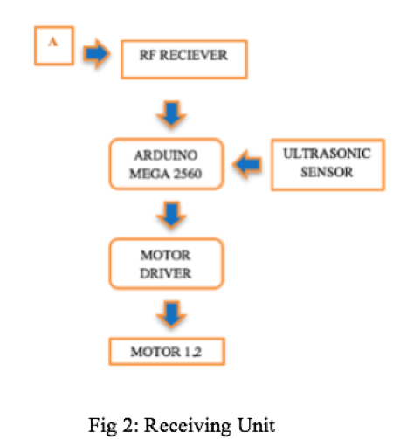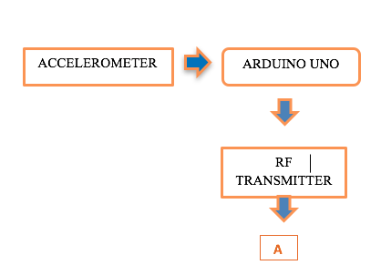**SCHEMATIC FLOW CHART**

Fig 1: Transmitting Unit

1. **DATA ANALYSIS**

The accelerometer readings for x, y, and z axes must be calibrated such that the tilting of the head by an appropriate amount results in the wheelchair turning in the desired direction. The code needs to account for certain boundary values, only beyond which the desired control is executed. This is essential because any random movements of the user’s head must not result in the wheel chair moving.

The table of values of the ADXL 335 accelerometer used is shown:

|  |  |  |  |
| --- | --- | --- | --- |
| Accelerometer Position | X Axis | Y Axis | Z Axis |
| Mean | 357.69  1.70  2.83  2.75 | 4.04  0.57  2.83  4.40 | 330.26  71.57  45.00  32.01 |
| Forward | 34.89  35.61  32.81  33.34 | 0.75  360.00  0.75  360.00 | 88.92  96.00  88.83  90 |
| Left | 354.29  354.75  354.29  354.89 | 334.56  335.51  333.80  335.98 | 191.82  192.38  188.75  186.97 |
| Right | 356.19  358.41  358.32  360.00 | 40.19  40.73  42.81  48.86 | 335.60  358.26  358.18  360.00 |

Table 1.1: Accelerometer Data Chart

The above data is obtained on tilting the accelerometer in the required directions by the desired amount. The amount of tilt is judged on an experimental data obtained from the user’s head motion. The data implied in the code is subject to the patient’s convenience and can be altered if the given values don’t meet the needs of the user. Based on the following data, the fundamental logic used in the transmitter’s code is given in the following tablature.

|  |  |
| --- | --- |
| Accelerometer Position | Logic Used |
| Forward | x<50&&x>20&&y<360&&y>0&&z<150&&z>40 |
| Left | x>=0&&x<=360&&y>50&&y<=360&&z>130&&z<210 |
| Right | x>0&&x<360&&y>15&&y<340&&z<20||z>345 |
| Stop | Executable for all other values |

Table 1.2: Data Analysis

NOTE: && implies logical “AND” and || implies logical “OR”.

1. **SENSORS**

The two sensors demonstrated in the prototype include the accelerometer and the ultrasonic sensor. While the accelerometer is a prerequisite for locomotion, the ultrasonic sensor is included to enhance the safety of the user. With added independence and freedom for mobility, comes the risk of potentially colliding with dangerous obstacles while moving from one point to another. The ultrasonic sensor’s primary motive is to ensure that that the wheelchair doesn’t collide with any obstacle. We must consider the delayed reaction time of the users as they have constrained reflex times. HC SR04 [2] initially sends a 10us high level signal, followed by eight 40 kHz signals to detect if the high signal returns. Using the time of return of the high signal sent, the corresponding distance of the obstacle is calculated. It has a minimum range of 2cm and a maximum range of 4m, which are well within the requirements of our application. The ultrasonic sensor has been programmed in such a way that it overrides any incoming data coming from the accelerometer. If there are any obstacles within 30 cm of the wheelchair, all motors will come to an immediate halt. As with the accelerometer, we have imposed the 30-cm distance confinement on a purely experimental basis. The value can be changed accordingly to suit needs of the patients using the wheelchair or the environment in which it is intended to be operated. The accelerometer used is ADXL 335, which is a triple axis analog-output accelerometer. This accelerometer has been chosen on the account of several distinguishing features that it possesses [1]. Its low cost, small size, low profile, low power (1.8V to 3.6V), 10,000 g shock survival capability, and excellent temperature stability make it an ideal device to be used for our application. 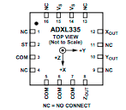

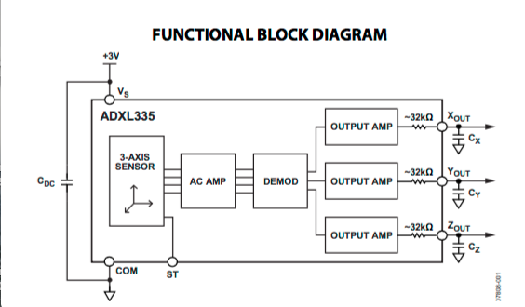Fig 3. Pin Configuration of ADXL 335

Fig 4: Functional Block Diagram of ADXL 335

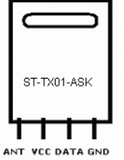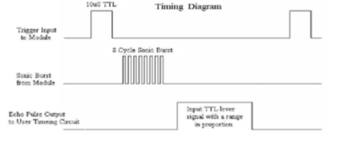

Fig 5. Timing diagram of HC SR04 Ultrasonic sensor

|  |  |
| --- | --- |
| Working Voltage | DC 5V |
| Working Current | 15mA |
| Working Frequency | 40Hz |
| Max Range | 4m |
| Min Range | 2cm |
| Measuring Angle | 15 degree |
| Trigger Input Signal | 10uS TTL pulse |
| Echo Output Signal | Input TTL lever signal and the range in proportion |
| Dimension | 45*20*15mm |

Table 3. HC SR04 Ultrasonic Sensor Parameters

1. **RADIO FREQUENCY WIRELESS COMMUNICATION**

The prototype wirelessly sends the accelerometer data from the transmitter on the user’s head to the processor at the receiving unit. This will control the signals to the motors based on the accelerometer data. We have selected ST TX01 433 MHz transmitter due to its small size, low cost and ease of modification [3].

Fig 6. ST-TX01-ASK Pin Diagram

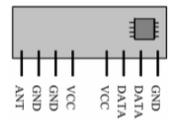For receiving the data, the 433 MHz ST-RX02-ASK Hybrid receiver module has been employed. It’s low cost, low power consumption and -20oC to +70oC temperature tolerance, suit the needs of our application [4].

Fig 7. Pin description of ST-RX02-ASK (433 MHz)

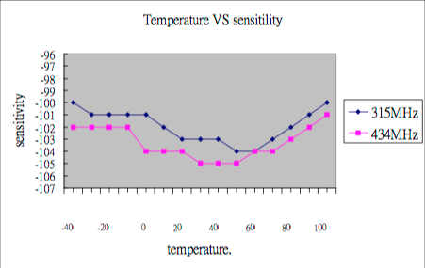

Fig 8. Temperature vs Sensitivity characteristics of ST-RX02-ASK

To increase the rate of communication, we only send one bit of data from the transmitter to the receiver. The one bit data sent from the transmitter to the receiver will be decoded at the receiving end accordingly. The following tablature represent the data transmitted and received.

|  |  |
| --- | --- |
| Data to be transmitted | Data sent |
| Forward | “f” |
| Left | “l” |
| Right | “r” |
| Stop | “s” |

Table 5. Data transmission key

At the receiving end, the data is decoded by comparing the values of the incoming data with their corresponding hexadecimal values as shown:

|  |  |  |
| --- | --- | --- |
| Data Received | Hexadecimal Value | Data Interpretation |
| “f” | 0x66 | Forward |
| “l” | 0x6C | Left |
| “r” | 0x72 | Right |
| “s” | 0x73 | Stop |

Table 6. Data receiving key

1. **CALCULATIONS**

We make the following assumptions for the calculations to be followed:

1. Weight of the wheelchair = 100 kg. (m1)
2. Weight of the person = 100 kg. (m2)
3. Total load = 200 kg. (m)
4. Velocity of wheelchair in a non-inclined track = 2.5 m/s (v1)
5. Velocity of wheelchair while climbing up the stairs = 0.2 m/s (v2)
6. Diameter of main wheel = 0.4 m (D1)
7. Diameter of the gear = 0.2 m (D2 )
8. Voltage of motor (manufacturer: Maxon, 400W) = 24V
9. Stall current of motor (manufacturer: Maxon, 400W) = 18.8 A
10. Efficiency of motor (manufacturer: Maxon, 400W) = 80%

Calculations for weight of wheelchair:

F = m*a ---(1)

Where, F = Force

m=Mass of the wheelchair

a=Acceleration due to gravity

F = 200 * 9.81 (m/s-2)

**F = 1962 N**

Calculations for power (Full Load) :

Output power = Pout =

= 0.8* 24 * 18.8

**Pout =360.960 W**

Calculations for rpm:

1. Non-inclined condition

D1)

N1 = 119.350 **RPM**

Where,

N1 = Speed in RPM

1 = Velocity of wheelchair in a non-inclined track

D1 = Diameter of the main wheel

1. Inclined (stair climbing)

D2)

=**19.096RPM**

**≈20RPM**

Calculation for torque:

1. Full load torque of motor when travelling on non-inclined surface:

**= 31.081 N-m**

1. Full load Torque of motor during climbing inclined surface (ascent):

**= 172.4 N-m**

1. **OFFLINE VOICE CONTROL TECHNOLOGY**

To make the wheelchair suitable for people who prefer to use their voice instead of the motion of their heads, we can implement voice control through an offline source, “Snowboy”. This software features a ‘hotword’ detection technology which can recognize certain key words that the user says through the USB microphone connected to the on-board processor. This offline voice control technology offers several advantages as opposed to the technology used in voice assistants in smart phones.

1. It is highly customizable allowing you to freely choose any desired ‘hotword’.
2. It facilitates enhanced privacy as the software is always listening but protects privacy because Snowboy does not connect to the Internet or stream the user’s voice anywhere.
3. Light-weight and embedded allows it to be run on Raspberry Pi’s, consuming less than 10% CPU on single-core 700M Hz ARMv6 processors. This is the greatest advantage over the other commonly used voice assistants including Siri, Alexa, etc.

1. 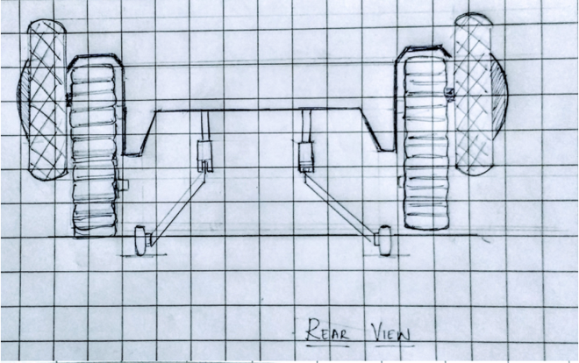**SHORT ACCOUNT ON DESIGN STAIR CASE CLIMBING WHEEL CHAIR**

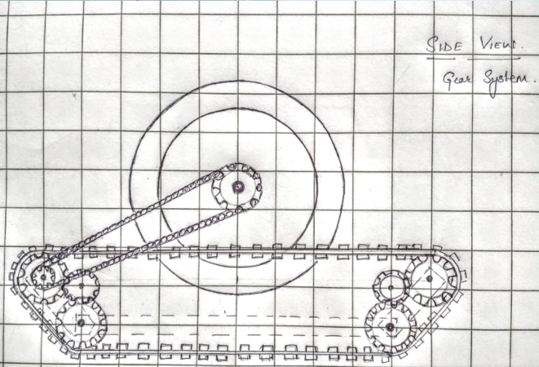The commercially available wheelchairs today do not facilitate integrated staircase climbing technology. External attachments are used to transport the wheelchair up a given flight of stairs. These external accessories are not mobile, making it impractical to be carried along with the user in the wheelchair. The following design shown below is an attempt to seamlessly integrate the stair climbing mechanism along with the wheelchair which will enhance mobility and eliminate their dependence on any external accessories.

Fig 10. Rear view

:

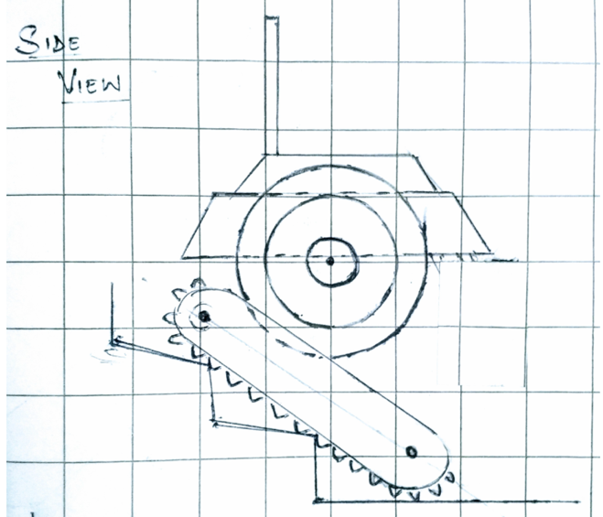

Fig 11. Side view gear system

:

Fig 9. Side view with gear system

:

Fig 9. Exterior side view

:

The reasons for selecting the track stair climber wheelchair design, like that used in military tanks, are due to the following advantages:

1. Moves Smoothly
2. Good Adhesion
3. High transmission efficiency
4. Adaptability to terrain
5. Simple control
6. **FUTURE POSSIBILITIES**

MIND CONTROLLED WHEEL CHAIR:

The obvious disadvantage of this concept is that patients who cannot move their head or neck without any discomfort will not be able to operate the wheelchair. The ultimate solution to this problem would be to fabricate a “mind controlled” wheelchair, wherein even a completely paralyzed patient who retains his ability to concentrate will be able to control the motion of the wheelchair.

WORKING OF EEG:

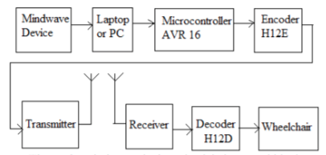

Fig 13. Functional block diagram of EEG

An EEG device records electrical signals from the brain, specifically postsynaptic potentials of neurons. The brain's electrical charge is maintained by billions of neurons. Neurons are electrically charged (or "polarized") by membrane transport proteins that pump ions across their membranes. Neurons are constantly exchanging ions with the extracellular space. Since ions of similar charge repel each other, when many ions are pushed out of many neurons at the same time, they can push their neighbors, who push their neighbors, and so on, in a wave. This process is known as volume conduction. When the wave of ions reaches the electrodes on the scalp, they can push or pull electrons on the metal in the electrodes. Since metal conducts the push and pull of electrons easily, the difference in push or pull voltages between any two electrodes can be measured by a voltmeter. Recording these voltages over time gives us the EEG.  The recording is obtained by placing macro-electrodes on the scalp, usually after some abrasion and with a conductive gel to create a better contact.

The mindwave mobile device by Neurosky reports the user’s mental state in the form of Neurosky’s proprietary attention and meditation e-sense algorithms, along with raw wave data and information about brain wave frequency bands. It uses TGAM 1 module and is compatible for wireless pairing with iOS, android, Windows and Mac operating systems. It consists of a head set, ear clip and a sensor alarm. It can detect bio-signals including EEG, EOG, EMG and ECG. EEG signals from the brain and EMG signals from the eye blinks and forehead muscles are the main signals which are implemented in this project. The ThinkGear used in the software is responsible for amplifying raw data and removing ambient noise as well as muscle movement. The e-sense attention meter indicates the intensity of the user’s level of “focus” or “attention”. The e-sense meditation meter relays information on the user’s state of “calmness” or “meditation”.

ADDITIONAL SENSORS AND ALTERNATE ENERGY SOURCES:

The open source nature of the Arduino platform allows more useful sensors to be added to the basic skeleton. For example, a moisture sensor can be used to detect if a patient with disabled motor control has urinated and alert the care takers. A Bluetooth communication facility can be included to send an emergency signal to health-care professionals in case the patient requires any medical attention. In addition, productive energy solutions in the form of piezoelectric sensors can be attached to the wheelchair’s wheels to generate electricity from the pressure that results as the wheel rotates. The wheelchair could also accommodate Peltier Tiles on the seating platform to convert the heat energy to electricity by maintaining a temperature gradient [6]. Although these methods don’t produce sufficient energy to sustain the entire operation of the wheelchair, the electricity generated can be used as an alternate backup for operating the low power consuming components in our model.

1. 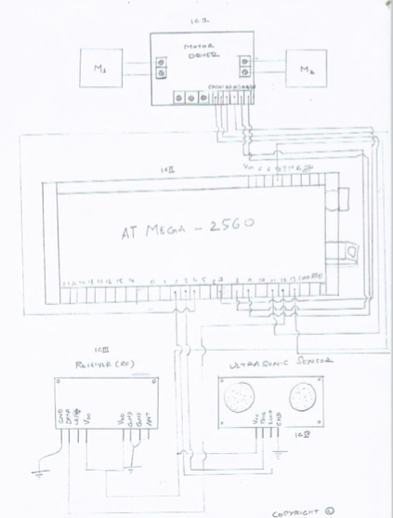**CIRCUIT DIAGRAM**

Fig 9. Transmitter Circuit Diagram

1. **GALLERY**

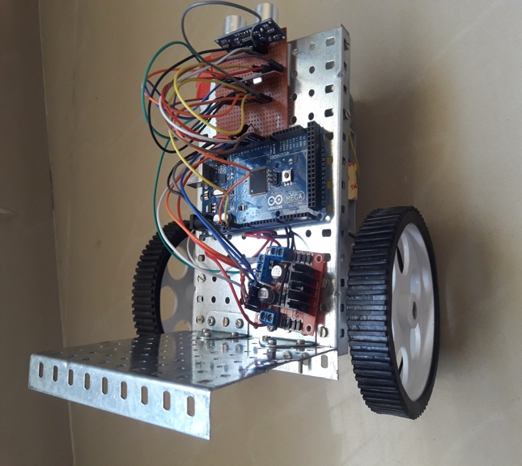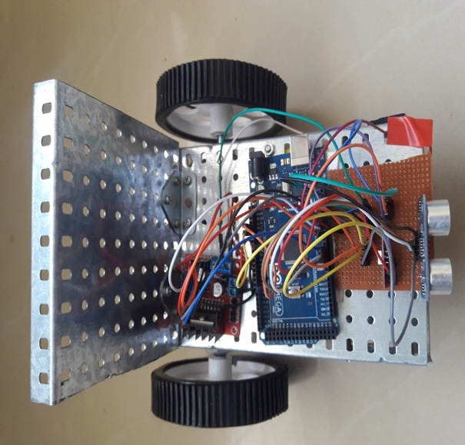

Fig 10: Prototype

1. **ACKNOWLEDGEMENT**

The authors thank the Principal, faculty and management of BMS Institute of Technology & Management for their continuous support and encouragement.

1. **REFERENCES**

[1]https://www.sparkfun.com/datasheets/Components/SMD/adxl335.pdf

[2] <http://www.micropik.com/PDF/HCSR04.pdf>

[3] http://138.197.44.96/datasheets/TXC1.pdf

[4] <http://138.197.44.96/datasheets/RXD1.pdf>

[5]http://www.airspayce.com/mikem/arduino/VirtualWire/

[6]http://gizmodo.com/the-cool-promise-of-machines-that-run-on-body-heat-1561923261

[7]https://en.wikipedia.org/wiki/Electroencephalography

[8]https://www.ijsr.net/archive/v5i6/NOV164722.pdf

[9]Neurosky Mindwave user guide

[10]http://developer.neurosky.com/docs/doku.php?id=mindwave_mobile_and_arduino

[11] <http://www.healthline.com/health/eeg>

[12]https://lsa.umich.edu/psych/danielweissmanlab/whatiseeg.htm

[13]http://www.ijrdet.com/files/Volume1Issue3/IJRDET_1213_07.pdf

[14]http://troindia.in/journal/ijapme/vol2iss5/1-4.pdf