APS COURSE PROJECT
CSE603

PERSISTENT SEGMENT TREE AND PERSISTENT BINARY TRIE

-SHOBHIT RAJ GAUTAM (2019201056)
-ABHINAV GUPTA (2019201064)

1. PERSISTENT SEGMENT TREE

1.1 TREE :

Tree data structure can be defined recursively (locally) as a collection of nodes (starting at a root node), where each node is a data structure consisting of a value, together with a list of references to nodes, with the constraints that no reference is duplicated, and none points to the root.

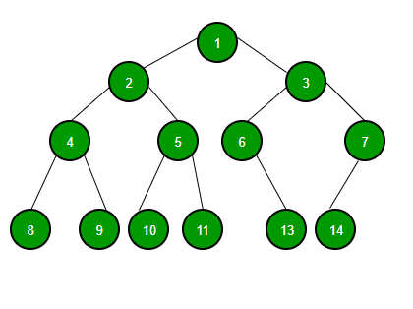

1.2 SEGMENT TREE

Segment tree is a tree data structure used for storing information about segments or intervals. It allows querying which of the stored segments contain a given point.For such intervals or segments endpoints are fixed or known a priori.
So Sets of intervals stored with the node can be structured in any manner convenient depending on the problem.

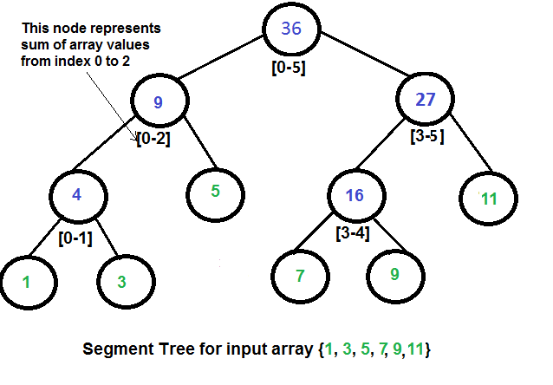

1.3 PROPERTIES
- It can be built in O(n) time.
- Segment trees support searching for all the intervals that contain a query point in O(log n).
- Leaf node of Tree correspond to the elementary intervals in an ordered way.
- The internal nodes of Tree correspond to intervals that are the union of elementary intervals of set I.
- Root of Tree is union of all elements in set I.

1.4 STRUCTURE OF SEGMENT TREE:

1.4.1 CODE SNIPPET
struct s_tree
{
int data;
s_tree *left,*right;
int max;
int min;
};

1.4.2 ALGORITHHM

- Let explain for sum representation in Segment Tree.
- the sum of the segment a[0…n−1] is stored as root.
- We then split the array into two halves a[0…n/2] and a[n/2+1…n−1] and compute the sum of each halve and store them.
- Each of these two halves in turn also split in half their sums are computed and stored.
- And this process repeats until all segments reach size 1.
- For each such segment we store the sum of the numbers on it.

1.5 PERSISTENT DATA STRUCTURE
A persistent data structure is a data structure that always preserves the previous version of itself when it is modified.
Such data structures are effectively immutable, as their operations do not (visibly) update the structure in-place, but instead always yield a new updated structure.

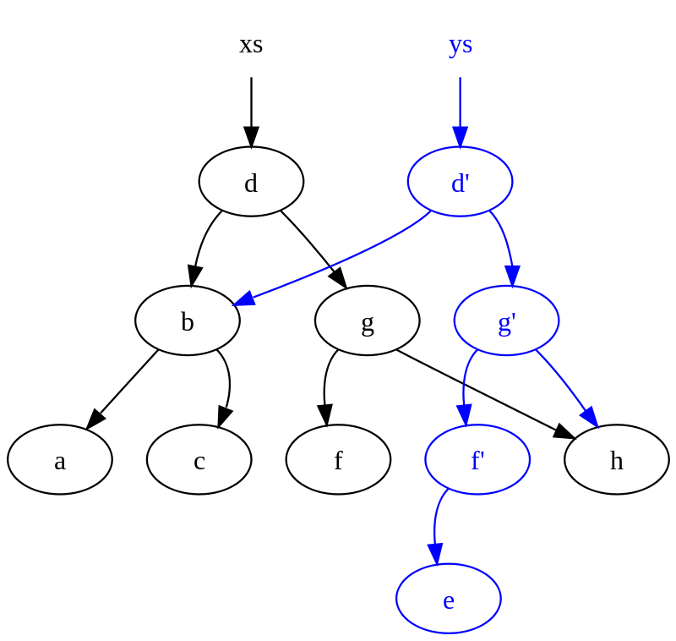

1.6 PERSISTENT SEGMENT TREE
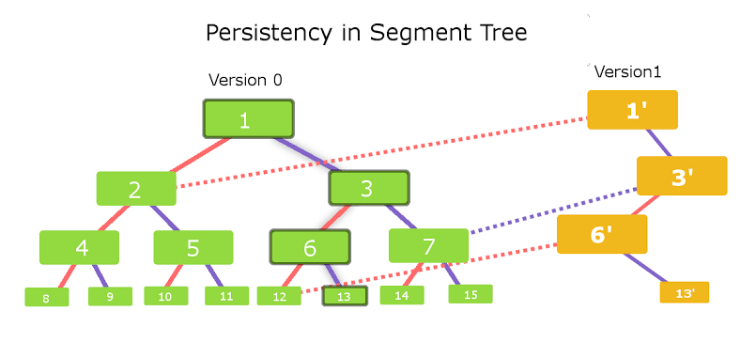

Any change request in the Segment Tree leads to a change in the data of only O(logn) vertices along the path starting from the root.
So if we store the Segment Tree using pointers (i.e. a vertex stores pointers to the left and the right child vertices), then when performing the modification query, we need to create new vertices instead of changing the available vertices.
Vertices that are not affected by the modification query can still be used by pointing the pointers to the old vertices.
Thus for a modification query O(logn) new vertices will be created, including a new root vertex of the Segment Tree.
The entire previous version of the tree rooted at the old root vertex will remain unchanged.

1.7 PERSISTENT SEGMENT TREE VS SEGMENT TREE

Keeping Size of Array constant i.e. 10000 and then applying various Test Cases by Varying the Query size and then Calculating the time taken by both Persistent Segment Tree and Normal Segment Tree (which has all the versions). The time complexity of creation in Normal Segment Tree is O(n) , it will take O(n) to create each version for every update making the graph grow linearly with increase in number of queries. whereas, The time complexity of creation of each version in Persistent Segment Tree is O(logn) , it will take O(logn) to create each version for every update making the graph will be similar as logn curve with increase in number of queries.

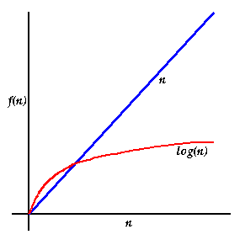

1.8 UPDATION IN PERSISTENT SEGMENT TREE

Now we want to modify a specific element in the array And we have to rebuild the Segment Tree, such that it correspond to the new, modified array.
This query is easier than the sum query. Each level of a Segment Tree forms a partition of the array. Therefore an element a[i] only contributes to one segment from each level. Thus only O(logn) vertices need to be updated.
It is easy to see, that the update request can be implemented using a recursive function. The function gets passed the current tree vertex, and it recursively calls itself with one of the two child vertices (the one that contains a[i] in its segment).

1.8.2 ALGORITHM
STEPS
- Create new Root node and create one child lying in path of modified element
- Point other child of new root to other child of root in original Tree.
- Recurse above steps till element is found at leaf node.

1.9 APPLICATIONS
1.9.1 SUM OPERATION
Obviously start the traversal from the root vertex of the Segment Tree.
Traverse the Segment Tree, Let's assume that we are currently at the vertex that covers the segment a[tl…tr].
There are three possible cases.
- The easiest case is when the segment a[l…r] is equal to the corresponding segment of the current vertex (i.e. a[l…r]=a[tl…tr]), then we are finished and can return its value.
- Alternatively the segment of the query can falls completely into the domain of either the left or the right child. Go in desired child and repeat process.
- There is the last case, the query segment intersects with both children. First we go to the left child, compute a partial answer for this vertex, then go to the right child, compute the partial answer using that vertex, and then combine the answers by adding them and return answer to parent.

1.9.2 MAX-MIN OPERATION
We only need to change the way each node is computed in the build and update functions. Each node will now store the maximum of the corresponding segment.
And we also need to change the calculation of the returned value of the sum function, replacing the summation by the maximum.
Of course this problem can be easily changed into computing the minimum instead of the maximum.

1.10 DRAWBACK
Update in range takes O(k) time where k is number of elements in range.
SOLUTION:
It can be done in O(log K) with Lazy Segment Tree.

2. PERSISTENT BINARY TRIE

2.1 TRIE

Trie, also called digital tree is a kind of search tree—an ordered tree data structure used to store a dynamic set or associative array where the keys are usually strings.
No node in the tree stores the key associated with that node, instead, its position in the tree defines the key with which it is associated.
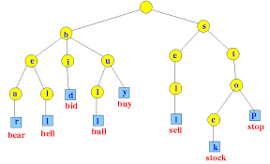
All the descendants of a node have a common prefix of the string associated with that node, and the root is associated with the empty string.

2.2 BINARY TRIE
Binary Tries are like usual tries are used to store strings containing only two characters i.e. 0 and 1.
We have implemented Binary Trie in 2 ways:
- Variable Bit length Binary Trie.
- Fixed Bit length Binary Trie.

2.3 FIXED LENGTH BINARY TRIE

This stores number in its bit representation in form of tree. It is Binary Tree where each node has 2 child, left child representing bit 0 and right child bit 1.
The height of tree is O(K) where k is number of fixed bits for each number. K = log n where n is largest decimal number that can represented with k bits.
For each query , path traversed is O(log n) as each query is traversed till leaf node.
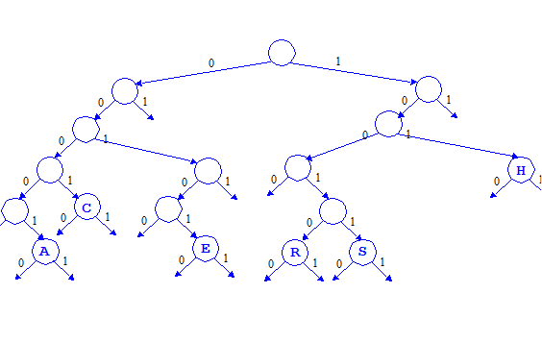

2.3.1 CONSTRUCTION

- Steps
- Convert Number to Binary Form.
- Pad 0 bit in start for making it to fixed length.
- Traverse Tree from root recusively,if bit is 0, go left and if bit is 1 go right, i.e create nodes for that particular number.
- Repeat process until whole bit string is traversed.
- Construction takes O(log n) time where n is largest number in decimal form represented in given fixed bits.

2.4 VARIABLE LENGTH BINARY TRIE

This also represents Number in form of bits in tree.
But, length of each number is equal to number of bits in binary form, i.e it does not pad bits to give fixed length to all numbers.
For ex:
2 – (10) , Takes 2 nodes in Trie,
7 -(111) , takes 3 nodes in Trie.
It is space optimized as no padded are used.
Search Query runs faster, equal to O(log q), where q is length of bits in searching that number.
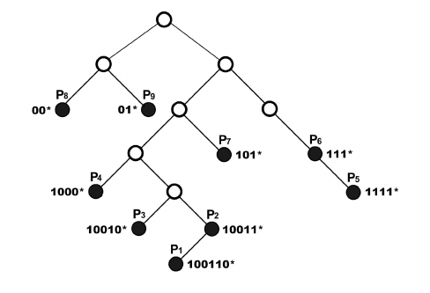

2.4.1 CONSTRUCTION

Steps same as Fixed length one but no padding is done.
Additionally, structure has flag bit, which is 1 for node representing LSB of number, else 0.
Takes space taken by bits in its binary form.
Time in search is number of bits in its binary form, not of largest number as above.
2.5 PERSISTENT BINARY TRIE

2.5.1 ALGORITHM
- Any new insertion in the trie leads to a change in the data of only O(logn) vertices along the path starting from the root.
- So if we store theTrie using pointers (i.e. a vertex stores pointers to the left and the right child vertices)
- Then while insertion,we simply need to create new vertices instead of changing the available vertices.
- Vertices that are not affected by the Insertion query can still be used by pointing the pointers to the old vertices.
- Thus O(logn) new vertices will be created, including a new root vertex of the Trie, and the entire previous version of the tree rooted at the old root vertex will remain unchanged.
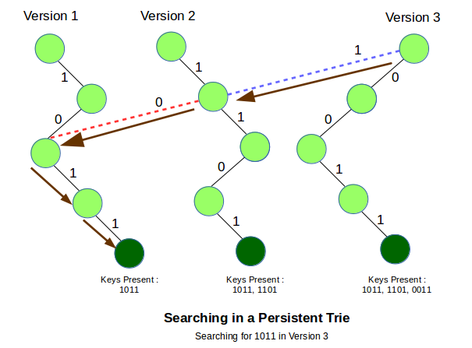

2.6 APPLICATIONS
2.6.1 MAX-XOR

Approach 1: Brute Force
For each query loop from l to rand compute XOR with each element and store the one that yields maximum XOR.
Time Complexity : O(q∗(r−L))
q: number of queries
L: left most index
r: right most index
In worst case L=1 and r=n, the time complexity becomes O(q∗n).

Approach 2: Fixed Length Persistent Binary Trie

- Given number is converted in binary form and padded to fixed length. Traverse till number length.
- If number bit is 0, if tree has Right node then go right.
- If number bit is 1, if tree has left node then go left.
- Repeat This procedure till whole bits of given number is traversed.
- While traversing back keep on increases count to 2 raised to power position of current bit and adding it to the previously calculated value.

2.6.2 TIME AND SPACE OPTIMIZED SEARCH

Using Variable length Binary Trie
Steps:
- Convert number to search in binary form.
- Traverse tree to length to number.
- Traverse left of node is bit 0 and left node exists,
- Traverse right of node is bit 1 and right node exists.
- If path exists till last bit of number and last node of tree has flag bit 1, then element found else not found.
It takes O(log n) time where n is number to be searched.

3. CODE

4. REFERENCES
1.https://en.wikipedia.org/wiki/Segment tree 2.https://www.geeksforgeeks.org/segment-tree-set-1-sum-of-given-range/
3.https://www.geeksforgeeks.org/persistent-segment-tree-set-1-introduction
4.https://cp-algorithms.com/data_structures/segment_tree.html#toc-tgt-11
5.https://en.wikipedia.org/wiki/Persistent_data_structure
6.https://opendatastructures.org/ods-java/13_1_BinaryTrie_digital_sea.html

