Quantization Comparison Report
Tanh + AvgPool vs ReLU + MaxPool

1. Overview
This report compares five numerical formats—Float32, Fixed16 <13,3>, Ultra-low (1,2), INT8, and INT4—using two model configurations. The comparison considers classification accuracy, quantization error, and memory usage.
Configurations: Tanh + AvgPool and ReLU + MaxPool.

2. Quantization Comparison — Tanh
Format | Source | Accuracy (%) | Max Error | Mean Error | RMSE | Memory (bytes)
Float32 | Baseline | 98.40 | 0.00000 | 0.00000 | 0.00000 | 246,824
Fixed16 <13,3> | Paper | 97.20 | 0.06250 | 0.03122 | 0.03605 | 123,412
Ultra-low (1,2) | Our test | 95.40 | 0.12499 | 0.06121 | 0.07105 | 30,853
INT8 | Our ext | 98.40 | 0.00241 | 0.00096 | 0.00111 | 61,706
INT4 | Our ext | 97.80 | 0.04379 | 0.01739 | 0.02013 | 30,853

3. Quantization Comparison — ReLU
Format | Source | Accuracy (%) | Max Error | Mean Error | RMSE | Memory (bytes)
Float32 | Baseline | 98.00 | 0.00000 | 0.00000 | 0.00000 | 246,824
Fixed16 <13,3> | Paper | 97.20 | 0.06250 | 0.03144 | 0.03622 | 123,412
Ultra-low (1,2) | Our test | 69.60 | 0.12500 | 0.06057 | 0.07038 | 30,853
INT8 | Our ext | 98.20 | 0.00277 | 0.00098 | 0.00115 | 61,706
INT4 | Our ext | 98.00 | 0.05030 | 0.01784 | 0.02096 | 30,853

4. Combined Comparison
Format | Source | Tanh Accuracy (%) | ReLU Accuracy (%) | Difference (%) | Tanh RMSE | ReLU RMSE | Memory (KB)
Float32 | Baseline | 98.40 | 98.00 | -0.40 | 0.00000 | 0.00000 | 241.04
Fixed16 <13,3> | Paper | 97.20 | 97.20 | +0.00 | 0.03605 | 0.03622 | 120.52
Ultra-low (1,2) | Our test | 95.40 | 69.60 | -25.80 | 0.07105 | 0.07038 | 30.13
INT8 | Our ext | 98.40 | 98.20 | -0.20 | 0.00111 | 0.00115 | 60.26
INT4 | Our ext | 97.80 | 98.00 | +0.20 | 0.02013 | 0.02096 | 30.13

5. Accuracy Graph
The following graph compares accuracy across the five quantization formats for the two model configurations: tanh + AvgPool and ReLU + MaxPool.
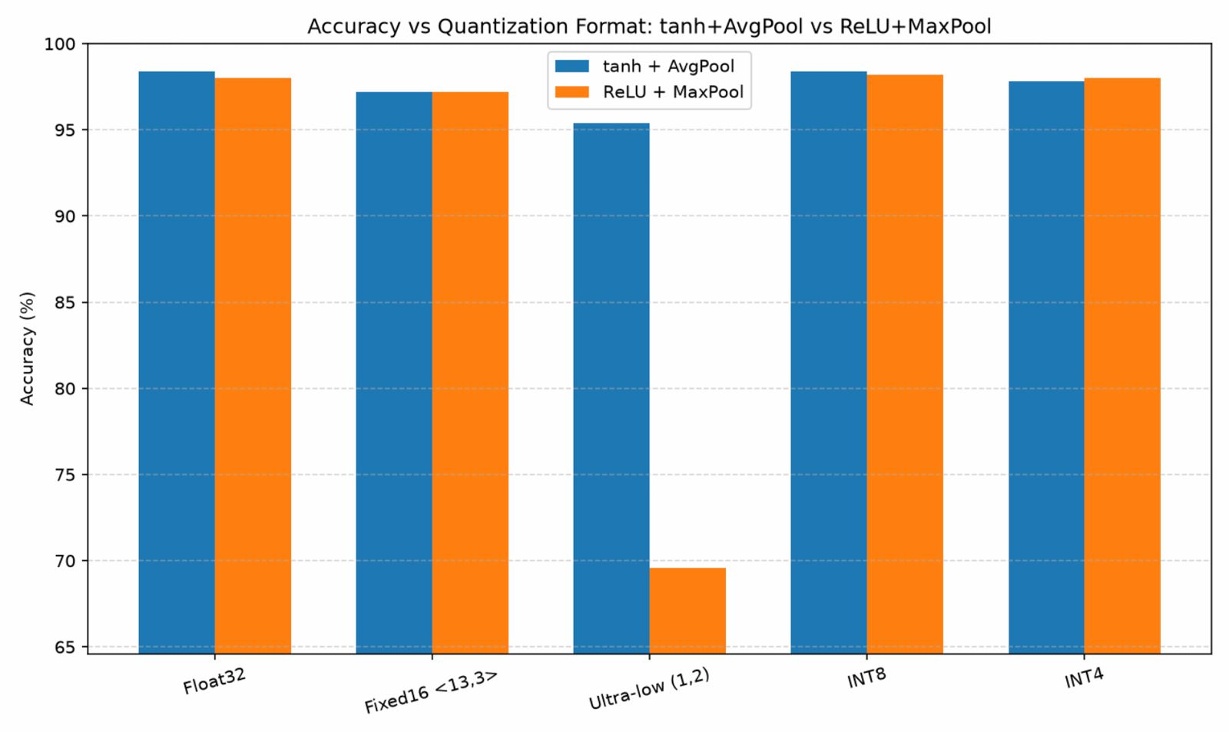

6. Key Findings
- Float32: Provides the baseline accuracy of 98.4% for tanh + AvgPool and 98.0% for ReLU + MaxPool, but requires the highest memory at 241.04 KB.
- Fixed16 <13,3>: Reduces memory by roughly half compared with Float32, while maintaining 97.2% accuracy for both configurations. Its RMSE is around 0.036.
- Ultra-low (1,2): Uses only 30.13 KB, but suffers a major accuracy degradation with ReLU + MaxPool, falling to 69.6%. With tanh + AvgPool it reaches 95.4%.
- INT8: Offers the strongest overall accuracy-to-memory trade-off. It reaches 98.4% on tanh + AvgPool and 98.2% on ReLU + MaxPool while using only 60.26 KB.
- INT4: Matches the Ultra-low format's 30.13 KB memory footprint while achieving much better accuracy: 97.8% with tanh + AvgPool and 98.0% with ReLU + MaxPool.

7. Conclusion
Based on the reported results, INT8 is the most balanced choice when both accuracy and memory efficiency are important. It retains essentially the Float32-level accuracy while reducing memory from 241.04 KB to 60.26 KB. If the primary objective is minimum memory, INT4 is considerably more reliable than the tested Ultra-low (1,2) format, especially for the ReLU + MaxPool configuration. The Ultra-low (1,2) representation appears highly sensitive to the activation/pooling combination and is therefore not the preferred option for the ReLU configuration.

8. Metric Notes
- Accuracy: Percentage of correctly classified samples.
- Max Error: Largest absolute difference between the reference and quantized values.
- Mean Error: Average absolute quantization error.
- RMSE: Root Mean Square Error; lower values indicate smaller overall numerical deviation.
- Memory: Reported storage required for the corresponding model representation.

