Assignment 1
Kaggle Competition
Group <put_group_number_here>
<put_student_name_here>
Student ID: <put_student_id_here>

Github ID: <put_github_id_here>
Kaggle ID: <put_kaggle_id_here>
2026 SPRING

Github Link | Group Experimentation Repo: <put_link_to_github>
Github Link | Custom Package Repo: <put_link_to_github>

36120 - Advanced Machine Learning Application
Master of Data Science and Innovation
University of Technology of Sydney
Table of Contents

1. Executive Summary 2
2. Business Understanding 3
a. Business Use Cases 3
b. Key Objectives 3
3. Data Understanding 4
4. Data Preparation 5
5. Modeling 6
6. Evaluation 7
a. Results and Analysis 7
b. Business Impact and Benefits 8
c. Data Privacy and Ethical Concerns 9
7. Conclusion 10
8. References 11

Executive Summary
This project develops a machine learning model to predict whether a U.S. college basketball player will have a sustained NBA career, defined as playing at least three NBA seasons. The model is intended to support analysts and scouts in identifying players with a higher likelihood of achieving long-term NBA careers. Model performance is evaluated using AUPRC (Average Precision), which measures the quality of ranking likely positive players.
The project involved data understanding and preparation followed by three modelling experiments. E1 Logistic Regression established a baseline Kaggle AUPRC of 0.60121. E2 LightGBM achieved stronger validation performance but a lower Kaggle score of 0.57163, indicating weaker performance on unseen data. E3 focused on feature selection within Logistic Regression, with L1-based selection reducing the model to 39 features. This approach achieved the strongest overall result, with a Kaggle AUPRC of 0.60391.
The results indicate that careful feature selection within an interpretable Logistic Regression model provided more reliable external performance than increasing model complexity. E3 is therefore the current best-performing approach, although the relatively modest improvement over the baseline indicates scope for further experimentation through feature engineering and alternative modelling strategies.

Business Understanding

Business Use Cases
The NBA draft provides teams with access to a large pool of promising basketball talent, but being drafted or reaching an NBA roster does not necessarily translate into a sustained professional career. The competition therefore focuses on a more specific talent-identification problem: determining which U.S. college basketball players are likely to remain in the NBA for at least three seasons. This distinction is important because the objective is not simply to predict whether a player reaches the NBA, but whether their career demonstrates a degree of sustained professional stability.
The resulting model can provide a data-driven decision-support tool for basketball analysts and scouts. College basketball produces a large amount of player-level performance information across different seasons, and manually assessing all available players using numerous statistical indicators can be challenging. A predictive model can complement expert assessment by assigning each player a probability of achieving the target outcome and consequently allowing analysts and scouts to prioritise players for further evaluation.
The main opportunity for machine learning is therefore to identify patterns in college-level performance that may be associated with longer NBA careers. Rather than relying on a single statistic or subjective assessment, the model can consider multiple player characteristics simultaneously and produce a consistent ranking of players according to their estimated likelihood of sustaining an NBA career.
However, this is also a challenging prediction problem. A player's NBA longevity is influenced by many factors, and college statistics alone may not capture every factor relevant to professional success. The model must therefore extract useful predictive information from the available college-level data while avoiding unnecessary complexity and overfitting. This makes model validation and comparison particularly important, as a model that performs well on historical data may not necessarily generalise to unseen players.

Key Objectives
The primary objective of the project is to develop a machine learning model that uses college-level statistics from each season to predict whether a U.S. college basketball player will subsequently play at least three NBA seasons. The model should generate probability estimates that can be used to rank players according to their likelihood of achieving a sustained NBA career.
A second objective is to identify an approach that provides strong performance on unseen data, rather than selecting a model solely on its performance on the training or validation data. This is particularly important because the competition evaluates predictions using AUPRC (Area Under the Precision-Recall Curve / Average Precision). The metric focuses on how effectively the model ranks players who achieve the positive outcome, making ranking quality more relevant than simply maximising overall classification accuracy.
The primary stakeholders identified for this project are basketball analysts and scouts. Their requirement is not to replace professional judgement, but to obtain an additional quantitative signal that can help them identify and prioritise players who may have a greater likelihood of developing sustained NBA careers. The model therefore needs to produce useful probability rankings while remaining sufficiently interpretable to support analytical assessment.
To address these requirements, the project evaluates different machine learning approaches and systematically experiments with model configuration and feature selection. The modelling process begins with a Logistic Regression baseline, evaluates a more complex LightGBM approach, and subsequently investigates feature-selection strategies within Logistic Regression. The objective is ultimately to select the approach that provides the strongest evidence of generalisation to unseen players while remaining appropriate for use as a decision-support tool.

Data Understanding

Dataset and Source
The project uses the competition-provided dataset containing season-level statistics for U.S. college basketball players. The training dataset contains 41,195 observations across 66 columns, while the test dataset contains 12,061 observations across 65 columns. The training data includes the binary label, representing whether the player subsequently achieved the competition's definition of a sustained NBA career: playing at least three NBA seasons.
The variables cover several aspects of collegiate player performance and characteristics. These include scoring and shooting statistics, rebounding and assists, defensive measures, playing time and usage, as well as advanced metrics such as offensive and defensive ratings and player impact measures. The dataset also contains categorical information such as player role and college year. Together, these variables provide different perspectives on player performance that can potentially distinguish players who go on to sustain an NBA career.

Data Quality and Limitations
Initial data exploration identified several issues that needed to be addressed before modelling. These included missing values, duplicate observations, inconsistent representations of player height, and invalid values in the yr variable. The height field was particularly inconsistent because the same type of measurement could appear in different formats, requiring transformation before it could be used reliably as a numerical feature.
The target variable was also highly imbalanced. Only approximately 3.42% of the original training observations belonged to the positive class. This was an important consideration because a model could achieve high classification accuracy simply by favouring the majority class while performing poorly at identifying players who achieve sustained NBA careers. Consequently, AUPRC/Average Precision was retained as the primary evaluation metric, consistent with the competition objective.
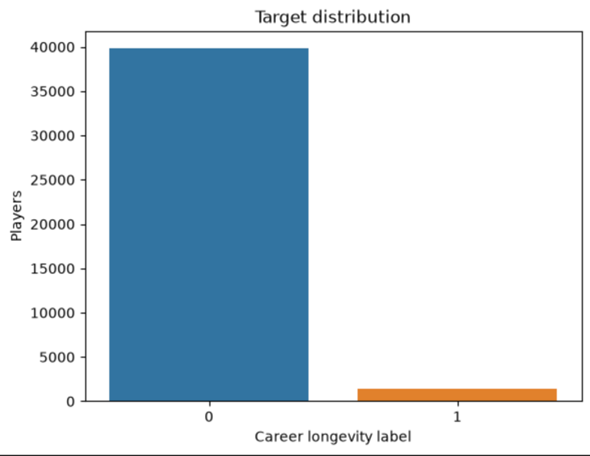
Figure 1. Distribution of the target classes in the modelling dataset.
The dataset also has an inherent limitation: predictions are based on college-level information only. Factors that may influence NBA career longevity but are not represented in the available data cannot be captured by the model. Therefore, the predictions should be interpreted as a statistical decision-support signal rather than a complete assessment of a player's future NBA career.

Exploratory Data Analysis
EDA was conducted before modelling to understand the dataset structure, data quality and relationships between variables. This included examining data types, missing values, duplicate records, numerical distributions, categorical values and the distribution of the target variable. Feature distributions were also examined across the target classes to identify variables that could potentially provide useful predictive information.
Correlation analysis identified substantial relationships between several basketball performance measures. For example, ORtg and adjoe had a correlation of 0.9631, Min_per and stops 0.9566, drtg and adrtg 0.9559, and gbpm and ogbpm 0.9366. These relationships indicated that some variables contained overlapping information and motivated the investigation of feature-selection techniques later in E3. Importantly, the subsequent experiments showed that simply removing highly correlated features did not necessarily improve predictive performance.
Overall, the EDA established the main characteristics and limitations of the dataset and provided the basis for the subsequent data preparation, feature engineering and model-development decisions.

Data Preparation
Data preparation was performed in stages to convert the competition data into a consistent, model-ready dataset. The process included removal of unsuitable variables, data cleaning, feature construction, missing-value treatment, train/validation/test splitting, categorical encoding and numerical scaling.

Data Cleaning and Feature Removal
Several variables were removed before modelling because they were identifiers, administrative or contextual fields, original variables replaced by engineered versions, high correlation or variables that were not retained as model predictors. The removed variables were:
pid, conf, num, team, dunksmade/(dunksmade+dunksmiss), Rec Rank, type, dunksmiss+dunksmade, TPA, twoPA, rimmade+rimmiss, FTA, midmade+midmiss, treb, mp, year, dob, and ht.
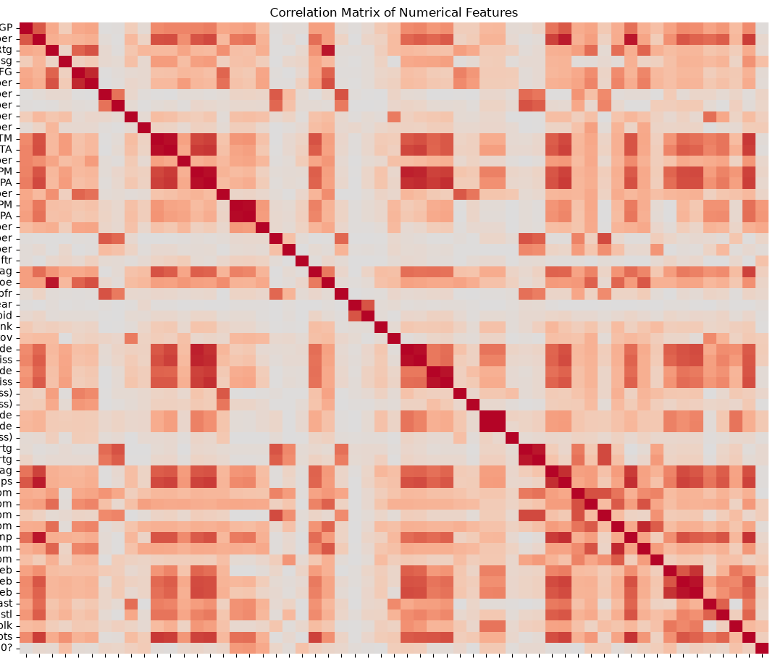
Figure 2. Correlation matrix of numerical player features.
The original ‘ht’ and dob variables were replaced through feature engineering. Height was converted into the numerical height_inches feature to standardise inconsistent height formats, while age was derived from date of birth and season information. This allowed the original raw representations to be removed while retaining potentially useful player characteristics.
Duplicate observations and invalid values identified during the initial data-quality assessment were also addressed before modelling. Missing values were retained where appropriate and handled systematically during preprocessing rather than replacing them arbitrarily.

Missing Values and Preprocessing
The data was first separated into training, validation and test sets. Missing-value treatment was then fitted using the training data: median imputation was applied to numerical variables and most-frequent-value imputation to categorical variables. The same fitted transformations were subsequently applied to validation and test data to prevent information from those datasets influencing preprocessing.
Categorical variables were one-hot encoded, while numerical variables were standardised. These transformations produced the model-ready representation used for Logistic Regression, containing 59 features.

Class Imbalance and Outliers
The target variable was highly imbalanced, with approximately 3.42% of the original training observations belonging to the positive class. We retained the original class distribution rather than artificially resampling the data. Instead, AUPRC/Average Precision was used as the primary evaluation metric because it is more informative for the rare positive outcome and is also the competition's evaluation metric.
Outliers were examined during EDA, but no blanket outlier-removal procedure was applied. Extreme values in basketball statistics could represent genuine player performances, so removing them solely because they were statistically unusual could remove meaningful predictive information.
The resulting 59-feature encoded and scaled datasets formed the common starting point for the modelling experiments. The subsequent correlation-based, coefficient-based and L1 feature-selection approaches were treated as model-development experiments, rather than part of the initial data-cleaning pipeline.

Modeling

Experimental Framework
Model development followed a staged experimental approach, beginning with an interpretable baseline and progressively testing whether increased model complexity or improved feature selection could improve AUPRC. The same provided train, validation and test datasets were used throughout, with 5-fold cross-validation and Average Precision (AUPRC) used for model tuning.
To support reproducibility, the experiments used a custom Python package containing reusable modules for data loading, cleaning, preprocessing, feature engineering, modelling, visualisation, model interpretation and submission generation. This reduced duplicated code and ensured consistent processing across experiments.

E1 — Logistic Regression
E1 established an interpretable baseline. The hypothesis was that Logistic Regression using player characteristics and performance statistics would identify meaningful patterns associated with sustained NBA careers and provide a useful benchmark for more complex approaches.
Logistic Regression was selected because it provides probability estimates while remaining relatively simple and interpretable. L2 regularisation was used to control coefficient magnitudes. Two rounds of 5-fold cross-validated grid search were conducted using AUPRC as the scoring metric. The first search explored a broad range of regularisation strengths (C) and class-weight configurations, followed by a finer search around the promising region. The final configuration was C = 0.1 with no class weighting, achieving a CV AUPRC of 0.4098 and validation AUPRC of 0.4448.

E2 — LightGBM
E2 investigated whether a nonlinear model could capture relationships that Logistic Regression could not represent directly. The hypothesis was that LightGBM would achieve higher validation AUPRC because boosted trees can capture nonlinear relationships and interactions between player features.
A broad first-round search evaluated 162 parameter combinations across the number of estimators, learning rate, number of leaves, maximum depth and minimum child samples. A narrower second-round search of 108 combinations was then conducted around the promising parameter region. Although Round 2 produced the higher CV AUPRC (0.4044), the Round 1 model achieved the stronger held-out validation result and was therefore retained as the final E2 model, with a validation AUPRC of 0.4538.

E3 — Feature Selection with Logistic Regression
E3 returned to Logistic Regression and investigated whether reducing the 59-feature input could improve generalisation. The hypothesis was that selecting informative predictors would improve AUPRC by removing redundant or weak features while retaining variables contributing most strongly to prediction.
Three feature-selection strategies were initially investigated. Correlation-based selection reduced the feature space from 59 to 54 features, but validation AUPRC decreased to 0.4369. Coefficient-based selection was then tested by removing the five and ten weakest coefficients, producing validation AUPRCs of 0.4458 and 0.4451, respectively.
L1 regularisation was subsequently used as an automated feature-selection mechanism. It reduced the feature set from 59 to 39 features, after which L2 Logistic Regression was fitted using the selected predictors. This produced a validation AUPRC of 0.4491 and became the strongest E3 configuration.
Further experiments tested the L2 regularisation strength and the L1 selection strength. Although L2 C = 0.4 increased validation AUPRC slightly to 0.4501, its external Kaggle performance was lower than the original configuration. Testing different L1 values similarly showed that C = 0.1 provided the strongest validation performance, while the alternative C = 0.5 did not improve the external result.

Final Model Selection
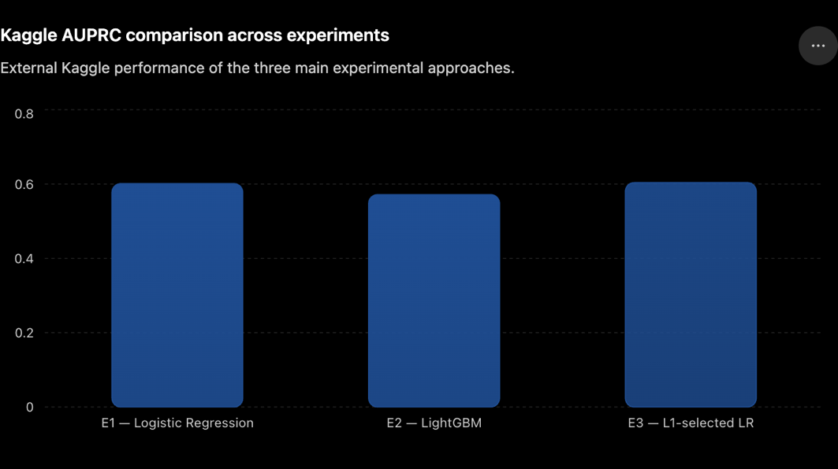
Figure 3. shows the final model performance of E1 vs E2 vs E3.
Models were selected using evidence from cross-validation, held-out validation and external Kaggle evaluation, rather than relying on a single score. The final model was therefore the E3 L1-selected L2 Logistic Regression, using 39 features, L1 C = 0.1, L2 C = 0.1 and no class weighting. It achieved the project's highest Kaggle AUPRC of 0.60391.

Evaluation

a. Results and Analysis
Model performance was evaluated primarily using AUPRC (Average Precision), consistent with the competition objective and the substantial class imbalance in the target. Results from cross-validation, the held-out validation set and Kaggle were considered when assessing model performance and generalisation.
Experiment | Approach | Features | Validation AUPRC | Kaggle AUPRC
E1 | Logistic Regression | 59 | 0.4448 | 0.60121
E2 | LightGBM | 59 | 0.4538 | 0.57163
E3.1 | Correlation-reduced LR | 54 | 0.4369 | 0.60219
E3.2 | Coefficient-reduced LR (5) | 54 | 0.4458 | 0.60266
E3.3 | Coefficient-reduced LR (10) | 49 | 0.4451 | 0.60097
E3.4 | L1-selected L2 LR | 39 | 0.4491 | 0.60391
E3.5 | L2 C tuning | 39 | 0.4501 | 0.60127
E3.6 | L1 C=0.5 | 50 | 0.4486 | 0.60323
Table 1. Performance across the principal modelling experiments.
The results demonstrate that the model with the highest validation performance was not necessarily the strongest on external data. LightGBM achieved the highest validation AUPRC of 0.4538, compared with 0.4448 for the E1 Logistic Regression baseline. However, its Kaggle score of 0.57163 was substantially below E1's 0.60121. This suggests that the additional flexibility of the nonlinear model did not translate into better generalisation to the external test data.
The E3 experiments showed that feature-selection strategy was more important than simply reducing feature count. Removing highly correlated features reduced validation AUPRC to 0.4369, while coefficient-based reduction produced only marginal changes. In contrast, L1-based selection reduced the feature set from 59 to 39 features and improved validation AUPRC to 0.4491. It also achieved the highest Kaggle score of 0.60391, representing an absolute improvement of 0.00270 over E1.
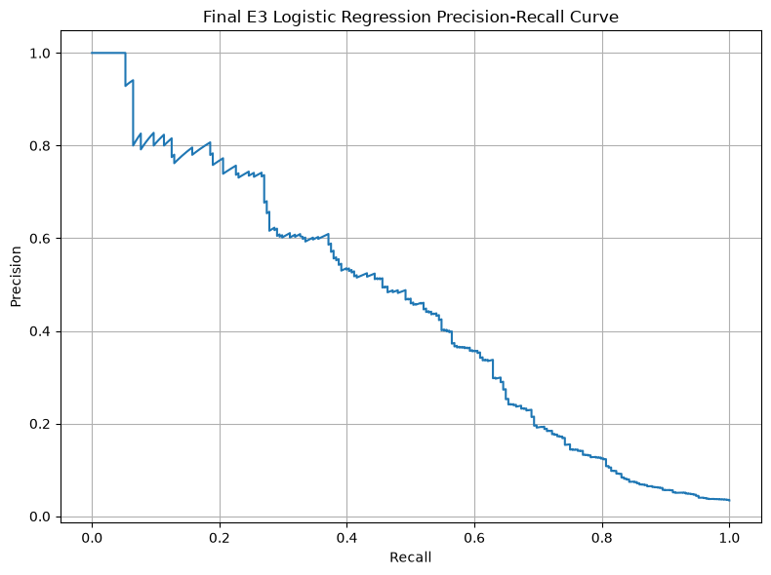
Figure 4. Precision–Recall curve for the final L1-selected L2 Logistic Regression model on the validation set.
Further tuning produced diminishing returns. Increasing L2 C produced a small validation improvement to 0.4501, but its Kaggle score fell to 0.60127. Similarly, increasing L1 C to 0.5 produced 0.60323 on Kaggle, still below the 0.60391 achieved with C=0.1. These results supported retaining the original E3 configuration rather than selecting a model based solely on small validation improvements.
The experiments also provide evidence about generalisation. The discrepancy between LightGBM's validation and Kaggle performance indicates that validation performance alone was insufficient for selecting the final model. However, because training-set AUPRC and learning curves were not recorded, the experiments do not provide a direct measure of overfitting or underfitting. Generalisation was instead assessed through cross-validation, held-out validation and external competition performance.
The final Logistic Regression coefficients provided an additional interpretability benefit. Stronger coefficients included variables such as Min_per, dporpag, age, porpag, adrtg, twoPM and TS_per. These represent associations learned by the model rather than causal relationships.
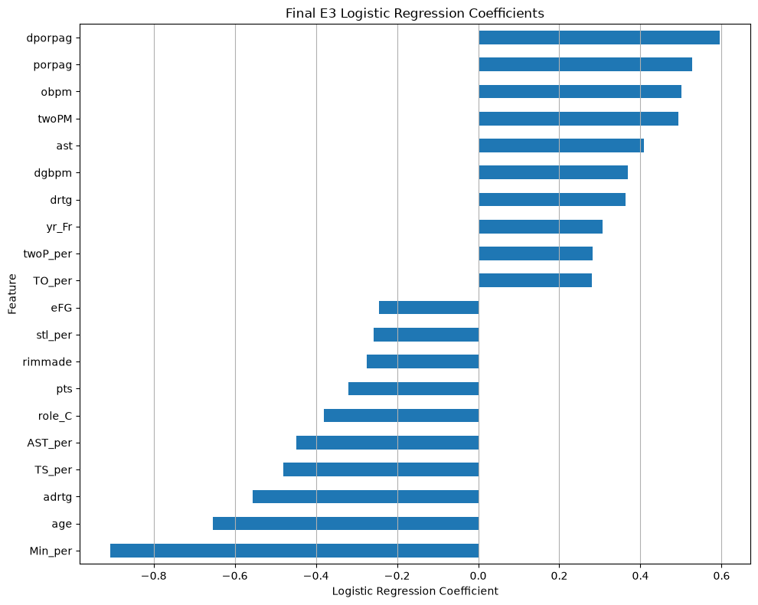
Figure 5. Strongest positive and negative coefficients of the final Logistic Regression model.
Overall, E3 provided the best balance of external predictive performance, feature parsimony and interpretability, making the L1-selected L2 Logistic Regression the preferred model.

b. Business Impact and Benefits
The final model provides analysts and scouts with a probability-based ranking of college players according to their likelihood of achieving a sustained NBA career. This can help prioritise players for further assessment and provide an additional quantitative signal alongside expert scouting judgement.
Relative to the E1 baseline, the final E3 model improved Kaggle AUPRC from 0.60121 to 0.60391, an absolute improvement of 0.00270, while reducing the feature set from 59 to 39 features. The model therefore achieved a modest predictive improvement while remaining interpretable and comparatively simple.
The potential business value is primarily improved scouting prioritisation and consistency. However, a financial value cannot be reliably quantified from the available data because the project does not contain information on scouting costs, player acquisition value or the financial consequences of prediction errors.

c. Data Privacy and Ethical Concerns
The dataset contains player-level information, including performance statistics, age-related information and physical characteristics. Although these variables are used for the competition's intended predictive task, using them to generate individual career predictions creates privacy and responsible-use considerations. Access to player-level predictions should therefore be appropriately controlled and restricted to legitimate analytical purposes.
A key ethical risk is over-reliance on automated predictions. A low predicted probability should not be interpreted as evidence that a player lacks ability or future potential. The model only observes the available college-level variables and cannot account for factors such as future development, injuries, coaching environment, team fit or other circumstances that may influence NBA longevity. Predictions should therefore complement rather than replace professional scouting judgement.
Fairness is also a consideration because models trained on historical outcomes can reproduce patterns present in the underlying data. Before operational deployment, performance should be monitored across relevant groups where such analysis is legally and ethically appropriate.
If deployed in a real scouting environment, the model should therefore remain subject to human oversight, ongoing performance monitoring and review of potentially discriminatory outcomes.

Conclusion
This project developed and evaluated machine learning approaches for predicting whether a U.S. college basketball player would achieve a sustained NBA career of at least three seasons. Following systematic data preparation and three modelling stages, the strongest approach was an L1-selected Logistic Regression model followed by L2 Logistic Regression, reducing the model from 59 to 39 features. It achieved a validation AUPRC of 0.4491 and the highest Kaggle AUPRC of 0.60391.
The experiments showed that greater model complexity did not necessarily produce better external performance. Although LightGBM achieved the highest validation AUPRC (0.4538), its Kaggle score of 0.57163 was substantially lower. Feature-selection experiments also demonstrated that removing correlated or weak features alone was insufficient; the L1 approach provided the most effective balance between feature reduction and predictive performance. Further hyperparameter tuning produced only marginal validation gains and did not improve the external score.
The final model therefore meets the project's primary objective of providing a data-driven probability ranking that can support analysts and scouts in prioritising players for further evaluation. However, the improvement over the baseline was modest, so the model should be considered a decision-support tool rather than a replacement for expert judgement.
Future work should focus less on further tuning of the existing Logistic Regression pipeline and more on understanding and addressing its remaining errors. Confusion-matrix-based error analysis could be used to examine misclassified players and identify systematic patterns in the errors. These findings could guide the development of additional predictive features and the testing of complementary modelling approaches, with the aim of improving generalisation and predictive performance.

References

- scikit-learn. SimpleImputer. Scikit-learn documentation.
https://scikit-learn.org/stable/modules/generated/sklearn.impute.SimpleImputer.html
- LightGBM. LightGBM documentation.
https://lightgbm.readthedocs.io/
- Pandas. Pandas documentation.
https://pandas.pydata.org/docs/
- Astral. uv documentation. https://docs.astral.sh/uv/
- Python Packaging Authority. Python Packaging User Guide. https://packaging.python.org/
- • Python Packaging Authority. TestPyPI. https://test.pypi.org/

