Drew Byford
Module 2 – Documented Debugging

Figure 1. The program was paused at a breakpoint before the calculate_pay function was executed.
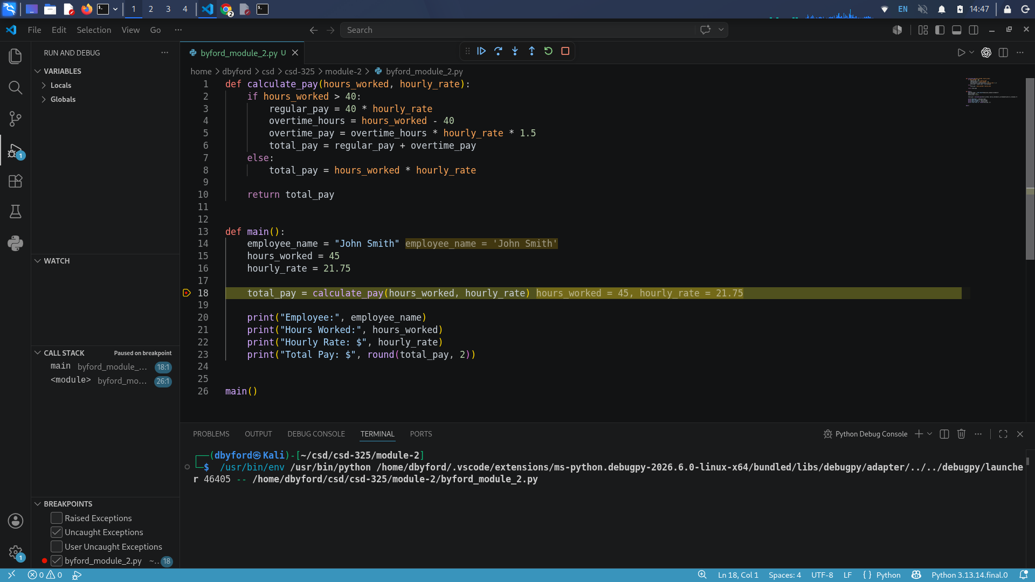

Figure 2. Step into was used to move execution into the calculate_pay function.
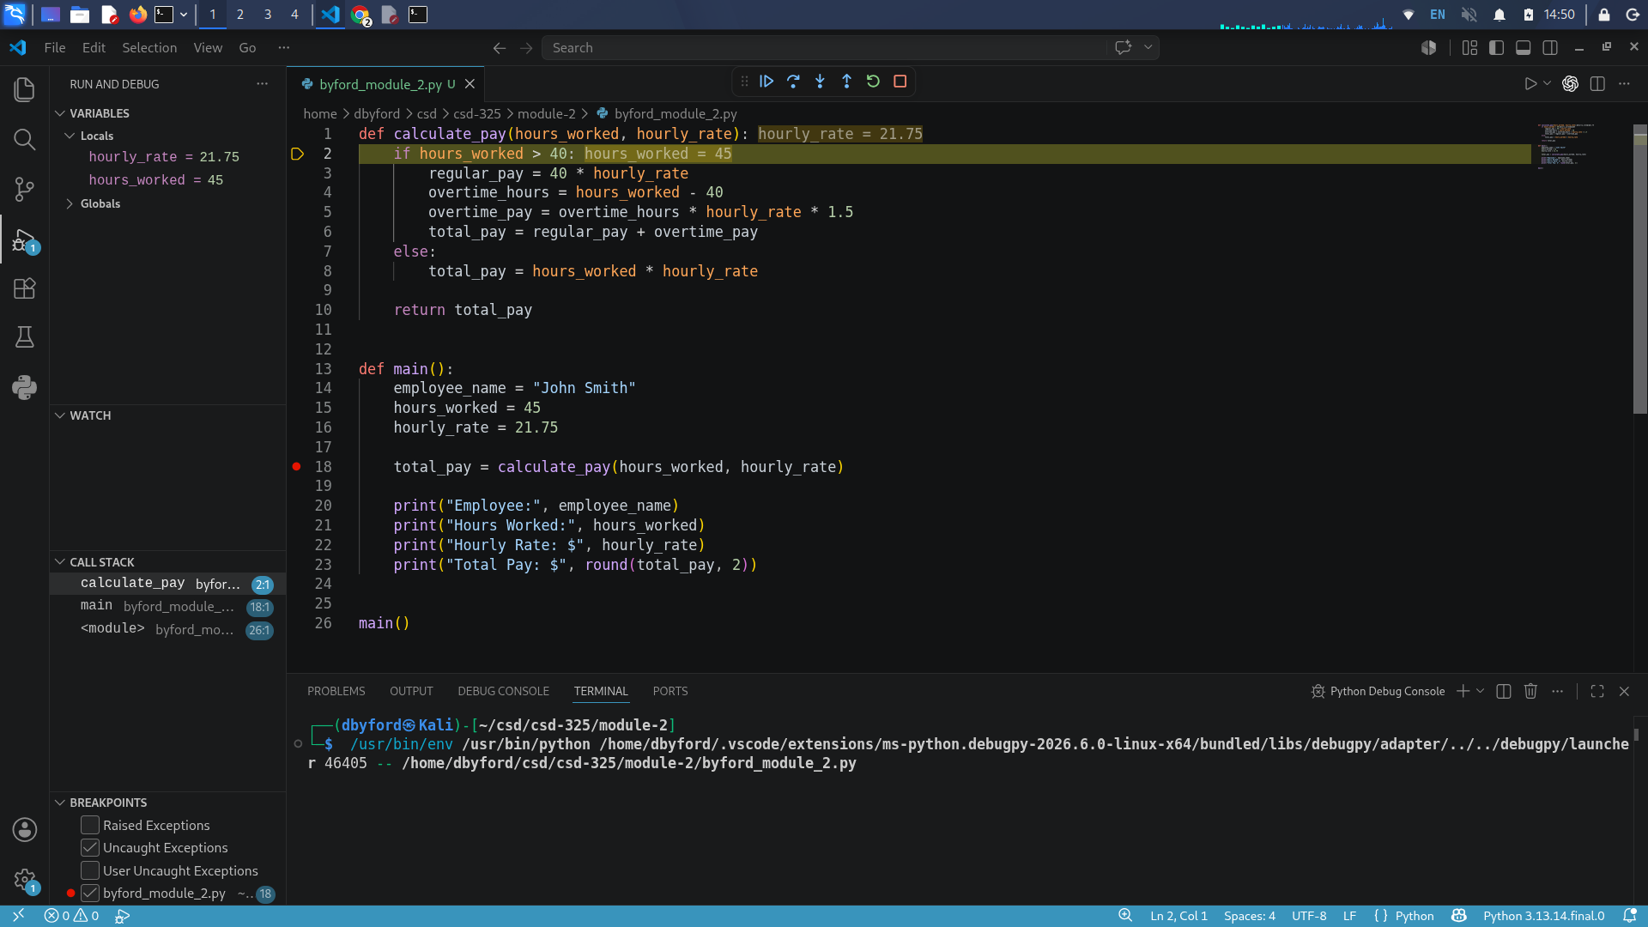
Figure 3. Step Over was used to move through the overtime calculations and observe the changing variable values.

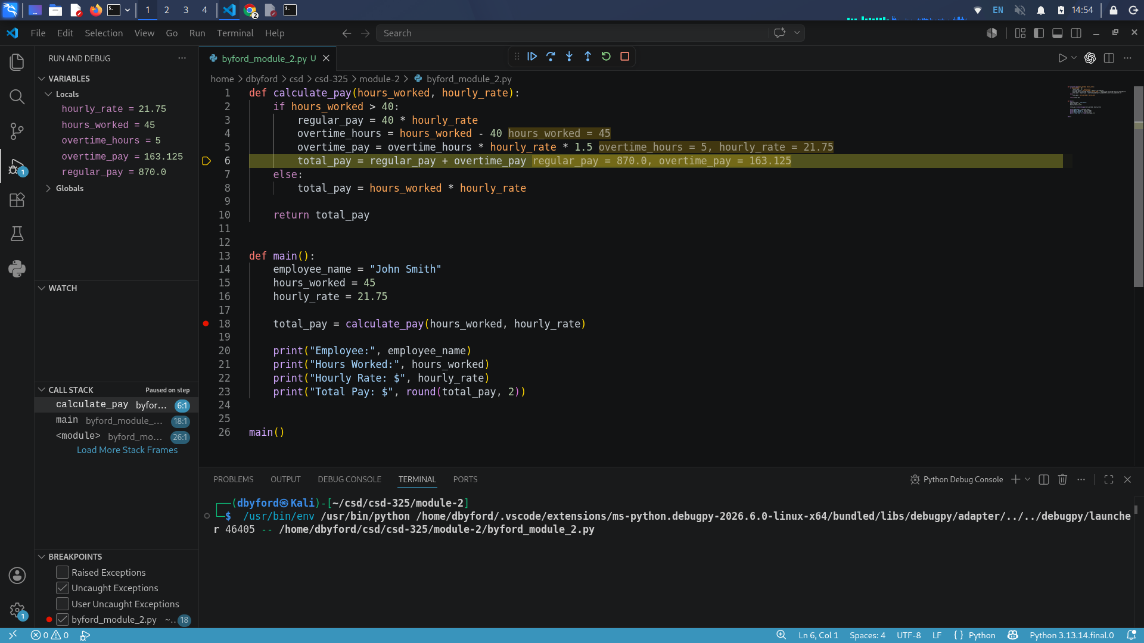

Using the debugger made it easier to follow how the program executed. The breakpoint stopped the program before the function call, Step Into allowed me to enter the calculate_pay function, and Step Over allowed me to watch the calculations happen one line at a time.

