1. Creating tables:

Airline_info and Airport table columns:

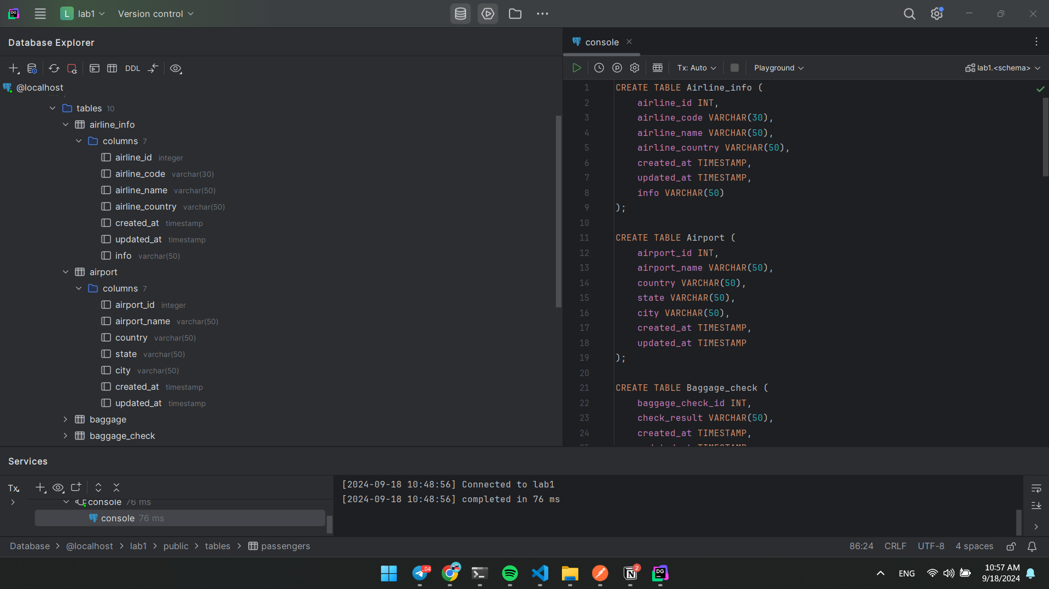

baggage and baggage_check table columns:

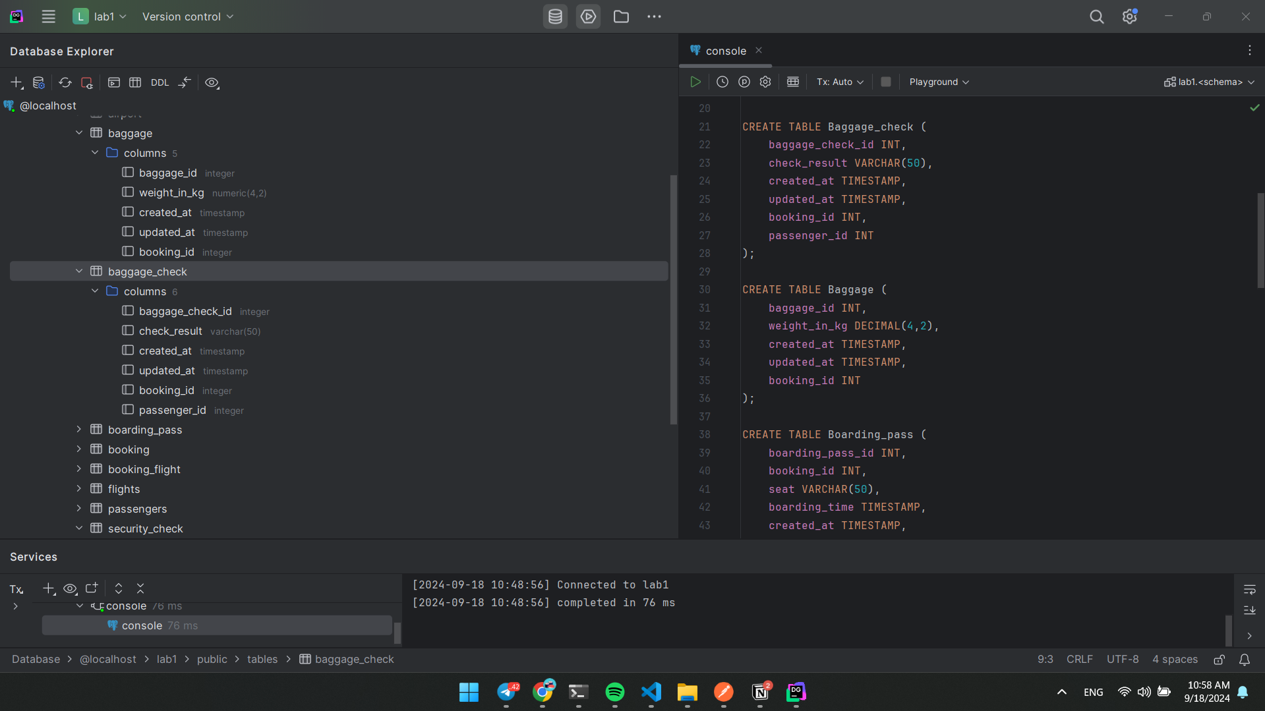

Boarding_pass and Booking table columns:

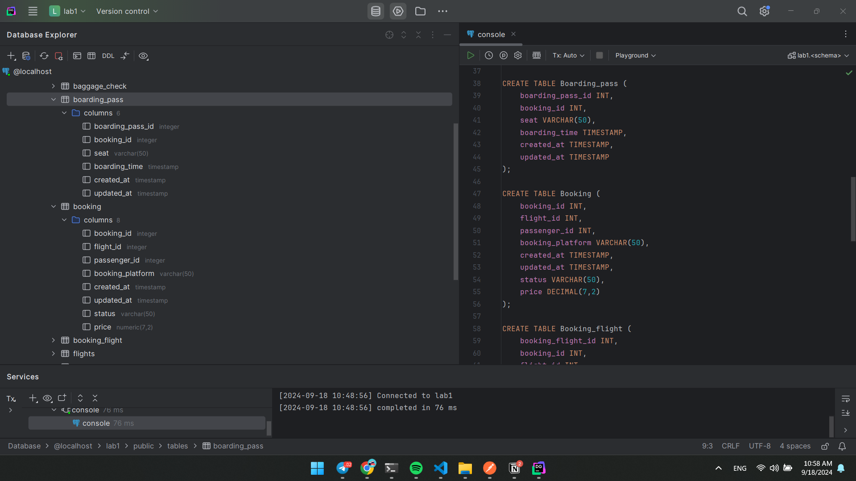Booking_flight and Flights table columns:

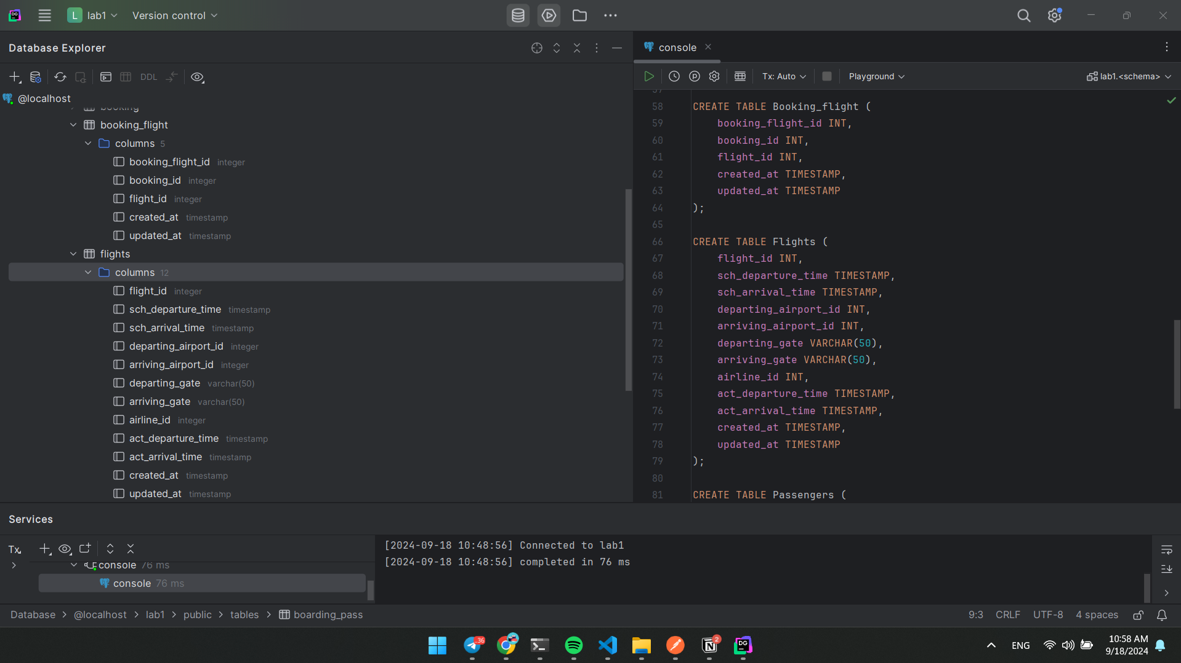

Passengers and Security_check table columns:

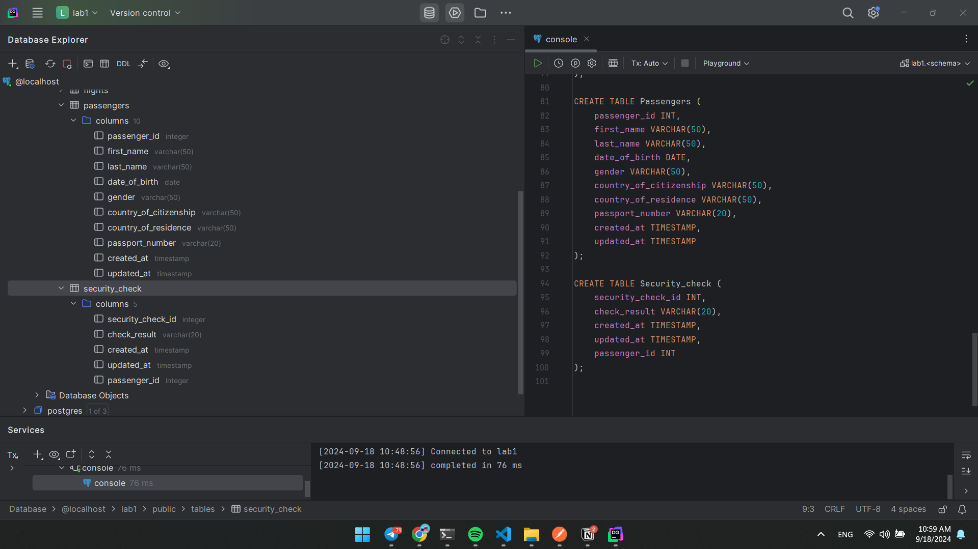

1. Define primary keys

Airline_info, Airport, Baggage_check, Baggage tables primary keys:

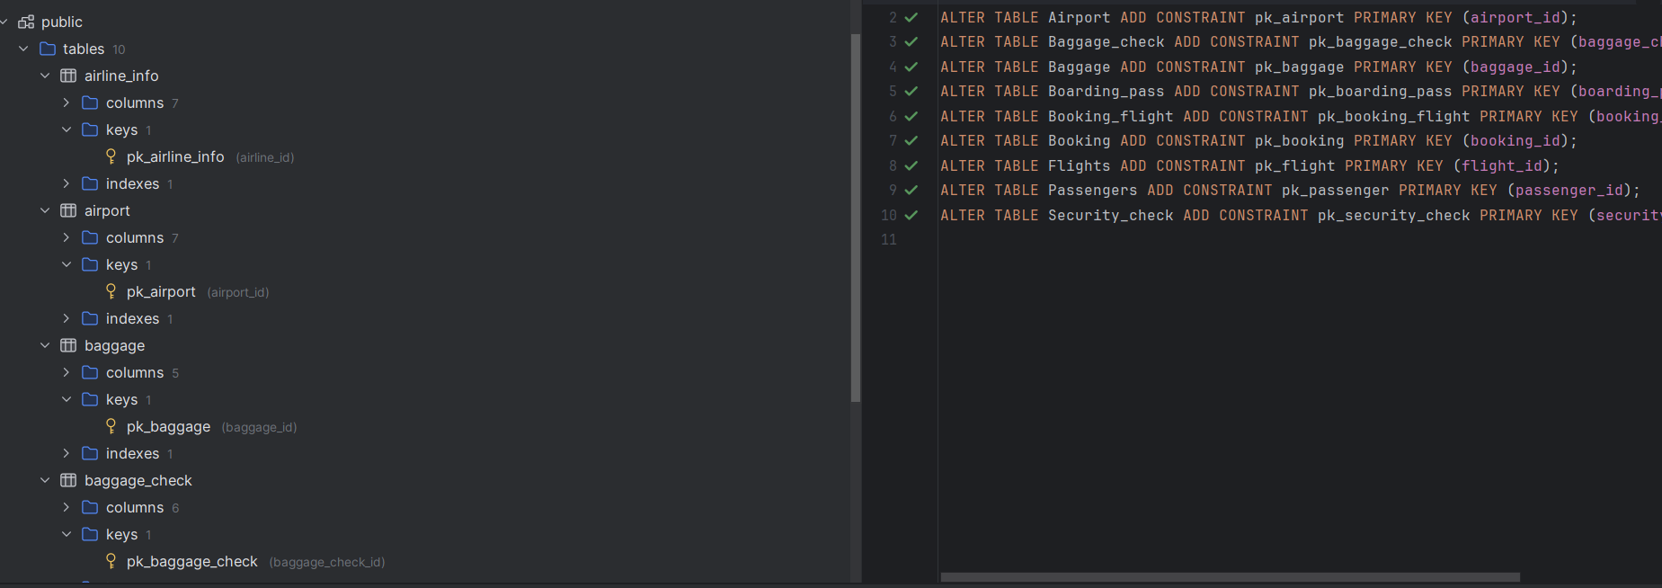

Boarding_pass, Booking, Booking_flight tables primary keys:

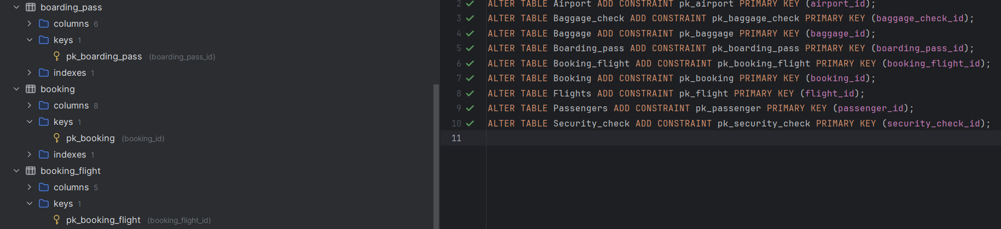

Flights, Passengers, Security_check tables primary keys:

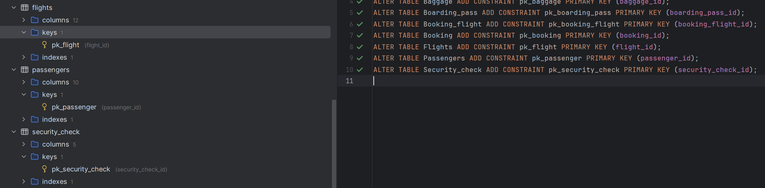

1. Set NOT NULL constraints

Setting NOT NULL constraints for important columns, others will remain nullable. For example on screenshot ***act_departure_time*** and ***act_arrival_time*** columns, which are nullable, other columns are NOT NULL.

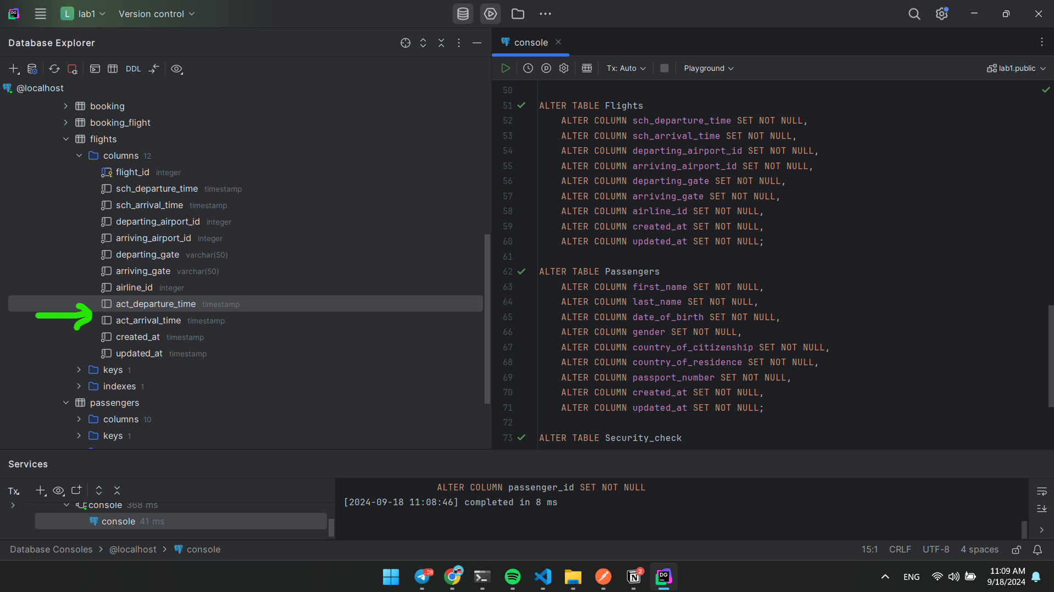

1. Rename ***airline_info*** table to ***airline***

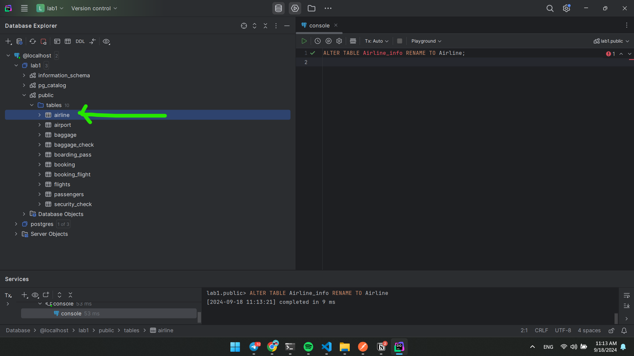

1. Rename ***price*** column to ***ticket_price***

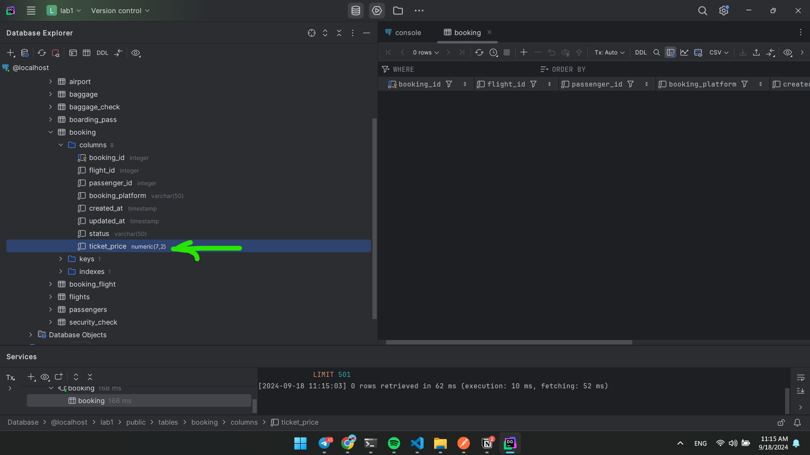

1. Change the data type of ***departing_gate*** from ***VARCHAR(50)*** to ***TEXT***

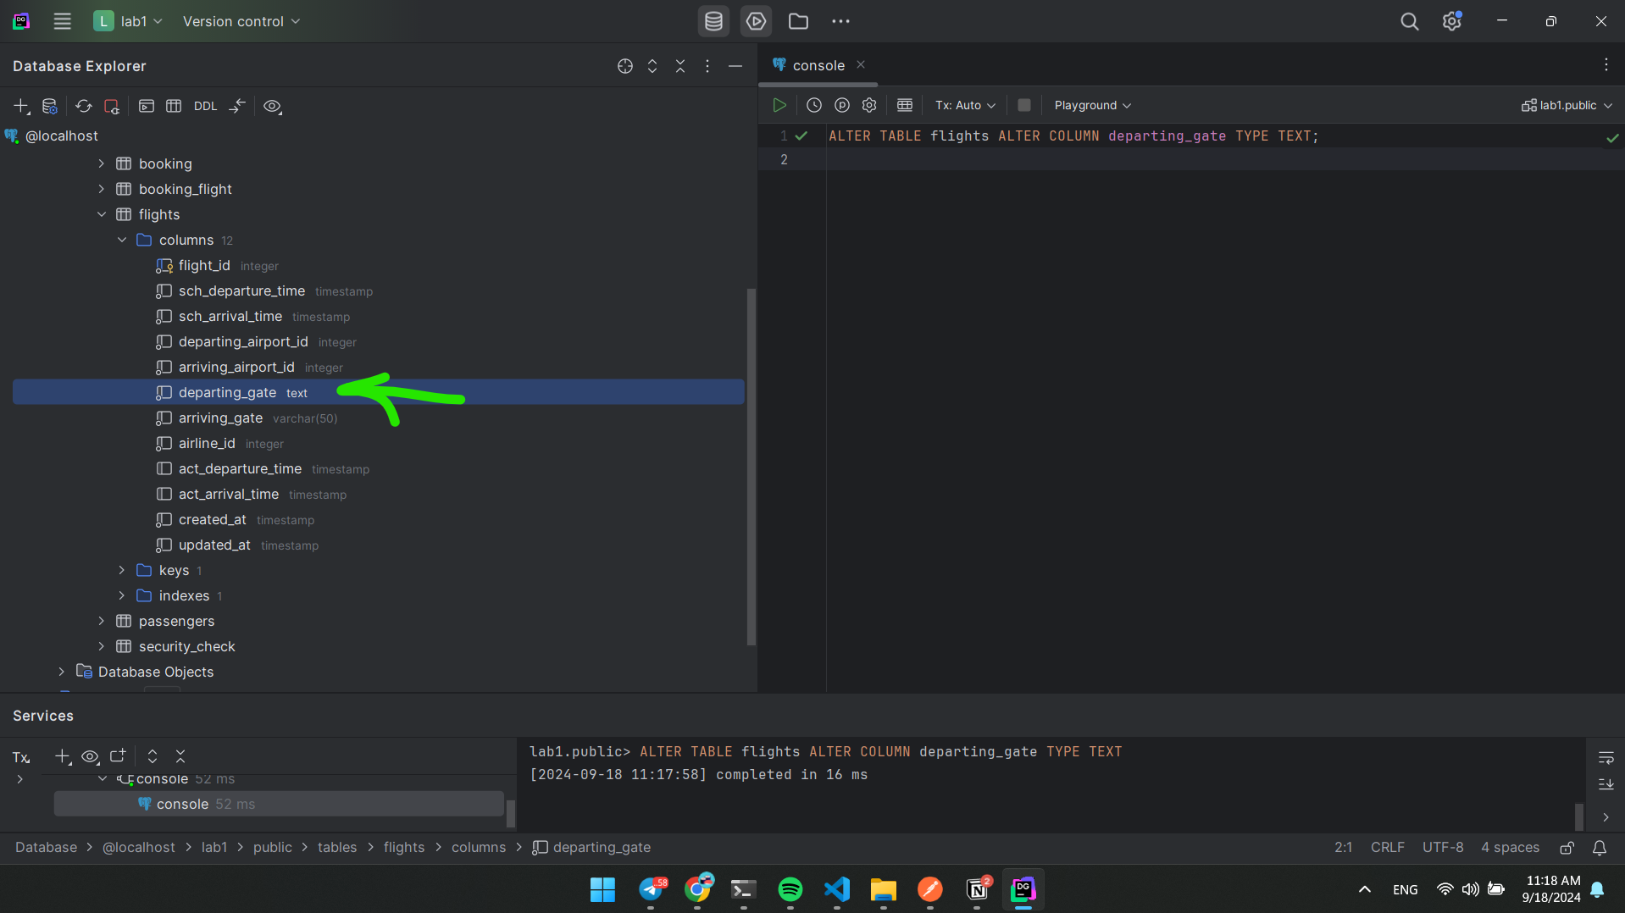

1. Drop the ***info*** column from the airline table

