📘 Project Report: Automated Network Request Management in ServiceNow

Project Title: Automated Network Request Management in ServiceNow
Submitted by: Abhishek Perla
GitHub Repository: Servicenow Project Link
Screenshots Folder: View Screenshots

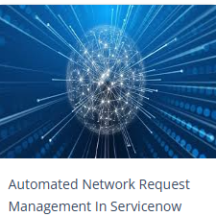

Abstract
This project demonstrates the automation of network request management within ServiceNow using Service Catalogs, Variable Sets, Flow Designer, Approvals, and Notifications.
The system allows users to raise a network-related request through a catalog item, capture all necessary inputs via variables, and process the request automatically using flow automation. The project eliminates manual intervention, reduces approval delays, and ensures real-time communication with stakeholders through email notifications.

Introduction
ServiceNow is a powerful cloud-based ITSM (IT Service Management) platform. One of its most impactful features is the ability to automate workflows, reducing repetitive tasks and ensuring standardization.
In IT organizations, network requests (VPN access, firewall changes, port requests, etc.) are frequent. Manual handling of such requests is prone to delays, miscommunication, and lack of tracking.
This project solves that by:
- Creating a Catalog Item for submitting network requests.
- Designing a Flow in Flow Designer to automatically process requests.
- Implementing approvals for supervisor authorization.
- Sending automated email notifications to requesters.

Objectives
- Automation – Replace manual request processing with fully automated workflows.
- Standardization – Ensure every request follows a structured and auditable path.
- Efficiency – Reduce delays caused by manual approvals and notifications.
- User Experience – Provide a simple and professional request submission form.
- Transparency – Keep all stakeholders informed of request status in real time.

Literature Review
- Service Catalog – A digital catalog containing services available for request. Each item can have fields (variables) to capture user input.
- Variable Set – A reusable group of variables that can be applied to multiple catalog items.
- Flow Designer – A no-code automation tool in ServiceNow for creating process flows.
- Approvals – Used to enforce authorization before fulfilling requests.
- Notifications – Automated emails or messages sent at key stages of the workflow.
This project combines all of these ServiceNow concepts into a single automated solution.

Methodology
The project follows a step-by-step approach:

Step 1: Service Catalog Item Creation
A catalog item titled Network Request was created to allow users to submit network-related requests.
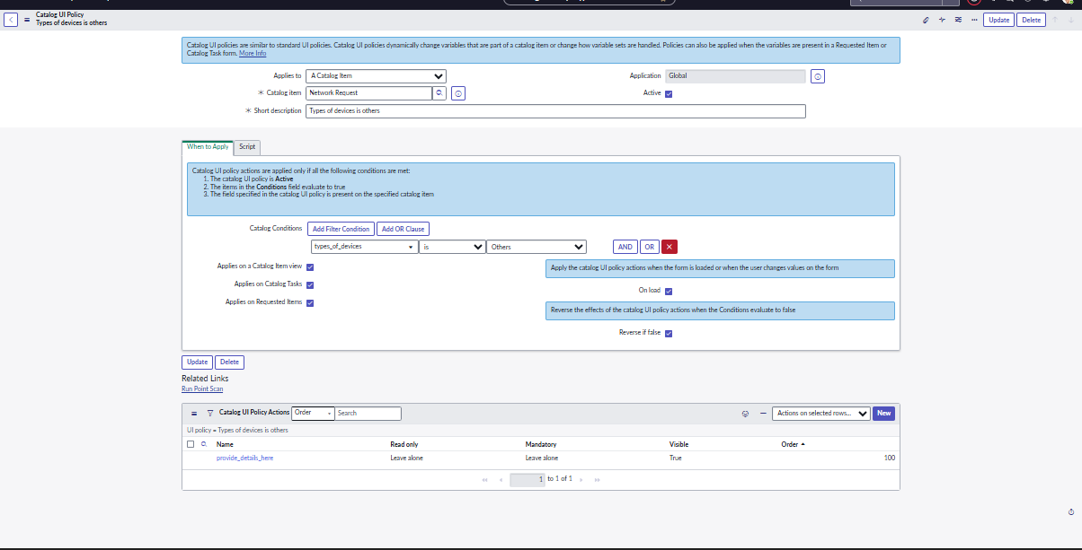

Step 2: Defining Variables and Variable Sets
A Variable Set was configured to capture inputs like:
- Request Type (VPN, Firewall, Port Access, etc.)
- Requester Details (Name, Department, Email)
- Justification
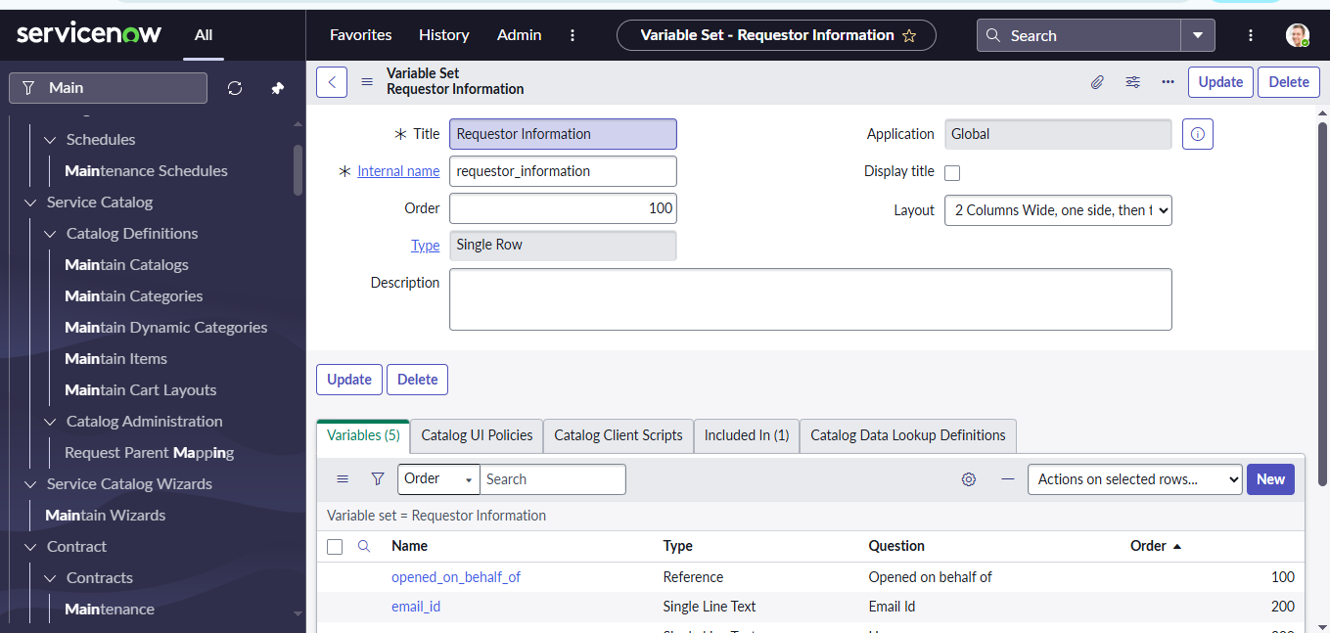

Step 3: Flow Designer – Initial Setup
A new flow was created in Flow Designer triggered when the catalog item is submitted.
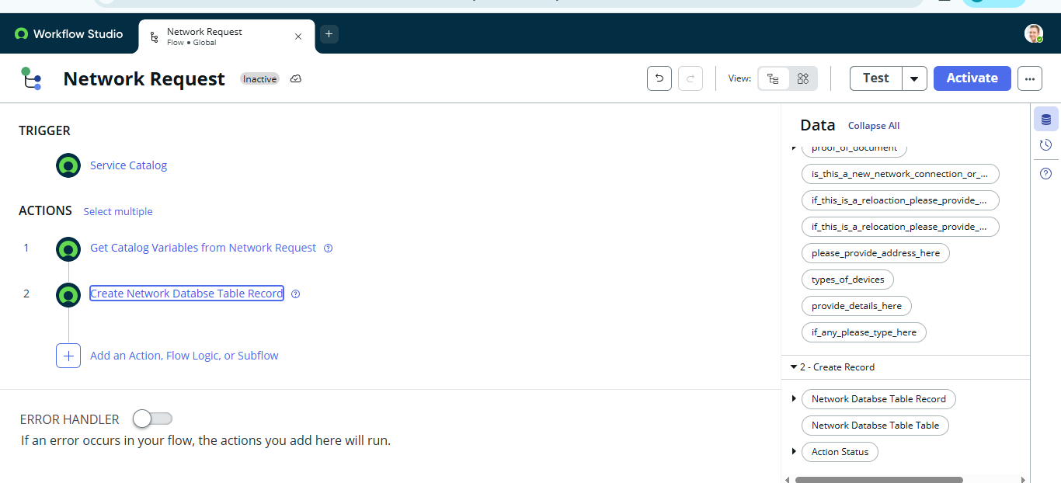

Step 4: Get Catalog Variables Action
This step fetches the submitted variables for further processing.

Step 5: Create Record Action
Automatically creates a record in the database for tracking.
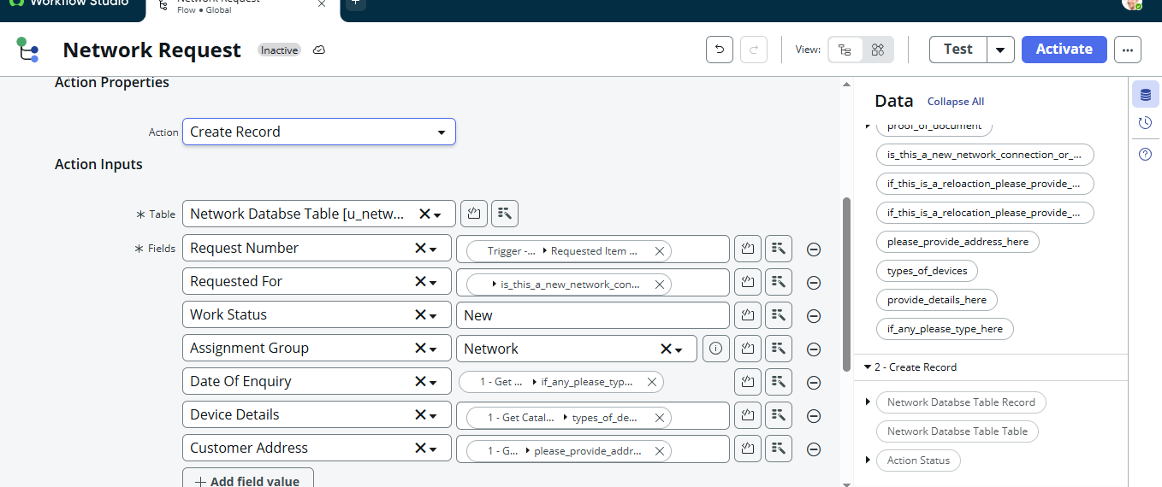

Step 6: Send Email Action
An automated email notification is sent to the requester with request details.
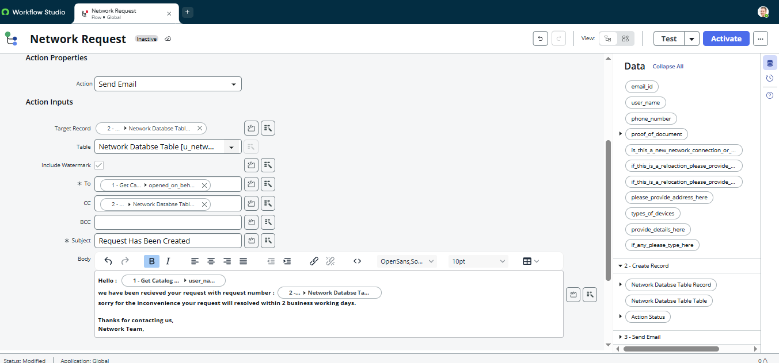

Step 7: Ask for Approval Action
The request is routed to the Approver (Manager/Network Admin) for authorization.
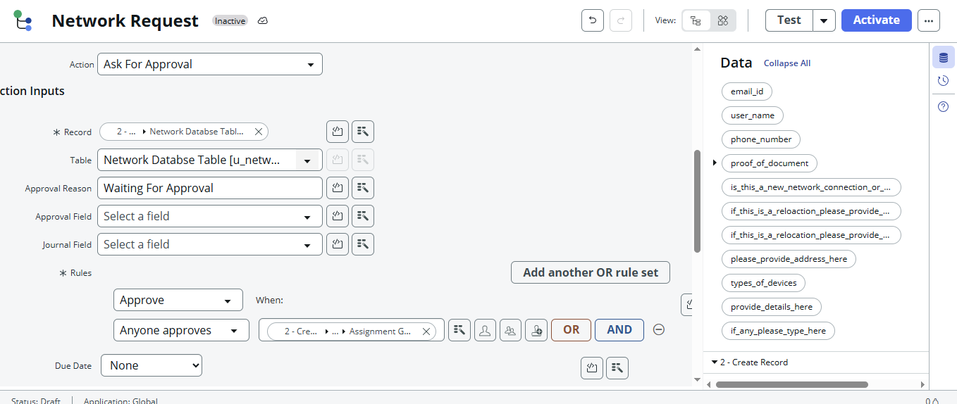

Step 8: Conditional Flow Logic
Based on approval:
- If Approved → Proceed with request fulfillment.
- If Rejected → Notify requester with reason.
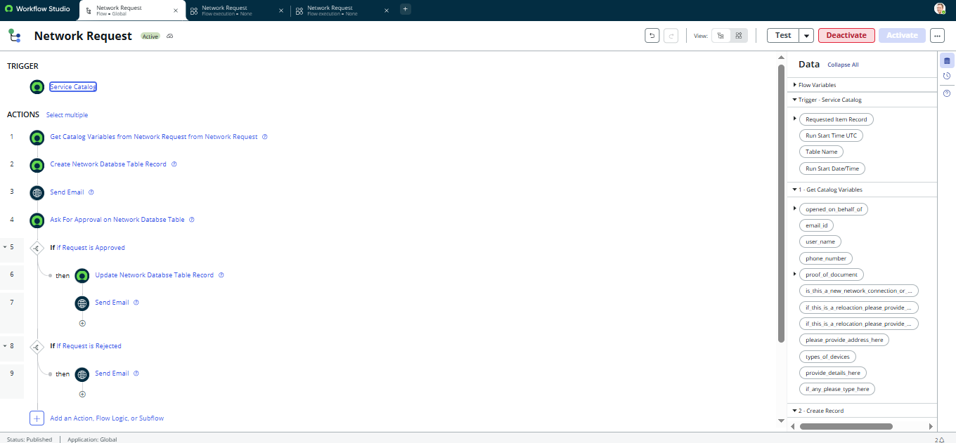

Step 9: Update Record Action
The record is updated with the latest status (Approved/Rejected).
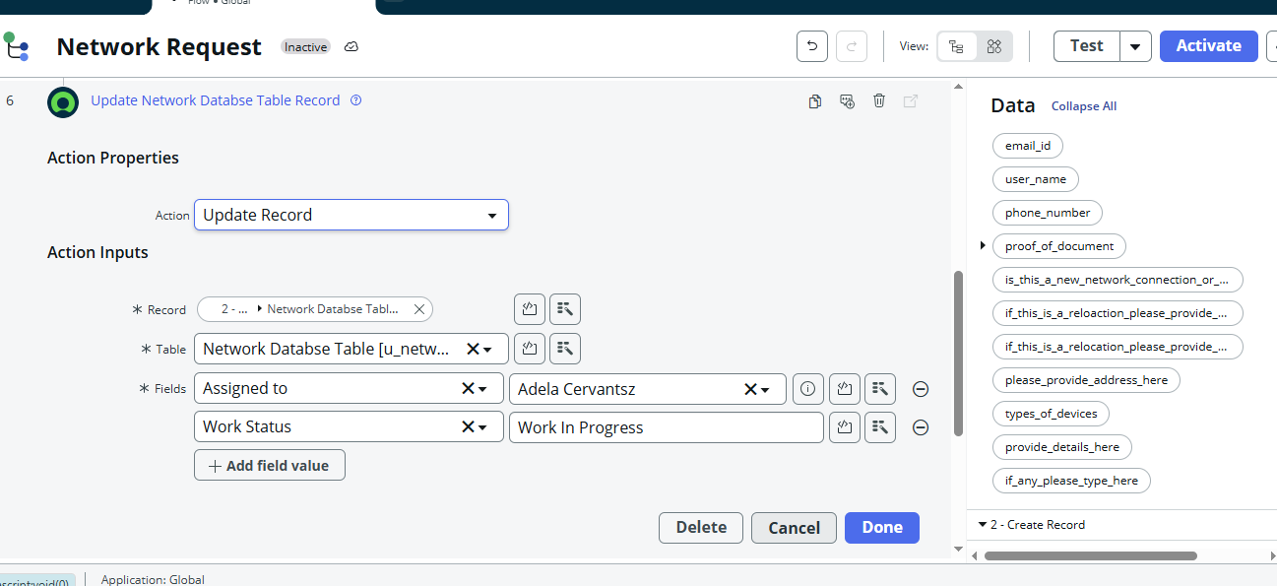

Step 10: Final Flow Design
The complete workflow is now automated end-to-end.

Results
- Users can now raise network requests directly from the catalog.
- Each request is automatically logged, tracked, and routed.
- Approvals and notifications are fully automated.
- Manual effort and errors are significantly reduced.
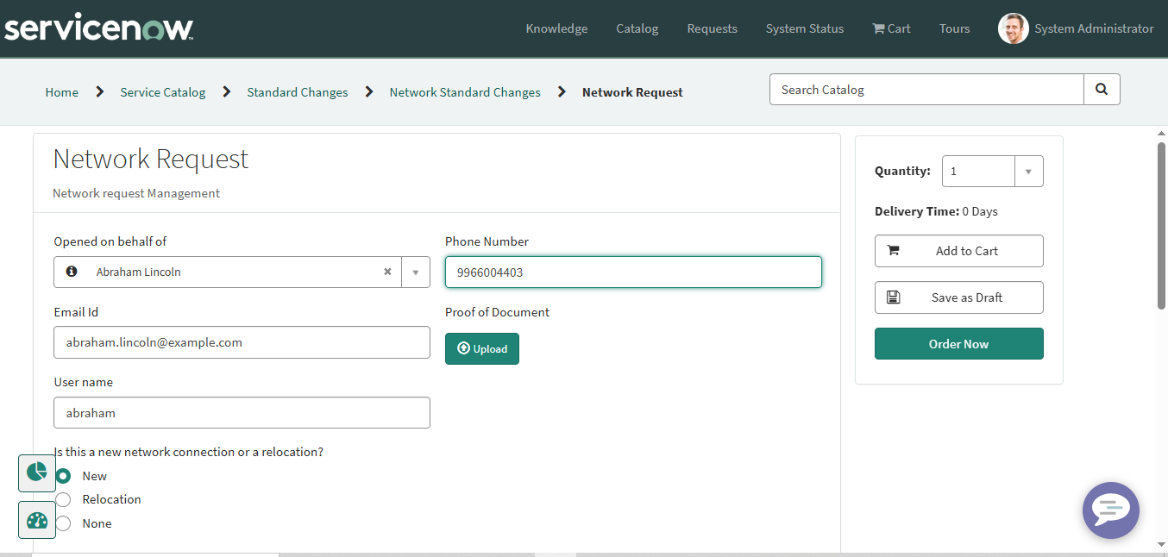

Conclusion
The project successfully demonstrates the automation of network requests in ServiceNow. By leveraging Catalogs, Variables, Flow Designer, Approvals, and Notifications, the system ensures faster resolution, transparency, and standardization.
This implementation can be scaled across other IT service requests like hardware provisioning, software installations, and employee onboarding.

Future Enhancements
- Integration with CMDB – Automatically update configuration items linked to requests.
- SLA Tracking – Attach Service Level Agreements for timely fulfillment.
- Chatbot Integration – Allow employees to raise requests via a virtual agent.
- Reporting Dashboard – Provide real-time analytics on request trends.

References
- ServiceNow Documentation – https://docs.servicenow.com/

