01 Assignment 1

**Directions:** Use an ITSM tool to simulate basic service management. **(20 points)**

1. Visit <https://www.zendesk.com/> and register for a free trial account using your Office 365 email account.
2. Fill in your account information and wait for verification and confirmation emails.

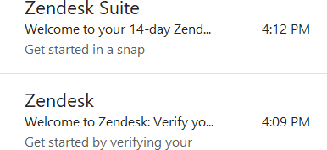

1. Open the link and match the information below if the same panel shows.

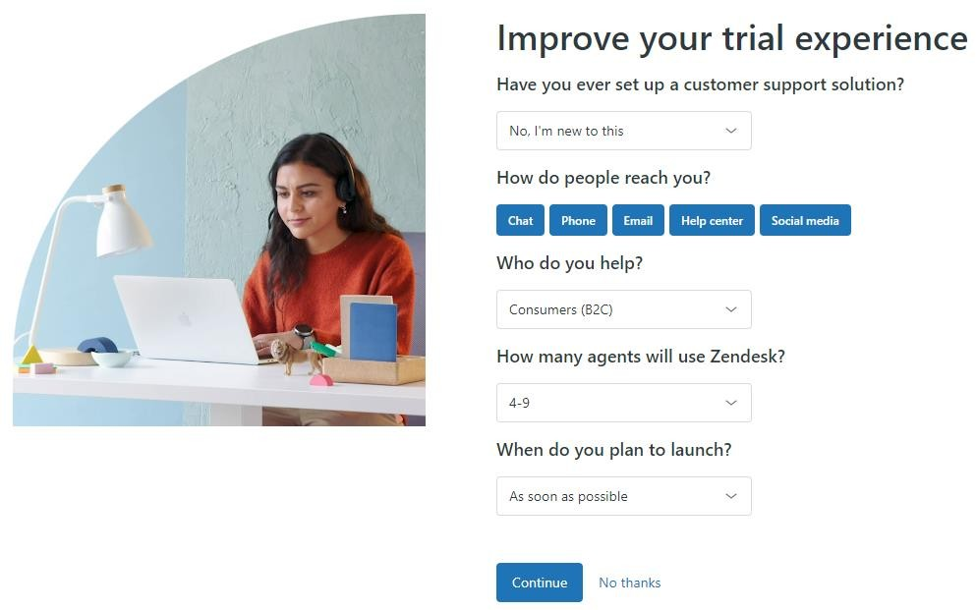

1. Start the free trial and explore the website as much as possible. Note that this trial only lasts for 14 days**.**
2. Clicking the **Dashboard** will display unresolved and unassigned sample ticket requests. Assign each request's Type (Question, Incident, Problem, Task) and Priority (Low, Normal, High, Urgent) based on their attached message/concern. Include a screenshot. See the image below as a reference format.

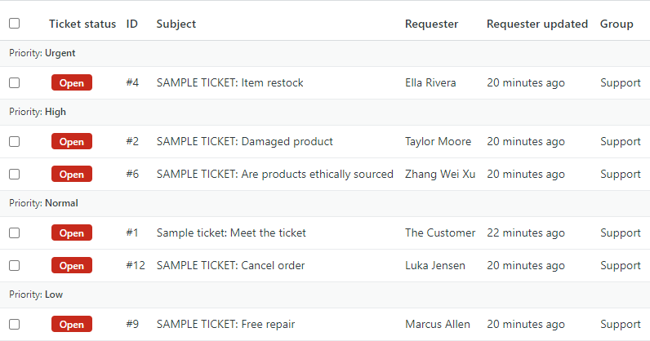

1. Using the exact sample ticket requests, set the status of four (4) tickets from **Open** to **Pending**. Go to **Views** and attach a screenshot of the requests. Make sure the **Type** of ticket is shown.
2. Go to **Customers**, select one (1) customer, and edit their information (Tags, Org., Time zone, Details). Send a screenshot of their filled-up user profile.
3. In at least three (3) sentences, comment on the tool's user interface based on its functionality, features, and user- friendliness.

**GRADING RUBRIC:**

|  |  |
| --- | --- |
| **Performance Standards** | **Points** |
| All submitted screenshots show the correct requirements. | 3 x 5 pts |
| The conclusion effectively tackles the tool's functionality, features, and user-friendliness. | 5 |
| **Total** | **20** |