CS718
Implementation Blackboard Architecture
Harshad Chavan 143050028
Aby Sam Ross 143050093

README File

Overall Structure of the implementation:
Blackboard
Component Interacting with the Controller
(parent process)
Component Interacting with Clients
(child process; multithreaded)
Controller
Code for Communicating with Blackboard
Set of nodes to be expanded
Spawn a client for each node
Client 1
Client n
Finds out the neighbours for the node that was assigned to it and returns them as result
Finds out the neighbours for the node that was assigned to it and returns them as result
Shared Message Queue
(Results of Client computations)

Contents of the submission:

- /bb/bb.c :
C source for the Blackboard
- /bb/bb.h :
Header file for the Blackboard source
- /bb/run_bb :
Executable for Blackboard
- /bb/graph.txt :
Contains the adjacency matrix for the graph on which BFS needs to be run. Each row is written on one line of the file and each element in a row is separated with “;” (semi-colon)
e.g.
0;1;1;
1;0;1;
1;1;0;
- /bb/keys.txt :
Contains a “;”(semi-colon) separated list of values(keys) on each node in the graph in a single line
e.g.
a;b;c;
- /bb/target.txt :
Contains the target key i.e. the key that the BFS will search in the graph.
e.g.
c;
- /bb/Makefile :
Makefile for compiling the Blackboard source with appropriate flags and building an executable
- /ctrl/ctrl.c :
C source for the Controller
- /ctrl/run_ctrl.c :
Executable for Controller
- /ctrl/BFS_client.c :
C source for a Client that expands the node assigned to it
- /ctrl/BFS_client :
Executable for Client
- /ctrl/trusted_hosts.txt :
List of hosts on which the controller can spawn clients.
Contains one line per host having
  - Hostname(user@ipaddress)
  - Password
  - Path to the directory where BFS_client resides on the host
in a “;”(semi-colon) separed format
- /ctrl/Makefile :
Makefile for compiling building executables of client and controller
- /README.pdf :
Contains instructions to set up and run codes, sample graph and screen shots.

Instructions for setting up and compiling the code:

- Extract the contents of submission into a directory of your choice. Let that be “/mydir/”.
- First we need to compile the Blackboard. Open up a terminal and type:
$ cd path-to-mydir/bfs/bb
- Compile the Blackboard source using a makefile i.e. type into the terminal:
$ make
- Open up another terminal and type:
$ cd path-to-mydir/bfs/ctrl
- Compile the Controller and Client source using a makefile i.e. type into the terminal:
$ make
- The list of hosts on which the Controller can spawn BFS_client is available in trusted_hosts.txt file. We can add/delete any hosts from this list by deleting a line from the file. While adding, make sure that the format is as follows:
username@ipaddress;password;absolute-path-to-the-directory-where-BFS_client-resides-on-host;
e.g. harshad@10.196.29.205;xyz;/home/harshad/bfs;
- Repeat steps 1 through 6 on each machine on which you want to deploy any component(Blackboard, Controller or Client) of the system. (Alternative you can only set up blackboard code on then machine where you want to a blackboard only, and so on for machines with Client and Controller.)
Instructions for Running the Code:

Following steps have to pe performed in the same order.

- Setting up a problem Instance:
The problem instance for BFS search is specified in files graph.txt, keys.txt and target.txt. If you wish to change the problem instance i.e. graph, node to be serached and values on each graph node, open the corresponding file in an editor an make appropriate changes as required, before proceeding to step 2.
- Running the Blackboard:
  - Open up a terminal and type:
$ cd path-to-mydir/bfs/bb
  - Run the blackboard by typing in the following command:
$ ./run_bb <port_num_1> <port_num_2>
where <port_num_1> is the port Blackboard uses to communicate with the Controller and <port_num_2> is the port the Blackboard used to communicate with the Client/s. You need to remember these values and use the same while running the controller.
- Running the Controller:
  - Open up another terminal and type:
$ cd path-to-mydir/bfs/ctrl
  - Run the controller by typing in the following command:
$ ./run_ctrl <ip_address_of_the_blackboard> <port_num_1> <port_num_2> <client_type>
where <port_num_1> and <port_num_2> should be the same values used for blackboard's execution. <client_type> can have values “L” or “R”.
    - “L” tells the Controller to spawn clients locally i.e. on the same machine as the Controller
    - “R” tells the Controller to spawn clients remotely i.e. on another machine which is one of the hosts specified in the trusted_hosts.txt file.

You will be able to see the messages sent during the communication between Blackboard, Controller and Clients. Once the BFS is done and the key is found in the graph, Controller will print the Node ID (and integer identifier) of the node of the graph which contains the target key.

Note 1:
Between successive runs of Blackboard(run_bb) , perform following actions:
1. Type the following command in the terminal:
$ ipcs
2. Note the msqid from “Message Queues” section.
3. Type the following command in the terminal:
$ ipcrm msg <msqid>
e.g.
$ ipcrm msg 32769

These actions are required for deleting any active message queues that might be created but not closed by the Blackboard.

Note 2:
The search on the graph will always start from the node with node_id=00.

Example Graph:

(example submitted with the assignment)
node_id=00
key='a'
node_id=01
key=''b'
node_id=04
key='e'
node_id=03
key='d'
node_id=02
key='c'

Adjacency Matrix (graph.txt):

0;1;0;1;0
1;0;0;0;1
0;0;0;0;1
1;0;0;0;1
0;1;1;1;0

Keys List (keys.txt):
a;b;c;d;e

Target (target.txt):
e;

Screenshots:

Blackboard Execution:

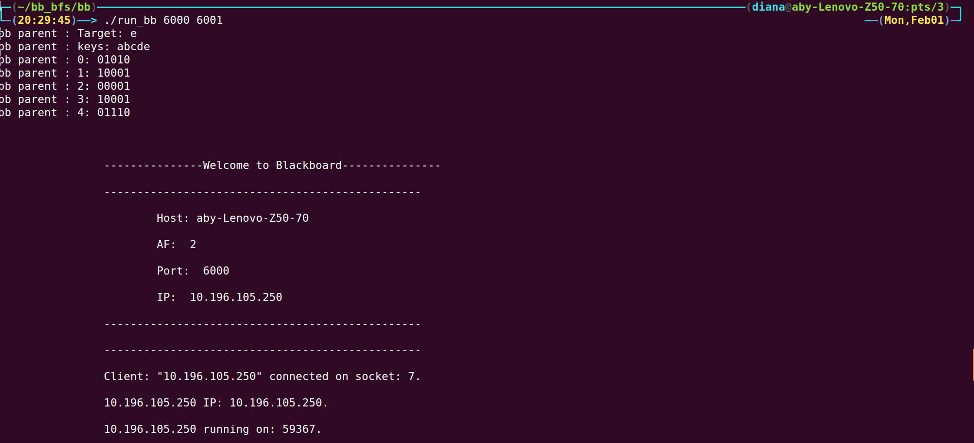
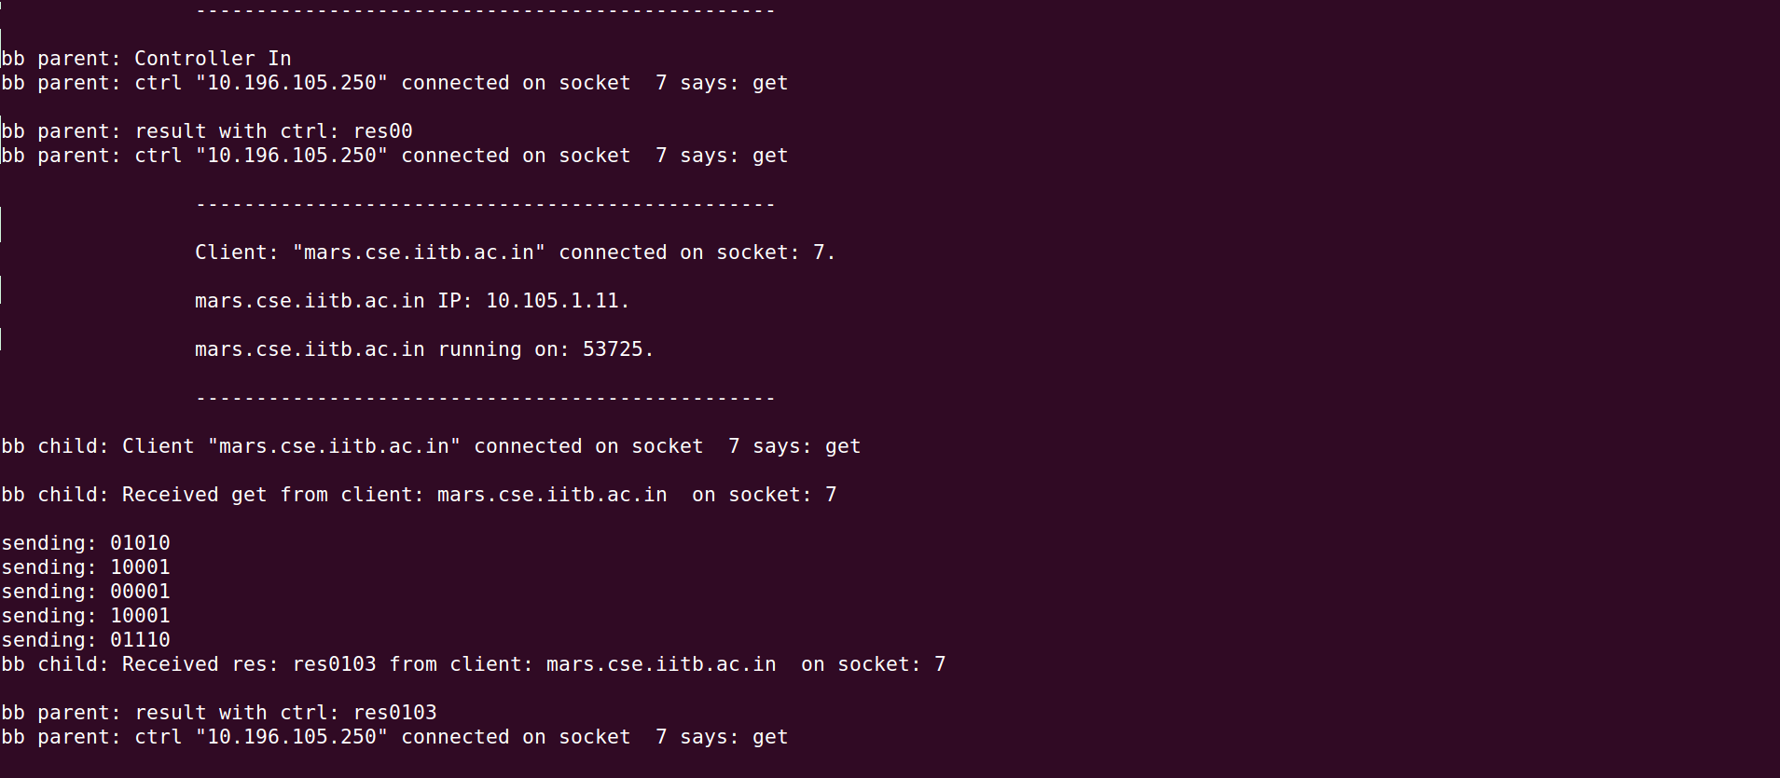

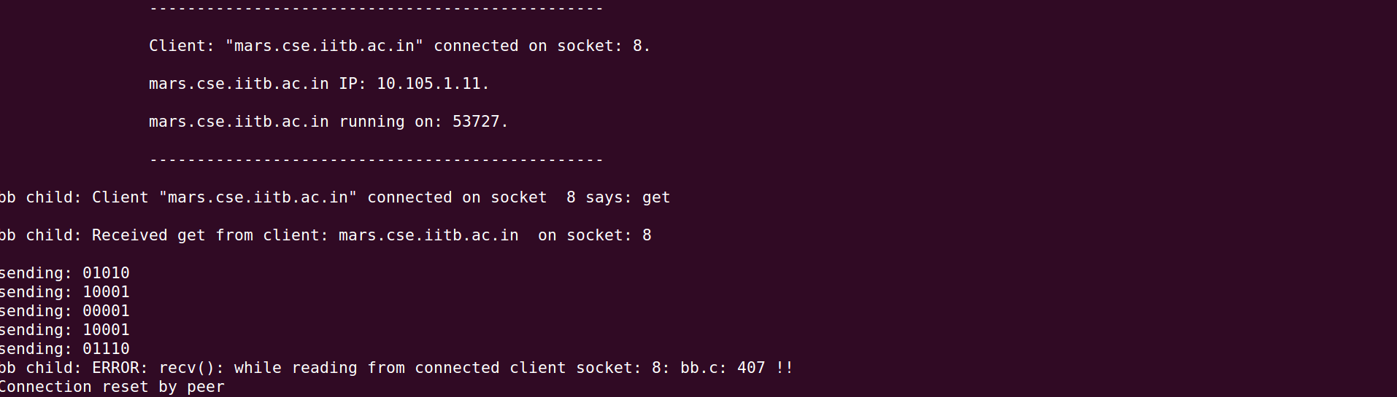
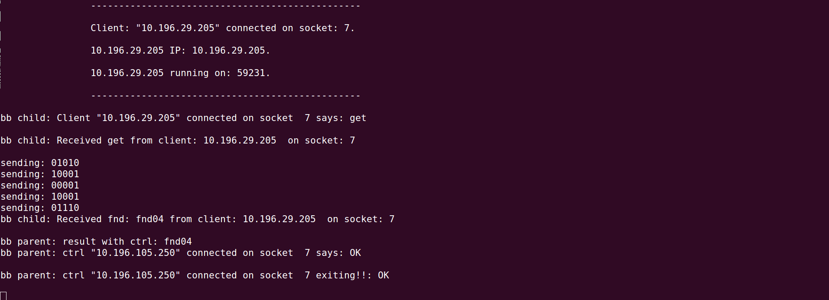
Controller and Client Execution:
(client runs on a different machine than controller but since controller spawns all the BFS_client, the stdout messages of BFS_clients appear in the same window as the controller)

