## Introduction:

This GUI as a hobby project, I definitely use AI to cut the code snipped to complete this project but not 100%. The main objective of this GUI is test the model for object detection using bounding box after training. It works with picture, Videos as well as live There are some feature definitely needs to fix I will fix in future.

## Upload the Trained model.

Make Sure your model should be trained ultralytics model

* **Step 1:** Browse the model

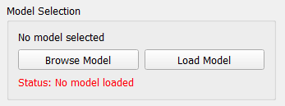

* **Step 2:** Select the model and click okay

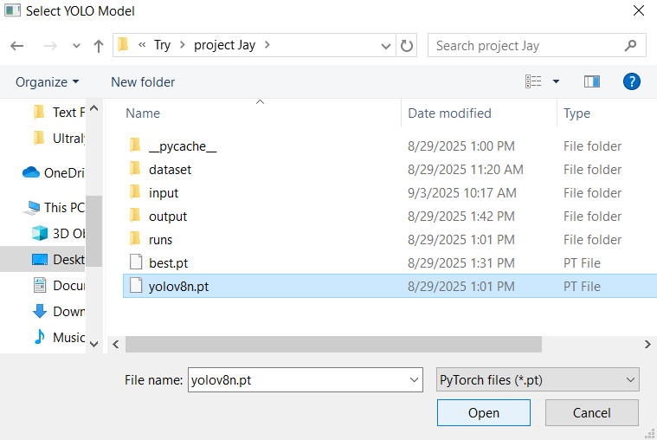

* **Step 3:** Load the model

|  |  |
| --- | --- |
|  |  |

## Detection Setting:

Here you can set the confidence level for the picture.

According your confidence level bounding box color will be either red, orange green.

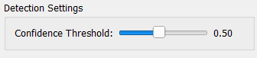

## Image detection:

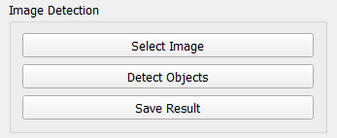

* **Select Image:** Browse the image you want to detect.
* **Detect Objects:** Detect the object based on your trained model. It will create bounding box around your object. For example, below Model can detect with 0.86 accuracy this is cat.

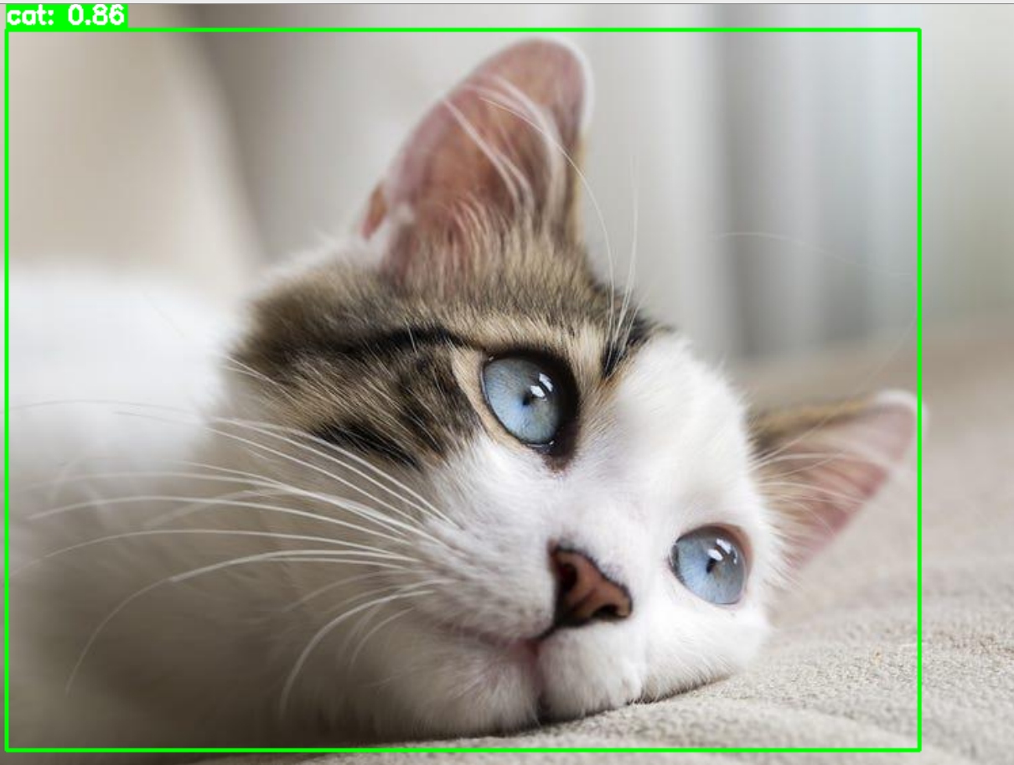

* **Save Result:** Save the result with bounding box.

## Video Detection:

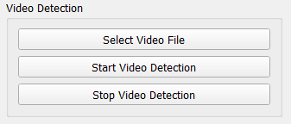

* **Select Video File:** Select the video file you want to detect.
* **Start Video Detection:** Detection on the video will start.
* **Stop Video Detection:** Use Stop detection.

**Note:** Each time you start the video detection it will automatically save in the root folder.

## Live Detection

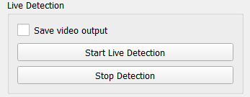

* **Start Live Detection:** Start live detection as soon as you click on this button.
* **Stop Detection:** Stop live detection as soon as you click on this button.