Ques 1:How are inline and block elements different from each other?

Sol 1:

Block Elements: These elements cover the width of complete page and always starts from the new line.

Inline Elements:These elements do not cover the width of complete page instead just take the required space.

Ques 2:Explain the difference between visibility:hidden and display:none
Sol 2:

display:none
Without deleting the elements,the elements are hidden.No space is occupied.

visibility:hidden
It also hides the elements but effects the layout by occupying space.

Ques 3:Explain the clear and float properties.

Sol 3:

Float Property: This property is used for the alignment of content on the page.It accepts 4 values i.e.
left-the element floats to the left
right-the element floats to the right
none-it is default,in this the element does not float
inherit-it takes the vlaue of parent float property

Clear Property: This property sets the elemnts which can be float. The value of clear must be decided on the basis on float value assigned. It takes 5 values i.e.:
none-this is default,it allows floating on both the sides.
Left-floating elements are not permitted on left side.
right-floating elements are not permitted on right side.
Both-floating not allowed on either sides.
Inherit-it inherits the value of the parent.

Ques 4:explain difference between absolute, relative,fixed and static.

Sol 4:

It specifies the element positioning method.

static: the elemenets are positioned according to the normal flow of the page.This is default.

Relative: It will adjust the element away from its normal position.

Fixed: the position of the element do not change even if the page in scrolled up or down.

Absolute: It moves along with the scrolling of the page.

Ques 5:Write the HTML code to create a table in which there are 4 columns( ID , Employee Name, Designation, Department) and at least 6 rows. Also do some styling to it.

Sol 5:

demo_table.html

<html>
<head>
<title>Table</title>
<link rel="stylesheet" type="text/css" href="table-style.css">
</head>
<body>
<div>

<h2>Sample Table</h2>
<table>
<tr>
<th>ID</th>
<th>Employee Name</th>
<th>Designation</th>
<th>Department</th>
</tr>
<tr>
<td>1</td>
<td>Abhishek</td>
<td>designer</td>
<td>Graphics</td>
</tr>
<tr>
<td>2</td>
<td>anuj</td>
<td>HR</td>
<td>Human Resource</td>
</tr>
<tr>
<td>3</td>
<td>sonal</td>
<td>Analyst</td>
<td>Statistics</td>
</tr>
<tr>
<td>4</td>
<td>rohit</td>
<td>software developer</td>
<td>IT</td>
</tr>
<tr>
<td>5</td>
<td>ankush</td>
<td>Trainee</td>
<td>IT</td>
</tr>
<tr>
<td>6</td>
<td>preety</td>
<td>Doctor</td>
<td>Medical</td>
</tr>
</table>
</div>
</body>
</html>

demo.css

table,th,td{
border: 2px solid black;
border-collapse: collapse;
padding: 10px;
margin: auto;
margin-top: 20px;
}
th{
color:green;
}
h2{
text-align: center;
}

Ques 6:Why do we use meta tags?

Sol 6:

Meta tag is used to provide data about the html page. It is similar to metadata which is data about data.
The information of meta tag is not diaplayed on the web browser instead it is used by the browsers,search engines for recognising the web page or web servers.
It containes information like description of the page,author of the document,keywords,last modified,etc.
This tag is written under head tag.

Ques 7:Explain box model.

Sol 7:

CSS box model is a box that wraps all the elemnts of HTML page.It contains margins,borders,padding and the actucal content.
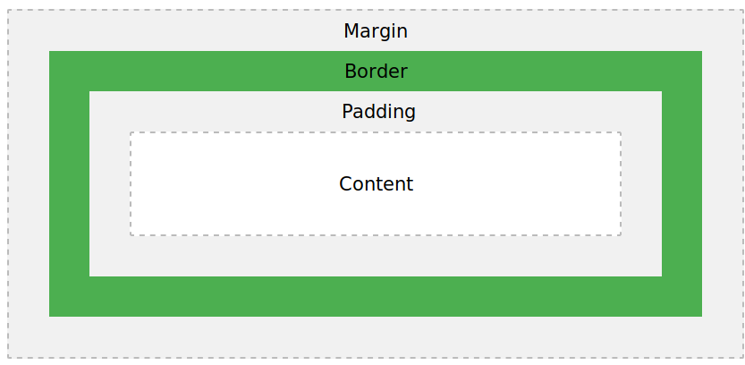

Ques 8: What are the different types of CSS Selectors?

Sol 8:

CSS Selectors are used for styling the content of the page.Various CSS selectors are:-

a. CSS Id Selector
Tags are assigned with a unique Id and this Id is used to select the text and apply styling to that content of the page.

b. CSS Element Selector
The content of the page is selected using the element name.

c. CSS Group Selector
This selector is used when same styling is required to be applied to multiple tags.We can group the elements and write the styling code only once and it will get applied to all the grouped elements..

d. CSS Class Selector
Class name is assigned to the tag.Same class name can be applied to multiple tags.

e. CSS Universal Selector
If any styling is required to be applied to complete html file Universal Selector is used.

Ques 9:Define Doctype.

Sol 9:

The <!DOCTYPE> is used to specify the version of html being used.It must be the first line in the html file befor the html tag.It is the instruction that is given to the browser.

Ques 10:Explain 5 HTML5 semantic tags.

Sol 10:

5 semantuc tags used in this example are:

<header> : Specifies header of the document.
<nav> : Defines navigation links.
<figure> : Used to add an iamge in the document.
<figcaption> : Usd to add a small description of the image added.
<footer> :Specifies footer of the document.

Ques 11: Create HTML for web-page.jpg (check resources, highest weightage for answers)

Sol 11:

html file:
q5.html

<html>
<head>
<title>To the New </title>
<link rel="stylesheet" type="text/css" href="q5.css">
</head>
<body>
<div id="div4">
<div id="div1">
<h2>To the New</h2>
<nav>
<a href="#">TEXTLINK</a>
<a href="#">TEXTLINK</a>
<a href="#">TEXTLINK</a>
<a href="#">TEXTLINK</a>
<a href="#">TEXTLINK</a>
</nav>
</div>
<div id="div2">
<div id="div3">
<p>960 x 360px</p>
</div>
<div id="div5">
<p>f future generations are to remember us more with gratitude than sorrow, we must achieve more than just the miracles of technology. We must also leave them a glimpse of the world as it was created, not just as it looked when we got through with it.”
</p>
</div>
<div id="div6">
<p>LATEST FROM THE GALLERY</p>
</div>
<div id="flex-con">

<div class="view">
<div class="view1">
<p>215 x 315px</p>
</div>
<p id="view-p">IMAGE CAPTION HERE</p>
</div>
<div class="view">
<div class="view1">
<p>215 x 315px</p>
</div>
<p id="view-p">IMAGE CAPTION HERE</p>
</div>
<div class="view">
<div class="view1">
<p>215 x 315px</p>
</div>
<p id="view">IMAGE CAPTION HERE</p>
</div>
<div class="view">
<div class="view1">
<p>215 x 315px</p>
</div>
<p id="view-p">IMAGE CAPTION HERE</p>
</div>

</div>
</div>
</div>
<footer id="footer">
<section id="con">
<div id="copyright">
Copyright &#169;2009-2017-All Rights Reserved-To The New
</div>
<div id="right">Web layout by To The New</div>
</section>
</footer>
</body>

</html>

css file
q5.css

*{
padding: 0px;
margin: 0px;
}
body{
background-color: #323232;
}

#div4{
margin:auto;
width: 1200px;
}
#div1{
margin: auto;
padding:10px;
width: 960px;
}
a{
text-decoration: none;
color: white;
}
nav{
padding:10px;
background-color: #222222;
}
#div2{
background-color: white;
padding: 30px 50px 30px 50px;
}
#div3{
background-color: #323232;
height: 360px;
width: 960px;
margin: auto;
display: flex;
justify-content: center;
align-items: center;
}
#div3 p{
color: white;
}
#div5{
width: 960px;
background-color: lightgray;
margin: auto;
}
#div5 p{

margin:20px;
}
#div6 p{
color: darkgray;
font-weight: bold;
width: 960px;
margin: auto;
border-bottom: 1px solid darkgray;
}
#div7{
height: 360px;
width: 960px;
margin: auto;
}

#flex-con{
width:960px;
height:325px;
margin:auto;
display: flex;
margin-top: 12px;
}
.view{
border: 1px solid grey;
width:215px;
height: 315px;
color: white;
padding: 5px;
margin-right: 15px;
}
.view1{
width: 215px;
height: 296px;
display: flex;
justify-content: center;
align-items: center;
background-color: #323232;
}
#view{
background-color: gray;
width: 215px;
}
#footer{
background-color: #222222;
}
#con{
width: 960px;
height: 60px;
margin: auto;
display: flex;
justify-content: space-between;
align-items: center;
color: white;
}

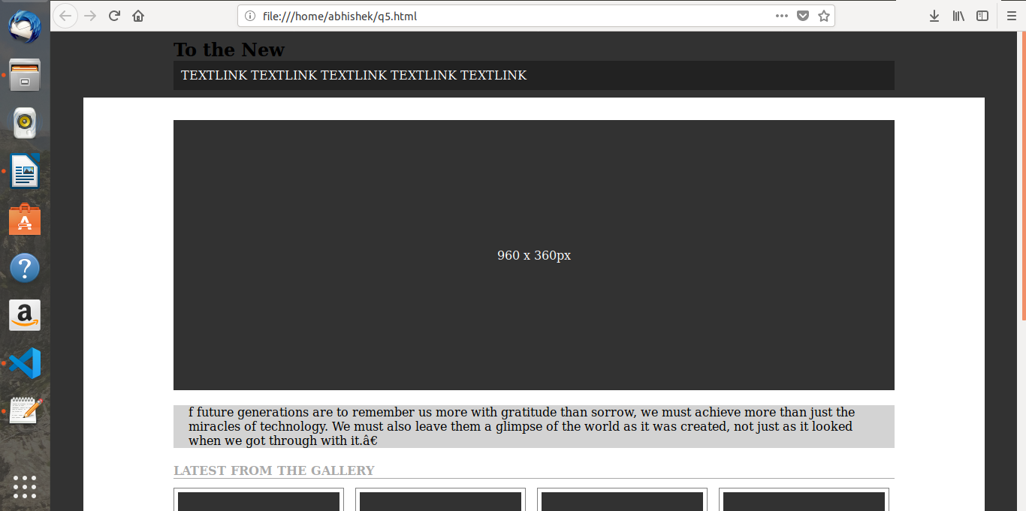
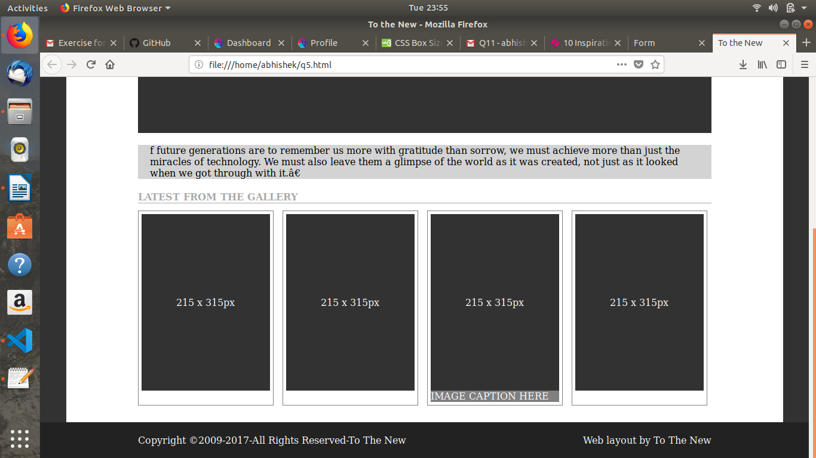

Ques 12:Create HTML for form.png

Sol 12:

html file:
q6.html

<html>
<head>
<title>Form </title>
<link rel="stylesheet" type="text/css" href="q6.css">
</head>
<body>
<header >
<h3>TO THE NEW</h3>
<nav>
<a href="#">Home</a>
<a href="#">QuickHelp</a>
</nav>
<br><br>
</header>
<div id="con-holder">
<div id="form">
<p>Bug Report</p>
</div>
<form id="fBody">
<label>Title:*</label><br>
<input type="text"><br>
<label>Description:*</label><br>
<textarea naame="desc"></textarea>
<label>Operating System:</label>
<select>
<option value="WindowsXP">WindowsXP</option>
<option value="Linux">Linux</option>
<option value="Mac">Mac</option>
<option value="Android">Android</option>
</select><br>
<label>Product:*</label><br>
<select id="product">
<option value="Formoid">Formoid</option>
<option value="Formoid1">Formoid1</option>
</select><br>
<label>Version:*</label>
</br><input type="text" style="width: 80px;"><br>

<label>License:</label><br>
<input type="radio" name="license"><label for="type">Free</label>
<input type="radio" name="license"><label for="type">Business</label><br>

<label>Severity:</label>
<select>
<option value="Critical">Critical</option>
<option value="Moderate">Moderate</option>
</select><br>
<label>Attachments:</label><br>
<ul>
<li id="noFile"><label for="fup">No File Selected</label></li>
<li id="upload"><label id="upload1">Choose file<input type="file" id="fup"></label></li>
</ul>
</form>
<div id="formFooter">
<input type="submit" name="Send" value="Send">
</div>

</div>
</body>
</html>

css file:
q6.css

*{
margin: 0px;
padding: 0px;
}
header{
margin: 10px;
border-bottom: 1px solid grey;
}
h3{
color: #1ABC9C;
float: left;
}
nav{
float:right;
}
a{
text-decoration: none;
color: #1ABC9C;
padding: 5px;
}
textarea{
width:100%;
height:70px;
border-radius: 5px;
margin-bottom: 5px;
}
#con-holder{
border-radius: 5px;
height: 577;
width:450px;
border: 2px solid gray;
margin: auto;
}
#form{
background-color: #BCC3CA;
color: white;
font-size: 18px;
padding: 10px;
font-weight: bold;
}
#fBody{
margin: 10px;
padding: 10px;
margin-top: 8px;
}
input[type="text"]{
width: 410px;
margin-bottom: 5px ;
}
input[type="radio"]{
margin-bottom: 8px ;
}
select{
width: 410px;
border: none;
padding: 5px 5px;
background-color: #1ABC9C;
color: #ffffff;
border-radius: 8px;
margin-bottom: 5px;
}

#formFooter{
background-color: lightgray;
height:18px;
padding: 10px;
}
#formFooter input{
float:right;
color:white;
background-color:#1ABC9C;
border-radius: 5px;
margin-right: 5px;
padding: 3px;
}
ul{
border: 2px solid grey;
border-radius: 5px;
display: inline-block;
}
li{
list-style-type: none;
float: left;

}
#noFile{
padding: 10px 100px 10px 5px;
}
#upload1{
padding: 10px;
display: table;
background: grey;
}
input[type="file"]{
display: none;
}

