Technical Design Document: React Mobile Remote Controller Engine

1 Overview
The React Native Mobile Remote Controller (MRC) application is a client-side engine designed to transform a mobile device into an interactive controller for TV-based or shared-screen gaming experiences. The application enables users to seamlessly connect to active game sessions and interact with them in real time using touch and input-based controls.
At its core, the MRC operates as a server-driven UI platform, where most of the user interface and interaction logic is dynamically defined and delivered by backend services via JSON configuration and synchronized through a WebSocket-based communication protocol. This allows a single mobile application to support multiple games and interaction models without requiring client-side updates.
The application flow is designed to be frictionless, starting from simple entry points such as scanning a QR code or opening a deep link. The application resolves the session context, establishes a connection to the backend, and renders the appropriate controller interface dynamically. Platform-specific deep linking strategies and deferred matching mechanisms ensure continuity of this flow even when the application is not installed at the moment of entry.
The system is built using React Native with TypeScript and follows a modular architecture that separates concerns between networking, rendering, and state management. Key components such as the dynamic rendering engine, WebSocket client manager, and layout processing utilities enable high flexibility, scalability, and resilience.
Overall, the MRC serves as a lightweight yet powerful runtime environment that bridges mobile devices with interactive entertainment systems, enabling real-time, configurable, and scalable second-screen experiences.

1.2 Technology Stack
· Framework: React Native (Expo SDK 52+)
· Platform: iOS / Android
· Language: TypeScript (TS/TSX)
· Bundler: Metro
· Networking: WebSocket via PW MP library (pwmp_client.min.js)
· Backend Integration: Play.Works Backend (PW BE)
· UI Configuration: JSON-based server-driven layouts
· State Management: React Hooks (useState, useEffect, useContext)
· Deep Linking:
  - iOS: Universal Links
  - Android: App Links
· QR Code Scanning: Camera / Barcode Scanner

2 Application Workflow
This section describes how users enter the Mobile Remote Controller (MRC) application and how the system ensures a seamless transition from a physical interaction (e.g., scanning a QR code) to an active gameplay session.

2.1 Workflow Diagram
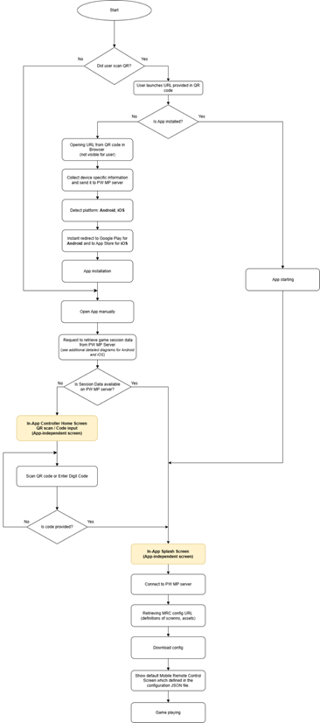
This diagram illustrates the end-to-end application flow from scanning a QR code (or manually entering a code) to joining a game session in the Mobile Remote Controller application.
Depending on whether the app is already installed:
- The user is either redirected through the installation flow (with deferred context recovery),
- Or launched directly into the application.
After launch, the system attempts to retrieve session data from the backend.
If the data is unavailable, the user is redirected to the Controller Home Screen for manual input or scanning QR.
Once a valid session is established:
- The app connects to the server
- Downloads the UI configuration
- Renders the controller interface
This enables real-time interaction with the game.

3 Platform-Specific Functionality for Data Transferring from PW BackEnd
This section explains how session data (such as roomId) is transferred from the PW BE to the Mobile Remote Controller (MRC) application.
There are two platform-specific cases: iOS and Android, as each operating system provides different capabilities for deep linking and post-install data recovery.

Direct Data Transfer (App Installed)
When the application is already installed, both platforms use deep links to open the app directly.
- Deep Links — URLs that open the mobile app and pass session data (e.g., roomId)
- Used after QR scan or link click
- Enable immediate connection to a game session without additional steps

Deferred Data Transfer (App Not Installed)
When the app is not installed, the flow continues in the browser and requires Deferred Context Recovery.
- Deferred Context Recovery — a mechanism to restore session data after the app is installed
- Needed because session data cannot be passed through the app store installation process
In this case:
- Session data is captured in the browser
- Stored temporarily on PW BE
- Retrieved after app installation

Platform Differences
- Android
  - Uses Install Referrer API
  - Allows more reliable (deterministic) recovery of session data
- iOS
  - Does not support install referrer
  - Requires probabilistic matching

Fingerprinting & Matching
To recover session data after installation, the system uses fingerprints:
- FP1 (Pre-install fingerprint)
  - Collected in the browser before installation
  - Represents the user/device context at the time of link opening
- FP2 (Post-install fingerprint)
  - Collected in the app after first launch
  - Represents the user/device context after installation
- Probabilistic Matching
  - A method of comparing FP1 and FP2 using signals such as:
    - Device type
    - Network (IP / location)
    - Time proximity
  - Used to determine if both fingerprints belong to the same user

3.1 iOS Deep Linking (Universal Links + Probabilistic Deferred Matching) flow diagram
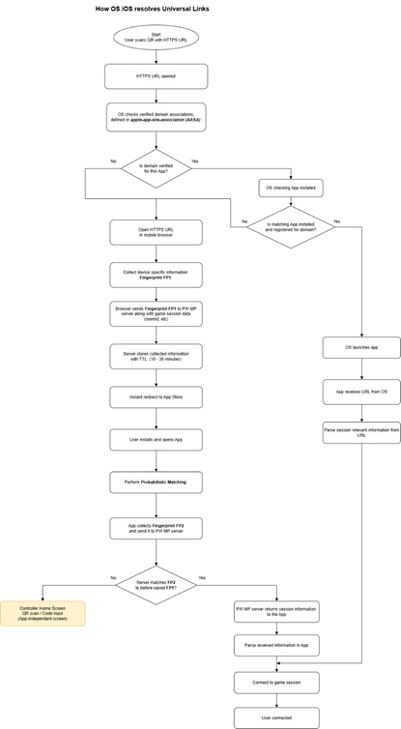
Direct Deep Link Handling
- Uses Universal Links with AASA (apple-app-site-association)
- If app is installed:
  - OS opens app directly
  - URL context passed via NSUserActivity
  - App extracts parameters (e.g., roomId) and starts session

Fallback Behavior (App Not Installed)
- Opens in Safari
- OS no longer manages flow beyond this point
- Responsibility shifts to web + BackEnd

Deferred Deep Linking Strategy (iOS Constraints)
Because iOS does not provide install referrer data:
- Step 1: Web Context Capture
  - Generate FP1 (browser fingerprint)
  - Store with session context (roomId) on backend
- Step 2: App Launch After Install
  - Generate FP2 (app fingerprint)
- Step 3: Context Resolution
  - BackEnd attempts probabilistic match (FP1 ↔ FP2)

Failure Handling
- If match succeeds → restore session context
- If match fails → fallback to:
  - Controller Home Screen (QR scan / manual input)

3.2 Android Deep Linking (App Links + Multi-Stage Resolution) flow diagram
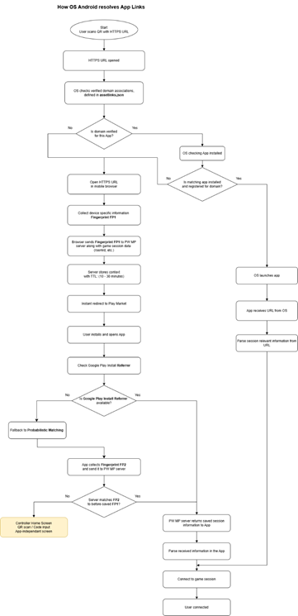
Direct Deep Link Handling
- Uses App Links with assetlinks.json
- If verified app is installed:
  - Opens via Intent
  - App extracts parameters and connects

Deferred Deep Linking Strategy (Android Advantage)
Android supports deterministic recovery:
Stage 1: Install Referrer (Primary)
- Retrieve data via Google Play Install Referrer API
- If valid → direct context recovery (no guessing)

Stage 2: Probabilistic Matching (Fallback)
- Generate FP2
- Match against stored FP1

Stage 3: Manual Recovery
- If all else fails → fallback to:
  - Controller Home Screen

Key Platform Difference
- Android: deterministic → probabilistic → manual
- iOS: probabilistic → manual only

3.3 Fingerprinting System (Context Recovery Mechanism)
This section describes how the system preserves and restores user session context when a direct data transfer is not possible, such as during app installation. Since some platforms (especially iOS) do not provide a reliable way to pass data through the install process, a fingerprinting-based approach is used to reconnect the user with their original session.

3.3.1 Context Preservation & Recovery Flow
When a user opens a game link but does not yet have the MRC app installed, the original session data (e.g., roomId) cannot be passed directly to the application. To solve this, the system temporarily stores the session context on the PW BE and later attempts to restore it after installation.
Flow overview:
- User opens a link (QR / URL) in the browser
- Session data (e.g., roomId) is extracted
- FP1 (pre-install fingerprint) is generated and sent to PW BE
- Data is temporarily stored on backend (with TTL)
- User installs and opens the app
- FP2 (post-install fingerprint) is generated in the app
- FP2 is sent to PW BE for matching
- If matched → session data is returned → user continues flow
- If not → fallback to Controller Home Screen

3.3.2. Fingerprint Data Collection
This section defines what data is collected before and after installation.
Pre-Install Fingerprint (FP1)
Generated in the browser when the user opens the link.
Typical data includes:
- Device & OS information
- User-Agent
- IP address (or hashed)
- Approximate location
- Browser/session identifiers
- Timestamp
This data is sent to PW BE together with session context.

Post-Install Fingerprint (FP2)
Generated in the app on first launch after installation.
Typical data includes:
- Device model and OS version
- App version / SDK version
- IP address and network type
- Installation / first launch timestamp
- Locale and timezone
- Optional identifiers (if permitted)
This data is sent to PW BE to retrieve stored context.

3.4 Matching Logic & Constraints
This section describes how the PW BE matches pre-install and post-install fingerprints (FP1 and FP2) to restore the user’s original session context (e.g., roomId).
Since deterministic identification is not always available (especially on iOS), the system relies on a probabilistic matching approach, where multiple signals are compared and evaluated to determine the likelihood that FP1 and FP2 belong to the same user. The purpose is to determine the proper user which.

3.4.1 Matching Logic Overview
1. Candidate Selection
· Retrieve all stored FP1 records within a defined time window (TTL)
· Filter candidates by basic criteria (e.g., platform, app version if available)
2. Similarity Evaluation
· Compare FP2 against each candidate FP1 using multiple signals
3. Scoring
· Assign a weighted score based on similarity across key attributes
4. Best Match Selection
· Select the candidate with the highest score above a defined threshold
5. Context Recovery
· If a valid match is found → return associated session data (roomId)
· If no match meets the threshold → no data is returned

3.4.2. Key Matching Signals
The following signals are used to evaluate similarity:
- Time Proximity (Critical)
  - Difference between FP1 creation and FP2 creation
  - Strongest indicator of correlation
- Network Similarity
  - IP address or hashed IP
  - Approximate geographic location
- Device Characteristics
  - OS type and version
  - Device model (if available)
- Environment Consistency
  - Timezone
  - Locale / language
Each signal contributes to the overall confidence score with different weights.

3.4.3 Scoring Strategy
- Matching is based on a weighted scoring model
- Higher weight is assigned to:
  - Time proximity
  - Network similarity
- Lower weight is assigned to:
  - Device and environment signals
A match is considered valid only if:
- The total score exceeds a predefined threshold
- No conflicting signals are detected

3.4.4 Constraints & Limitations
The matching process is subject to several constraints:
- Privacy Restrictions
  - Limited access to unique identifiers (ATT, GDPR)
  - No cross-app tracking on iOS
- Network Variability
  - IP address may change between browser and app launch
  - Use of VPN or mobile networks reduces accuracy
- Device Ambiguity
  - Multiple devices with similar characteristics
- Time Sensitivity
  - Matching is only reliable within a short time window

3.4.5 Fallback Behavior
If no reliable match is found:
- The backend does not return any session data
- The application falls back to Controller Home Screen
- The user must manually reconnect (QR scan or code input)

4 MRC System Architecture
This section defines the internal architecture of the React Native application, including component structure, state flow, UI rendering, and built-in application-level screens that operate independently of game-specific configurations.

4.1 Architecture Overview
The MRC client is designed as a server-driven UI system, where:
- UI is fully defined by JSON configuration
- Components are dynamically instantiated at runtime
- State is synchronized via WebSocket

Key Principles:
- No hardcoded UI layouts
- High flexibility and scalability
- Clear separation of concerns

The diagram below shows the high-level MRC architecture and component interaction flow.
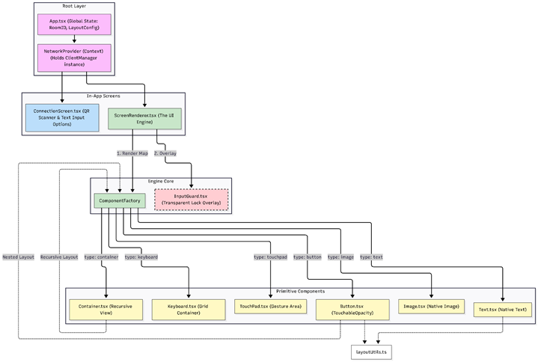

4.2 UI Architecture Model
The application UI is divided into two main categories:
1 Game-Driven Screens (Dynamic)
- Defined via .json configuration from backend
- Rendered through ScreenRenderer + ComponentFactory
- Fully customizable per game

2 Application-Level Screens (Engine-Controlled)
- Built directly into the MRC client
- Not controlled by backend layout configs
- Handle system states and user entry flows

4.3 Application Layers & Responsibilities

4.3.1 Root Layer (Application Core)
App.tsx – Application Bootstrap & Global State
Responsibilities:
- Global State Holder: Manages active RoomID and LayoutConfig
- Lifecycle Management: Handles splash screen and asset preloading
- Environment Lock: Enforces landscape mode and error boundaries

NetworkProvider (Context) – Network Communication Layer
Responsibilities:
- Holds ClientManager instance
- Manages WebSocket lifecycle
- Provides network context to all screens

4.3.2 Screen Layer (User-Facing Interfaces)
ConnectionScreen.tsx – Entry & Discovery
Responsibilities:
- Initial user entry point
- QR code scanning
- Manual room code input

ScreenRenderer.tsx – UI Engine
Responsibilities:
- Parses layout configuration
- Builds render map
- Controls InputGuard overlay

4.3.3 Rendering Engine Core
ComponentFactory – Dynamic Component Instantiation
Responsibilities:
- Maps JSON nodes to React Native components
- Handles recursive rendering for nested layouts
InputGuard.tsx – Interaction Control Overlay
Responsibilities:
- Blocks user interaction when required
- Used during loading or server-enforced locks

4.3.4 UI Component Layer (Primitive Components)
Dynamically instantiated UI building blocks:
- Container.tsx – Layout grouping and nesting
- Button.tsx – Interactive element with nested layouts
- Text.tsx – Text rendering
- Image.tsx – Image rendering
- Keyboard.tsx – Virtual input grid
- TouchPad.tsx – Gesture input (swipe, drag, tap)

4.3.5 Utility & Service Layer
layoutUtils.ts – Layout Engine
- Converts logical layout → device pixels
- Handles scaling and positioning

ClientManager.ts – WebSocket Manager
- Manages connection lifecycle
- Handles serialization and reconnection

app.json – Native Configuration
- Defines build settings
- Controls splash screen and system UI

4.4 Application-Level Screens
These screens are built into the application and are not part of server-driven UI.
They handle:
- Application lifecycle
- Connection management
- Error recovery
- User onboarding

4.4.1 Core Screens
Controller Home Screen (Entry & Recovery)
- QR code scanner
- Manual code input
- Used for:
  - Initial entry
  - Recovery after failed deep linking
  - Reconnection

Splash Screen (Initialization State)
- Displayed during app startup
- Covers:
  - Asset loading
  - Configuration fetch
  - Network initialization

4.4.2 Error Handling Screens
Connection Error Screen / Popup
Triggers:
- WebSocket disconnect
- Server unreachable
- Timeout
Behavior:
- Show error message
- Retry option
- Optional auto-reconnect

Invalid Room / Join Error Screen
Triggers:
- Invalid room code
- Expired session
- Server rejection
Behavior:
- Display error
- Allow retry (QR or manual input)

Configuration / JSON Error Screen
Triggers:
- Invalid JSON
- Missing layout
- Version mismatch
Behavior:
- Show fallback UI
- Log error
- Allow retry or fallback

4.5 Data Flow & Rendering Pipeline
1. Server sends initial layout/configuration via WebSocket
2. Client stores configuration in global state
3. ScreenRenderer parses the configuration
4. ComponentFactory builds the component tree
5. UI is rendered dynamically
6. Game state updates are sent from the game via backend to the MRC
- Server pushes updates (e.g., component state, text, visibility)
- Client applies updates to existing UI components
7. User interactions are sent back to the server via WebSocket

4.6 Key Architectural Benefits
- Dynamic UI – fully server-controlled
- Platform consistency – shared logic across devices
- Scalability – easy to extend components
- Resilience – robust network handling

5 UI Engine & Component Library
This section describes the UI rendering system and the set of reusable components used to build the Mobile Remote Controller interface. All UI elements are dynamically generated based on server-provided configuration, allowing flexible and game-specific layouts without client updates.

5.1 Available Components
The following core components are supported by the UI engine:
Component | Purpose | Key Features
Button | Interactive button element | Focus states, textures, click events, navigation
TouchPad | Gestural & continuous input area | Multi-touch support, swipe/drag tracking, tap detection, real-time coordinate streaming
Container | Layout grouping element | Nested layouts, positioning, clipping, styling
Text | Text display element | Dynamic content, styling, positioning
Image | Image display element | Texture loading, positioning, caching
Keyboard | Virtual keyboard input | Text input handling, character events (QWERTY if needed)

5.2 Component Properties
All UI components are defined and configured via server-provided JSON. Each component shares a common set of base properties, with additional properties depending on its type.

5.2.1 Common Properties (All Components)
- type (string) — Component type (button, text, image, container, keyboard)
- id (string, optional) — Unique identifier for state updates
- anchor (array[number, number]) — Anchor point for positioning [x, y]
- position (array[number, number]) — Position offset relative to anchor
- size (array[number, number], optional) — Width and height
- rotate (number, optional) — Rotation in degrees
- scaleX / scaleY (number, optional) — Scaling factors
- visible (boolean, optional) — Visibility control
- style (object, optional) — Styling properties (CSS-like)

5.2.2 Button
- action (string, optional) — Action triggered on press
- keyCode (string, optional) — Hardware/navigation key code
- content (string, optional) — Button label
- texture (string) — Default background image
- states (object, optional) — State-based overrides:
  - normal
  - pressed
  - disabled

Each state may include:
- texture (string)
- scale (number)
- style (object)
- layout (array, optional) — Nested components (for composite buttons)

5.2.3 Text
- content (string) — Text value
- style (object) — Includes:
  - color, fontSize, fontFamily, fontWeight
  - textAlign, width, etc.

5.2.4 Image
- texture (string) — Image source (URL/path)
- style (object, optional) — Additional visual styling (opacity, tint, etc.)

5.2.5 Container
- layout (array) — Child components
- Used for grouping and nesting UI elements

5.2.6 Keyboard
- states (object) — Same structure as button states
- keySize (array[number, number]) — Size of individual keys
- size (array[number, number]) — Overall keyboard size

6 Network Communication Protocol
The system uses a WebSocket-based, event-driven protocol to synchronize state and UI between the PW BE and the Mobile Remote Controller (MRC) client.
All communication is performed via structured messages, where each message contains a type and a corresponding data payload.

6.1 Message Types
This section defines the WebSocket message types used for communication between the backend/game server and the MRC client.
Messages are divided into two groups:
- Server → MRC Client — updates UI, screen state, connection state, and feedback
- MRC Client → Server — sends user interactions back to the game/backend

6.1.1 Server → MRC Client Messages
SET_SCREEN
Transitions the MRC client to a new screen and optionally provides initial component state.
{
"type": "SET_SCREEN",
"data": {
"screenId": "CONTROL_SCREEN",
"components": {
"player_name": {
"content": "John"
},
"fire_btn": {
"disabled": false
}
}
}
}

UPDATE_COMPONENTS
Updates properties of components on the currently active screen.
{
"type": "UPDATE_COMPONENTS",
"data": {
"components": {
"server_message": {
"content": "Wrong code!",
"style": {
"color": "white",
"fontSize": 60
}
},
"submit_btn": {
"disabled": true
},
"fire_btn": {
"visible": true
},
"avatar": {
"texture": "avatar.png"
}
}
}
}

UPDATE_COMPONENTS with patches
Updates the same properties for multiple components at once.
{
"type": "UPDATE_COMPONENTS",
"data": {
"patches": [
{
"target": {
"ids": ["btnHint", "btnVowel", "btnSolve"]
},
"props": {
"disabled": true,
"style": {
"opacity": 0.6
}
}
}
]
}
}

gameState
Synchronizes the full game state, typically after reconnection or full state restore.
{
"type": "gameState",
"data": {
"state": {
"controllerConfigURL": "https://example.com/layout.json",
"data": {
"screenId": "CONTROL_SCREEN",
"components": {
"player_name": {
"content": "Player 1"
},
"money": {
"content": "$500"
}
}
}
}
}
}

TRIGGER_HAPTICS
Triggers local vibration feedback on the mobile device.
{
"type": "TRIGGER_HAPTICS",
"data": {
"duration": 400
}
}

Alternative with vibration pattern:
{
"type": "TRIGGER_HAPTICS",
"data": {
"pattern": [0, 100, 50, 100]
}
}

SHOW_ERROR
Displays an error message to the user.
{
"type": "SHOW_ERROR",
"data": {
"message": "Wrong code"
}
}

6.1.2 MRC Client → Server Messages
keyDown
Sent when a button mapped to keyCode is pressed.
{
"type": "keyDown",
"data": {
"keyCode": "Down"
}
}

keyUp
Sent when a button mapped to keyCode is released.
{
"type": "keyUp",
"data": {
"keyCode": "Up"
}
}

action
Sent when a button with a custom action is triggered.
{
"type": "action",
"data": {
"id": "submit_btn"
"action": "submit"
}
}

6.1.3 Runtime Update Rules
- components is a key-value map where the key matches the component id.
- Component updates are merged into the current screen state.
- patches allow updating multiple components at once.
- Nested objects such as style are shallow-merged instead of fully replaced.
- Relative texture or src values are resolved using settings.assetsBaseUrl.
- If a component is not currently rendered, the update may be stored but will only affect UI when that component appears.

7 UI Configuration Specification (JSON Schema & Component Definitions)
This section defines all supported configuration options for the server-driven UI system used by the Mobile Remote Controller (MRC). It describes the structure of the layout.json file, supported component types, and all available properties.

7.1 Global Configuration
The root object defines application-wide settings and entry point.
{
"clientVersion": "1.0.0",
"settings": { ... },
"fonts": { ... },
"background": { ... },
"initialScreen": "SCREEN_ID",
"templates": { ... }
"screens": { ... }
}

Properties
- clientVersion (string) — Version of the UI configuration
- settings (object) — Application-level behavior:
  - orientation — Screen orientation (e.g., landscape)
  - keepAwake — Prevent device sleep
  - useSafeArea — Enable safe area handling
  - assetsBaseUrl — Base URL for assets
- fonts (object) — Custom font mapping (name → URL)
- background.texture (string) — Default background image
- initialScreen (string) — Initial screen ID
- templates (object) — Define reusable UI blocks that can be referenced from multiple screens. This helps avoid repeating the same component structure, such as avatar groups or shared navigation buttons.
- screens (object) — Screen definitions

templates:
define reusable UI blocks that can be referenced from multiple screens. This helps avoid repeating the same component structure, such as avatar groups or shared navigation buttons.

"templates": {
"AVATAR_GROUP": {
"type": "container",
"size": [60, 60],
"layout": [ ... ]
},
"BACK_BUTTON": {
"type": "button",
"keyCode": "Backspace",
"texture": "back_btn.png"
}
}

Parameters:
- template key (string) — Unique template name, e.g. AVATAR_GROUP
- type (string) — Base component type rendered by the template
- layout (array, optional) — Nested child components
- Any standard component properties may be defined inside a template
Templates are declared globally and instantiated inside screens using type: "template" and templateId.

7.2 Screen Definition
{
"SCREEN_ID": {
"layout": [ ... ]
}
}

7.3 Common Component Properties
All components share the following base properties:
Property | Type | Description
type | string | Component type (button, text, image, container, keyboard, template)
id | string | Unique identifier (used for updates)
templateId | string, template only | Reference to a reusable template defined in the global templates object
position | [x, y] | Offset relative to anchor
size | [w, h] | Width and height
anchor | [x, y] | Pivot point (0–1 range)
rotate / rotation | number | Rotation in degrees
scale, scaleX, scaleY | number | Transform scaling
visible | boolean | Visibility control
style | object | React Native styles

7.4 Component Types

7.4.1 Container
Used for grouping and nesting UI elements.
Properties:
- layout (array) — Child components
Behavior:
- Acts as a coordinate system for children
- Supports flexbox layout and transformations

7.4.2 Image
Displays textures from assets or dynamic sources.
Properties:
- texture (string) — Image source
- style (object) — Includes:
  - opacity
  - borderRadius
  - tintColor
  - objectFit
Transformations:
- Supports scaleX, scaleY, scale, rotation

7.4.3 Text
Displays dynamic or static text.
Properties:
- content (string) — Text value
- style (object):
  - fontSize, color, fontFamily
  - textAlign
  - fontWeight, fontStyle
  - textShadow*
Behavior:
- Supports dynamic updates from server
- Scales automatically based on device resolution

7.4.4 Button
Interactive component supporting actions and states.
Core Properties:
- action (string) — Custom event trigger
- keyCode (string) — Navigation/input mapping
- content (string) — Button label
- texture (string) — Default background
Interaction Features:
- haptic (string) — Local vibration feedback
- autoRepeat (boolean) — Continuous input
- repeatInterval (number) — Repeat timing
- hitbox (number) — Extended touch area
State System:

"states": {
"normal": {},
"pressed": {},
"disabled": {}
}

Each state may define:
- texture
- scale
- style
Behavior:
- Handles press, hold, and release events
- Supports nested layouts (composite buttons)

7.4.5 Keyboard
The keyboard component generates a configurable grid of interactive buttons. It can be used for letter keyboards, numeric input, vowel selection, or custom action rows. By default, if rows array not defined, keyboard looks as QWERTY.

{
"type": "keyboard",
"anchor": [0.5, 0.5],
"position": [0, 30],
"gapX": 10,
"gapY": 10,
"keySize": [60, 70],
"rows": [
["Q", "W", "E", "R"],
[
{
"id": "Pass",
"action": "Pass",
"content": "Pass",
"size": [100, 70]
},
"A",
"B"
]
],
"states": {
"normal": {
"texture": "keyboard_letter_btn.png"
},
"pressed": {
"texture": "keyboard_letter_btn_focused.png",
"scale": 0.95
}
}
}

Properties:
- rows (array) — Defines keyboard rows
- keySize (array[number, number]) — Default key size
- gapX (number, optional) — Horizontal spacing between keys
- gapY (number, optional) — Vertical spacing between rows
- states (object, optional) — Default button states for generated keys
- disabled (boolean, optional) — Disables all generated keys
- keyStyle (object, optional) — Default style applied to generated keys
- size (array[number, number], optional) — Overall keyboard container size
Row item types:
- String key
  - Automatically creates a button
  - id, content, and action are generated from the string value
- Object key
  - Allows a fully customized button inside the keyboard
  - Can override id, action, content, size, states, style, etc.
Behavior:
- Each key is rendered internally as a Button
- Default keyboard states are applied to generated keys
- Custom key objects can override default behavior
- Server updates can target individual keys by their id

7.5 State System (states)
Used for dynamic visual behavior of interactive components.
"states": {
"normal": { ... },
"pressed": { ... },
"disabled": { ... }
}
Supported properties:
- texture
- scale
- style
Behavior:
- Automatically switches based on interaction state
- Overrides base properties

7.4.6 Template
The template component is used to render a predefined reusable UI block from the global templates section.
It allows commonly repeated UI elements to be defined once and reused across multiple screens with optional overrides.
{
"type": "template",
"id": "avatar_group",
"templateId": "AVATAR_GROUP",
"anchor": [0, 0],
"position": [25, 30],
"size": [60, 60]
}

Properties:
- type (string) — Must be template
- id (string, optional) — Instance identifier
- templateId (string, required) — Reference to a template from the global templates object
- anchor (array, optional) — Instance anchor override
- position (array, optional) — Instance position override
- size (array, optional) — Instance size override
- Any supported component property can override the base template definition
Behavior:
- The engine looks up the referenced template by templateId
- Template properties are merged with instance-level overrides
- The final rendered component uses the original component type from the template definition
- If templateId is missing or not found, the component is not rendered

8 Key Technical Features

8.1 Focus Management System
- Grid-based navigation (up, down, left, right).
- Automatic focus calculation using layoutUtils.
- Visual feedback for focused elements.

8.2 Asset Preloading
- Images and fonts preloaded on layout fetch
- Prevents UI flickering
- Improves the overall user experience

8.3 Dynamic Component Rendering
- Components instantiated exclusively from JSON definitions.
- No hard-coded UI structure.
- Fully configurable interfaces dynamically controlled by the server.

8.4 Network Resilience
- Robust WebSocket connection management.
- Automatic reconnection logic (managed by ClientManager).
- Event queuing during disconnection to ensure no interactions are lost.

9 Open Questions & Decisions Required
This section outlines key product and UX decisions that require alignment with management before finalizing implementation.

9.1 Controller Home Screen – Input Methods
Question:
Should the Controller Home Screen support manual room code input in addition to QR code scanning?
Context:
- QR scanning provides the primary, fastest entry method
- Manual input serves as a fallback when QR is unavailable or fails
Need additional implementation from FW and PW MP backend.

9.2 “Tap To Connect” Screen
Question:
Is the “Tap To Connect” screen required in the native MRC application after QR scan?
Context:
- This screen was previously required in the web-based MRC (for mobile Browsers) to:
  - Enable user interaction
  - Ensure fullscreen engagement
- In native mobile apps, interaction and fullscreen behavior are handled differently
Decision needed:
- Keep it
- Or remove to streamline user experience

9.3 Controller Home Screen – Look & Feel
Question:
What is the desired look & feel (L&F) for the Controller Home Screen?
Scope:
- Layout and visual design
- Branding and styling guidelines

Context:
This screen serves as the primary entry and fallback point, making it critical for first impressions and usability.

