Logical Pixels — Complete Explanation
What Is a Pixel?
Before diving into logical pixels, it helps to understand what “pixel” actually means in different contexts.
A physical pixel is a single light-emitting dot on the screen hardware — the smallest unit the display can actually illuminate. A 1080p screen has exactly 1,920 × 1,080 of them.
A logical pixel (also called a CSS pixel, point, or dp depending on the platform) is an abstract, software-defined unit that does not directly correspond to a physical dot on the screen. It is a measurement of visual size, not hardware resolution.

The Problem: Screen Density
In the early days of mobile (pre-2010), every phone had roughly the same low-density screen. One physical pixel ≈ one visible dot, and coordinates mapped directly.
Then high-density (Retina, AMOLED, etc.) screens arrived. Manufacturers started packing dramatically more physical pixels into the same physical area to make images look sharper. This created a fundamental problem:
A button defined as 80 × 80 pixels now renders at physically the same size — but because there are now 2× or 3× more dots per millimeter, the button appears tiny on the new display.
Real Example
Imagine two phones with the same physical screen size (~5 inch diagonal):
Device | Physical Resolution | Pixels per inch (PPI) | DPR
Old budget phone | 480 × 854 | ~196 PPI | 1x
Modern flagship | 1080 × 1920 | ~441 PPI | 3x
If you place a button at size: [80, 80] in physical pixels:
- On the budget phone → button is 80 physical px wide → looks normal
- On the flagship → button is still 80 physical px wide → but at 441 PPI, this is only ~4.6mm wide — impossibly small to tap
The same UI breaks on different hardware. This was a real, industry-wide crisis.

The Solution: Device Pixel Ratio (DPR)
The solution adopted by Apple (iOS), Google (Android), and the Web is to introduce a scaling layer between software coordinates and hardware pixels.
Each device reports a Device Pixel Ratio (DPR) — how many physical pixels correspond to one logical pixel:
Physical Pixels = Logical Pixels × DPR
DPR | Meaning | Common on
1x | 1 logical px = 1 physical px | Old/budget devices, most desktops
1.5x | 1 logical px = 1.5 physical px | Mid-range Android
2x | 1 logical px = 2 physical px | iPhone SE, most mid-range phones
2.625x | 1 logical px = 2.625 physical px | Samsung Galaxy S series
3x | 1 logical px = 3 physical px | iPhone Pro, high-end Android
3.5x | 1 logical px = 3.5 physical px | Some ultra-high-density Android
Now developers write coordinates in logical pixels, and the OS/engine multiplies by DPR automatically before sending pixels to the display hardware.

How the Viewport Shrinks
The practical effect is that the logical viewport (the coordinate space you work in) is smaller than the physical screen resolution:
Logical Viewport Width = Physical Width ÷ DPR
Logical Viewport Height = Physical Height ÷ DPR
Common devices in landscape mode
Device | Physical (landscape) | DPR | Logical Viewport
iPhone SE (2022) | 1334 × 750 | 2x | 667 × 375
iPhone 14 | 2532 × 1170 | 3x | 844 × 390
iPhone 15 Pro Max | 2796 × 1290 | 3x | 932 × 430
Samsung Galaxy S23 | 2340 × 1080 | 2.625x | ~892 × 411
Google Pixel 7 | 2400 × 1080 | 2.625x | ~914 × 411
iPad Air (landscape) | 2360 × 1640 | 2x | 1180 × 820
Notice: even though flagship phones have very different physical resolutions, their logical viewports are surprisingly similar (~390–430 logical px wide in portrait). This is intentional — it makes layout much more predictable.

Visual Comparison
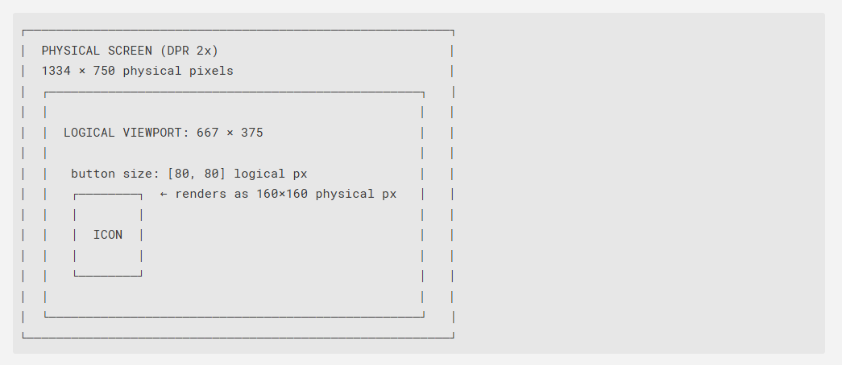The button is always 80 logical px, but the engine renders 80 × DPR actual physical dots — making it sharp at any density.

Why This System for layout.json
The layout engine in this project is built on React Native, which uses logical pixels natively. This means:
- You always work in logical pixels. You never touch physical pixels or DPR — the engine handles everything.
- One layout file works on all devices. No need to write separate layouts for iPhone vs. Android vs. tablet.
- Sizes feel intuitive. size: [80, 80] is roughly ~13mm across on any phone, which is a comfortable tap target.
- Text, gaps, and borders scale correctly. fontSize: 30 will look the same size on a budget Android and an iPhone Pro.

What 1 Logical Pixel Looks Like Physically
A useful mental model: 1 logical pixel ≈ 0.16mm on most phones.
Logical Size | Approx. Physical Size | Typical Use
44 lp | ~7mm | Minimum comfortable tap target
60–80 lp | ~10–13mm | Standard button
100–120 lp | ~16–19mm | Large/primary button
200+ lp | ~32mm+ | Full-width elements, backgrounds
Apple’s Human Interface Guidelines and Google’s Material Design both recommend a minimum touch target of 44–48 logical pixels for accessibility.

Relationship to Other Platforms
Logical pixels in React Native are the same concept across all major platforms — just different names:
Platform | Name for Logical Pixel
React Native | logical pixel (unitless number)
iOS (Swift/ObjC) | point (pt)
Android (XML) | density-independent pixel (dp / dip)
Web (CSS) | CSS pixel (px)
Flutter | logical pixel
They all describe the same idea: a unit of visual measurement independent of screen density.

Summary
Concept | Physical Pixel | Logical Pixel
What it is | Hardware dot on screen | Abstract software unit
Depends on device | Yes — varies with resolution | No — consistent across devices
Who uses it | Display driver, GPU | Developer, layout engine
Relation | physical = logical × DPR | logical = physical ÷ DPR
In layout.json | Never used directly | Used for ALL sizes and positions
Bottom line: You write layout in logical pixels. React Native passes those values to the native layer, and the OS (CoreGraphics on iOS, Android’s rendering pipeline on Android) applies the DPR multiplication before the GPU draws physical pixels. Your UI looks identical in size and proportion on every supported device — without you ever dealing with DPR directly.

