Technical Design Document: React Mobile Remote Controller Engine

1. Project Overview

Project Name: React Native MRC (Mobile Remote Controller)
Technology Stack:
- Framework: React Native (Expo SDK 52+)
- Language: TypeScript (TS/TSX)
- Bundler: Metro
- Network: WebSocket
- State Management: React Hooks (useState, useEffect, useContext)

2. User Flows & Deep Linking Methods
This section defines the entry points into the application, mapping out the connection flow from a physical touchpoint (QR code) to active gameplay.

2.1 Generic Flow Diagram

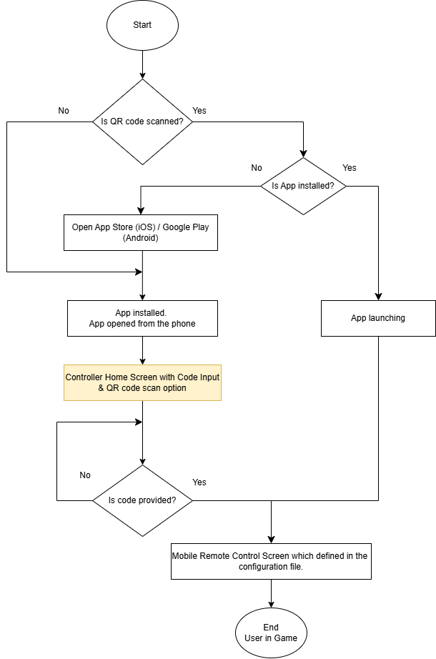

2.2 Detailed Flow Diagram
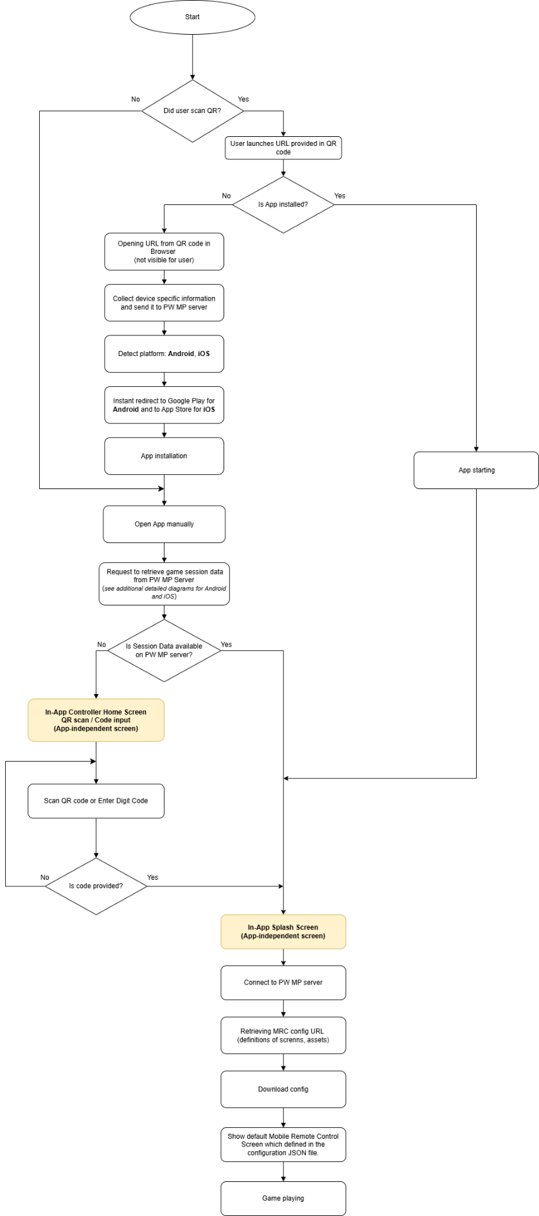

2.3 OS-Level Deep Link Resolution with Deferred Matching (iOS vs Android)
Detailed flow diagram for Android
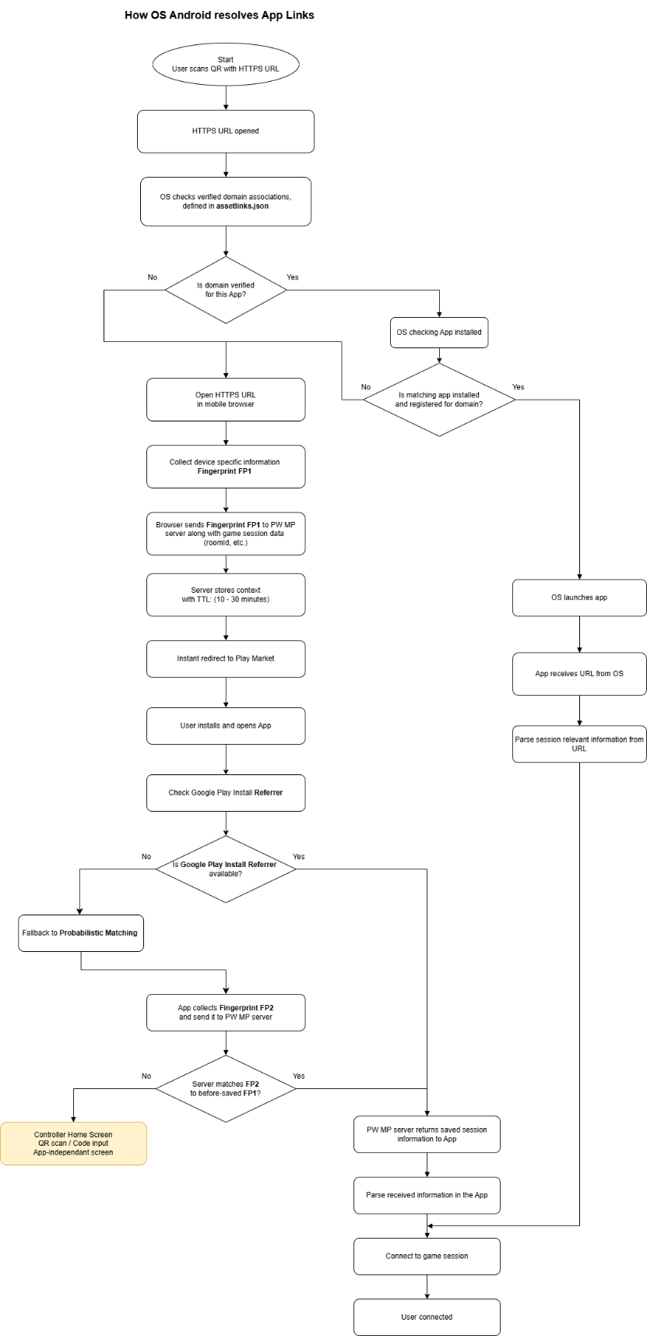

Detailed flow diagram for iOS
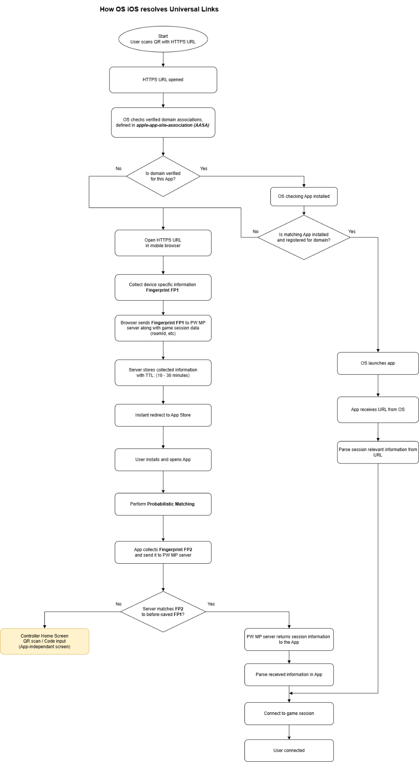

2.3.1. iOS Implementation (Universal Links + Deferred Matching)
On iOS, Universal Links rely on a strict domain-to-application trust relationship defined via the apple-app-site-association (AASA) file. When a user opens an HTTPS URL, the system evaluates whether the domain and path are associated with a locally installed application.
If the association is valid and the application is installed, the OS launches the app directly and delivers the URL via NSUserActivity. The application receives the full context and proceeds with parsing (e.g., extracting roomId) and initiating the session.
If the application is not installed, the OS falls back to Safari. From this point forward, the operating system is no longer involved in routing decisions, and all continuation logic is handled at the application and backend level.
Deferred Deep Linking on iOS
When the user lands in the browser, the system initiates a context preservation flow implemented via backend services.
The web layer captures a first fingerprint (FP1) along with the contextual payload (e.g., roomId) and stores it temporarily on the server.
After the user installs and launches the app, the application generates a second fingerprint (FP2) and attempts to resolve previously stored context.
Because iOS does not provide a deterministic install referrer mechanism, matching relies entirely on:
- Probabilistic matching (FP1 ↔ FP2)
If a match is successfully established, the backend returns the stored context to the application, allowing it to resume the intended flow as if it had been launched via a direct deep link.
If probabilistic matching fails (due to insufficient signal overlap, privacy constraints, or expiration), the application falls back to:
Controller Home Screen (QR scan / Code input)
This represents the final recovery state when no deferred context can be restored.

2.3.2. Android Implementation (App Links + Multi-Stage Deferred Resolution)
On Android, App Links operate through intent-based routing combined with domain verification via assetlinks.json. When a user opens an HTTPS URL, the system evaluates whether a verified application is capable of handling the link.
If a verified app is installed, it is launched directly and receives the URL via an Intent. The application extracts the required parameters and proceeds with connection logic.
If the app is not installed, the system opens the URL in the browser, initiating the deferred flow.
Deferred Deep Linking on Android
Android supports a more deterministic recovery mechanism through the Google Play Install Referrer API, which allows retrieving install attribution data after installation.
When the user reaches the web layer, the system captures:
- FP1 (browser-side fingerprint)
- Context payload (e.g., roomId)
After installation and first launch, the application attempts to resolve context using a multi-stage strategy:
Resolution Strategy (Android)
1. Google Play Install Referrer (Primary)
The app queries the Play Store for install referrer data.
- If available and valid:
  - Context is recovered deterministically
  - No probabilistic matching required
2. Probabilistic Matching (Fallback)
If Install Referrer is unavailable, missing, or incomplete:
- The app generates FP2
- Backend attempts to match FP2 against stored FP1
3. Final Fallback
If probabilistic matching fails:
The app navigates to Controller Home Screen (QR scan / Code input)
Key Difference vs iOS
- Android: deterministic → probabilistic → manual fallback
- iOS: probabilistic → manual fallback only

2.3.3. Fingerprinting Strategy (FP1 & FP2)
The effectiveness of deferred deep linking depends heavily on the quality and consistency of the fingerprinting signals.
FP1 (Browser-Side Fingerprint)
Collected in the web layer before redirecting to the store.
Should include:
Device & Environment
- User-Agent string
- OS type and version
- Device model (if available)
- Screen resolution
- Timezone
- Language / locale
Network Signals
- IP address (or hashed IP)
- Approximate geolocation (derived from IP)
Browser Context
- Cookies / local storage identifiers
- Session ID
- Referrer URL (QR source if available)
Timing
- Timestamp of interaction
- Session duration indicators

FP2 (App-Side Fingerprint)
Collected on first app launch after installation.
Should include:
Device & OS
- OS version
- Device model
- App version
- SDK version
Network Signals
- IP address (or hashed IP)
- Network type (WiFi / Cellular)
App-Specific Identifiers
- Installation timestamp
- First launch timestamp
- Advertising ID (if permitted)
- Vendor ID (iOS) / App Instance ID (Android)
Environment Consistency Signals
- Timezone
- Locale
- Device orientation / screen size

2.3.4. Matching Considerations
Matching FP1 ↔ FP2 should:
- Use weighted similarity scoring
- Account for:
  - Time proximity (critical)
  - IP / network similarity
  - Device consistency
- Respect privacy constraints (GDPR / ATT / Play policies)
TTL (e.g., 30 minutes) should be enforced to reduce false positives.

2.3.5. Summary of Resolution Logic
iOS
- Universal Link → direct app open if installed
- Otherwise:
  - Browser → FP1 captured
  - App launch → FP2 generated
  - Probabilistic match
  - Fallback → manual input screen
Android
- App Link → direct app open if installed
- Otherwise:
  - Browser → FP1 captured
  - Install → App launch
  - Try:
    - Play Referrer (deterministic)
    - Probabilistic match
    - Manual fallback

2.3.6. Final Insight
The OS itself does not solve deferred deep linking. It only performs:
- Domain trust validation
- App routing
Everything after browser fallback is a distributed system problem involving:
- Web layer
- Backend
- App runtime

3. System Architecture
To implement the above-mentioned flow this section outlines the React Native component architecture and core modules that drive the client application.

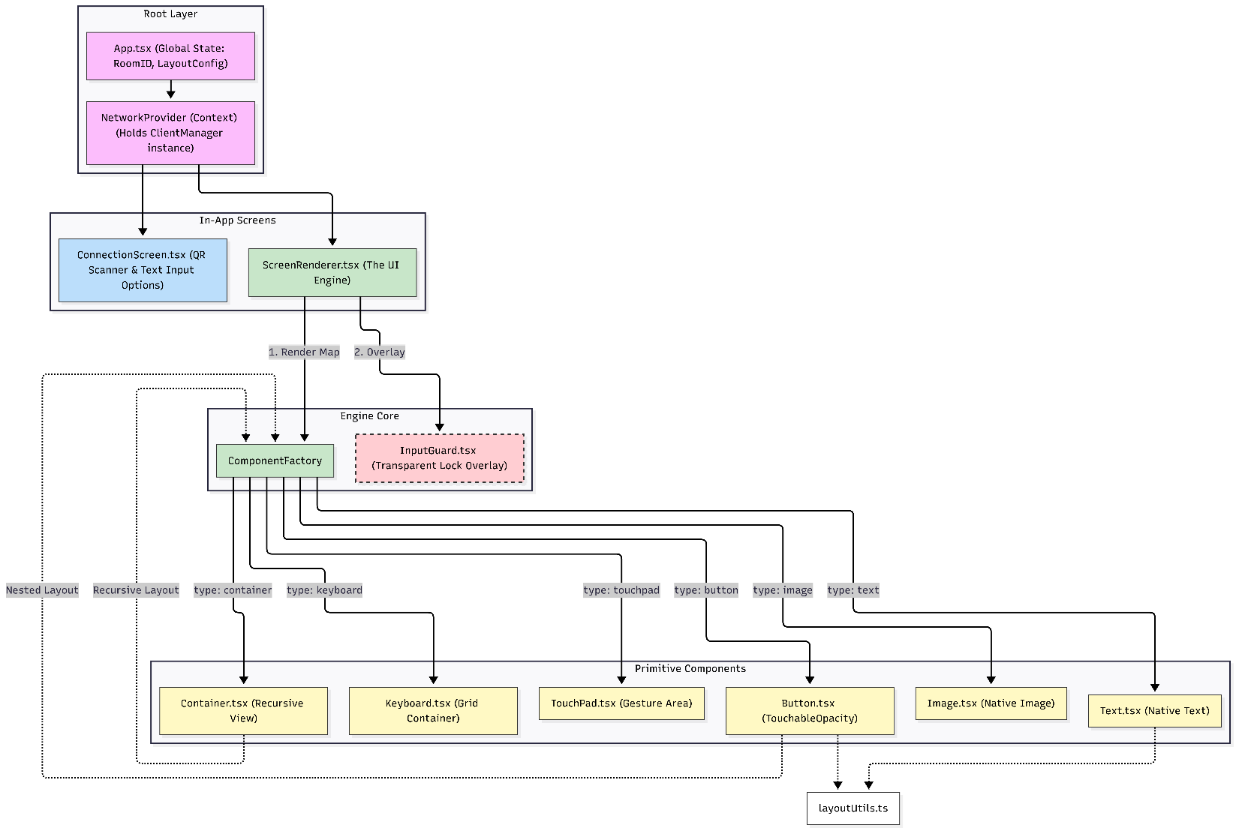

3.1 Core Components
1. Root Layer
- App.tsx - Application Bootstrap & Global State
  - Responsibilities:
    - Global State Holder: Manages the active RoomID and global LayoutConfig.
    - Lifecycle Management: Orchestrates Splash Screen and asset preloading.
    - Environment Lock: Enforces Landscape mode and handles application-level error boundaries.
- NetworkProvider (Context) - Network Communication Layer
  - Responsibilities:
    - Holds the ClientManager instance.
    - Manages the WebSocket connection lifecycle.
    - Wraps the application to provide network context to all underlying in-app screens.
2. In-App Screens
- ConnectionScreen.tsx - Entry & Discovery
  - Responsibilities:
    - Provides the initial interface for room connection.
    - Handles both QR Scanner integration and manual Text Input options for resolving the RoomID.
- ScreenRenderer.tsx - The UI Engine
  - Responsibilities:
    - Parses the active layout configuration.
    - Passes the "Render Map" down to the ComponentFactory for processing.
    - Controls the rendering of the InputGuard overlay when UI locks are required.
3. Engine Core
- ComponentFactory - Dynamic Component Instantiation
  - Responsibilities:
    - Acts as a central router that receives a configuration node and returns the corresponding React Native component based on its type property.
    - Handles recursive rendering (routing back to itself) for nested structures inside Container and Button components.
- InputGuard.tsx - Interaction Control Overlay
  - Responsibilities:
    - Renders a transparent lock overlay dynamically controlled by the ScreenRenderer to intercept and block user touches during loading states or server-enforced locks.
4. Primitive Components Instantiated dynamically by the ComponentFactory, these components represent the fundamental building blocks of the UI:
- Container.tsx: A recursive view element used for nesting and grouping layouts.
- Button.tsx: Uses TouchableOpacity for interactive elements. It acts as a container itself and supports recursive nested layouts.
- Text.tsx: A native text wrapper for displaying stylized string content.
- Image.tsx: A native image wrapper for rendering fetched textures.
- Keyboard.tsx: A grid container specifically designed for virtual text input handling.
- TouchPad.tsx: A dedicated gesture area for handling swipe/drag input from the user.
5. Utilities & Managers
- layoutUtils.ts - Layout Calculation Engine
  - Responsibilities: Called heavily by primitive components (like Button and Text) to convert logical JSON coordinates into device pixels (dp), process layout constraints, and handle scaling.
- ClientManager.ts - WebSocket Client Manager (Held by NetworkProvider)
  - Responsibilities: Establishes connections, handles serialization/deserialization, and executes reconnection logic.
- app.json - Native Configuration
  - Responsibilities: Defines build properties, Splash Screen setup, and OS-level view configurations (like hiding status/navigation bars).

4. UI Engine & Component Library

4.1 Available Components

Component | Purpose | Key Features
Button | Interactive button element | Focus states, textures, click events, navigation
TouchPad | Gestural & continuous input area | Multi-touch support, swipe/drag tracking, tap detection, real-time coordinate streaming
Container | Layout grouping element | Nested layouts, positioning, clipping, styling
Text | Text display element | Dynamic content, styling, positioning
Image | Image display element | Texture loading, positioning, caching
Keyboard | Virtual keyboard input | Text input handling, character events (QWERTY if needed)

4.2 Component Properties
The components are configured via the server state. Below are their standard properties:
- Button
  - disabled (boolean): Interaction state
  - visible (boolean): Visibility
  - content (string): Button text
  - texture (string): Normal state image URL/path
- Text
  - content (string): Text content
  - visible (boolean): Visibility
  - style (object): CSS-like properties
- Image
  - texture (string): Image URL/path
  - visible (boolean): Visibility

5. Network Communication Protocol
The system uses a WebSocket-based event-driven protocol to synchronize state and UI between the server and the React Native client.

5.1 Message Types
INIT_CONFIG Set a new screen with an optional initial state.
{
"type": "INIT_CONFIG",
"data": {
"config": { "... layout definitions ..." },
"screenId": "CONTROL_SCREEN"
}
}
SET_SCREEN Transitions to a new screen with an optional initial state.
- Parameters:
  - screenId (string, required): Screen ID from layout.json
  - components (object, optional): Initial component states

{
"type": "SET_SCREEN",
"data": {
"screenId": "CONTROL_SCREEN",
"components": {
"player_name": { "content": "John" },
"fire_btn": { "disabled": false }
}
}
}
UPDATE_DATA Update component properties on the currently active screen.
- Parameters:
  - components (object, required): Component updates

{
"type": "UPDATE_DATA",
"data": {
"components": {
"server_message": {
"content": "Wrong code!",
"style": { "color": "white", "fontSize": 60 }
},
"submit_btn": { "disabled": true },
"fire_btn": { "visible": true },
"some_img": { "texture": "https://...", "visible": true }
}
}
}
REQUEST_FULL_STATE_SYNC Request the current game state (e.g., after the application emerges from sleep).
{
"type": "REQUEST_FULL_STATE_SYNC",
"data": {
"... additional parameters if required ..."
}
}

7. Key Technical Features

7.1 Focus Management System
- Grid-based navigation (up, down, left, right).
- Automatic focus calculation using layoutUtils.
- Visual feedback for focused elements.

7.2 Asset Preloading
- Images and fonts preloaded on layout fetch.
- Prevents UI flickering.
- Improves the overall user experience.

7.3 Dynamic Component Rendering
- Components instantiated exclusively from JSON definitions.
- No hard-coded UI structure.
- Fully configurable interfaces dynamically controlled by the server.

7.4 Network Resilience
- Robust WebSocket connection management.
- Automatic reconnection logic (managed by ClientManager).
- Event queuing during disconnection to ensure no interactions are lost.

