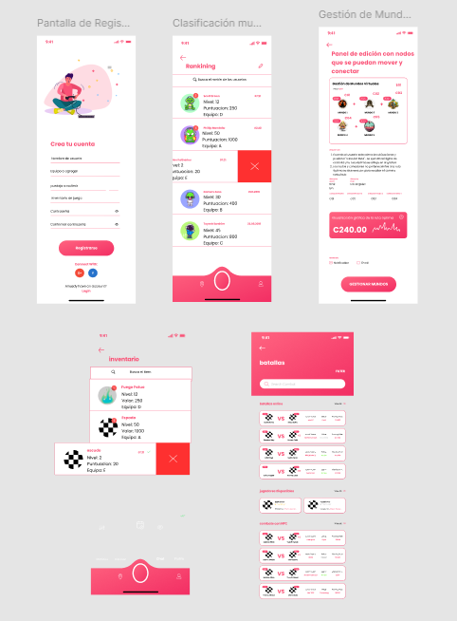

Link: <https://www.figma.com/design/WBSBWA6rEl7O6FhvKuXfE3/GAAMETIIME-MOBILE-UI-KIT-(Community)?node-id=34-3>

Link-video[: https://uniempresarial-my.sharepoint.com/personal/aguerreroh_uniempresarial_edu_co/_layouts/15/stream.aspx?id=%2Fpersonal%2Faguerreroh_uniempresarial_edu_co%2FDocuments%2FGrabaciones%2FPROYECTO%201-20241207_174736-Grabaci%C3%B3n%20de%20la%20reuni%C3%B3n%2Emp4&referrer=Teams%2ETEAMS-ELECTRON&referrerScenario=RecapOpenInStreamButton%2Eview%2Ecf9d145b-8ab9-40c2-8d8e-ccd59b130b8c](:%20https:/uniempresarial-my.sharepoint.com/personal/aguerreroh_uniempresarial_edu_co/_layouts/15/stream.aspx?id=%2Fpersonal%2Faguerreroh_uniempresarial_edu_co%2FDocuments%2FGrabaciones%2FPROYECTO%201-20241207_174736-Grabaci%C3%B3n%20de%20la%20reuni%C3%B3n%2Emp4&referrer=Teams%2ETEAMS-ELECTRON&referrerScenario=RecapOpenInStreamButton%2Eview%2Ecf9d145b-8ab9-40c2-8d8e-ccd59b130b8c)