IFL Sack Management System — User & IT Guide
Ibrahim Fibres Limited (IFL)
Version 0.2.0
2026-10-01
Confidential — IFL internal

Table of Contents
About this guide 5
Who this guide is for 5
Conventions used in this guide 5
Quick start 6
How to know it works 6
1 How SMS works 7
1.1 The big picture 7
1.2 The ~18-minute lag 7
1.3 Plant clock and computer clock 7
1.4 Source generations, in plain words 8
1.5 Glossary 8
2 What is in the package 9
2.1 What you receive 9
2.2 What is built on the server 9
2.3 What is not in the package 9
3 What IFL IT must provide 10
4 Installation, step by step 11
4.1 Prerequisites 11
4.2 Ask IFL's DBA for the read-only login 11
4.3 Create the app database and its logins 11
4.4 Create .env 11
4.5 npm ci and npm run build 12
4.6 Migrate 12
4.7 First admin account 12
4.8 Manager accounts 12
4.9 Windows services (NSSM) 13
4.10 Firewall 13
4.11 First connection to the plant: sync halts → epoch:accept → verify 13
4.12 Scheduled tasks 14
4.13 Wall display PC 14
5 Verification checklist 16
6 Configuration 18
6.1 The .env keys that matter 18
6.2 Setup page 18
6.3 Roles and what each can do 27
6.4 PDAS writes: what they are, why they are off, what enabling them requires 28
6.5 Optional TLS 28
7 Daily use 29
7.1 Signing in, the top bar and the period 29
7.2 Line: is it running right now? 32
7.3 Readings: every cone and every sack 34
7.4 Weight: are the cones the right weight? 38
7.5 Rejects: why are cones being rejected? 43
7.6 Sacks: how many sacks and what is in stock 46
7.7 Product: what is running, and how to change it 48
7.7.1 Running 49
7.7.2 Changeover 50
7.7.3 Catalogue 53
7.7.4 History 54
7.8 Report: printable and exportable reports 55
7.9 Wall: the fullscreen display 59
7.10 Health: is SMS itself working? 60
8 Troubleshooting 64
9 Maintenance 67
9.1 Backups and a restore test 67
9.2 Scheduled tasks 67
9.3 Retention 67
9.4 Database maintenance 68
9.5 Configuration backup 68
9.6 Logs and rotation 68
9.7 Restarting services 68
9.8 Upgrade and rollback 68
9.9 Health checks worth a glance 68
9.10 Loading the missing 10 July to 5 August data 68
9.11 Database size 69
10 Security 70
10.1 Logins and least privilege 70
10.2 Protecting .env 70
10.3 Password policy 70
10.4 Sessions 70
10.5 Roles 70
10.6 Audit log 70
10.7 TLS 71
10.8 Air-gapped operation 71
10.9 The separate PDAS writer 71
11 FAQ 72
12 Contacts and escalation 74
12.1 Escalation order 74
A Configuration keys 75
B Command reference 78
B.1 The CLI — node cli/dist/index.js <command> [flags] 78
B.2 npm scripts (from the package root) 79
B.3 sms\scripts\*.ps1 79
B.4 sqlcmd and Windows commands used during installation 79
C Known limitations 81
D Sign-off sheet 83
D.1 Installation 83
D.2 Verification 83
D.3 Sign-off 83

About this guide
This guide covers the IFL Sack Management System (SMS): a web application that reports on sack and cone production from IFL's TP1 Line 3 / Unit 2 yarn spinning line, built for Ibrahim Fibres Limited (IFL).

Who this guide is for
Two audiences share this book:
- IFL's IT staff, who install SMS on the plant PC, connect it to the SQL Server databases, keep it running, back it up, and troubleshoot it. Chapters 1 to 6 and 8 to 10, and appendices A and B, are written for this reader.
- Daily users — the GM, managers and process engineers of IFL's process department. Chapter 7 walks through each screen. Chapter 11 answers the questions this audience asks most often.
Both audiences are technical. SMS was built for one department, not a mix of floor staff and management, so every screen is written in plain, direct language rather than simplified for a non-technical reader.

Conventions used in this guide
- Text shown in bold that is quoted from the screen itself — a button, a menu item, a column header — is copied exactly, including capitalisation.
- A shaded box like the one below is a command to type exactly as shown, or output to expect back:
example command or output

- A numbered step is followed by "You should see: …", describing the result, and "If it fails, see …", pointing at the relevant troubleshooting entry.
- ☐ marks a checklist item to tick off as it is confirmed.
- A blue box marked Note: adds useful context. An amber box marked Warning: flags something that can lose data or lock an account out if skipped.
- Placeholder paths use C:\sms for the install folder and C:\sms-backups for the backup folder — substitute the real folders IT chose during installation if they differ.
Note: Every screenshot in this guide was taken from a demonstration system fed by a plant simulator that generates realistic but entirely synthetic readings, not IFL's real production data. Every screen the simulator feeds shows this in the wording itself — the provenance label reads Simulator and a sentence on screen states that the figures shown are the simulator's, not the plant's. The real, live installation will never show this banner or label — it appears only because these screenshots come from a demonstration, not because it is a normal part of the application.

Quick start
This is the fast path for someone who already has the package, SQL Server Express, and Node installed, and just needs SMS running so it can be tested. Chapters 3 and 4 give the full, detailed version of every step below, including what to do if a step fails.
- Create the app database and its SQL logins. Run db\bootstrap\00_create_app_database.sql against the app database server with sqlcmd, as described in section 4.3.
- Create .env. Copy .env.example to .env in the package root and fill in the database connection details, the read-only IFL login, and the other keys described in section 6.1.
- Build, migrate, and create the first admin account. Run npm ci && npm run build, then npm run db:migrate, then node cli/dist/index.js user:create with --role=admin, as described in section 4.5 and section 4.7.
- Start the services and connect to the plant for the first time. Start the API and sync-worker services (directly, or as Windows services once NSSM is set up — section 4.9), then run the first sync, accept the source generation with epoch:accept, and confirm with verify, as described in section 4.11.
- Sign in. Open the SMS web address in a browser and sign in with the admin account created in step 3.

How to know it works
- GET /api/health returns "status": "ok" (or an explainable "degraded" — see section 8).
- The Health screen turns green — its headline reads Everything is healthy. — within two sync passes of the plant connection being live.
- node cli/dist/index.js verify exits with no STOP lines and no weight mismatches.
If any of these do not hold, do not consider the installation finished — work through the relevant numbered installation step again before moving on to daily use.

1 How SMS works

1.1 The big picture
SMS is built from three long-running pieces, plus the app's own database. The plant's Siemens S7-1500 PLCs weigh every cone and every sack; a tag-acquisition layer IFL already runs writes those readings into two SQL Server databases (DATA_TP1U2 for weights and rejects, PDAS_TP1U2 for product/material master data). SMS never touches those databases except to read from them.
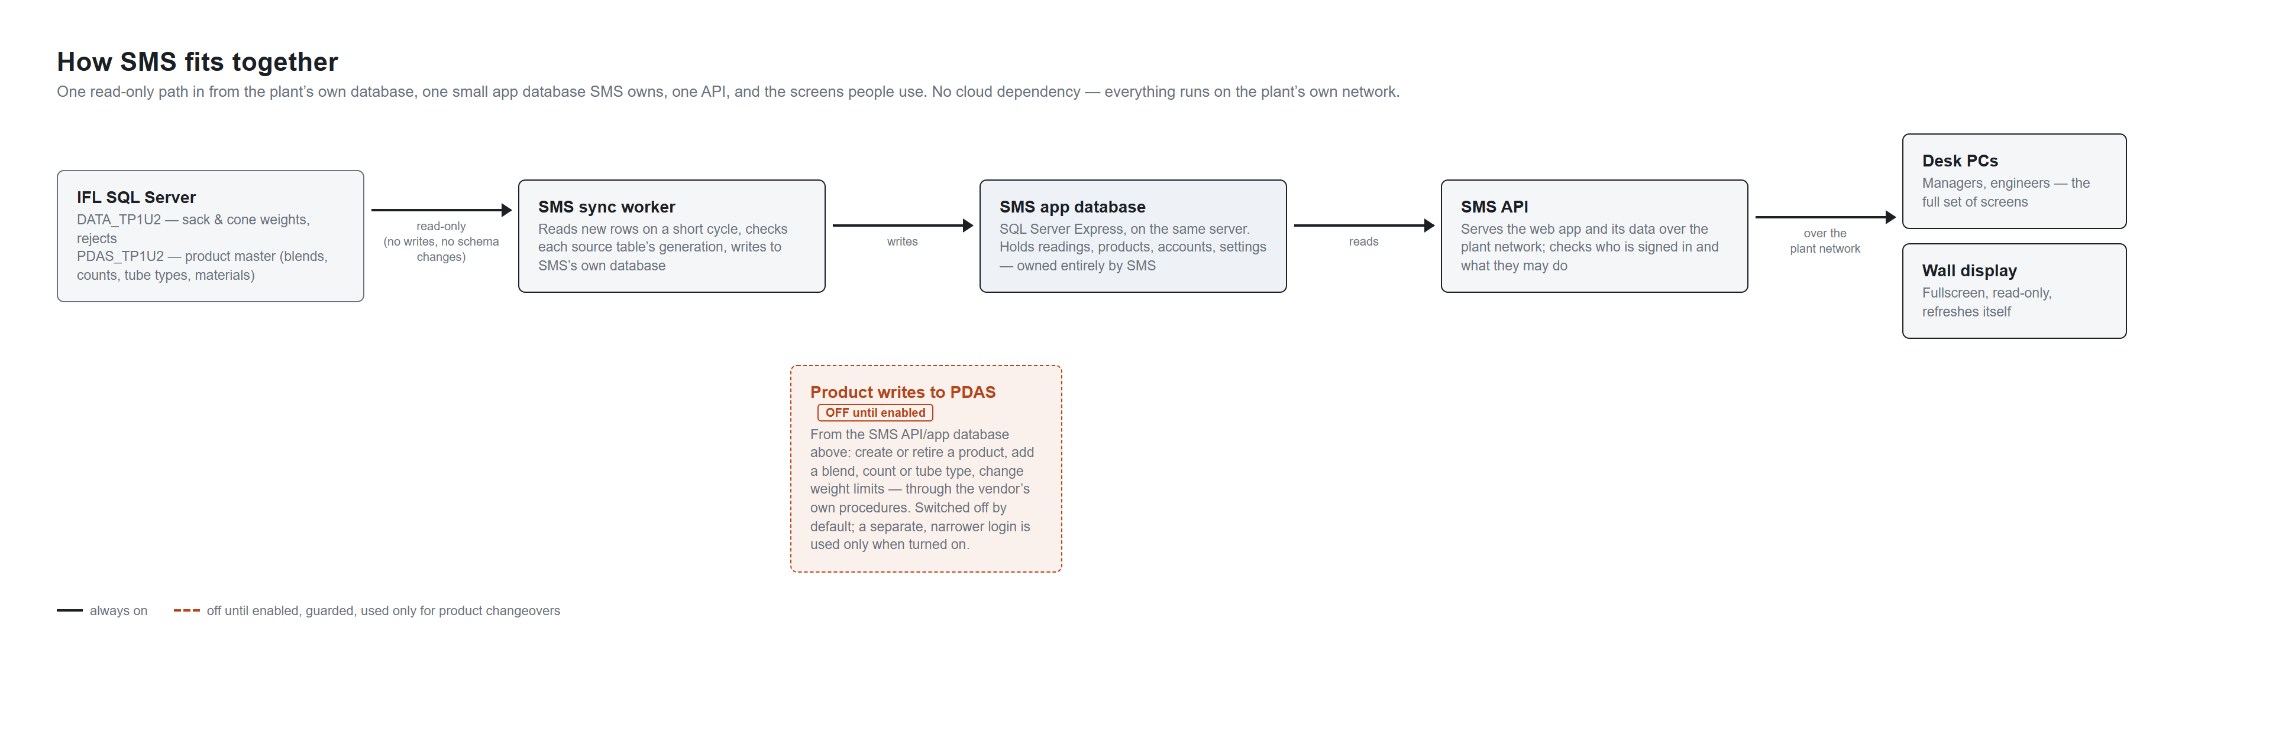
Figure 1 — SMS architecture: the sync worker reads IFL's SQL Server (read-only) on a short cycle and writes to SMS's own app database; the API reads that database and serves the desk PCs and the wall display over the plant network. Product writes to PDAS are shown as off until enabled. The command-line tool is not drawn.
- The sync worker is the only SMS process that connects to IFL's SQL Server, and it only ever reads. It runs on a schedule (every SYNC_INTERVAL_SECONDS, 60 seconds by default), pulls new rows, and writes them into SMS's own app database after resolving which source generation they belong to (see section 1.4).
- The API serves /api/* to the browser, and also serves the built web app itself when WEB_DIST is set — the normal production setup is one process doing both.
- The CLI (node cli/dist/index.js <command>) runs one-off operations: the first sync, verifying data against the source, listing and accepting source generations, creating accounts, and maintenance tasks. See Appendix B for the full command reference.
- The app database is SMS's own SQL Server Express database. It holds the canonical readings the sync worker has processed, plus everything SMS itself writes: accounts, sessions, the audit log, calibration adjustments, and the product timeline.

1.2 The ~18-minute lag
IFL's own acquisition layer writes a cone's row to the database about 18 minutes after the cone is actually weighed (measured: 909 seconds minimum, 1090 seconds mean, over more than 142,000 readings). This means the newest reading available to SMS is always some minutes behind the present moment — even on a perfectly healthy, running line.
SMS accounts for this rather than hiding it. Every screen that talks about "now" measures the lag from IFL's own data (the gap between when a reading was produced and when it was written) and judges whether the line is running against now − that lag, not the wall clock. The strip under the top bar states the lag in words, with a details link through to Health. Do not read "no readings in the last few minutes" as "the line is stopped" — check the stated lag first.

1.3 Plant clock and computer clock
SMS deliberately keeps two clocks separate, and never mixes them:
- The plant's production clock. Every cone, sack and reject reading carries a production timestamp written by the plant's own systems. This timestamp is stored labelled as UTC but is really the plant's own local wall clock.
- The app's own clock. Anything SMS itself writes — the product timeline, calibration adjustments, sync-run records, account actions — is stamped in genuine UTC, from the server the API and sync worker run on.
On this plant the two are about five hours apart (PLANT_UTC_OFFSET_MINUTES, UTC+5). A screen that shows both a production time and an app-written time never mixes them without saying so; when comparing the two matters, the screen states which clock it means.

1.4 Source generations, in plain words
IFL's own source tables can be rebuilt: dropped and recreated with every identity counter restarted from 1. This has already happened once, on 2026-08-05. SMS calls each such rebuilt period of a table a generation (or epoch). Two generations of the same table are not one continuous record — an id of 500 in one generation is a different row from id 500 in another — so SMS never silently merges them.
When the sync worker meets a generation it has not seen before, it halts and waits for an operator to run epoch:accept (see section 4.11 and Appendix B) rather than guessing. Reports and charts that would otherwise mix two generations state plainly that they cover one generation only, and how many readings from another generation were left out.

1.5 Glossary
Term | Meaning
Cone | A single wound package of yarn, weighed individually as it comes off a machine.
Sack | A finished sack of packed cones, weighed as a unit on the packing scale.
Station / machine | A physical spinning machine on the line; SMS uses "station" and "machine" for the same thing depending on the screen.
Reject | A cone the scale or an inspector marked as not acceptable — for a weight reason or a quality reason.
Product / material | The blend, count and tube combination a machine is currently running, recorded in PDAS.
PDAS | IFL's existing product-master database (PDAS_TP1U2) — blends, counts, tube types, materials and pallets. SMS reads it, and can optionally write to it (see section 6.4).
Generation | A distinct rebuild of one of IFL's source tables; see section 1.4.
Sync pass | One run of the sync worker's read-transform-write cycle.
DQ finding | A data-quality finding SMS raises about its own readings or its own connection health — shown on Health and Setup.
Shift day | The production day used for reporting, running 06:00 to 06:00 on the plant clock (see section 1.1 for how that clock is defined).

2 What is in the package
"The package" means the sms folder of the release, at one version (this guide describes version 0.2.0), plus what npm ci && npm run build produces on the server, plus this guide. Nothing else is needed from the developer's machine.

2.1 What you receive
Folder | What it is for
shared | Types and settings used by every other part.
db | The app database's setup: numbered migrations (001 to 042) and the bootstrap scripts that create the database and its logins.
sync-worker | The only program that talks to IFL's SQL Server. Read-only.
cli | The command-line tool, run as node cli/dist/index.js <command>. See Appendix B.
api | The web service: sign-in, permissions and every screen's data. It also serves the web app once it is built.
web | The screens people see in the browser.
scripts | Backup, scheduled-task and database-maintenance scripts, and the plant simulator used only for demonstrations.
layout-tests | Browser-based layout tests. Used by developers; not needed to run SMS.

2.2 What is built on the server
npm ci && npm run build (see section 4.5) creates a dist folder inside api, sync-worker, cli and web. The two long-running programs are api\dist\index.js and sync-worker\dist\index.js.

2.3 What is not in the package
- .env. IT creates it from .env.example on the server (see section 4.4). It holds every password and is never shipped.
- node_modules. Restored by npm ci.
- Log files. Written at run time.
- NSSM. Third-party service software that IT must supply.
- IFL's own data. SMS reads it from IFL's SQL Server; it is never part of the package.
Note: Use the placeholders C:\sms for the install folder, C:\sms-backups for backups and C:\sms\logs for logs unless IT chose other folders.

3 What IFL IT must provide
Before installation begins (Chapter 4), IFL's IT department needs to have the following ready. Each item is referenced again from the installation steps that need it.
- Server hardware. A PC or server on the plant network with enough disk space for SQL Server Express and the app database, running Windows, set to the plant's own local time zone (UTC+5, the same offset the app itself is told about via PLANT_UTC_OFFSET_MINUTES — see section 6.1).
- SQL Server Express. Free, and already used elsewhere at the plant. It caps a single database file at 10 GB — see Appendix C, item 10, for what this means in practice.
- Node.js, the version pinned in the package's .nvmrc file. The API, sync worker and CLI all run on Node; npm ci && npm run build (section 4.5) needs it.
- Microsoft Edge, for PDF report export. The API launches Edge headless to render a report to PDF; PDF_EDGE_PATH can point at a non-default install location (see section 6.1).
- NSSM (the Non-Sucking Service Manager), to run the API and sync worker as Windows services that restart on crash and start with the machine. NSSM is third-party software and is not part of the SMS package — IT must download and provide it themselves.
- Network access: a static IP or a resolvable name for the server, and the API's port (API_PORT, 4000 by default) open in the Windows Firewall for anyone who will browse to SMS.
- A read-only SQL login into IFL's own databases, with db_datareader on both DATA_TP1U2 and PDAS_TP1U2, and nothing more — SMS never writes to DATA_TP1U2, and writes to PDAS_TP1U2 only through the separate, off-by-default path described in section 6.4. See section 4.2.
- A Windows account to run the scheduled backup, maintenance and retention tasks (RunAs in section 4.12) — it needs db_backupoperator on the app database.
- A backup folder the SQL Server service account can write to and the API can read from, for example C:\sms-backups — Health reports the age of the newest backup file it finds there.
- A wall-display PC (optional), if IFL wants a fullscreen, no-navigation board — any PC with a browser pointed at /?s=wall will do; see section 4.13.
- A decision on who will be the first administrator, so their account can be created in section 4.7 and they can create manager and engineer accounts for everyone else from Setup.

4 Installation, step by step
Run every command below from the package root (C:\sms once installed, or the extracted package folder) unless a step says otherwise. Each step names what you should see, and where to look if it does not match.

4.1 Prerequisites
- Confirm every item in section 3 is in place: SQL Server Express reachable, Node.js installed at the version in .nvmrc, Microsoft Edge installed, NSSM downloaded, and the backup folder created.
- Copy the package to its install folder, for example C:\sms.
You should see: the package folder containing api, web, cli, sync-worker, shared, db, and scripts subfolders, and no node_modules or .env (these are created by later steps). If it fails, see section 8.

4.2 Ask IFL's DBA for the read-only login
Before SMS can read anything, IFL's own database administrator must create a SQL login for SMS with db_datareader on DATA_TP1U2 and on PDAS_TP1U2, and nothing more. A template script for this is in the package at db\bootstrap\10_ifl_readonly_login.template.sql — hand it to IFL's DBA to adapt and run against their own server; SMS's own installer never connects to IFL's server to create this login itself (Working rule: never modify IFL's database without their own hand on it).
You should see: a login (the documented generic name is sms_readonly) with db_datareader on both databases, and its username/password recorded securely for step section 4.4. If it fails, see section 8.

4.3 Create the app database and its logins
- Run the bootstrap script against the app database server, substituting the real server/instance name and two strong passwords:
sqlcmd -S <server\instance> -E -i db\bootstrap\00_create_app_database.sql -v AppPassword="…" -v MigratePassword="…"

You should see: no error from sqlcmd, and the app database plus its sms_app and sms_migrate logins created on the server. If it fails, see section 8.
Note: -E uses your own Windows login to connect and create the database; it must be a login with permission to create databases and logins on that SQL Server instance.

4.4 Create .env
- Copy .env.example (in the package root) to .env in the same folder.
- Fill in every key described in section 6.1 — at minimum the APP_DB_* keys (using the sms_app login from the previous step), the IFL_DB_* keys (using the read-only login from section 4.2), LINE_ID, BACKUP_DIR, and PLANT_UTC_OFFSET_MINUTES.
You should see: a .env file with no __set_me__ placeholders left in it. If it fails, see section 8.
Warning: Never commit .env to version control and never send it by email. It holds every database password SMS uses.

4.5 npm ci and npm run build
- From the package root, install dependencies and build every workspace:
npm ci && npm run build

You should see: api\dist, sync-worker\dist, cli\dist and web\dist each created with no build errors. On a plant PC with no internet access, run npm ci once on a machine that does have access and copy the resulting node_modules folders across instead — npm ci itself needs the npm registry. If it fails, see section 8.
Note: npm run verify:release (npm run typecheck && npm test && npm run build) is a stronger check than a plain build, if you want to confirm the package itself is sound before relying on it.

4.6 Migrate
- Apply every database migration:
npm run db:migrate

You should see: each migration file applied in order with no error, ending at the newest migration in db\migrations. If it fails, see section 8.
Note: MIGRATE_DB_USER/MIGRATE_DB_PASSWORD (the sms_migrate login), if set, is preferred over APP_DB_USER for this one step only — set it in the shell you run this command from, not in .env, since it is never loaded by the long-running services.

4.7 First admin account
- Create the first administrator account:
node cli/dist/index.js user:create --username=admin --password=<strong> --role=admin

You should see:
created user 'admin' (admin)

If it fails, see section 8.
Warning: The password must be at least 10 characters (PASSWORD_MIN_LENGTH). Choose the real administrator's username, not literally admin, if IFL prefers a personal account.

4.8 Manager accounts
- Create one account per manager or engineer who needs to record changes (set the running product, log a calibration adjustment, record a sack movement, change local product limits — see section 6.3 for what each rank can do):
node cli/dist/index.js user:create --username=<u> --password=<p> --role=<viewer|engineer|manager|admin> [--display=<name>]

You should see: created user '<u>' (<role>) for each account created. If a role name is rejected, only viewer, engineer, manager and admin are valid — the older names operator and supervisor are refused. If it fails, see section 8.
Note: Every account can read every screen — Setup is the only screen restricted, to admin. Roles only govern who can write — see section 6.3.

4.9 Windows services (NSSM)
The API (api\dist\index.js) and the sync worker (sync-worker\dist\index.js) are meant to run continuously and restart automatically if they crash or the machine reboots. NSSM is the recommended way to do this on Windows, wrapping each as a Windows service (the documented generic service names are SMS-Api and SMS-Sync). NSSM is third-party software, outside the SMS package — follow NSSM's own instructions to register each service, pointing it at the Node executable and the built entry point for each process, with the working directory set to the package root so .env is found.
You should see: SMS-Api and SMS-Sync listed as running services in Windows' Services console, and GET /api/health answering once SMS-Api is running. If it fails, see section 8.

4.10 Firewall
- Open the API's port for anyone on the plant network who needs to browse to SMS:
netsh advfirewall firewall add rule name="SMS API" dir=in action=allow protocol=TCP localport=4000

You should see: the rule listed in Windows Firewall's inbound rules, and the SMS sign-in page reachable from another PC on the network at http://<server>:4000/. If it fails, see section 8.

4.11 First connection to the plant: sync halts → epoch:accept → verify
A brand-new app database has no source generation registered yet, so the very first sync is expected to stop and ask for one to be accepted — this is not a failure.
- Run the first sync:
node cli/dist/index.js sync

You should see: it halts, reporting an unregistered source generation and exiting 1. This is expected on a first run.
- Accept the generation currently on the plant. First without --confirm, to see the plan:
node cli/dist/index.js epoch:accept --all --provenance=ifl_live --label="Plant, live"

You should see: a printed plan describing the generation to register, and nothing changed yet.
- Re-run identically with --confirm added to apply it:
node cli/dist/index.js epoch:accept --all --provenance=ifl_live --label="Plant, live" --confirm

You should see: the generation registered, with no error.
- Run sync again, and confirm the data against the source:
node cli/dist/index.js sync
node cli/dist/index.js verify

You should see: sync completes with per-table read/written counts and exit 0; verify reports no STOP lines and no weight mismatch.
- List the registered generations at any time with:
node cli/dist/index.js epoch:list

If any of these steps fails, see section 8.
Warning: Use --provenance=ifl_live for the real plant connection. --provenance=simulator is refused unless the target database name ends in _SIM, and exists only for development and demonstration systems like the one that produced this guide's own screenshots.

4.12 Scheduled tasks
- Register the three production scheduled tasks (nightly backup, weekly database maintenance, daily retention), previewing first with -WhatIf:
powershell -ExecutionPolicy Bypass -File scripts\install-scheduled-tasks.ps1 -InstallDir "C:\sms" -RunAs "<domain>\<svc account>" -Server "SERVER-SQL,<port>" -BackupDir "C:\sms-backups" -WhatIf

- Once the preview looks right, re-run the same command with -WhatIf removed to register the tasks for real.
Note: -Server is a required parameter with no default; give it the host and port of the app database on this server, as shown in the command above. The script refuses to run without it, so the nightly backup cannot silently look at the wrong place. -Database defaults to sms. Run the command as an administrator.

You should see: "SMS Nightly Backup", "SMS Weekly Maintenance" and "SMS Daily Retention" listed in Windows Task Scheduler. Confirm one runs with:
schtasks /run /tn "SMS Nightly Backup"
schtasks /query /tn "SMS Nightly Backup" /v /fo LIST

If it fails, see section 8 and Chapter 9's backup section.

4.13 Wall display PC
The wall display is any PC with a browser, pointed at /?s=wall on the SMS server — this view has no navigation and refreshes itself every 10 seconds, so it is meant to be left open, not signed out of. A dedicated Windows PC running Edge in kiosk mode is one way to do this:
msedge --kiosk http://<plant-ip>:4000/?s=wall --edge-kiosk-type=fullscreen

Create a low-privilege viewer account for the wall PC to sign in with, so its session can be revoked independently of any person's own account:
node cli/dist/index.js user:create --username=wall --password=<strong> --role=viewer

You should see: the wall board filling the screen with no browser chrome, updating on its own. If it fails, see section 8.

5 Verification checklist
Work through this list after installation (Chapter 4) and after any significant change — a service restart, a Windows update, a new source generation accepted. Tick each item off only once you have actually seen it, not because the step before it passed.
☐ GET /api/health returns "status": "ok", or a "degraded" status with a stated reason you recognise from section 8.
☐ Health shows Everything is healthy. as its headline — see the figure below.
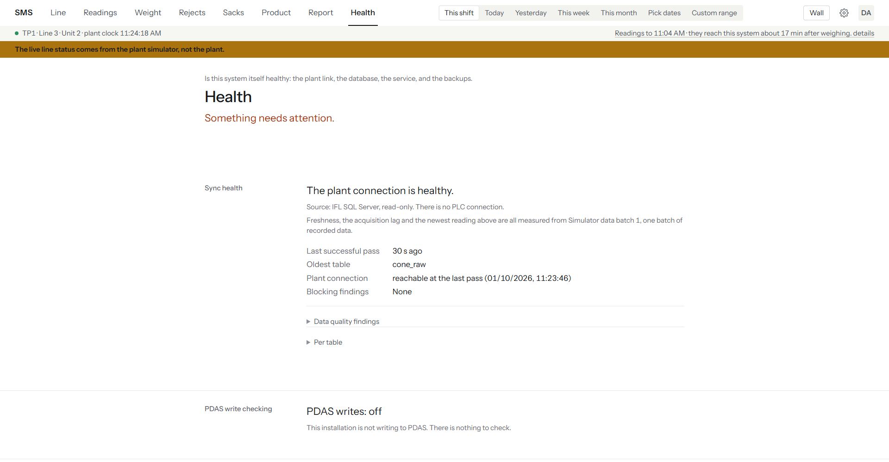
Figure 2 — Health on the demonstration copy: the Sync health block is healthy, but the headline reads "Something needs attention" because the demo has no backup. A clean installation should not show that. The blocks further down the screen are not in this picture.
☐ The sync block on Health shows a healthy outcome for every source table, not The last sync attempt failed. or The plant connection has not delivered anything recently.
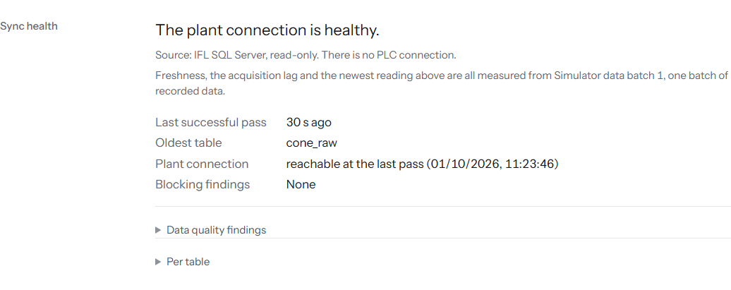
Figure 3 — The Sync health block: "The plant connection is healthy", the last successful pass, the oldest table and blocking findings, with Data quality findings and Per table folded away.
☐ node cli/dist/index.js verify exits clean: no STOP line, no weight mismatch.
☐ node cli/dist/index.js epoch:list shows the generation you accepted in section 4.11, with row counts that are growing on a re-run a few minutes later.
☐ The Backups block on Health says the newest backup has been proven restorable (This backup has been proven restorable — RESTORE VERIFYONLY passed and its size still matches.), not This backup has not been proven restorable. Do not rely on it until it verifies.
☐ The Disk space block on Health shows plenty free on both the database volume and the backup volume (SMS warns below 2 GB).
☐ The Database block on Health shows a size comfortably under the 10 GB SQL Server Express cap (see Appendix C, item 10).
☐ The Backups block on Health shows a recent backup, once the first scheduled backup has run (see section 4.12 and Chapter 9).
☐ Signing in as the first admin account works, and Setup is reachable (admin only — every other screen should also be reachable by every account you created).
☐ The Sign out menu item ends the session and returns to the sign-in form.
☐ SMS-Api and SMS-Sync (or whatever names NSSM was given) both show as running services, and restart on their own if stopped (test this deliberately once, in a maintenance window).
☐ The firewall rule from section 4.10 allows a browser on another PC on the plant network to reach SMS.
If any box cannot be ticked, do not consider the installation complete — work through section 8 for that symptom before moving on.

6 Configuration

6.1 The .env keys that matter
The full list of every key SMS reads is in Appendix A. The keys below are the ones most likely to need attention after the first install, or to be gotten wrong.
Key | Why it matters
COOKIE_SECURE | Must be true once SMS is served over HTTPS (the normal plant setup); set to false only on a plain-HTTP link such as a demonstration system — leaving it true on a plain-HTTP link means nobody can sign in, because the browser will not send the session cookie back.
PLANT_UTC_OFFSET_MINUTES | The plant's declared UTC offset, in minutes (UTC+5 = 300). Used for the two-clocks cross-check described in section 1.3 — get this wrong and Health may report a clock mismatch that is not real.
LINE_ID | Which line this installation serves. Immutable once data has been ingested against it — decide it once, correctly, before the first sync.
BACKUP_DIR | Where Health's Backups block looks for the newest .bak file — it must match the -OutDir/-BackupDir value the backup scripts and scheduled tasks actually use, or Health will report no backup found even though one exists.
WEB_DIST | Set this (to ./web/dist) so the API also serves the built web app itself — the normal single-process production setup described throughout this guide.
PDAS_WRITE_ENABLED | Master switch for the PDAS write path — see section 6.4. Off by default, and should stay off until the conditions in that section are met.
PDAS_LIMIT_MAX_SETPOINT_CHANGE_PCT, PDAS_LIMIT_MAX_OFFSET_CHANGE_G | The size of a limits change (default 3 % and 20 g) above which an engineer must confirm and give a longer reason. These are the developer's defaults, not IFL's; see section 6.4.
LIVE_ALLOW_SIMULATOR | Development only; never set at IFL. It lets the live screens follow the plant simulator. The API ignores it unless the database name ends in _SIM and the server is local.
WEIGHT_BASIS, SHIFT_MODE | Not yet confirmed by IFL for this plant (see Appendix C, item 12) — leave at their defaults (as_recorded, corrected) unless IFL has given a written answer.

6.2 Setup page
Setup is reached from the gear icon at the right of the top bar and is open only to admin accounts. It is one long page, not a set of tabs — each block below is a section of that same page.
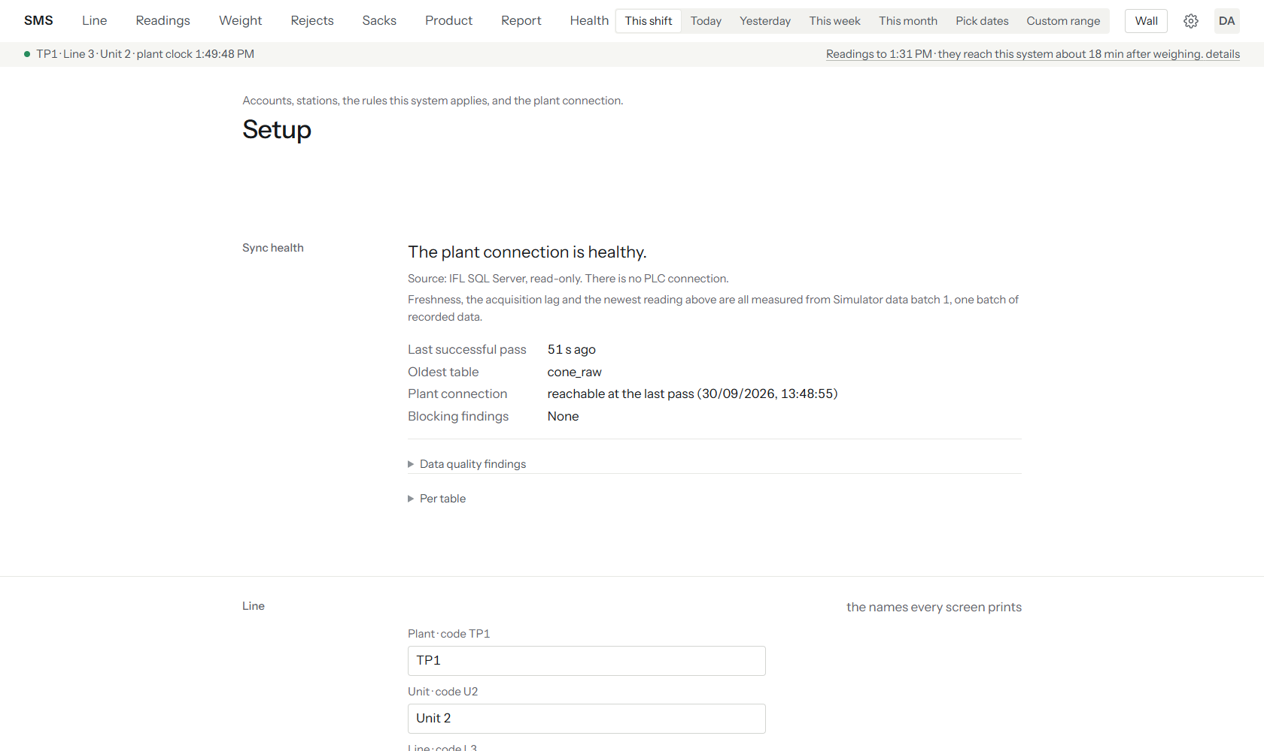
Figure 4 — The top of the Setup page: the heading, the Sync health block and the start of the Line block. The other blocks are shown separately below.
- Sync health — the same per-table sync outcome shown on Health, with more detail: the current watermark and the registered generation for each source table.
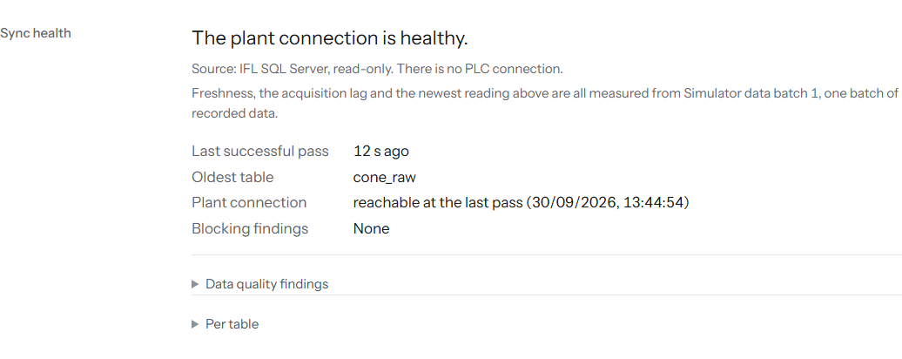
Figure 5 — Setup, Sync health block: healthy plant connection, last successful pass, oldest table, with Data quality findings and Per table folded away.
- Line — the line's own display name and identifying details.
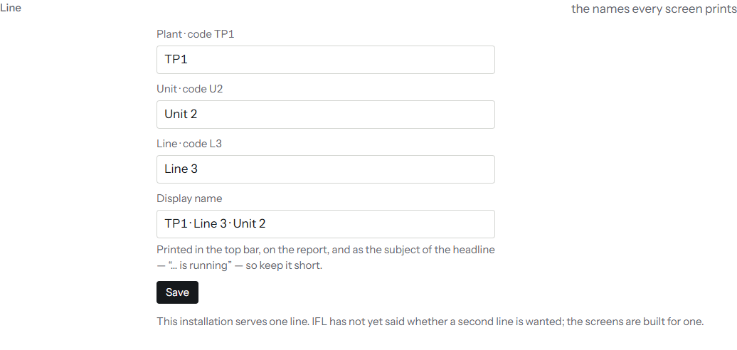
Figure 6 — Setup, Line block: plant, unit and line codes, the display name and Save.
- Machines — the roster of physical machines on the line. New ones are added with the Add a machine form (machine number, kind, name, make, model, notes).
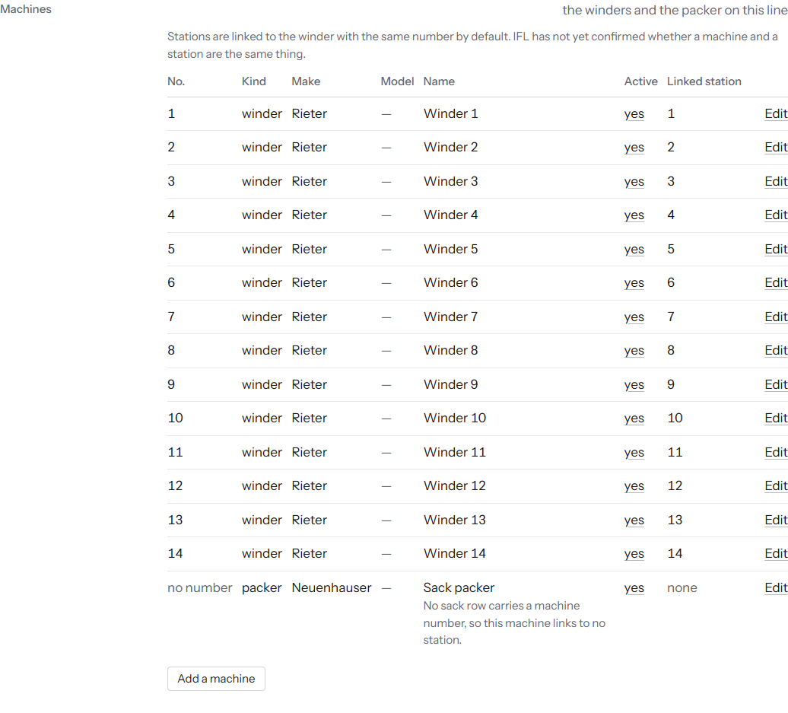
Figure 7 — Setup, Machines block: 14 winders and the sack packer, each with Edit, and the Add a machine button.
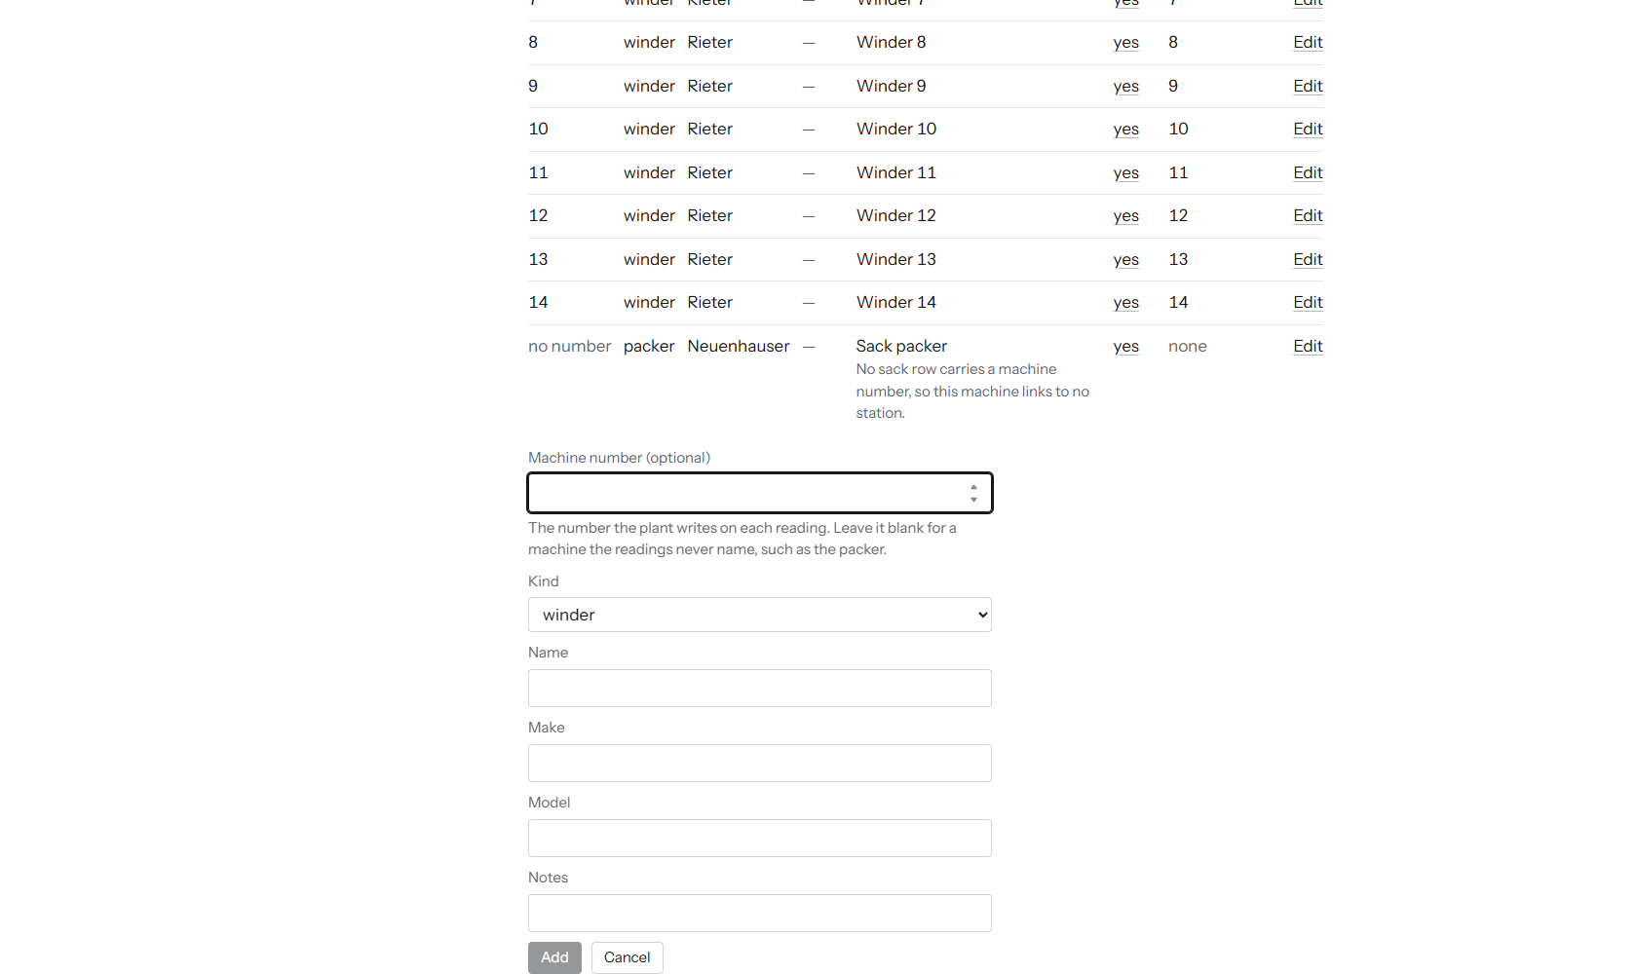
Figure 8 — The Add a machine form open: machine number, kind, name, make, model and notes, with Add and Cancel at the foot (the image is cropped at the bottom edge).
- Stations — the roster of weighing stations, each optionally linked to a machine. New ones are added with the Add a station form (station number, optional name).
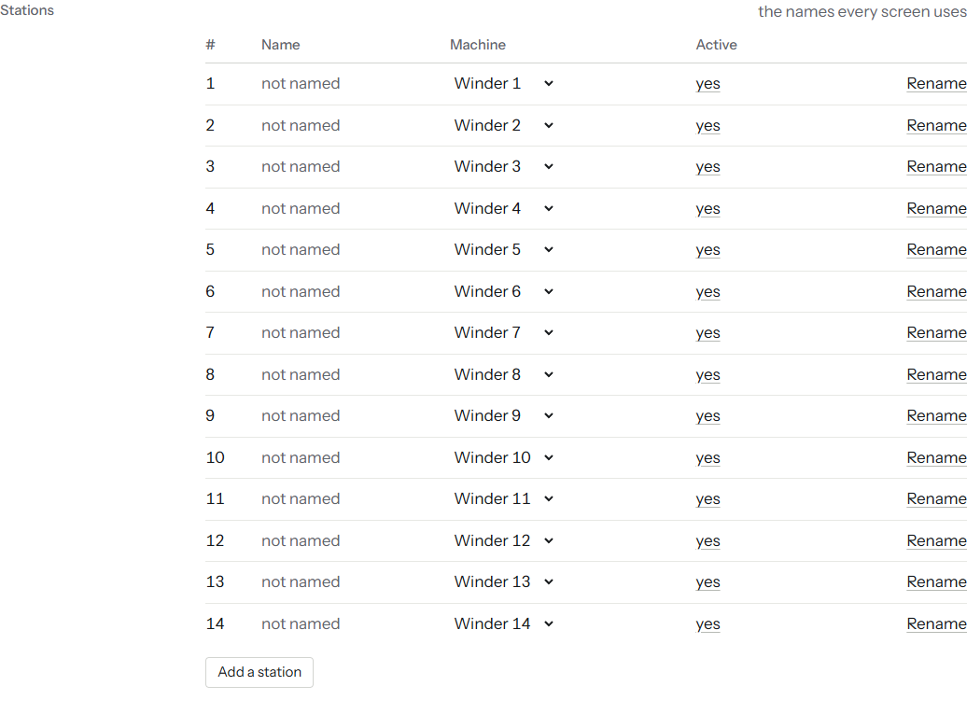
Figure 9 — Setup, Stations block: 14 stations, none named yet, each linked to its winder, with Rename and Add a station.
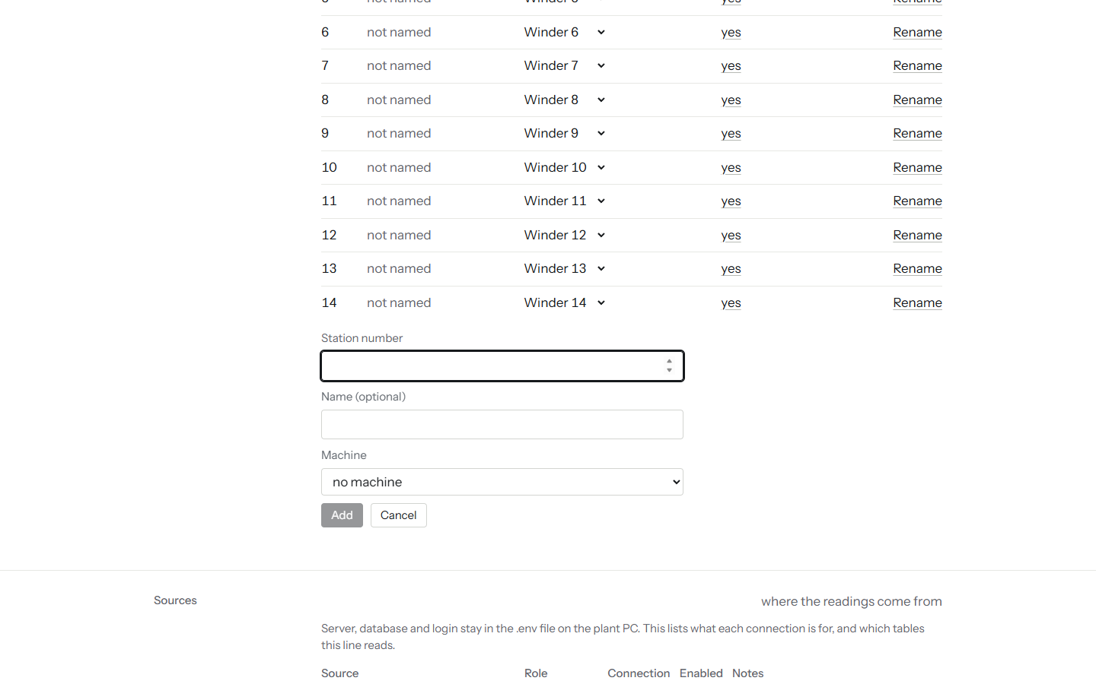
Figure 10 — The Add a station form open: station number, optional name, machine, Add and Cancel.
- Sources — which source tables and generations feed this line.
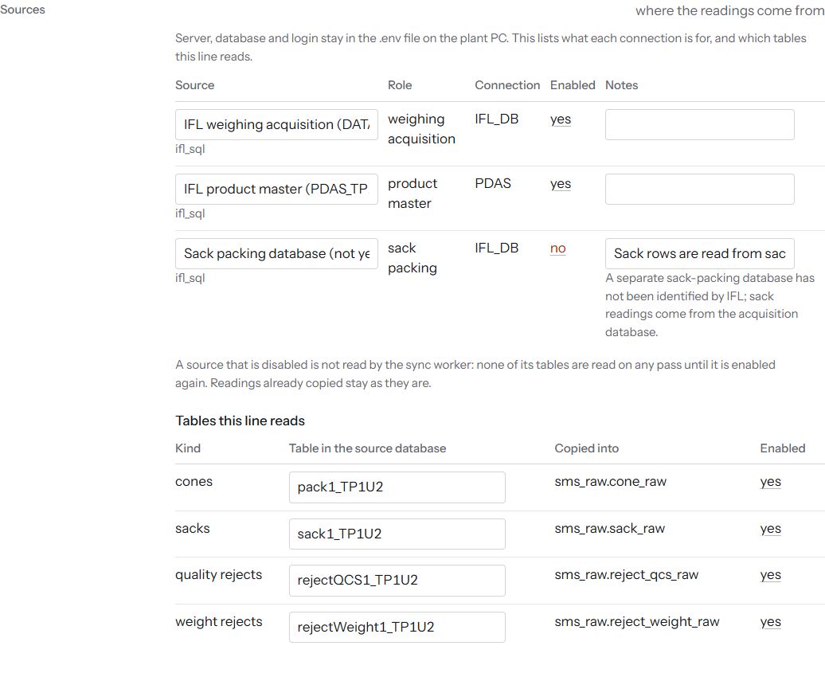
Figure 11 — Setup, Sources block: the acquisition and product-master sources enabled, the sack-packing source disabled, and the four tables this line reads.
- Rules — the shift, weight and plausibility rules in force, and when they changed.
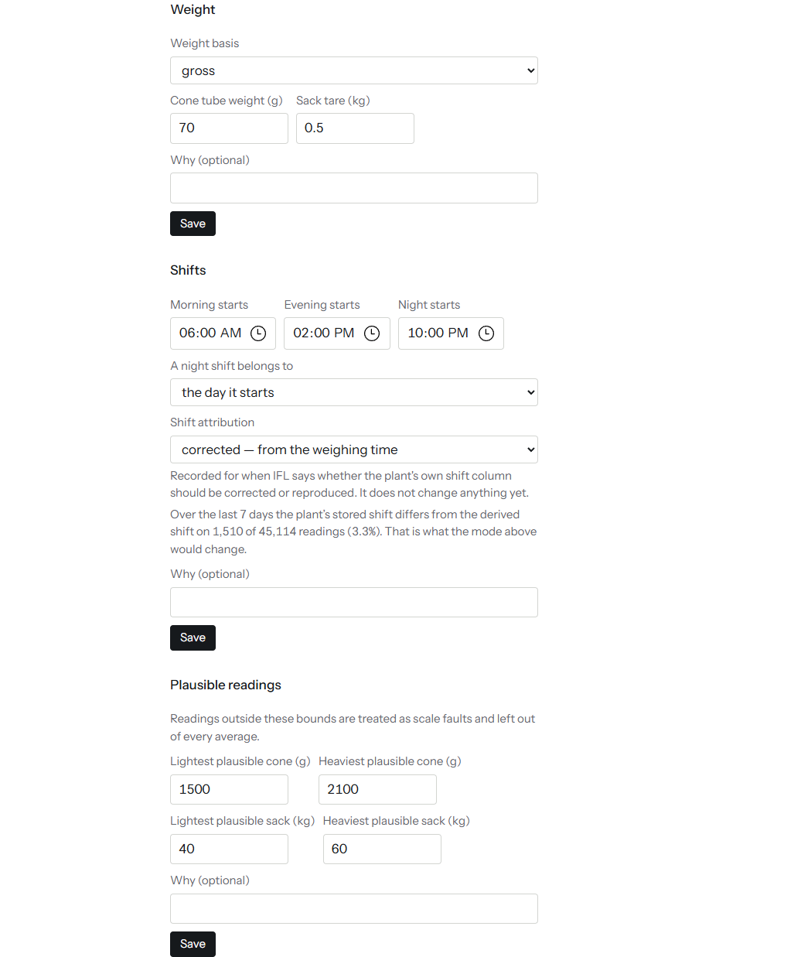
Figure 12 — Setup, Rules block, first part: weight basis with cone tube weight and sack tare, shift start times with night-shift and attribution choices, and the plausible-reading bounds for cones and sacks.
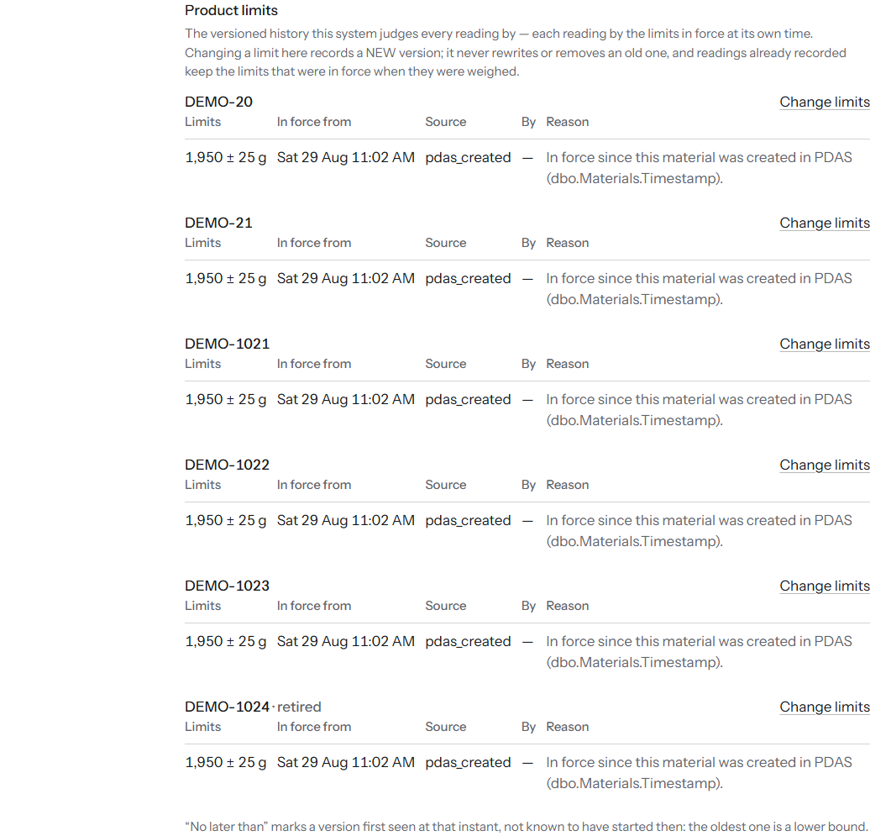
Figure 13 — Setup, Rules block, second part: the product limits history, one entry per material with its limits, when they came into force, their source, and a Change limits link.
- Reject codes — every reject code with its type, tube code and material code, a Name box (the name applies to every reading, past and future), and Pass? and Severity choices. A code can also be named from the Rejects screen itself.
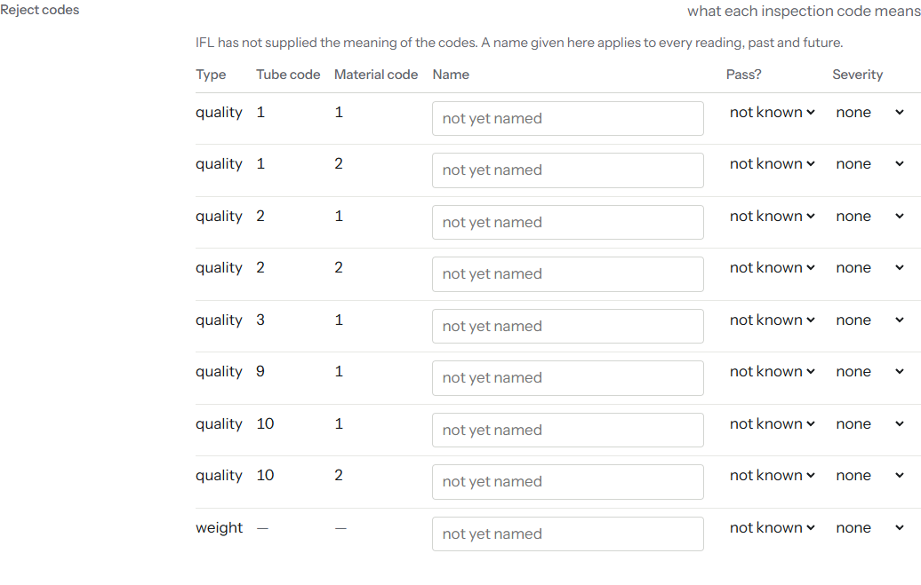
Figure 14 — Setup, Reject codes block: nine codes from the demo, all still "not yet named".
- People — accounts. New ones are created with the New account form (Username, Display name (optional), Password, Role); an existing account's password can be Reset from the same block. See section 6.3 for what each role can do.
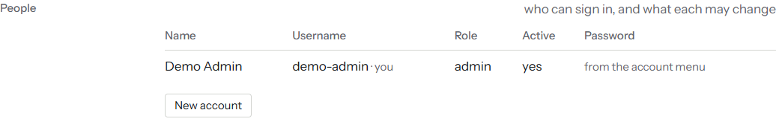
Figure 15 — Setup, People block: the one demo account, with a New account button.
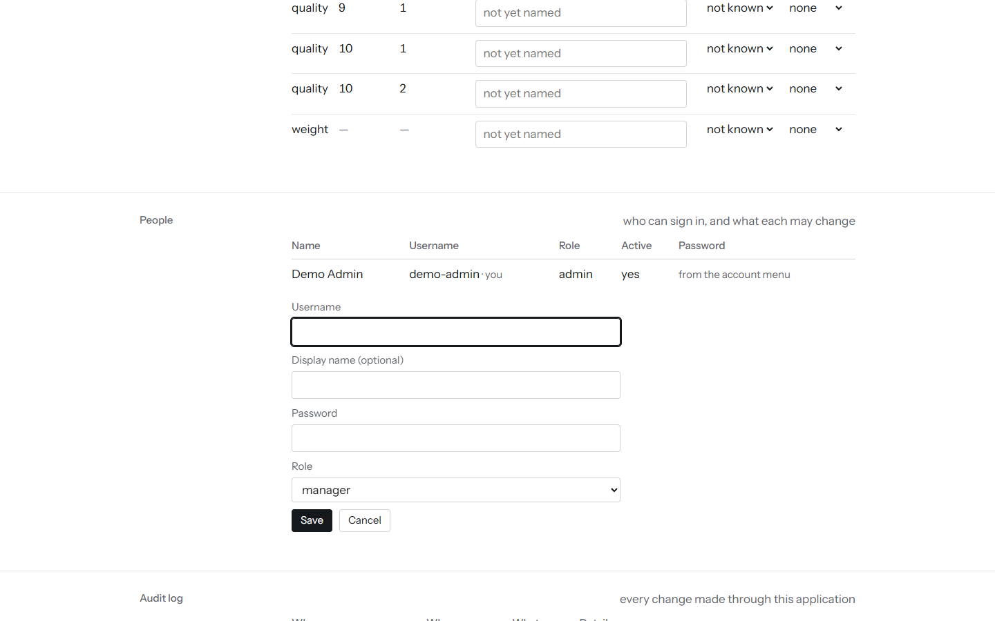
Figure 16 — The New account form open and empty: username, display name, password, role and Save.
- Audit log — every write SMS itself has made: account changes, calibration adjustments, product changes, and PDAS write attempts.
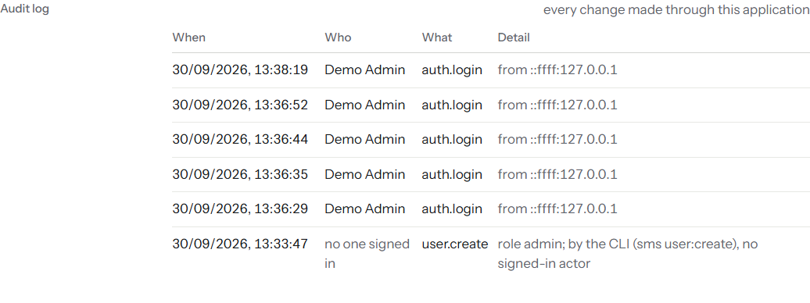
Figure 17 — Setup, Audit log block: five sign-ins and one account created from the command line.

6.3 Roles and what each can do
Every screen described in Chapter 7 is open to every signed-in account, at every rank — Setup is the only screen restricted, to admin. Roles govern writing, not reading:
Role | Rank | Can additionally do
viewer | 1 | Read every screen. Cannot write anything.
engineer | 2 | Set the running product, log a calibration adjustment, name a reject code, record a sack movement, set local product limits, acknowledge a known data finding on Health.
manager | 3 | Everything engineer can, plus export a report or the raw register.
admin | 4 | Everything manager can, plus everything in Setup: accounts, machines, stations, rules.

Note: PDAS writes (creating or retiring a product, changing limits in PDAS, executing a changeover) require rank 2 (engineer) and PDAS_WRITE_ENABLED=true — see section 6.4. Rank alone does not turn this on.

6.4 PDAS writes: what they are, why they are off, what enabling them requires
SMS can, in principle, write to IFL's product-master database (PDAS_TP1U2) through the same stored procedures IFL's own PDAS client uses — creating or retiring a material, adding a blend/count/tube type, creating or retiring a pallet, and changing a material's weight limits. This is a separate path from the read-only connection used for everything else in this guide: it uses its own login (PDAS_WRITE_USER, the documented generic name is sms_pdas_writer), never the read-only login.
Why it is off. PDAS_WRITE_ENABLED=false is the default, and stays false until all of the following are true:
- IFL has given written authority for SMS to write to PDAS.
- A separate sms_pdas_writer login has been provisioned on the plant's own PDAS server (PDAS_WRITE_SERVER/PORT/DATABASE/USER/PASSWORD in Appendix A) — distinct from the read-only login.
- The write path has been proven end to end against a non-production copy first.
What a limits change asks for. Changing a product's limits is a two-step form: a review step that shows each old and new value with the change in grams and per cent, then a write step. A change that moves the target by more than 3 % or a limit by more than 20 g is called out as a large change and needs a tick in the box and a reason of at least 20 characters. Those two figures are the developer's own choice, not IFL's, and can be changed in .env. On Product › Catalogue the block Pallets in PDAS lists every pallet with a Retire or Reactivate button, gated the same way as products. Who at IFL may make these changes, and how a changed limit reaches the machine, are still open questions; SMS does not claim to know.
What it looks like while off. Product › Changeover's Check the plan button still works — it is a read-only dry run that never opens the PDAS writer connection. Its Execute the changeover button is disabled, and the screen states why, in the server's own words: PDAS_WRITE_ENABLED is not true. Health's PDAS write block reads PDAS writes: off with the body text This installation is not writing to PDAS. There is nothing to check.
What enabling it requires. Set PDAS_WRITE_ENABLED=true and fill in the PDAS_WRITE_* connection keys in .env, once every condition above is met. Every write made through this path is checked: read back from PDAS immediately afterward, with any mismatch raised as a finding rather than assumed to have succeeded. A changeover executed this way still only makes a product selectable in PDAS — it does not, by itself, put that product on a machine; whether the machine's own controller reads its limits from PDAS live is a separate question for IFL.

6.5 Optional TLS
SMS can terminate TLS itself rather than sit behind IIS or another reverse proxy, using TLS_CERT_PATH/TLS_KEY_PATH (a certificate and key file pair) or TLS_PFX_PATH/TLS_PFX_PASSPHRASE (a combined PFX file). Leave all four unset to serve plain HTTP — reasonable on an isolated plant LAN, but then COOKIE_SECURE must be false (see section 6.1) or nobody will be able to stay signed in.

7 Daily use
This chapter walks through every screen a signed-in person uses. Each section says what the screen is for, shows it, lists the steps for the usual jobs, and explains what each part of the screen means.
Note: Every screenshot in this chapter was taken from a demonstration copy of SMS fed by the plant simulator, not by IFL's plant. The numbers, product names (DEMO-20, DEMO-21 and so on) and the single "Demo Admin" account are therefore made up. A yellow banner across the top of the screen says so whenever the figures come from the simulator; at IFL that banner does not appear. Your own screens will show your own numbers, but the layout and wording are the same.

Every screen is open to every signed-in account; only Setup is limited to administrators (see section 6.3). What differs by role is who may change things: recording the running product, logging a calibration adjustment or naming a reject code needs the engineer role or above, and exporting a report needs manager or above.

7.1 Signing in, the top bar and the period
Open the SMS address in a browser. The first thing you see is the sign-in form.
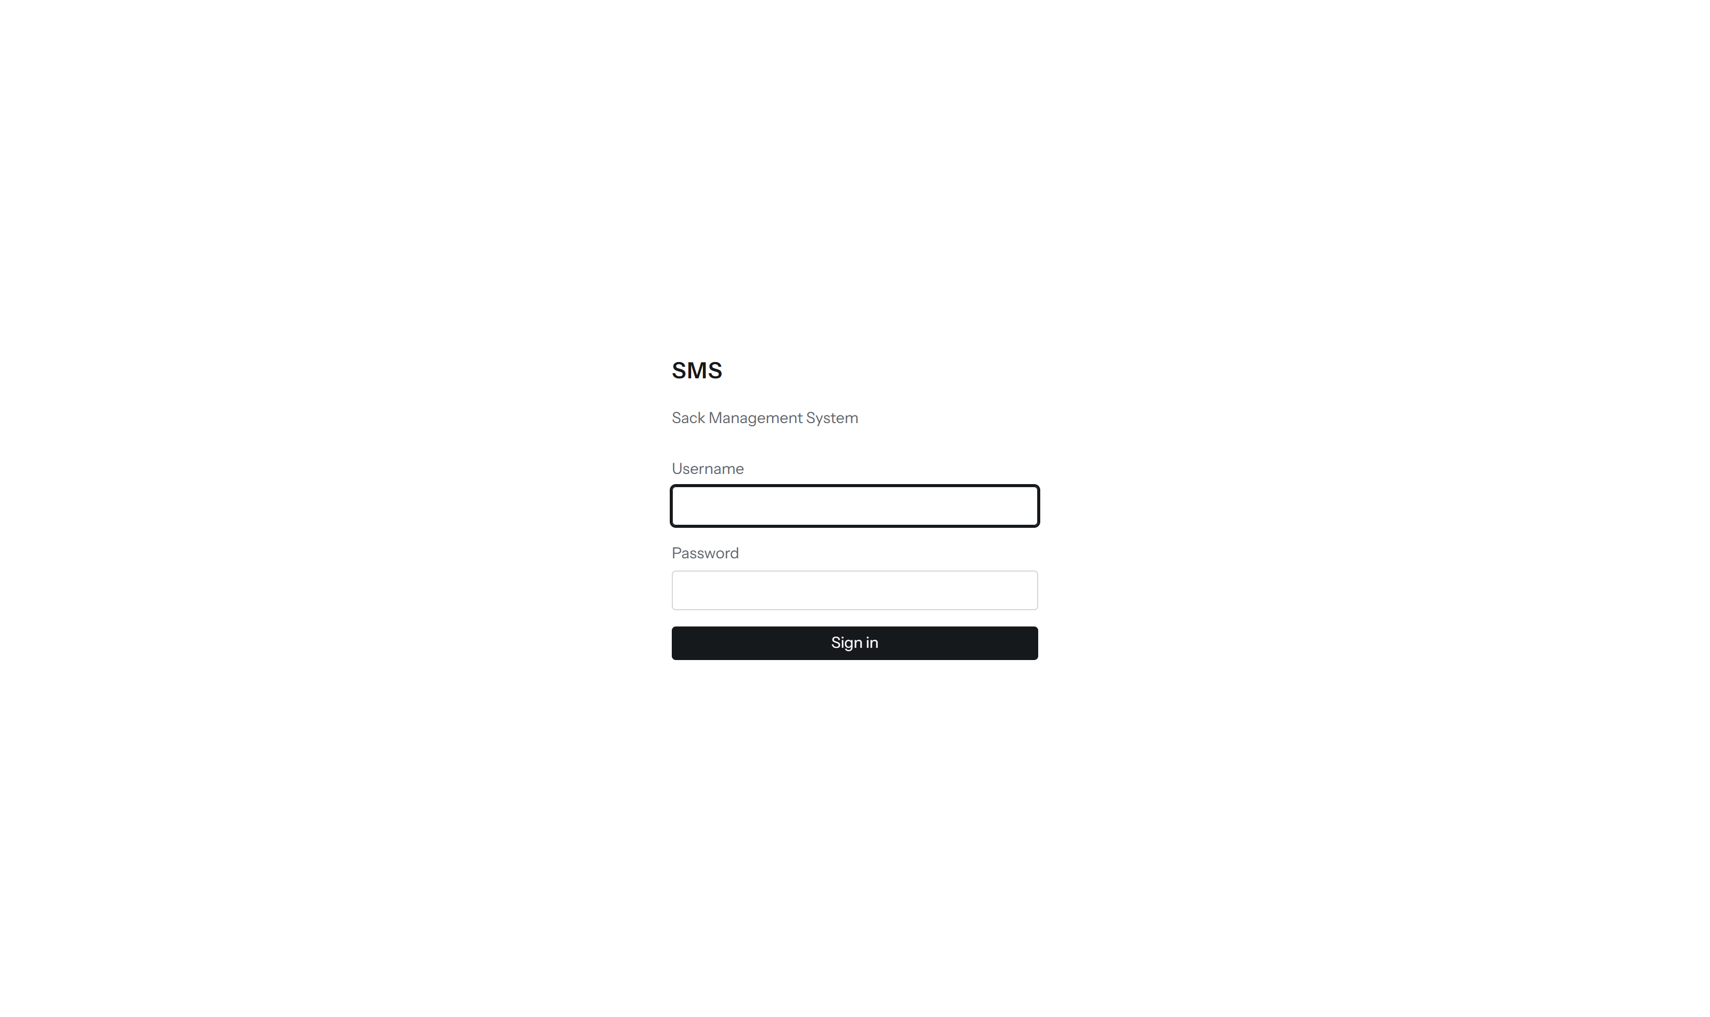
Figure 18 — Sign-in form: SMS, Sack Management System, Username and Password fields, Sign in button.
- Type your username in Username.
- Type your password in Password.
- Press Sign in.
If the details are wrong SMS says That username and password did not match. and after several wrong attempts it makes you wait a few minutes before trying again. It never says which of the two was wrong.
Once you are in, every screen shares the same bar along the top.
Figure 19 — The top bar and the strip beneath it: screen names, Health, the period buttons, the Wall button, the gear icon, the DA account menu, the plant clock and the data-age sentence.
Part | What it tells you
SMS and the screen names | Click a name to move to that screen: Line, Readings, Weight, Rejects, Sacks, Product, Report and Health. The current one is underlined.
Period buttons (This shift, Today, Yesterday, This week, This month, Pick dates, Custom range) | The stretch of time every screen is describing. It applies to the whole application at once: change it here and each screen follows.
Wall | Opens the fullscreen wall display (see section 7.9).
Gear icon | Opens Setup. Only administrators see it.
Initials button (here "DA") | Opens the account menu described below.
plant clock | The time at the plant, not the time on your PC. All SMS times use the plant's clock.
The sentence on the right, ending in details | How fresh the data is. Readings reach SMS about 18 minutes after the cone is weighed, so this sentence names the time of the newest reading and the delay. If it warns that nothing has arrived, the plant link may be down and no screen should be read as "the line is running".

To look at a stretch of time that is not a shift, day, week or month, press Pick dates. Two date boxes appear in the bar beside the period buttons.
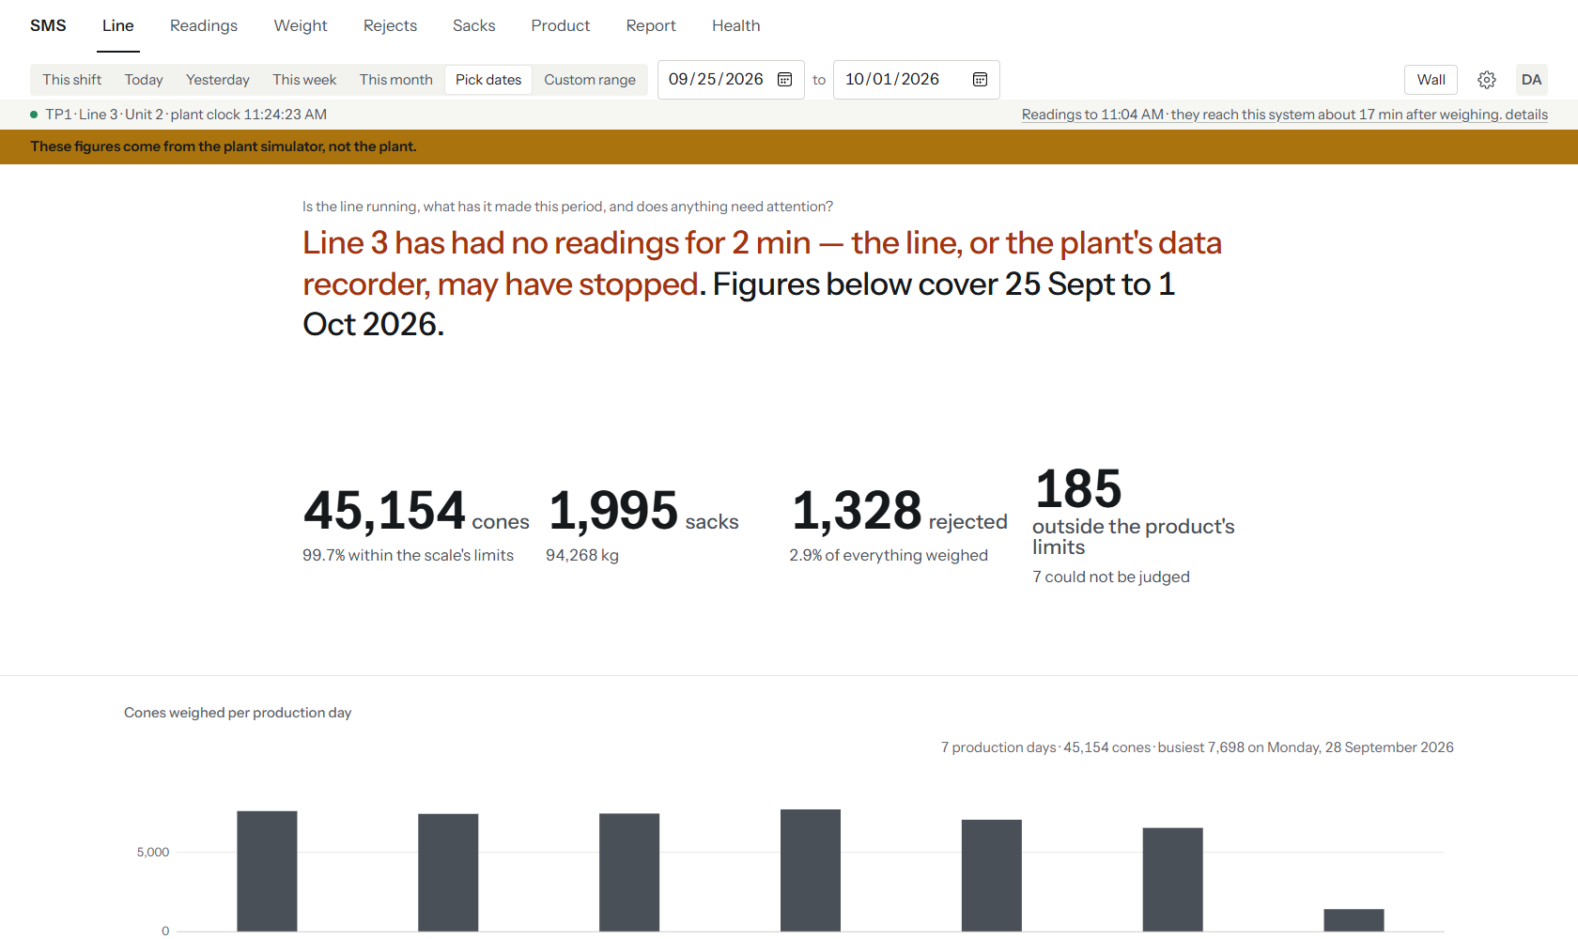
Figure 20 — Line screen with Pick dates chosen: the two date boxes (25 Sept to 1 Oct) appear in the top bar beside the period buttons, and every screen name stays visible.
- Press Pick dates.
- Enter the first and last day in the boxes.
- Read the screen; it now covers those days.
The initials button at the right of the bar opens the account menu.
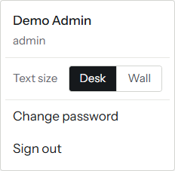
Figure 21 — The account menu: name Demo Admin, role admin, Text size with Desk and Wall choices, Change password, Sign out.
- Text size switches between Desk (normal) and Wall (larger, for a screen read from a distance).
- Change password opens a small form.
- Sign out ends the session.
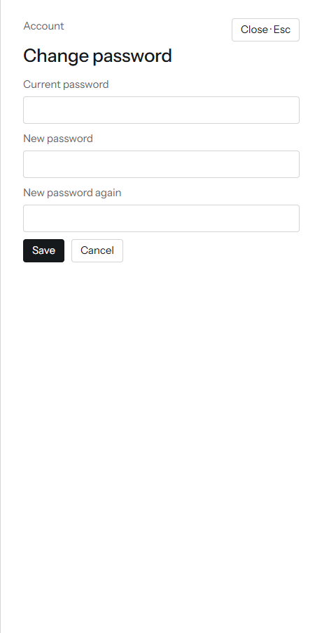
Figure 22 — The Change password panel, empty: Current password, New password, New password again, Save and Cancel.
To change your own password:
- Open the account menu and choose Change password.
- Type the current password, then the new one twice.
- Press Save. Press Cancel, or the Esc key, to leave without saving.
An administrator can also reset another person's password from Setup; see section 6.3 and Chapter 10.

7.2 Line: is it running right now?
Line is the screen SMS opens on. It answers one question: is the line running, what has it made this period, and does anything need attention?
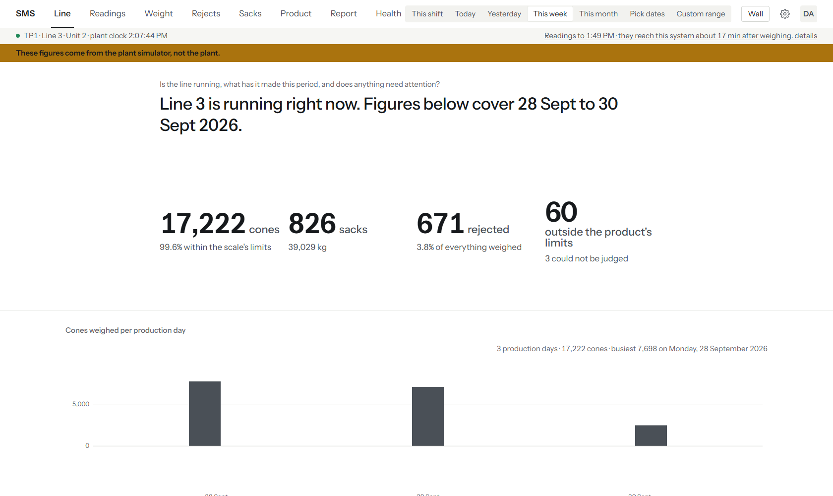
Figure 23 — Line screen, This week, on the demo: the headline "Line 3 is running right now", 17,222 cones, 826 sacks, 671 rejected, 60 outside the product's limits, and the start of the cones-per-day chart. The station bars and the Attention block lie below the visible part of the screen.
- Press Line in the top bar.
- Choose a period. This shift shows the current shift so far.
- Read the headline first. It says whether the line is running, stopped or idle, and how far into the shift it is.
- Look at the Attention block. If it lists something, press See them.
- To see which product each machine is making, read "What is being made".
Figure 24 — The Attention block on the demo: one finding, cones passed by the scale that sit outside the product's limits, with a See them link.
Part | What it tells you
Headline ("Line 3 is running — 7 h 44 min into the morning shift…") | Whether the line is running, based on when the newest reading arrived, corrected for the 18-minute delay. When the data link is unhealthy the headline refuses to say.
The four big figures | Cones weighed and the share within the scale's limits; sacks and their weight; cones rejected; and cones the scale passed that sit outside the product's own limits.
Cones weighed per shift | A shape comparison between shifts. With only one shift in the period it says so, as in the figure; choose This week to see it.
Attention | Things that need a person to look: cones outside product limits, a station reading consistently heavy or light, a rising reject rate. It always looks back 14 production days, whatever period you chose.
Stations bars | One bar per station: cones this period against the middle station. A station with many rejects shows its count underneath. The demo's station 7 has 38 rejected.
What is being made | The product each machine is running now, and for how long at least. It is anchored on the newest reading, not on your chosen period. The Change and History buttons open the Product screen.
Last readings | The most recent sack and cone. Click either to open its record.

7.3 Readings: every cone and every sack
Readings is the register. It lists each cone or sack that was weighed, newest first, so you can look up one reading or scan a stretch of them.
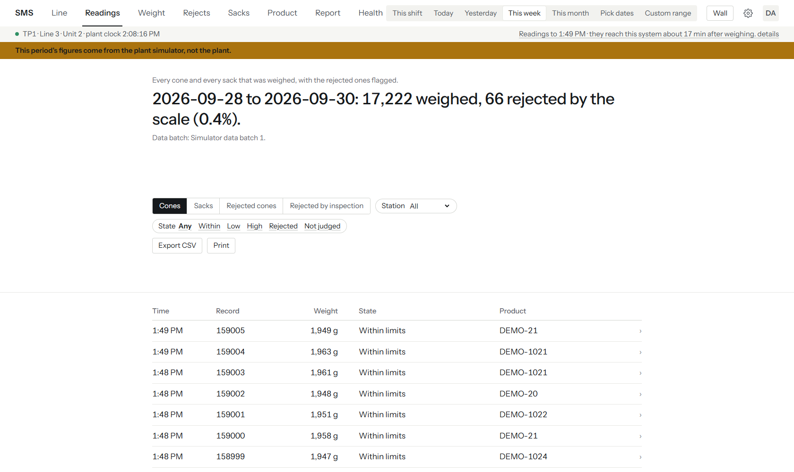
Figure 25 — Readings, Cones list for This week: the headline, the Cones, Sacks, Rejected cones and Rejected by inspection tabs, the Station and State filters, Export CSV and Print, and the first rows of the list with time, record, weight, state and product. The list continues below.
- Press Readings.
- Choose the list with the buttons under the headline: Cones, Sacks, Rejected cones or Rejected by inspection.
- Narrow the cones list with the Station box and the State buttons.
- Press any row to open its record.
- Use Next and Previous at the foot of the list to page through it.
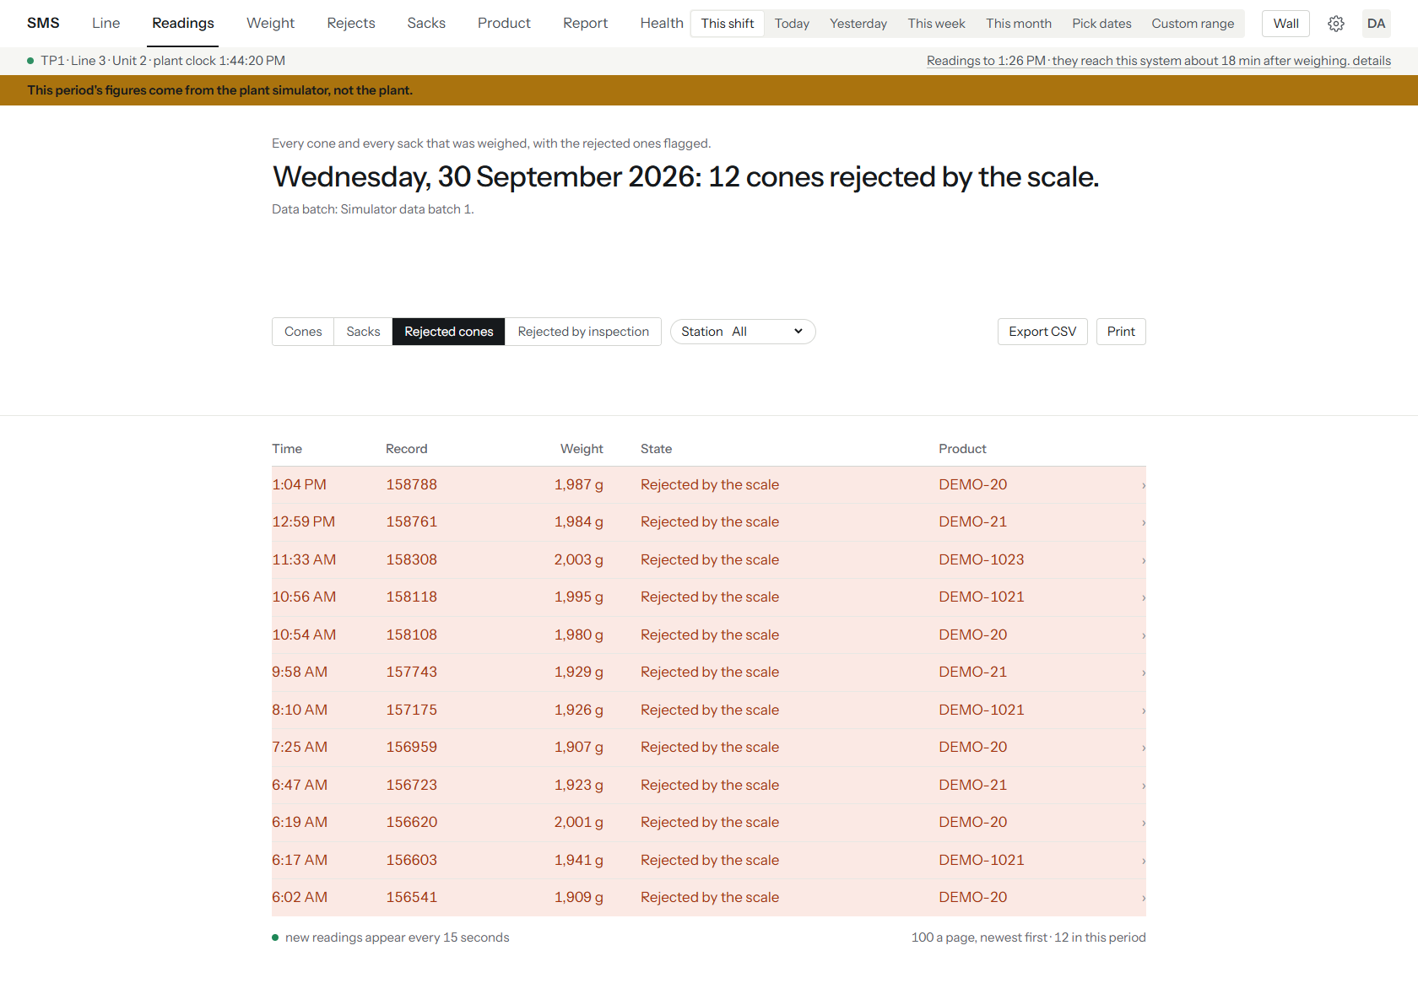
Figure 26 — Readings, Rejected cones list: 12 cones the scale rejected this shift, shaded, each with its time, record number, weight and product.
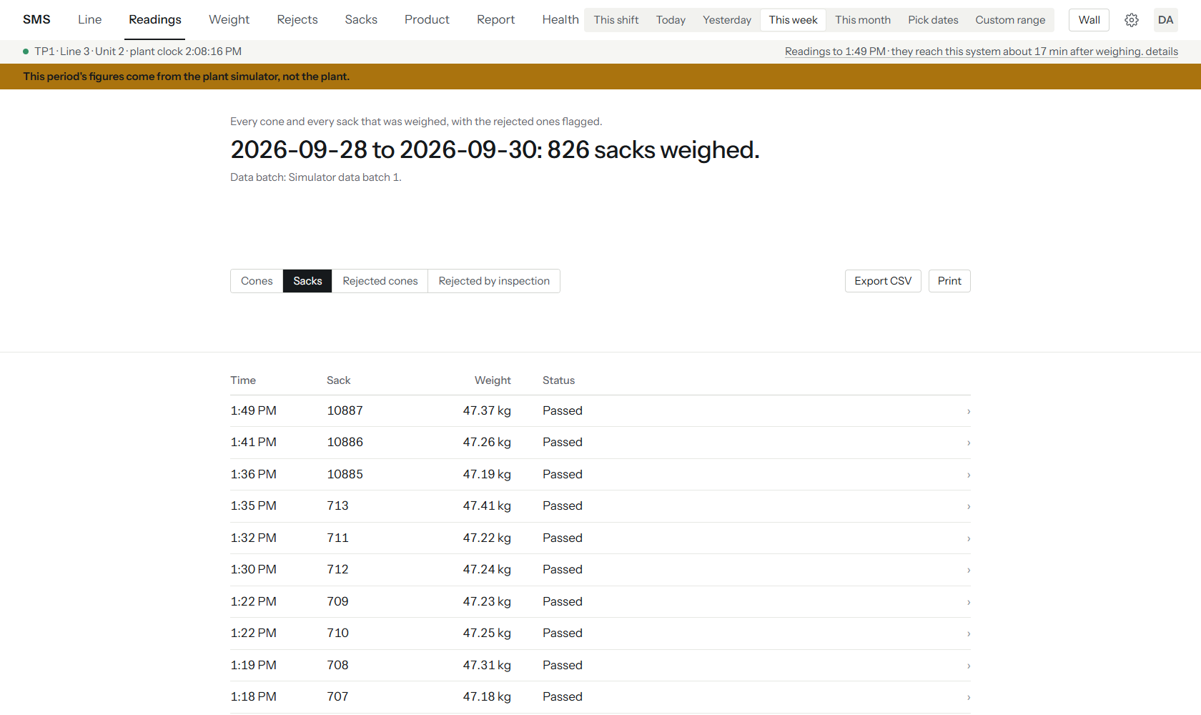
Figure 27 — Readings, Sacks list for This week: 826 sacks, the first rows with time, sack number, weight and Passed status, and Export CSV and Print.
Part | What it tells you
Headline | How many were weighed and how many the scale rejected in the period.
Data batch line | Which batch of source data this period comes from. On the demo it reads "Simulator data batch 1".
State column | The scale's own verdict: Within limits, or Rejected by the scale. A second fact, "outside the product's limits", appears only where a product was recorded for that reading.
Export CSV | Downloads the list you are looking at as a spreadsheet file (manager or above).
Print | Prints the list with the line, period and time it was produced in the page header.
"new readings appear every 15 seconds" | The list refreshes itself while you look at it.

Press a cone, sack or rejected row to open its record.
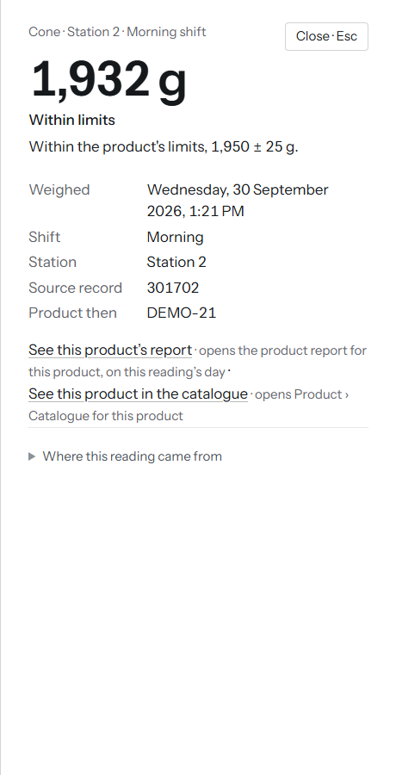
Figure 28 — Cone record: 1,932 g, Within limits, from station 2 on the morning shift, weighed at 1:21 PM, source record, product DEMO-21 at that time, with links to the product's report and catalogue.
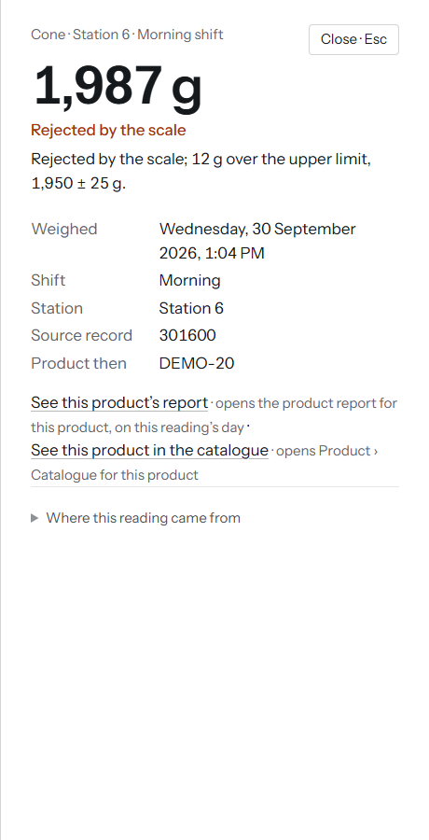
Figure 29 — Cone record for a rejected cone: 1,987 g, "Rejected by the scale; 12 g over the upper limit", station 6.
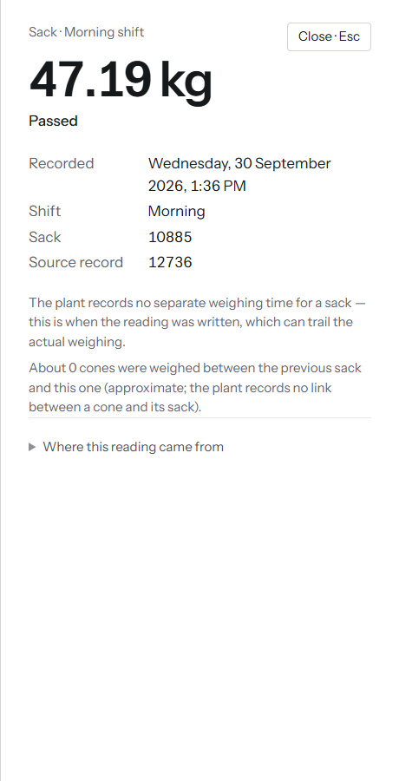
Figure 30 — Sack record: 47.19 kg, Passed, sack number 10885, with the note that the plant records no link from a cone to its sack.
Press the Close button or the Esc key to go back to the list. Note that the sack record says the time is when the plant wrote the reading, which can trail the actual weighing, and that the "cones weighed between this sack and the previous one" figure is an estimate; SMS does not know which cones went into which sack.

7.4 Weight: are the cones the right weight?
Weight answers whether cones are at the right weight and whether any station's scale needs attention.
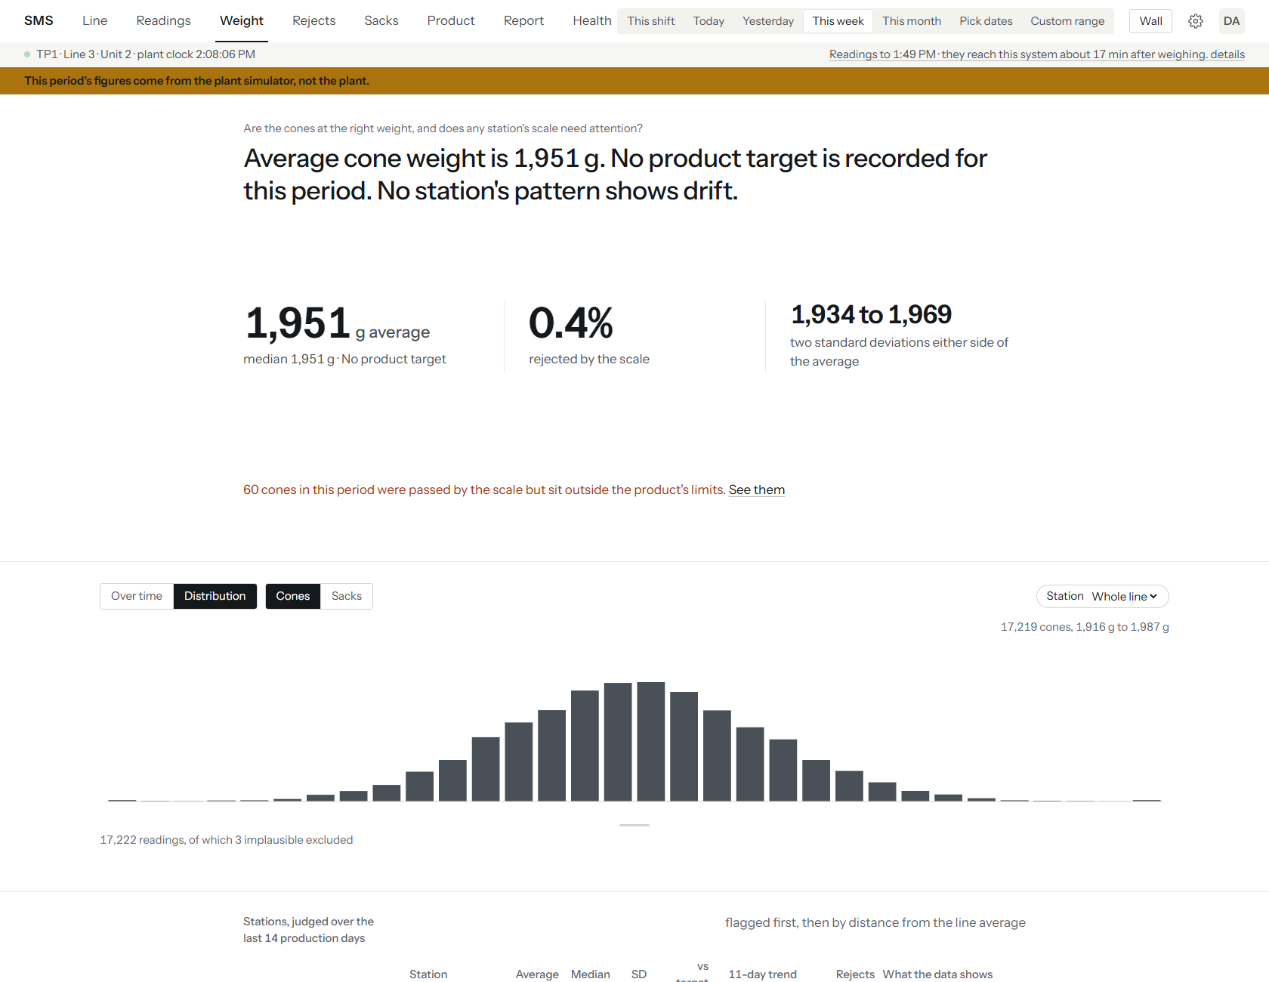
Figure 31 — Weight, This week, Distribution view: average cone weight 1,951 g, "No product target is recorded for this period", the two-standard-deviation range, and the bell-shaped spread of the cones. The station table lies below the visible part of the screen.
Note: The demo has no product target recorded for the line as a whole, so this screenshot has no target or limit lines on the chart and the headline says so. On a real installation with a running product recorded you will see them.

- Press Weight and choose a period.
- Read the headline: the average cone weight and, where a target exists, how it compares.
- Use the buttons above the chart to switch between Over time and Distribution, and between Cones and Sacks.
- Use the Station box to look at one station instead of the whole line.
- Press a station's name in the table to open its record.
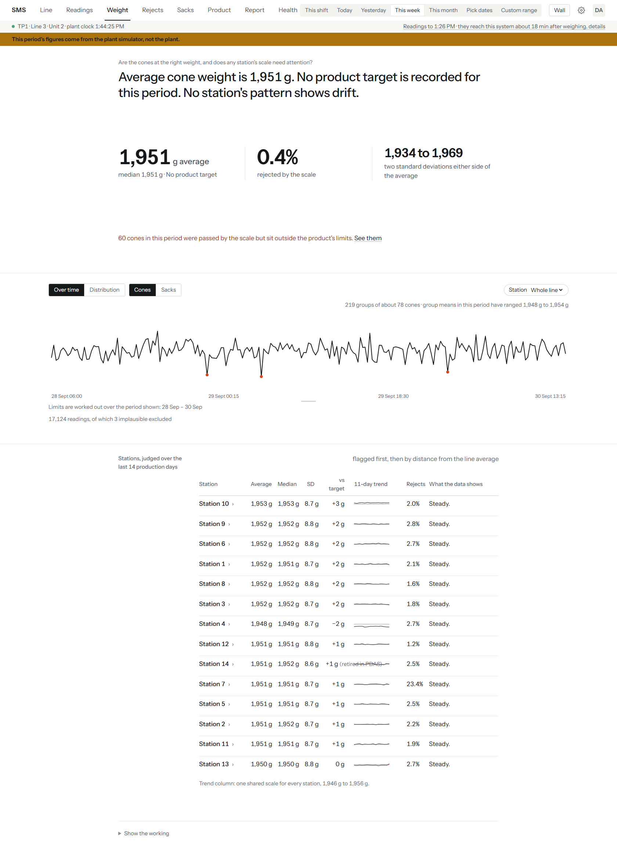
Figure 32 — Weight, This week, Over time view: group means across 17,124 readings, with three unusually low groups marked in red.
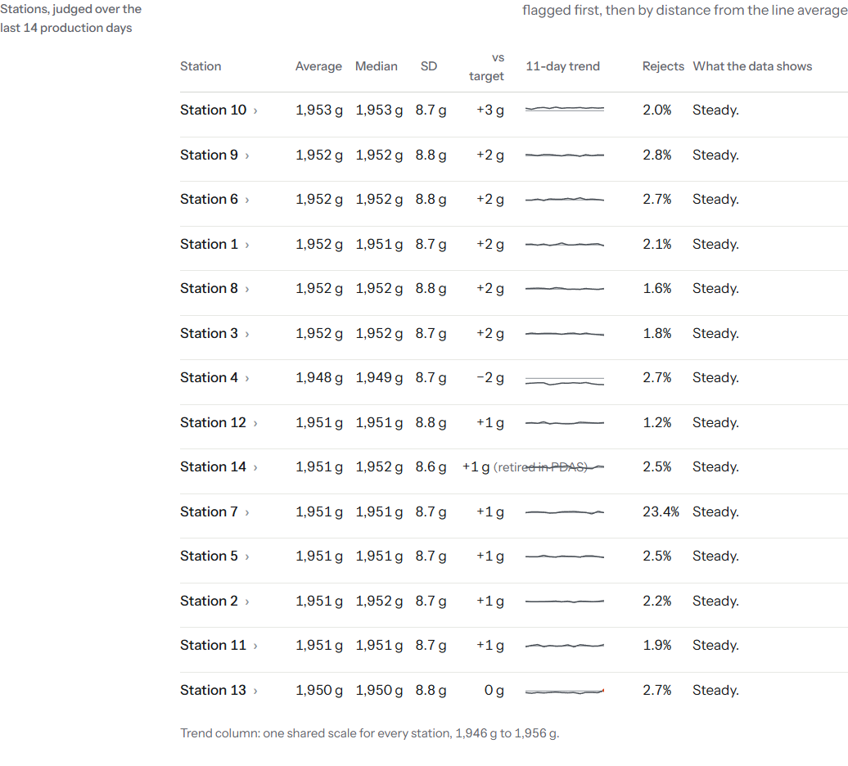
Figure 33 — The station table on Weight, This week: each station's average, median, spread, difference from the target, 11-day trend, reject share and verdict. Station 4 sits about 2 g below the others and station 7 rejects 23.4%; every station is still marked Steady.
Part | What it tells you
Average, "rejected by the scale" and "two standard deviations either side" | The centre, the share the scale rejected, and the normal spread of cone weights.
Distribution chart | How many cones fell at each weight. A single bell is healthy; two bumps or a long tail suggest a problem.
Over time chart | The average weight of consecutive groups of cones. Red points are groups that fell outside the usual range.
Station table | One row per station. "vs target" shows how far the station's average is from the target in force. The trend column uses one shared scale so stations compare fairly. The last column says Steady unless a drift pattern has held for several days.
Judged over the last 14 production days | The table always looks back 14 days, whatever period you chose, because a drift needs consecutive days to show.

Press a station to see its detail.
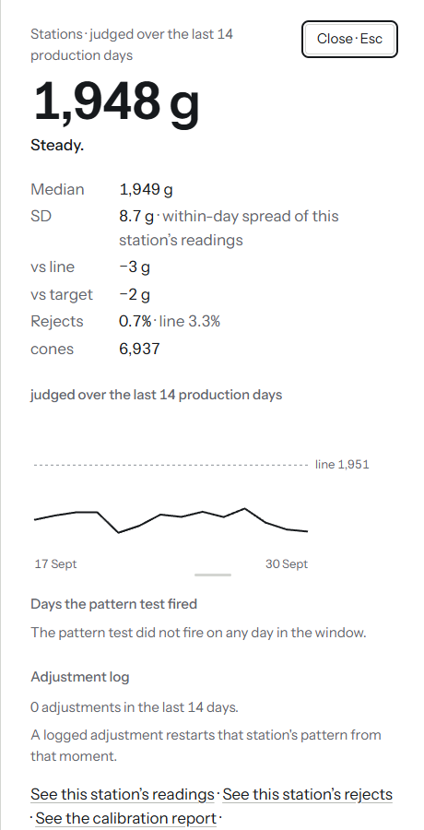
Figure 34 — Station 4's record: average 1,948 g, Steady, difference from the line and target, reject share, 14-day line and adjustment log.
An engineer or above can log that a scale was adjusted, so later readings are judged from that moment on. Scroll to the bottom of the station's record.
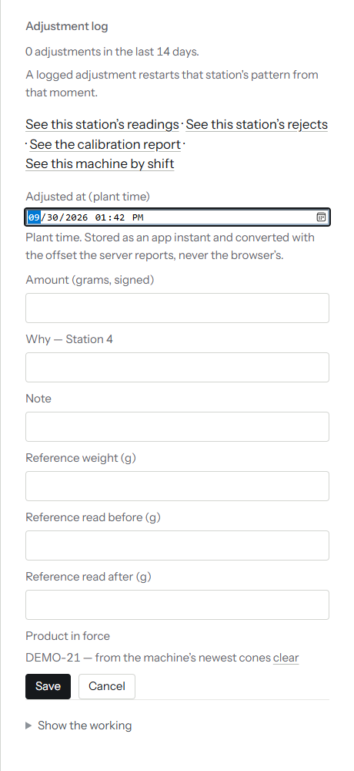
Figure 35 — The station record's adjustment form: when, the amount in grams, why, a note, reference weights, the product in force, Save and Cancel. Nothing was saved when this was captured.
- Open the station from the table.
- Fill in when it was adjusted (plant time), the amount in grams and the reason.
- Press Save. An adjustment cannot be edited afterwards; a correction is a new entry.
The weighing data cannot tell a heavy scale from heavy cones, so SMS never says which way to adjust a station.

7.5 Rejects: why are cones being rejected?
Rejects answers how many cones are rejected, for what reason, whether it is getting worse, and where.
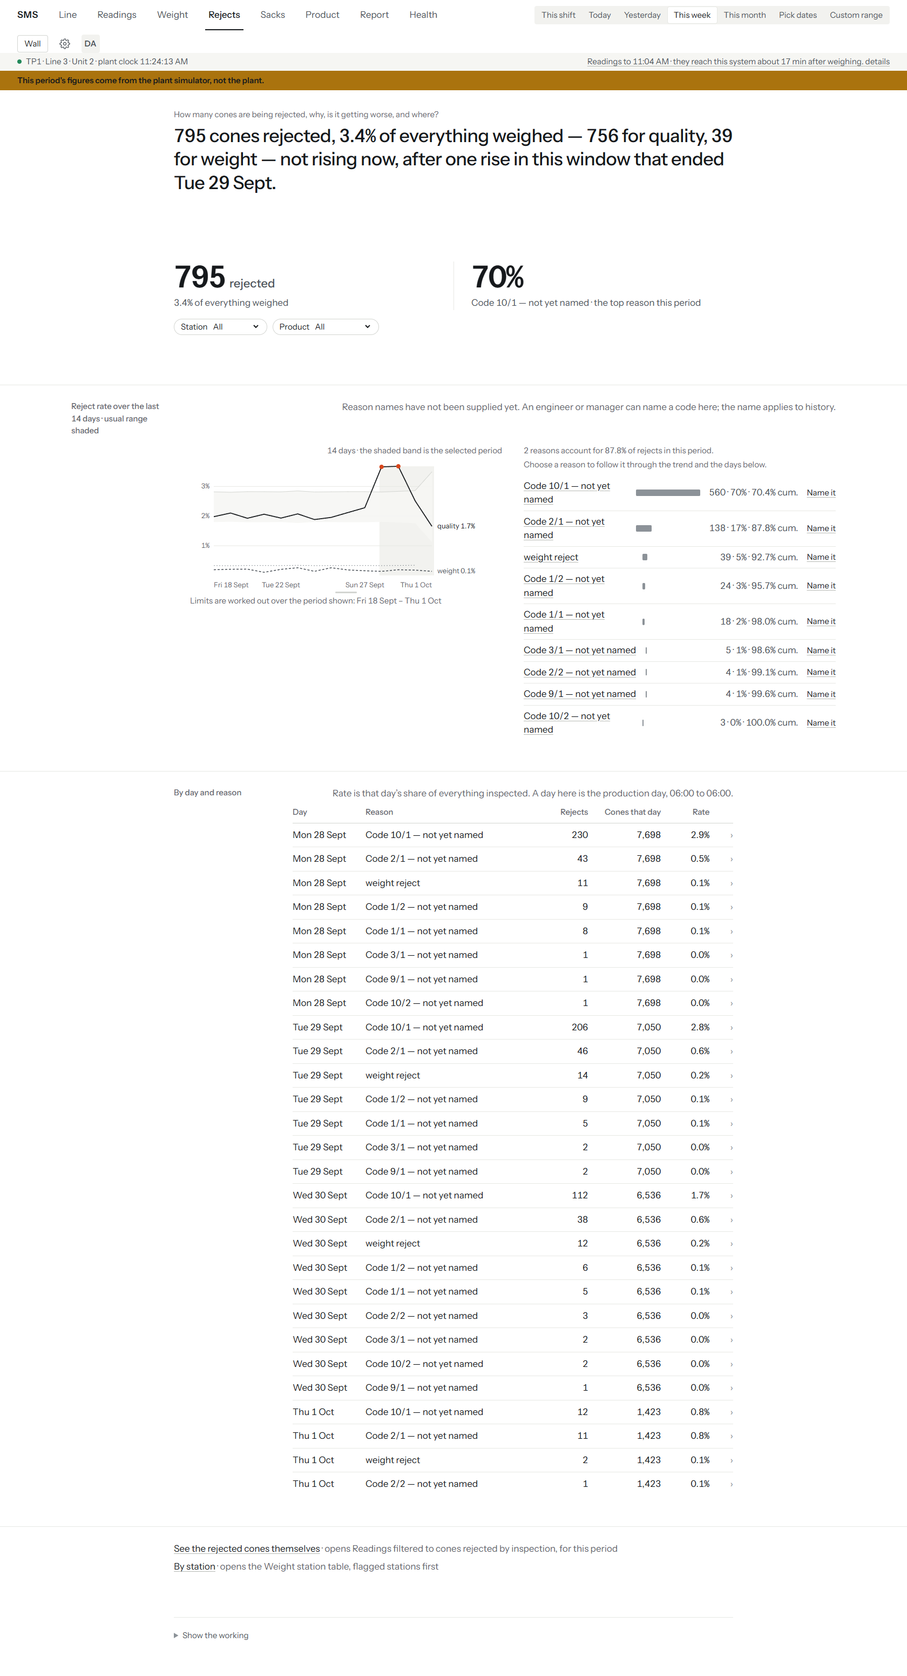
Figure 36 — Rejects, This week: 668 cones rejected (3.8%), Code 10/1 the top reason at 75%, the 14-day reject rate, the reasons chart with a Name it link on each, and the day-by-reason table.
- Press Rejects and choose a period.
- Use Station and Product boxes to narrow the picture.
- Press a reason in the reasons list to follow it through the trend and days.
- Press the same reason again, or the small x on its chip, to clear it.
- To give a reason a name, see below.
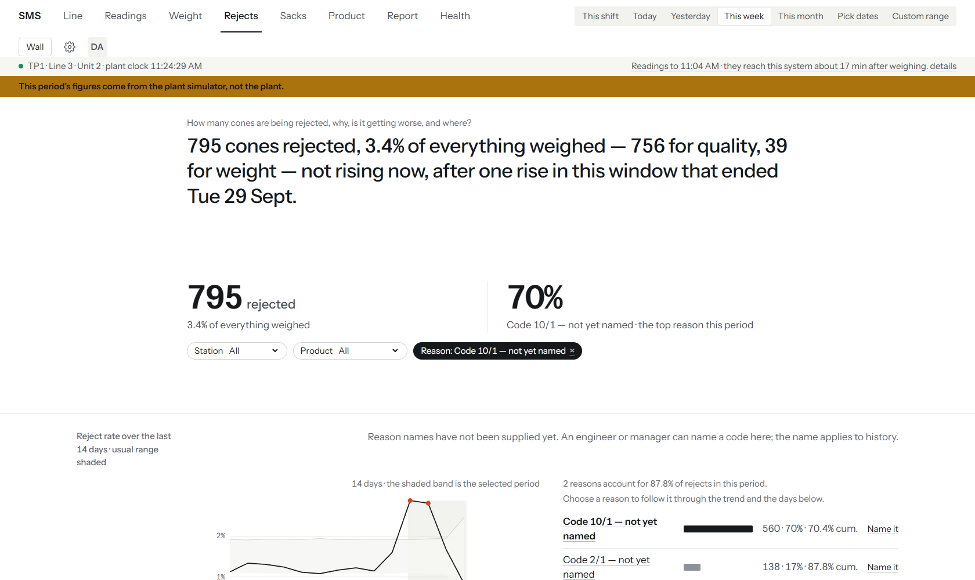
Figure 37 — Rejects with the reason Code 10/1 chosen: a dark chip "Reason: Code 10/1" appears beside the station and product boxes and the headline changes to describe only that reason.
Part | What it tells you
Headline | Total rejected, the share of everything weighed, the split between quality and weight rejects, and whether the rate is rising.
Reject rate over the last 14 days | The line is the reject rate; the shaded band is the usual range; the darker band marks your chosen period.
Reasons list | Each reason with its count, share and running total. Two reasons make up about 90% of rejects in the demo.
By day and reason | Each production day (06:00 to 06:00) and reason with its rate.
See the rejected cones themselves | Opens Readings filtered to the rejected cones for this period.

The plant supplies only numeric codes such as "Code 10/1"; IFL has not yet said what they mean. An engineer or above can type a name for a code and it applies to all past and future readings. (The note on the Rejects screen reads "An engineer or manager can name a code here", matching the server rule.)
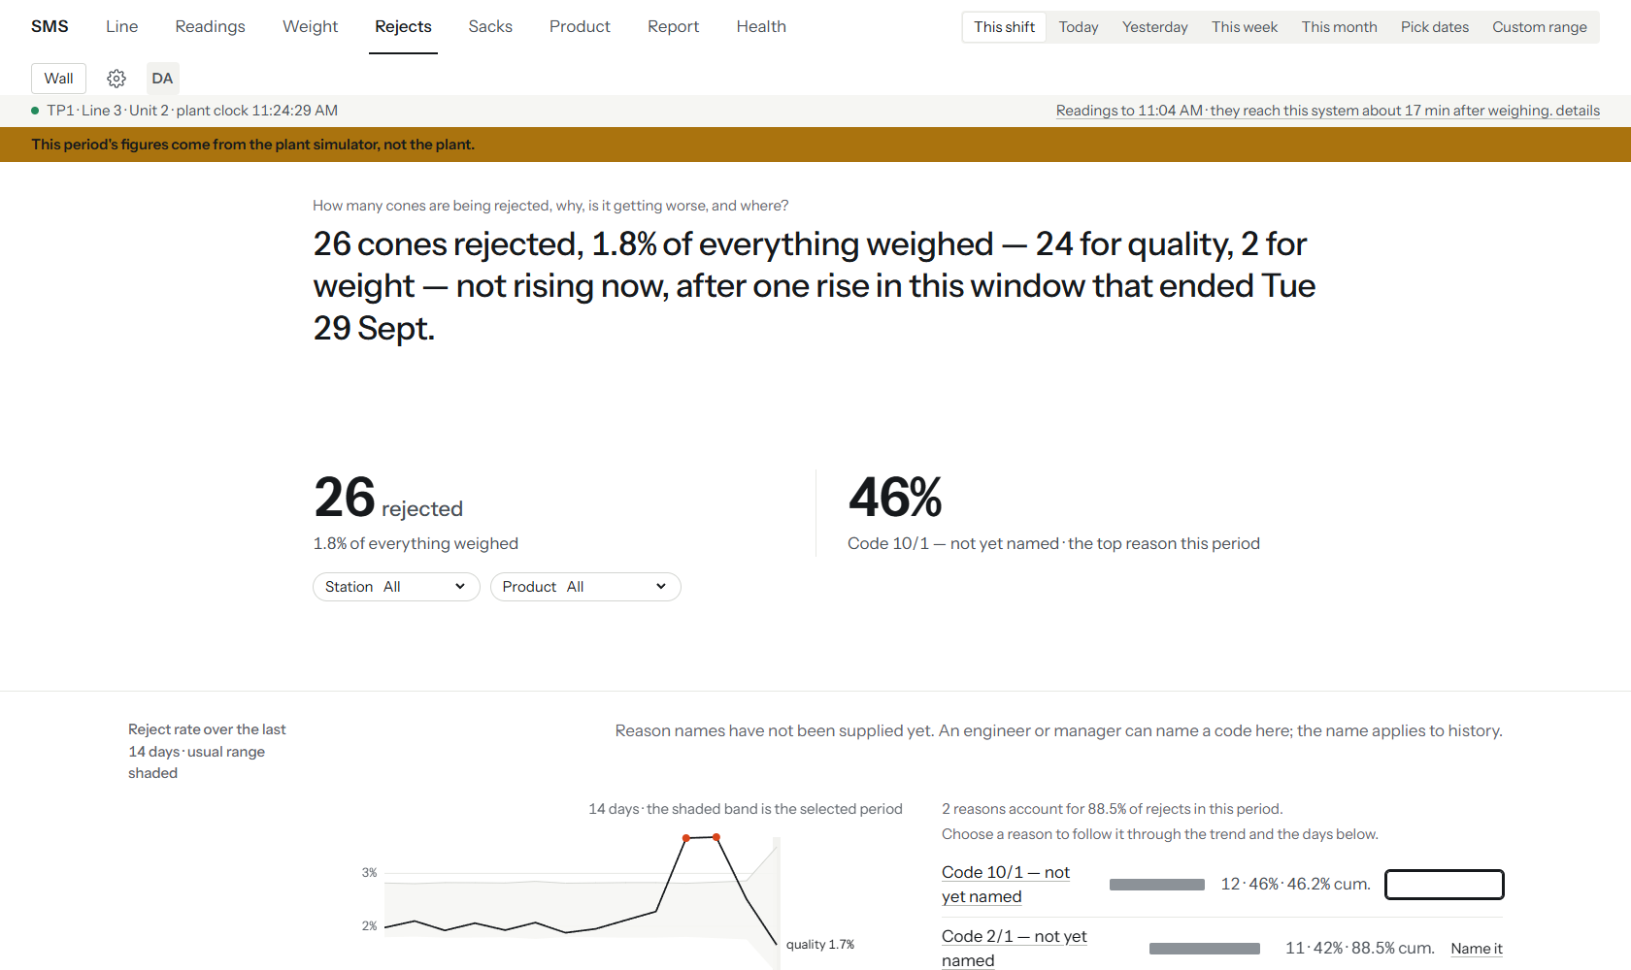
Figure 38 — Rejects, This shift: the first reason's name box is open in the reasons list (an empty outlined box beside the bar). Nothing was saved.
- Find the reason in the list and press Name it.
- Type the name and confirm it.

7.6 Sacks: how many sacks and what is in stock
Sacks reports on sacks weighed, their weight, and a running line stock.
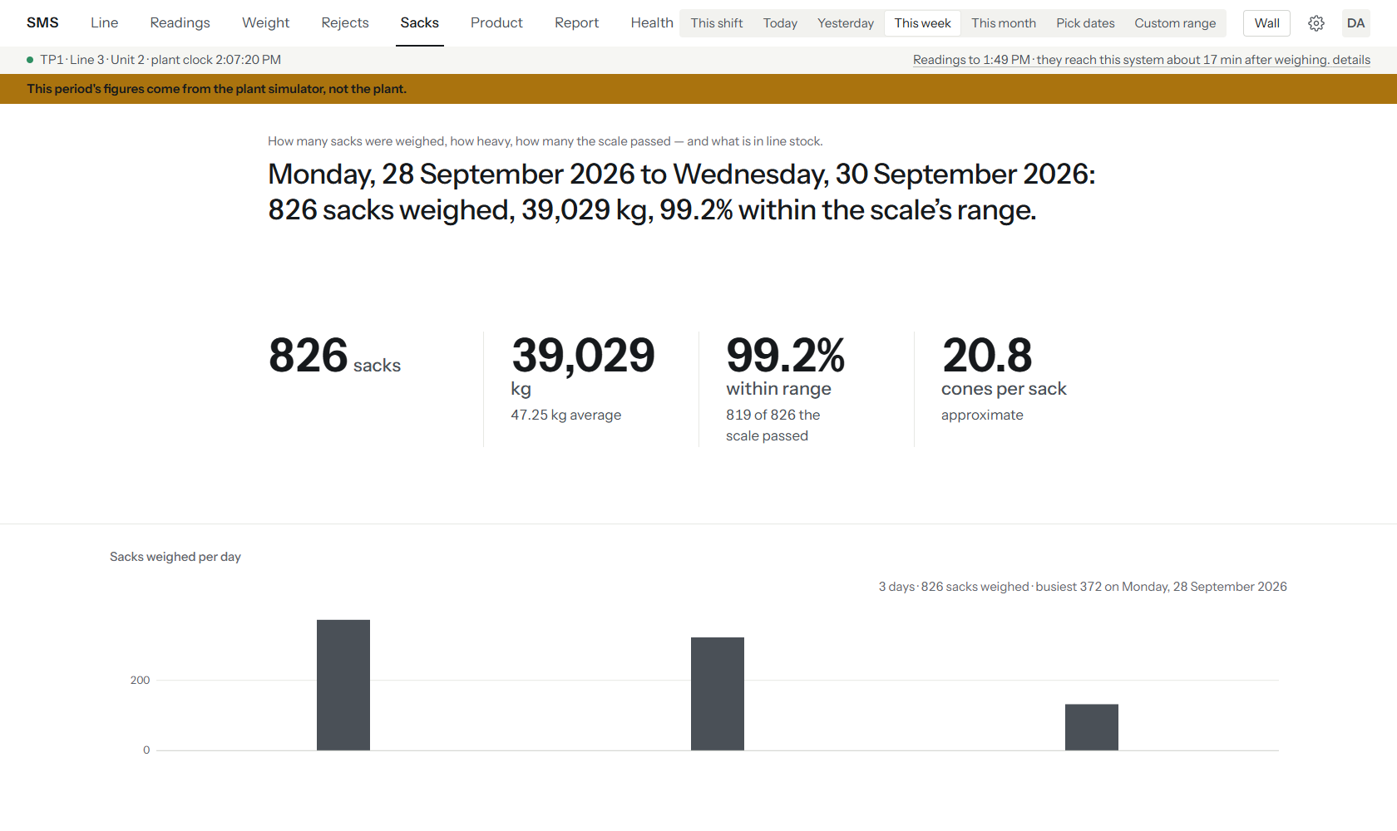
Figure 39 — Sacks, This week: 826 sacks, 39,029 kg, 99.2% within range, 20.8 cones per sack, and the sacks-per-day chart. The blocks below (By product, By shift, Stock ledger, Sack history) are not in this picture.
- Press Sacks and choose a period.
- Read the headline and the four figures.
- Scroll to By shift to compare Morning, Evening and Night.
- Scroll to Stock ledger for the line's stock, opening and closing per day.
- Press any row of the Sack history to open the sack's record.
Part | What it tells you
"cones per sack, approximate" | An estimate only; the plant records no link between a cone and its sack.
By product | Sacks grouped by product. On the demo all sacks say "No product on the reading", because sack readings carry no product.
Stock ledger | Opening stock, receipts (each sack weighed counts as a receipt), issues, consumption, adjustments and closing. It is stock for the whole line, never per machine: the plant's sack records carry no machine.

Press a day in the ledger to see that day's movements.
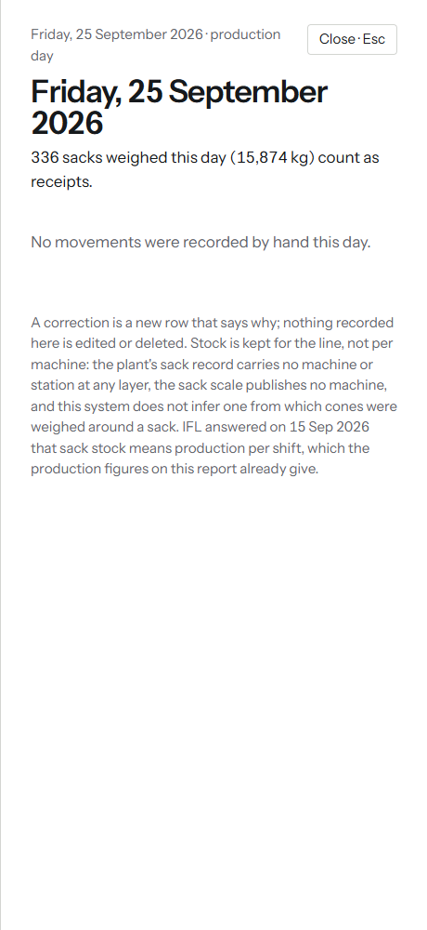
Figure 40 — A day in the stock ledger, Friday 25 September: 336 sacks (15,874 kg) counted as receipts and no movements recorded by hand.
An engineer or above can record a movement made by hand, such as sacks issued.
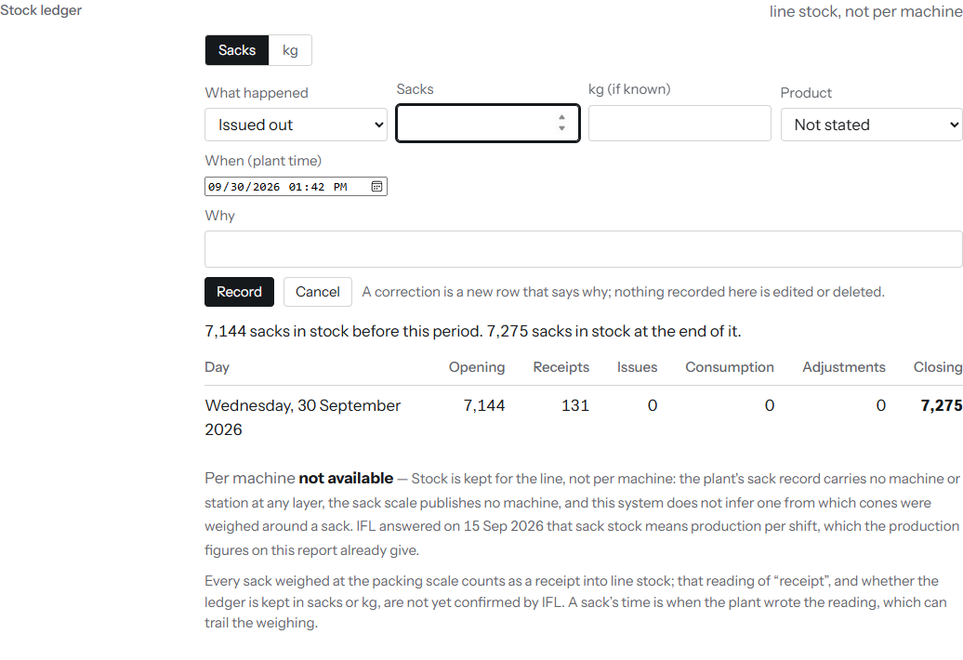
Figure 41 — The stock movement form: what happened (Issued out), number of sacks, kg if known, product, when, why, Record and Cancel. Cancelled when captured.
- Press Record a movement in the Stock ledger.
- Choose what happened, and enter the sacks (or kg), the plant time and a reason.
- Press Record. Nothing recorded can be edited or deleted; a correction is a new row that says why.

7.7 Product: what is running, and how to change it
Product has four tabs: Running, Changeover, Catalogue and History.

7.7.1 Running
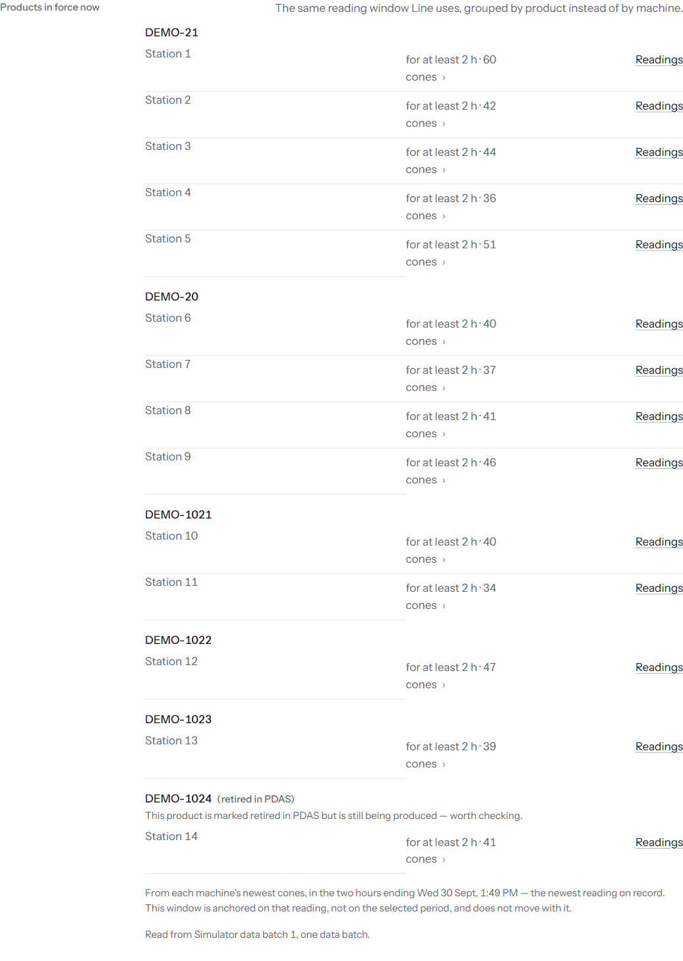
Figure 42 — Product, Running tab, the "Products in force now" block: six products with their stations. DEMO-1024 on station 14 is marked "(retired in PDAS)" with the note "This product is marked retired in PDAS but is still being produced - worth checking."
The tab lists each product currently being made and the stations making it, using the same readings as Line. A product marked "(retired in PDAS)" that is still being produced deserves a check: someone retired it in the product database but a station still runs it.
To record the line's product in SMS (engineer or above):
- On the Running tab, press Change.
- Pick the product and give a reason if you wish.
- Press Record this product.
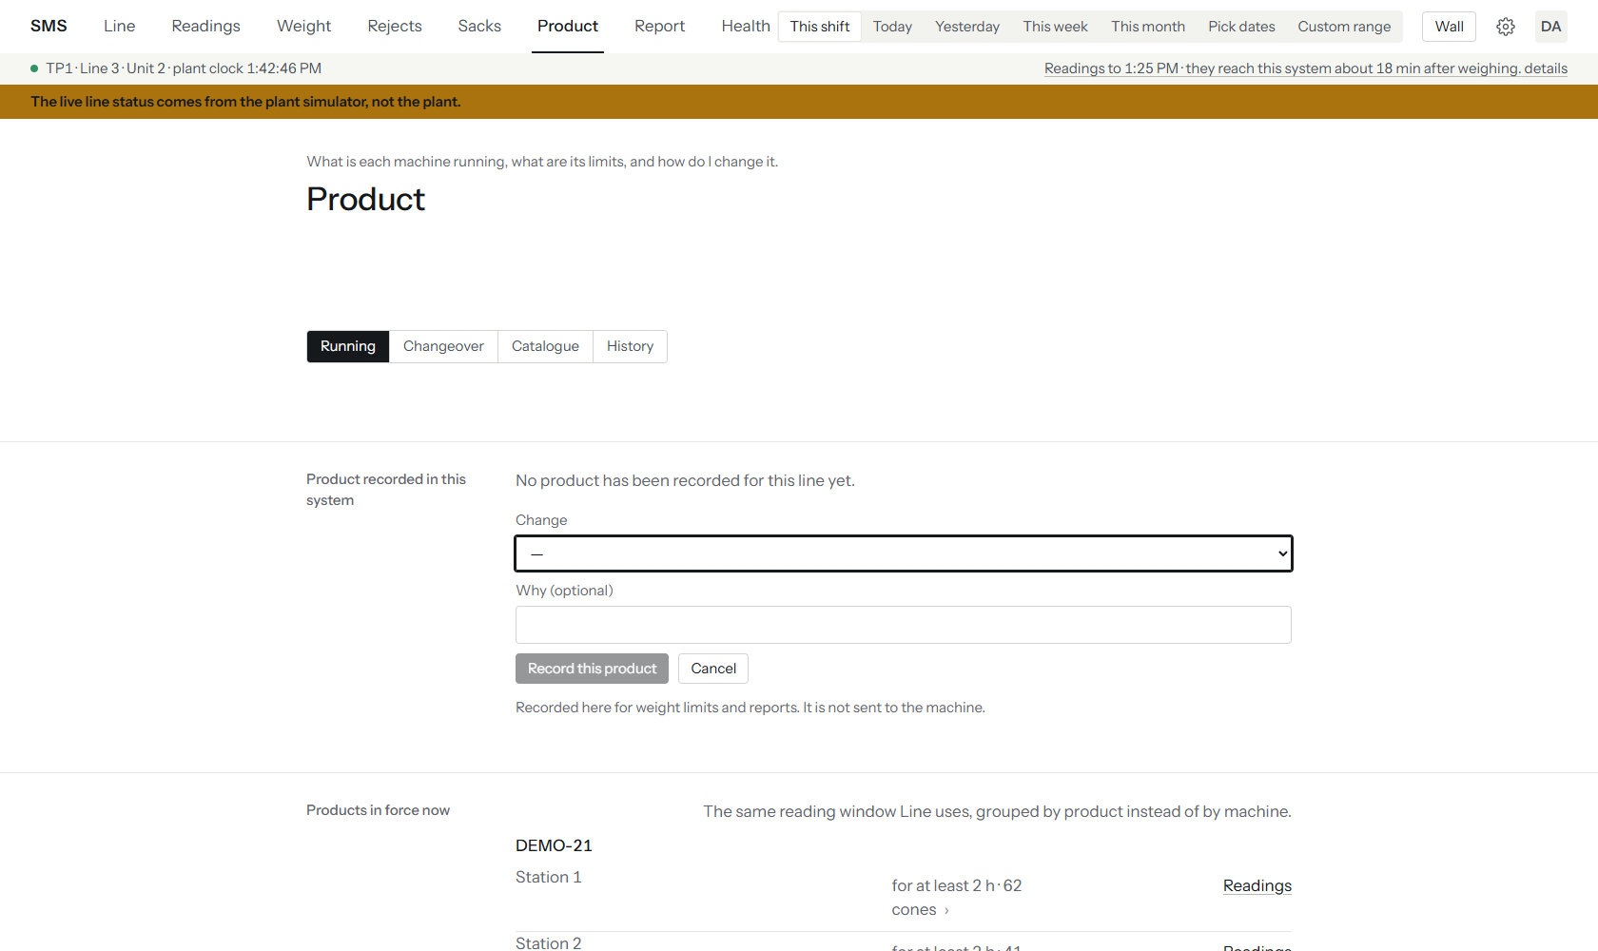
Figure 43 — The Running tab with the Change form open: a product picker, an optional reason, Record this product and Cancel.
This records the product in SMS for weight limits and reports only. It is not sent to the machine.

7.7.2 Changeover
The Changeover tab plans a product change and checks it for problems before anything is written.
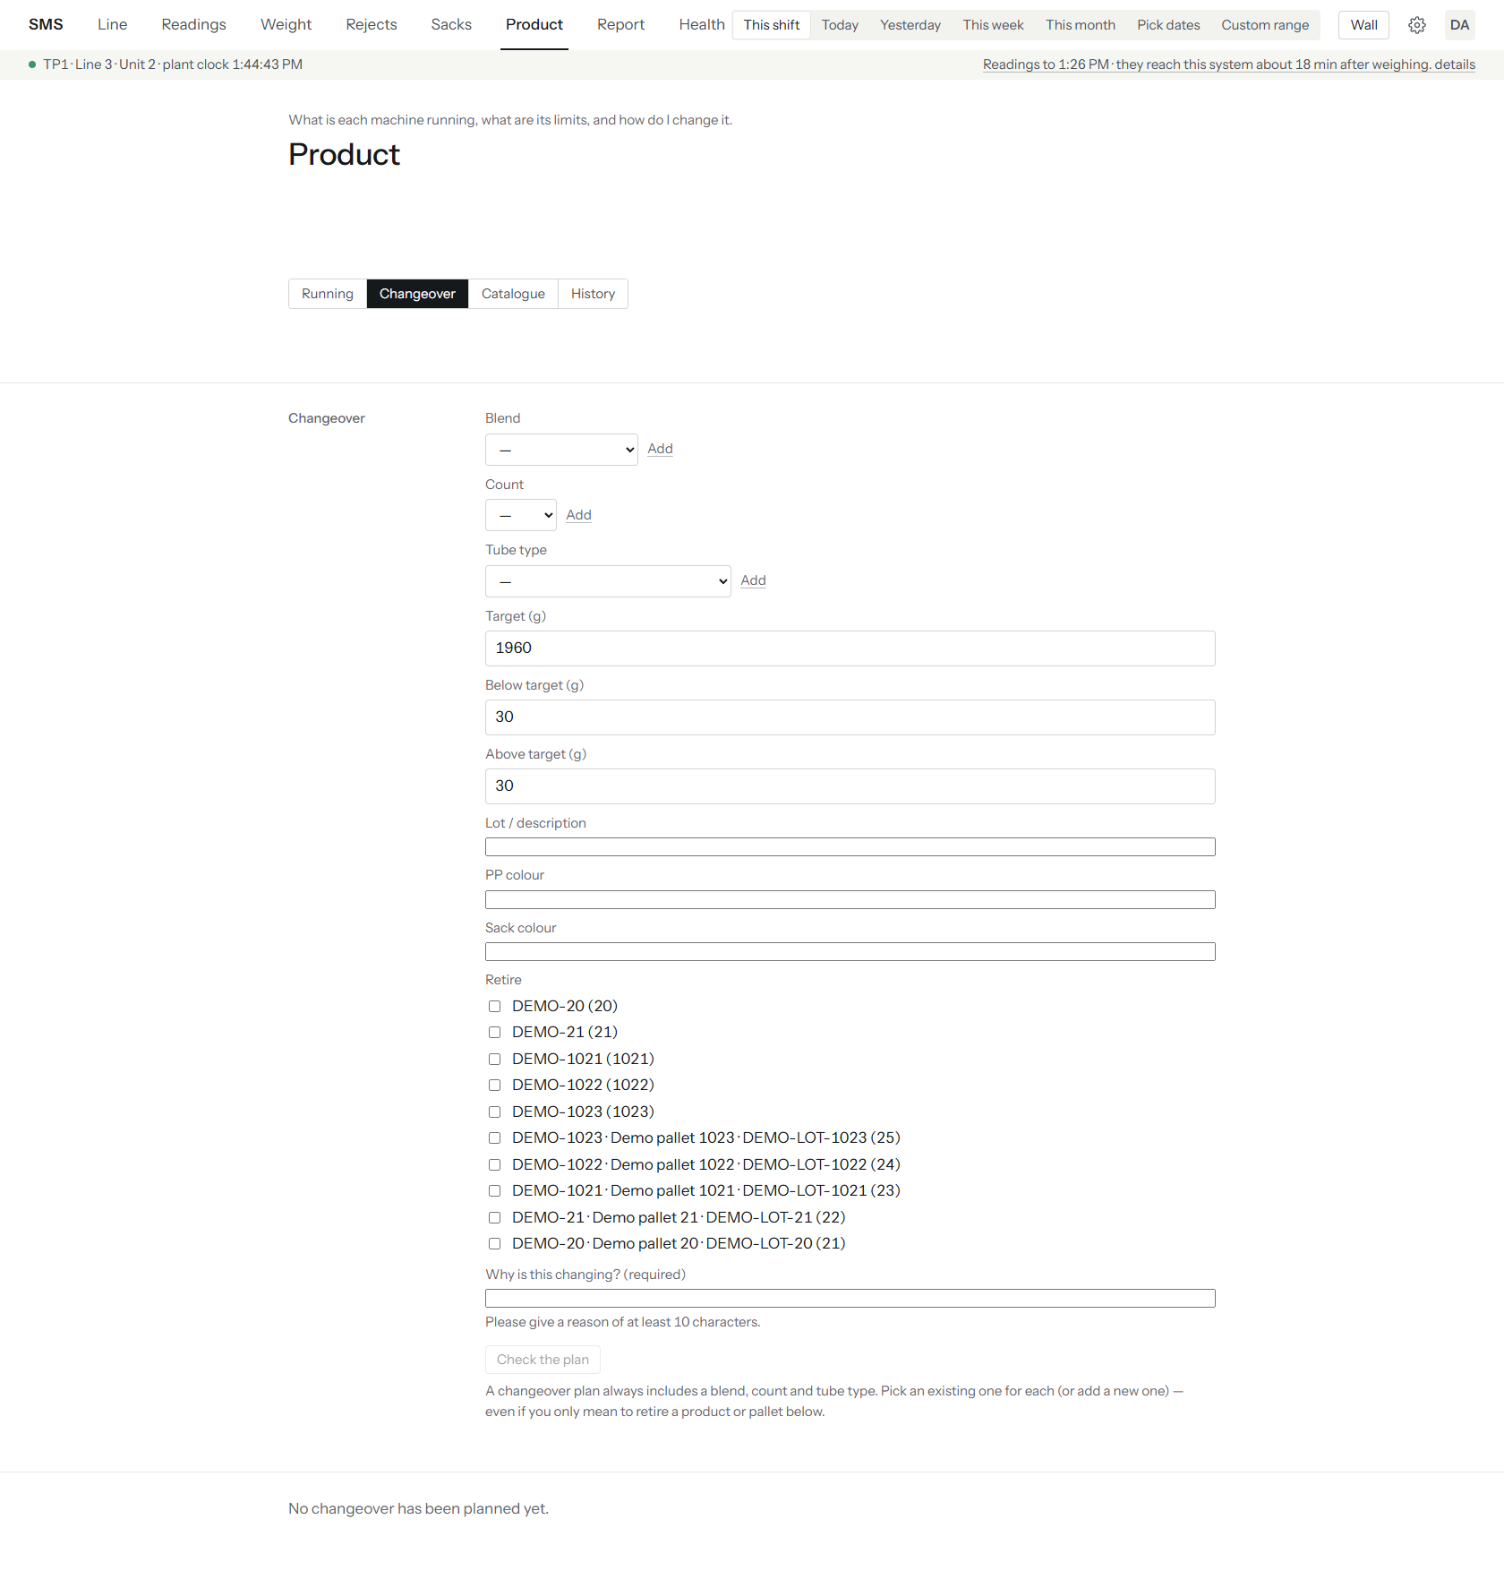
Figure 44 — Changeover tab, empty: pickers for blend, count and tube type, Target 1960 g, below and above 30 g, lot and colours, a Retire checklist, a required reason and the Check the plan button.
- Pick an existing blend, count and tube type, or press the Add link beside one to create a new one.
- Set the target weight and the amounts below and above it, and type a lot / description (the plan is blocked without one).
- Tick anything to retire, and type the reason (at least 10 characters).
- Press Check the plan.
- Read the plan and any Blockers.
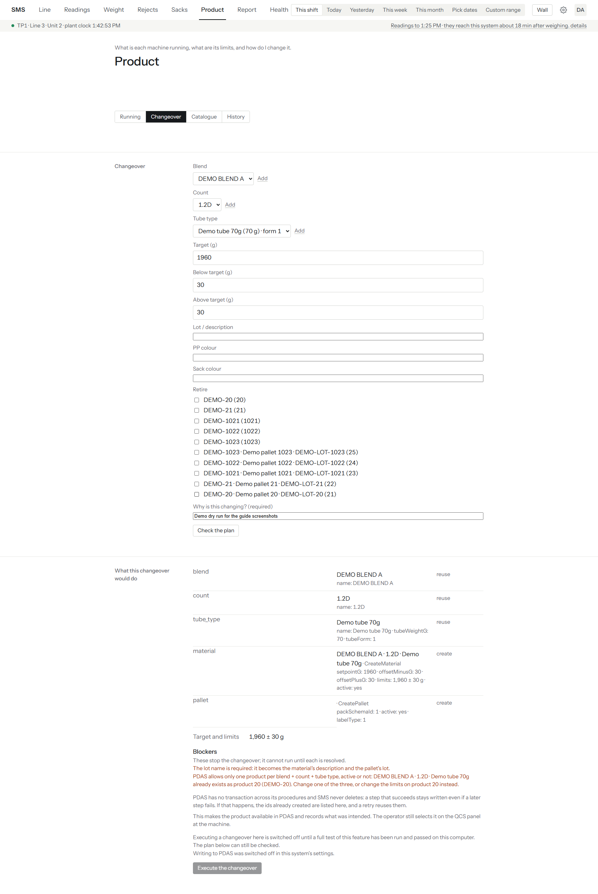
Figure 45 — Changeover dry run: DEMO BLEND A, 1.2D and Demo tube 70g re-used, a new material and pallet planned, a Blocker saying that product already exists as product 20, and a greyed Execute the changeover button.
The plan lists each step (re-use or create) and lists Blockers in red. Here the blocker says PDAS allows only one product per blend, count and tube type, so this plan cannot run; the fix it suggests is to change the limits of the existing product instead.
Warning: Executing a changeover is switched off in this release. The button Execute the changeover stays greyed and the screen says why: writing to PDAS is disabled until a full test has passed on the plant PC. The plan can still be checked as often as you like; checking never writes anything. See section 6.4 for the conditions for turning writes on. Also, retiring a product and creating it again with the same blend, count and tube type cannot work, by PDAS's own design; change the limits of the existing product instead.

7.7.3 Catalogue
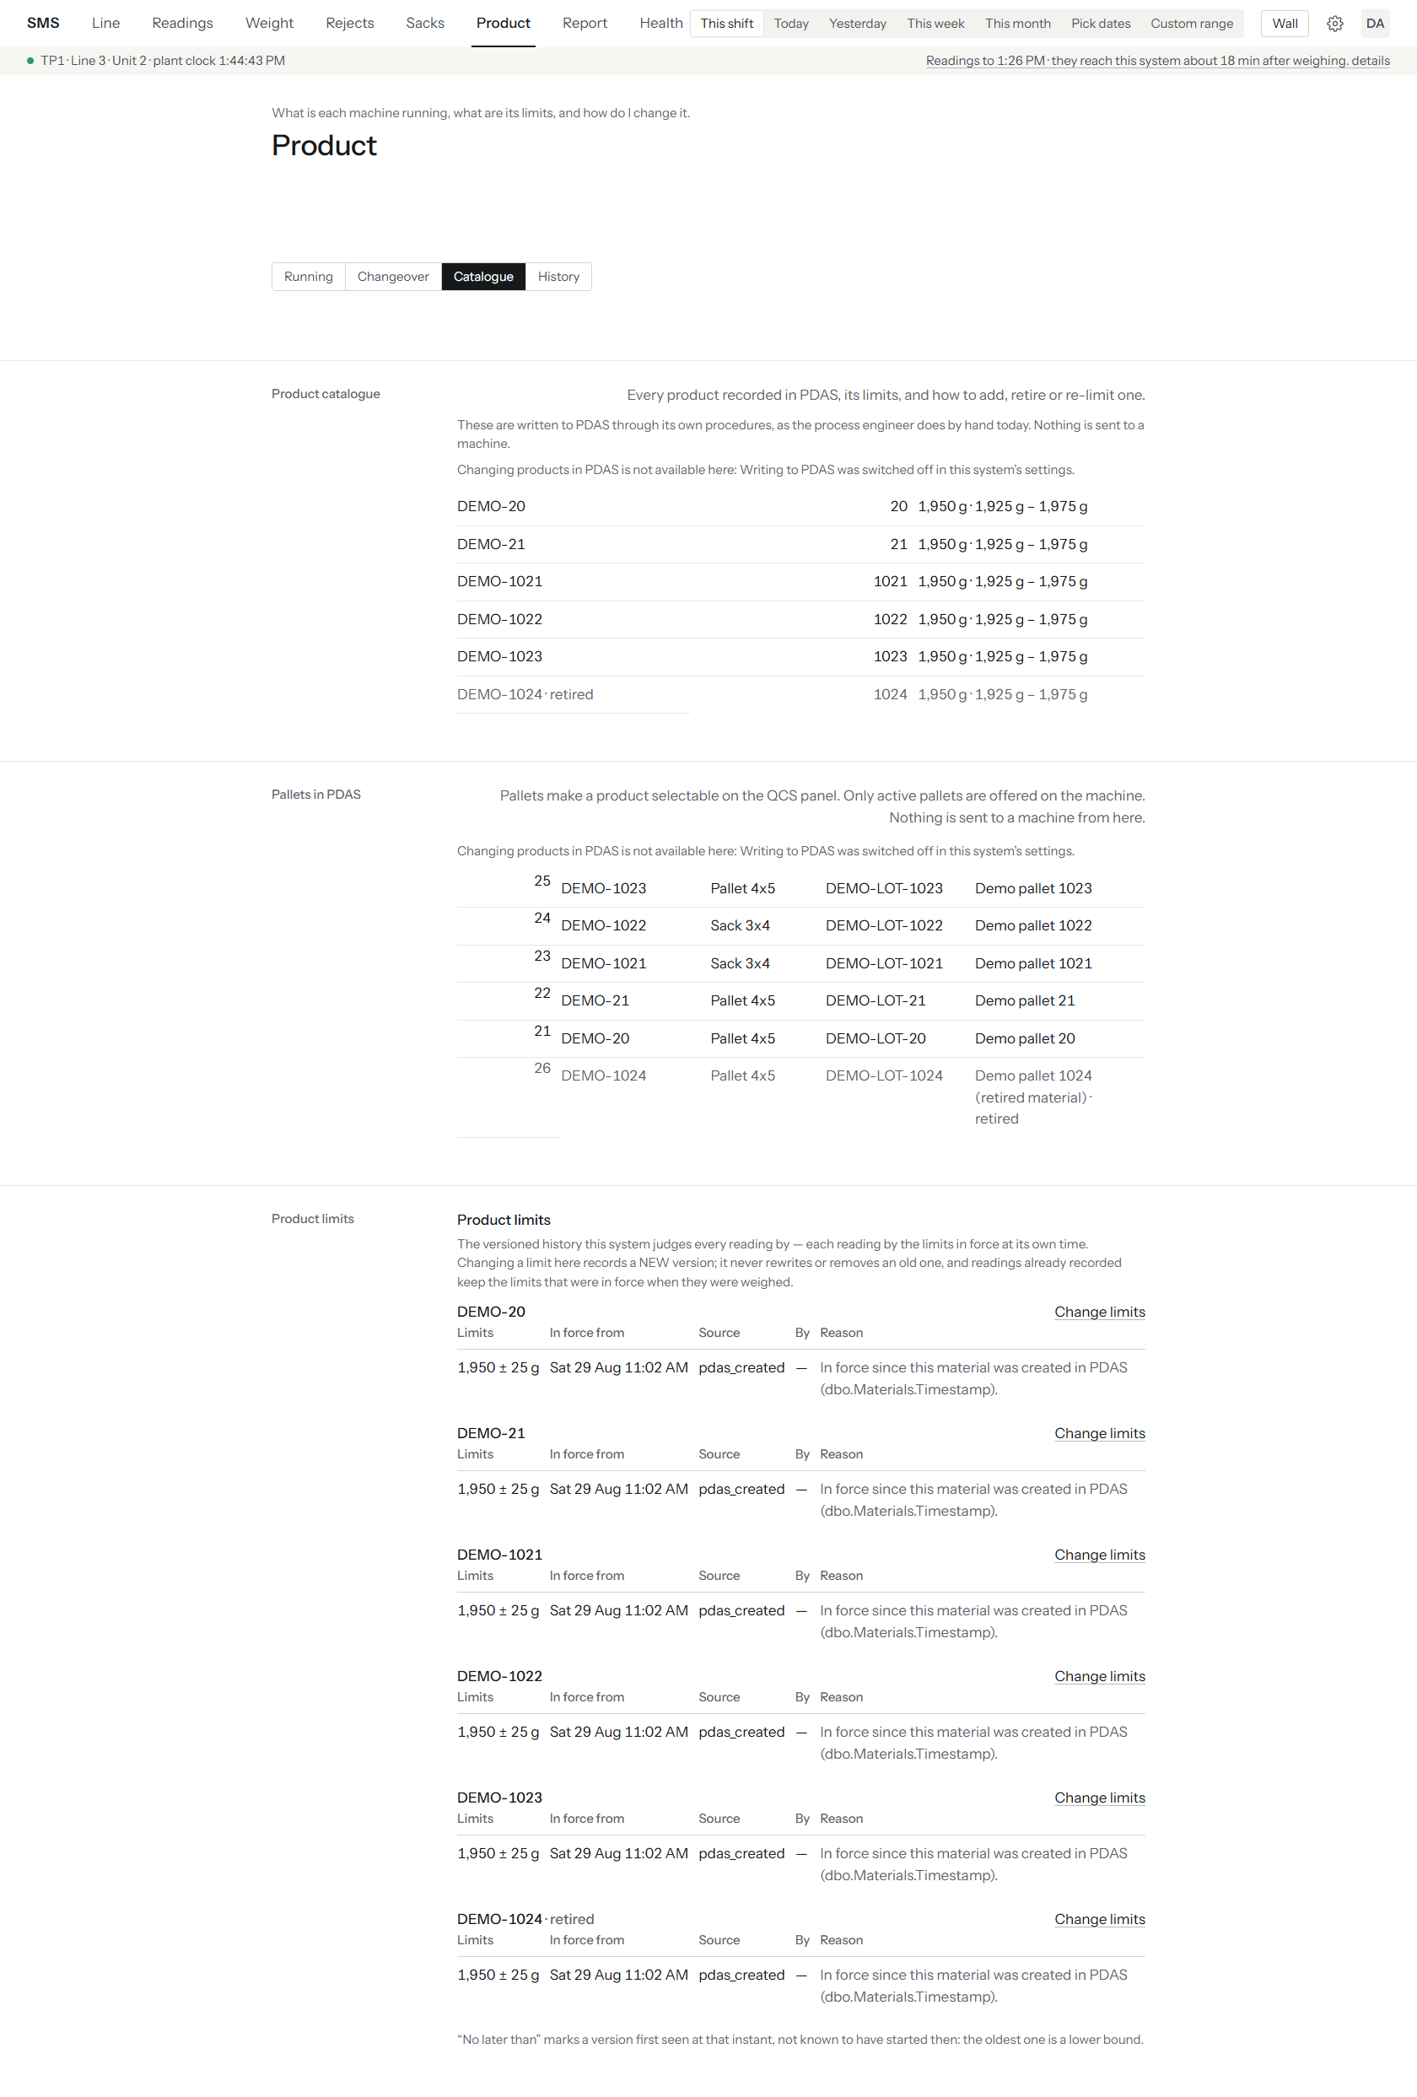
Figure 46 — Catalogue tab: every product recorded in PDAS with its target and limits, the pallets, and the versioned limits history with a Change limits link per product; a notice says writing to PDAS is switched off.
The tab shows products, pallets and each product's limits history. Every reading is judged by the limits in force when it was weighed, so changing a limit adds a new version and never rewrites the old ones. To change a limit in SMS (engineer or above):
- Press Change limits beside the product.
- Enter the target and the amounts below and above it, and a reason.
- Press Save.
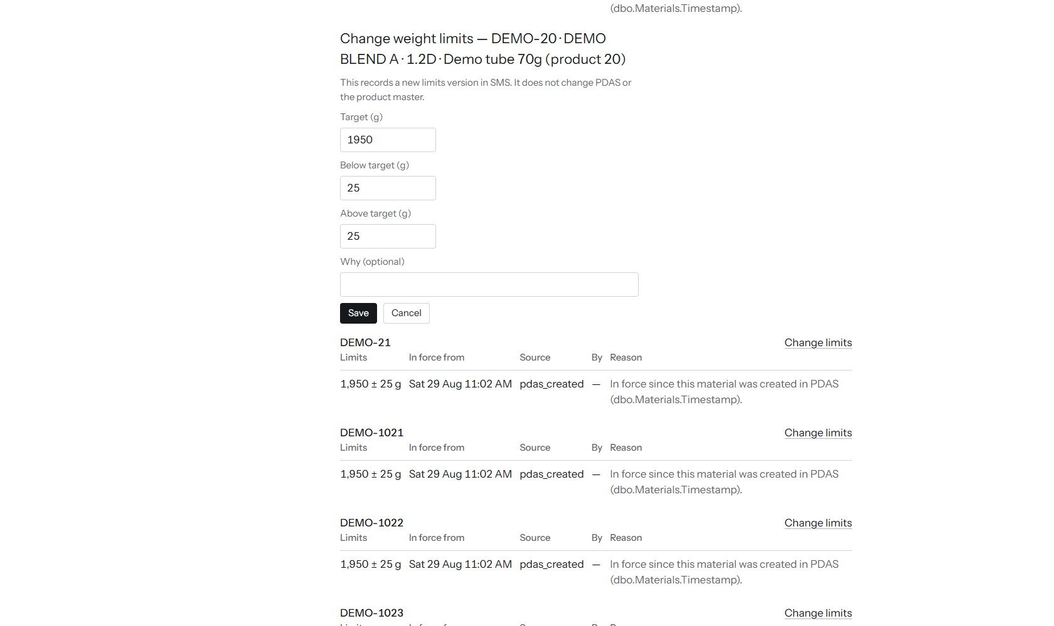
Figure 47 — The Change weight limits form for DEMO-20: Target 1950, Below target 25, Above target 25, an optional Why box, Save and Cancel. Nothing was saved.
The form says this records a new limits version in SMS and does not change PDAS or the product master.

7.7.4 History
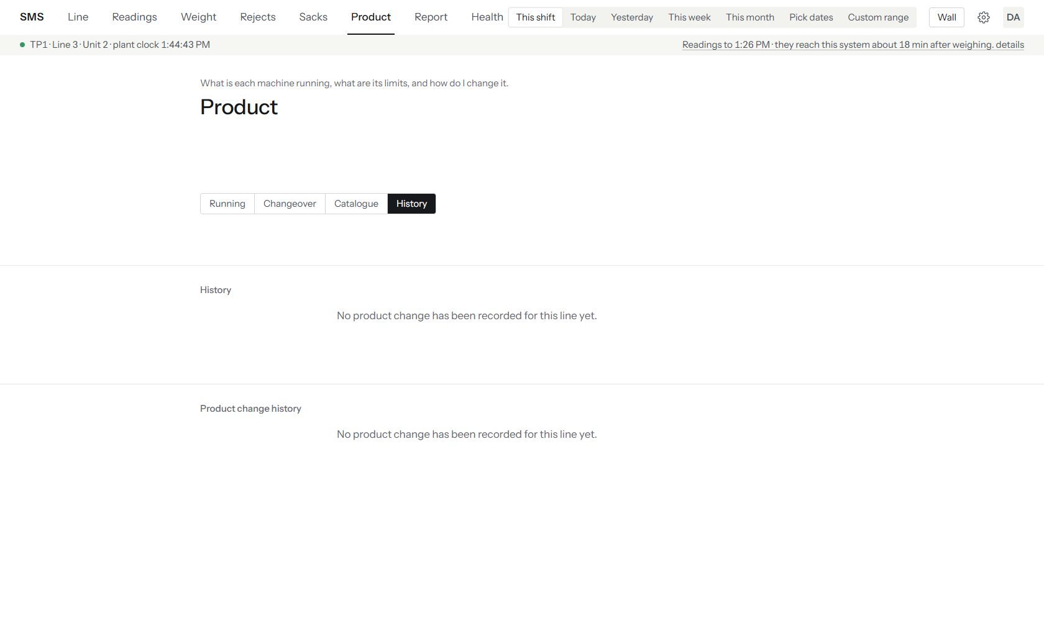
Figure 48 — History tab: both blocks read "No product change has been recorded for this line yet."
The trail of product changes made through SMS. On the demo none has been made, so both blocks are empty.

7.8 Report: printable and exportable reports
Report produces the reports IFL asked for, for the period in the top bar.
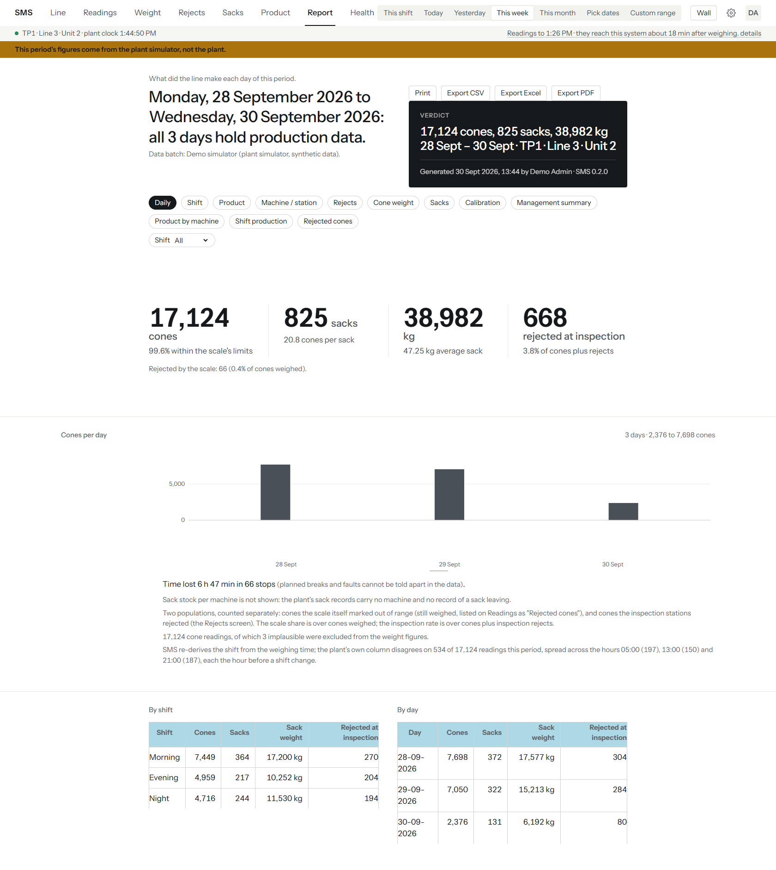
Figure 49 — Report, Daily, This week: the report type buttons, the Print and Export buttons, a dark verdict panel with the totals and who generated it, KPIs, the cones-per-day chart and the By shift and By day tables.
- Press Report and choose a period.
- Choose the report type from the row of buttons under the verdict.
- Use the extra boxes that appear for some types (Shift, Station) to narrow it.
- Press Print to print, or one of the Export buttons to download.
The report types are Daily, Shift, Product, Machine / station, Rejects, Cone weight, Sacks, Calibration, Management summary, Product by machine, Shift production and Rejected cones.
Part | What it tells you
Verdict panel | The headline totals, the period, the line and who generated the report and when, with the SMS version.
Data batch line | The source of the data. On the demo it says the data is synthetic.
KPIs and charts | The figures for the period, then the same data by shift and by day.
Notes under the chart | Time lost, what the report does not know (for example no sack stock per machine), and how the shift was worked out.
Export CSV, Export Excel, Export PDF | Download the report as a file. Needs manager rank. The file carries the same period and provenance as the screen.
Print | Opens the browser's print dialog. Reports print landscape.

Print and Export were used only by pressing the buttons and are not shown as screenshots, because the files and print dialog open outside the browser page.
The management summary sets each figure beside the same figure for the period just before it.
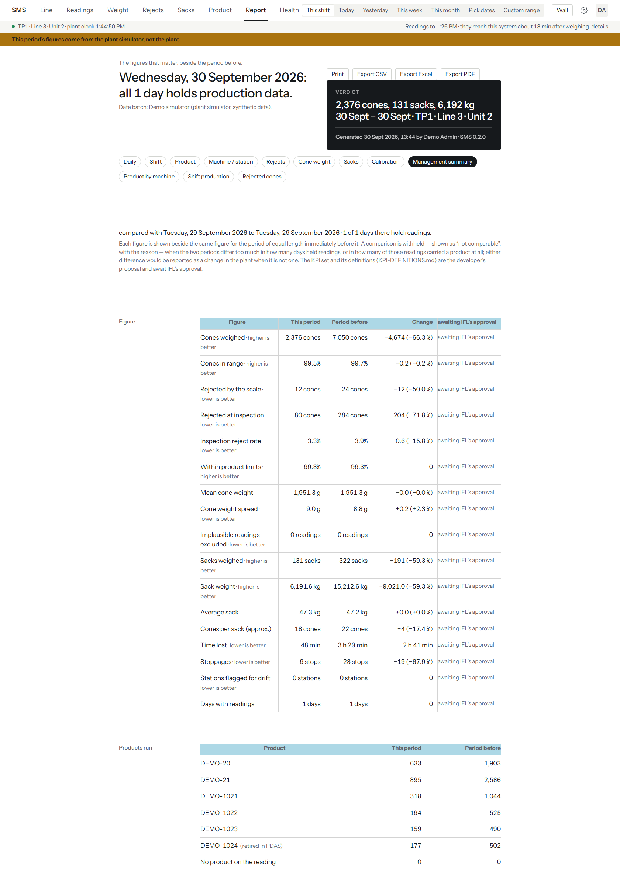
Figure 50 — Management summary, This shift: each KPI this period against the period before, a Change column and "awaiting IFL's approval" on every row, then Products run. The demo shows one day, so the figures compare a partial day with a full one.
Every row says "awaiting IFL's approval" because the choice and definition of these figures is the developer's proposal and IFL has not yet approved it.
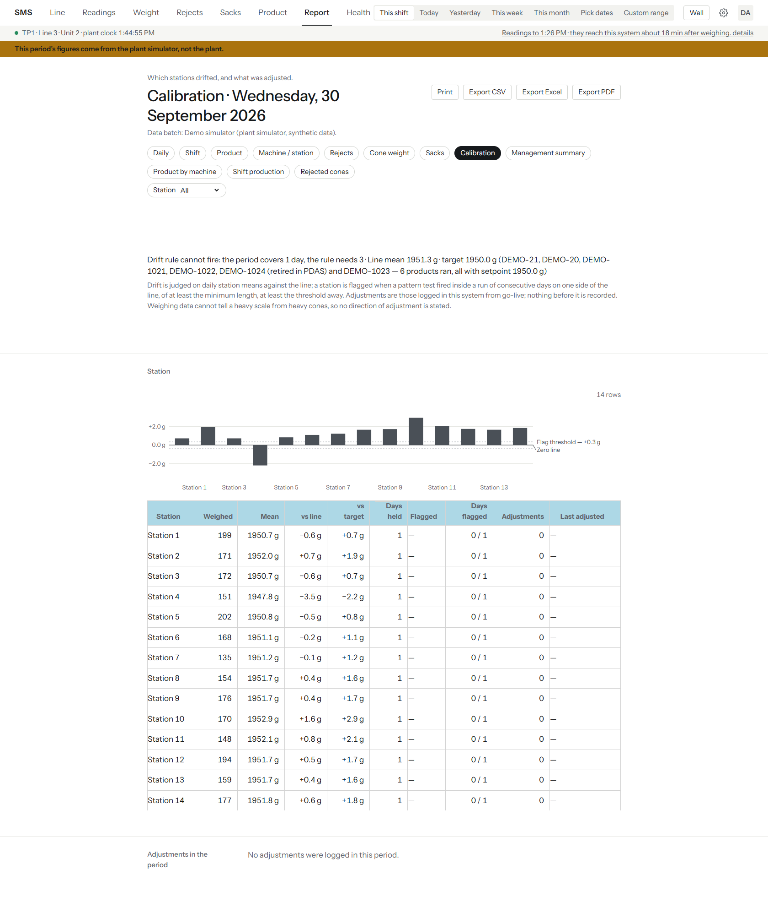
Figure 51 — Calibration report, This shift: a note that the drift rule cannot fire with only one day, a chart of each station's average against the line, a station table and "No adjustments were logged in this period".
The calibration report needs several days to judge drift, so it says so rather than showing a verdict for one shift. Choose This week or longer.
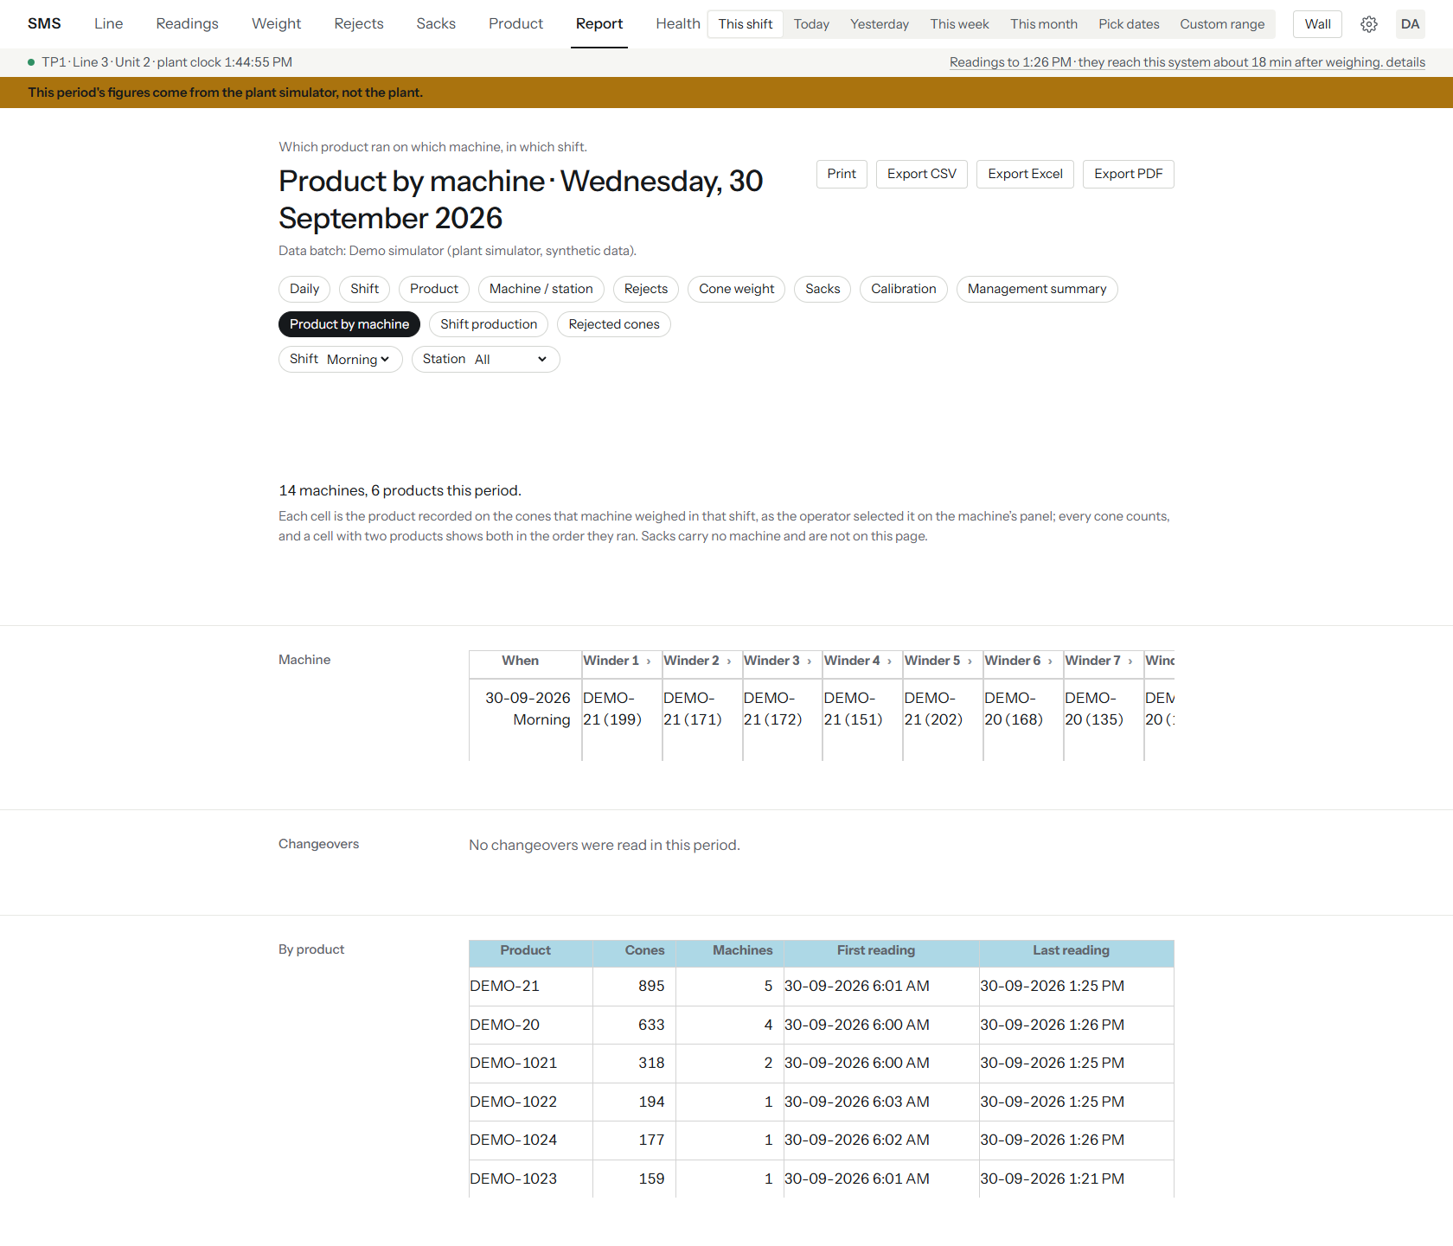
Figure 52 — Product by machine, Morning shift: one row per shift and one column per winder showing the product and cone count; the table is wider than the screen and scrolls sideways (winder 8 is cut off at the edge). Below are Changeovers and By product.
In Product by machine each cell is the product recorded on the machine for that shift, with the cones it weighed in brackets. A cell with two products lists both in the order they ran. On paper this report says the same data is in the CSV export, because it is too wide to print.

7.9 Wall: the fullscreen display
The wall display is for a screen or TV that people read from across the room. It has no menus and refreshes itself.
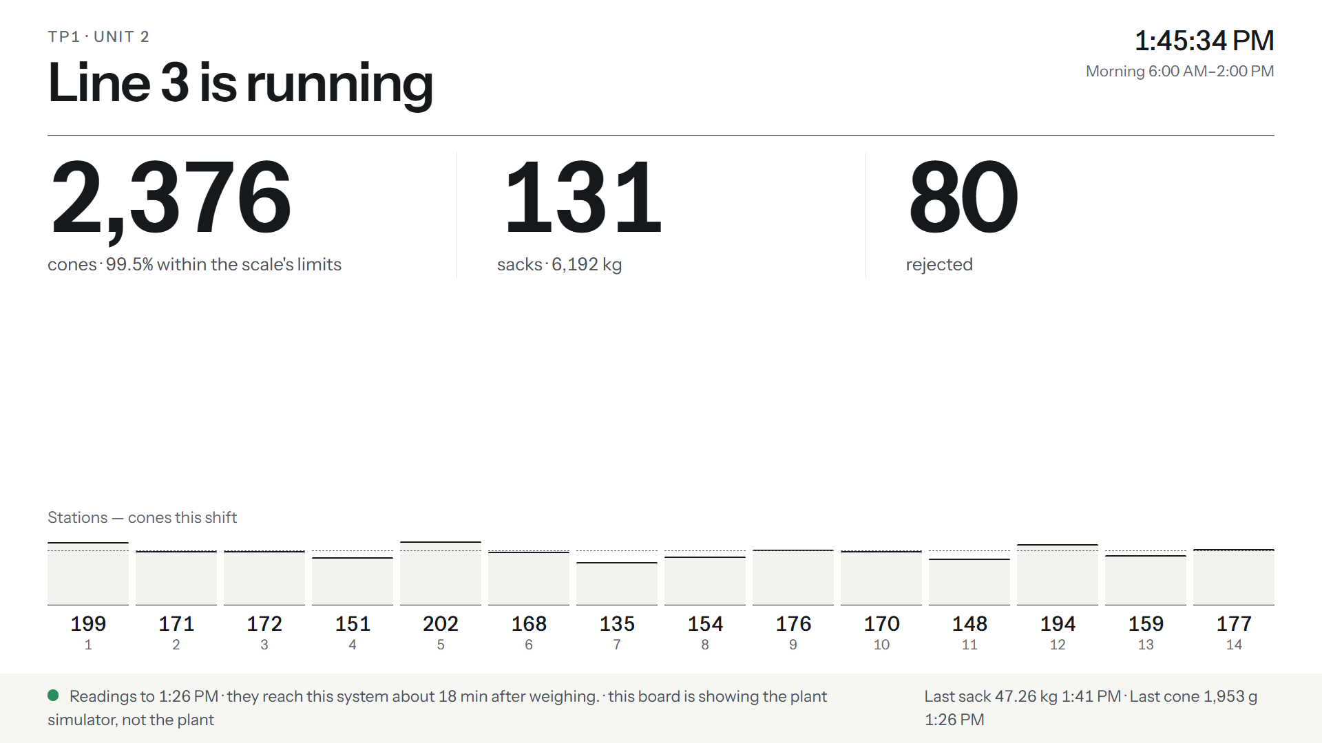
Figure 53 — The wall display on the simulator: "Line 3 is running", 2,376 cones (99.5% within limits), 131 sacks (6,192 kg), 80 rejected, one bar and count per station, and a footer with the data delay and the last sack and cone.
- Press Wall in the top bar.
- Leave it up. It updates by itself.
- Press Esc or use the browser's back button to return.
Part | What it tells you
Line name and state | Whether the line is running, in very large type.
Clock and shift | Plant time and the current shift.
The three figures | Cones, sacks and rejected for this shift.
Station bars | One bar per station, with the count under it. A shorter bar is a station making fewer cones than the others.
Footer | The data delay, and the last sack and cone. On the demo it also says the board shows the simulator.

7.10 Health: is SMS itself working?
Health reports on SMS itself, not on the line: the plant link, the database, the service and the backups. Open it from the top bar.
Figure 54 — Health on the demo: "Something needs attention", and the Sync health block reporting that the plant connection is healthy, with the PDAS write checking block below it. The demo has no backup, so the screen reports as degraded; the blocks further down are not in this picture.
Note: This demo reads "Something needs attention" for one reason only: no backup has been taken (the Backups block says so). On a healthy live installation the headline reads as healthy. Do not treat the demo as an example of a clean install.

- Press Health.
- Read the headline, then any block shown in red.
- Open the collapsed lines (Data quality findings, Per table, Readings by state) for detail.
- If something is red, follow section 8.
Figure 55 — The Sync health block: "The plant connection is healthy", last successful pass, oldest table, plant connection time and blocking findings, with Data quality findings and Per table folded away.
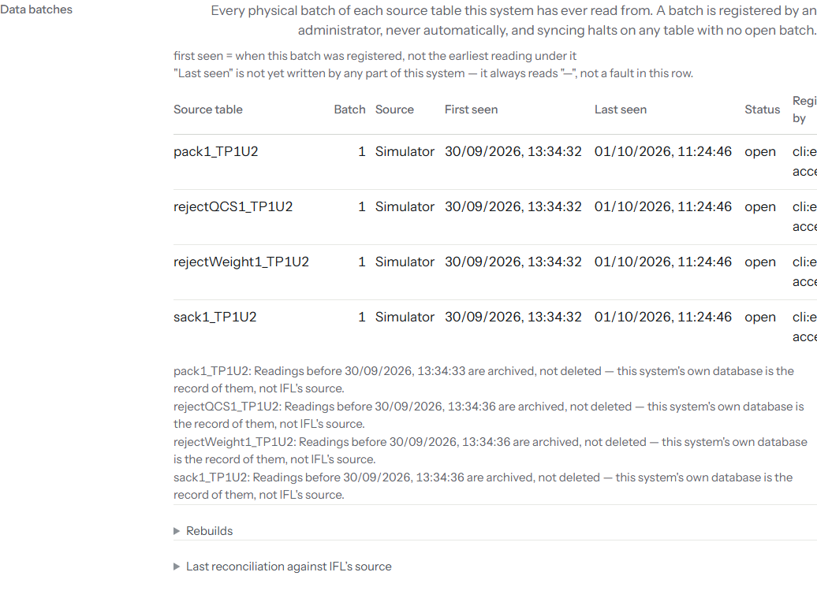
Figure 56 — The Data batches block: one row per source table batch, with Batch, Source, First seen, Last seen and Status in separate, readable columns. The table scrolls sideways on narrower windows to reach Registered by.
Figure 57 — The PDAS write checking block: "PDAS writes: off. This installation is not writing to PDAS. There is nothing to check."
Block | What it tells you
Sync health | Whether the sync worker is reading the plant, when it last succeeded, and whether any finding blocks it.
PDAS write checking | Whether SMS is allowed to write to the product database. Off unless deliberately enabled.
Reconciliation | A census of the readings SMS holds. It is not a comparison against IFL's database.
Data batches | Every physical batch of each source table SMS has read, when it was registered and how many rows it holds.
Database | Response time and how much of the 10 GB SQL Server Express limit is used.
Service | The SMS version and how long the service has been running. A short uptime beside an old "since" date means it restarted.
Backups | Whether a backup was found and proven restorable. Red means the nightly job has stopped.
Disk space | Free space on the database and backup volumes.
Last manual verification run | When someone last ran the verify command by hand. It is a record, not a live check.

8 Troubleshooting
In the messages quoted below, ${span} and ${since} are placeholders: SMS replaces each with an actual time or duration when it shows the message.
Symptom | Likely cause | Fix
Line's headline reads has had no readings for ${span} — the line, or the plant's data recorder, may have stopped on a line you know is running | The ~18-minute acquisition lag (see section 1.2) — the newest reading has not arrived yet, which is normal, not a fault. | Check the lag sentence under the top bar first. If the stated lag is much larger than usual, treat it as the next row instead.
The lag sentence reads No new readings since ${since} — the plant link may be down. | The sync worker has not delivered a new reading recently — a real connectivity or service problem, not the normal acquisition lag. | Check SMS-Sync is running. Check Health's sync block for the failing table. Check the plant's own SQL Server is reachable from this machine.
sync halts, reporting an unregistered source generation | IFL's source tables were rebuilt (dropped and recreated with identities restarted) — a new generation. This is expected behaviour, not a bug — see section 1.4. | Run node cli/dist/index.js epoch:list to see it, then epoch:accept for it as in section 4.11. Never assume the new generation is a continuation of the old one.
Sign-in fails with a generic error for everyone, including known-good accounts | That username and password did not match. is shown for a wrong password, but also — per a known, open gap — for some database-connection failures, which look identical on screen. | Check GET /api/health and the plant/app database connectivity before assuming every account's password is wrong.
sqlcmd/the app cannot reach the app database at all | APP_DB_SERVER/APP_DB_PORT wrong, SQL Server Express not running, or a firewall blocking the app database port. | Confirm the SQL Server service is running and reachable with sqlcmd directly using the same server/port/login as .env.
PDF export fails or the Export PDF button errors | Microsoft Edge is not installed, or not at the path SMS expects. | Install Edge, or set PDF_EDGE_PATH to its actual location.
Health's Backups block reads No backup file was found. | BACKUP_DIR does not match where the backup script actually writes, or no backup has run yet. | Confirm BACKUP_DIR in .env matches -OutDir in the backup script/scheduled task exactly, and that the scheduled task from section 4.12 has actually run once.
retention --dry-run or a real retention run reports far more or fewer rows than expected | Retention only prunes sms.sync_run (default 90 days, newest row per line/table always kept) and non-CRITICAL sms.dq_finding (default 365 days) — never readings, sms.audit_log, or sms.product_change. | Confirm you are reading the right table's figures; see Appendix A for the two retention keys.
cutover --confirm refuses with exit code 2 | The required --backup=<path.bak> flag was left off — DEPLOY.md's own shorthand omits it, but the code requires it. | Always include --backup=<path to a .bak file> — see Appendix B.
user:create refuses with an invalid-role error | An old role name (operator, supervisor) was used. | Use exactly viewer, engineer, manager or admin.
A screen shows a Simulator label, or a sentence saying the figures shown are the plant simulator's and not the plant's, on what should be the live plant | The installation is pointed at a demonstration/simulator database, not the real plant. This should never appear on a live installation. | Confirm IFL_DB_SERVER/IFL_DB_NAME_DATA/IFL_DB_NAME_PDAS in .env point at the plant's own server and databases, not a _SIM copy.
A DQ finding or a "needs attention" state appears on Health that you do not recognise | See the Sync health and DQ blocks on Setup for which table and which finding. | Read the finding's own stated text — SMS states in words what it could not do and why, rather than a bare error code. If the cause is still unclear, it is a question for whoever maintains SMS's own code, not something this guide can resolve generically.
Weight basis or shift-boundary figures look wrong for this plant | WEIGHT_BASIS/SHIFT_MODE are not yet confirmed by IFL for every plant — see Appendix C, item 12. | Do not change these keys without a written answer from IFL; the app states plainly wherever this is unconfirmed.
Health stays at Something needs attention. because of a data finding that is real and needs no action (for example a recorded weight of exactly 0) | Known data findings do not clear themselves. | An engineer (rank 2 or above) opens the finding under Data quality findings, presses Acknowledge and writes a reason of at least 10 characters. The finding stops counting against the status and stays visible, with who acknowledged it. Findings that say the software itself is failing (repeated sync failure, a failed transform, an unverified PDAS write) have no Acknowledge button: they must be fixed.
Health says This backup has not been proven restorable. Do not rely on it until it verifies. | The newest .bak has no matching verification marker, or its size no longer matches the marker. | Run backup-appdb.ps1 again by hand and read its output. A backup that fails verification is renamed to end in .unverified; do not rely on it.
Health's Disk space block shows a volume below the warning line | Less than 2 GB is free on the database volume or the backup volume. | Free space, or move backups elsewhere. When it is low, Health reads Something needs attention..
The recorder line on Health shows a check-in time that is old | The sync worker has stopped checking in. A recent check-in beside an old newest reading means the worker is fine and the plant simply has nothing new. | Check SMS-Sync is running.
epoch:accept refuses with a message about an old archive, exit 2 | SMS suspects the source is a restored old database, not a new generation. It compares the data itself, because a restore gets today's create date. | Do not override. If the data is IFL's late archive of an existing generation, it belongs with epoch:backfill (Appendix B). Use --i-know-this-is-a-new-generation only on the maintainer's instruction; every use is audited.
A limits change is refused with a message about a large change | The target moved by more than 3 % (or a limit by more than 20 g) in one edit. These two numbers are the developer's defaults. | Tick the large-change box and give a reason of at least 20 characters if the change is intended. See section 6.4.
A request for a period over a year is refused, "range too large" | Production and weight requests are capped at 366 days. | Ask for a shorter period.

If a symptom is not listed here, check GET /api/health and the Health screen first — both are designed to state what is wrong in plain words rather than a bare error code.

9 Maintenance

9.1 Backups and a restore test
The nightly backup task (registered in section 4.12) runs backup-appdb.ps1, which backs up the app database only, checks the file with RESTORE VERIFYONLY ... WITH CHECKSUM, and deletes .bak files older than 30 days from its output folder (add -NoPrune to keep every file for that run):
powershell -File scripts\backup-appdb.ps1 -Server "<host>,<port>" -Db sms -Pass "<sms_backup password>" -OutDir "<backup dir>"

The scheduled task itself runs it with -User '' (a trusted Windows connection via sqlcmd -E), so no password needs to be stored for it.
When the check passes, the script writes a small marker file beside the backup, named like the backup with .verified.json added. Health reads it, so its Backups block can say the newest backup has been proven restorable. If the check fails, the backup file is renamed to end in .unverified and the script exits with an error; Health then reports the newest backup that does have a good marker. Keep BACKUP_DIR in .env the same as the backup folder, or Health will look in the wrong place.
Note: A verified marker proves the file is intact, not that it restores cleanly onto your server. The restore test below is still needed.

Warning: A backup is only worth having if it can be restored. Test this deliberately, on a spare or scratch SQL Server instance, not the live app database — restore the newest .bak file with SQL Server's own RESTORE DATABASE, and confirm the restored copy opens and its row counts look sane, on a schedule IFL is comfortable with (for example, after every significant configuration change, and at least once a quarter).

Configuration (not the database) is backed up separately, into an ACL-locked folder, and never includes the database itself:
powershell -ExecutionPolicy Bypass -File scripts\backup-config.ps1 -InstallDir "C:\sms" -BackupDir "C:\sms-backups"

9.2 Scheduled tasks
The three scheduled tasks registered in section 4.12 run on their own; check any one's history with:
schtasks /query /tn "SMS Nightly Backup" /v /fo LIST

Substitute "SMS Weekly Maintenance" or "SMS Daily Retention" for the other two.

9.3 Retention
retention prunes only sms.sync_run history (default 90 days, always keeping the newest row per line/table) and non-CRITICAL sms.dq_finding rows (default 365 days) — never readings, sms.audit_log, or sms.product_change. Preview what a run would remove before running it for real:
node cli/dist/index.js retention --dry-run

Then, once satisfied:
node cli/dist/index.js retention

The daily scheduled task already runs this automatically; running it by hand is for checking its behaviour, not something to do routinely.

9.4 Database maintenance
The weekly maintenance task runs SQL Server's own maintenance script directly:
sqlcmd -S .\SQLEXPRESS -E -d sms -b -i scripts\db-maintenance.sql

9.5 Configuration backup
See section 9.1 above — backup-config.ps1 is the dedicated tool for this, separate from the database backup.

9.6 Logs and rotation
The API and sync worker write their own log files under C:\sms\logs. Check them directly when a service's behaviour does not match what Health or GET /api/health reports.

9.7 Restarting services
Restart SMS-Api and SMS-Sync from Windows' Services console, or with NSSM's own restart command, whenever .env changes — neither process re-reads .env while running.

9.8 Upgrade and rollback
- Take a fresh, verified backup first (see section 9.1).
- Stop SMS-Api and SMS-Sync.
- Replace the package contents with the new release (keep the existing .env — never overwrite it from .env.example).
- Run npm ci && npm run build and npm run db:migrate again.
- Start the services and work through section 5 again.
To roll back, restore the previous release's package contents and the database backup taken immediately before the upgrade, then repeat section 5.

9.9 Health checks worth a glance
Besides the backup verification above, Health shows the free space on the database volume and the backup volume, the record of the last manual verify run, and when the sync worker last checked in beside the newest reading's own time. A worker that checks in on time and finds nothing new looks different from a dead one only when both times are shown, which is why both are. Findings that are known and need no action can be acknowledged by an engineer (see section 8).

9.10 Loading the missing 10 July to 5 August data
IFL has not yet sent the data between the July and September samples. When it arrives, do not run epoch:accept on it: it belongs to a generation SMS already holds. epoch:backfill adds it to the end of that generation's raw tables, and refuses everything if its checks fail. The --i-know-this-is-a-new-generation flag is not part of this procedure: it only bypasses epoch:accept's data-vintage check, and epoch:accept's chronology check refuses an older archive regardless. Run it first without --confirm to read the plan, then with it, then run rebuild for the same generation to derive the readings, then verify with --source-db and --epoch. This has been proven only on scratch copies of the database. The exact commands are in Appendix B; ask the maintainer before running them for the first time.

9.11 Database size
Health's Database block states the current size against the 10 GB SQL Server Express cap and raises a warning past 80% full (see Appendix C, item 10). How long readings are kept against this cap is IFL's own decision to make — nothing in SMS prunes readings automatically today.

10 Security

10.1 Logins and least privilege
SMS uses five distinct SQL logins, each scoped to exactly what it needs — never one shared login for everything:
Login (generic name) | Access
sms_app | The app database only — the API and sync worker's normal connection.
sms_migrate | The app database only, used solely for running migrations, set in the invoking shell rather than .env.
sms_readonly | db_datareader on IFL's DATA_TP1U2 and PDAS_TP1U2 only — never write access, never any other database.
sms_pdas_writer | A separate login, used only if the PDAS write path in section 6.4 is turned on — distinct from sms_readonly by design, so a compromised read-only connection can never write.
sms_backup | db_backupoperator on the app database, used by the scheduled backup task.

SMS never reuses DATA_TP1U2.Users (IFL's own existing table there holds plaintext passwords) — every SMS account is a fresh, hashed-password account in SMS's own database.

10.2 Protecting .env
.env holds every database password SMS uses. Restrict its file permissions to the account the services run as and to administrators only; never email it, commit it to version control, or copy it into a support ticket. backup-config.ps1 (see section 9.1) copies it into an ACL-locked folder as part of the configuration backup — treat that backup folder with the same care as .env itself.

10.3 Password policy
Every account password must be at least PASSWORD_MIN_LENGTH characters (default 10, configurable 6–128 — see Appendix A). Passwords are hashed (argon2), never stored or logged in plain text. Resetting a password from Setup revokes every existing session for that account immediately.

10.4 Sessions
SMS uses server-side session cookies, not tokens the browser can decode. COOKIE_SECURE must be true once served over HTTPS — see section 6.1. Signing out from the user menu's Sign out item ends that one session; resetting a password from Setup ends every session for that account.

10.5 Roles
See section 6.3 for the full rank table. Every screen is readable by every signed-in account; writing is gated by rank, and Setup is the only screen restricted outright, to admin.

10.6 Audit log
Every write SMS itself makes — account changes, calibration adjustments, product changes, PDAS write attempts — is recorded in the Audit log block on Setup, including who made it and when. So are acknowledgements of data findings (with the reason given) and any use of the --i-know-this-is-a-new-generation override on epoch:accept.

10.7 TLS
See section 6.5 in Chapter 6 for how to configure it. On an isolated, plant-only LAN, plain HTTP with COOKIE_SECURE=false is a defensible choice IFL can make; on any network reachable more broadly, TLS should be turned on.

10.8 Air-gapped operation
The plant PC has no internet access, and SMS is designed around that: no cloud dependency, no email alerting (see Appendix C, item 13), and GET /api/health is meant to be polled by whatever monitoring tool the plant already runs on its own network, rather than SMS reaching out itself.

10.9 The separate PDAS writer
See section 6.4. The PDAS write path uses its own login (sms_pdas_writer), separate from the read-only login used for everything else, specifically so that turning PDAS writes on or off is a single, auditable switch (PDAS_WRITE_ENABLED) that never affects the read-only connection's own permissions.

11 FAQ
Why is the data about 18 minutes old? IFL's own acquisition layer writes a cone's row roughly 18 minutes after the cone is actually weighed — this is measured from IFL's own data, not an SMS delay. SMS states this lag on screen rather than hiding it, and judges whether the line is running against now − that lag. See section 1.2.
Why is there no sack stock per machine? IFL's sack table carries no machine or station column on each sack row — only the sack number, its weight, whether the scale judged it in range, and when the reading was written. Sack stock per machine cannot be computed from data that does not exist, by SMS or by anyone else, without either a PLC integration IFL has deferred or a manual entry screen. See Appendix C, item 2, and the Sacks screen's own on-screen note.
Can SMS change the product on a machine? No. The PDAS write path (see section 6.4) can make a product selectable in IFL's product-master database, but it never writes to a machine or a PLC — whether the machine's own controller reads its limits from PDAS live is a separate question for IFL. See Appendix C, item 4.
Is there AI in SMS? No, and SMS does not claim otherwise. What exists is real statistics: a station-drift calibration signal (one control rule, deliberately not eight — see Appendix C, item 11) and a projection of when a drifting station reaches its action limit, worked out from its own recent readings with a stated confidence range. It is a measured trend, not a machine-learning model, and it says so wherever it is shown.
Why does a report only cover part of the period I picked? IFL's source tables have been rebuilt once already (see section 1.4), and a report never silently mixes two generations together as if they were one continuous record. If a period spans a rebuild, the report states which generation it covers and how many readings from another generation were left out.
Why doesn't a station's reject or weight figure match another screen exactly? Every canonical-table query states which source generation it resolved and what it excluded; figures that look close but not identical usually differ because they cover slightly different scopes (a single generation versus a whole window that spans a rebuild) — check each screen's own stated period and generation before assuming a mismatch is a bug.
Why is Health "degraded" when the plant looks fine? Usually a real but harmless data finding, such as two recorded weights of exactly 0, or a backup that has not verified, or low disk space. Health names the reason. An engineer can acknowledge a known data finding with a written reason; findings about the software itself cannot be acknowledged.
What does the Back button in the top bar do? Dragging across a chart zooms the page to that range, and the Back to previous range button undoes the zoom.
Why can my report figures differ from IFL's own vendor screen? SMS works out shifts from the time a cone was produced. The vendor's Shift column comes from insert time. Reports carry a footnote saying so.
Who can see what? Every screen listed in Chapter 7 is open to every signed-in account, at every rank. Setup is the only screen restricted, to admin. See section 6.3.
Can I trust the "days to the action limit" projection? It is a straight-line projection through a station's recent daily averages, with a stated 90% confidence range on the rate itself — not a forecast of what the scale will actually do. When the range spans zero, SMS says the drift is not established rather than printing a number that would overstate its own confidence.

12 Contacts and escalation
Role | Contact | When to use
IFL IT / SMS administrator | <IT contact name and phone/email> | Account issues, installation, service restarts, backups.
IFL process department lead | <process department contact> | Questions about how a report or figure should be read, or a request to change a role.
SMS maintainer / developer | <maintainer contact> | A defect, an unclear finding on Health that Chapter 8 does not explain, or a request to extend SMS.
IFL's database administrator | <DBA contact> | The read-only login (sms_readonly), or anything on IFL's own DATA_TP1U2/PDAS_TP1U2 databases.

Note: Fill in the placeholders above with IFL's own current contacts before distributing this guide.

12.1 Escalation order
- Check Health and GET /api/health — both are designed to state what is wrong in plain words.
- Check section 8 for the symptom.
- Contact the IFL IT / SMS administrator.
- If the cause is inside SMS's own code rather than the local environment, the administrator escalates to the SMS maintainer.

A Configuration keys
Every key below lives in .env (copied from .env.example — see section 4.4). Defaults shown are the template's own defaults, not necessarily what a real plant should use.
Key | Default/example | Meaning
APP_DB_SERVER | .\SQLEXPRESS | App database server.
APP_DB_PORT | 1433 | App database port (required, no code default).
APP_DB_NAME | sms | App database name.
APP_DB_USER | sms_app | App's own SQL login.
APP_DB_PASSWORD | — | Password for APP_DB_USER.
APP_DB_ENCRYPT | true | TLS to the app database.
APP_DB_TRUST_SERVER_CERTIFICATE | true | Accept a self-signed certificate on the app database.
MIGRATE_DB_USER / MIGRATE_DB_PASSWORD | — | The sms_migrate login, used only for npm run db:migrate, set in the invoking shell rather than .env for a long-running service.
IFL_DB_SERVER | .\SQLEXPRESS | IFL's SQL Server — the dev-vs-live switch.
IFL_DB_PORT | 1433 | IFL server port (required).
IFL_DB_NAME_DATA | DATA_TP1U2 | The weighing-data database name.
IFL_DB_NAME_PDAS | PDAS_TP1U2 | The product-master database name.
IFL_DB_USER | sms_readonly | Read-only login into IFL's databases.
IFL_DB_PASSWORD | — | Password for IFL_DB_USER.
IFL_DB_ENCRYPT | true | TLS to IFL's server.
IFL_DB_TRUST_SERVER_CERTIFICATE | true | Accept a self-signed certificate on IFL's server.
PDAS_WRITE_ENABLED | false | Master switch for the PDAS write path — see section 6.4.
PDAS_WRITE_SERVER / PORT / DATABASE / USER / PASSWORD | — | The separate sms_pdas_writer connection, used only when PDAS_WRITE_ENABLED=true.
PDAS_LIMIT_MAX_SETPOINT_CHANGE_PCT | 3 | Largest percent a product's target may move in one limits edit before it counts as a large change (tick-box plus a reason of 20+ characters). The developer's default, not IFL's.
PDAS_LIMIT_MAX_OFFSET_CHANGE_G | 20 | Largest change in grams to either weight limit in one edit before it counts as a large change. The developer's default, not IFL's.
PDAS_WRITE_ENCRYPT / PDAS_WRITE_TRUST_SERVER_CERTIFICATE | true | TLS on the PDAS writer connection.
SYNC_INTERVAL_SECONDS | 60 | How often the sync worker runs a pass (minimum 5).
SYNC_OVERLAP_ROWS | 500 | Watermark overlap window, in rows (minimum 0).
LINE_ID | 1 | Which line this process serves — immutable once data has been ingested.
SYNC_ONCE | — | Dev/CI single-pass mode.
SYNC_FAILURE_CRITICAL_AFTER | 5 | Consecutive failed passes before a CRITICAL finding is raised.
SACK_BLACKOUT_HOURS | 4 | Hours without a new sack row before a WARNING is raised.
PASSWORD_MIN_LENGTH | 10 | Shortest accepted account password (valid range 6–128).
BACKUP_DIR | C:\sms-backups | Where Health looks for the newest .bak file — must match the backup scripts' own output folder.
RETENTION_SYNC_RUN_DAYS | 90 | Days of sync-run history kept (newest row per line/table always kept regardless).
RETENTION_DQ_FINDING_DAYS | 365 | Days of non-CRITICAL data-quality finding history kept.
SIM_DB_NAME / SIM_DB_USER / SIM_DB_PASSWORD | — | Dev-only: the plant simulator's target database and login. Not used on a real installation.
API_PORT | 4000 | HTTP port the API listens on.
CACHE_TTL_SECONDS | 5 | In-memory response cache time-to-live.
LINE_NAME | TP1 · Line 3 · Unit 2 | Seed-only fallback display name for the line, used only until a line record exists.
LIVE_ALLOW_AS_OF | false | Allows a replay/demo parameter to move the plant clock — must stay false in production.
LIVE_ALLOW_SIMULATOR | false (commented out) | Development PC only; never set at IFL. Lets live screens follow the plant simulator. Ignored unless the database name ends in _SIM and the server is local.
PLANT_UTC_OFFSET_MINUTES | 300 | The plant's declared UTC offset in minutes (UTC+5 = 300) — see section 1.3.
TRUST_PROXY | false | Whether to trust X-Forwarded-For from a reverse proxy in front of SMS.
COOKIE_SECURE | true | Secure flag on the session cookie — must be false on a plain-HTTP LAN.
TLS_PFX_PATH / TLS_PFX_PASSPHRASE | — | Direct TLS termination, PFX form.
TLS_CERT_PATH / TLS_KEY_PATH | — | Direct TLS termination, certificate/key file form.
WEB_DIST | ./web/dist | When set, the API also serves the built web app from this path — the normal production setup.
WEIGHT_BASIS | as_recorded | Cone/sack weight interpretation (as_recorded, gross or net) — not fully confirmed by IFL; see Appendix C, item 12.
CONE_TUBE_WEIGHT_G | 70 | Tube tare weight, used only under the net basis — a developer placeholder, not IFL-confirmed.
SACK_TARE_KG | 0.5 | Sack tare weight, used only under the net basis.
SHIFT_MODE | corrected | Shift-boundary basis (corrected or legacy) — see Appendix C, item 12.
SHIFT_NIGHT_BELONGS_TO | start_day | Night-shift attribution rule (start_day or calendar_day).
PLC_READER_ENABLED, PLC_HOST, PLC_RACK, PLC_SLOT, PLC_CONE_ID_DB | false / placeholders | The still-deferred direct PLC reader — see Appendix C, item 1. None of these keys is read by any current code path; they exist only as a documented, dependency-free re-entry point.
PDF_EDGE_PATH | — | Explicit path to msedge.exe, if PDF export cannot find Edge at its default install location.

Five further keys tune connection-pool and request-timeout behaviour with safe built-in defaults and are not in .env.example: API_DB_POOL_MAX (10), API_DB_POOL_MIN (1), API_DB_POOL_IDLE_TIMEOUT_MS (30000), API_DB_REQUEST_TIMEOUT_MS (30000), and PDAS_MIRROR_REFRESH_SECONDS (600, minimum 5) — leave these unset unless a specific performance problem calls for tuning them.
There is no SESSION_SECRET key: sessions are server-side random identifiers, not signed tokens, so there is nothing for such a key to sign.

B Command reference
All commands below run from the package root (C:\sms once installed) unless stated otherwise. Arguments use --key=value; a bare space-separated --flag value is not accepted.

B.1 The CLI — node cli/dist/index.js <command> [flags]
Command | Purpose
sync | Runs one full read-transform-write pass. Halts and exits 1 on an unregistered source generation or a partial failure.
verify [--weights] [--from=YYYY-MM-DD --to=YYYY-MM-DD] [--source-db=<name> --epoch=<id>[,<id>]] | Reconciles the app database against the source, per generation. Exits 1 on any mismatch. --source-db checks a backfilled generation against an archive database and needs --epoch.
summary [--date=YYYY-MM-DD] [--shift=<text>] [--epoch=N[,M]] | Prints one block per source generation covering the date. Read-only, always exits 0.
rebuild --table=<cone_event|sack_event|reject_event> --snapshot-id=<id> (--epoch=N[,M] | --all-generations) --confirm | Deletes and re-derives canonical rows for one table and scope. Prints a plan first; without --confirm, exits 2 and changes nothing.
cutover --confirm --backup=<path.bak> | Clears canonical and raw readings ahead of a cutover from a test copy to the live plant. --backup=<path.bak> is required — a bare --confirm with no backup flag is refused at exit 2, even though DEPLOY.md's own shorthand omits it. Preserves accounts, product timeline, rule history and the audit log.
retention [--dry-run] | Prunes old sms.sync_run and non-CRITICAL sms.dq_finding rows only — never readings, the audit log, or the product-change history.
user:create --username=<u> --password=<p> --role=<viewer|engineer|manager|admin> [--display=<name>] | Creates an account. Role must be exactly viewer, engineer, manager or admin.
user:password --username=<u> --password=<new password> | Resets a password and revokes every session for that account.
epoch:list | Lists every registered source generation with its row counts and time range.
epoch:accept (--all | --table=<sourceTable>) --confirm --provenance=<ifl_live|ifl_copy|simulator> [--label="…"] | Registers a source generation. Two-step: run once without --confirm to see the plan, then re-run identically with --confirm added. --provenance is required for a new registration. It refuses a restored old archive posing as a new generation; --i-know-this-is-a-new-generation overrides that, audited, only on the maintainer's instruction.
epoch:backfill (--table=<sourceTable> | --all) --epoch=<id> --source-db=<archive database> [--confirm] [--sampled] | Adds older rows to the end of a closed generation's raw tables. Dry run without --confirm (exit 2, nothing changed). Refuses everything on any failed check. Proven only on scratch copies; IFL's real archive has not been sent. Run rebuild afterwards.
epoch:purge --epoch=N[,M] --confirm --backup=<path.bak> | Deletes rows for closed generation(s), keeping the generation record itself as a tombstone. Same backup gate as cutover.
epoch:drop --epoch=N --confirm | Deletes a generation record entirely — only if it holds no rows; use epoch:purge first otherwise.

B.2 npm scripts (from the package root)
Script | Does
npm run build:shared | Builds the shared workspace only.
npm run typecheck | Type-checks every workspace.
npm test | Runs the test suite.
npm run test:layout | Runs the browser layout tests (developers).
npm run db:migrate | Applies every pending database migration.
npm run build | Builds every workspace in dependency order (shared, sync-worker, cli, api, web).
npm run verify:release | typecheck + test + build, together.

B.3 sms\scripts\*.ps1
Script | Purpose
backup-appdb.ps1 -Server <host,port> -Db sms -Pass <password> -OutDir <dir> | Nightly checksummed backup of the app database only. -User "" uses a trusted Windows connection instead of a SQL login/password — what the scheduled task itself uses. Writes a .verified.json marker beside a backup that passes RESTORE VERIFYONLY, and renames one that fails to .unverified. Deletes .bak files (and markers) older than 30 days in -OutDir unless -NoPrune is given.
backup-config.ps1 -InstallDir C:\sms -BackupDir C:\sms-backups | Copies .env, TLS material, service definitions and scheduled-task XML into an ACL-locked folder — never the database itself. Must run as administrator.
install-scheduled-tasks.ps1 -InstallDir C:\sms -RunAs <account> -Server <host>,<port> -BackupDir C:\sms-backups [-WhatIf] | Registers the three production scheduled tasks: nightly backup, weekly database maintenance, daily retention. -WhatIf previews without registering.

B.4 sqlcmd and Windows commands used during installation
Purpose | Command
Create the app database and its logins | sqlcmd -S <server\instance> -E -i db\bootstrap\00_create_app_database.sql -v AppPassword="…" -v MigratePassword="…"
Open the API port | netsh advfirewall firewall add rule name="SMS API" dir=in action=allow protocol=TCP localport=4000
Weekly database maintenance | sqlcmd -S .\SQLEXPRESS -E -d sms -b -i scripts\db-maintenance.sql
Check/run a scheduled task | schtasks /query /tn "SMS Nightly Backup" /v /fo LIST, schtasks /run /tn "SMS Nightly Backup"
Wall-mode kiosk browser | msedge --kiosk http://<plant-ip>:4000/?s=wall --edge-kiosk-type=fullscreen

Warning: DEPLOY.md's own shorthand for cutover, sms cutover --confirm, omits the required --backup=<path.bak> flag and is refused by the code. Always include --backup=<path.bak>.

C Known limitations
These are current, known limitations of SMS — not bugs waiting to be fixed before go-live, but honest statements of what the system does and does not do today.
- No PLC integration. SMS reads from SQL Server only. A direct connection to the line's PLCs was scoped out by IFL's own decision; the .env keys for it exist only as a disabled, dependency-free re-entry point, read by no code path today.
- Sack stock per machine is not computable. IFL's sack data carries no machine or station column — only the sack number, weight, in-range flag and insert time. The Sacks screen states this on screen rather than guessing.
- PDAS writes are off, and the plant writer login is not yet provisioned. See section 6.4. The nine write actions have been proven against a non-production copy; none has ever run against the plant itself. Who at IFL may make limit changes, whether that needs a higher permission than the engineer role, and the size of change that counts as large (3 % or 20 g, the developer's numbers) are all still open.
- A changeover does not select the product on a machine. It only makes a product selectable in PDAS. Whether a machine's own controller reads its limits from PDAS live is a separate, still-open question for IFL.
- The data is always some minutes old. See section 1.2 — roughly 18 minutes, measured from IFL's own acquisition layer, not an SMS delay.
- Two separate clocks. Production timestamps are the plant's own wall clock labelled UTC; everything SMS itself writes is genuine UTC — see section 1.3. Never assume the two match without conversion.
- Planned breaks and faults cannot be told apart in the source data. No downtime reason code exists; time-lost figures on the Report screen carry this caveat.
- A real gap exists in the historical data supplied so far (26 days, 10 July to 5 August), not yet filled by IFL. Nothing in SMS substitutes for the missing data; a data-quality check flags a production day that could plausibly sit inside this kind of gap. A tool to load it once it arrives exists (epoch:backfill) but has been proven only on scratch copies.
- One line is served per API process today. Serving several lines from one installation is follow-on work, pending an IFL decision on whether more than one line is in scope.
- SQL Server Express caps a single database file at 10 GB. Health reports the current size against this cap and raises a warning past 80% full. How long readings should be retained against this cap is IFL's own decision, not yet made.
- Only one calibration pattern rule is shown, deliberately. The further seven Nelson rules were evaluated and rejected by measurement — they flagged an unworkably large share of stations on real data, because station weight readings are naturally autocorrelated from one reading to the next. Health and the Weight screen state this rather than silently omitting the rules.
- Weight basis and the shift-boundary rule are not fully confirmed by IFL. The app states "not confirmed" wherever this matters; do not change WEIGHT_BASIS or SHIFT_MODE without a written answer from IFL.
- No email alerting, because the plant PC is air-gapped. GET /api/health is meant to be polled by whatever monitoring tool the plant already runs.
- Retention of raw and canonical readings is undecided. Nothing prunes readings automatically today; at the measured accumulation rate this is not urgent, but it remains IFL's decision to make.
- "Reports with graphics" is a requirement still being matched against what is built. PDF, Excel and CSV export exist, with tables and charts rendered into the PDF — whether this fully satisfies IFL's own expectation is being tracked, not assumed closed.
- Not every elevated-rank route has an automated client/server rank cross-check. The mechanical check covers only about 6 of roughly 25 to 32 elevated-rank routes; the rest are verified by reading the code rather than by a mechanical test, a lower bar of proof, worth knowing if a future change touches access control.
- No off-machine backup of IFL's own source data exists yet, beyond what this guide's own section 9.1 section covers for the app database. Both of IFL's data samples, and every copy of the SMS deliverable itself, currently live on a single machine — an operational risk for IFL to accept or remedy, not a defect in SMS's own code.
- Backups are proven, not yet unattended. The backup script checks each file and writes a marker Health reads. It has been run by hand once. The nightly schedule has not run unattended, and no copy leaves this one PC.
- SMS shifts can differ from IFL's vendor screen. SMS works shifts out from production time; the vendor's Shift column uses insert time. Reports carry a footnote. Which is right for IFL is an open question.
- A wrong time zone only warns. If the PC's time zone does not match PLANT_UTC_OFFSET_MINUTES, SMS logs a warning but still starts.
- Rules are read as "current", not "in force". Weight and plausibility rules apply as they are now; shift-rule history is honoured for range edges since 29 September 2026, but rows transformed earlier keep their old shift.
- A recorded weight of exactly 0 is unexplained. Two real IFL rows are zero. What a zero means is a question for IFL. They keep Health at "degraded" until an engineer acknowledges them.
- A sign-in failure can hide a database problem. The generic sign-in error is shown for a wrong password and for some database-connection failures.
- Go-live conditions are still open. The software is ready for a supervised pilot, not unattended production: read-only logins for both databases, services and backups proven on the target PC, an off-machine copy, a two-week parallel run, and written answers from IFL are all outstanding.
- The print/PDF layout has a real automated test harness, but no case needing a signed-in session has been run through it yet for want of a dedicated test account and credentials.
- No one has yet signed in as a viewer-rank account on a live instance. Rank-1 rendering is proven by an automated test against a simulated sign-in, not by an actual person's session — worth confirming once IFL has created a viewer account.

D Sign-off sheet
Use this sheet to record that installation was completed and verified. Keep a signed copy with IFL's own records.

D.1 Installation
☐ Prerequisites confirmed (section 4.1)
☐ Read-only login obtained from IFL's DBA (section 4.2)
☐ App database and logins created (section 4.3)
☐ .env created and filled in (section 4.4)
☐ Build completed with no errors (section 4.5)
☐ Migrations applied (section 4.6)
☐ First admin account created (section 4.7)
☐ Manager/engineer accounts created (section 4.8)
☐ Windows services registered and running (section 4.9)
☐ Firewall rule added (section 4.10)
☐ First sync completed, generation accepted, verify clean (section 4.11)
☐ Scheduled tasks registered (section 4.12)
☐ Wall display configured, if in scope (section 4.13)

D.2 Verification
☐ Every item in section 5 ticked off
☐ A backup has run and been confirmed restorable (section 9.1)
☐ Sign-in tested for at least one account of each role in use

D.3 Sign-off
Field
Installed by (name) | _________________________
Installed by (signature) | _________________________
Date | _________________________
Confirmed by IFL (name) | _________________________
Confirmed by IFL (signature) | _________________________
Date | _________________________

Note: Signing this sheet confirms only that the installation and verification checklists above were completed; the known limitations in Appendix C stay open items for IFL and the maintainer.

