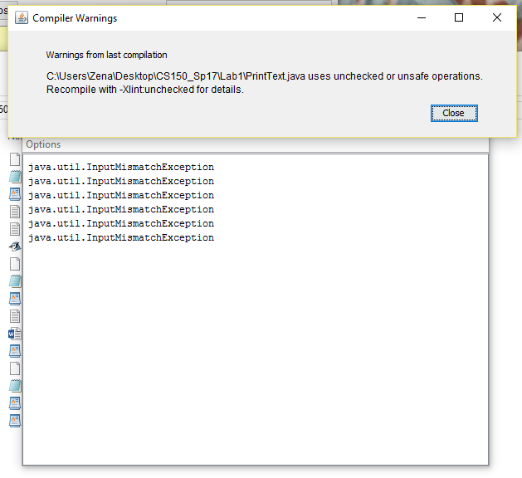

Code:

import java.util.*;

import java.io.*;

import java.lang.Object;

/**

* Write a description of class PrintText here.

*

* @author Zainab Hussein

* @version 1/28/2017

*/

public class PrintText

{

// instance variables - replace the example below with your own

/**

* Constructor for objects of class PrintText

*/

public PrintText()

{

// initialise instance variables

}

/**

* static class-method

*/

public static void main( String[] args ) //throws IOException

{

PrintText text = new PrintText();

//catch exception

try{

File inFile = new File( "datain.txt" ); //throws IO exception

Scanner scan = new Scanner( inFile );

String item_class = null;

String cheapest_item = null;

while( scan.hasNext() ){

//arraylist to find the index of min price

ArrayList num = new ArrayList( scan.nextInt() );

int min_num_index = num.indexOf( Collections.min(num));

//array to get the item class and cheapest item

Object[] inputs = new Object[]{ scan.next() };

for( int i=0; i<inputs.length; i++){

item_class = inputs[0].toString();

System.out.println( "item class :" + item_class );

cheapest_item = inputs[min_num_index-1].toString();

System.out.println( "cheapest item :" + cheapest_item );

}

scan.close();

}

File outFile = new File( "dataout.txt" );

FileWriter written = new FileWriter( outFile.getAbsoluteFile() );

PrintWriter print = new PrintWriter( written );

while( written != null ){

print.println( "the cheapest " + item_class +

"is " + cheapest_item);

}

print.close();

}

catch( Exception e ){

System.out.println( e );

}

}

}

Datain file:

Writing_tool Pen 3 Pencil 1 Sharpie 5 Highlighter 4

Flight United 139 Swiss 137 Emirates 200 Lufthansa 144

Bottled_water Springs 2 Serova 3 Laicoregency 7

Color Green 4 Red 9 Blue 3 Pink 7

Laptop Asus 249 Lenovo 299 Dell 275