Author: Zainab Hussein

Date: 2-2-2017

Unit Testing and Experimentation:

Analysis of Time Complexities of Add and Sort Methods on an ArrayList of Integers

# Introduction

This introduces the problem that you are trying to solve. What are the goals? What assumptions did you make?

# Approach

This section describes your approach to solving the problem. Example: design of the program, choice of algorithm and data structure. Include the design/architecture including the classes and the functionality/purpose of each class. Do not include a description of the methods.

# Methods

This section describes your experimental setup. Example: how many runs, what parameters did you use, why the particular choice of experimental setup, parameter values

# Data and Analysis

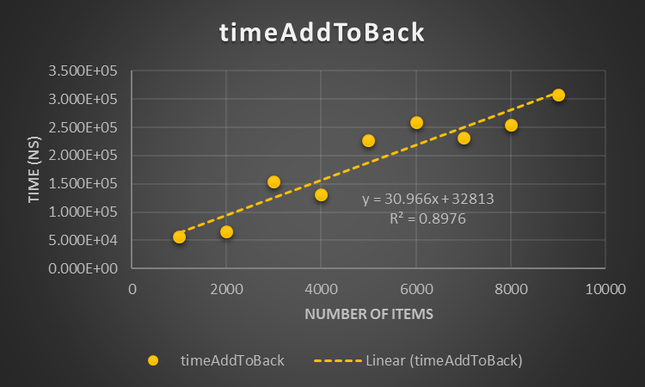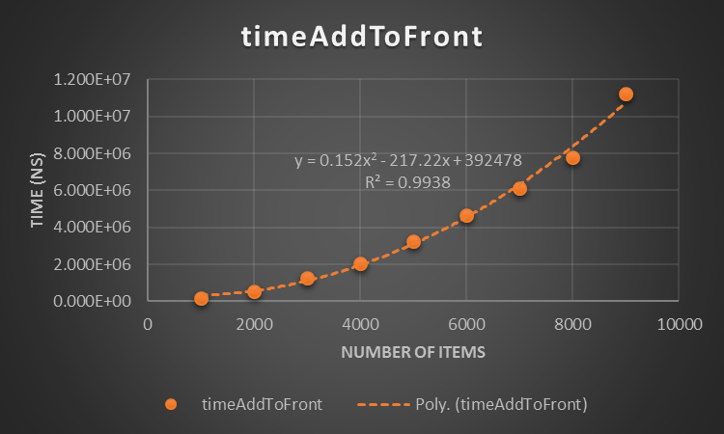This section describes the data that you obtained (plotted) and your analysis of the data.

Figure 1 complexity of ArrayList addToFront method

Figure 2 complexity of ArrayList addToBack method

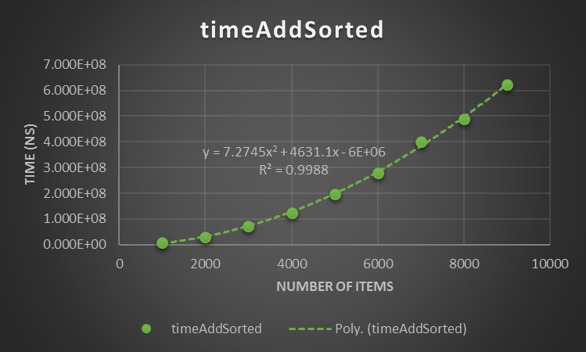

Figure 3 complexity of ArrayList addSorted method

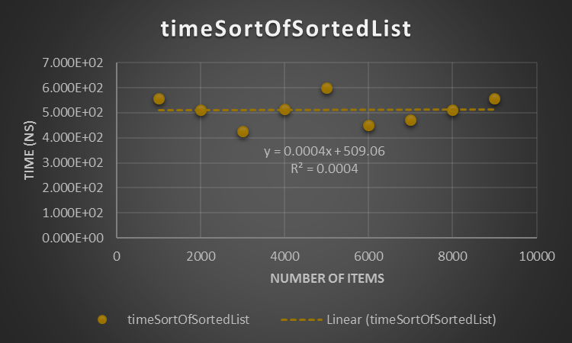

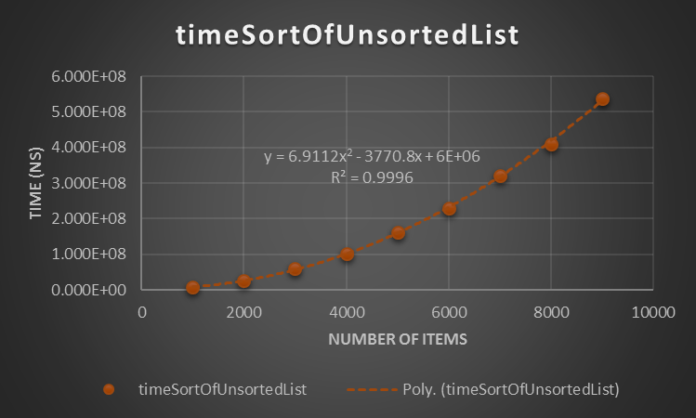

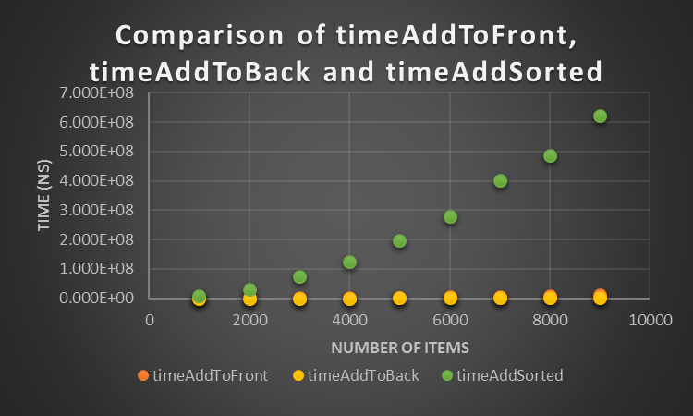Figure 4 complexity of ArrayList insertionSort method on an unsorted list

Figure 5 complexity of ArrayList insertionSort on a sorted list

Figure 6 Comparison of ArrayList add methods

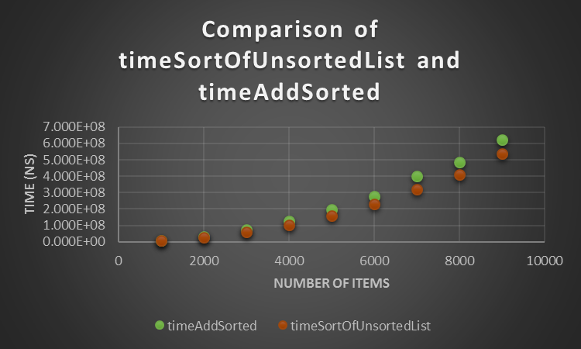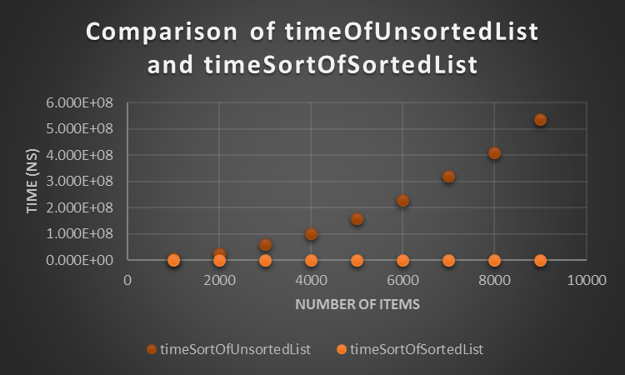

Figure 7 comparison of sorting unsorted lists on ArrayList Figure 8 Comparison of sorting a sorted and unsorted list

# Conclusion

# References

List, ArrayList and Array API

# Appendix

