**Department of Electrical and Computer Engineering**

Author: Zainab Hussein

Title: FPGA & Logic Design Refresher

Date: 2/4/2017

Time spent: 5 Hours

**Block diagram:**



**System Verilog files:**

1. Debouncer & Level-To-Pulse converter

//-----------------------------------------------------------------------------

// Title : debounce -- Button debouncer

// Project : Lab 7

//-----------------------------------------------------------------------------

// File : debounce.sv

// Author : Jon Wallace

// Created : 15 Oct. 2015

// Last modified : 15 Oct. 2015

//-----------------------------------------------------------------------------

// Description :

// This module provides code to debounce a raw button input.

// Inputs:

// clk Clock

// button_in Raw button input with bounce

// Outputs:

// button_out Debounced button

// pulse Provides a one-clock pulse when button is pressed

//-----------------------------------------------------------------------------

module debounce(input logic clk, //should be synchronized

input logic button_in,

output logic button_out,

output logic pulse);

parameter DEBOUNCE_TIME_MS = 5;

parameter CLKFREQ = 100_000_000;

parameter WAIT_COUNT = DEBOUNCE_TIME_MS*(CLKFREQ/1000);

// States for button debouncing

logic button_state, button_state_next;

// Counter for debouncing

logic [26:0] count_reg, count_next;

// Counter and button state register

always_ff @(posedge clk)

begin

button_state <= button_state_next;

count_reg <= count_next;

end

// Next-state / output logic

always_comb

begin

// Defaults

button_state_next = button_state;

count_next = count_reg;

pulse = 1'b0;

// Does the button input match the stored button state?

if (button_in == button_state)

// Yes, so just reset the counter

count_next = 0;

else if (count_reg == WAIT_COUNT-1)

begin

// No, so if the counter is done, transition to the other state

button_state_next = ~button_state;

count_next = 0;

// Generate a pulse if going from 0=>1

pulse = ~button_state;

end

else

// Have not reached wait count yet, so increment counter.

count_next = count_reg + 1;

end // always_comb

assign button_out = button_state;

endmodule // debounce

1. Clock divider

//-----------------------------------------------------------------------------

// Title : clkdiv - parameterized clock divider

// Project : ECE 211 - Digital Circuit 1

//-----------------------------------------------------------------------------

// File : clkdiv.sv

// Author : John Nestor

// Created : 09.08.2011

// Last modified : 10.16.2015

//-----------------------------------------------------------------------------

// Description :

// This module divides the 100MHz clock on the Nexys4 board down to a lower

// frequency. Set the DIVFREQ parameter to the desired frequency in Hz.

// If a frequency lower than 1 Hz is desired, the DIVBITS bitwidth parameter

// must be increased. If a higher frequency is used, we assume that synthesis

// will trim the unused most signficant counter bits and logic.

// To use, instantiate this module whiel setting the DIVFREQ parameter to the

// desired frequency in Hz.

// For example, to generate a 1 Hz clock, instantiate a module as follows:

//

// clkdiv #(.DIVFREQ(1)) U_DIV (clk, reset, sclk);

//

// Where:

// clk is the 50MHz system clock that arrives on an input pin of the FPGA

// (see the documentation)

// reset is a signal that resets the clock divider counter

// (connect it to zero if unused)

// sclk is the output clock - connect this to your logic

//

//-----------------------------------------------------------------------------

module clkdiv(input logic clk, input logic reset, output logic sclk);

parameter DIVFREQ = 100; // desired frequency in Hz (change as needed)

parameter DIVBITS = 26; // enough bits to divide 100MHz down to 1 Hz

parameter CLKFREQ = 100_000_000;

parameter DIVAMT = (CLKFREQ / DIVFREQ) / 2;

logic [DIVBITS-1:0] q;

always_ff @(posedge clk)

if (reset)

begin

q <= 0;

sclk <= 0;

end

else if (q == DIVAMT-1) begin

q <= 0;

sclk <= ~sclk;

end

else q <= q + 1;

endmodule // clkdiv

1. Nexys4 top level

module nexys4 (

// un-comment the ports that you will use

input logic CLK100MHZ,

// input logic [15:0] SW,

input logic BTNC,

input logic BTNU, //reset

input logic BTNL,

input logic BTNR,

// input logic BTND,

// output logic [6:0] SEGS,

// output logic [7:0] AN,

// output logic DP,

output logic [15:0] led

// input logic UART_TXD_IN,

// input logic UART_RTS,

// output logic UART_RXD_OUT,

// output logic UART_CTS

);

//internal signals

logic btnc_pls, btnr_pls, btnl_pls, btnu_pls;

logic btnc_dbn, btnr_dbn, btnl_dbn, btnu_dbn;

// add SystemVerilog code & module instantiations here

//debouncing

debounce U_DBN_C( .clk(CLK100MHZ), .button_in(BTNC), .button_out(btnc_dbn), .pulse(btnc_pls) );

debounce U_DBN_R( .clk(CLK100MHZ), .button_in(BTNR), .button_out(btnr_dbn), .pulse(btnr_pls) );

debounce U_DBN_L( .clk(CLK100MHZ), .button_in(BTNL), .button_out(btnl_dbn), .pulse(btnl_pls) );

debounce U_DBN_U( .clk(CLK100MHZ), .button_in(BTNU), .button_out(btnu_dbn), .pulse(btnu_pls) );

//fsm logic for blink mode

logic [1:0] led_state;

typedef enum logic [1:0] {

solid = 2'b00,

oneHz = 2'b01,

twoHz = 2'b10

} states_t;

states_t state, next;

always_ff @(posedge CLK100MHZ)

if (btnu_pls) state <= solid;

else state <= next;

always_comb

begin

next = solid;

case( state )

solid:

begin

if (btnc_pls) next = oneHz;

else next = solid;

end

oneHz:

begin

if (btnc_pls) next = twoHz;

else next = oneHz;

end

twoHz:

begin

if (btnc_pls) next = solid;

else next = twoHz;

end

default:

next = solid;

endcase

end

assign led_state = state;

//counter for led shift

logic [3:0] cnt;

always_ff @(posedge CLK100MHZ)

if (btnu_pls) cnt <= 4'd0;

else if (btnr_pls) cnt <= cnt - 1; //shift right

else if (btnl_pls) cnt <= cnt + 1; //shift left

// use demux to get 16 bits of LED

logic [15:0] led_shift;

//testing always comb block

`ifdef TEST

assign led_shift = 16'b0000000000000001;

`else

always_comb

case(cnt)

4'd0: led_shift = 16'b0000000000000001;

4'd1: led_shift = 16'b0000000000000010;

4'd2: led_shift = 16'b0000000000000100;

4'd3: led_shift = 16'b0000000000001000;

4'd4: led_shift = 16'b0000000000010000;

4'd5: led_shift = 16'b0000000000100000;

4'd6: led_shift = 16'b0000000001000000;

4'd7: led_shift = 16'b0000000010000000;

4'd8: led_shift = 16'b0000000100000000;

4'd9: led_shift = 16'b0000001000000000;

4'd10: led_shift = 16'b0000100000000000;

4'd11: led_shift = 16'b0001000000000000;

4'd12: led_shift = 16'b0010000000000000;

4'd13: led_shift = 16'b0100000000000000;

4'd14: led_shift = 16'b1000000000000000;

4'd15: led_shift = 16'b0000000000000001;

default: led_shift = 16'b0000000000000001;

endcase

`endif

//blink rate mux

parameter BAUD = 1; // desired frequency in Hz

parameter TWICEBAUD = 2;

//clkdiv

logic oneHz_clk, twoHz_clk, solid_clk;

clkdiv #(.DIVFREQ(BAUD)) U_CD_oneHz(.clk(CLK100MHZ), .reset(BTNU), .sclk(oneHz_clk));

clkdiv #(.DIVFREQ(TWICEBAUD)) U_CD_twoHz(.clk(CLK100MHZ), .reset(BTNU), .sclk(twoHz_clk));

// clkdiv #(.DIVFREQ(100)) U_CD_solid(.clk(CLK100MHZ), .reset(BTNU), .sclk(solid_clk));

//mux for blink rate selection based on blink mode

logic blink;

//testing blink rate mux

`ifdef TEST

assign blink = 1;

`else

always_comb

unique case (led_state)

2'd0 : blink = 1;

2'd1 : blink = oneHz_clk;

2'd2 : blink = twoHz_clk;

default : blink = 0; // fills all bits with 0s

endcase // case(led_state)

`endif

//display

//replicate blink 16 bits and wire led

assign led = ( {16{blink}} & led_shift );

// assign led = 16'b1010101010101010; //for testing

endmodule // nexys4

**Testbench**

`timescale 1ns / 1ps

module Nexys4Test();

// inputs

logic CLK100MHZ;

logic BTNR;

logic BTNL;

logic BTNU;

logic BTNC;

//output

logic [15:0] led;

// instantiate device under verification (nexys4DDR)

nexys4DDR DUV(.CLK100MHZ, .BTNC, .BTNU, .BTNL, .BTNR, .led );

// clock generator with period=20 time units

always begin

CLK100MHZ = 0; #10;

CLK100MHZ = 1; #10;

end

//stimulus

initial begin

// Initialize Inputs

CLK100MHZ= 0;

BTNU = 1; //reset

BTNC = 0;

BTNL = 0;

BTNR = 0;

// Wait 100 ns for global reset to finish

#10;

@(posedge CLK100MHZ) #1;

BTNU = 0;

BTNC = 1; //change in flash mode

BTNL = 1; //lsb led move left 1

BTNR = 0;

repeat(10) @(posedge CLK100MHZ) #1;

BTNL = 0; //lsb led move left 1

BTNR = 1;

repeat(10) @(posedge CLK100MHZ) #1;

BTNC = 0;

repeat(10) @(posedge CLK100MHZ) #1;

BTNU = 1; //reset led

repeat(5) @(posedge CLK100MHZ) #1;

$stop;

end

endmodule

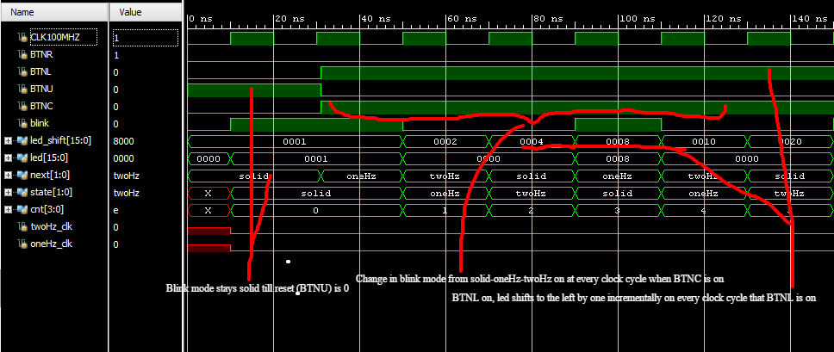**Waveforms annotated**

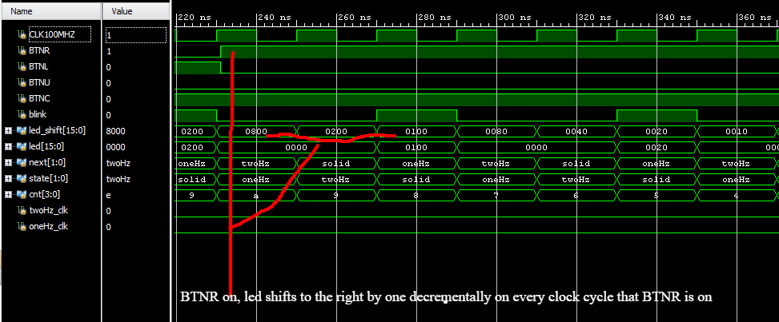

Final design worked correctly on the FPGA board and accepted by Prof. Shmult

Making lab better – the first lab went well.