SOC Home Lab – Wazuh SIEM Monitoring
Author: Abzal | Date: 03–04 Oct 2026 | Tool: Wazuh (Overview, Vulnerability Detection, Threat Hunting)

1. Objective
Build a small SOC lab where a Wazuh server collects logs from endpoints, detects vulnerabilities, and raises alerts that are investigated like a real SOC analyst workflow.

2. Lab Architecture
Component | Details
Wazuh Server / Manager | Kali Linux (dashboard on localhost), agent name "abzal"
Monitored Endpoint | Windows 11 Home laptop, agent name "aravinth" (ID 001)
Modules Used | Overview, Vulnerability Detection, Threat Hunting
Cluster name | abzal

3. Agent Setup
- Installed Wazuh server on Kali Linux.
- Installed Wazuh agent on the Windows 11 laptop and pointed it to the Kali server IP.
- Agent registered as aravinth (001) and started sending events.
- Verified in Overview > Agents Summary (it showed Disconnected (1) while the laptop was offline).
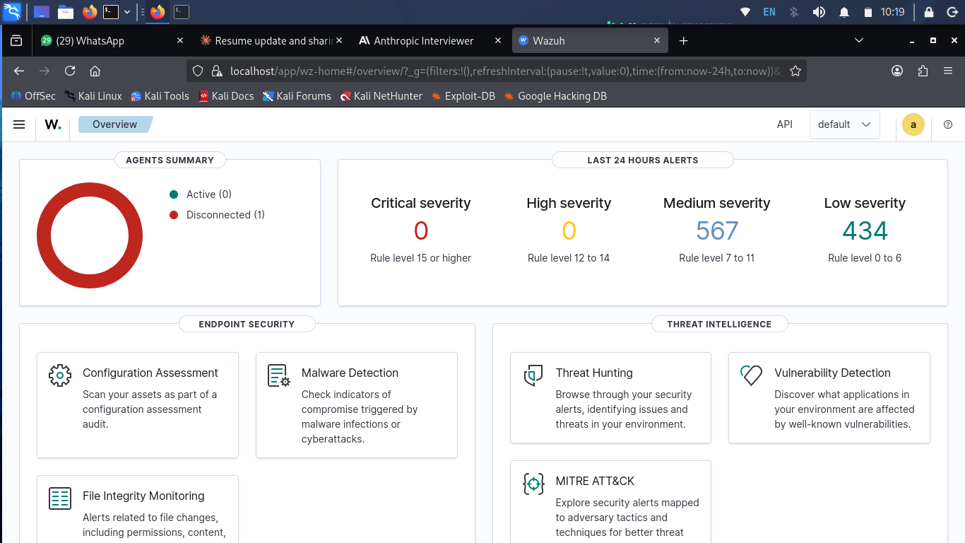
Figure 1: Overview – agents summary and last 24 hours alerts

4. Vulnerability Detection
Agent aravinth was scanned and CVEs were listed per package.
Severity | Count | Notes
Critical | 1 | CVE-2026-81376 – Visual Studio Code 1.130.0, incomplete comparison lets an unauthorized attacker bypass a security feature over a network
High | 320 | Mostly Adobe Acrobat Reader and VS Code
Medium | 174 | VS Code, WinRAR 5.31, Node.js 24.18.0, WhatsApp, Adobe Acrobat Reader DC

Top vulnerable packages (High filter)
Package | CVE count
Adobe Acrobat Reader | 297
Microsoft Visual Studio Code | 15
WinRAR 5.31 (64-bit) | 7
Node.js | 1

4.1 Critical
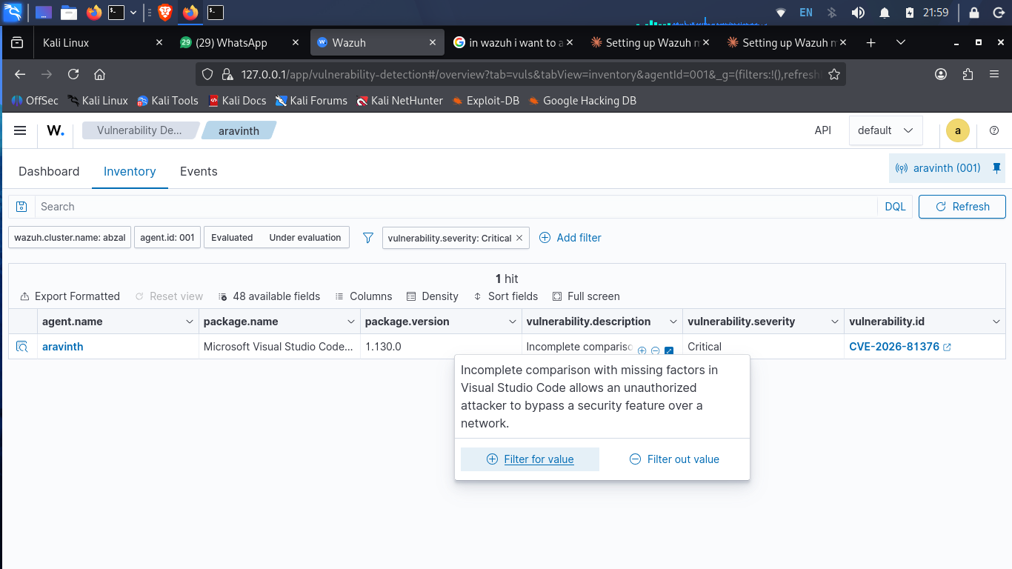
Figure 2: Critical severity filter – CVE-2026-81376 (VS Code 1.130.0)

4.2 High
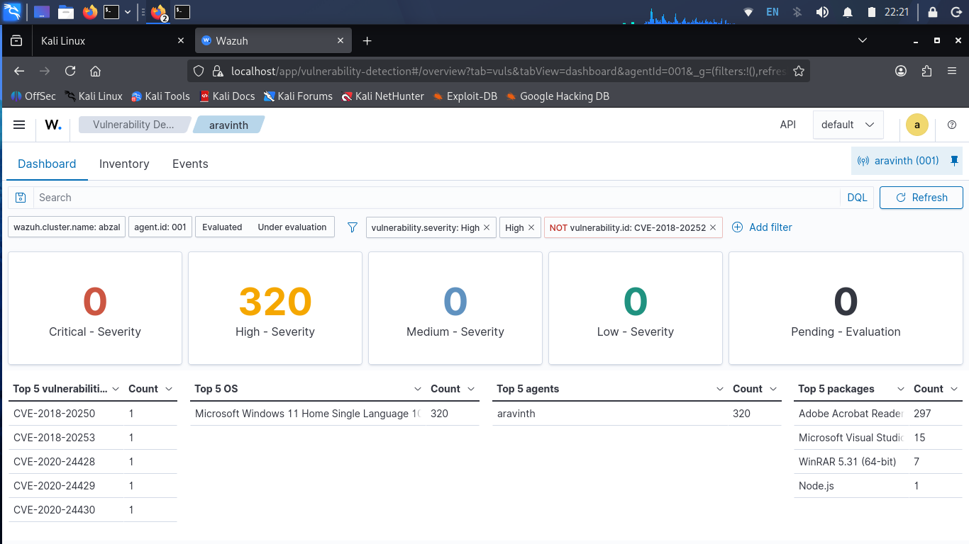
Figure 3: Vulnerability dashboard – High 320, top 5 packages
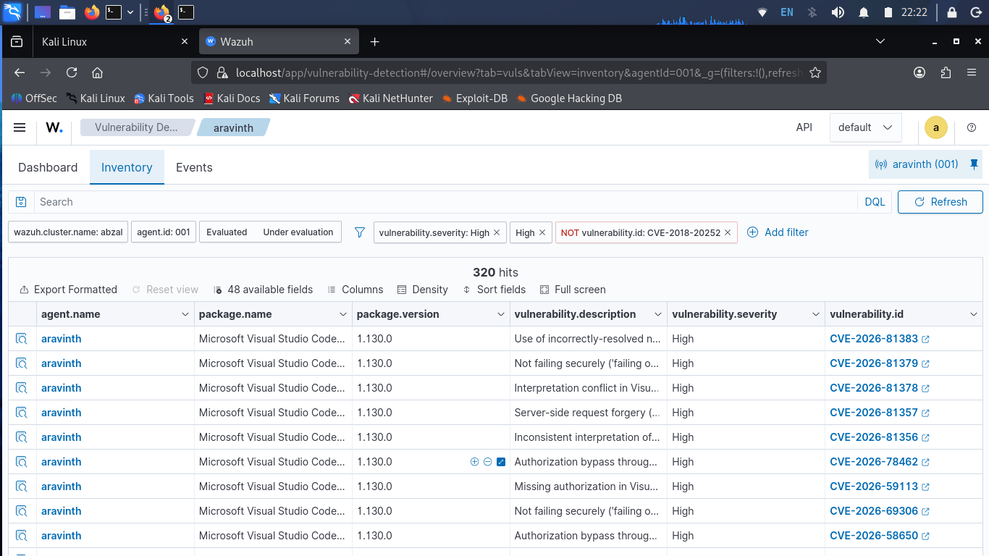
Figure 4: High severity inventory – VS Code CVEs
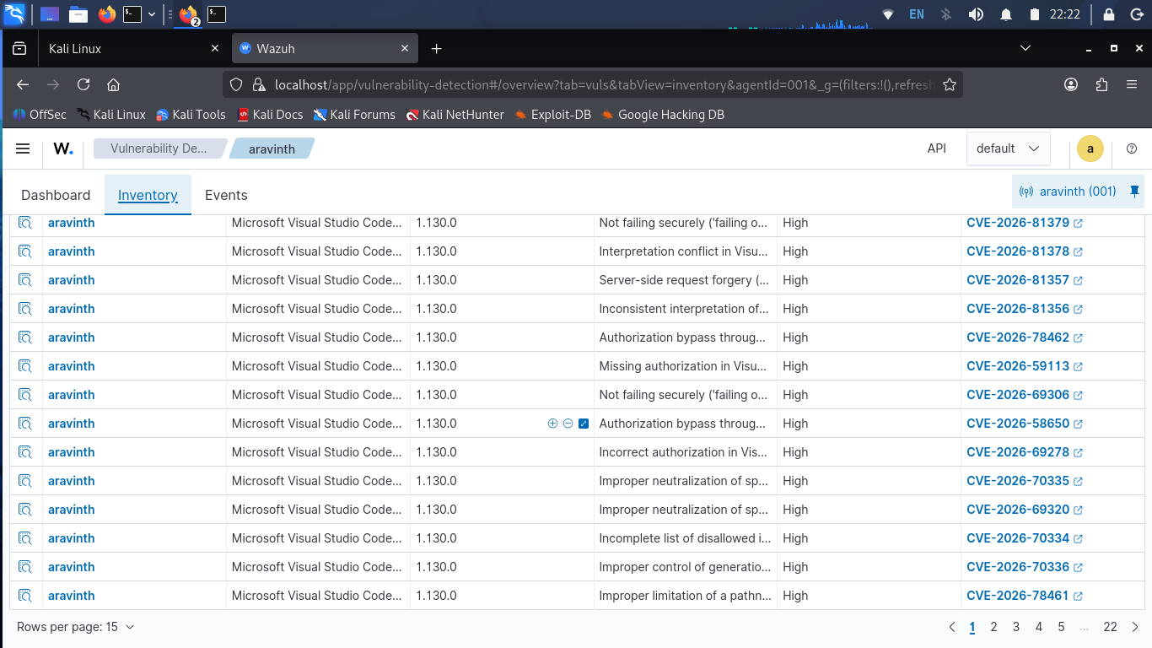
Figure 5: High severity inventory – more VS Code CVEs

4.3 Medium
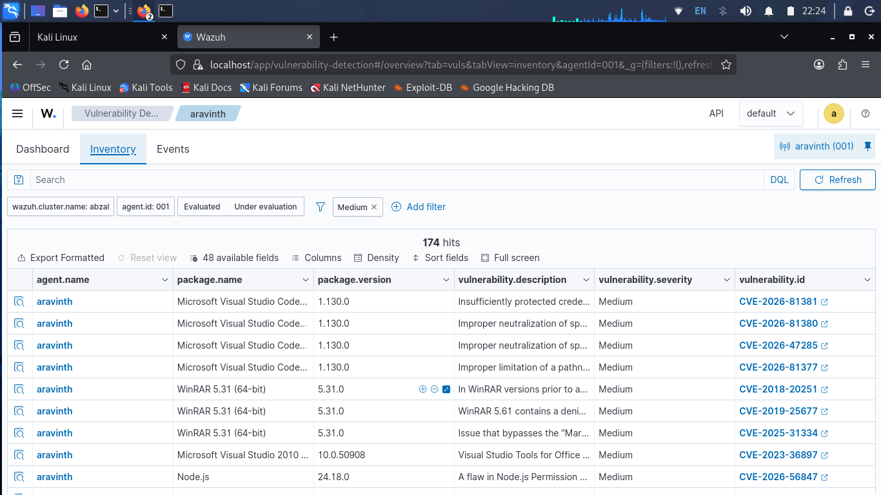
Figure 6: Medium severity inventory – 174 hits
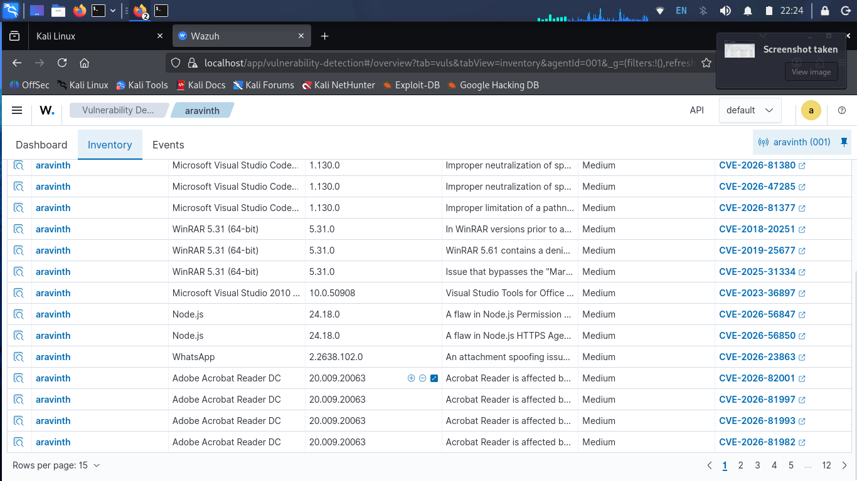
Figure 7: Medium severity – WinRAR, Node.js, WhatsApp, Acrobat Reader DC

Recommended fixes
Software | Action
Visual Studio Code | Update to latest version
Adobe Acrobat Reader DC 20.009 | Update or replace with a maintained version
WinRAR 5.31 | Upgrade to current release
Node.js 24.18.0 | Update to latest patched release

5. Threat Hunting and Alert Analysis
Overview (last 24h): Critical 0, High 0, Medium 567, Low 434. Threat Hunting showed 1,506 events between Oct 3 11:16 and Oct 4 11:16.
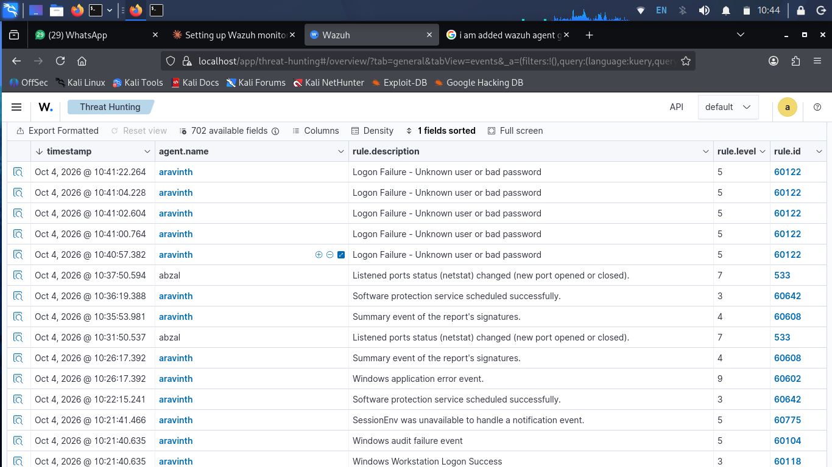
Figure 8: Threat Hunting – logon failures, port change, Windows events
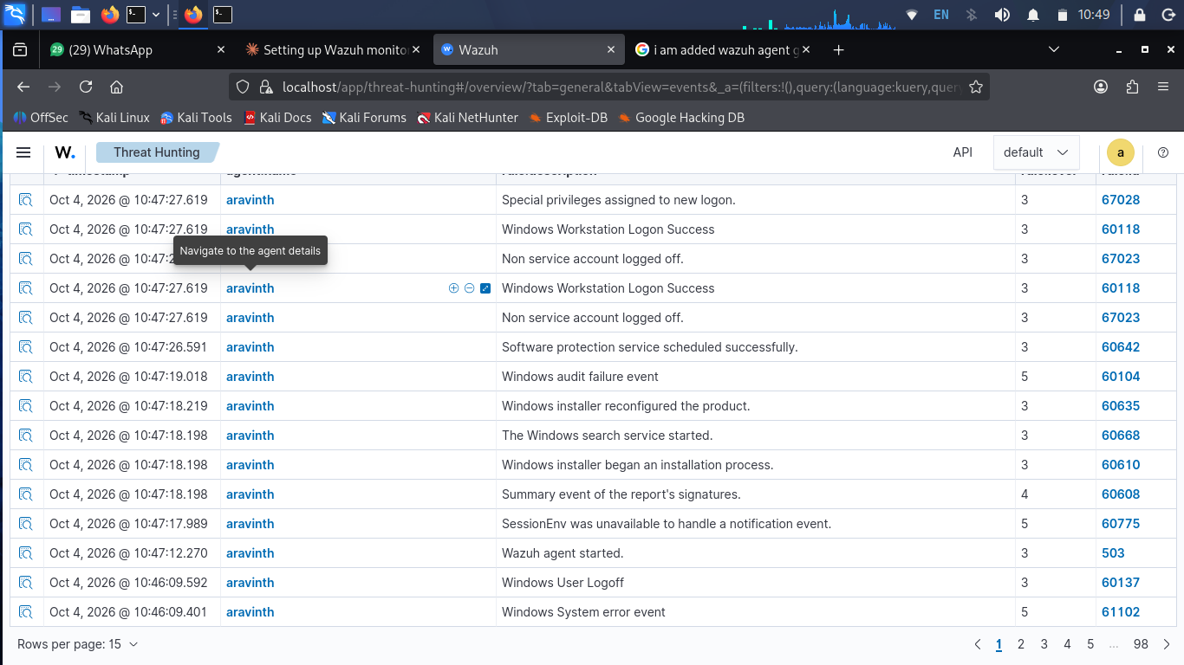
Figure 9: Threat Hunting – agent start and logon/logoff events
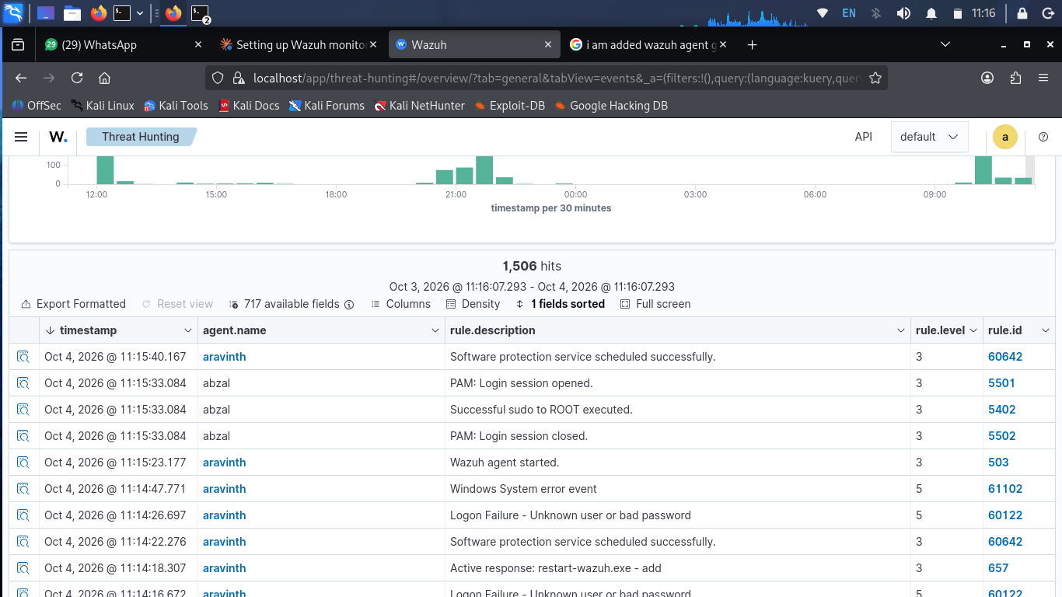
Figure 10: Threat Hunting – 1,506 hits, event timeline, sudo/PAM events
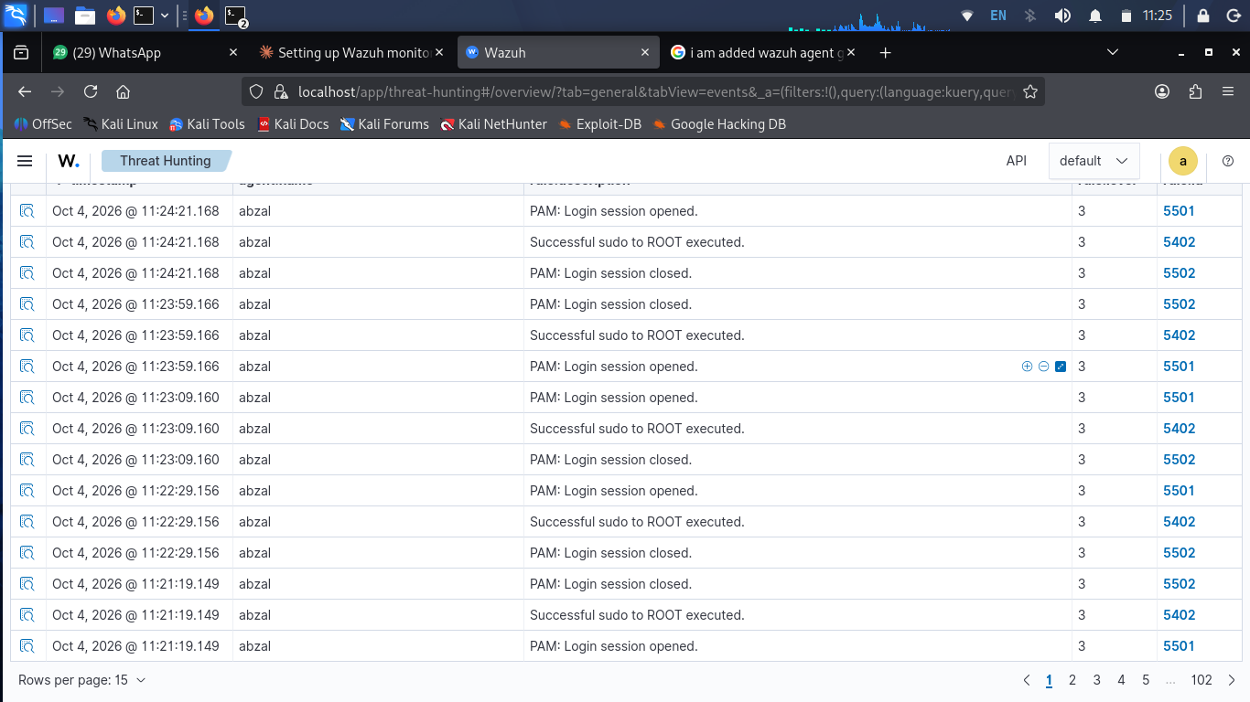
Figure 11: Sudo and PAM session events on Kali (abzal)
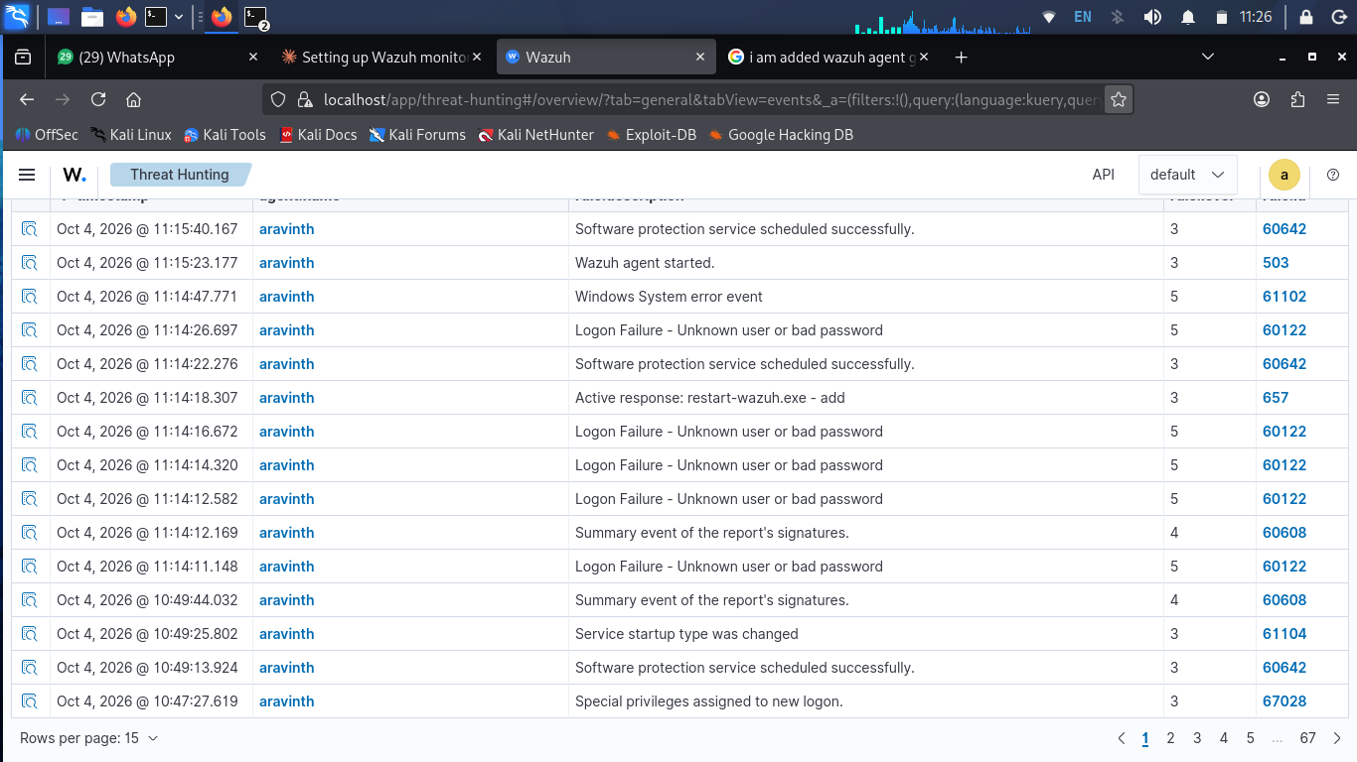
Figure 12: Agent restart, logon failures and service change events
Rule ID | Description | Level | Agent | Meaning
60122 | Logon Failure – Unknown user or bad password | 5 | aravinth | Repeated failed logins – check brute force vs typo
533 | Listened ports status changed | 7 | abzal | New port opened/closed – verify service
60602 | Windows application error event | 9 | aravinth | App crash – check application
5402 | Successful sudo to ROOT | 3 | abzal | Admin activity on Kali
5501/5502 | PAM login session opened/closed | 3 | abzal | Session tracking with sudo
503 | Wazuh agent started | 3 | aravinth | Agent restart
657 | Active response: restart-wazuh.exe | 3 | aravinth | Wazuh auto-restart action
597 | Registry Key deleted (FIM) | 5 | aravinth | Registry change under CurrentControlSet\Services – verify cause
61104 | Service startup type changed | 3 | aravinth | Service config change
67028 | Special privileges assigned to new logon | 3 | aravinth | Admin-level logon

Investigation notes
- 60122 came in short bursts (around 10:40–10:41 and 11:14 on Oct 4) – matches my own wrong password attempts, classified benign.
- 5402 / 5501 / 5502 on abzal came from my sudo commands while working on the lab – expected.
- 533 on abzal appeared when I started/stopped services – expected.
- Alert volume peaked when the laptop was online.

6. File Integrity Monitoring (FIM)
FIM tracks changes to files and Windows registry keys on the agent. On aravinth, many events were logged on Oct 4 around 10:20:54–10:20:55 with rule 597 (level 5): registry keys under HKEY_LOCAL_MACHINE\System\CurrentControlSet\Services were deleted.
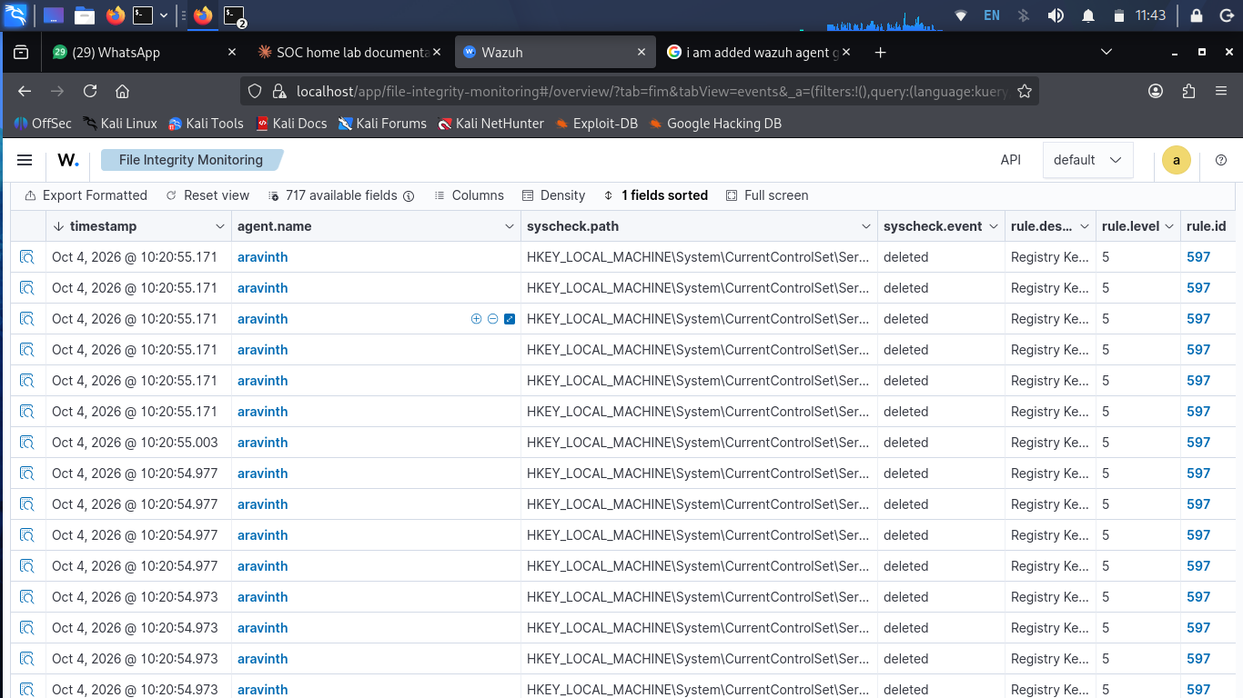
Figure 13: File Integrity Monitoring – registry key deleted events (rule 597)

Investigation notes
- Event type: deleted; path: HKLM\System\CurrentControlSet\Services (service registry keys).
- Many events within one second – looks like a single software install/uninstall or service cleanup, not repeated manual changes.
- To confirm: check what was installed or removed on the laptop at 10:20 and compare with Windows installer events (60610 / 60635).

7. Skills Demonstrated
- Wazuh server and agent deployment
- Endpoint log collection (Windows + Linux)
- Vulnerability assessment and CVE severity triage
- Alert analysis using rule ID and rule level
- File Integrity Monitoring (registry change detection)
- Separating true positives from benign activity
- File integrity (registry) change monitoring

8. Next Steps
- Create custom alert monitors for rule 60122 (multiple failed logins).
- Explore the MITRE ATT&CK view.
- Patch vulnerable software and re-scan for a before/after comparison.

