Guide for recreating experiments and using this benchmarking platform.
Keyboard
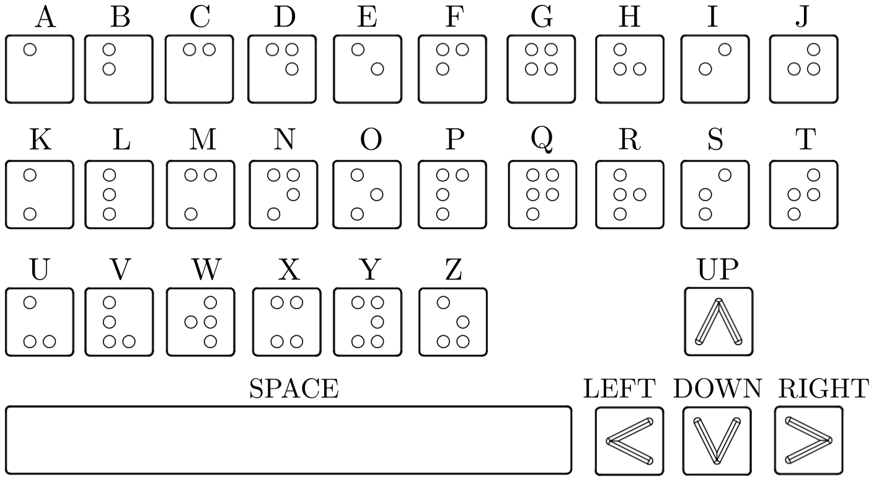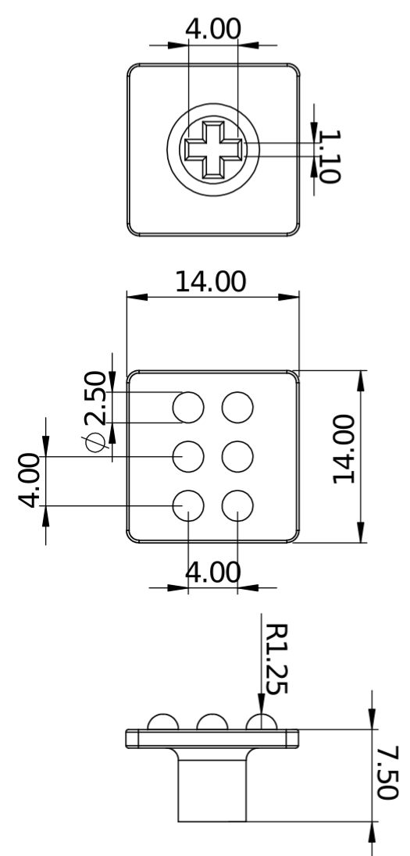
The keyboard used for these experiments is the DREVO Excalibur 84 Key Mechanical Keyboard with Cherry MX Black switches (available here).
The 3d printable keycaps are designed to fit on Cherry MX switches, the Black switches have been used as they offer a relatively stiff switch (requiring 60N for actuation) making the task slightly easier.
We printed the keycaps using a high precision 3d printer (Stratasys Objet260 Connex), this ensures that the features to be interpreted are accurate and consistent.
Ideally, recreating these experiments will use the same keyboard or the same key switches, if these components are unavailble a similar experiment can be created using alternatives but differences should be noted.
Configuring Sensor
Configuring Robot Arm

