Huckel_TB Program

Version 2.0 (August/2025)

This document provides relevant information about the Huckel_TB program, as well as the procedures required for its installation, execution, and the structure of the input files required to run it. Questions, criticisms and suggestions for improvements and/or incorporation of new features regarding the program can be sent to Adriano Martins.
I. INTRODUCTION
I.1) Theory
The Huckel_TB program is intended for calculating the electronic structure of crystalline solids within the tight binding approximation. To this end, it employs the Extended Hückel Method (EHT) [1] to construct the matrix elements of the Hamiltonian in the monoelectronic approximation, using a basis of atomic orbitals, which are assumed to have the functional form given by a radial part (Slater Orbitals, STO) multiplied by the spherical harmonics. The radial part is expanded in terms of a double zeta basis of Slater orbitals:
(I.1)
where a_{j} are the expansion coefficients, the decay constant related to the i STO and N_{j} the corresponding normalization constants:
(I.2)
In the EHT, given two orbitals α and β located, respectively, on the crystal sites i and j, the Hamiltonian matrix element is given by the Wolfsberg-Helmholtz formula [1]:
(I.3)
where K is a dimensionless constant whose value is traditionally set at 1.75 (original work by Hoffmann), E_{iα} corresponds to the energy of the α orbital at site i, and S_{iα,jβ} is the overlap between the α and β orbitals. Within the tight-binding (TB) approximation, the electronic states of the system are expressed as linear combinations of the base orbitals (LCAO):
, | (I.4)
Where the subscript μ refers to the atomic orbital of an atom located at a R_{j} site within the unit cell. The values ​​of the expansion coefficients c_{i}, in this approach, are to be determined. To determine the coefficients, a widely used approach is the application of the variational principle: although it is an approximate method, the solutions found converge to the exact solution of the problem. The energy of a state i defined by equation (I.4) is
. | (I.5)
For the sake of notation simplification, in (I.5) equation the summation index μ and ν run over the atomic sites and the orbitals. In order to determine the eigenstates of the system, we proceed to minimize the above functional with the constraint , using the Lagrange multiplier method. To do so, we construct the functional:
. | (I.6)
In terms of the base orbitals (I.4), equation (I.6) can be rewritten as
. | (I.7)
Minimizing the functional (I.7) with the normalization constraint and defining the overlap between the orbitals as , we obtain the following equation:
, | (I.8)
which corresponds to a system of N homogeneous algebraic equations known as Rootham's equations, where N is the total number of atomic orbitals in the system. In the above equation, we absorb at the same rate both the dependence on the type of the orbital and the site where it is located. The explicit presence of overlaps in (I.8) leads to a generalized eigenvalue problem: only in the case where the orbitals form an orthonormal set, with zero overlap between orbitals belonging to different sites, do we fall back into the standard eigenvalue problem..
The above formulation is general, without dwelling on the specific form of the base orbitals. However, in crystalline systems, translational symmetry allows us to write the solutions of the Hamiltonian in the form of Bloch sums:
, | (I.9)
where μ denotes the atomic orbital, k is a reciprocal lattice vector, and R denotes the crystal lattice sites. Using periodic boundary conditions, the values ​​of k are defined within the first Brillouin zone. Considering n orbitals per site and N crystal sites, we have a total of n x N states in the system.
In the same way as outlined in the previous section, the crystalline electronic states can be expressed as linear combinations of the Bloch functions, and following the same procedure we will thus again have a generalized eigenvalue problem:
, | (I.10)
where
, | (I.11)
In equation (I.11) above, the greek letters α and ν label the atoms of the unit cell and their respective orbitals, while m' labels the unit cells. The value m' = 0 corresponds to the reference unit cell. The summation over ν' runs over all atoms that have a position equivalent to the atom ν of the reference cell. The matrix elements and are calculated using the prescriptions of the Hückel method, Eq. (I.3).
I.2) Overlaps Calculation
The Huckel_TB program employs a numerical procedure for calculating overlaps between atomic orbitals. The subroutine allows the calculation of overlaps for s, p, and d orbitals only. In a previous version of the program, Michael Barnett's analytical formulas [2] were used to calculate overlaps, but for some orbitals (with Z > 54), some of the formulas resulted in erroneous values, so it was decided to discontinue use of these formulas.
The numerical subroutine used by the program was submitted by J. Cerdá and has been extensively tested, yielding reliable results for calculating the σ, π, and δ components of the overlap. After calculating these components, the calculation must be completed by applying the two-center integral formulas of Slater and Koster [3], which express the overlaps between orbitals in terms of their relative position with respect to a Cartesian coordinate system.
II. A General View of the Program
The Huckel_TB program has a modular structure to facilitate the incorporation of new features and capabilities. In its current version, the program has the following technical characteristics:
- Expansion of valence atomic orbitals in a double zeta basis of Slater orbitals;
- Numerically calculated overlaps;
- Different from the older version, the program works with just one input file, where the variables of the different old input files are grouped using the NAMELIST facility of the fortran language.
Below is a brief description of the modules and their respective subroutines that make up the current version of the program:
Huckel_TB.f90 | The main program, responsible for reading input files, printing the read information, and, depending on the calculation options, generating the k-points required for the desired calculation based on the information read from the input files. Finally, it calls the subroutine for calculating the energies.
Diagonalize.f90 | Its main subroutine is designed to construct the system's Hamiltonian and the overlap matrix, and then diagonalize them in a given k-path.
overlaps_jc.f90 | Contain the subroutine that calculates the sigma, pi and delta components of the overlap between two orbitals separated for a given distance. From that components utilizes the tow center formulas to give the overlaps along the cartesian directions.

III. Compiling and Running the Program
To compile the program, you must have a Fortran compiler (GFORTRAN or INTEL) and the LAPACK and BLAS libraries installed on your computer. In addition to the source code, some input files related to different types of calculations and systems are also provided, as well as a small compilation file (mcopt.sh). This file is a shell script written for the GFORTRAN compiler and contains a few optimization options. If you want to modify or add new optimization options, simply edit this file. Just type:
sh tbopt.sh &
At the end of compilation, the HTB.x executable file will be created. To run it, you must provide the input file and, if the system has a non-conventional unit cell, the ATOMS.DAT file, which contains information about the number of atoms in the cell, the primitive vectors, and the coordinates of the basis atoms. The input file can have any name, while the other file cannot. To run it, run:
./htb.x<input>out &
In the OUT file the program writes various information, such as the input parameters readen from the input file and some final results. An additional output files are generated, as will be explained in the section devoted to application examples.
IV. Huckel Parameters for the Crystalline Compounds
In the typical tight-binding parameterizations of crystalline compounds, the basis orbitals are assumed to form an orthonormal set, and the range of interactions between atoms, expressed in hopping integrals, is short-range, generally restricted to second neighbors. Under these conditions, the parameters are not only not transferable to other chemical environments, but it is also necessary to employ empirical formulas to correct for hopping when the atoms in the system occupy positions other than the crystalline position for which the parameters were obtained, as is the case in systems under applied pressure. In the Extended Hückel Method, the basis orbitals are assumed to be non-orthogonal, and the range of interaction is much greater than in traditional schemes, resulting in better parameter transferability.
For a given crystalline compound, the calculation of its electronic structure within the MHE is performed by specifying a valence orbital basis for each chemical element and computing the matrix elements (I.3) in this basis. In the Huckel_TB program, the valence orbitals are expressed in a double zeta basis. Thus, the parameterization of a given compound involves specifying, for each valence orbital of the basis, its energy and the expansion coefficients c_{i} and the zetas ζ_{i} of the Slater orbitals, resulting in four parameters per quantum number l for each constituent atom of the material. The second expansion coefficient can be obtained from the first by imposing orbital normalization. Denoting by and the Slater orbitals which form the basis, we have:
, | (IV.1)
For a given the Slater orbitals have the same quantum numbers , differing by the values of the coefficient . Imposing the normalization to :
, | (IV.2)
Since Slater functions are normalized, we have . The overlap between two Slater functions centered at the same site is:
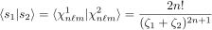, | (IV.3)
From expressions (IV.2) and (IV.3) we can calculate c₂ as a function of c₁. In the case of one of the Slater functions that makes up the atomic orbital, for example, being very localized (typically ζ₂ > 20), we simply have that .
An important aspect of working with tight-binding methodologies is the availability of parameterizations for different compounds. In the case of MHE, there is a reasonable availability of parameters for metals and semiconductors, published by J. Cerdá [4-6]. However, although the transferability of the parameters is better than in orthogonal tight-binding, the parameters published there refer to bulk compounds [4,5] and, in the case of carbon, to nanotubes [6].
V. Input File Structure
In the first version of the program, the input variables were read from three different input files: one containing information about the unit cell, another with general information, identification of the base orbitals of each atomic species and the Hückel parameters and, finally, a file with the k-path for calculating the band structure.
In this version of the program, we have only a single input file, and the input variables are arranged in groups. We use the Fortran NAMELIST feature to identify each group of variables. The NAMELIST command creates a group of variables identified by a name. Within the group, we can have integer, real, and array parameters. The Huckel_TB program has four groups of variables, identified respectively by the names globalvars, unitcell, kpath, and orbitals. Taking the first as an example, within the main program, the following line identifies the group:
namelist /globalvars/ nauc, numtp, nsybz, ndiv, cltit, eshift
The group of variables that make up the globalvars namelist have all been declared before, and the group is read as follows within the program:
read(*,NML=globalvars)
Next, we will specify the variables for each namelist which is part of the input file structure, remembering that the order of presentation of the following namelists does not need to be followed within the input file.
V.1) Namelist GLOBALVARS
This namelist contains some general program information and the integers needed to allocate the arrays of the other namelists. The figure below shows an excerpt from the input file for gallium arsenide that contains this namelist.
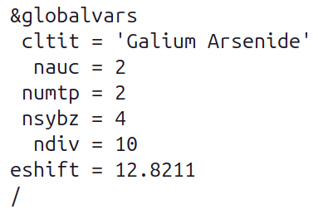
Note the structure of the namelist in the input file: it begins with & followed by the namelist identifier (globalvars) and ends with /. Within it, variables can appear in any order, not necessarily the one above. The table below describes each variable in the namelist:

Variable | Kind | Description
CTIT | Character | Calculation title, to be printed in the output file.
NAUC | Integer | Number of atoms in the unit cell. In the case of GaAs, we have two atoms.
NUMTP | Integer | Number of atomic species of the material.
NSYBZ | Integer | The number of high symmetry points in the Brillouin Zone of the adopted kpath. In the figure above, NSYBZ = 4, and thus we will have 3 segments in the kpath.
NDIV | Integer | Number of splits of each kpath segment.
ESHIFT | Real | ESHIFT corresponds to a shift to be applied to the Hamiltonian matrix according to the equation , where λ is the shift. It serves to position the Fermi level at a certain value.

V.2) Namelist UNITCELL
Using the example of gallium arsenide, below is the part of the input file that contains this namelist:
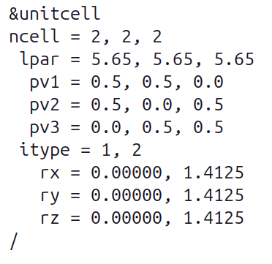
Again, it is important to emphasize that the order ao appearance of the variables within a namelist is does not matter. Below we have the description of the variables that make up this namelist

Variable | Kind | Description
NCELL(3) | Integer | Indicates, for each direction defined by the primitive vectors, the number of primitive cells neighboring the central cell that will be taken into account for calculating hoppings.
LPAR(3) | Real | Lattice parameters along the directions of the primitive vectors.
PV1, PV2, PV3 | Real | The arrays PV1(3), PV2(3) and PV3(3) correspond to the primitive vectors that define the unit cell, in units of the LPAR lattice parameter.
ITYPE | Integer | ITYPE(NUMTP) is an array that assigns the type of each atom belonging to the unit cell.
RX, RY, RZ | Real | RX(NAUC), RY(NAUC) and RZ(NAUC) specify the Cartesian coordinates of the atoms in the primitive cell, in angstroms.

Here we must highlight a characteristic of the FORTRAN language: note that all variables in this group are one-dimensional arrays. Within the namelist, the array elements must be arranged horizontally and separated by commas.

V.3) Namelist ORBITALS
This namelist specifies the variables that characterize the atom types belonging to the system and their corresponding base orbitals by specifying its Huckel parameters. We generally work with the spd de orbitais, ou seja, com três tipos de orbitais, identificados pelo número quântico orbital basis, that is, with three types of orbitals, identified by the quantum number . However, since there are distinct values ​​for the quantum number m, we have in this basis one s-type orbital, three p-type orbitals, and five d-type orbitals.
Following the presentation structure of the previous namelists, below is this namelist for gallium arsenide:

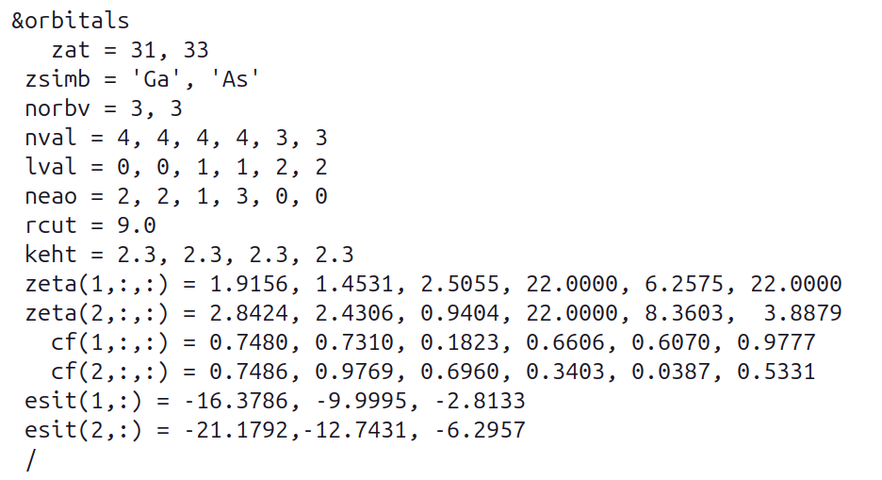
Variable | Kind | Description
ZAT | Real | ZAT(NUMTP) is an array that stores the atomic numbers of each atomic species that makes up the material.
ZSIMB | Character | ZSIMB(NUMTP) is an array that stores the symbols of the atomic species of the system.
NORBV | Integer | NORBV(NUMTP) is an array that assigns, for each atomic species, the number of orbital types that make up its valence base: NORBV(1) = 1 means that atomic specie 1 will only have s-type orbitals in its base, while NORBV(2) = 3 means that the base of species 2 will have s, p and d orbitals.
NVAL | Integer | NVAL(I,J) is a two-dimensional array that assigns the value of the principal quantum number n of the J orbital (J = 1, ..., NORBV(I)) of the specie I (I = 1, ..., NUMTP).
LVAL | Integer | LVAL(I,J) is a two-dimensional array that assigns the value of the secondary quantum number of the J orbital (J = 1, ..., NORBV(I)) of species I (I = 1, ..., NUMTP).
NEAO | Integer | NEAO(NUMTP,NORBV) gives the number of electrons in each orbital, of each species.
RCUT | Real | Cutoff radius, i.e., the range of interaction between atoms, in angstroms.
KEHT | Real | K parameter of the Wolfsberg-Helmholtz formula, equation (I.3). Dimensionless.
ZETA | Real | ZETA(NUMTP,NORBV,2) is the array that assigns the value of the zeta decay constant of the Slater orbitals that form the base orbital of each atomic species.
CF | Real | CF(NUMTP,NORBV,2) is the array that assigns the value of the expansion coefficients cj of the Slater orbitals that form the base orbital of each atomic species, equation (I.4).
ESIT | Real | ESIT(I,J), where I = 1, ..., NUMTP and J = 1, ..., NORBV(I) is the array that assigns the value of the energies of the valence orbitals of each atomic species.

Here again we have to pay attention to the reading of the second rank (NVAL, LVAL, NEAO, KEHT and ESIT) and third rank (ZETA and CF) arrays. In FORTRAN, if we have a second rank array A(3,2), the reading of its elements follows the indexes from left to right, that is, the first index runs faster than the second. Thus, if in the namelist we have
A = 1, 0, 1, -1, 1, 0
that means A(1,1) = 1, A(2,1) = 0, A(3,1) = 1, A(1,2) = -1, A(2,2) = 1, A(3,2) = 0. According this, we could read the values of ESIT using just one line:
ESIT = -16.3786, -21.1792, -9.9995, -12.7431, -2.8133, -6.2957,
As the dimensions of the variable are ESIT(NUMTP,NORV), with NUMTP = 2 and NORBV = 3, in the line above we first have the value of the energy of the S orbital of species 1, then of the S orbital of species 2, followed by the energy of the P orbital of species 1, of the P of 2 and the same for the d orbitals.
For the third rank arrays ZETA(NUMTP,NORBV,2) and CF(NUMTP,NORBV,2), where 2 denotes the double zeta basis, remember that the reading will run first over the species, then over the orbitals (s, p and d) and last over the zetas. The line:
zeta(1,:,:) = 1.9156, 1.4531, 2.5055, 22.0000, 6.2575, 22.0000
means that the first index was set to 1 and thus zeta(1,1,1) = 1.9156, zeta(1,2,1) = 1.4531, zeta(1,3,1) = 2.5055, zeta(1,1,2) = 22.00, zeta(1,2,2) = 6.2575 and zeta(1,3,2) = 22.00

V.3) Namelist KPATH
This file stores information about the k-path for which the energy bands will be calculated. The printout below corresponds to the GaAs:
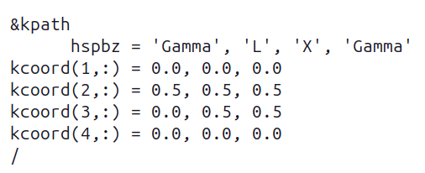
For NSYBZ = 4 and NDIV = 10, both read from the GLOBALVARS namelist, in the example given above, the 4 high symmetry points will generate three segments: Γ-L, L-X and X-Γ . Each of these segments will be divided into 10 parts, and thus we will have 31 k points generated.

REFERENCES
[1] R. Hoffmann, An Extended Hückel Theory . I. Hydrocarbons, J. Chem. Phys. 39, 1397 (1963)
[2] M. P. Barnett, Molecular Integrals and Information Processing, Int. Journ. Quantum Chem. 95, 791 (2003)

[3] J. C. Slater and G. F. Koster, Simplified LCAO Method for the Periodic Potential Problem. Phys. Rev. 90, 1498 (1954)
[4] J. Cerdá and F. Soria, Accurate and Transferable Extended Hückel-type Tight-Binding Parameters. Phys. Rev. B 61, 7965 (2000)
[5] D. Kienle et al., Extended Hückel theory for band structure, chemistry, and transport. I. Carbon nanotubes. J. Appl. Phys. 100, 043715 (2006)
[6] D. Kienle et al., Extended Hückel theory for band structure, chemistry, and transport. II. Silicon. J. Appl. Phys. 100, 043715 (2006)

