# Option #1

# Pseudocode:

Class Module1

Method main(arguments)

Print "First name: John"

Print "Last name: Smith"

Print "Street Address: 123 Main Street"

Print "City: Salt Lake City"

Print "Zip Code: 12345"

# Source Code:

class Module1 {

    public static void main(String[] args) {

        System.out.println("First name: John");

        System.out.println("Last name: Smith");

        System.out.println("Street address: 123 Main Street");

        System.out.println("City: Salt Lake City");

        System.out.println("Zip code: 12345");

    }

}

# Screenshot of application execution:

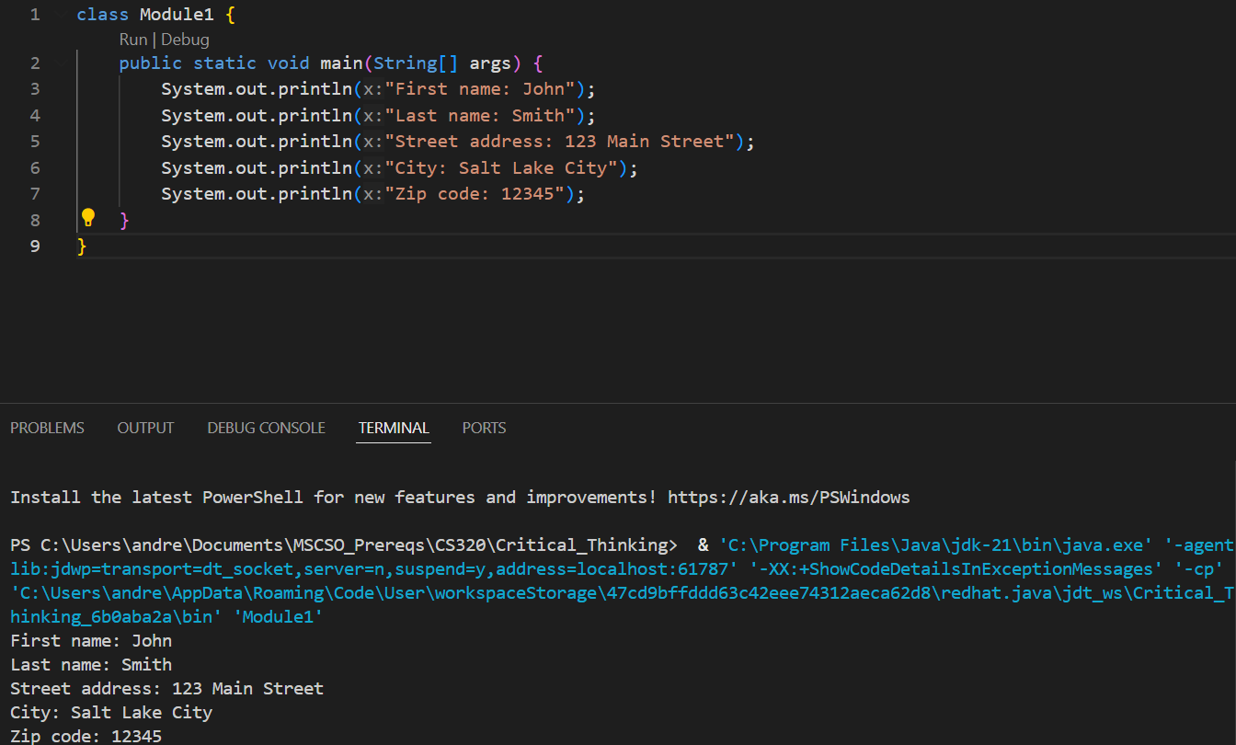

# Git Repository

https://github.com/ac-potts/CS320_CritThinking/tree/main/Module1