# Option #1

# Pseudocode:

# Class Module3

# Method main(arguments)

# PROMPT user to enter weekly income

# READ weeklyIncome

# IF weeklyIncome < 500 THEN

# taxRate = 0.10

# ELSE IF weeklyIncome < 1500 THEN

# taxRate = 0.15

# ELSE IF weeklyIncome < 2500 THEN

# taxRate = 0.20

# ELSE

# taxRate = 0.30

# 

# taxWithholdings = weeklyIncome * taxRate

# 

# OUTPUT "Weekly income: " + weeklyIncome

# OUTPUT "Tax rate: " + taxRate

# OUTPUT "Tax withholdings: " + taxWithholdings

# Source Code:

import java.util.Scanner;

public class Module3 {

    public static void main(String[] args) {

        Scanner scnr = new Scanner(System.in);

        double weeklyIncome;

        double taxRate;

        double taxWithholdings;

        System.out.println("Enter your weekly income:");

        weeklyIncome = scnr.nextDouble();

        if (weeklyIncome < 500) {

            taxRate = 0.10;

        } else if (weeklyIncome < 1500) {

            taxRate = 0.15;

        } else if (weeklyIncome < 2500) {

            taxRate = 0.20;

        } else {

            taxRate = 0.30;

        }

        taxWithholdings = weeklyIncome * taxRate;

        System.out.println("Weekly income: " + weeklyIncome);

        System.out.println("Tax rate: " + taxRate);

        System.out.println("Tax withholdings: " + taxWithholdings);

    }

}

# Screenshot of application execution:

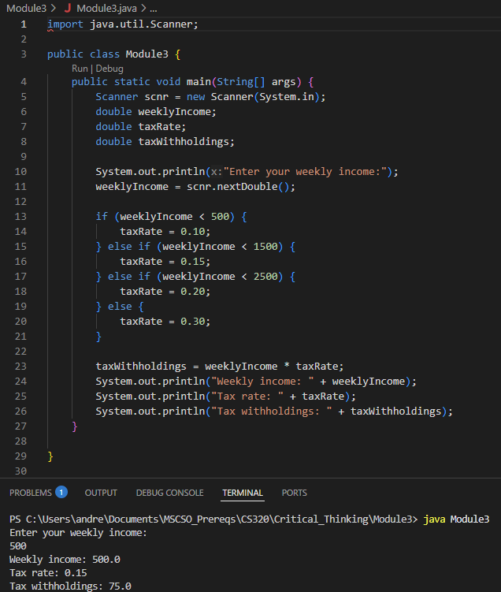

# Git Repository

https://github.com/ac-potts/CS320_CritThinking/tree/main/Module3